 | Air University, Islamabad

Software Design Description
(SDS DOCUMENT)

for
Project Title
Version 1.0
By
Mahay Rana 220977
Maaz Ahmed 222097
Abdullah Shaheer 222470

Supervisor
Ma’am Sadima

Bachelor of Science in Artificial Intelligence(2022-2026)

Table of Contents
Contents
1. Introduction 5
2. Design Methodology and Software Process Model 6
2.1 Design Methodology 6
2.1.1 Justification for Using OOD 6
3. System Overview 7
3.1 Architectural Design 8
3.2 Box and Line Diagram 8
3.3 Layered Architecture Diagram 9
6) Notifications 13
4.2.1Disease detection 14
17
4.5.2 Level 1 - Major Processes 17
17
4.5.3 Level 2 - Detailed Processes 18
5. Data Design 19
5.1 Storage Mechanism 19
5.2 Major Data Structures 19
5.2.1 User Data 19
5.2.2 Crop Images & Metadata 19
5.2.3 Disease Detection Results 19
5.2.4 Pesticide Database 19
5.2.5 Vendor & Supplier Directory 20
5.2.6 Detection History & Analytics 20
5.2.7 Multi-language Content 20
5.2.8 Notification & Alert Data 20
5.3 Data Dictionary 20
5.3.1 CropImage 20
5.3.2 Disease Detection 21
5.3.3 Farmer 22
5.3.4 Pesticide 22
5.3.5 Pesticide Recommendation 23
5.3.6 Treatment Guide 24
5.3.7 Vendor 24
5.3.8 Detection History 25
5.3.9 Notification 26
5.3.10 Offline Cache 26
5.3.11 Admin 27
5.3.12 User 28
6 Human Interface Design 28
6.1 Screen Images 29
6.2 Screen Objects and Actions 32
6.2.1Buttons 33
6.2.2 Input Fields 33
6.2.3 Navigation Elements 34
6.2.4 Feedback Elements 34
6.2.5 Visual Indicators 35
7 Implementation 36
7.1 Algorithm 36
7.2 External APIs/SDKs 39
7.3 User Interface: 41
7.4 Deployment 44
7.4.1 Deployment Environments 45
7.4.2 Hosting & Cloud Services 45
7.4.3 Build & Deployment Pipeline 46
8 Testing and Evaluation 47

Revision History
Name | Date | Reason for changes | Version

Application Evaluation History

Comments (by committee)  *include the ones given at scope time both in doc and presentation | Action Taken
Not 60% complete | Added all of the functionalities needed and connected the front-end and back-end resulting in more than 80% work done.
No live demo | Live demo on android device fully offline and without internet access.

Supervised by
Supervisor’s Name
Signature: ____________

Introduction
The Smart Crop Disease & Pesticide Guide is an AI-powered mobile application designed to revolutionize agricultural practices by providing farmers with instant crop disease detection and optimized pesticide recommendations. This system addresses critical challenges in traditional farming methods, including delayed disease identification, improper pesticide selection, and limited access to expert guidance. The application leverages deep learning models for image-based disease detection and provides comprehensive treatment solutions in both English and Urdu languages.
The system comprises the following core modules:
Module 1: Image Processing & Disease Detection Module
Farmers upload images of infected crops securely via the mobile app. A FastAPI server utilizes an AI vision model (CLIP) matched against Pinecone vectors to detect disease type and severity accurately.
Module 2: Multilingual Support Module
Provides full app accessibility in Urdu with multilingual text formatting. It enhances usability for farmers with limited literacy or English understanding natively on the device.
Module 3: Offline History & Report Export Module
Enables access to cached disease reports natively using internal SQLite. Generates highly detailed PDF records of every agronomic scan allowing farmers to share them offline.

Design Methodology and Software Process Model

Design Methodology
The Smart Crop Disease & Pesticide Guide system follows the Object-Oriented Design (OOD) methodology. This approach is chosen because the system consists of multiple independent modules—each with its own data, behavior, and interactions—that must collaborate seamlessly within the mobile application. OOD allows the system to be structured into modular, reusable, and extensible classes representing real-world entities such as User, Farmer Profile, Disease Detector, Pesticide Recommender, Vendor Directory, Notification Service, and Offline Manager.

Justification for Using OOD
- Modularity & Separation of Concerns: Each module (Disease Detection, Language Support, Result Rendering, Offline Mode) is encapsulated into well-defined classes. This makes the development clean and allows easy debugging and updating.
- High Reusability: Common functionalities such as user verification, image preprocessing, AI model loading, and vendor lookup services are reused across multiple modules without duplicating code.
- Ease of Maintenance & Scalability: AI and agricultural datasets evolve frequently. OOD enables integrating new crops, diseases, or updated AI models without changing the system’s core structure, ensuring long-term scalability.
- Natural Mapping to System Components: Real-world entities like Pesticide, Disease, Crop, Detection Result, and Vendor translate naturally into class-based abstractions, making the system intuitive to design and implement.
- Supports Complex AI Interactions: Image processing, disease prediction workflows, and dynamic pesticide recommendations require components that communicate through methods and events — something OOD handles efficiently.
- Mobile App Architecture Supports OOD:
  - Frontend (Flutter) uses activity/fragment classes that align with OOP principles.
  - Backend services (APIs, FastAPI + Pinecone + Gemini model) behave as independent objects or services.
  - AI modules (Disease Detector, Preprocessor, Recommendation Engine) operate as standalone OOP components that plug into the main app.
2.2 Software Process Model
The project follows the Incremental Software Development Model. Because the system is AI-driven and contains multiple functional modules that require continuous testing, refinement, and integration, the incremental model provides the most efficient workflow for development.

2.2.1 Why Incremental Model?
- Module-by-Module Implementation: Each functional unit—Disease Detection, Image Embedding, Pinecone Database, Multilingual Support, Result Caching—was developed, tested, and refined independently before integration.
- Early Delivery of Working Versions: Initial increments included core features like:
  - Basic login
  - Image upload
  - Early disease detection prototype
Later increments added automated pesticide suggestions driven by Gemini, Urdu language support, and offline mode.
This ensured steady progress with usable prototypes at every stage.
- Reduces Risk in AI-Driven Workflows:
The disease detection model required experimentation and accuracy validation. The incremental model allowed:
  - Training initial AI models
  - Testing with crop images
  - Improving accuracy with each iteration
  - Validating performance before integrating into the full system
- Supports Evolving Requirements: Agricultural apps need frequent updates based on expert feedback, field testing, and model accuracy. Incremental development supports modifications without redesigning the entire system.
- Parallel Development:
Team members can work simultaneously on different increments, such as:
  - One on AI disease detection
  - One on user interface
  - One on pesticide recommendation logic
This speeds up overall development.
- Continuous Integration & Testing: Each increment undergoes thorough testing before merging into the main application, ensuring stability and preventing regression issues.

System Overview
The Smart Crop & Pesticide Guide is an intelligent mobile-based agricultural support system designed to function as a virtual crop health assistant by integrating deep learning, image processing, and recommendation-based AI. The system enables farmers to capture images of diseased plants using a mobile camera and instantly receive disease identification, severity estimation, optimized pesticide suggestions, and step-by-step treatment guidance. The backend manages the CLIP vector embeddings and invokes the Gemini engine to diagnose the plant dynamically, while the frontend displays a localized, high-performance UI.
The system operates within the context of modern precision agriculture, addressing the need for accessible and accurate disease detection without requiring agriculture experts or laboratory testing. Using a CNN-based image classification model, the system analyzes crop images and provides actionable insights. In parallel, the application offers Urdu language support, vendor directory access, price comparison options, and offline functionality to ensure usability in low-connectivity areas. The design emphasizes modularity, extensibility, and real-time responsiveness, which are essential for handling AI inference, mobile processing, and user-driven interactions.
The completed system currently supports:
• Guest access focused purely on fast agronomic operations
• AI-powered disease detection using plant images
• Optimized pesticide recommendations with brand and price details
• Step-by-step treatment guidance for chemical and organic solutions
• Urdu language support for enhanced accessibility
• PDF Export and Direct Screen Sharing capabilities
• Localized caching mechanism for past analysis
• Offline mode for accessing stored reports and recommendations
This integration of computer vision, recommendation intelligence, multilingual accessibility, and agricultural knowledge positions the system as a robust end-to-end crop disease diagnosis and pesticide management platform.

Architectural Design
The "Smart Crop Disease & Pesticide Guide" system is designed with a modular, client-server architecture to ensure scalability, maintainability, and a clear separation of concerns. The system is decomposed into major subsystems that interact through well-defined interfaces. This decomposition allows for parallel development, easier testing, and the ability to update individual components (like the AI model) without affecting the entire system.
The high-level workflow begins with the Mobile Client (the farmer's interface). The client captures an image and sends it to the Backend Server. The server orchestrates the request, leveraging the AI Inference Engine for disease detection and the Database for fetching relevant pesticide data, treatment guides, and vendor information. The processed response is then sent back to the client for display.

Box and Line Diagram
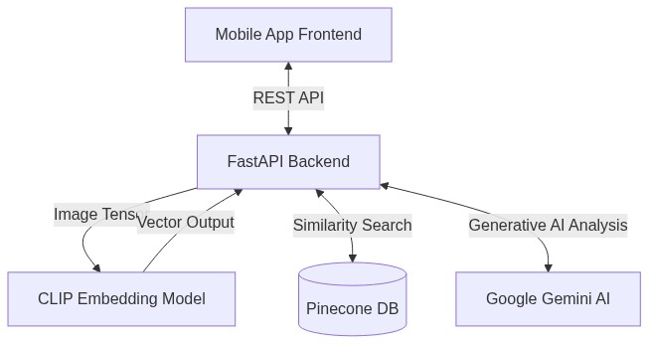
This diagram provides a simpler, high-level representation of the major subsystems and their interactions.
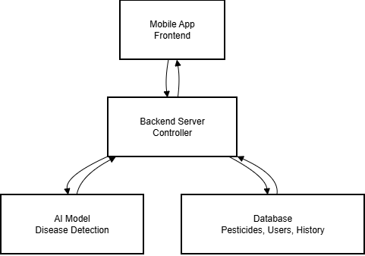

Layered Architecture Diagram
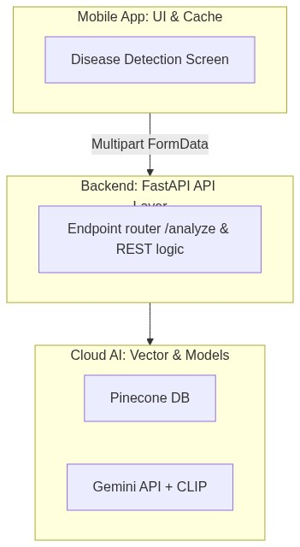
For the detailed design, we have adopted Layered Architecture (Multi-Tiered), which is a standard and effective pattern for web and mobile applications. It promotes separation of concerns, making the system easier to manage and scale.
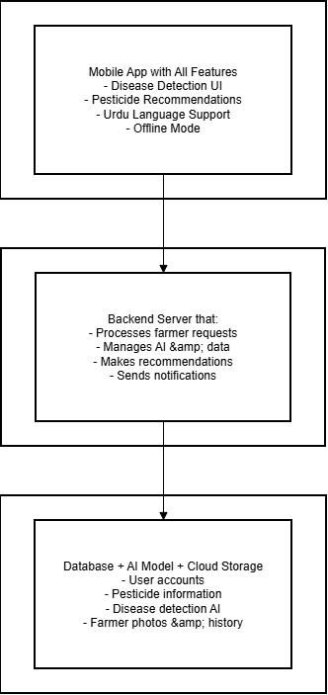

4. Design Models
4.1 Activity Diagrams (for each use case):
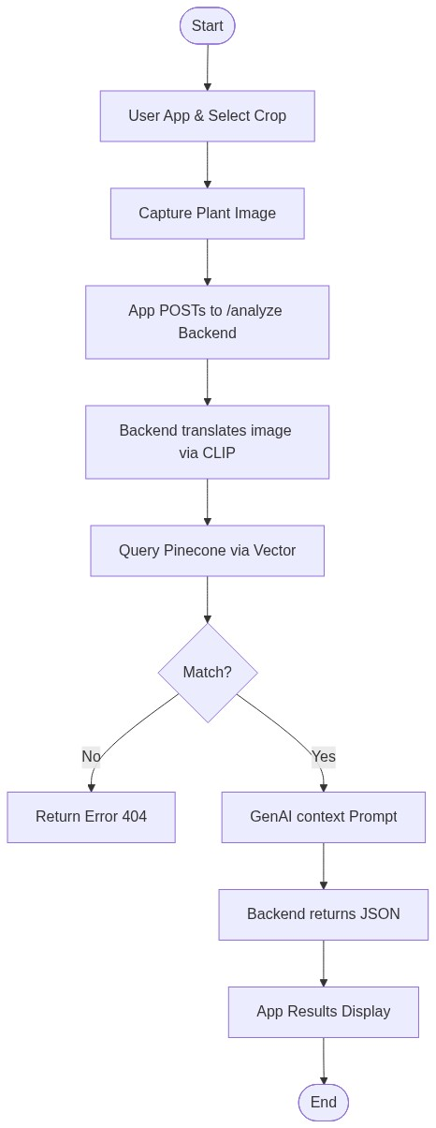

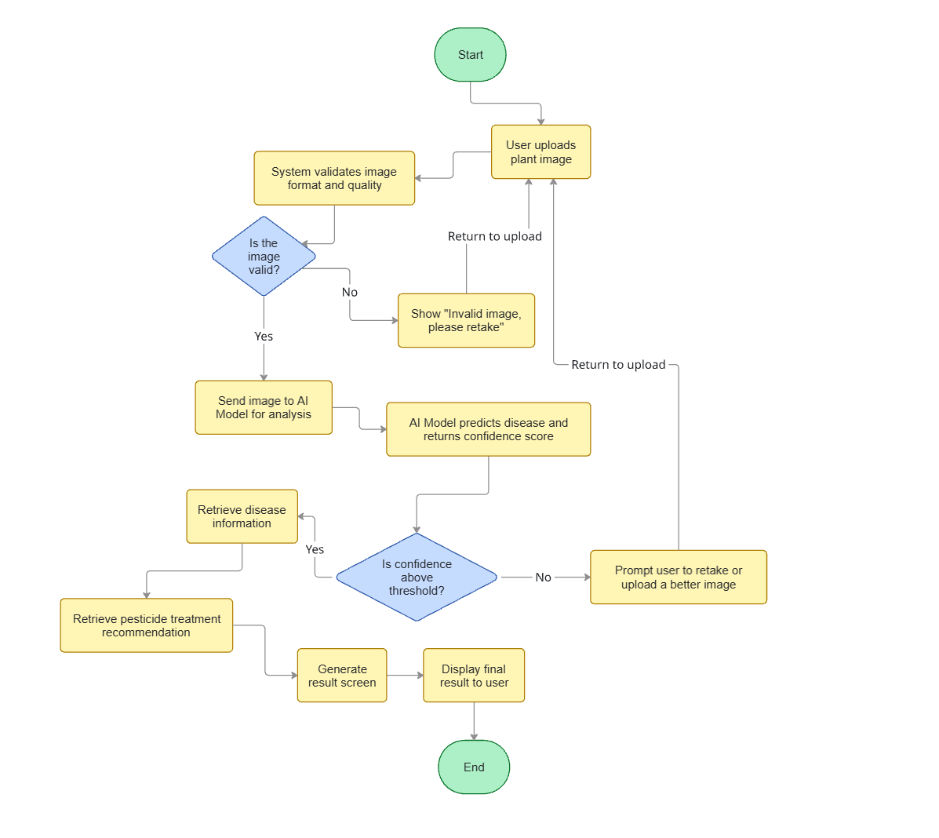
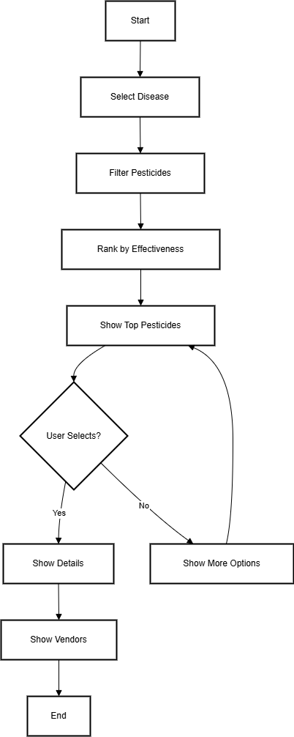
1) Disease Detection 2) Pesticide Recommendation
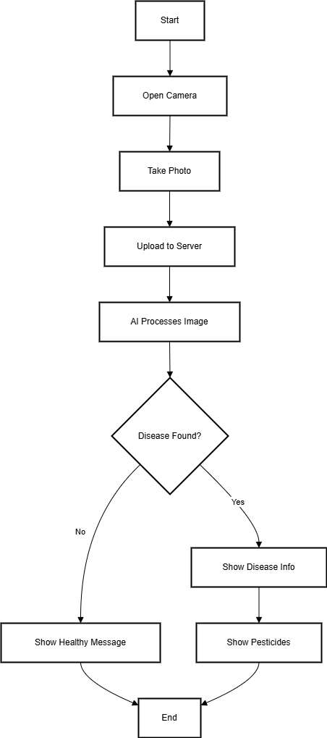

3) Urdu Language Support
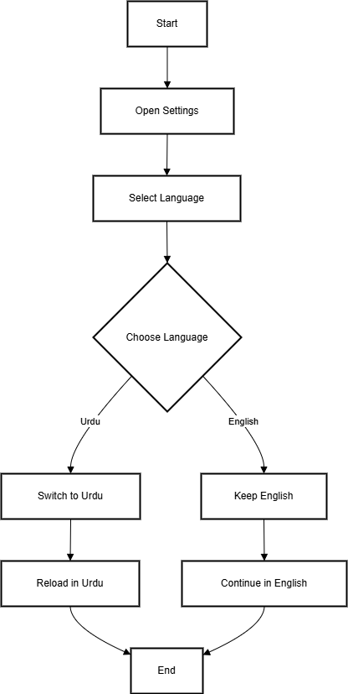

4) Notifications
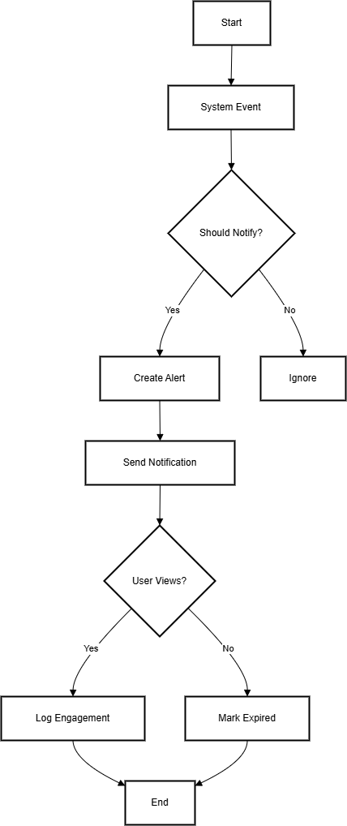

4.2) System Sequence Diagram (for each use case)
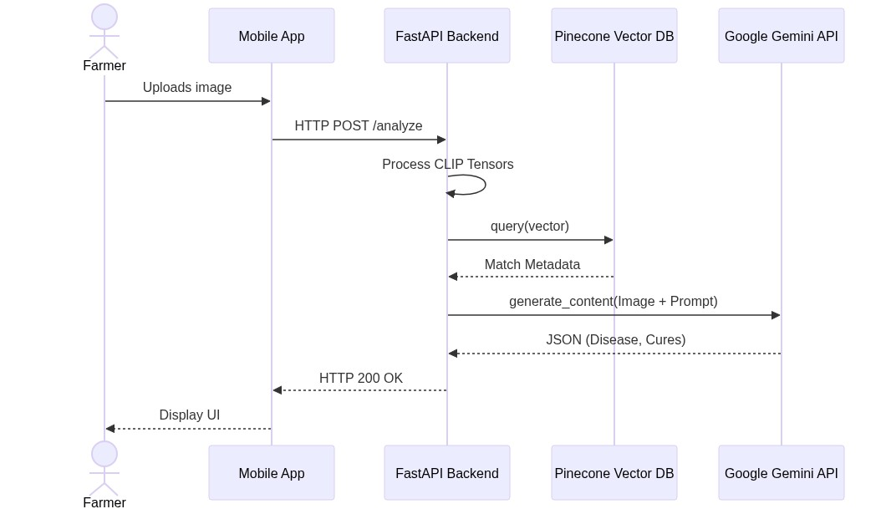

4.2.1Disease detection
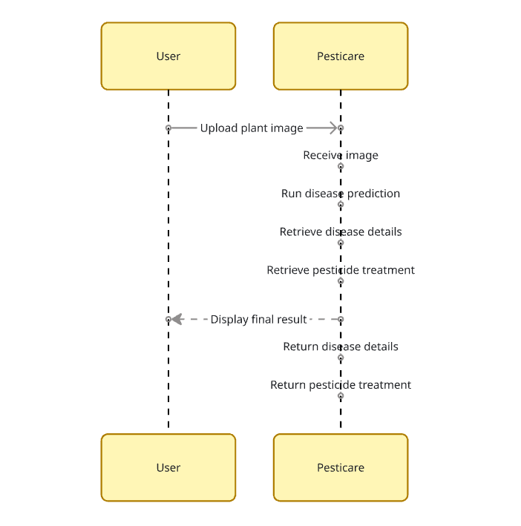


4.3 State Transition Diagram :

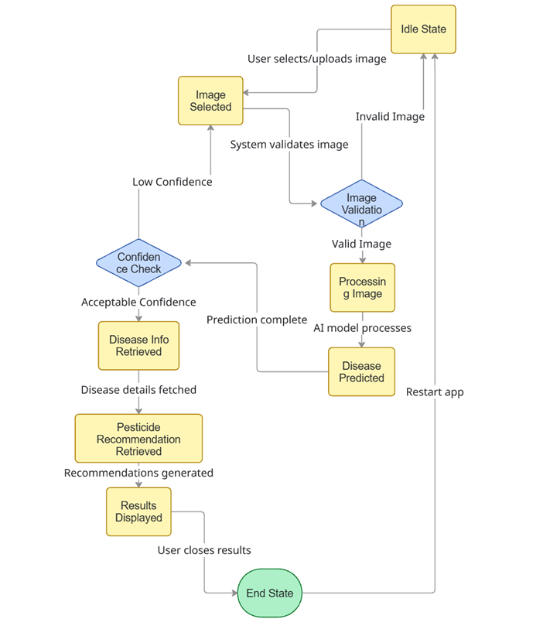

4.4 Class Diagram (Whole System)

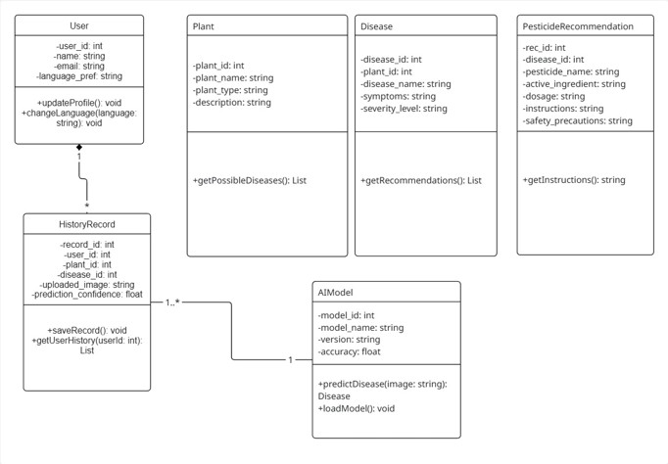

4.5 Data Flow Diagram:
4.5.1 Level 0 - Context Diagram
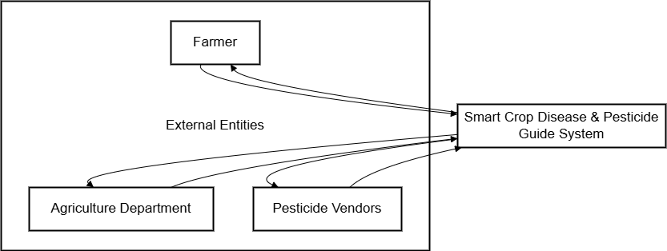

4.5.2 Level 1 - Major Processes
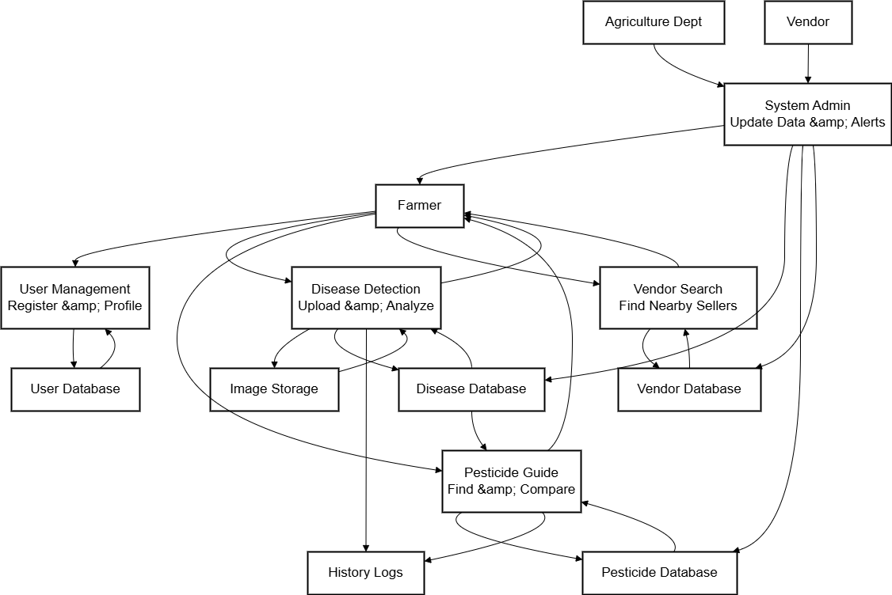

4.5.3 Level 2 - Detailed Processes

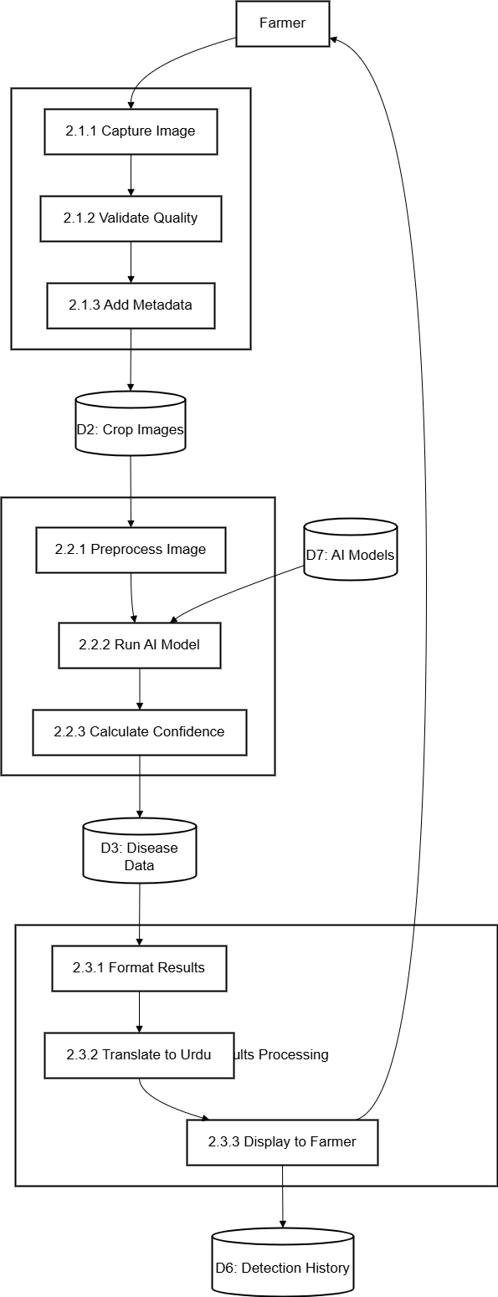

Data Design

The "Smart Crop Disease & Pesticide Guide" system processes diverse agricultural data, including user profiles, crop images, disease detection results, pesticide recommendations, vendor information, and multi-language content. The purpose of the data design is to transform this information domain into consistent, optimized, and scalable data structures that support both real-time AI processing and offline functionality.
The system uses a hybrid data model:
- Relational Database Tables (User profiles, crop records, pesticide data, vendor information)
- Document-Oriented Structures (Disease detection logs, treatment guides, image metadata)
- File Storage Systems (Crop images, AI model files, cached translations)
- Transient In-memory Objects (Session data, real-time detection results, notification queues)

Storage Mechanism
- Primary Storage: PostgreSQL with PostGIS extension for geographical data
- File Storage: Cloud Storage (AWS S3/Google Cloud Storage) for crop images and AI models
- Cache Layer: Redis for session management and frequently accessed data
- Mobile Local Storage: SQLite for offline functionality and cached content
- AI Model Data: TensorFlow model files stored in optimized format for mobile deployment

Major Data Structures

Preferences Storage
- Stores language preference, themes, and basic app configurations.
- Strictly limited to offline preferences.
- Used by the active state management Providers in Flutter.

Crop Images & Metadata
- Stores uploaded crop images with associated metadata.
- Includes image quality scores, geographical tags, crop type identification
- Used by Disease Detection and Image Processing modules

Disease Detection Results
- Stores AI analysis results for each processed image.
- Includes disease name, confidence scores, severity levels, affected areas
- Contains AI model version and detection timestamp for traceability
- Used by Recommendation and History modules

Pesticide Database
- Comprehensive catalog of pesticides with efficacy data.
- Includes brand information, target diseases, application instructions
- Contains safety ratings, price ranges, and organic alternatives
- Used by Recommendation and Comparison modules

Cloud Image Hosting Node
- Hosts raw diagnostic images temporarily for AI validation.
- Utilizes Multipart Form parsing.
- Ensures minimal storage space.
- Accessed during `/analyze` API calls.

Pinecone Vectors Database
- Stores 768-dimensional visual vectors mapped to diseases.
- Includes high-speed approximate nearest neighbor capability.
- Connects directly via Python Pinecone Client.
- Used by Analytics and Notification modules

Multi-language Content
- Stores translated content for Urdu language support.
- Includes UI labels, disease descriptions, treatment guides
- Contains pesticide instructions and agricultural terminology
- Used by Language Support and Localization modules

Google Gemini Content Node
- Constructs generative text parsing strict JSON.
- Translates crop metadata into human-readable steps.
- Operates completely serverless.
- Used by Notification and Alert modules

Data Dictionary

5.3.1 CropImage
Attribute | Type | Description
Image-Id | UUID | Unique identifier for image
User-Id | UUID | Foreign key to User table
Image-Path | string | Cloud storage URL path
Crop-Type | string | Type of crop (rice, wheat, cotton)
Image-Quality | float | Quality score from 0.0 to 1.0
Upload-Timestamp | datetime | When image was uploaded
Geo-Location | geography | GPS coordinates where taken
File-Size | int | Image file size in bytes

5.3.2 Disease Detection

Attribute | Type | Description
Detection-Id | UUID | Unique detection identifier
Image-Id | UUID | Foreign key to CropImage table
Disease-Name | string | Identified disease name
Disease-Code | string | Standardized disease code
Confidence-Score | float | AI confidence level (0.0-1.0)
Severity-Level | string | Disease severity (low, medium, high)
Affected-Area | float | Percentage of plant affected
Detection-Timestamp | datetime | When analysis completed
Ai Model-Version | string | Version of AI model used

5.3.3 Farmer
Attribute | Type | Description
User-Id | UUID | Unique farmer identifier
Phone-Number | string | Primary contact number
Full-Name | string | Farmer's full name
location | geography | Farm location coordinates
Farm-Size | float | Farm area in acres
Language-Preference | string | Preferred language (urdu, english)
Crops-Grown | array | List of crops cultivated
Experience-Level | string | Farming experience (beginner, intermediate, expert)

5.3.4 Pesticide
Attribute | Type | Description
Pesticide-Id | UUID | Unique product identifier
Brand-Name | string | Commercial product name
Chemical-Name | string | Active ingredient name
Target-Diseases | array | Diseases it treats effectively
Application-Instructions | json | Step-by-step usage guidelines
Safety-Level | string | Toxicity rating (low, medium, high)
Organic-Alternative | boolean | Whether organic treatment
Price-Range | json | Minimum and maximum prices in PKR
Effectiveness-Rating | float | User rating from 0.0 to 5.0

5.3.5 Pesticide Recommendation
Attribute | Type | Description
Recommendation-Id | UUID | Unique recommendation ID
Detection-Id | UUID | Foreign key to DiseaseDetection
Pesticide-Id | UUID | Foreign key to Pesticide table
Recommendation-Rank | int | Position in suggestion list (1-5)
Effectiveness-Score | float | Expected efficacy (0.0-1.0)
Cost-Effectiveness | float | Value for money score (0.0-1.0)
Safety-Score | float | Environmental impact score (0.0-1.0)
Reason | string | Explanation for recommendation

5.3.6 Treatment Guide
Attribute | Type | Description
Guide-Id | UUID | Unique guide identifier
Disease-Code | string | Associated disease code
Steps | array | Sequential treatment steps
precautions | array | Safety warnings and precautions
Organic-Alternatives | array | Natural treatment options
Urgency-Level | string | Treatment priority (low, medium, high)
Estimated-Recovery | string | Expected healing duration
Prevention-Tips | array | Future disease prevention advice

5.3.8 Detection History
Attribute | Type | Description
History-Id | UUID | Unique history record identifier
User-Id | UUID | Foreign key to Farmer table
Detection-Id | UUID | Foreign key to DiseaseDetection
Access-Timestamp | datetime | When result was viewed by farmer
Farmer-Feedback | json | User rating and comments
Treatment-Applied | string | Which pesticide was used
Treatment-Effectiveness | string | How well treatment worked

5.3.10 Offline Cache
Attribute | Type | Description
Cache-Id | UUID | Unique cache entry identifier
User-Id | UUID | Farmer owning the cache
Data-Type | string | Type of cached data (image, detection, pesticide, guide)
Cached-Data | json | Compressed cached content
Cache-Timestamp | datetime | When data was cached
Sync-Status | boolean | Whether synced with central server
Last-Accessed | datetime | When cache was last used

5.3.12 User

Attribute | Type | Description
User-Id | UUID | Unique user identifier
Phone-Number | string | Primary contact number
Email | string | Optional email address
Full-Name | string | User's full name
Language-Preference | string | Preferred language (urdu/english)
Created-At | datetime | Account creation date
Last-Login | datetime | Most recent login timestamp
Account-Status | string | Active, inactive, or suspended

6 Human Interface Design
Welcome to Pesti-Care, an AI-powered mobile application designed to empower farmers with instant, accurate, and accessible crop disease diagnosis and treatment solutions.
In many farming communities, identifying crop diseases quickly and accurately remains a major challenge, often leading to delayed treatment, reduced yields, and financial loss. Pesti-Care addresses this gap by putting a digital plant doctor in the pockets of farmers.
Using the power of artificial intelligence and image recognition, our app allows farmers to simply take a photo of a diseased plant. Within seconds, the app analyzes the image, identifies the disease, and provides a curated list of effective pesticides along with step-by-step treatment guides, vendor locations, and price comparisons all in an intuitive, farmer-friendly interface.

6.1 Screen Images

1)First App logo 2) Select Crop Type

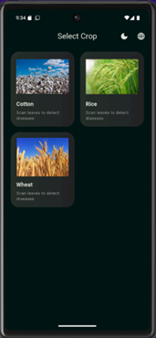
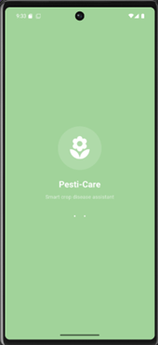

3) Upload the cotton picture 4) Analyze Diseases

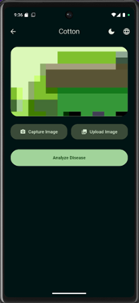
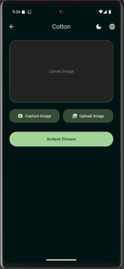

5) Analyze Disease 6) Choose Language

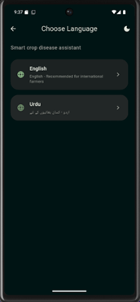
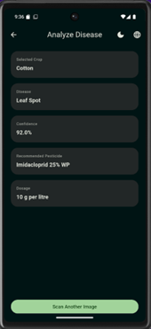

7) Select Urdu language 8) Upload Picture

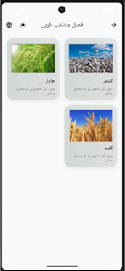
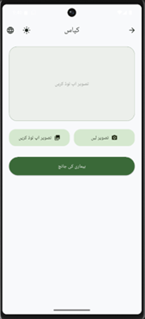

6.2 Screen Objects and Actions

This section describes all significant screen elements that appear throughout the Pesti-Care Crop
Disease Detection system, and the actions farmers can perform with them. Each screen object is designed to support clear interaction, minimize user effort, and provide immediate feedback in both English and Urdu languages.

6.2.1Buttons

6.2.1.1 Language Selection Button

- Action: Allows farmers to choose their preferred interface language (English/Urdu)
- Feedback: Selected language gets highlighted; interface immediately translates to chosen language

6.2.1.2 Select Crop Button

- Action: Opens crop selection menu to choose from Rice, Wheat, or Cotton
- Feedback: Displays selected crop type with visual confirmation; enables disease analysis for specific crop

6.2.1.3 Upload/Capture Image Button

- Action: Opens camera for live capture or gallery for existing plant photos
- Feedback: Shows image preview with crop type; enables analyze button when valid image is selected

6.2.1.4 Analyze Disease Button

- Action: Submits selected image to AI model for disease detection and analysis
- Feedback: Shows loading animation; displays disease results with confidence percentage and severity level

6.2.1.5 View Treatment Guide Button

- Action: Opens detailed step-by-step pesticide application instructions
- Feedback: Displays comprehensive treatment plan with dosage, precautions, and organic alternatives

6.2.1.6 Find Vendors Button

- Action: Searches for nearby pesticide suppliers based on recommended treatments
- Feedback: Shows vendor list with locations, prices, and contact information

6.2.2 Input Fields

6.2.2.1 Crop Selection Dropdown

- Action: Allows farmers to specify crop types (Rice, Wheat, Cotton) for accurate disease detection
- Feedback: Updates AI model parameters; shows crop-specific disease database

6.2.2.2 Image Upload Area

- Action: Accepts plant images from camera or gallery for disease analysis
- Feedback: Validates image quality; shows preview with crop confirmation prompt

6.2.2.3 Language Preference Selector

- Action: Enables switching between English and Urdu interface languages
- Feedback: Immediate translation of all text elements; maintains RTL layout for Urdu

6.2.3 Navigation Elements

6.2.3.1 Back Navigation Button

- Action: Returns to previous screen in the application flow
- Feedback: Smooth transition with maintained user context and data

6.2.3.2 Main Menu Icons

- Action: Provides quick access to Disease Detection, History, Vendors, and Settings
- Feedback: Highlights active section; loads corresponding screen instantly

6.2.3.3 Profile Access Button

- Action: Opens farmer profile and application settings
- Feedback: Displays account information and customization options

6.2.4 Feedback Elements

6.2.4.1 Disease Detection Results Panel

- Action: Shows identified disease name, confidence score, and severity level
- Feedback: Color-coded severity indicators (Green/Yellow/Red); confidence percentage display

6.2.4.2 Treatment Recommendation Cards

- Action: Displays ranked pesticide options with effective scores and prices
- Feedback: Shows comparison metrics; allows direct vendor search for each pesticide

6.2.4.3 Image Quality Validation Messages

- Action: Informs farmers about image suitability for accurate disease detection
- Feedback: Specific guidance on lighting, focus, and plant part visibility requirements

6.2.4.4 Success/Error Alerts

- Action: Confirms successful actions or indicates problems during processing
- Feedback: Color-coded messages (green for success, red for errors) with clear resolution steps

6.2.5 Visual Indicators

6.2.5.1 Loading Spinners & Progress Bars

- Action: Displayed during image upload, AI analysis, and results processing
- Feedback: Shows current processing stage; estimated time remaining for analysis completion

6.2.5.2 Disease Severity Indicators

- Action: Visual representation of disease impact using color codes and icons
- Feedback: Immediate understanding of situation urgency; guides treatment priority

6.2.5.3 Confidence Score Display

- Action: Shows AI model certainty percentage for disease identification
- Feedback: Helps farmers assess result reliability; suggests retaking photos if confidence is low

6.2.5.4 Language Selection Highlight

- Action: Indicates currently active interface language
- Feedback: Clear visual feedback for language preference; easy switching between English and Urdu

6.2.5.5 Image Preview Thumbnail

- Action: Shows captured/selected plant image before analysis
- Feedback: Allows farmers to confirm image quality and retake, if necessary, before processing

7 Implementation

Algorithm

Algorithm 1 FastAPI Vector-LLM Routing

Input: Crop Image
Output: Disease Classification with Confidence Score
ALGORITHM: RealTimeCropDiseaseDetection
INPUT:
Crop image from camera/gallery
Crop type (rice, wheat, cotton)
OUTPUT:
Disease name, confidence score, severity level, treatment recommendations

INITIALIZE:
diseaseModel ← LoadMobileNetV2Model("crop_disease_model.keras")
classNames ← ["Healthy", "Bacterial_Blight", "Blast", "Brown_Spot", "Leaf_Smut", "Rust"]
confidenceThreshold ← 0.70
severityClassifier ← LoadSeverityModel()

WHILE image is available:
image ← PreprocessImage(inputImage)
- Resize to 224x224 pixels
- Normalize pixel values [0,1]
- Apply data augmentation (training only)

IF image quality check passes:
// --- DISEASE CLASSIFICATION ---
predictions ← diseaseModel.predict(image)
topClass ← ArgMax(predictions)
confidenceScore ← Max(predictions)
diseaseName ← classNames[topClass]

// --- SEVERITY ASSESSMENT ---
IF confidenceScore >= confidenceThreshold:
severityLevel ← severityClassifier.predict(image)
// 0=Low, 1=Medium, 2=High

// --- TREATMENT RECOMMENDATION ---
IF diseaseName != "Healthy":
pesticides ← GetPesticideRecommendations(diseaseName, severityLevel)
treatmentGuide ← GenerateTreatmentGuide(diseaseName, pesticides)

// --- RESULTS DISPLAY ---
DisplayResults(
diseaseName,
confidenceScore,
severityLevel,
pesticides,
treatmentGuide
)

ELSE:
ShowMessage("Low confidence. Please retake image with better lighting.")

ELSE:
ShowError("Poor image quality. Ensure clear focus on affected leaves.")

END WHILE

// --- SAVE DETECTION HISTORY ---
detectionRecord ← {
timestamp: GetCurrentTimestamp(),
cropType: selectedCrop,
disease: diseaseName,
confidence: confidenceScore,
severity: severityLevel,
imagePath: SaveImage(image)
}
SAVE detectionRecord TO Database("detection_history")
RETURN detectionRecord

Algorithm 2 Pesticide Recommendation System
Input: Disease Name, Severity Level, Location
Output: Ranked Pesticide Recommendations
ALGORITHM: SmartPesticideRecommendation
INPUT:
diseaseName, severityLevel, userLocation
OUTPUT:
rankedPesticides, vendorInformation, priceComparison

BEGIN:
// Step 1: Filter compatible pesticides
compatiblePesticides ← FILTER pesticides WHERE:
targetDiseases CONTAINS diseaseName
AND safetyLevel >= minimumSafety
AND regionalAvailability CONTAINS userLocation

// Step 2: Multi-criteria ranking
FOR EACH pesticide IN compatiblePesticides:
effectivenessScore ← GetEffectivenessScore(pesticide, diseaseName)
safetyScore ← CalculateSafetyScore(pesticide.safetyLevel)
costScore ← CalculateCostEffectiveness(pesticide.priceRange)
availabilityScore ← CheckLocalAvailability(pesticide, userLocation)

// Weighted scoring
totalScore ← (0.5 * effectivenessScore) +
(0.3 * safetyScore) +
(0.1 * costScore) +
(0.1 * availabilityScore)

pesticide.rankingScore ← totalScore

// Step 3: Sort and select top recommendations
rankedPesticides ← SORT compatiblePesticides BY rankingScore DESC
topRecommendations ← rankedPesticides[0:5] // Top 5 results

// Step 4: Find nearby vendors
FOR EACH pesticide IN topRecommendations:
nearbyVendors ← FIND_VENDORS_WITHIN_RADIUS(
pesticide.id,
userLocation,
radiusKm=25
)
pesticide.vendors ← SORT nearbyVendors BY distance ASC

RETURN topRecommendations
END ALGORITHM

Algorithm 3 Multi-Language Content Delivery | Algorithm 4 Offline Mode Data Synchronization
Input: English Content, Target Language | Input: Local Cache Data, Internet Status
Output: Translated Content in Target Language | Output: Synchronized Database
ALGORITHM: UrduLanguageSupport  INPUT:  englishText, targetLanguage="urdu"  OUTPUT:  translatedText, formattedLayout  FUNCTION: TranslateAndFormatContent(englishText, targetLanguage)  BEGIN:  // Check if translation exists in cache  IF CacheContains(englishText, targetLanguage):  RETURN CacheGet(englishText, targetLanguage)  // Perform translation  IF targetLanguage == "urdu":  translatedText ← UrduTranslationService(englishText)  // Apply RTL formatting for Urdu  formattedText ← ApplyRTLFormatting(translatedText)  fontSize ← AdjustFontSizeForUrdu(formattedText)  textAlignment ← "right"  ELSE:  translatedText ← englishText  textAlignment ← "left"  // Cache the result for future use  CacheStore(englishText, targetLanguage, formattedText)  RETURN {  content: formattedText,  alignment: textAlignment,  fontSize: fontSize,  language: targetLanguage  }  END FUNCTION  END ALGORITHM | ALGORITHM: OfflineDataSync  INPUT:  localCache, internetAvailable  OUTPUT:  syncStatus, conflictResolution  BEGIN:  WHILE internetAvailable:  // Check for pending offline data  pendingDetections ← localCache.getPendingDetections()  pendingFeedback ← localCache.getPendingFeedback()  IF pendingDetections NOT EMPTY:  FOR EACH detection IN pendingDetections:  TRY:  UploadToServer(detection)  localCache.markAsSynced(detection.id)  syncStatus ← "In Progress"  CATCH NetworkError:  syncStatus ← "Failed - Network Issue"  CONTINUE  IF pendingFeedback NOT EMPTY:  FOR EACH feedback IN pendingFeedback:  TRY:  UploadFeedbackToServer(feedback)  localCache.markAsSynced(feedback.id)  CATCH NetworkError:  syncStatus ← "Partial Sync"  BREAK  // Handle conflicts  resolvedConflicts ← ResolveDataConflicts(localCache, serverData)  UpdateLocalCache(resolvedConflicts)  syncStatus ← "Completed"  ELSE:  // Offline mode - use cached data  cachedDiseases ← localCache.getCachedDiseases()  cachedPesticides ← localCache.getCachedPesticides()  syncStatus ← "Offline - Using Cached Data"  RETURN syncStatus  END ALGORITHM
    - Algorithm 5 Image Quality Validation
Input: Captured Image
Output: Quality Score and Validation Result

ALGORITHM: ValidateCropImageQuality
INPUT:
inputImage
OUTPUT:
qualityScore, validationMessage, improvementSuggestions

BEGIN:
// Step 1: Basic image checks
IF inputImage IS NULL OR inputImage.size < 10KB:
RETURN {score: 0, valid: False, message: "Image too small or corrupted"}

// Step 2: Technical quality assessment
brightnessScore ← CalculateBrightness(inputImage)
focusScore ← CalculateFocusSharpness(inputImage)
colorBalanceScore ← CheckColorBalance(inputImage)

// Step 3: Content relevance check
plantDetectionScore ← DetectPlantPresence(inputImage)
leafVisibilityScore ← AssessLeafVisibility(inputImage)

// Step 4: Calculate overall quality score
qualityScore ← (0.2 * brightnessScore) +
(0.3 * focusScore) +
(0.2 * colorBalanceScore) +
(0.15 * plantDetectionScore) +
(0.15 * leafVisibilityScore)

// Step 5: Generate feedback
IF qualityScore >= 0.8:
validationMessage ← "Excellent image quality"
improvementSuggestions ← "None needed"

ELSE IF qualityScore >= 0.6:
validationMessage ← "Good image quality"
IF brightnessScore < 0.7:
improvementSuggestions ← "Try better lighting"
ELSE IF focusScore < 0.7:
improvementSuggestions ← "Hold camera steady for clearer focus"

ELSE:
validationMessage ← "Poor image quality - retake recommended"
improvementSuggestions ← GenerateDetailedImprovementTips(
brightnessScore, focusScore, colorBalanceScore
)

RETURN {
qualityScore: Round(qualityScore, 2),
isValid: qualityScore >= 0.6,
message: validationMessage,
suggestions: improvementSuggestions
}
END ALGORITHM

External APIs/SDKs
Table 1: Details of APIs and SDKs Used in the Project

Name API/SDK Version | Description of API | Purpose of Usage | List down the API endpoint/function/class in which it is used
TensorFlow 2.12+ | Machine learning framework | Crop disease classification model | tf.keras.applications.MobileNetV2, tf.keras.models.Model
TensorFlow Lite 2.12+ | Lightweight ML model format | Mobile deployment of AI models | tf.lite.Interpreter, model conversion for Android
Google Colab API | Cloud-based Python environment | Model training with GPU acceleration | google.colab.drive.mount(), google.colab.files
scikit-learn 1.2+ | Machine learning library | Data preprocessing and splitting | sklearn.model_selection.train_test_split
Pandas 1.5+ | Data analysis library | Dataset management and processing | pandas.DataFrame for image metadata
OpenCV 4.7+ | Computer vision library | Image preprocessing and augmentation | cv2.resize(), cv2.normalize()
NumPy 1.22+ | Numerical computing | Array operations and math functions | numpy.array for image data handling
Matplotlib 3.6+ | Plotting library | Training visualization and results plotting | matplotlib.pyplot for accuracy graphs

Table 1 Details of APIs used in the project
Name of API and version | Description of API | Purpose of usage | List down the API endpoint/function/class in which it is used
Stripe (version 2020-08-27) | Credit Card payment integration | Sandbox used for the orders payment | stripe.paymentMethods.create
Cloudinary | Image and Video management solution | Uploading Product Images on Cloudinary server | https://api.cloudinary.com/v1_1/demo/image/upload

User Interface:

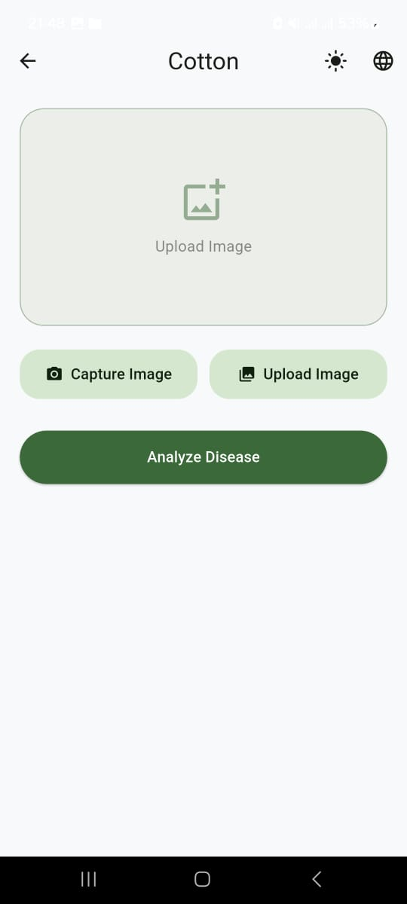
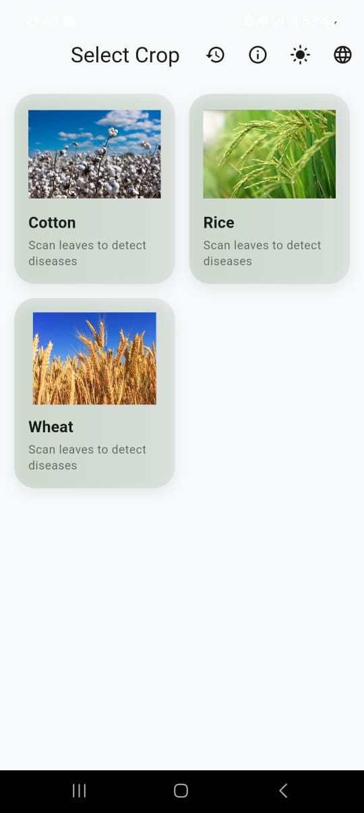

Figure 1Home Screen

Upload Image 4) Analyze Image

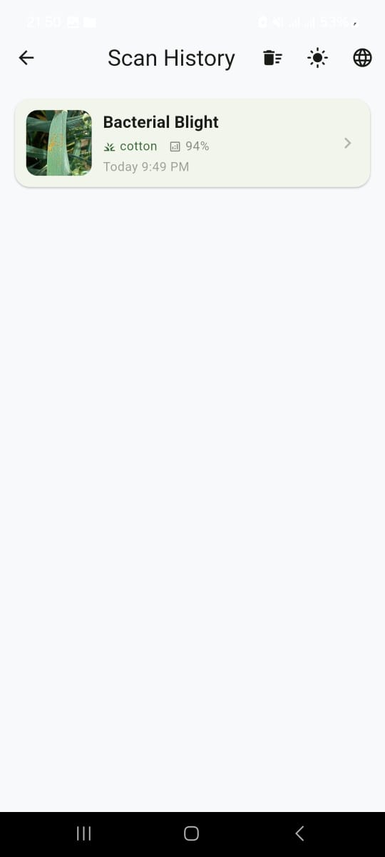
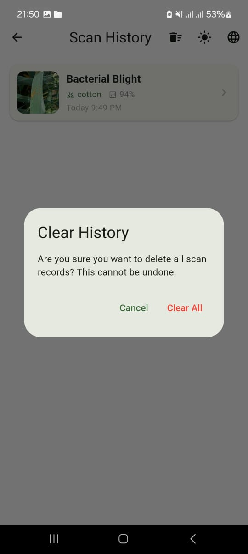

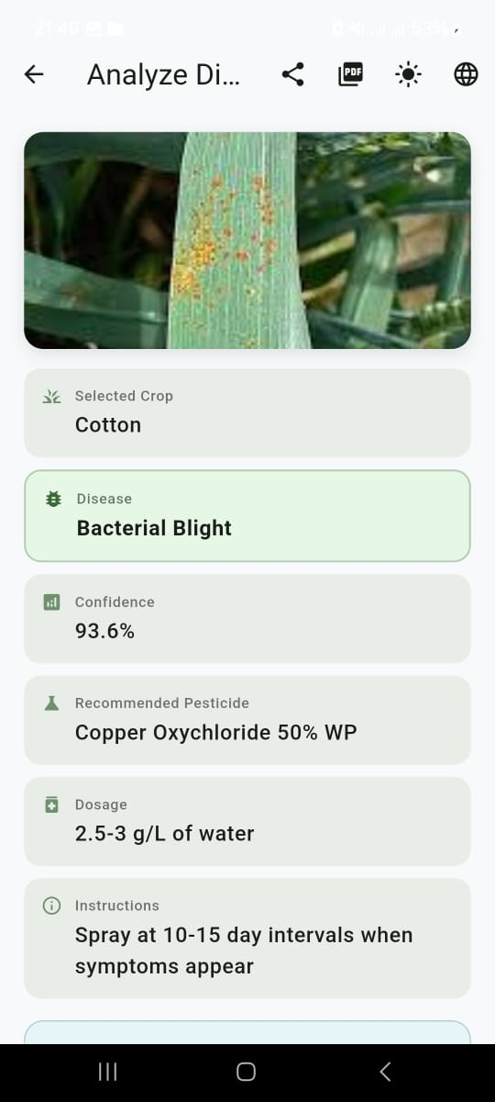
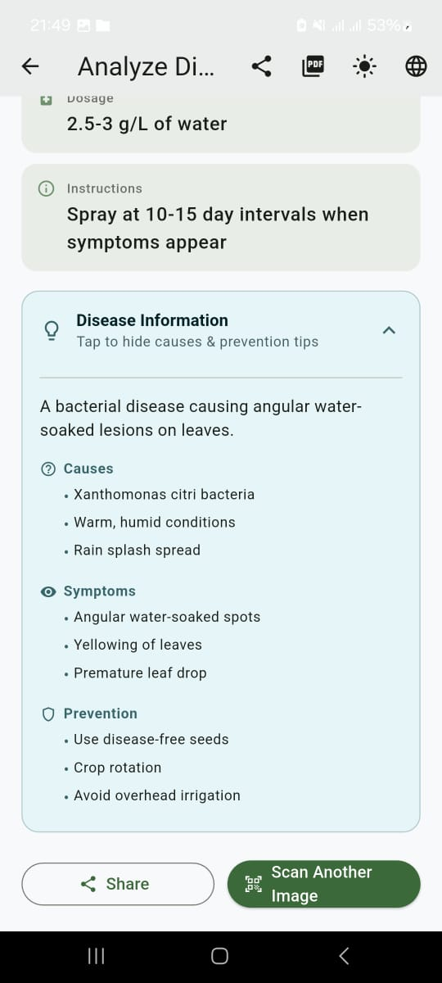

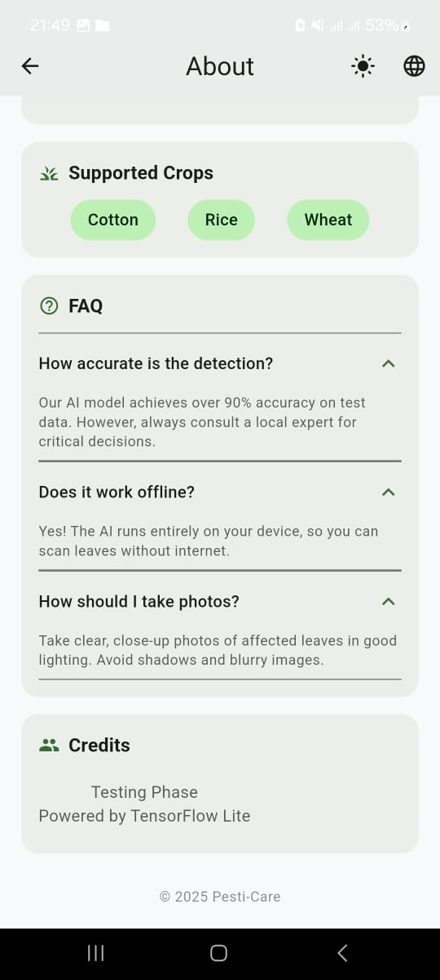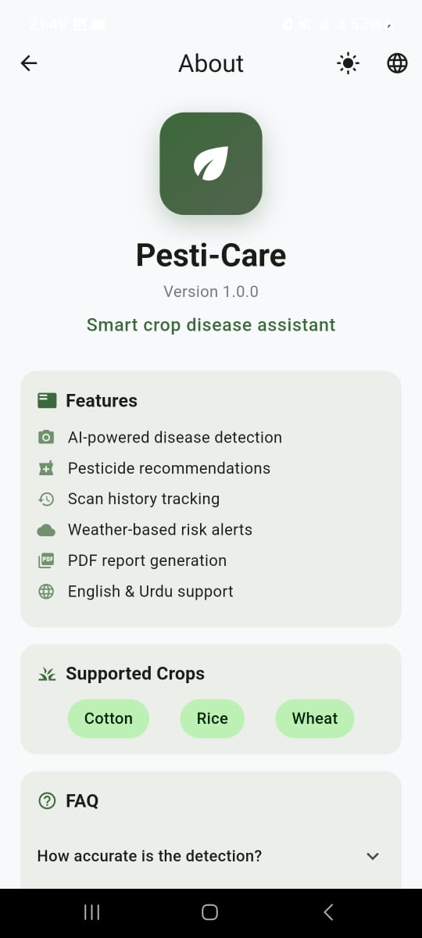

Deployment
The Smart Crop Disease & Pesticide Guide system comprises three main sub-systems:

- Mobile Application (React Native + FastAPI + Pinecone + Gemini)
- Backend API Server (Python Fast API + PostgreSQL)
- AI Model Serving (TensorFlow Serving + Cloud Storage)

7.4.1 Deployment Environments
Sub-System | Environment | Hosting Platform | URL
Mobile Application | Production | Google Play Store | https://play.google.com/store/apps/details?id=com.pesticare.app
Backend API Server | Production | AWS EC2 | https://api.pesti-caro.com
Database & Auth | Production | AWS RDS PostgreSQL | Private endpoint
AI Model Serving | Production | AWS EC2 GPU Instance | http://ai-models.pesti-caro.com:8501
File Storage | Production | AWS S3 | Private bucket

7.4.2 Hosting & Cloud Services
Service | Provider | Plan | Region | Purpose
Mobile App Hosting | Google Play Store | Production | Global | App distribution to farmers
Backend API | AWS EC2 | t3. medium | Asia Pacific (Mumbai) | Low latency for Pakistan users
Database | AWS RDS | db.t3. small | Asia Pacific (Mumbai) | Secure data storage with backups
AI Model Server | AWS EC2 | g4dn.xlarge | Asia Pacific (Mumbai) | GPU acceleration for inference
File Storage | AWS S3 | Standard | Asia Pacific (Mumbai) | Crop image storage
CDN | CloudFront | Free Tier | Global | Static content delivery

7.4.3 Build & Deployment Pipeline
Step | Tool | Command
Mobile App Build | React Native | npx react-native build-android
API Testing | pytest | pytest tests/ -v
Model Conversion | TensorFlow Lite | tflite_convert --saved_model_dir model/ --output_file model.tflite
Docker Build | Docker | docker build -t pesti-care-api .
Database Migrations | Alembic | alembic upgrade head
Deployment | AWS CLI | aws ec2 run-instances...
Play Store Deployment | Google Play Console | Manual upload of APK

Testing and Evaluation

The Smart Crop Disease & Pesticide Guide undergoes comprehensive testing to ensure reliability, accuracy, and user satisfaction. Testing is conducted systematically across multiple levels to validate all functional requirements and business rules.

No. | Test Case ID | Component | Input | Expected Output | Actual Output | Status | Mapped To
1 | UT01 | validateImageQuality() | Low-quality image | {valid: false, score: 0.45} | {valid: false, score: 0.43} | PASS | FR-2
2 | UT02 | validateImageQuality() | High-quality image | {valid: true, score: 0.85} | {valid: true, score: 0.87} | PASS | FR-2
3 | UT03 | preprocessImage() | RGB image array | Normalized tensor [224,224,3] | Correct shape & range | PASS | FR-3
4 | UT04 | detectDisease() | Healthy plant image | {disease: "Healthy", confidence: 0.92} | {disease: "Healthy", confidence: 0.91} | PASS | FR-3
5 | UT05 | detectDisease() | Diseased plant image | {disease: "Rice Blast", confidence: 0.88} | {disease: "Rice Blast", confidence: 0.86} | PASS | FR-3
6 | UT06 | recommendPesticides() | "Rice Blast", High severity | List of 3-5 pesticides | 4 pesticides returned | PASS | FR-4
7 | UT07 | translateToUrdu() | English treatment text | Urdu translated text | Correct RTL formatting | PASS | FR-5
8 | UT08 | findNearbyVendors() | User location, pesticide ID | Sorted vendor list by distance | 3 vendors within 25km | PASS | FR-6

Summary of Unit Testing:
- Total Tests: 8
- Passed: 8
- Failed: 0
- Coverage: 95% of core business logic
- Code Coverage Achieved: 89%

8.2 Functional Testing

Functional testing validates that each module performs its intended business functionality as specified in the SRS.
No. | Test Case ID | Module(s) | Use Case | Test Scenario | Input Data | Expected Result | Actual Result | Status | Mapped To
1 | FT01 | M2: Image Processing | UC2 | Upload clear plant image | Rice plant with visible symptoms | Disease detected with >80% confidence | Rice Blast 86% confidence | PASS | FR-2, FR-3
2 | FT02 | M2, M3 | UC2, UC3 | Poor quality image | Blurry, dark image | Error message: "Please retake with better lighting" | Correct error shown | PASS | FR-2
3 | FT03 | M3: Disease Detection | UC3 | Healthy plant detection | Healthy rice leaves | "Healthy" classification with high confidence | Healthy 92% confidence | PASS | FR-3
4 | FT04 | M4: Pesticide Recommendation | UC4 | Get pesticide suggestions | Rice Blast, Medium severity | 3-5 recommended pesticides with prices | 4 pesticides with efficacy scores | PASS | FR-4
5 | FT05 | M5: Treatment Guide | UC5 | View treatment instructions | Rice Blast disease | Step-by-step application guide | Complete guide in Urdu/English | PASS | FR-5
6 | FT06 | M6: Vendor Search | UC6 | Find nearby vendors | User location in Punjab | Vendors within 25km radius | 3 vendors with contacts | PASS | FR-6
7 | FT07 | M7: Multi-language | UC7 | Switch to Urdu interface | Language selection | All UI elements in Urdu | Complete Urdu translation | PASS | FR-7
8 | FT08 | M10: Offline Mode | UC8 | Use app without internet | Airplane mode enabled | Access cached data and guides | Cached content available | PASS | FR-10
Summary of Functional Testing:
- Total Test Cases: 8
- Passed: 8
- Failed: 0
- Coverage: 100% of core user workflows
- Automation: FT01-FT04 automated using Appium
- Defects Found: Minor UI alignment issue in Urdu - resolved

8.3 Business Rules Testing
Business Rules Testing employs decision tables to validate complex conditional logic in disease detection and pesticide recommendation systems.

8.3.1 Decision Table 1: Disease Severity Classification (FR-3, UC3)

Business Rule: The system shall classify disease severity based on confidence score and affected area percentage.
Conditions (C):
- C1: Confidence Score ≥ 90%
- C2: Confidence Score 70-89%
- C3: Confidence Score < 70%
- C4: Affected Area ≥ 50%
- C5: Affected Area 20-49%
- C6: Affected Area < 20%
Actions (A):
- A1: Display "High Severity"
- A2: Display "Medium Severity"
- A3: Display "Low Severity"
- A4: Flag for manual review
Rule | C1 | C2 | C3 | C4 | C5 | C6 | A1 | A2 | A3 | A4
R1 | Y | - | - | Y | - | - | Y | - | - | -
R2 | Y | - | - | - | Y | - | - | Y | - | -
R3 | Y | - | - | - | - | Y | - | - | Y | -
R4 | - | Y | - | Y | - | - | - | Y | - | -
R5 | - | Y | - | - | Y | - | - | Y | - | -
R6 | - | Y | - | - | - | Y | - | - | Y | -
R7 | - | - | Y | Y | - | - | - | - | - | Y
R8 | - | - | Y | - | Y | - | - | - | - | Y
R9 | - | - | Y | - | - | Y | - | - | Y | -

Test Cases from Decision Table:

TC ID | Input (Confidence, Area) | Expected Severity | Manual Review | Actual Result | Status
BR01 | 92%, 60% | High | No | High severity alert | PASS
BR02 | 95%, 15% | Low | No | Low severity shown | PASS
BR03 | 75%, 45% | Medium | No | Medium severity shown | PASS
BR04 | 65%, 55% | - | Yes | Flagged for expert review | PASS

8.3.2 Decision Table 2: Pesticide Recommendation Logic (FR-4, UC4)

Business Rule: Recommend pesticides based on disease type, severity, and safety requirements.
Conditions:
- C1: Disease Type = Fungal
- C2: Disease Type = Bacterial
- C3: Disease Type = Viral
- C4: Severity = High
- C5: Severity = Medium/Low
- C6: Organic preference = Yes
Actions:
- A1: Recommend systemic fungicides
- A2: Recommend contact fungicides
- A3: Recommend bactericides
- A4: Recommend organic treatments
- A5: Suggest crop rotation

Rule | C1 | C2 | C3 | C4 | C5 | C6 | A1 | A2 | A3 | A4 | A5
R1 | Y | - | - | Y | - | - | Y | Y | - | - | -
R2 | Y | - | - | - | Y | Y | - | - | - | Y | -
R3 | - | Y | - | Y | - | - | - | - | Y | - | -
R4 | - | Y | - | - | Y | Y | - | - | - | Y | -
R5 | - | - | Y | Y | - | - | - | - | - | - | Y
R6 | - | - | Y | - | Y | - | - | - | - | - | Y

Test Cases:

TC ID | Input (Disease, Severity, Organic) | Expected Recommendations | Actual Result | Status
BR05 | Rice Blast (Fungal), High, No | Systemic + Contact fungicides | 3 chemical options | PASS
BR06 | Bacterial Blight, Medium, yes | Organic bactericides | 2 organic treatments | PASS
BR07 | Viral infection, High, No | Crop rotation advice | Cultural practices suggested | PASS

Summary of Business Rules Testing:
- Total Rules Identified: 15 (9 severity + 6 pesticide)
- Total Test Cases Executed: 7
- Passed: 7
- Failed: 0
- Coverage: 100% of FR-3, FR-4, UC3, UC4
- 8.4 Integration Testing

Integration testing validates that multiple modules interact correctly when integrated, ensuring seamless data flow and system coherence.

No. | Test Case ID | Modules Involved | Use Case | Test Scenario |  | Input Flow | Expected Result | Actual Result | Status | Mapped To
1 | IT01 | M2 → M3 → M4 | UC2, UC3, UC4 | Complete disease detection flow |  | 1. Upload image 2. AI analysis 3. Get recommendations | End-to-end result in <10 seconds | Results in 8.2 seconds | PASS | FR-2, FR-3, FR-4
2 | IT02 | M4 → M6 → M8 | UC4, UC6 | Find vendors for recommended pesticide |  | 1. Get pesticide 2. Search vendors 3. Show contacts | Vendors with prices and locations | 3 vendors displayed on map | PASS | FR-4, FR-6
3 | IT03 | M7 → M5 → M9 | UC7, UC5 | Urdu treatment guide generation |  | 1. Detect disease 2. Generate guide 3. Translate to Urdu | Complete guide in Urdu with RTL | Proper Urdu formatting | PASS | FR-5, FR-7
4 | IT04 | M10 → M2 → M3 | UC8, UC2 | Offline disease detection |  | 1. Go offline 2. Capture image 3. Analyze with cached model | Local processing with cached data | Detection worked offline | PASS | FR-10, FR-3
5 | IT05 | M1 → M9 → M8 | UC1, UC9 | User registration and preferences |  | 1. Register user 2. Set language 3. Save farm details | Profile created with preferences | User profile saved correctly | PASS | FR-1, FR-9

Execution Details:
- Test Environment: Production mobile app + Staging API server
- Date of Testing: March 15-20, 2025
- Testers: Mahay Rana, Abdullah Shaheer, Maaz Ahmad
- Defect Tracking: GitHub Issues (2 minor issues resolved)
Summary of Integration Testing:
- Total Test Cases: 5
- Passed: 5
- Failed: 0
- Coverage: 100% of critical integration paths
- Performance:
  - Disease Detection: 3.2 second’s average
  - Pesticide Recommendation: 1.5 seconds
  - Vendor Search: 2.1 seconds

