**JAX RS**

**GET**  
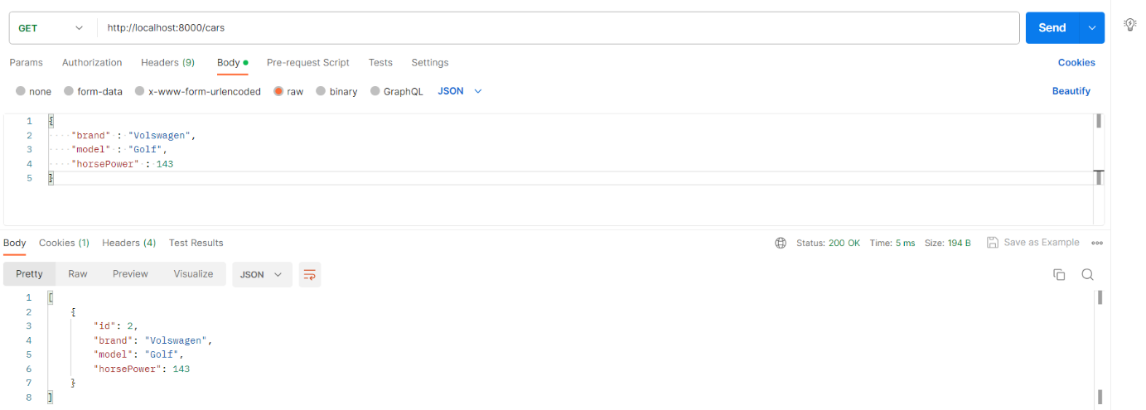  
  
**POST**  
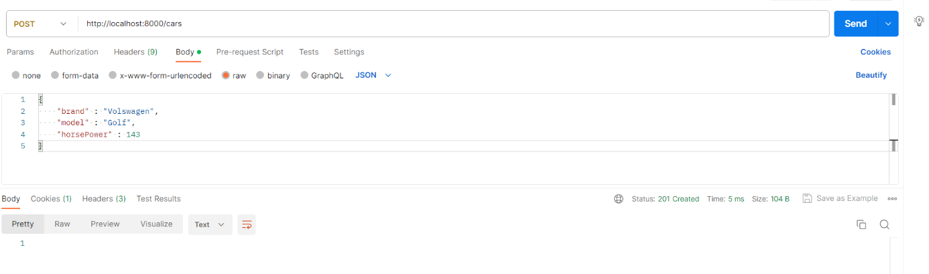



**PUT**  
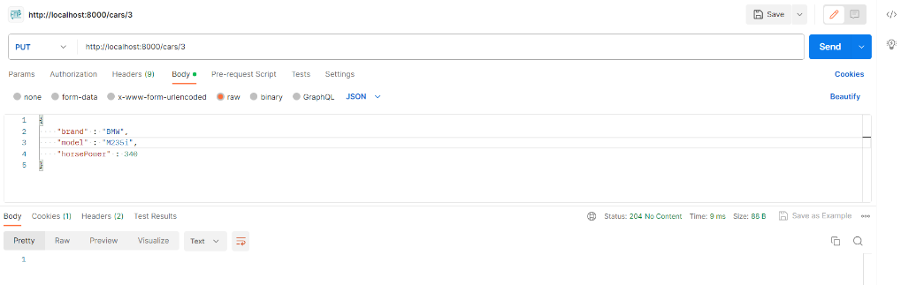



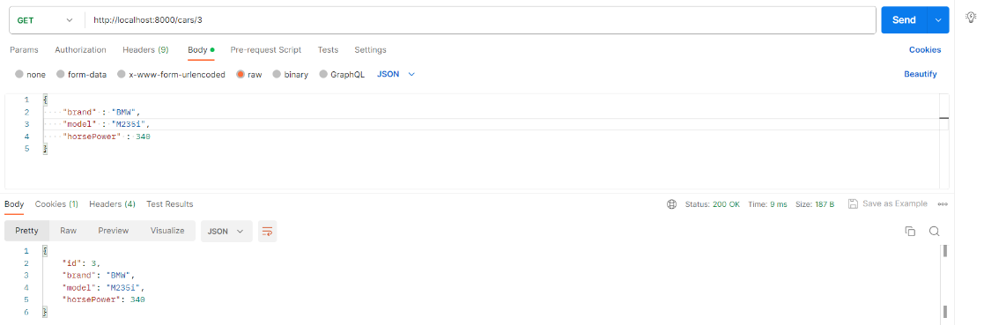



**DELETE**

