UNIVERSITY OF BUEA

FACULTY OF ENGINEERING AND TECHNOLOGY
DEPARTMENT OF COMPUTER ENGINEERING

CEF440: Internet Programming and Mobile Programming
COURSE INSTUCTOR: Dr. Valery Nkemeni

TASK 4: SYSTEM MODELLING AND DESIGN

BY GROUP 3

NAMES | MATRICULE
- ABONGWA CALEB NFORNGWA | FE22A133
- BEKONO AKONO MARTHE LUNYA LAWRICA | FE22A171
- MUKETE ATIA HANS MASANGO | FE22A250
- NGUIMFACK AZAFACK JOREL | FE22A267

Academic Year (2024/2025)
TABLE OF CONTENTS
TASK 4: SYSTEM MODELLING AND DESIGN 1
INTRODUCTION 2
System Modelling 3
System Design 3
Class Diagram Overview 4
What is a Class Diagram? 4
Why is a Class Diagram Important? 4
Identified Classes 4
Figure of Class Diagram from starUML. 5
Use Case Diagram Overview 6
What is a Use Case Diagram? 6
Why This Use Case Diagram Is Important 6
Parts Of A Use Case Diagram 6
Actors 6
Use Cases 7
Relationships Between Actors and Use Cases 7
Relationships Between Use Cases (Optional but Logical) 8
Summary of Relationship Types 8
Sequence Diagram Overview 9
What is a sequence diagram? 9
Why is it important? 9
Network Data Recording and User Input Data Processing Overview 9
A. Network Data Recording Process 10
B. User Input Data Process 11
Security Considerations 13
Performance Considerations 14
1. Network measurements should: 14
2. Feedback processing should: 14
Context Diagram Overview 14
What is a Context Diagram? 14
Why This Diagram is Important 14
Parts of A Context Diagram 14
System: Mobile Network QoE Monitoring App 14
External Entities 14
Data Flows 15
Data flow Diagram Overview 16
What is a Dataflow Diagram (DFD)? 16
Importance of a Data Flow Diagram 16
Parts of a Level 1 DFD for QoE Monitoring App 16
Processes 16
Data Stores 16
External Entities 17
Data Flows (Key Examples) 17
Diagram Layout 17
Deployment Diagram Overview 18
What is a Deployment Diagram? 18
Why This Diagram Matters 18
Deployment Diagram Parts 18
Nodes (Physical Devices/Systems) 19
Software Components in Each Node 19
Communication Paths 20
Conclusion 21

INTRODUCTION
This phase transforms user and system requirements into a set of structured, visual representations that define how the system functions and how its components interact. Through various UML diagrams, we illustrate the external interactions, internal processes, system behavior, and deployment structure of the proposed solution.

The diagrams included are; Context Diagram, Dataflow Diagram, Use Case Diagram, Sequence Diagram, Class Diagram, and Deployment Diagram. They collectively provide a comprehensive blueprint of the system. These models not only guide implementation but also help ensure clarity, consistency, and scalability in the design of the app.
These diagrams model how the system works and support the design of how it will be built.

System Modelling
This is about visualizing and understanding the system’s structure and behavior. Diagrams like: Use Case Diagram, Context Diagram, Dataflow Diagram, Class Diagram
Help model:
- What the system does
- How users interact with it
- What data it uses

System Design
This is about planning how the system will be implemented. Diagrams like: Sequence Diagram, Deployment Diagram, Class Diagram
Help design:
- The technical structure
- The order of interactions
- Where each component will run

Class Diagram Overview

What is a Class Diagram?
A class diagram is a type of UML (Unified Modeling Language) diagram that visually represents the structure of a system by showing:
- The classes (or components)
- Their attributes (data they hold)
- Their operations (functions or behaviors)
- The relationships between them (e.g., association, inheritance)

Why is a Class Diagram Important?
- Clarifies system architecture: Helps developers, designers, and stakeholders understand the key components and how they interact.
- Guides coding structure: It acts as a blueprint for writing object-oriented code.
- Improves team communication: Makes it easier to discuss system design with both technical and non-technical stakeholders.
- Supports scalability: Allows for better planning when extending or modifying the system in the future.
- Facilitates debugging and documentation: Makes the codebase more maintainable and understandable.

Identified Classes
Class | Purpose in the Project
User | Represents the app user who submits feedback, views performance, and customizes settings. Core to all user interactions.
NetworkReport | Stores individual feedback reports, including geolocation and timestamp. Essential for tracking and diagnosing issues.
Performance Metric | Logs real-time network speed, latency, and signal strength. Critical for the app’s core function: performance monitoring.
Settings | Manages user preferences like language, data sharing, and notifications. Supports personalization and privacy compliance.
Operator | Represents network staff who receive user reports and diagnose problems. Key for backend integration and accountability.
Admin (optional) | Could be used for managing users, metrics, or overall platform. Useful if you add a web/admin dashboard later.
ReportService | Acts as the controller for handling data input/output. Implements business logic for collecting reports and metrics.
NotificationService | Sends alerts when issues are detected. Keeps users informed and improves user engagement and trust.

Figure of Class Diagram from starUML.
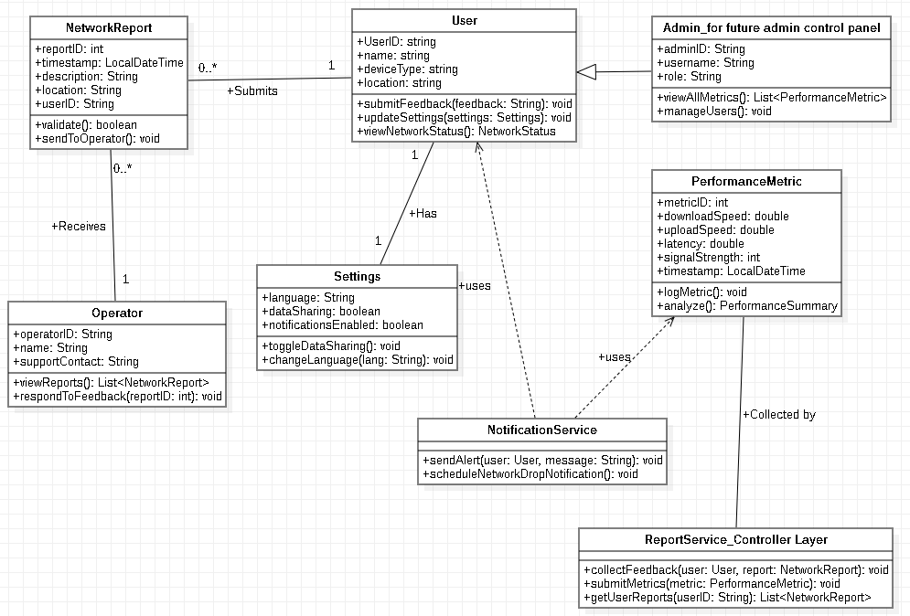

Use Case Diagram Overview

What is a Use Case Diagram?
A Use Case Diagram is a type of UML (Unified Modeling Language) diagram that shows how users (actors) interact with a system through specific actions (use cases).
It answers the question: "Who does what in the system?"
It provides a high-level visual of:
- The system's functionalities
- The users or systems that interact with it
- The relationships between them

Why This Use Case Diagram Is Important
- Helps you define user needs and system functions clearly
- Guides UI/UX design and testing
- Simplifies developer understanding of system scope and features
- Shows who does what in the system.
- Helps developers plan interfaces and backend APIs.
- Supports testing and validation, ensuring all user needs are addressed.

Parts Of A Use Case Diagram

Actors

Who are Actors?
Actors are people, other systems, or devices that interact with your system.
They don’t do the processing, they trigger or receive actions.

Types of actors:
- Primary Actor – the main user (e.g., app user)
- Secondary Actor – supports the process (e.g., mobile operator)
- External Actor – interacts with the system externally (e.g., regulator)

Actors of the System
- User (Primary Actor)
– Submits feedback, views network stats, adjusts settings.
- Network Operator (Secondary Actor)
– Accesses reports, analyzes data, provides responses.
- Regulatory Authority (External Actor)
– Receives anonymized data for transparency and monitoring.
- System (App) (System boundary – not drawn as actor but contains all use cases)

Use Cases

What are Use Cases?
Use Cases are the actions or services the system provides to an actor.
Each use case represents a functional requirement, something the system must allow the actor to do.
Examples : Submit Feedback, Monitor Network Performance

Identified Use cases
Use Case | Description | Actor(s) Involved
1. Submit Feedback | User reports poor network experience, optionally with location and screenshots. | User
2. Monitor Network Performance | App collects real-time speed, latency, and signal quality in the background. | User
3. Receive Alerts | App notifies user when network drops or performance is poor. | User
4. Change Privacy Settings | User configures whether data is shared and to what extent. | User
5. View Report History | User checks their previous complaints and reports. | User
6. Change Language | User switches between English and French. | User
7. View Aggregated Reports | Operator views user-submitted data, visualized or summarized. | Network Operator
8. Respond to Reports (optional) | Operator provides feedback or status update on submitted issues. | Network Operator
9. View Anonymized Data | Regulator accesses anonymized user data to assess service coverage. | Regulatory Authority

Relationships Between Actors and Use Cases
Actor | Use Cases (Directly Associated) | Type of Relationship
User | Submit Feedback, Monitor Network Performance, Receive Alerts, Change Privacy Settings, View Report History, Change Language | Association
Network Operator | View Aggregated Reports, Respond to Reports (optional) | Association
Regulatory Authority | View Anonymized Data | Association
These are straightforward associations, meaning each actor interacts directly with those specific system functionalities.

Relationships Between Use Cases (Optional but Logical)
Use Case | Relationship Type | Related Use Case | Explanation
Monitor Network Performance | «extend» | Receive Alerts | Alerts happen only if a performance issue is detected
Change Settings | «include» | Change Language, Change Privacy Settings | These are specific settings options

Summary of Relationship Types
Association: A direct interaction between an actor and a use case.
«include»: A use case always includes another smaller/common use case.
«extend»: A use case may optionally add behavior to another, based on a condition.
Figure of Use case Diagram from starUML.

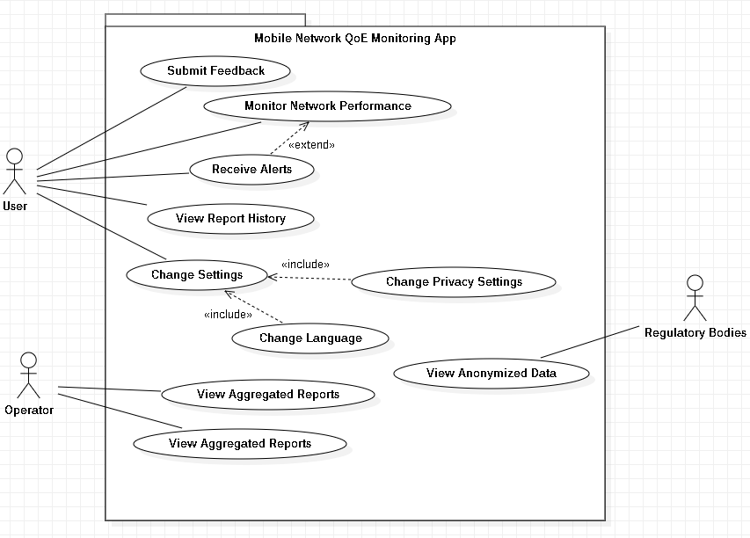

Sequence Diagram Overview

What is a sequence diagram?
A Sequence Diagram is a type of UML diagram that shows how objects or components interact over time to complete a specific process.
It focuses on the order of messages exchanged between system elements (e.g., user, app interface, database) for a particular scenario.

Why is it important?
- Visualizes the flow of events in a system step-by-step.
- Clarifies object interactions during tasks like submitting feedback or receiving alerts.
- Helps developers understand the logic and timing of operations.
- Supports efficient implementation and testing of system behavior.
- Identifies dependencies and sequence of calls, reducing errors in integration.
- Useful for both frontend (UI actions) and backend (process logic) planning.

Network Data Recording and User Input Data Processing Overview
This documentation describes two key system processes: Network Data Recording and User Input Data handling. These processes involve interactions between users, system components, APIs, and databases to perform various operations including network measurements, feedback collection, and geolocation services.

A. Network Data Recording Process
System Components:
- System: The main application handling the network operations
- OS Network API: Operating system's network interface for measurements
- Database: Storage for network metrics and logs

Sequence Flow:
1. Measure Network Speed and Latency
- The System initiates a request to the OS Network API to measure current network performance metrics
- This includes download/upload speeds and latency measurements
- Implementation would typically use ICMP ping for latency and file transfer tests for bandwidth

2. Return Measurement Results
- The OS Network API responds with the collected metrics
- Data format might include: {timestamp, download_speed, upload_speed, latency, packet_loss}

3. Display Real-time Network Details
- The System processes the raw metrics and presents them in a user-friendly format
- May include visualizations like graphs or simple numerical displays
- Could trigger alerts if metrics fall below thresholds

4. Encrypt User Data
- Any user-identifiable information in the network metrics is encrypted
- Likely uses AES-256 or similar encryption standards
- Ensures privacy compliance with regulations like GDPR

5. Save Log Metrics
- System stores the encrypted metrics in a log management system
- May include both the raw data and processed/aggregated metrics
- Logs are typically time-series data for historical analysis

6. Update Database
- The System writes the processed data to the persistent database
- Database schema likely includes tables for network_metrics, sessions, devices
- May use batch processing for efficiency with frequent measurements

7. Update Successfully
- Completion confirmation is generated
- May trigger notifications or update UI indicators
- System is ready for next measurement cycle

Figure of Network Data Recording Sequence diagram on starUML.
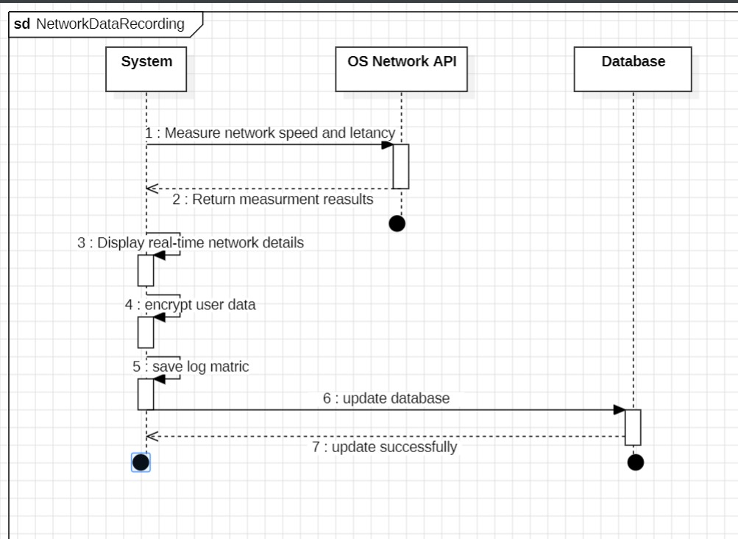

B. User Input Data Process
System Components:
- User: The end-user interacting with the application
- System: Core application handling user requests
- Geolocation API: Service providing location coordinates
- Database: Storage for user feedback and location data

Sequence Flow:
1. Open Feedback Form
- User initiates action to provide feedback
- System loads the feedback form UI components
- May check authentication status at this point

2. Display Feedback Form
- System renders the feedback interface
- Typically includes: rating inputs, free-text fields, attachment options
- Form validation rules are initialized

3. Submit Feedback Details
- User completes and submits the form
- Client-side validation occurs first
- Data payload is prepared for transmission

4. Request Current Location
- System checks if location data is required
- Requests permission to access device location
- Prepares geolocation API call parameters

5. Return Coordinates
- Geolocation API provides current position data
- Format: {latitude, longitude, accuracy, timestamp}
- May include reverse-geocoded address information

6. Encrypt User Data
- Sensitive information is encrypted:
- Personal details in feedback
- Precise location coordinates
- Device identifiers
- Uses secure encryption protocols

7. Record Logs
- System creates audit logs of the feedback submission
- Includes: timestamp, user ID (if authenticated), action type
- Helps with debugging and compliance

8. Update Database
- Encrypted feedback data is written to database
- Location data stored in appropriate geospatial format
- May trigger analytics processing

9. Update Successfully
- User receives confirmation of submission
- System may initiate follow-up actions (e.g., thank you email)
- UI returns to default state

Figure of User Input Data Sequence diagram on starUML.
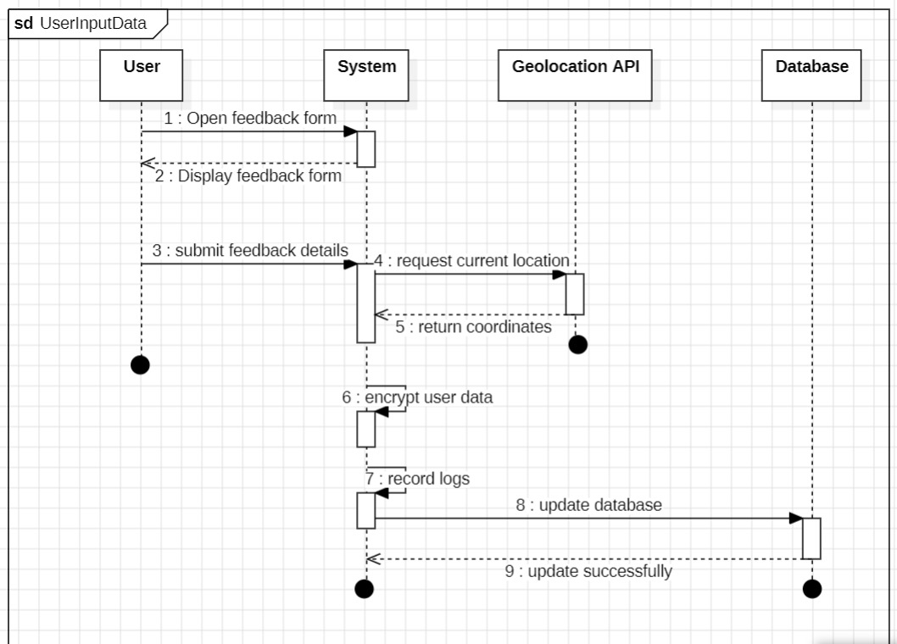

Security Considerations
Both processes emphasize data encryption:
1. In Transit: All API communications should use TLS 1.2+
2. At Rest: Sensitive data is encrypted before database storage
3. Key Management: Encryption keys are properly secured and rotated

Performance Considerations

1. Network measurements should:
- Have minimal impact on actual network performance
- Use appropriate sampling frequencies
- Implement caching where possible

2. Feedback processing should:
- Provide quick acknowledgment to users
- Queue intensive operations for background processing
- Optimize database writes

Context Diagram Overview

What is a Context Diagram?
A Context Diagram is a high-level diagram that shows the system as a single process and illustrates:
- All external entities that interact with it (users, other systems)
- The data flows between the system and those entities
It helps answer:
“Who interacts with the system, and what information flows in and out?”

Why This Diagram is Important
- Shows the system boundary — what’s inside vs. outside
- Defines who interacts with the system and what data flows between them

Parts of A Context Diagram

System: Mobile Network QoE Monitoring App
This is the central system, everything revolves around this.

External Entities
Entity | Role / Interaction
User | Uses the app to submit feedback, view performance, set preferences, receive alerts
Mobile Network Operator | Receives feedback and performance reports for diagnostics
Regulatory Authority | Receives anonymized data for compliance and monitoring
Support System (e.g., MTN Zigi) | Optional integration for user support (chatbot/helpdesk)

Data Flows
Between | Data Flow Direction | Information Exchanged
User → App | Input | Feedback, preferences, language
App → User | Output | Alerts, performance stats, history
App → Operator | Output | User reports, performance metrics
Operator → App | Input (optional) | Network performance updates, service status
App → Regulator | Output | Anonymized reports/data for auditing
App ↔ MTN Zigi (optional) | Bidirectional | Helpdesk queries and responses

Figure of Context Diagram from Draw.io
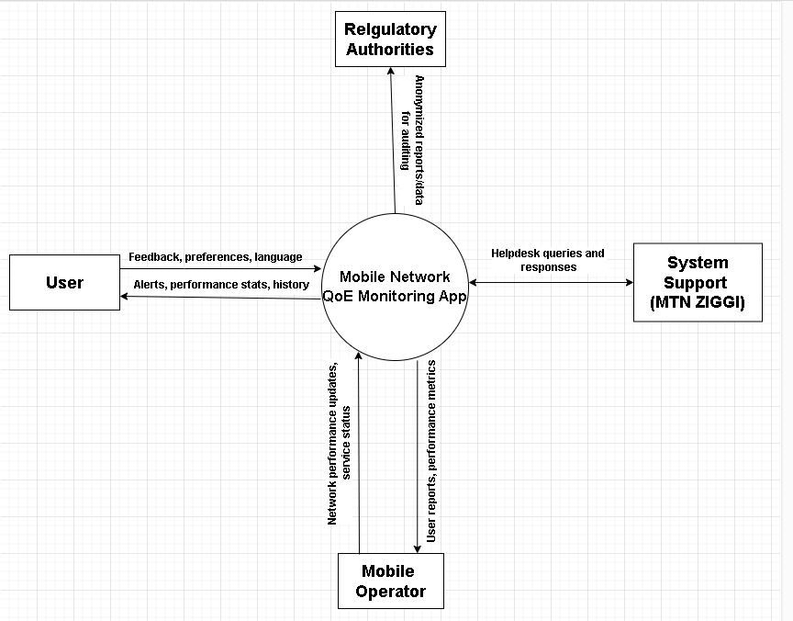

Data flow Diagram Overview

What is a Dataflow Diagram (DFD)?
A DFD shows how data moves through a system, focusing on:
- Processes (what the system does)
- Data stores (where data is kept)
- External entities (who interacts with the system)
- Data flows (arrows showing data in/out of processes)

Importance of a Data Flow Diagram

- Shows how data moves through the system (from users to backend and vice versa).
- Identifies key processes like feedback collection, monitoring, and reporting.
- Clarifies data inputs, outputs, and storage (e.g., reports, metrics, settings).
- Helps detect redundancies or gaps in data handling early in design.
- Improves communication between developers, designers, and stakeholders.
- Supports accurate implementation by guiding how components exchange data.

Parts of a Level 1 DFD for QoE Monitoring App

Processes
ID | Name | Description
1.0 | Monitor Network Performance | Collects speed, latency, signal
2.0 | Collect User Feedback | Accepts reports from users
3.0 | Manage Settings | Handles language, privacy, notifications
4.0 | Generate Reports | Prepares summaries for operator/regulator

Data Stores
ID | Name | Description
D1 | User Reports | Stores feedback from users
D2 | Performance Logs | Stores collected speed, signal data
D3 | User Preferences | Stores user settings (e.g., language)

External Entities
- User
- Mobile Network Operator
- Regulatory Authority
- Support System (MTN Zigi) (optional)

Data Flows (Key Examples)
From | To | Data
User → 2.0 | Feedback submission
2.0 → D1 | Save report
1.0 → D2 | Store metrics
3.0 ↔ D3 | Update/retrieve preferences
4.0 → Operator | Aggregated reports
4.0 → Regulator | Anonymized stats
3.0 → User | Updated settings
1.0 → User | Real-time performance alerts

Diagram Layout
  - 4 processes (1.0 to 4.0) as rounded boxes
  - D1, D2, D3 as open-ended rectangles (data stores)
  - External entities as rectangles labeled: User, Operator, Regulator
- Connect with Arrows:
  - Label each arrow with the type of data (e.g., “feedback”, “metrics”, “report”)

Figure of Data Flow Diagram from starUML.

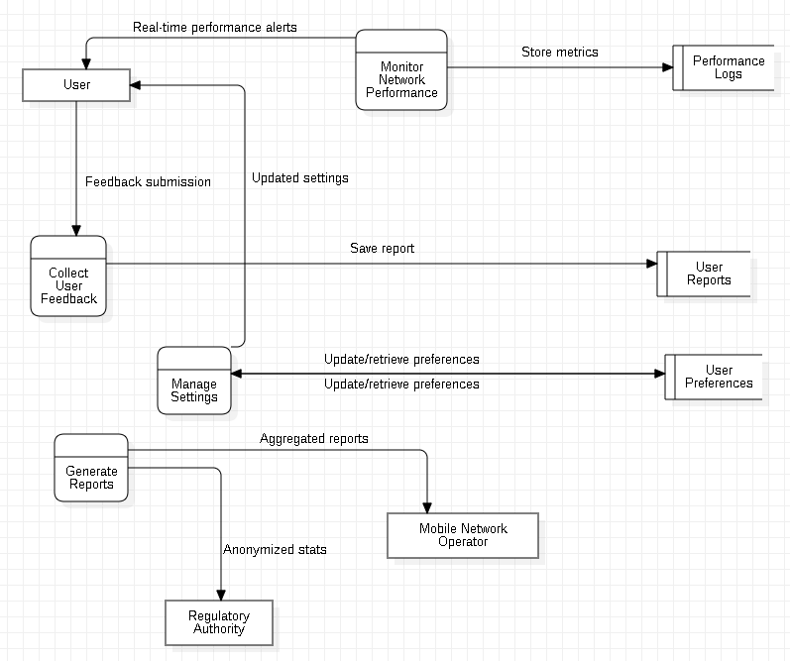

Deployment Diagram Overview

What is a Deployment Diagram?
A Deployment Diagram is a UML diagram that shows:
- The physical architecture of your system
- Hardware nodes (devices/servers)
- The software components deployed on them
- And how they communicate with each other
It's essential for understanding where and how the system runs.

Why This Diagram Matters
- Shows where each service/component is deployed
- Clarifies inter-node communication
- Helps during development, testing, and scaling.

Deployment Diagram Parts

Nodes (Physical Devices/Systems)
Node | Description
Mobile Device | User's phone running the app
Cloud Server | Backend services hosted on a cloud platform
Firebase Services | Handles notifications, analytics, auth, and DB
Operator System | MTN or Orange dashboard system for feedback
Regulatory Dashboard | Used by regulators to monitor performance trends

Software Components in Each Node

Mobile Device
- QoEApp.apk (React Native)
- Network Monitor Module
- Feedback Form
- Geolocation
- WorkManager (Android) / BackgroundTasks (iOS)
- Redux Store + Localization (i18n)

Cloud Server (Node.js + Express)
- API Gateway
- User Management Service
- Feedback Processing Service
- Network Analytics Service
- Notification Service (via Firebase)
- MongoDB Atlas (database)

Firebase Cloud Services
- Authentication
- Push Notification Service
- Real-Time Database (optional cache)
- Firebase Analytics

Operator System
- DashboardClient
- Report Viewer
- Feedback Response Tools

Regulatory Dashboard
- Data Analytics UI
- Anonymized Report Viewer

Communication Paths
From | To | Protocol / Technology
Mobile Device | Cloud Server | HTTPS (RESTful API)
Cloud Server | Firebase Services | Firebase SDKs / REST API
Cloud Server | Operator System | Secure WebSocket / API
Cloud Server | Regulator System | Secure export (CSV/JSON)

Figure of Deployment Diagram from starUML.
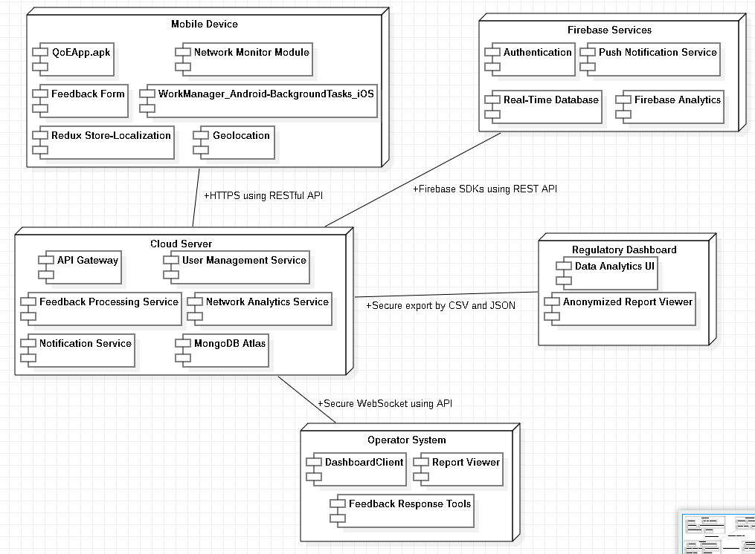

Conclusion
System modelling and design serve as the foundation for successful system development. The diagrams presented in this task capture the key functionalities, user interactions, system processes, and physical architecture of the Mobile Network QoE Monitoring App. By clearly representing these elements, the modelling phase bridges the gap between abstract requirements and concrete implementation. This structured design approach ensures that all stakeholders share a unified vision of the system and provides developers with a clear path forward for building a robust, user-centered solution.

