Collective reputation, rice market, and externality:  
 Evidence from Fukushima nuclear accident

Masanori Matsuura[1], Yuzuka Kashiwagi[2], Taisuke Takayama[3], Tetsuji Senda[4],

Tsuyoshi Fujie[5]

Abstract

The existence of collective reputation implies an important externality. Among farmers, reputational damage could affect the demand of agricultural product, nonetheless they do not have causes. We study such a reputational damage in the context of a sensational issue that affected the Japanese agrarian sector in 2011 due to Fukushima Nuclear Accident. Leveraging detailed household-level agriculture census data and a natural experiment stemming from the accident, we document sizable externalities on uncontaminated areas. We further investigate potential mechanisms that could mediate the strength of collective reputation, including information accuracy, observability of the supply chain, and prior export experience.

1. Introduction

In a commodity market, information friction may affect disrupt supply chain.

1. Background on rice market in Japan and Fukushima nuclear accident
2. Rice brand in Japan

In Japan, one of the most famous rice brands is *Koshihikari*. It is widely planted especially in eastern part of Japan. Among *Koshihikari* brands*, Uonuma Koshihikari* from Niigata prefecture and *Aizu Koshihikari* from Fukushima prefecture are one of the most popular brands in Japan[6]. Figure 1 shows the geography of east part of Japan and Fukushima and Niigata prefectures are nearby.

1. Fukushima nuclear accident

On 11th March, 2011, Great East Japan Earthquake (also known as 2011 Tohoku earthquake) hit Tohoku region in Japan. Following the earthquake, Fukushima nuclear power plants exploded and emitted radioactive

1. Conceptual framework
2. Methodology
3. Data
4. Identification strategy

To examine the effect of reputation damage on rice farmers, we use a border between Fukushima prefecture and Niigata prefecture as an exogenous and spatial variation. We apply spatial regression discontinuity design.

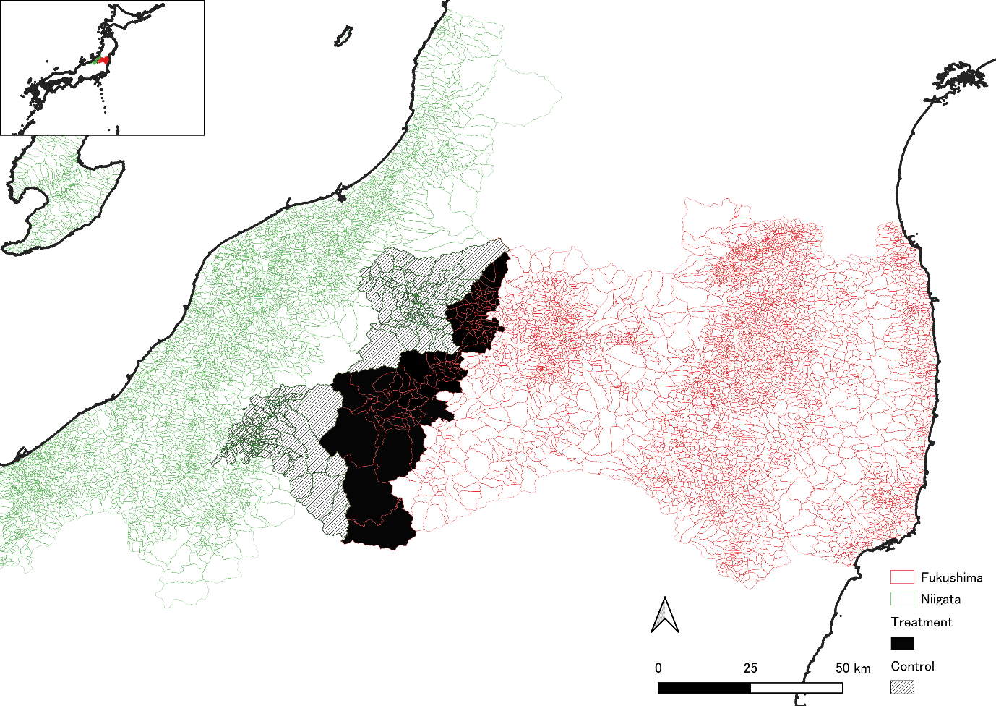

1. Results and discussion

Table ? shows that

1. Conclusions and policy implications

1. Institute of Developing Economies-JETRO, Corresponding author, masanori.matsu.econ@gmail.com
2. Tokyo University of Science
3. Fukushima University
4. Kyoto University
5. Meiji University
6. Koshihikari has been a best-selling rice product in Japan.