Collective reputation and externalities in agriculture:  
 Lessons from Fukushima nuclear accident[1]

Masanori Matsuura-Kannari[2], Taisuke Takayama[3], Yuzuka Kashiwagi[4],   
Tetsuji Senda[5], Takeshi Fujie[6]

Abstract

The existence of collective reputation implies an important externality. Among farmers, a reputational loss could affect the demand for agricultural products, nonetheless, they do not have causes. We document such reputational loss in the context of a sensational issue that affected the Japanese agrarian sector in 2011 due to the Fukushima Nuclear Accident. Using an agrarian census panel dataset and a two-way fixed effect approach, we examine sizable effects on areas that are not contaminated but located in Fukushima prefecture. Our findings suggest that the reputational loss due to negative externalities affects farmers’ input decision-making such as renting out their farmland and adoption of high-value-added agricultural practices.

**Keywords**: Collective reputation, Negative externality, Information friction, Supply shock, Organic agriculture

1. Introduction

In commodity markets, collective reputation crises, driven by negative externality, can disrupt supply chains and influence consumer behaviors. Collective reputation, an aggregation of individual reputations (Tirole, 1996), plays a crucial role in sectors like agriculture, where geographical indicators influence markets. Farmers using a geographical indicator may face repercussions, despite their quality standards, due to issues with other products from the same area. Negative externalities from environmental pollution are believed to affect collective reputation, and measuring these effects poses challenges. This study is the first to identify and explore the reputational impact on farmers' input decision-making in the face of such challenges.

While collective reputation has been extensively studied in various sectors such as the vehicle industry, software industry, garment industry, and food industry (Bachmann et al., 2023; Bai et al., 2022; Banerjee & Duflo, 2000; Gergaud et al., 2017; Ito & Kuriyama, 2017; Jin & Leslie, 2009; Koenig & Poncet, 2022; Matsumoto & Hoang, 2020), empirical research on the relationship between collective reputation and input decisions remains understudied. Moreover, negative externalities due to environmental concerns cause collective reputation crises, but the empirical literature is scarce on that collective reputation. We build Our study contributes to several strands of literature. First, it relates to research on the we show that the collective reputation due to negative externalities affects suppliers’ decision-making, taking advantage of a quasi-experimental situation and an agricultural census panel dataset. This study is one of the first studies to investigate the reputational effect on input decision-making while the literature has mainly focused on consumers’ preferences and suppliers’ output. Second, our results demonstrate that collective reputation with information friction can have important implications for high-value-added industries.

This paper is consisted as follow. Section 2 describes background information about the rice market in Japan and what Fukushima nuclear accident it. Data we used for this study is explained in Section 3 while Section 4 discusses our econometric model and the estimated results. Finally, Section 5 concludes.

1. Background on the rice market in Japan and the Fukushima nuclear accident
2. Rice production in Japan

In Japan, one of the most famous rice brands is *Koshihikari*. The name of *Koshihikari* varies across local areas of the production. For example, if Koshihikari is cultivated in a part of Niigata prefecture, it is called “*Uonuma Koshihikari*” while it is called as “*Aizu Koshihikari*” when it is cultivated in the western part of Fukushima prefecture. Figure 1 shows the year-level value added of rice production in Fukushima prefecture and Niigata prefecture. Overall, rice production is decreasing, but the production value of Niigata prefecture in 2011 slightly increased from the production in 2010 while the value of Fukushima prefecture after the accident in 2011.

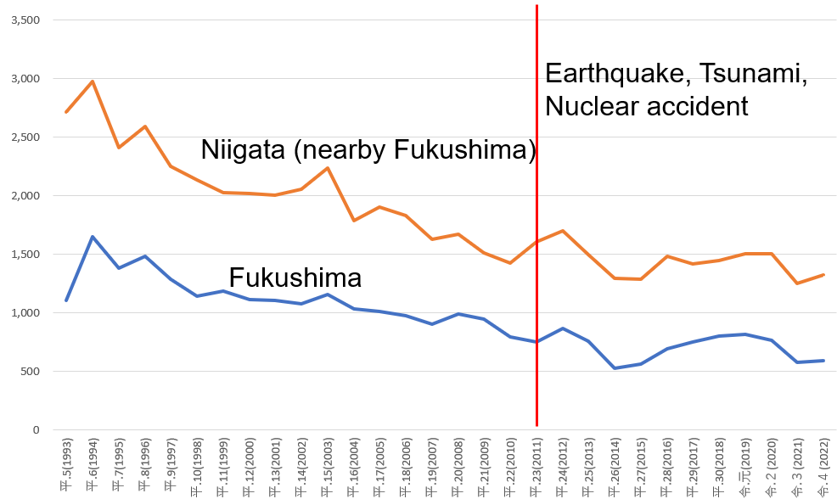

Figure Value added of rice production in Fukushima and Niigata (100k JPY)

Source: Author’s calculation based on Statistics of Agricultural Income Produced by MAFF.[7]

1. Fukushima nuclear accident

On March 11, 2011, the Great East Japan Earthquake struck, causing a tsunami that hit the Fukushima nuclear power plant and resulted in a meltdown of the reactors. This incident led to a significant release of radioactive material, raising nationwide concerns about nuclear safety. While the middle and coastal areas of Fukushima prefecture experienced partial contamination, the western part remained unaffected. Despite government inspections confirming the safety of rice shipments from the western part after the accident, concerns persisted about the potential contamination of agricultural products in that region.

Figure A1 shows the distribution map of areas contaminated by radioactive materials in Fukushima and neighboring six prefectures in 2012. Figure A1 shows that the western side of Fukushima prefecture was not contaminated by radioactive materials while the central and coastal side of Fukushima were highly contaminated. Some parts of Gunma prefecture which is south of Fukushima and Miyagi prefecture which is north of Fukushima were also contaminated. Since the western part of Fukushima was not physically affected by radioactive materials, we consider that it would be affected by only reputational loss by the Fukushima nuclear accident.

1. Data

Our data are drawn from the Agriculture and Forestry census of Japan collected by the Ministry of Agriculture, Forestry, and Fishery, Government of Japan in 1995, 2000, 2005, 2010, and 2015[8]. The census was processed as a household-level panel structure. We consider farm households in four municipalities, Hinoemata village, Tadami town, Kaneyama town, and Nishi Aizu town in Fukushima prefecture as treatment groups that are supposed to be affected by the collective reputation and the accident after the Great East Japan Earthquake. Other farm households in Aga-town, Sanjo-city, and Uonuma-city in Niigata prefecture are considered as control groups which are supposed not to be affected by the collective reputation and the accident. Figure 2 shows the geographical boundaries between Fukushima and Niigata prefecture and the boundaries of rural communities. The communities falling inside the contiguous towns formed by the boundary of the prefectures contribute to the treatment groups.

The dependent variables are several measurements of agricultural production, input decisions, and practices. First, we use the rice revenue as an output of farm households. Second, we measure some input variables, which are hectares of owned paddy fields, cultivated paddy fields, total farmland rent out, and paddy field rent out. Third, we use dummy variables of adoption of eco-friendly agricultural practices such as non-pesticide farming, manure farming, and compost soil farming.

Table 1 shows the summary statistics of the used data for this study and the pre-trend balance test of the Fukushima nuclear accident.-----

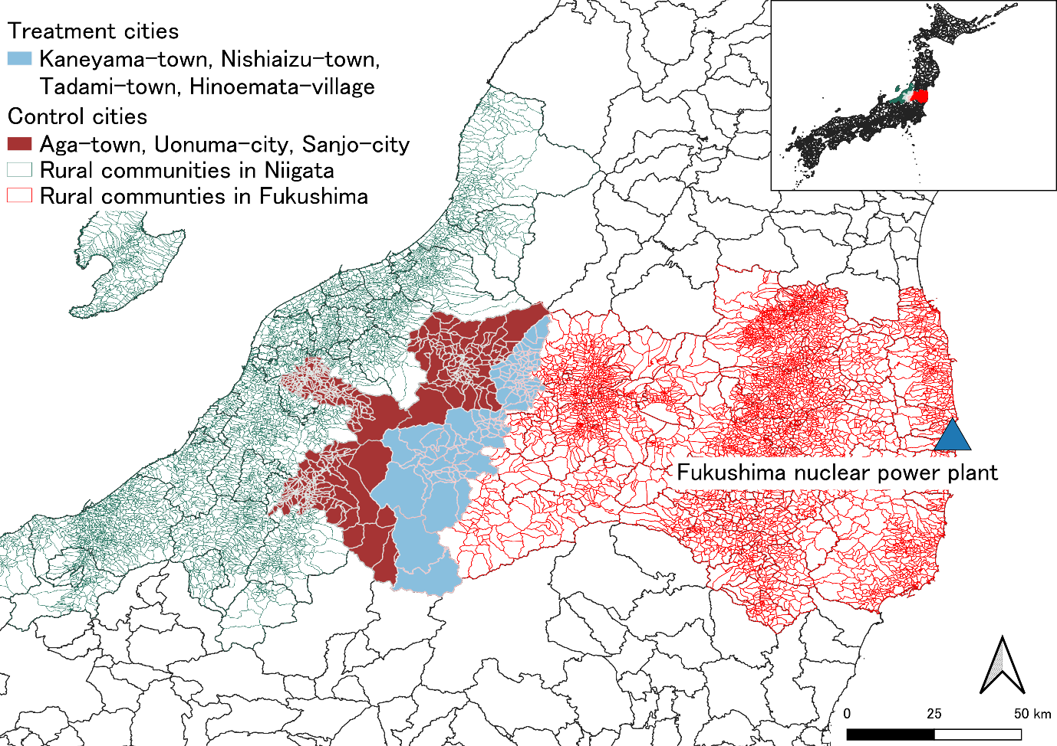 Figure Geographical relationship between Fukushima and Niigata prefectures.  
Source: Authors’ design.

Table 1 Descriptive statistics from 1995-2010: Pre-trend of Fukushima nuclear accident

|  |  |  |  |  |  |  |
| --- | --- | --- | --- | --- | --- | --- |
| Variables | Definition | Treatment |  | Control |  | Balance |
|  |  | Mean | SD | Mean | SD | Dif |
| Rice revenue |  |  |  |  |  |  |
|  |  |  |  |  |  |  |
|  |  |  |  |  |  |  |
|  |  |  |  |  |  |  |
|  |  |  |  |  |  |  |
|  |  |  |  |  |  |  |
|  |  |  |  |  |  |  |
|  |  |  |  |  |  |  |
|  |  |  |  |  |  |  |
|  |  |  |  |  |  |  |

Source: Agriculture and Forestry census 1995, 2000, 2005, and 2010.

Note: Author calculation.

1. Conceptual and empirical framework

To estimate the effects of the reputational loss on rice farmers in Japan after the Fukushima nuclear accident, we propose the following conceptual framework with hypothesis to be tested.

We consider a basic model which assumes that price is determined by the collective reputation and farmers choose quality at a cost (Winfree, 2023). The objective profit function for farmers may be given as follows:

$$\begin{aligned}π_{i}=q_{i}p_{i}\left(k_{i},R_{j}, Q\right)-q_{i}c\left(k_{i}\right)\#\left(1\right)\end{aligned}$$

where $π_{i}$ is a farmer *i*'s profits, $q_{i}$ is the farmer’s quantity, $p_{i}$ is the price, $k_{i}$ represents quality for the farmer’s product, $R_{j}$ represents group *j’*s reputation (farmer *i* is a member of this group), $Q$ is the total production in the market, and *c* is the cost of production.

A collective reputation may induce stronger incentives to invest than an individual brand because it induces less extreme good and bad reputations (Neeman et al., 2019). Collective reputation is greater when public information is disseminated more rapidly (Saak, 2012). Moreover, past bad collective behavior increases the probability of being stuck in a “bad reputation trap.” (Castriota & Delmastro, 2015). Therefore, we hypothesize that the collective reputation is heavily affected by the Fukushima nuclear accident, thus the reputational damage affects.

To examine the reputational effects on farmers, we outline the two-way fixed effect model:

$$\begin{aligned}y_{it} =γAccident_{pt}+βX_{it}+α_{i}+δ_{t}+ϵ_{it}\#\left(2\right)\#\end{aligned}$$

where $y_{it}$ is the outcome variables of household *i* in year *t* including the inverse hyperbolic sine (HIS) transformation of rice revenue, owned paddy field, cultivated paddy field, total field rent out, paddy field rent out, and dummy variables of adoption of no-pesticide, manure fertilizer, and compost soil faming. $Accident_{it}$ is an indicator variable whether a household *i* at year *t* experience the Fukushima nuclear accident. $X_{it}$ is a vector of covariates. $α_{i}$ and $δ_{t}$ are respectively household and year fixed effects. $ϵ_{it}$ is an error term. The coefficient $γ$ measures the reputational impacts of the Fukushima nuclear accident. Furthermore, the model requires a parallel trend assumption to satisfy the common trends assumption. Our additional analysis, an event study that exploits variation in , confirms whether the outcome variables meet the parallel trend assumption[9]

There are some concerns about the identification strategy[10]. First, we are concerned about supply chain disruption due to an earthquake and a tsunami in 2011. Based on the literature, such supply chain disruption would be diminished after six months of natural disasters (Barrot & Sauvagnat, 2016). We assume the supply chain disruption due to the earthquake and tsunami does not confound our estimation strategy. Furthermore, a catastrophic flood hit near Fukushima in September 2015 which may reduce agricultural production, but the census survey in 2015 was conducted in February. Therefore, the above concern does not matter in the estimation.

1. Reputational loss of farmers’ rice production in Fukushima

This section estimates the reputational impact of the Fukushima nuclear accident on the rice production of Fukushima prefecture. Section 5.1 and 5.2 show results of our baseline specification, TWFE and finds that the reputational loss due to the accident decreased by 12.4% of rice revenue. The following sections discuss are mechanisms of the reputational impacts and what kind of farmers are more affected by the reputational loss.

1. Impact of the reputational loss on agricultural output and input

Table 2 reports the estimates from Equation (2). The baseline specification Column (1) examines the reputational effect of the Fukushima nuclear accident on the IHS of rice revenue, IHS and shows that 12.4% of annual rice revenue is lost after the accident happened in Fukushima prefecture compared to Niigata prefecture. However, the event study analysis does not verify the parallel trend assumption for Column (1).

Next, Columns (2) to Column (5) shows the effects of the accident on agricultural input decisions. They reveal that the accident led to a 3.9 % reduction in paddy fields for Fukushima farmers compared to those in Niigata (Column (2)). In addition, Column (3) indicates a 6.7% decrease in cultivated paddy fields due to the accident. Furthermore, the coefficients of the accident are significant and positive in Columns (4) and (5). Column (4) indicates that the farmland rented out increased by 16.4% after the accident. Moreover, Column (5) shows that the paddy-field rent out increased by 22.3% after the accident. They suggest that collective reputation increases well as reduces cultivated land size that These findings highlight the significant and economically impactful influence of reputational damage on farmers' input-related decision-making. Despite government assurances on product quality, the reputational loss persists in rice revenue after the accident in Fukushima.

Table Impact of the accident on farmers' decision-making (TWFE)

|  |  |  |  |  |  |
| --- | --- | --- | --- | --- | --- |
|  | (1) | (2) | (3) | (4) | (5) |
|  | Rice revenue | Owned paddy field | Cultivated paddy field | Total field rent out | Paddy field rent out |
| Accident | -0.124** | -0.060** | -0.103*** | 0.164** | 0.223*** |
|  | (0.593) | (0.027) | (0.038) | (0.070) | (0.066) |
| Household FE | *Yes* | *Yes* | *Yes* | *Yes* | *Yes* |
| Year FE | *Yes* | *Yes* | *Yes* | *Yes* | *Yes* |
| Control variables | *Yes* | *Yes* | *Yes* | *Yes* | *Yes* |
| Parallel trend | *No* | *Yes* | *Yes* | *Yes* | *Yes* |
| Observations | 39,558 | 39,558 | 39,558 | 39,558 | 39,558 |

Note: Two-way cluster standard errors at household and rural community level in parenthesis. *, **, and*** denote significance at the 10%, 5%, and 1% level, respectively. The outcome variables are transformed by inverse hyperbolic sine. Control variables include age and sex of household head, household size, dummy variables of incorporated farmers, farmers who gain non-farm income, and self-sufficient farmers.

1. Reputational effects on the adoption of high-value-added agriculture

In this section, we investigate what kind of farmers are more affected by the collective reputation loss. We estimate the effects of the accident on the decision to environmentally friendly agriculture which has a premium.

Column (1) of Table 3 presents the negative coefficient of the accident for non-pesticide farming. It indicates that the reputational loss reduces 12.9% of the likelihood of adopting non-pesticide farming, which is one of the organic farming practices. Column (2) also demonstrates that the coefficient of the accident is negative and statistically significant, indicating that the reputational loss reduces the probability of adopting manure fertilizer by 15.9%. Furthermore, Column (3) shows a statistically significant coefficient of -0.065 for Fukushima, indicating a 6.5% decline in the adoption of compost soil farming due to the accident's collective reputation damage from information friction.

The results suggest that the reputational loss affects and decreases eco-friendly agricultural practices which is perceived as high-value by consumers. Therefore, we argue that farmers who adopt high-value agriculture and are likely to have individual contracts with consumers are highly affected by the reputational loss due to the accident. Yet, the event study analysis shows that the estimation for compost soil farming meets the parallel trend assumption while the others in Columns (1) and (2) do not meet the assumption.

Table Reputation effect on eco-friendly farming (TWFE)

|  |  |  |  |
| --- | --- | --- | --- |
|  | (1) | (2) | (3) |
|  | Non-pesticide | Manure fertilizer | Compost soil |
| Accident | -0.129*** | -0.159*** | -0.065*** |
|  | (0.023) | (0.023) | (0.018) |
| Household FE | *Yes* | *Yes* | *Yes* |
| Year FE | *Yes* | *Yes* | *Yes* |
| Control variables | *Yes* | *Yes* | *Yes* |
| Parallel trend | *No* | *No* | *Yes* |
| Observations | 28,501 | 28,501 | 28,501 |

Note: Two-way cluster standard errors at household and rural community-level in parenthesis. *, **, and*** denote significance at the 10%, 5%, and 1% level, respectively. The outcome variable is a dummy variable. Control variables include age and sex of household head, household size, dummy variables of incorporated farmers, farmers who gain non-farm income, and self-sufficient farmers.

1. Heterogeneous collective reputation

Table 5 shows that ----. This is consistent with an empirical study showing that men became more risk-tolerant after the earthquake than women (Hanaoka et al., 2018). The result indicates that

1. Conclusions and policy implications

We find evidence that reputational loss reduces the adoption of high-value-added farming practices. To our knowledge, this is some of the first evidence of the causal effects of collective reputation on input decision-making of farmers. two important policy implications. First, the reputational damage from negative externalities influences farmers' decision-making, even with government quality assurances, highlighting the economic significance of collective reputation as an externality. Secondly, the study emphasizes that incentives for investing in high-value-added practices are significantly affected by the collective reputation, urging policymakers to reconsider the promotion of such practices through strategic consideration of collective reputation.

Reference

Bachmann, R., Ehrlich, G., Fan, Y., Ruzic, D., & Leard, B. (2023). Firms and Collective Reputation: A Study of the Volkswagen Emissions Scandal. *Journal of the European Economic Association*, *21*(2), 484–525. https://doi.org/10.1093/jeea/jvac046

Bai, J., Gazze, L., & Wang, Y. (2022). Collective Reputation in Trade: Evidence from the Chinese Dairy Industry. *The Review of Economics and Statistics*, *104*(6), 1121–1137. https://doi.org/10.1162/rest_a_01032

Banerjee, A. V., & Duflo, E. (2000). Reputation Effects and the Limits of Contracting: A Study of the Indian Software Industry. *Quarterly Journal of Economics*, *115*(3), 989–1017. https://doi.org/10.1162/003355300554962

Barrot, J.-N., & Sauvagnat, J. (2016). Input Specificity and the Propagation of Idiosyncratic Shocks in Production Networks*. *The Quarterly Journal of Economics*, *131*(3), 1543–1592. https://doi.org/10.1093/qje/qjw018

Castriota, S., & Delmastro, M. (2015). The Economics of Collective Reputation: Evidence from the Wine Industry. *American Journal of Agricultural Economics*, *97*(2), 469–489. https://doi.org/10.1093/ajae/aau107

Gergaud, O., Livat, F., Rickard, B., & Warzynski, F. (2017). Evaluating the net benefits of collective reputation: The case of Bordeaux wine. *Food Policy*, *71*, 8–16. https://doi.org/10.1016/j.foodpol.2017.07.002

Hanaoka, C., Shigeoka, H., & Watanabe, Y. (2018). Do Risk Preferences Change? Evidence from the Great East Japan Earthquake. *American Economic Journal: Applied Economics*, *10*(2), 298–330. https://doi.org/10.1257/app.20170048

Ito, N., & Kuriyama, K. (2017). Averting Behaviors of Very Small Radiation Exposure via Food Consumption after the Fukushima Nuclear Power Station Accident. *American Journal of Agricultural Economics*, *99*(1), 1–18. https://doi.org/10.1093/ajae/aaw078

Jin, G. Z., & Leslie, P. (2009). Reputational Incentives for Restaurant Hygiene. *American Economic Journal: Microeconomics*, *1*(1), 237–267. https://doi.org/10.1257/mic.1.1.237

Koenig, P., & Poncet, S. (2022). The effects of the Rana Plaza collapse on the sourcing choices of French importers. *Journal of International Economics*, *137*, 103576. https://doi.org/10.1016/j.jinteco.2022.103576

Matsumoto, S., & Hoang, V. (2020). Economic Loss Due to Reputation Damage: A New Model and Its Application to Fukushima Peaches. *Journal of Agricultural Economics*, *71*(2), 581–600. https://doi.org/10.1111/1477-9552.12366

Neeman, Z., Öry, A., & Yu, J. (2019). The benefit of collective reputation. *The RAND Journal of Economics*, *50*(4), 787–821. https://doi.org/10.1111/1756-2171.12296

Tirole, J. (1996). A Theory of Collective Reputations (with Applications to the Persistence of Corruption and to Firm Quality). *The Review of Economic Studies*, *63*(1), 1. https://doi.org/10.2307/2298112

Winfree, J. A. (2023). Collective reputation and food. *Applied Economic Perspectives and Policy*, *45*(2), 666–683. https://doi.org/10.1002/aepp.13291

1. We thank the valuable comments from Yuma Noritomo, Kei Kajisa, Takiko Igarashi. This paper does not represent opinions of the authors’ affiliation. We acknowledge research grants from the Tokyo Center for Economic Research, JSPS Grant-in-Aid for Challenging Research (Pioneering) 22K18353, and Institute of Developing Economies-JETRO. All errors are our own.
2. Institute of Developing Economies-JETRO, National Graduate Institute for Policy Studies, Corresponding author, masanori.matsu.econ@gmail.com
3. Fukushima University
4. Nihon University
5. Kyoto University
6. Meiji University
7. The dataset is available from E-stat of Government of Japan. The link is as follows https://www.e-stat.go.jp/stat-search/files?page=1&layout=datalist&toukei=00500215&tstat=000001013427&cycle=0&tclass1=000001032288&tclass2=000001034728&tclass3val=0.
8. The data is available for onsite and confidential access at Kyoto University, Meiji University, Fukushima University only with permission from Ministry of Agriculture, Forestry and Fisheries.
9. The graphical description of the event study analysis is shown in Appendix. The following regression is estimated for the event study analysis;
10. Public financial aid for Fukushima after the earthquake and tsunami may affect the input decision-making and thereafter the outcome variables. However, there were a smaller number of subsidies and compensation from public sectors for rice farmers in western part of Fukushima (Aizu area), compared to coastal areas called *Hama-dori* where the nuclear power plants were located. Tokyo Electric Power company gives mainly financial support for radioactive materials detection tests for Aizu area. We assume that using the data from Aizu area enables us to identify the direct effects of the reputational loss due to the accident.