Collective reputation, rice market, and externality:  
 Lessons from Fukushima nuclear accident[1]

Masanori Matsuura-Kannari[2], Taisuke Takayama[3], Yuzuka Kashiwagi[4], Tetsuji Senda[5],

Takeshi Fujie[6]

Abstract

The existence of collective reputation implies an important externality. Among farmers, reputational loss could affect the demand for agricultural products, nonetheless, they do not have causes. We study such reputational damage in the context of a sensational issue that affected the Japanese agrarian sector in 2011 due to the Fukushima Nuclear Accident. Using agriculture census panel data and Difference-in-Differences approach, we document sizable externalities in areas that are not contaminated but located in Fukushima prefecture. Our findings suggest that the reputational loss affects farmers’ input decision-making such as renting out their farmland and adoption of highly-valued agricultural practices.

Keywords: Reputational effect, Information friction, Supply shock, Difference-in-Differences

1. Introduction

In commodity markets, collective reputation crises, driven by information friction, can disrupt supply chains and influence consumer behaviors. Collective reputation, an aggregation of individual reputations (Tirole, 1996), plays a crucial role in sectors like agriculture, where geographical indicators impact marketing. Farmers using a geographical indicator may face repercussions, despite their quality standards, due to issues with other products from the same area. In summary, negative externalities stem from collective reputation, and measuring these effects poses challenges. This study is the first to identify and explore the reputational impact on farmers' decision-making in the face of such challenges.

While collective reputation has been extensively studied in various sectors such as the vehicle industry, garment industry, and food industry (Bachmann et al., 2023; Bai et al., 2022; Gergaud et al., 2017; Jin & Leslie, 2009; Koenig & Poncet, 2022; Matsumoto & Hoang, 2020). From consumer perspectives, collective reputation affects consumers’ preferences (Ito & Kuriyama, 2017). The growing empirical literature focuses primarily on its effects on output measures. Empirical research on the relationship between collective reputation and input decisions is limited and remains understudied.

This study has two main contributions. First, we show that collective reputation affects suppliers’ decision-making, taking advantaging of a natural experiment and a large panel household dataset. Our study is one of the first studies to investigate the reputational effect on input decision-making. Second, our results demonstrate that collective reputation with information friction can have important implications for high-value-added industries.

This paper is consisted as follow. Section 2 describes background information about the rice market in Japan and what Fukushima nuclear accident it. Data we used for this study is explained in Section 3 while Section 4 discusses our econometric model and the estimated results. Finally, Section 5 concludes.

1. Background on the rice market in Japan and the Fukushima nuclear accident
2. Rice production in Japan

In Japan, one of the most famous rice brands is *Koshihikari*. The name of Koshihikari varies across local areas of the production. For example, if Koshihikari is cultivated in a part of Niitaga prefecture, it is called as “Uonuma Koshihikari” while it is called as “Aizu Koshihikari” when it is cultivated in western part of Fukushima prefecture. Figure 1 shows the year-level value added of rice production in Fukushima prefecture and Niigata prefecture. Overall, the rice production is decreasing, but the production value of Niigata prefecture in 2011 is slightly increased from the production in 2010 while the value is decreased of Fukushima prefecture after the accident in 2011.

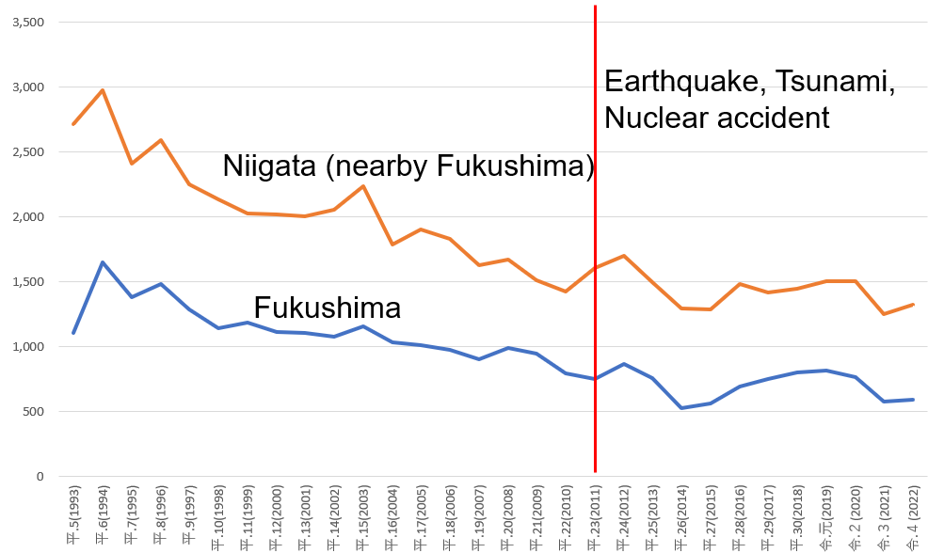

Figure 1 Value added of rice production in Fukushima and Niigata (100k JPY)

Source: Author’s calculation based on Statistics of Agricultural Income Produced by MAFF.[7]

1. Fukushima nuclear accident

On March 11, 2011, the Great East Japan Earthquake struck, causing a tsunami that hit the Fukushima nuclear power plant and resulted in a meltdown of the reactors. This incident led to a significant release of radioactive material, raising nationwide concerns about nuclear safety. While the middle and coastal areas of Fukushima prefecture experienced partial contamination, the western part remained unaffected. Despite government inspections confirming the safety of rice shipments from the western part after the accident, concerns persisted about the potential contamination of agricultural products in that region.

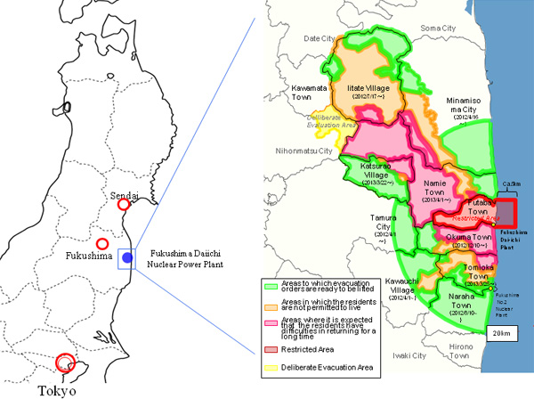

Figure 2 Evacuation map regarding the Fukushima nuclear accident

Source: Reconstruction Agency. (https://www.reconstruction.go.jp/english/topics/2013/03/the-status-in-fukushima.html).

1. Data

We use the Agriculture and Forestory census of Japan collected in 1995, 2000, 2005, 2010, and 2015[8]. We consider farm households in four Hinoemata-village, Tadami-town, Kaneyama-town, and Nishi Aizu-town in Fukushima prefecture as treatment groups that are supposed to be affected by the collective reputation and the accident. Other farm households in Aga-town, Sanjo-city, and Uonuma-city in Niigata prefecture are considered as control groups which are supposed not to be affected by the collective reputation and the accident. Figure 1 shows the geographical boundaries between Fukushima and Niigata prefecture and the boundaries of rural communities. The communities falling inside the contiguous towns formed by the boundary of the prefectures contribute to the treatment groups.

Table 1 Descriptive statistics

|  |  |  |  |
| --- | --- | --- | --- |
| Variables | Definition | Mean | SD |
| Rice production |  |  |  |
|  |  |  |  |
|  |  |  |  |
|  |  |  |  |
|  |  |  |  |
|  |  |  |  |
|  |  |  |  |
|  |  |  |  |
|  |  |  |  |
|  |  |  |  |

Source: Agriculture and Forestry census 1995, 2000, 2005, 2010, 2015.

Note: Author calculation.

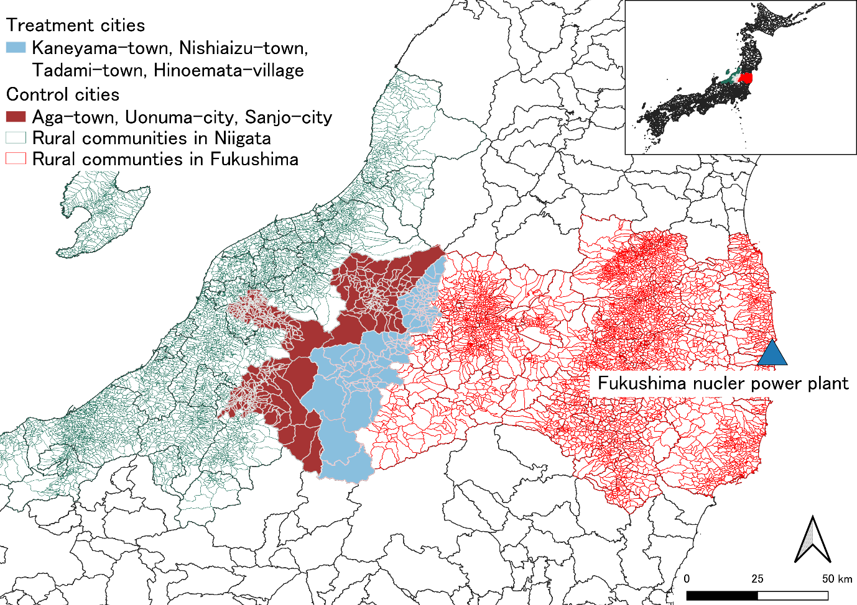 Figure 3 Geographical relationship between Fukushima and Niigata prefectures.  
Source: Authors’ design.

1. Impact of the accident
2. Impact of the accident on rice farm activities

We hypothesize that collective reputation is damaged by information friction between producers and consumers. Collective reputation is greater when public information is disseminated more rapidly (Saak, 2012).

To examine the reputational effects on farmers, we outline the difference-in-difference approach which is also known as the Two-way Fixed Effect (TWFE).

$$\begin{aligned}y_{it} =γFukushima_{p}×Post_{t}+βX_{it}+α_{i}+δ_{t}+ϵ_{it}\#\end{aligned}$$

where $y_{it}$ is the outcome variables of household *i* in year *t*. $Fukushima_{p}$ is an indicator variable whether a household *i* is in Fukushima Prefecture. $Post_{t}$ is an indicator variable showing that the accident happened in 2011. $X_{it}$ is a vector of covariates. $α_{i}$ and $δ_{t}$ are respectively household and year fixed effects. $ϵ_{it}$ is an error term. The coefficient $γ$ measures the change in outcome variables for rice farmers in Fukushima Prefecture that experienced the Fukushima nuclear accident. The model requires parallel trend assumption. Our additional analysis, event study design, confirms the parallel trend assumption, regarding the results of from Columns (1) to (4) of Table 3 and Column (3) of Table 4[9]

There are some concerns about the treatment variable. Supply chain disruption due to an earthquake and a tsunami in 2011(Barrot & Sauvagnat, 2016).

Table 2 shows the effect of the accident on farmer’s rice revenue. Column (1) shows that 12.4% of annual rice revenue is lost after the accident happened in Fukushima Prefecture compared to

Table 3 reveals that the accident led to a 3.9 percentage point reduction in paddy fields for Fukushima farmers compared to those in Niigata (Column (1)). Additionally, Column (2) indicates a 6.7% decrease in cultivated paddy fields due to the accident. These findings highlight the significant and economically impactful influence of reputational damage on farmers' input-related decision-making. Despite government assurances on product quality, collective reputational damage persists.

Table 2 Reputational effects after the Fukushima nuclear accident (TWFE)

|  |  |
| --- | --- |
|  | (1) |
|  | Rice revenue |
| Fukushima | -0.124** |
|  | (0.593) |
| Household FE | *Yes* |
| Year FE | *Yes* |
| Control variables | *Yes* |
| Mean dep. var |  |
| Parallel trend | *No* |
| Observations | 39,558 |

Note: Two-way cluster standard errors at household and rural community-level in parenthesis. *, **, and*** denote significance at the 10%, 5%, and 1% level, respectively. The outcome variable is transformed by inverse hyperbolic sine. Control variables include age and sex of household head, household size, dummy variables of incorporated farmers, farmers who gain non-farm income, and self-sufficient farmers.

1. The effects of the reputation damage on farmers’ decision-making

Before evaluating the impact of the Fukushima nuclear accident on the collective reputation of the rice sector, one would like to know more relationship between the

Table 3 Impact of the accident on farmers' decision-making (TWFE)

|  |  |  |  |  |
| --- | --- | --- | --- | --- |
|  | (1) | (2) | (3) | (4) |
|  | Owned paddy field | Cultivated paddy field | Total field rent out | Paddy field rent out |
| Fukushima | -0.060** | -0.103*** | 0.164** | 0.223*** |
|  | (0.027) | (0.038) | (0.070) | (0.066) |
| Household FE | *Yes* | *Yes* | *Yes* | *Yes* |
| Year FE | *Yes* | *Yes* | *Yes* | *Yes* |
| Control variables | *Yes* | *Yes* | *Yes* | *Yes* |
| Parallel trend | *Yes* | *Yes* | *Yes* | *Yes* |
| Observations | 39,558 | 39,558 | 39,558 | 39,558 |

Note: Two-way cluster standard errors at household and rural community-level in parenthesis. *, **, and*** denote significance at the 10%, 5%, and 1% level, respectively. The outcome variables are transformed by inverse hyperbolic sine. Control variables include age and sex of household head, household size, dummy variables of incorporated farmers, farmers who gain non-farm income, and self-sufficient farmers.

1. Who gets more affected by the reputation damage?

In this section, we investigate what kind of farmers are more affected by the collective reputation loss. We estimate the effects of the accident on the decision of environmentally friendly agriculture which has premium. In Table 4, Column (1) shows a statistically significant coefficient of -0.046 for Fukushima, indicating a 4.6% decline in environmentally friendly agricultural practices due to the accident's collective reputation damage from information friction.

Table 4 Reputation effect on eco-friendly farming (TWFE)

|  |  |  |  |
| --- | --- | --- | --- |
|  | (1) | (2) | (3) |
|  | No-pesticide | Manure fertilizer | Compost soil |
| Fukushima | -0.129*** | -0.159*** | -0.065*** |
|  | (0.023) | (0.023) | (0.018) |
| Household FE | *Yes* | *Yes* | *Yes* |
| Year FE | *Yes* | *Yes* | *Yes* |
| Control variables | *Yes* | *Yes* | *Yes* |
| Parallel trend | *No* | *No* | *Yes* |
| Observations | 28,501 | 28,501 | 28,501 |

Note: Two-way cluster standard errors at household and rural community-level in parenthesis. *, **, and*** denote significance at the 10%, 5%, and 1% level, respectively. The outcome variable is a dummy variable. Control variables include age and sex of household head, household size, dummy variables of incorporated farmers, farmers who gain non-farm income, and self-sufficient farmers.

Table 5 shows that ----. This is consistent with an empirical study showing that men became more risk tolerant after the earthquake than women (Hanaoka et al., 2018) The result indicate that

In this section, we test

1. Conclusions and policy implications

We investigate whether

Our study yields two policy implications. First, the reputational loss from information friction influences farmers' decisions, even with government quality assurances, highlighting the economic significance of collective reputation as an externality. Secondly, the study emphasizes that incentives for investing in high-value-added practices are significantly impacted by collective reputation, urging policymakers to reconsider the promotion of such practices through strategic consideration of collective reputation.

Reference

Bachmann, R., Ehrlich, G., Fan, Y., Ruzic, D., & Leard, B. (2023). Firms and Collective Reputation: A Study of the Volkswagen Emissions Scandal. *Journal of the European Economic Association*, *21*(2), 484–525. https://doi.org/10.1093/jeea/jvac046

Bai, J., Gazze, L., & Wang, Y. (2022). Collective Reputation in Trade: Evidence from the Chinese Dairy Industry. *The Review of Economics and Statistics*, *104*(6), 1121–1137. https://doi.org/10.1162/rest_a_01032

Barrot, J.-N., & Sauvagnat, J. (2016). Input Specificity and the Propagation of Idiosyncratic Shocks in Production Networks. *The Quarterly Journal of Economics*, *131*(3), 1543–1592. https://doi.org/10.1093/qje/qjw018

Gergaud, O., Livat, F., Rickard, B., & Warzynski, F. (2017). Evaluating the net benefits of collective reputation: The case of Bordeaux wine. *Food Policy*, *71*, 8–16. https://doi.org/10.1016/j.foodpol.2017.07.002

Hanaoka, C., Shigeoka, H., & Watanabe, Y. (2018). Do Risk Preferences Change? Evidence from the Great East Japan Earthquake. *American Economic Journal: Applied Economics*, *10*(2), 298–330. https://doi.org/10.1257/app.20170048

Ito, N., & Kuriyama, K. (2017). Averting Behaviors of Very Small Radiation Exposure via Food Consumption after the Fukushima Nuclear Power Station Accident. *American Journal of Agricultural Economics*, *99*(1), 1–18. https://doi.org/10.1093/ajae/aaw078

Jin, G. Z., & Leslie, P. (2009). Reputational Incentives for Restaurant Hygiene. *American Economic Journal: Microeconomics*, *1*(1), 237–267. https://doi.org/10.1257/mic.1.1.237

Koenig, P., & Poncet, S. (2022). The effects of the Rana Plaza collapse on the sourcing choices of French importers. *Journal of International Economics*, *137*, 103576. https://doi.org/10.1016/j.jinteco.2022.103576

Matsumoto, S., & Hoang, V. (2020). Economic Loss Due to Reputation Damage: A New Model and Its Application to Fukushima Peaches. *Journal of Agricultural Economics*, *71*(2), 581–600. https://doi.org/10.1111/1477-9552.12366

Tirole, J. (1996). A Theory of Collective Reputations (with Applications to the Persistence of Corruption and to Firm Quality). *The Review of Economic Studies*, *63*(1), 1. https://doi.org/10.2307/2298112

1. We thank the valuable comments from xxx, xxx. We acknowledge research grants from the Tokyo Center for Economic Research and JSPS Grant-in-Aid for Challenging Research (Pioneering) 22K18353.
2. Institute of Developing Economies (IDE-JETRO), National Graduate Institute for Policy Studies, Corresponding author, masanori.matsu.econ@gmail.com
3. Fukushima University
4. Nihon University
5. Kyoto University
6. Meiji University
7. The dataset is available from https://www.e-stat.go.jp/stat-search/files?page=1&layout=datalist&toukei=00500215&tstat=000001013427&cycle=0&tclass1=000001032288&tclass2=000001034728&tclass3val=0.
8. The data is available for onsite access at Kyoto University, Meiji University, Fukushima University with permission from Ministry of Agriculture, Forestry and Fisheries.
9. The graphical description of the event study analysis is shown in Appendix. The following regression is estimated for the event study analysis;