**Keywords:** Women empowerment, Land rights, Bargaining power, Matrilineal and patrilineal societies, Difference-in-Differences, Sub-Saharan Africa

# Introduction

Agriculture has long been a critical component of the economic and labor structure in Sub-Saharan Africa (SSA), and Zambia is no exception. In 2019, agriculture in Zambia accommodates more than 50% of workers, and the GDP share of the agriculture, forestry, and fishing sectors in terms of value-addition remained at 2.7% in 2020 (Mulenga, 2021). In the agrarian sector, women play a crucial role in increasing food security; however, social norms force women to say that they work in the home, even when they are heavily involved in agriculture (Deere, 2005). Moreover, when new opportunities are created through market and/or technological changes, women’s labor burden in household work and food production may limit their ability to exploit these opportunities (Doss, Meinzen-Dick, Quisumbing, & Theis, 2018). Therefore, there is need to build women’s access to the resources needed for productive agriculture to achieve gender equality and empowerment of all women and girls, as declared in Sustainable Development Goal 5.

Despite the consensus on the role of women in agriculture, studies have consistently found a gender gap in agricultural productivity in SSA. Ali, Bowen, Deininger, and Duponchel (2016) identified drivers of the gender gap in agricultural productivity. These include the fact that women have less access to male family labor and land. The researchers also found that women have lower use of contemporary farm technologies, plant fewer high-value crops, and have a high burden of unpaid household care and domestic work. One significant cause of this gender gap is women’s lack of access to land rights, which has received increasing attention from development practitioners and activists (Doss, 2018). As such, narrowing gender inequality in land rights could be one way of narrowing the gender gap in agricultural productivity and, consequently, to improve household welfare in SSA[1].

There are several definitions of women’s land rights (WLR): 1) land tenure; 2) the right to make planting decisions; 3) the right to transfer/sell farm produce or property, and 4) the right to make output decisions (Kang, Schwab, & Yu, 2020). For example, land tenure is linked to farmers’ investments in soil quality improvement, such as bunding, terracing, irrigation, and fallowing (Agarwal & Mahesh, 2023). WLR and women’s participation in decision making are highly linked together (Twyman, Useche, & Deere, 2015; Gacia-Moran & Yates, 2022). However, empirical studies on the right to make planting decisions and farm investment are scarce. Taking advantage of the traits of our dataset, we identified household decision-making processes (sole vs. joint decision-making). To represent WLR, this information is more reliable than the commonly used information such as the gender of the household head or plot holders (de la O Campos, Covarrubias, & Prieto Patron, 2016).

In this paper, we address two research questions. First, we examine whether there are any heterogeneous associations among land tenure security, farm income, and food insecurity among the gender of decision makers and kinship systems (matrilineal vs patrilineal). Second, we test whether the gendered mechanism varies across kinship systems. To this end, we use a new nationally representative panel dataset designed to obtain a comprehensive picture of Zambia’s small- and medium-scale farming sector. Furthermore, we exploit the fact that Zambia has both patrilineal and matrilineal kinship systems to examine whether the gender gaps in agricultural productivity stem from inequality in land tenure security and power differentials in agricultural decision-making due to differences in kinship systems.

There is a substantial body of literature on the relationship between land tenure security and farm investment in rural areas of developing economies (Hayes, Roth, & Zepeda, 1997; Bellemare et al., 2020). On the one hand, land is the most important natural capital for supporting agricultural production and providing food security (FAO, 2018). On the other hand, Place (2009) argues that debates continue debate continues as to whether land tenure security enhances agricultural productivity. Although previous studies have found that increasing women’s bargaining power in farming is associated with increased household food consumption in SSA (Doss, 2006; Muchomba, 2017), Meinzen-Dick, Quisumbing, Doss, and Theis (2019) state that there is less agreement and insufficient evidence on the association between WLR and livelihoods including household food (in)security, in contrast to bargaining power and decision-making on consumption and human capital investment. In addition, Kang et al., (2020) conclude that women supply more of their labor to plots they control, and gender inequality in labor allocation according to structure-domain combination. However, little is known about whether this observed agricultural gender inequality is innate or derived from societal differences like kinship systems.

The main contribution of this paper is threefold. First, we provide novel evidence of a link between land tenure security, farm investment decisions, and household welfare in Zambia where matrilineal and patrilineal kinship systems coexist. Previous empirical studies have not examined the relevance of sole and joint decision-making in the association between farm investment and WLR (Meinzen-Dick et al., 2019). This is because the linkage depends on local context and the overarching macro and sectoral conditions (Place, 2009). Second, we examine the association between farm investment and not only farm income but also household food insecurity across the gender status of decision-makers. Finally, we provide insights into the underpinnings of the observed gender differences in agricultural decision-making across men and women by comparing patrilineal and matrilineal households.

Our results reveal the heterogeneous effect of land tenure security on household welfare. Land tenure security increases farm income of matrilineal households with women decision-makers and patrilineal households with men decision-makers. Moreover, we find asymmetric pathways of the land tenure effects across gender of decision-makers and kinship systems. Land tenure security increases investment in irrigation if matrilineal households make planting decisions solely by women while it increases a usage of the fertilizer of patrilineal households with men decision-makers. Such insights may also be relevant to the policy community where the gender gap in agriculture is poorly understood.

The remainder of this paper is organized as follows: In Section 2, we provide background on the Zambian agrarian sector. Section 3 presents the data and descriptive statistics. Section 4 presents the conceptual and empirical framework for answering our research questions. Finally, Section 5 concludes the paper and discusses policy implications.

# Land tenure systems and kinship systems in Zambia

Zambia has two land tenure systems, namely, the customary and statutory systems. Under the customary system, traditional establishments such as the chief and/or village headman allocate vacant land to families and individuals on the recommendation of village headmen or headwomen as the first persons of contact at the village level. Customary land is advantageous to many farmers at the village level. Under this system, land is easy to acquire because the process is short and affordable for many users. However, the customary land tenure system is governed using ethnically diverse and unwritten local cultural rules, whereas western-style statutory tenure system is based on national laws enacted by the Zambian parliament. Hence, enforcement of statutory laws supersedes customary laws. This situation renders usufruct land users vulnerable to displacement by more powerful individuals and corporations (Chu, Young, & Phiri, 2015).

In 1995, the Zambian government implemented the Lands Act to allow for individual ownership rights and other formal land rights transfers. The Lands Act aimed at protecting land rights of holders from displacement by external people, and it gives chance for conversion of customary land to leasehold tenure for those seeking larger production (Sitko, Chamberlin, & Hichaambwa , 2014). If households want formal access to customary lands through the statutory system, the lands must be devolved from customary to statutory status (Chamberlin & Ricker-Gilbert, 2016). However, once converted, land cannot be returned to its customary tenure (Hall, Murombedzi, Nkonkomalimba, Sambo, & Sommerville, 2017). Under the statutory system, landowners have the rights to sell, rent, mortgage, and transfer their land (Chapoto, Jayne, & Mason, 2011). According to the statutory law, women in Zambia can apply for any land in the country, the same as their male counterparts. In the event of divorce or widowhood, if the husband dies without leaving a will and if he held state land, the Intestate Succession Act stipulates that the surviving spouse inherits 20% of the deceased’s property, including land and, together with any children, the house (Kapihya, 2017). However, this Act is generally not applied to customary land. If the deceased husband held customary land, the widow may be permitted to continue utilizing the land. However, the widow may also be ejected from the land by relatives of the deceased (Kapihya, 2017). Because of the limited data availability, we considered both customary and statutory tenure systems in this study. However, in Zambia, as in almost all SSA, women rarely own or oversee the land (Southern & Africa Office, 2003). Therefore, understanding how the interaction between the gender of the decision-maker and land tenure security relates to both investment and household welfare would encourage policymakers to plan interventions that empower women in rural economies.

Zambia is one of the most ethnically diverse countries in SSA (Posner, 2004), and thus social norms can vary across the country. There are matrilineal and patrilineal societies in Zambia. In a matrilineal society, an individual’s descent is traced through a female line (Mizinga, 2000) and inheritance of property, including land, passes through the female line (Hall, Murombedzi, Nkonkomalimba, Sambo, & Sommerville 2017). However, in most cases, women acquire rights to land through their husbands when they marry. Under the statutory system, women have the right to land ownership regardless of the kinship systems, but titles tend to be transferred through male relatives in both matrilineal and patrilineal societies (Chapoto et al. 2011). For instance, for land sales, even though women own the land, they must turn to their maternal uncles, who have the final say in decisions. Hence, consideration of gender roles in patrilineal and matrilineal systems can provide a deeper understanding of women’s empowerment and rural development in SSA.

# Data

We use the Rural Agricultural Livelihood Survey (RALS), a two-round household panel survey conducted in 2012 and 2015 by the Indaba Agricultural Policy Research Institute, together with the Central Statistical Office and the Ministry of Agriculture in Zambia (Fung, Liverpool-Tasie, Mason, & Oyelere, 2020). The RALS covers the 2010/2011 and 2013/2014 agricultural years and is in accordance with the maize marketing years 2011/2012 and 2014/2015, respectively. A total of 8571 households in the first wave, and 7579 households in the second wave, were surveyed in 442 Standard Enumeration Areas[2] (SEAs) in all districts of the country after removing observations with missing values. The sample was designed to represent rural farm households that cultivate less than 20 ha of land for farming and/or livestock production (Sitko, Chamberlin, & Hichaambwa, 2014).

This survey enables us to examine a variety of questions about smallholder farmers who have land titles and their effects on household welfare channeled by farm investment. The land tenure security variable takes a value of one if one or more of a farm household’s plots were titled. Descriptions of the variables used in this study are provided in Table 1. Regarding outcome variables, there is no significant difference in farm income but there is one in food insecurity. In Zambia, the adoption of tree planting and irrigation is low as shown in Table 1. It indicates that most of the farmers rely on rainfall. Farmers who have land tenure security are more likely to invest in fertilizer than farm households without land tenure security. The share of households that their decision-makers are women is 21%-28%. Moreover, the share of matrilineal households is approximately 37%–39%. As the number of plots decreases, the number of households planting cash crops and obtaining credit increases over time.

Table 1 Descriptive statistics (baseline year, 2012)

|  |  |  |  |  |  |  |  |  |
| --- | --- | --- | --- | --- | --- | --- | --- | --- |
| Variable | Description | N | Mean | SD | N | Mean | SD | Dif |
|  |  |  | Tenured |  |  | Non tenured |  | Tenured-non tenured |
| Farm income | Total Farm income (ZMW) | 144 | 7154.375 | 12241.230 | 6,322 | 5251.220 | 13769.580 | 1903.155 |
| Food insecurity | Number of months of food insecurity | 144 | 0.840 | 1.466 | 6,322 | 1.197 | 1.828 | -0.357** |
| Tree planting | Hectare of planting trees | 144 | 0.256 | 1.421 | 6,322 | 0.171 | 1.248 | 0.085 |
| Irrigation | Hectare of irrigation | 144 | 1.387 | 3.129 | 6,322 | 0.879 | 3.112 | 0.508 |
| Fertilizer | Kilogram of usage of chemical fertilizer | 142 | 354.225 | 553.631 | 6,299 | 264.197 | 523.568 | 90.028** |
| Decision making by women | 1 if the household make a planting decision by only women | 144 | 0.278 | 0.449 | 6,322 | 0.212 | 0.409 | 0.065** |
| Joint decision making | 1 if the household jointly make a planting decision by men and women | 144 | 0.118 | 0.324 | 6,322 | 0.121 | 0.326 | -0.003 |
| Matrilineal household | 1 if the household is matrilineal, 0 if the household is patrilineal | 144 | 0.368 | 0.484 | 6,322 | 0.388 | 0.487 | -0.020 |
| Age of HH | Age of household head | 144 | 47.618 | 14.347 | 6,322 | 45.255 | 14.888 | 2.363* |
| Local household head | 1 if the household head is local, 0 otherwise | 144 | 0.868 | 0.340 | 6,322 | 0.886 | 0.318 | -0.018 |
| Land holding | Land holding (ha) | 144 | 4.485 | 5.329 | 6,322 | 3.942 | 6.985 | 0.543 |
| Adult equivalent | Number of adult equivalents | 144 | 4.042 | 2.038 | 6,322 | 3.650 | 1.883 | 0.392** |
| Food Reservation Agency (FRA) | 1 if the household sells a maize to FRA | 144 | 0.382 | 0.488 | 6,322 | 0.324 | 0.468 | 0.058 |
| Cash crop | 1 if the household plant a cash crop, 0 otherwise | 144 | 0.146 | 0.354 | 6,322 | 0.189 | 0.392 | -0.044 |
| Number of plots | Number of plots | 144 | 3.215 | 2.042 | 6,322 | 3.098 | 1.592 | 0.118 |
| Educational level of HH | Educational year of household head | 144 | 7.868 | 4.156 | 6,322 | 7.868 | 4.156 | 1.816*** |
| Credit access | 1 if the household can obtain credit, 0 otherwise | 144 | 0.194 | 0.397 | 6,322 | 0.191 | 0.393 | 0.004 |
| Tropical Livestock Unit | Ownership and access to tropical livestock | 144 | 3.289 | 9.185 | 6,322 | 2.364 | 7.542 | 0.925 |
| Asset index | Asset index based on principal component analysis | 144 | 0.887 | 2.594 | 6,322 | -0.018 | 2.090 | 0.905*** |
| Time to the nearest paved road | Time from homestead to the nearest paved road (minutes) | 144 | 72.826 | 102.629 | 6,322 | 110.515 | 252.690 | -37.689* |

Note: Authors’ calculation using RALS2012. Zambian Kwacha (ZMW) values are in real 2017 terms. 2017 exchange rate: 9.5 ZMW/US$. The calculation of Tropical livestock Unit is based: cattle = 0.7, sheep = 0.1, goats = 0.1, pigs = 0.2, chicken = 0.01 (Otte & Chilonda, 2002). Small-scale households are defined as households cultivating 4.99 hectares of crop area or less. Households cultivating between 5 and 19.99 hectares of area under crops are classified as Medium-scale households. We excluded households who earn less than 0 ZMW as outliers. It is important to note that the costs of production are partially observed. Thus, net crop income accounts for fertilizer costs and the costs of transportation, but not for labor, transaction, seed, or other input expenditures. ***, **, * denote level of significance at 1%, 5% and 10% respectively.

1. **Measurement of key variables**

The variables of interest are land tenure security, tree planting, irrigation, fertilizer adoption, farm income, and months of food insecurity. The household-level tenure security variable takes a value of 1 if the household owns at least one plot secured by the government and 0 otherwise. The variable for the gender of decision-makers is assigned a value of 1 if the decision-makers are only women and 0 otherwise. At the household level, joint decision-making means that households have both male and female decision-makers, while women’s decision-making means that only women participate in decision-making in land management. Three types of farm investments are included in the analysis: tree planting, irrigation, and chemical fertilizer. These are measured according to application areas at the household levels. Due to the data availability, we consider farm investment as both stock and flow because the dataset we use does not include the timing of investment. In terms of tree planting, *Faidherbia albida* and *Gliricidia sepium*, a sort of legume, are mainly planted to protect the harvest of crops, especially maize. These trees have a relatively higher germination rate, and they improve the soil quality since they are in the family of legumes. Their leaves are even used for feeding livestock. Thus, tree planting can be considered as investment rather than speculation. Finally, two outcome variables are analyzed. The first outcome variable is farm income, which captures income from farm products, such as maize, cassava, vegetables, fruits, and other crops. It is important to note that farm income accounts for partially observed costs of production. Thus, the net farm income accounts for fertilizer costs and the costs of transportation, but not for labor, transaction, seed, or other input expenditures due to data availability. Values are given in Zambia Kwacha (ZMW) and deflated to real 2017 terms[3]. The second outcome variable is food insecurity, which measures the number of months in which a household lacks enough food to meet its needs. Although household food security is generally captured by food availability which is usually measured by food expenditure and food accessibility which is usually measured by dietary diversity (Matsuura, Luh, & Islam, 2023), the dataset we use fails to contain the information. In terms of the food security variable, we must be cautious about the interpretation of it because it may mainly reflect the seasonality of access to food, whether from production or markets.

1. **Descriptive statistics**

Table 2 shows that the ratio of women decision makers of household with land tenure security is higher than the ones without land tenure security. This result is contrary to our intuition that women have less access to land. One plausible explanation is that women who can decide how to use a plot are relatively central to the networks of social and political power in a community (Goldstein & Udry, 2008). Table 2 also reports the relationships between the kinship system and the decision-making process. Women are more likely to make decisions in a matrilineal system than in a patrilineal system.

Figure 2 presents the geographical distribution of farmers with land titles, farm income, and farm investment management based on RALS 2012 and 2015. Panel A shows the geographical distribution of farmers with land tenure (%). Panel B shows the geographical distribution of the average annual farm income (ZMW). Copperbelt Province, Central Province, and Southern Province have the highest farm incomes and are the pivots of the Zambian rural economy. Panels C, D, and E show the geographical distribution of the farm investment. Panel F presents agro-ecological zone in Zambia. In Panel F, Zone Ⅰ lie in southern, eastern, and western Zambia. Zone Ⅱ includes much of central Zambia, and Zone Ⅲ lies in band across northern Zambia. From the graphical analysis, linkages between land tenure security, farm investment, and household welfare superficially exists. Moreover, agro-ecological zones may be related to farm investment decisions. To claim the empirical linkage among them, we need to examine the nexuses empirically such as by controlling for geographical factors. The detailed empirical methods are explained in a following section.

Table 2 Decision making, land tenure security, and kinship system

|  |  |  |  |  |  |  |  |
| --- | --- | --- | --- | --- | --- | --- | --- |
|  |  | Land tenure security |  |  |  | Kinship |  |
|  | Yes | No | Dif |  | Matrilineal | Patrilineal | Dif |
| Decision making by women | 0.278 | 0.212 | 0.065* |  | 0.434 | 0.375 | 0.059*** |
|  | (0.449) | (0.409) |  |  | (0.496) | (0.484) |  |
| Observation | 144 | 6,322 | 6,466 |  | 1,383 | 5,083 | 6,466 |

Source: Authors’ calculation using the RALS2012. Standard deviations are in parenthesis. Dif means the mean difference between tenure ownership and non-tenure ownership and between patrilineal and matrilineal households. ***, **, * denote level of significance at 1%, 5% and 10% respectively.

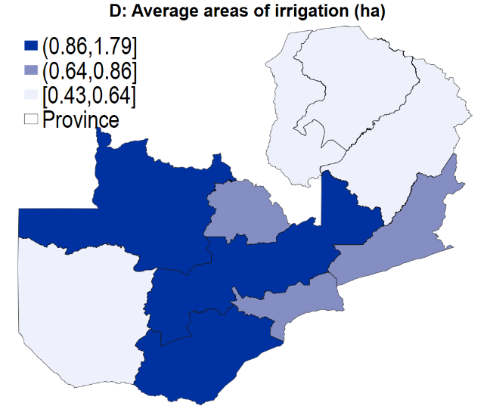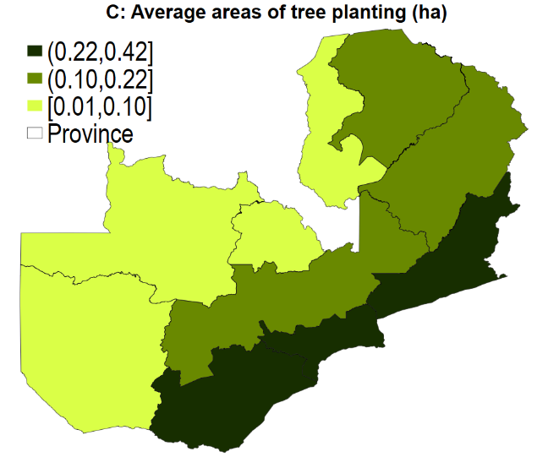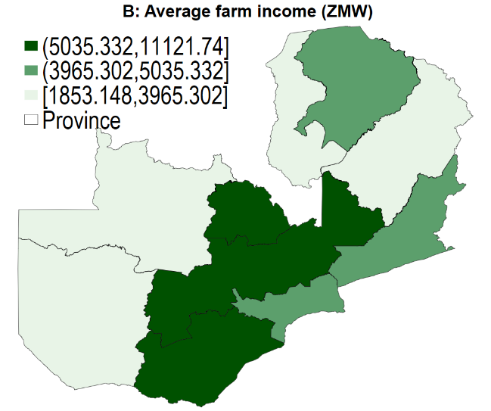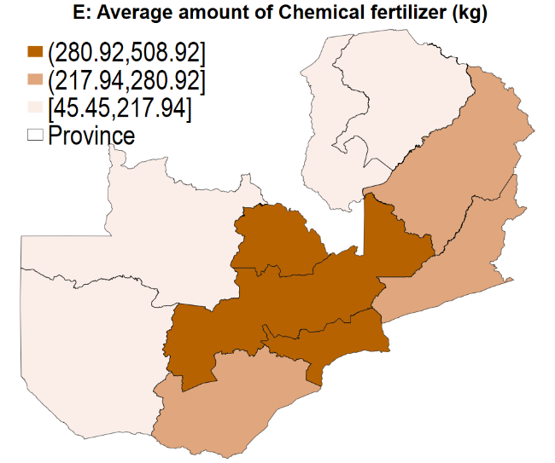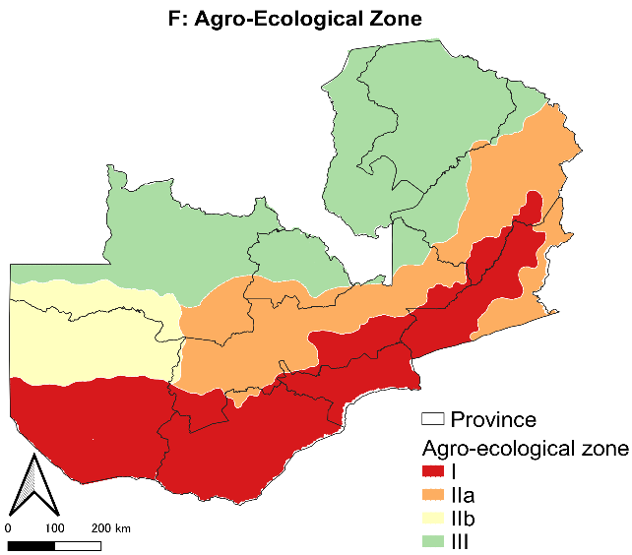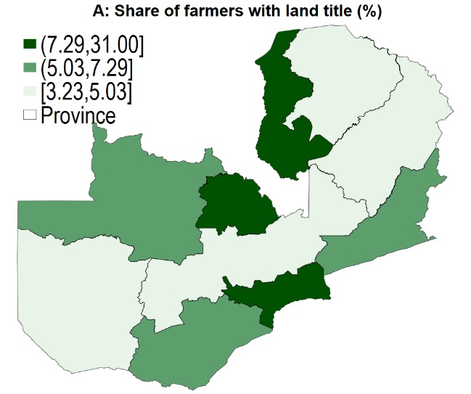

Figure 2 Land tenure security, farm income, and farm investment in Zambia

Note: Panel A shows the proportion of households with land titles by province. Panel B shows the average farm income by province. Panel C shows the average areas of tree planting per household by province. Panel D shows the average areas of irrigation per household by province. Panel E shows the average amount of chemical fertilizer usage per household by provinces. Panel F presents the agro-ecological zone. Source: Authors’ compilations using the RALS2012 and 2015 data and SASSCAL Data and Information Portal.

# Methodology

To address our research questions, we construct a conceptual framework and employ empirical approaches. This conceptual framework presents a concise potential mechanism for the link between land tenure security, farm investment, income, and food insecurity through graphical and descriptive representations. Empirical approaches outline a method for estimating the model specified in a conceptual framework using a dataset.

1. **Conceptual framework**

The extreme purpose of this analysis is to provide insights into the nexus among land tenure security, farm investment, and household welfare from perspectives on gender and social norms. Land tenure security is believed to increase farm investment because profits from farm investment will not be seized by others in the future. The cost of farm investment becomes lower than the sum of the additional profit from the investment. Second, land tenure security and farm investment may be linked through some factors such as credit access, gains from trade, and capital investment (Feder & Onchan, 1987; Galiani & Shargrodsky, 2010; Besley, 1995). Passing through the potential channels, we expect that land tenure security would increase farm investment: tree planting, irrigation, and fertilizer adoption in this study.

Some possible determinants of farm investment should be considered in an empirical analysis. Risk preference may be a driver of farm investment (Liu, 2013). Unfortunately, we do not have any information about the risk preferences of decision-makers, but we manage to consider this dimension by including the wealth level of the household, the educational level of the household head and the gender of decision-makers. Moreover, farmers’ knowledge through agricultural extension services may also affect farm investment decisions (Nakano, Tsusaka, Aida, & Pede, 2018). In this study, we consider the distance to the nearest paved road as a proxy of agricultural services.

In many African settings, agricultural production is conducted simultaneously on many plots controlled by different household members. Many studies on gender and agricultural labor use household-level information, which ignores within-household variations in plot-level ownership (Doss, 2018), and women’s plot ownership does not always imply their managerial rights (Doss, Kovarik, Peterman, Quisumbing, & van den Bold, 2015). Therefore, it is worth noting that we consider sole decision-making by women and men, and joint decision-making, without assuming a unitary household. Since women are less likely to have access to land rights, we expect that they are more likely to invest in agricultural technologies when they have tenured plots. Furthermore, women in patrilineal societies may relatively have weaker bargaining power than women in matrilineal societies. The effect of land tenure security for women in patrilineal societies may be larger than the one for women in matrilineal societies.

Although land tenure security is believed to improve household welfare by increasing farm investment (Bellemare et al., 2020; Issahaku & Abdulai, 2020), short-lived investments such as labor, fertilizer, and pesticide are doubted because of land tenure security (Fenske, 2011). Thus, we focus on only long-lived investments such as tree planting, irrigation, and chemical fertilizer. Tree planting improves soil fertility and planted trees may feed livestock (Sitko, Chamberlin, & Hichaambwa , 2014). Thus, tree planting can increase farm income and improve household food security. Irrigation improves efficiency of water use and increases yields and net returns (Abdulai & Huffman, 2014). Furthermore, Chemical fertilizer adoption contributes to increasing soil quality and preventing land degradation (Abdulai & Huffman, 2014). Increased soil quality can increase farm income and yield which is related to self-consumption.

Although Deininger, Xia, Kilic, & Moylan (2021) found that women’s rights affect investment, little is known about the relationship between land ownership and productivity from the perspective of gender in most regions (Agarwal & Mahesh, 2023). In Africa, customary systems, such as patrilineal succession, restrict or exclude women’s access to ownership and control over land (Najjar, Baruah, & El Garhi, 2020). This is related to the lower female labor supply in farming without ownership of land (Palacios-Lopez, Christiaensen, & Kilic, 2017). It would induce less farm production because adult male labor is found to contribute more than adult female labor to the production (Jacoby, 1991). Furthermore, as theory predicts that women prefer to devote resources to improving their nutritional status (Thomas, 1990); households with land tenure security that are solely held by a woman, compared with those without land tenure security, allocate more of their family budget to food (Menon, van der Meulen Rodgers, & Nguyen, 2014). Therefore, we expect that households that are solely held by a woman in patrilineal households benefit more from farm investment and land tenure security than the matrilineal ones. Our study contributes to the literature on land tenure security and farm investment from the perspective of gender and social norms. Figure 2 illustrates the conceptual framework of the links between land tenure security, farm investment, and household welfare. The normal arrows show the possibility of a causal relationship while the dashed arrows present potential reverse causality. Based on the above discussion, we propose two hypotheses to be tested by our empirical approach.

1. Land tenure security improves farm income and food security. The effect of land tenure security is larger for farmers with women decision-makers in matrilineal societies.
2. Land tenure security enhances farm investment. Women in matrilineal households are more likely to invest when the household has a land tenure security than those in patrilineal societies.

Figure 2 Conceptual framework for links among land tenure security, farm investment, and household welfare

Source: Build by authors. Note: Dashed lines show possible reverse causal relationships

1. **Estimation methods and empirical approach**

First, we explore the association between land tenure security and household welfare. A treatment effect model, as a rule, compares the average potential outcome of interest between treated and untreated groups. In this regard, let $E \left(Y_{1} | T=1\right)$ be the average potential outcome (farm income and food insecurity indicator) for the treated group (households with land tenure security), and $E(Y_{0}|T=0)$ be the average potential outcome for the untreated group (households without land tenure security). The impact known as the average treatment effect (ATE) is defined as:

$$ATE=E \left(Y_{1} | T=1\right)-E(Y_{0}|T=0)$$

To enable the ATE to be eligible for measuring the treatment effect, we need have the conditional independence assumption as follows:

$$\{Y_{1}, Y_{0}⊥T_{i}|X_{i}\}$$

Where $X_{i}$ is the covariates that affect the treatment status (land tenure status) and the outcome. This assumption enables comparisons of the outcomes of treated and untreated groups, conditional on $X_{i}$. To explicitly account for the selection on observable factors $X_{i}$ with similar characteristics, propensity score matching (PSM) can be used as an estimation method when other plausible instruments were not available (Bellemare & Novak, 2017; Issahaku & Abdulai, 2020; Lawin & Tamini, 2019). The probability of land tenure security status, conditioned on the household characteristics, can be expressed as

$$\begin{aligned}P\left(T_{i}=1 | X_{i}\right)≡p\left(X_{i}\right)\#(1)\#\end{aligned}$$

where $T_{i}$ is status of land tenure security of household *i*. Equation (1) is estimated by the probit model. An important assumption of PSM is the overlap assumption, which requires substantial overlap in covariates between households with land tenure and households without land tenure, so that households being compared have a common probability of being both tenured and non-tenured, such that 0 < $p(X_{i})$ <1. In this study, the matched sample is constructed using the nearest neighbor matching based on the estimated propensity.

After matching households and creating the matched sample to account for observable characteristics, we estimate two-way fixed-effect models (also known as Difference-in-Difference, here we call PSM-DiD) to investigate the impact of land tenure security on household welfare over gender of decision makers and kinship systems with incorporation of the interaction terms with land tenure security. A limitation of PSM is that if unobservable characteristics affect land tenure security, the estimated results may be biased by the selection of the unobservable[4]. To minimize selection-on-unobservable bias, we use the two-way fixed-effect models so that bias based on time-invariant unobserved characteristics can be addressed. The DiD estimator between the treated and untreated groups is given by

$DiD=E\left[Y_{a}-Y_{b} | T=1\right]-E\left[Y_{a}-Y_{b} | T=0\right]=E\left[ΔY | T=1\right]-E[ΔY|T=0]$

where subscripts *b* and *a* denote “before” and “after” the households obtain land tenure security. Thus, *ΔY* denotes a difference in the outcomes before and after gaining the land tenure security. The land tenure effects can be naively obtained by a standard two-way fixed effects specification:

$$\begin{aligned}y_{it}=γ_{1}{ Tenure}_{it}+γ_{2}Tenure_{it}×Wome{n(Men)}_{it}×Matrilinea{l(Patrilineal)}_{it} \\ +γ_{3}Tenure_{it}×Wome{n\left(Men\right)}_{it}+γ_{4}Tenure_{it}×Matrilinea{l\left(Patrilineal\right)}_{it} \\ +γ_{5}Wome{n(Men)}_{it}×Matrilinea{l(Patrilineal)}_{it} \\ +γ_{6}X_{it}+α_{i}+σ_{t}+v_{g}+ϵ_{it}. \#\left(2\right)\end{aligned}$$

where $y_{it}$ is outcome variables of household *i* at year *t*; $Tenure_{it}$ is a dummy variable for whether the household *i* has a tenured plot; $Wome{n(Men)}_{it}$ is a dummy variable for whether the decision-makers are women (men); and $Matrilinea{l(Patrilineal)}_{it}$ is a dummy variable of matrilineal (patrilineal) households. By including $Wome{n(Men)}_{it}$ and $Matrilinea{l(Patrilineal)}_{it}$ in Equation (2), we can investigate the heterogeneous effects of land tenure security on household welfare across gender of decision makers and social norms. $X_{it}$ is the vector of covariates; $α_{i}$ is the household fixed effect; $σ_{t}$ is the year fixed effect; $v_{g}$ is a province dummy to account for geographical characteristics; and $ϵ_{it}$ is the error term*.* By using PSM-DiD, we can more effectively reduce remaining bias that may occur when systematically differentiating between treated and untreated groups (Ferraro & Miranda, 2014). Nonetheless, no study that relies on observational data can claim to have fully controlled for all unobservable factors, and we cannot address that land tenure security are endogenous because of their potential correlation with unobservable time-varying factors. Therefore, although some studies using only fixed effect models give insightful implications in economics studies such as Kathage & Qaim (2012) and Kubitza, Krishna, Urban, Alamsyah, & Qaim (2018), our findings should be merely treated as an association rather than causality.

Beyond the relationship between land tenure security and household welfare, we examine the mechanism of the relationship. Land tenure security can positively affect household welfare through the mechanisms, of which more farm investment is only one. To test whether farm investment is a relevant mechanism, we replace the outcome variables with variables of farm investment from Equation (2).

# Results and discussions

The study presents empirical results on the gendered impacts of land tenure security on household welfare, highlighting the heterogeneity across kinship systems. The study finds that increased farm investment, particularly irrigation in matrilineal households and fertilizer adoption in patrilineal households, is a significant factor in these impacts. We then present the results of our analysis using the RALS dataset and accompanying sensitivity test.

1. **Association between land tenure security and household welfare**

As discussed in Section 4, our main research objective is to examine the empirical link between land tenure security, farm investment, and household welfare. Panel A of Table 3 summarizes the results of the PSM-DiD model by estimating Equation (3). The coefficient estimates for the factors related to farm income are shown in Columns (1) and (3) while Columns (2) and (4) are for the food insecurity indicator. Column (1) in Panel A of Table 3 reports PSM-DiD results with no control except household and time-fixed effects. According to the baseline results, the coefficient of land tenure security interacted with decision-making by only women and matrilineal household is positively significant. It indicates that matrilineal households whose decision-makers are women are more likely to benefit from land tenure security, compared to patrilineal households whose decision-makers are women. Column (2) shows that land tenure security does not affect the food security of matrilineal households with women decision-makers.

To allow for the observable differences that enable households to improve their livelihood by themselves, in Columns (3) and (4) we include a range of covariates. The results derived using two-way fixed effects with control variables indicate that land tenure security increases farm income in Column (3). Across Panel A of Table 3, the coefficient on the interest is strongly significant. The coefficient of the interaction term among land tenure security, decision-making by women, and matrilineal households is positively significant. In the bottom rows, we report the overall effects of the land tenure security as well as the effects for households that are matrilineal and make agricultural decisions by women separately that are comparable across columns. The results are robust to adding these covariates both for the farm income and the food security indicator. From the bottom rows, matrilineal households whose decision-makers are women can enjoy the benefit of land tenure security while patrilineal households whose decision-makers are women cannot.

In Panel B of Table 3, we show the results of a different specification using the PSM-DiD method. Instead of focusing on matrilineal households and women decision makers, we include variables of patrilineal households and men decision makers. Columns (1) and (3) show the results of the effect of land tenure security on farm income whatever we control for confounding factors. We find that land tenure security significantly increases farm income for households that are patrilineal and have men decision makers. Same as the Panel A of Table 3, the coefficients on interest are insignificant for the food security indicator in Columns (2) and (4).

The results indicate symmetric heterogeneous effects of land tenure security on household welfare. If decision makers are women, land tenure security is effective only for matrilineal households while if decision makers are men, land tenure security is effective only for patrilineal households. This pattern appears to reflect the significance of gender-related social norms to maximize land tenure security. In other words, women in patrilineal households meaning male-dominant societies are less likely to benefit from land tenure security due to the gender inequality stemming from the social norm.

Overall, the welfare benefits of land tenure security are generally consistent with those of previous studies by Abdulai and Huffman (2014), Nkomoki, Bavorová, and Banout (2018), and Issahaku and Abdulai (2020). However, our findings contribute to the vast literature on land tenure security and household welfare from viewpoints of gender and social norms. Social norms hinder the maximized effect of land tenure on women in developing countries. The results are consistent with our Hypothesis 1.

Table 3 Heterogeneous association between land tenure and household welfare among gender and kinship: PSM-DiD estimates

|  |  |  |  |  |
| --- | --- | --- | --- | --- |
| Panel A | (1) | (2) | (3) | (4) |
|  | Farm income | Months of food insecurity | Farm income | Months of food insecurity |
| Land tenure security (LTS) | 0.069 | 0.646** | 0.326 | 0.559* |
|  | (0.479) | (0.308) | (0.451) | (0.315) |
| LTS × Decision making by women × Matrilineal household | 5.329*** | 0.143 | 5.333*** | 0.149 |
|  | (1.558) | (1.212) | (1.365) | (1.223) |
| LTS × Decision making by women | -1.242 | 0.883 | -1.015 | 0.883 |
|  | (0.961) | (0.649) | (0.910) | (0.677) |
| LTS × Matrilineal household | -0.901 | -1.151*** | -1.157 | -1.073** |
|  | (0.732) | (0.430) | (0.734) | (0.445) |
| Decision making by women × Matrilineal household | -0.854*** | 0.277** | -0.600*** | 0.269* |
|  | (0.185) | (0.138) | (0.176) | (0.142) |
| Decision making by women | -0.704*** | 0.366*** | -0.423*** | 0.377*** |
|  | (0.173) | (0.121) | (0.164) | (0.126) |
| Matrilineal household | -0.011 | 0.110** | 0.002 | 0.134** |
|  | (0.086) | (0.056) | (0.083) | (0.057) |
| Control variables | *No* | *No* | *Yes* | *Yes* |
| Household FE | *Yes* | *Yes* | *Yes* | *Yes* |
| Province FE | *Yes* | *Yes* | *Yes* | *Yes* |
| Year FE | *Yes* | *Yes* | *Yes* | *Yes* |
| Observation | 13,214 | 13,270 | 12,580 | 12,634 |
| Marginal effects |  |  |  |  |
| LTS | 0.069 | 0.646** | 0.326 | 0.559* |
|  | (0.479) | (0.308) | (0.450) | (0.314) |
| LTS, decision making by women | -1.172 | 1.529*** | -0.688 | 1.443** |
|  | (0.839) | (0.577) | (0.795) | (0.605) |
| LTS, decision making by women, matrilineal household | 4.156*** | 1.671 | 4.644*** | 1.591 |
|  | (1.311) | (1.062) | (1.107) | (1.058) |
| Panel B | (1) | (2) | (3) | (4) |
|  | Farm income | Months of food insecurity | Farm income | Months of food insecurity |
| Land tenure security (LTS) | 1.912* | 0.054 | -0.601 | -1.333 |
|  | (1.000) | (0.803) | (1.721) | (1.170) |
| LTS × Decision making by men × Patrilineal household | 3.709*** | 0.104 | 3.589** | 0.867 |
|  | (1.426) | (1.012) | (1.431) | (1.237) |
| LTS × Decision making by men | -2.580** | -0.579 | -3.626*** | -1.202 |
|  | (1.157) | (0.851) | (1.033) | (1.008) |
| LTS ×Patrilineal household | -2.552** | 0.997 | 1.122 | 1.669 |
|  | (1.170) | (0.893) | (1.886) | (1.294) |
| Decision making by men ×Patrilineal household | 0.057 | -0.122 | 1.238*** | -0.537** |
|  | (0.124) | (0.090) | (0.305) | (0.241) |
| Decision making by men | 0.046 | 0.000 | 0.595*** | -0.108 |
|  | (0.129) | (0.095) | (0.180) | (0.146) |
| Patrilineal household | 0.091 | 0.035 | 0.813*** | -0.150 |
|  | (0.118) | (0.087) | (0.191) | (0.151) |
| Control variables | *No* | *No* | *Yes* | *Yes* |
| Household FE | *Yes* | *Yes* | *Yes* | *Yes* |
| Province FE | *Yes* | *Yes* | *Yes* | *Yes* |
| Year FE | *Yes* | *Yes* | *Yes* | *Yes* |
| Observation | 13214 | 13270 | 12580 | 12634 |
| Marginal effects |  |  |  |  |
| LTS | 1.912* | -0.421 | 2.103** | -0.267 |
|  | (1.000) | (0.966) | (0.919) | (0.959) |
| LTS, decision making by men | -0.667 | -0.525* | -0.207 | -0.714** |
|  | (0.592) | (0.303) | (0.637) | (0.342) |
| LTS, decision making by men, patrilineal household | 3.041** | 0.053 | 2.797** | 0.044 |
|  | (1.294) | (0.803) | (1.199) | (0.782) |

Note: Robust standard errors are clustered by household in parentheses. The outcome variables were log farm income and number of months of food insecurity. TWFE model is used after PSM to account for both observed and unobserved time-invariant factors. Households who covert the kinship system between the waves are exclude for sub-sample analysis to include household fixed effects without singleton. ***, **, * denote level of significance at 1%, 5% and 10% respectively. Full regression table is available at Table A2 and A3. Source: Authors’ calculations using RALS2012 and 2015 data.

1. **Potential mechanisms**

Many views by development practitioners assume that the causality between agricultural intervention and women’s productivity is rational, and donors are increasingly calling for gender issues to be addressed in development projects and proposals. Others continue to cast doubt on a women-focused blueprint in the agrarian sector, or at least suggest that there may be trade-offs related to targeting interventions at women (Doss, 2018). The most natural route by which land tenure security increases farm income is through farm investment. In this section, we investigate how land tenure security improves household welfare channeled through farm investment, such as tree planting, adoption of irrigation, and usage of fertilizer. Moreover, we confirm whether the mechanism varies on gender and social norms (matrilineal vs patrilineal).

Panel A of Table 4 shows the result with a focus on women decision-makers and matrilineal households. Columns (1) to (3) show the estimates from PSM-DiD without covariates while Column (4) to (6) report the results with covariates. The results in Columns (1), (3), (4) and (6) show that land tenure security is insignificantly associated with tree planting and fertilizer. The interaction terms among land tenure security, decision-making by women, and matrilineal households are thoroughly insignificant. In Column (2), the result shows that the coefficient of interaction term among land tenure security, decision-making by women, and matrilineal households is positively significant while the coefficient on the interest is insignificant in Column (5). This indicates that matrilineal households with women decision-makers are more likely to invest in irrigation when they have land tenure security compared to households where their decision makers are women but are patrilineal households. There may be several plausible reasons behind this result. One is that women decision-makers are more risk-averse than men. Therefore, women are more likely to invest in irrigation to reduce the risk of weather shocks which severely affect agricultural production (Kebede, 2022; Gatti, Baylis, & Crost, 2021).

Panel B of Table 4 shows the result for patrilineal households and households with men decision-makers. Although the coefficient of an interaction term among land tenure security, patrilineal households and decision-making by men is insignificant in Columns (1), (2), (4), and (5), Column (3) excluding covariates and Column (6) with covariates show that the coefficient on interest is positive and significant. It indicates that men decision-makers in patrilineal households are likely to invest in chemical fertilizer when they have land tenure security. These results confirm our Hypothesis 2 and are consistent with Tufa, et al. (2022). We find the different channel of the land tenure security effects on household welfare varying across gender of decision makers and social norms. One of the plausible explanations of the results would be gender differences in risk preference (Kebede, 2022). A bulk of empirical studies find that women tend to be more risk-averse than men. Since the fertilizer adoption is a high-risk and high-return investment option for smallholder farmers relying on rainfall (Kebede, 2022), men in male dominant societies who would be more risk-taker are likely to invest more in fertilizer.

Overall, it is important to note that land tenure security provide benefits for farm income channeled through farm investment, but the plausible channel varies across gender of decision makers and social norms. From the perspective of women’s empowerment, the results imply that policymakers need to consider not only gender but also social norms when they implement land policies for agricultural development. However, as the study did not reveal convincing source of the mechanisms, further research is warranted to investigate the underlying factors responsible for the mechanisms.[5]

Table 4 Heterogeneous association land tenure and farm investment among gender and kinship: PSM-DiD estimates

|  |  |  |  |  |  |  |
| --- | --- | --- | --- | --- | --- | --- |
| Panel A | (1) | (2) | (3) | (4) | (5) | (6) |
|  | Tree planting | Irrigation | Fertilizer | Tree planting | Irrigation | Fertilizer |
| Land tenure security (LTS) | 0.813 | 0.796 | 64.203 | 0.770 | -1.285 | 52.346 |
|  | (0.696) | (1.099) | (103.605) | (0.673) | (1.502) | (101.745) |
| LTS × Decision making by women × Matrilineal household | 1.139 | 2.797* | 205.732 | 1.010 | 1.366 | 198.561 |
|  | (0.735) | (1.455) | (168.641) | (0.712) | (1.856) | (176.254) |
| LTS × Decision making by women | -1.109 | -2.143* | -161.478 | -1.049 | 0.780 | -127.765 |
|  | (0.725) | (1.266) | (136.532) | (0.703) | (1.778) | (136.757) |
| LTS × Matrilineal household | -0.915 | -1.320 | -112.388 | -0.896 | -0.585 | -137.184 |
|  | (0.706) | (1.291) | (141.529) | (0.694) | (1.596) | (146.179) |
| Decision making by women × Matrilineal household | -0.079 | -0.031 | 29.648 | -0.069 | 0.508** | 39.247** |
|  | (0.053) | (0.167) | (19.387) | (0.062) | (0.236) | (18.675) |
| Decision making by women | -0.093* | -0.219 | -7.145 | -0.081 | 0.371* | 6.624 |
|  | (0.055) | (0.187) | (15.084) | (0.065) | (0.213) | (14.732) |
| Matrilineal household | -0.093* | -0.219 | -7.145 | -0.081 | 0.371* | 6.624 |
|  | (0.055) | (0.187) | (15.084) | (0.065) | (0.213) | (14.732) |
| Control variables | *No* | *No* | *No* | *Yes* | *Yes* | *Yes* |
| Household FE | *Yes* | *Yes* | *Yes* | *Yes* | *Yes* | *Yes* |
| Year FE | *Yes* | *Yes* | *Yes* | *Yes* | *Yes* | *Yes* |
| Province FE | *Yes* | *Yes* | *Yes* | *Yes* | *Yes* | *Yes* |
| Observations | 13,270 | 13,270 | 13,152 | 12,634 | 12,634 | 12,520 |
| Panel B | (1) | (2) | (3) | (4) | (5) | (6) |
|  | Tree planting | Irrigation | Fertilizer | Tree planting | Irrigation | Fertilizer |
| Land tenure security (LTS) | -0.126*** | -0.257 | -23.162 | -0.195*** | -0.252 | -30.278 |
|  | (0.035) | (0.265) | (29.191) | (0.060) | (0.428) | (29.878) |
| LTS × Decision making by men × Patrilineal household | 1.253 | 0.405 | 388.412** | 1.159 | 2.472 | 434.444** |
|  | (0.955) | (1.903) | (191.975) | (0.963) | (2.737) | (199.938) |
| LTS × Decision making by men | -0.021 | -0.872 | -42.558 | 0.085 | -2.187* | -95.147 |
|  | (0.031) | (0.808) | (115.751) | (0.076) | (1.257) | (126.860) |
| LTS ×Patrilineal household | -0.049 | 0.802 | -163.797* | -0.028 | -1.156 | -159.858* |
|  | (0.404) | (1.355) | (96.785) | (0.391) | (2.127) | (94.971) |
| Decision making by men ×Patrilineal household | -0.027 | -0.775*** | -20.263 | 0.041 | -0.511** | -37.270** |
|  | (0.074) | (0.163) | (13.907) | (0.071) | (0.245) | (17.431) |
| Decision making by men | -0.101 | -0.704*** | 2.560 | -0.032 | -0.449* | -12.127 |
|  | (0.072) | (0.156) | (15.424) | (0.075) | (0.241) | (18.152) |
| Patrilineal household | -0.085 | -0.240 | -26.988** | -0.087 | -0.135 | -25.500** |
|  | (0.054) | (0.152) | (12.312) | (0.057) | (0.151) | (12.424) |
| Control variables | *No* | *No* | *No* | *Yes* | *Yes* | *Yes* |
| Household FE | *Yes* | *Yes* | *Yes* | *Yes* | *Yes* | *Yes* |
| Province FE | *Yes* | *Yes* | *Yes* | *Yes* | *Yes* | *Yes* |
| Year FE | *Yes* | *Yes* | *Yes* | *Yes* | *Yes* | *Yes* |
| Observation | 13,270 | 13,270 | 13,152 | 12,634 | 12,634 | 12,520 |

Note: Robust standard errors in parentheses. Land tenure security is a dummy variable. The outcome variables are hectare of tree planting, hectare of irrigation, and kilograms of fertilizer respectively. Control variables, province dummy variables, and year dummy variables are included. ***, **, * denote level of significance at 1%, 5% and 10% respectively. TWFE model is used after PSM to account for both observed and unobserved time-invariant factors. Full regression table is available in Table A4 and A5.

Source: Authors’ calculations using RALS2012 and 2015.

# Conclusions and policy implications

This study makes two major contributions to the literature. First, it assesses the impact of land tenure security on household welfare and how the association differs according to the gender of the decision-makers and social norms. Second, we investigate the mechanism by which household welfare improves through farm investment with land tenure. To this end, we take advantage of RALS datasets, which include information on the gender of decision-makers and kinship systems. Although there have been mixed empirical findings on the relationship between land tenure security and farm investments, we find that women in matrilineal households tend to invest more in irrigation and men in patrilineal households tend to invest more in fertilizer when households have land tenure security. Our empirical analysis of Zambian farmers provides robust evidence given the conceptual framework stating the positive association between greater tenurial security and further farm investments. Our findings corroborate previous evidence that farm investment increases farm income, ultimately improving household welfare. Lastly, we provide a deeper and new understanding of the associations between land tenure security, farm investment, and household welfare from a perspective of gender and social norms. The heterogeneous analysis shows that land tenure security improves household welfare, but the mechanism of the effect varies across the gender of decision-makers and kinship systems. Given that there are few studies examining the mechanism using nationally representative surveys in Zambia and addressing kinship systems, the results and implications should help policymakers consider sustainable agricultural development and land policies and avoid mistargeting.

The lessons learned in our study are valuable for considering future directions in rural development and women empowerment in Zambia. This is the first study to examine how differences in the gender of decision-makers and social norms affect the relationship among land tenure security, farm investment, and household welfare. This study highlights the significance of gender and social norms in policies and agricultural development and suggests that the policies should consider who they target and underlying social norms. Although our study uses datasets only from Zambia, we can draw policy recommendations for countries near Zambia, such as Malawi, Mozambique, Tanzania, and Angola, where environmental settings are similar and both patrilineal and matrilineal societies coexist.

Reference

Abdulai, A., & Huffman, W. (2014). The Adoption and Impact of Soil and Water Conservation Technology: An Endogenous Switching Regression Application. *Land Economics, 90*(1), 26-43.

Abdulai, A., Owusu, V., & Goetz, R. (2011). Land tenure differences and investment in land improvement measures: Theoretical and empirical analyses. *Journal of Development Economics, 96*(1), 66-78.

Agarwal, B., & Mahesh, M. (2023). Does the Landowner’s Gender Affect Self-Cultivation and Farm Productivity? An Analysis for India. *The Journal of Development Studies, 59*(5), 758-777.

Ali, D., Bowen, D., Deininger, K., & Duponchel, M. (2016). Investigating the Gender Gap in Agricultural Productivity: Evidence from Uganda. *World Development, 87*, 152-170.

Ali, D., Deininger, K., & Goldstein, M. (2014). Environmental and gender impacts of land tenure regularization in Africa: Pilot evidence from Rwanda. *Journal of Development Economics, 110*, 262-275.

Babatunde, R. O., & Qaim, M. (2010). Impact of off-farm income on food security and nutrition in Nigeria. *Food Policy, 35*, 303-311.

Bellemare, M., & Novak , L. (2017). Contract Farming and Food Security. *American Journal of Agricultural Economics, 99*(2), 357-378.

Bellemare, M., Chua, K., Santamaria, J., & Vu, K. (2020). Tenurial security and agricultural investment: Evidence from Vietnam. *Food Policy, 94*, 101839.

Besley, T. (1995). Property Rights and Investment Incentives: Theory and Evidence from Ghana. *Journal of Political Economy, 103*(5), 903-937. doi:https://doi.org/10.1086/262008

Campos, A. D., Covarrubias, K., & Patron, A. (2016). How Does the Choice of the Gender Indicator Affect the Analysis of Gender Differences in Agricultural Productivity? Evidence from Uganda. *World Development, 77*, 17-33.

Chamberlin, J., & Ricker-Gilbert, J. (2016). Participation in Rural Land Rental Markets in Sub-Saharan Africa: Who Benefits and by How Much? Evidence from Malawi and Zambia. *American Journal of Agricultural Economics, 98*, 1507-1528. doi:https://doi.org/10.1093/ajae/aaw021

Chapoto, A., Jayne, T., & Mason, N. (2011). Widows’ Land Security in the Era of HIV/AIDS: Panel Survey Evidence from Zambia. *Economic Development and Cultural Change, 59*(3), 511-547.

Chu, J., Young, K., & Phiri, D. (2015). *large-scale land acquisitions, dispalcement and resettlement in Zambia.* Cape Town, South Africa: University of Western Cape.

Deere, C. (2005). The feminization of agriculture? Economic restructuring in rural Latin America. *UNRISD Occasional Paper No. 1*.

Deininger, K., & Jin, S. (2006). Tenure security and land-related investment: Evidence from Ethiopia. *European Economic Review, 50*, 1245-1277. doi:https://doi.org/10.1016/j.euroecorev.2005.02.001

Deininger, K., Xia, F., Kilic, T., & Moylan, H. (2021). Investment impacts of gendered land rights in customary tenure systems: Substantive and methodological insights from Malawi. *Word Development, 147*, 105654.

Dillon, B., & Voena, A. (2018). Widows’ land rights and agricultural investment. *Journal of Development Economics, 135*, 449-460.

Doss, C. (2006). The Effects of Intrahousehold Property Ownership on Expenditure Patterns in Ghana. *Journal of African Economies, 15*(1), 149-180.

Doss, C. (2018). Women and agricultural productivity: Reframing the Issues. *Development Policy Review*, 36:35-50.

Doss, C., Kovarik, C., Perterman, A., Quisumbing, A., & Bold, M. (2015). Gender inequalities in ownership and control of land in Africa: myth and reality. *Agricultural Economics, 46*(3), 403-434.

Doss, C., Meinzen-Dick, R., Quismbing, A., & Theis, S. (2018). Women in agriculture: Four myths. *Global Food Security, 16*, 69-74.

FAO. (2018). *The gender gap in land rights.* Rome, Italy: Food and Agriculture Organization of the United Nations (FAO). Retrieved from https://www.fao.org/3/i8796en/I8796EN.pdf

Feder, G., & Onchan, T. (1987). Land Ownership Security and Farm Investment in Thailand. *American Journal of Agricultural Economics, 69*(2), 311-320. doi:https://doi.org/10.2307/1242281

Fenske, J. (2011). Land tenure and investment incentives: Evidence from West Africa. *Journal of Development Economics, 95*(2), 137-156.

Ferraro, P., & Miranda, J. (2014). The performance of non-experimental designs in the evaluation of environmental programs: A design-replication study using a large-scale randomized experiment as a benchmark. *Journal of Economic Behavior & Organization, 107*(A), 344-365. doi:https://doi.org/10.1016/j.jebo.2014.03.008

Fung, W., Liverpool-Tasie, L., Mason, N., & Oyelere, R. (2020). Do crop purchase programs improve smallholder welfare? The case of Zambia’s Food Reserve Agency. *Agricultural Economics, 51*(4), 519-533.

Gacia-Moran, A., & Yates, J. (2022). In between rights and power: Women’s land rights and the gendered politics of land ownership, use, and management in Mexican ejidos. *World Development, 152*, 105804. doi:https://doi.org/10.1016/j.worlddev.2021.105804

Galiani, S., & Shargrodsky, E. (2010). Property rights for the poor: Effects of land titling. *Journal of Public Economics, 94*, 700-729. doi:https://doi.org/10.1016/j.jpubeco.2010.06.002

Gatti, N., Baylis, K., & Crost, B. (2021). Can Irrigation Infrastructure Mitigate the Effect of Rainfall Shocks on Conflict? Evidence from Indonesia. *American Journal of Agricultural Economics, 103*, 211-231. doi:https://doi.org/10.1002/ajae.12092

Goldstein, M., & Udry, C. (2008). The Profits of Power: Land Rights and Agricultural Investment in Ghana. *Journal of Political Economy, 116*(6), 981-1022.

Hall, M., Murombedzi, J., Nkonkomalimba, M., Sambo, P., & Sommerville, M. (2017). *Zambia Customary Lannd Documentation Tenure Assessment.* Lusaka, Zambia: USAID Tenure and Global Climate Change Program.

Hayes, J., Roth, M., & Zepeda, L. (1997). Tenure Security, Investment and Productivity in Gambian Agriculture: A Generalized Probit Analysis. *American Journal of Agricultural Economics, 79*, 369-382. doi:https://doi.org/10.2307/1244136

Indaba Agricultural Policy Research Institute. (2016). *Rural Agricultural Livelihoods Survey; 2015 Survey Report.* Lusaka, Zambia: Indaba Agricultural Policy Research Institute. Retrieved from http://www.iapri.org.zm/

Issahaku, G., & Abdulai, A. (2020). Household welfare implications of sustainable land management practices among smallholder farmers in Ghana. *Land Use Policy, 94*, 104502.

Jacoby, H. (1991). Productivity of men and women and the sexual division of labor in peasant agriculture of the Peruvian Sierra. *Journal of Development Economics, 37*(1-2), 265-287.

Kang, M., Schwab, B., & Yu, J. (2020). Gender differences in the relationship between land ownership and managerial rights: Implications for intrahousehold farm labor allocation. *World Development, 125*, 104669.

Kapihya, L. (2017). *A comparative study on women’s land rights in Zambia: Access, ownership, control, and decision-Making.* Washington DC: USAID Tenure and Global Climate Change Program.

Kathage, J., & Qaim, M. (2012). Economic impacts and impact dynamics of Bt (Bacillus thuringiensis) cotton in India. *Proceedings of the National Academy of Sciences, 109*(29), 11652-11656. doi:https://doi.org/10.1073/pnas.1203647109

Kebede, H. (2022). Risk Aversion and Gender Gaps in Technology Adoption by Smallholder Farmers: Evidence from Ethiopia. *The Journal of Development Studies, 58*(9), 1668-1692. doi:https://doi.org/10.1080/00220388.2022.2048653

Kubitza, C., Krishna, V. V., Urban, K., Alamsyah, Z., & Qaim, M. (2018). Land Property Rights, Agricultural Intensification, and Deforestation in Indonesia. *Ecological Economics, 147*, 312-321. doi:https://doi.org/10.1016/j.ecolecon.2018.01.021

Lawin, K., & Tamini, L. (2019). Land Tenure Differences and Adoption of Agri-Environmental Practices: Evidence from Benin. *The Journal of Development Studies, 55*(2), 177-190.

Lawry, S., Camii, C., Hall, R., Leopold, A., Hornby, D., & Mtero, F. (2017). The impact of land property rights interventions on investment and agricultural productivity in developing countries: A systematic review. *Journal of Development Effectiveness, 9*(1), 61-81.

Li, H., & Zhu, J. (2023). Property Rights and Land Quality. *American Journal of Agricultural Economics*, 1-29. doi:https://doi.org/10.1111/ajae.12440

Liu, E. M. (2013). Time to Change What to Sow: Risk Preferences and Technology Adoption Decisions of Cotton Farmers in China. *The Review of Economics and Statistics, 95*(4), 1386-1403. doi:https://doi.org/10.1162/REST_a_00295

Livelihoods Centre. (Unknown, Unknown Unknown). *Change in Tropical Livestock Units*. Retrieved 08 08, 2023, from Livelihoods Centre: https://www.livelihoodscentre.org/-/change-in-tropical-livestock-units-tlu-per-target-household

Lovo, S. (2016). Tenure Insecurity and Investment in Soil Conservation. Evidence from Malawi. *World Development, 78*, 219-229.

Ma, M. (2022). Insecure Land Tenure, Social Protection, and Resource Misallocation: Evidence from China’s Agricultural Sector. *Economic Development and Cultural Change, 70*(2), 835-863.

Mano, Y., Njagi, T., & Otsuka, K. (2022). An inquiry into the process of upgrading rice milling services: The case of the Mwea Irrigation Scheme in Kenya. *Food Policy, 106*, 102195.

Matsuura, M., Luh, Y.-H., & Islam, A. (2023). Weather shocks, livelihood diversification, and household food security: Empirical evidence from rural Bangladesh. *Agricultural Economics, 54*(4), 455-470. doi:https://doi.org/10.1111/agec.12776

Meinzen-Dick, R., Quismbing, A., Doss, C., & Theis, S. (2019). Women's land rights as a pathway to poverty reduction: Framework and review of available evidence. *Agricultural Systems, 172*, 72-82.

Menon, N., Rodgers, Y., & Nguyen, H. (2014). Women’s Land Rights and Children’s Human Capital in Vietnam. *World Development, 54*, 18-31.

Mizinga, F. (2000). Marriage and Bridewealth in a Matrilineal Society: The Case of the Tonga of Southern Zambia: 1900-1996. *African Economic History, 28*, 53-87.

Morris, M. (2007). *Fertilizer Use in African Agriculture : Lessons Learned and Good Practice Guidelines.* Washington DC, USA: World Bank.

Muchomba, F. (2017). Women’s Land Tenure Security and Household Human Capital: Evidence from Ethiopia’s Land Certification. *World Development, 98*, 310-324.

Mulenga, B., Kabisa, M., & Chapoto, A. (2021). *Zambia Agricultural Status Report 2021.* Lusaka, Zambia: Indaba Agricultural Policy Research Institute.

Najjar, D., Baruah, B., & Garhi, A. (2020). Gender and Asset Ownership in the Old and New Lands of Egypt. *Feminist Economics, 26*(3), 119-143.

Nakano, Y., Tsusaka, T. W., Aida, T., & Pede, V. O. (2018). Is farmer-to-farmer extension effective? The impact of training on technology adoption and rice farming productivity in Tanzania. *World Development, 105*, 336-351. doi:https://doi.org/10.1016/j.worlddev.2017.12.013

Nkomoki, W., Bavorova, M., & Banout, J. (2018). Adoption of sustainable agricultural practices and food security threats: Effects of land tenure in Zambia. *Land Use Policy, 78*, 532-538.

Otsuka, K., Quismbing, A., & Payongayong, E. (2003). Land tenure and the management of land and trees: the case of customary land tenure areas of Ghana. *Environmental and Development Economics, 8*(1), 77-104.

Otte, M., & Chilonda, P. (2002). *Cattle and Small Ruminant Production Systems in sub-Saharan Africa - A Systematic Review.* Rome: Food and Agriculture Organization of the United Nations. Retrieved from https://www.fao.org/3/Y4176E/y4176e00.htm#Contents

Palacios-Lopez, A., Christiaensen, L., & Kilic, T. (2017). How much of the labor in African agriculture is provided by women? *Food Policy, 67*, 52-63.

Place, F. (2009). Land Tenure and Agricultural Productivity in Africa: A Comparative Analysis of the Economics Literature and Recent Policy Strategies and Reforms. *World Development, 37*(8), 1326-1336. doi:https://doi.org/10.1016/j.worlddev.2008.08.020

Posner, D. (2004). Measuring Ethnic Fractionalization in Africa. *American Journal of Political Science, 48*(4), 849-863.

Republic of Zambia. (2005). *Baseline Survey on women's access to agricultural land in Zambia.* Lusaka, Zambia: Republic of Zambia. Retrieved from https://catalog.ihsn.org/citations/35683

Sitko, N., Chamberlin, J., & Hichaambwa , M. (2014). Does Smallholder Land Titling Facilitate Agricultural Growth? An Analysis of the Determinants and Effects of Smallholder Land Titling in Zambia. *World Development, 64*, 791-802.

Thomas, D. (1990). Intra-Household Resource Allocation: An Inferential Approach. *Journal of Human Resources, 25*(4), 635-664.

Tufa, A., Alene, A., Cole, S., Manda, J., Feleke, S., Abdoulaye, T., . . . Manyong, V. (2022). Gender differences in technology adoption and agricultural productivity: Evidence from Malawi. *World Development, 159*, 106027.

Twyman, J., Useche, P., & Deere, C. (2015). Gendered Perceptions of Land Ownership and Agricultural Decision-making in Ecuador: Who Are the Farm Managers? *Land Economics, 91*(3), 479-500. doi:https://doi.org/10.3368/le.91.3.479

Udry, C. (1996). Gender, agricultural production and theory of the household. *Journal of Political Economy, 104*(5), 1010-1046.

UNECA Southern Africa Office. (2003). *Land Tenure Systems and Sustainable Development in Southern Africa.* Lusaka, Zambia: UN Economic Commission for Africa.

United Nations Women. (2019, 7 9). The Gender Gap in Agricultural Productivity in Sub-Saharan Africa. *UN Women Policy Briefs*, p. 5.

World Bank. (2022). *World Bank Open Data*. Retrieved from World Bank Open Data: https://data.worldbank.org/

Zambia Statistics Agency. (2015, December 31). *Agriculture Statistics of Zambia, 2014*. Retrieved from Zambia Data Portal: https://zambia.opendataforafrica.org/ZMAGRISTAT2016/agriculture-statistics-of-zambia-2014

1. Granting rights are not enough to narrow the gender gap in agricultural productivity; operationalizing them is another important challenge in practice.
2. SEAs are the lowest geographical sampling units used by CSO and are the primary sampling units in RALS. An SEA typically contains 100-200 households.
3. In 2017, the exchange rate was 9.5 ZMW/US$.
4. The reverse causality between land tenure security and farm investment may be accounted for the usage of the time of acquisition to be used as instruments.
5. Although we cannot provide the convincing source of the mechanism, the descriptive statistics shows that patrilineal households with men decision makers have more asset than matrilineal households with men decision makers. It indicates that households in patrilineal households are generally wealthier than matrilineal households. Access to assets would also be a factor of farm investment.