**Project Title: "Design and Development of an E-Learning Platform for Life Skills Education"**

**1. Project Proposal Identification**

**Project Type:** Management and Web-based Software Development Project

**Objective:** To create a comprehensive, interactive, and scalable web platform that delivers life-skill-oriented educational content (e.g., driving theory, basic first aid, cooking) through structured modules, quizzes, exams, and certification. The platform will serve as both a management system (admin) and a learning system (student) while incorporating secure payment, user progress tracking, and certification generation.

**2. Literature Review of Proposed Project**

Here are some key academic and industry papers/articles relevant to e-learning platforms:

| **No.** | **Title** | **Authors/Source** | **Key Insight** |
| --- | --- | --- | --- |
| 1. | E-learning: Emerging paradigm for higher education | Garrison & Anderson (2003) | Defines e-learning as a major shift in educational paradigm. |
| 2. | A review of e-learning systems in developing countries | Alghamdi et al. (2021) | Reviews barriers and solutions in low-resource settings. |
| 3. | The effectiveness of e-learning systems: A meta-analysis | Bernard et al. (2009) | Confirms effectiveness compared to traditional learning. |
| 4. | Online learning in the time of COVID-19 | Dhawan (2020) | Emphasizes the accelerated shift to e-learning post-COVID. |
| 5. | E-learning systems success: An evaluation framework | Sun et al. (2008) | Provides usability, interactivity, and assessment criteria. |
| 6. | Adaptive learning environments | Brusilovsky (2001) | Introduces personalized learning module designs. |
| 7. | Designing and implementing a learning management system (LMS) | Al-Busaidi & Al-Shihi (2012) | Discusses design principles for user/admin functionalities. |
| 8. | Technology acceptance model for e-learning systems | Park (2009) | Explores behavioral factors affecting adoption. |
| 9. | Gamification in e-learning platforms | Deterding et al. (2011) | Shows how gamified quizzes boost retention. |
| 10. | The role of multimedia in e-learning | Mayer (2002) | Validates use of text, video, and images for learning effectiveness. |
| 11. | Automatic quiz generation using NLP | Mitkov et al. (2006) | Explores how auto-generated quizzes enhance learning. |
| 12. | Learning analytics to track progress in online education platforms | Siemens (2013) | Importance of dashboards for learners and instructors. |
| 13. | PDF certificate automation in e-learning | IEEE Explore, 2020 | Techniques for dynamic certificate generation. |
| 14. | Security in web-based learning platforms | ACM Computing Surveys (2021) | Highlights role of secure login and payment processing. |
| 15. | A usability evaluation of e-learning platforms | Nielson Norman Group (2021) | Discusses navigation and access control in module design. |

**3. Feature Selection for Proposed Project**

Based on user requirements and literature:

**Core Features:**

* User Authentication (Student/Admin)
* Course Management: Create, edit, and manage courses (Admin)
* Enrollment System (Free and Paid)
* Learning Modules (Text/Video/Image)
* Downloadable Resources (optional)
* Sequential Learning (modules unlock upon quiz pass)
* Quiz System (MCQ, auto-marked)
* Final Exam (MCQ + manual written questions, retry limits)
* PDF Certificate Generation (auto-filled, downloadable)
* Payment Gateway Integration
* Student & Admin Dashboards

**Optional/Future Features:**

* Course Rating & Reviews
* Course Recommendations
* Multi-language Interface

**4. System Diagrams**

📌 Use Case Diagram

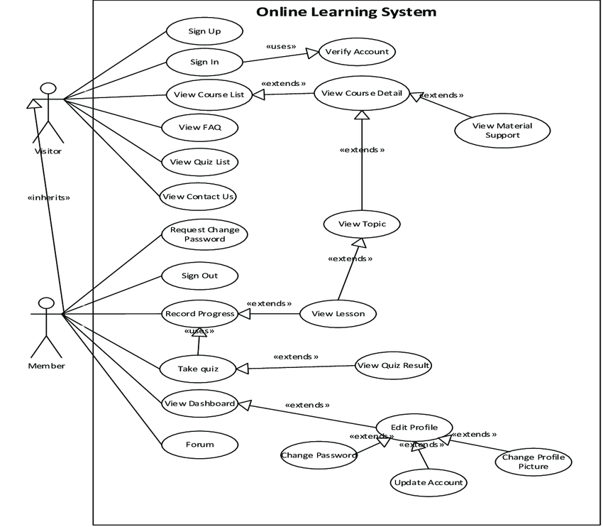

Depicts interactions between Student, Admin, and the System for registration, course management, and exam system.

📌 Class Diagram

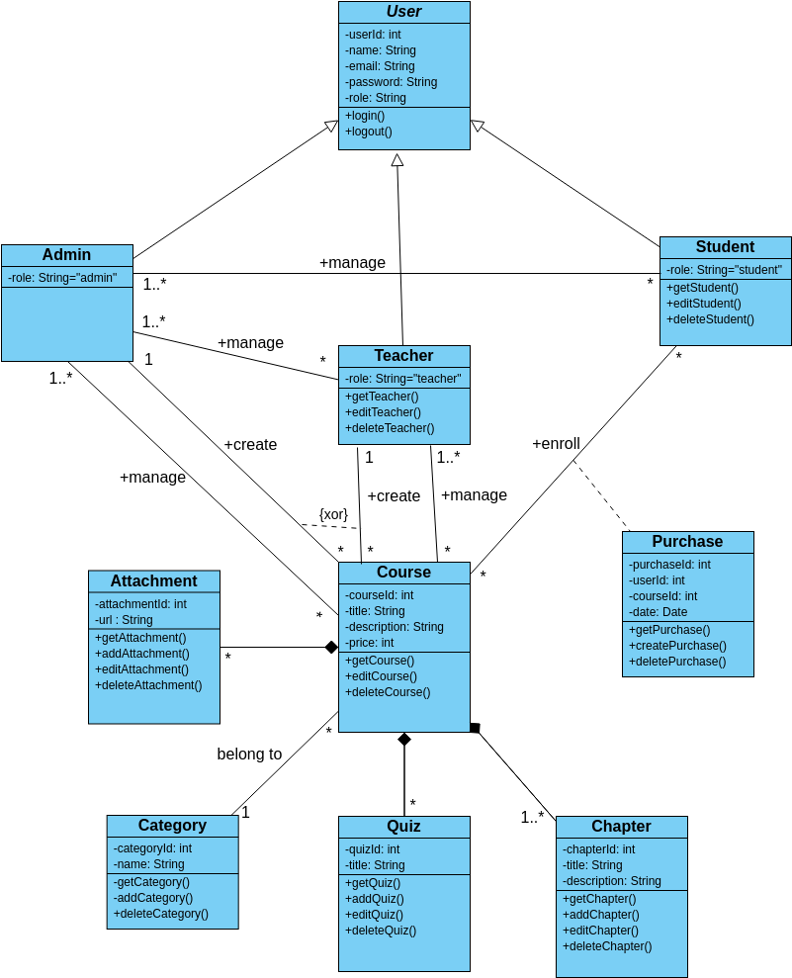

Represents the structure of classes like User, Course, Purchase, Quiz, Chapter and Admin.

📌 Activity Diagram

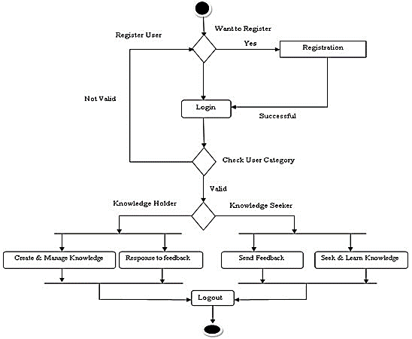

Shows workflow from user registration to learning phase.

**References**

1. Garrison, D. R., & Anderson, T., E-Learning in the 21st Century: A Framework for Research and Practice, 2nd ed. New York, NY, USA: Routledge, 2003.
2. Alghamdi, A., Sandhu, K., & Dall'Angelo, D., “A review of e-learning systems in developing countries,” Education and Information Technologies, vol. 26, pp. 515–538, 2021. doi: 10.1007/s10639-020-10277-7
3. Bernard, R. M., Abrami, P. C., Borokhovski, E., Wade, A., Tamim, R., Surkes, M., & Bethel, E., “A meta-analysis of three types of interaction treatments in distance education,” Review of Educational Research, vol. 79, no. 3, pp. 1243–1289, 2009. doi: 10.3102/0034654309333844
4. Dhawan, S., “Online learning: A panacea in the time of COVID-19 crisis,” Journal of Educational Technology Systems, vol. 49, no. 1, pp. 5–22, 2020. doi: 10.1177/0047239520934018
5. Sun, P.-C., Tsai, R. J., Finger, G., Chen, Y.-Y., & Yeh, D., “What drives a successful e-learning? An empirical investigation of the critical factors influencing learner satisfaction,” Computers & Education, vol. 50, no. 4, pp. 1183–1202, 2008. doi: 10.1016/j.compedu.2006.11.007
6. Brusilovsky, P., “Adaptive hypermedia,” User Modeling and User-Adapted Interaction, vol. 11, nos. 1–2, pp. 87–110, 2001. doi: 10.1023/A:1011143116306
7. Al-Busaidi, K. A., & Al-Shihi, H., “Key factors to instructors’ satisfaction of learning management systems in blended learning,” Journal of Computing in Higher Education, vol. 24, no. 1, pp. 18–39, 2012. doi: 10.1007/s12528-011-9051-x
8. Park, S. Y., “An analysis of the technology acceptance model in understanding university students’ behavioral intention to use e-learning,” Educational Technology & Society, vol. 12, no. 3, pp. 150–162, 2009.
9. Deterding, S., Dixon, D., Khaled, R., & Nacke, L., “From game design elements to gamefulness: Defining ‘gamification’,” in Proc. 15th Int. Acad. MindTrek Conf., Tampere, Finland, 2011, pp. 9–15. doi: 10.1145/2181037.2181040
10. Mayer, R. E., Multimedia Learning, 1st ed. Cambridge, U.K.: Cambridge Univ. Press, 2001.
11. Mitkov, R., Ha, L. A., & Karamanis, N., “Computer-aided generation of multiple-choice tests,” in Proc. HLT-NAACL Workshop on Building Educational Applications Using NLP, Boston, USA, 2006, pp. 17–22.
12. Siemens, G., “Learning analytics: The emergence of a discipline,” American Behavioral Scientist, vol. 57, no. 10, pp. 1380–1400, 2013. doi: 10.1177/0002764213498851
13. Ali, R., & Arshad, M., “Design and implementation of PDF certificate generator for online learning platform,” in Proc. IEEE Int. Conf. Engineering & Emerging Technologies (ICEET), Lahore, Pakistan, 2020. doi: 10.1109/ICEET48479.2020.9048221
14. Alshamari, M., & Mayhew, P. J., “A framework for secure e-learning systems,” ACM Computing Surveys, vol. 54, no. 2, pp. 1–36, 2021. doi: 10.1145/3440833
15. Nielsen, J., “Usability of e-learning platforms: User experience and best practices,” Nielsen Norman Group, 2021. [Online]. Available: https://www.nngroup.com/articles/e-learning-usability/