1D inversion of time-domain electromagnetic data with induced polarization effects for a sea-floor hydrothermal deposit
Masayuki Motoori^{1,2}, Lindsey J. Heagy¹, Gosuke Hoshino², Kunihito Yamamoto², Haruhisa Morozumi², Kunpei Nagase², Shingo Sugimoto²
1 University of British Columbia Geophysical Inversion Facility
2 Japan Organization for Metals and Energy Security (JOGMEC)

Summary
Seafloor hydrothermal deposits are polymetallic massive sulfide ore deposits formed by the precipitation of metal components contained in hot water ejected from the seafloor. The sea depth is 700- 2000m. Ore bodies extend hundreds of meters horizontally and tens of meters vertically. Ore bodies are exposed on the sea floor. Some lab-based petrophysics study indicates that resistivity and chargeability are diagnostic physical properties, even compared with seawater (3.0-3.5 S/m). Time-domain electromagnetic methods (TEM) are sensitive to variations in resistivity. WISTEM (Waseda integrated seafloor time-domain electromagnetic exploration) surveys have been conducted in several areas. Negative transients, which are due to induced polarization effects (IP), have been observed for data collected over known deposits. It is important to understand the system response to invert these data. The pressure vessel (PV), which contains the transmitter and receivers, can impact the data. We use numerical simulations to quantify these effects, and we develop a workflow for estimating a linear filter which captures the effects of the PV. This filter will then be used in subsequent simulations and inversions. Finally, we perform one-dimensional time-domain IP inversion of the field data. The estimated resistivity and IP parameters agree with physical property measurements from the area.

Background
Seafloor hydrothermal deposits are polymetallic massive sulfide ore deposits formed by the precipitation of metal components contained in hot water ejected from the seafloor (JOGMEC, 2020). The depth of the sea in the regions where these deposits are found ranges from 700-2000m. The ore bodies extend hundreds of meters horizontally and tens of meters vertically and are exposed on the sea floor (Morozumi et al., 2020). A lab-based petrophysics study indicates that resistivity and chargeability are diagnostic physical properties, with the hydrothermal deposits expected to be more conductive and more chargeable than seawater and host rock (Nakayama et al., 2012). Time-domain electromagnetic methods (TEM) are sensitive to variations in resistivity. The WISTEM (Waseda integrated seafloor time-domain electromagnetic exploration system) has been proven to be effective, and surveys have been conducted in several areas (Nakayama and Saito, 2016). Some “fixed type” measurements are collected when the WISTEM system is landed on the seafloor. In this type of measurement, negative transients, due to induced polarization effects (IP), have been observed for data collected over known deposits (Nakayama, Motoori, Saito, 2019). The survey we will focus on was conducted by JOGMEC in the Okinawa Trough in 2018. IP effects are particularly relevant when chargeable materials, namely sulfides, are present. Motoori and Heagy (2024) simulated and illustrated field plots about negative transients due to the IP effect, performed a 1D synthetic study and showed sensitivity to all IP parameters.
In order to invert data collected in the field, it is important to understand the system response and be able to simulate it numerically, The WISTEM system utilizes a 3.5-meter square loop for the transmitter loop and a five-turn coincident-type receiver loop. Equipment like the transmitter and the receiver is placed in the center of the loop, and this can affect the data. “Reference measurements” where WISTEM measures at a height of 100m above the seafloor are used for estimating the system response. In this study, we first perform a simulation to study the effect of the pressure vessel using the two-dimensional cylindrical in SimPEG (Cockett, 2015; Heagy, 2017) and simpegEMIP (Kang, 2016). Second, we deconvolve reference data with the analytical response of seawater to obtain a linear filter that captures the system response. This filter will then be used in subsequent simulations and inversions. Finally, we perform a one-dimensional IP inversion using Empymod (Werthmüller, 2017) with the fixed-type data containing negative transients.

Simulating pressure vessel impacts
The transmitter current is a rectangular waveform with a certain ramp time. The amplitude is 120 A, the base frequency is 0.125 Hz, and the duty ratio is 5%, so the on-time is 200 msec. The receiver utilizes 24-bit A/D resolution and a sampling rate of 50 kHz. WISTEM is towed by a Remotely Operated Vehicle (ROV) during the reference measurement. The pressure vessel (PV) is made of aluminum, which is conductive but non-magnetic.
For numerical simulations, we use SimPEG and simpegEMIP, which employ the finite volume method in space and the backward Euler method in time. To describe the IP effects, we refer to the chargeable model in the following Pelton et al. (1978).
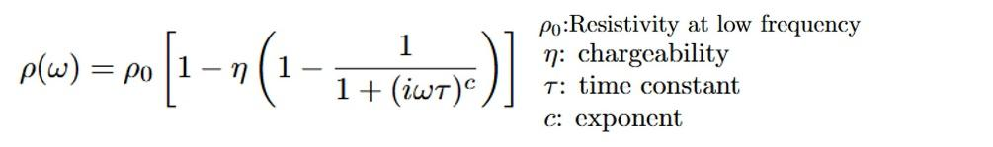
This study aims to test if a linear filter can capture the PV effect. We consider four models: 1) Whole Space Seawater Response, 2) Seawater and PV, 3) Target layer, 4) Target layer with PV. The geometry and physical properties of the PV and target layer are shown in Figure 1. We obtain a linear filter by deconvolving the data obtained from the simulation of model 1 from the data obtained when simulating model 2. Then, we apply the acquired filter to the data from model 3 and compare those to the data from model 4. If the results align well, the linear filter is considered effective. The results and models of our simulations are shown in Figure 1. Figure 1a indicates that the deconvolved linear filter acts as a smoothing filter, representing an additional current waveform that persists after the transmitter. The filter applied to model 3 agrees well with the simulated data for model 4, as shown in Figure 1b. This demonstrates that the deconvolved linear filter captures the PV effect effectively, enabling 1D simulation using the filter.
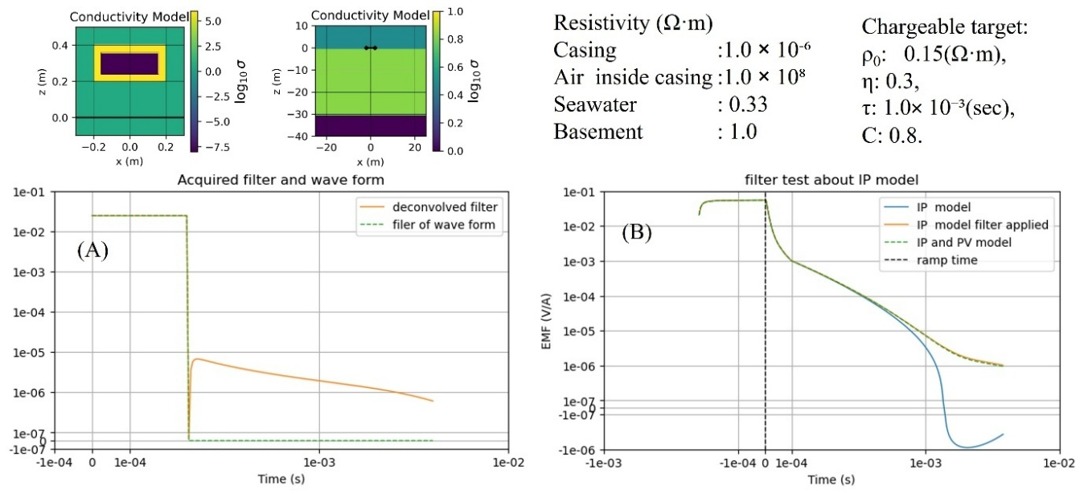
Figure 1 Simulation on Pressure vessel (PV) effect: (A) Acquired filter from models 1 and 2, (B) Test of the filter on model with IP.

Processed Data and Filter Acquisition
Now, we turn our attention to the field data shown in Figure 2. The ramp time is 260 μsec. To estimate the linear filter, we first simulate the step-off response with a 200 kHz sampling rate. We then apply a low-pass filter with a 25 kHz cut-off frequency, which is based on the Nyquist frequency of the A/D converter. Second, we deconvolve a linear filter from reference data. We apply a Tikhonov inversion to stabilize the filter derivation.

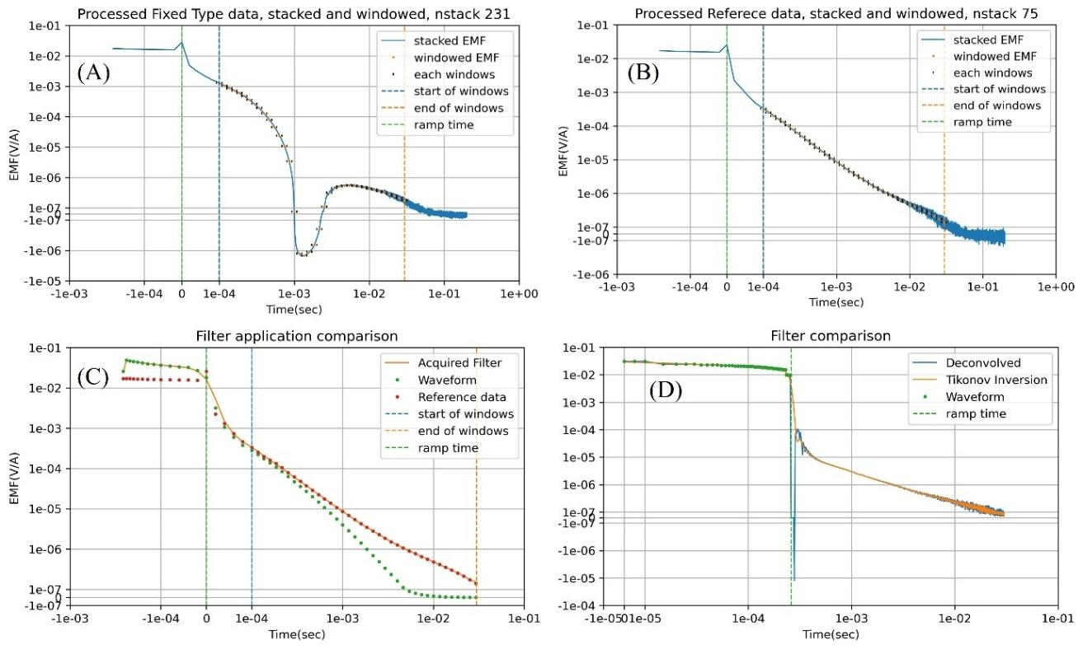
Figure 2 Processed data and filter acquisition. (A) Processed fixed type data, (B) Processed reference measurement data, (C) Comparison between simulations of a whole-space seawater model with the filter applied and the field reference data. (D) Filters acquired using deconvolution and Tikhonov inversion

Both the field data and the data obtained from simulations are averaged using the same windows. The results of our data processing and filter acquisition are shown in Figure 2. The acquired filter appears reasonable when compared with the previous simulations.

1D inversion using the acquired filter
To invert the fixed-type data, we used a five-layer model. Each layer includes four IP parameters. The time constant τ, and the exponent C are assumed to be common across all layers. The seawater layer is fixed at a conductivity value of 0.304 (Ω·m) as measured using the CTD (Conductivity, Temperature, and Depth sensor) attached to the ROV. The inversion is performed using L2 norms for smallness and smoothness regularization terms and Gauss-Newton optimization (Oldenburg and Li, 2005). We use Empymod for the forward simulation. The Jacobian matrix is approximated using finite differences.
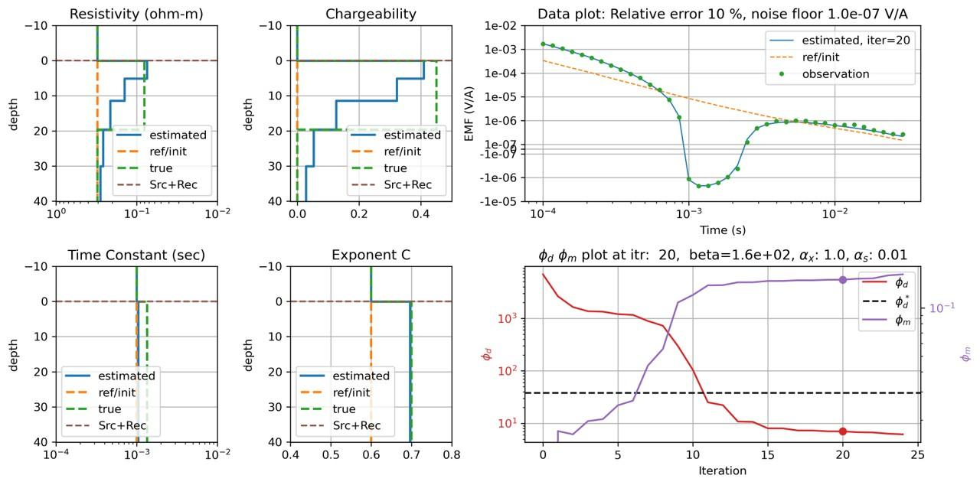
Figure 3 Synthetic Study using the acquired filter.
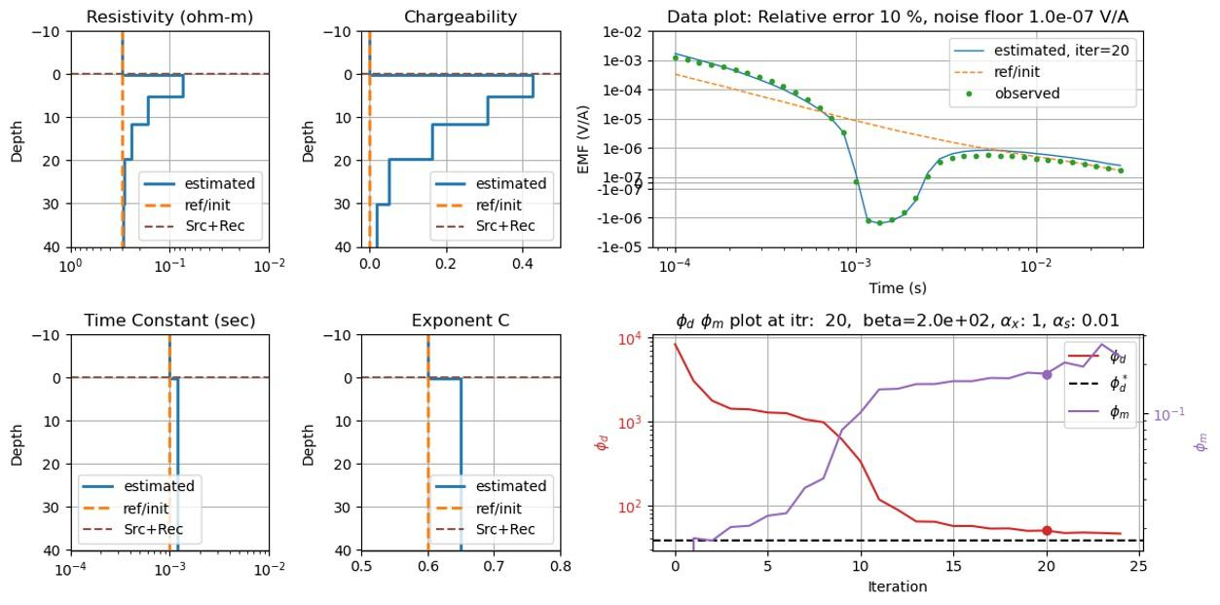
Figure 4 Inversion of fixed-type data collected by WISETEM in 2018 at the Okinawa Trough

To assess what we can expect to recover in the inversion, we first conduct a synthetic study using a chargeable target layer of 20m thickness and with the parameters; ρ₀: 0.08 (Ω·m), η: 0.45, τ: 1.35×10⁻³ (sec), C: 0.7. The results are shown in Figure 3. We can see that there is a low resistivity and high changeability target concentrated in the shallow layers, where the sensitivity is the highest compared to the true model.
We then apply our inversion workflow to the fixed-type data collected with the WISTEM system in 2018. The results are shown in Figure 4. The data are fit adequately, and the model recovers a conductive, chargeable target near the seafloor. The model resembles that obtained in the synthetic study, and the recovered physical property values are within the expected range based upon physical property measurements.

Discussion and Conclusion
We inverted inductive-source marine TEM data that included IP effects. Using deconvolution, we obtained a linear filter which captures the conductive pressure vessel. The inversion successfully recovered IP parameters within the expected ranges from the petrophysics study. Non-uniqueness remains a significant challenge when estimating IP parameters of deep structures. Chargeability has the effect of decreasing resistivity at early times and increasing resistivity at late times, making it difficult to distinguish between conductive shallow layers and resistive deep layers. To address this issue, we plan to investigate strategies for integrating geological and petrophysical information.

Acknowledgements
The field data in this study were collected as part of projects sponsored by the Manufacturing Industries Bureau, Ministry of Economy, Trade and Industry (METI), Japan. We would like to acknowledge Dr. Keiko Nakayama (GeoBless), Dr. Akira Saito (Emeritus Professor at Waseda University) and Dr. Masashi Endo (RedStoneGEO) for their advice on WISTEM.

References
Cockett, R., Kang, S., Heagy, L. J., Pidlisecky, A., & Oldenburg, D. W. (2015). SimPEG: An open source framework for simulation and gradient based parameter estimation in geophysical applications. Computers & Geosciences, 85, 142–154.
Heagy, L. J., Cockett, R., Kang, S., Rosenkjaer, G. K., & Oldenburg, D. W. (2017). A framework for simulation and inversion in electromagnetics. Computers & Geosciences, 107, 1–19.
JOGMEC Conducts World’s First Successful Excavation of Cobalt-Rich Seabed in the Deep Ocean;Excavation Test Seeks to Identify Best Practices to Access Essential Green Technology Ingredients While Minimizing Environmental Impact: News Releases | Japan Organization for Metals and Energy Security (JOGMEC). (n.d.). Retrieved April 3, 2025, from https://www.jogmec.go.jp/english/news/release/news_01_000033.html
Kang, S., & Oldenburg, D. W. (2016). On recovering distributed IP information from inductive source time domain electromagnetic data. Geophysical Journal International, 207(1), 174–196.
MOROZUMI, H., WATANABE, K., SAKURAI, H., HINO, H., KADO, Y., MOTOORI, M., & TENDO, H. (2020). Additional information for characteristics of seafloor hydrothermal deposits investigated by JOGMEC. Shigen-Chishitsu, 70(2), 113–119.
Motoori, M., & Heagy, L. J. (2024). A synthetic study investigating induced polarization effects on time-domain electromagnetic data for Sea-floor hydrothermal deposit. AGU24.
Nakayama, K., Moroori, M., & Saito, A. (2019). Application of Time-Domain Electromagnetic Survey for Seafloor Polymetallic Sulphides in the Okinawa Trough. 25th European Meeting of Environmental and Engineering Geophysics, 1–5.
Nakayama, K., & Saito, A. (2016). Practical marine TDEM systems using ROV for the ocean bottom hydrothermal deposits. 2016 Techno-Ocean (Techno-Ocean), 643–647.
NAKAYAMA, K., YAMASHITA, Y., YASUI, M., YAMAZAKI, A., & Akira, S. (2012). Electric and magnetic properties of the sea-floor hydrothermal mineral ore deposits for the marine EM explorations. Proceedings of the SEGJ Conference, 126, 162–165.
Oldenburg, D. W., & Li, Y. (2005). Inversion for Applied Geophysics: A Tutorial. In Near-Surface Geophysics. Society of Exploration Geophysicists.
Pelton, W. H., Ward, S. H., Hallof, P. G., Sill, W. R., & Nelson, P. H. (1978). MINERAL DISCRIMINATION AND REMOVAL OF INDUCTIVE COUPLING WITH MULTIFREQUENCY IP. GEOPHYSICS, 43(3), 588–609.
Werthmüller, D. (2017). An open-source full 3D electromagnetic modeler for 1D VTI media in Python: Empymod. GEOPHYSICS, 82(6), WB9–WB19.

