
CONFIDENTIAL 27 Aug 2026

TECHNICAL ARCHITECTURE DOCUMENT
LinkedERP AI Development Agent
AI-Assisted Odoo Development Platform
Version 1.10 technical architecture for an AI development platform that connects to LinkedERP and Odoo projects, on a TypeScript-centred, provider-agnostic and self-hostable technology stack with a data-sovereignty and zero-trust data-access model. This version records six decisions taken since v1.9 — an ephemeral UI preview before approval, an approved chat write that lands like a change task, per-client backups now built with a pre-push restore point, a per-project on-host-models-only flag, module selection at project creation (proposed, not yet accepted), and an admin-run action that promotes a reviewed staging branch onto main and restarts the live instance.

CLIENT | PREPARED BY | VERSION
Linked ERP (Pty) Ltd | Muhammad Bintang | 1.10
 | Product Owner / Senior Engineer

§ 00 · METADATA

Revision History
Every published version of this document has a row below.
DATE | VERSION | UPDATE DESCRIPTION | AUTHOR
27 Aug 2026 | 1.0 | Initial draft issued for architectural review. | Bintang
27 Aug 2026 | 1.1 | Added the Data Sovereignty and Zero-Trust Data Access chapter and granular database permissions. | Bintang
27 Aug 2026 | 1.2 | Re-based the technology stack on a TypeScript, provider-agnostic, self-hostable set of frameworks (Next.js, NestJS, Vercel AI SDK, Temporal, Firecracker) per the Framework and Technology Selection record; upgraded workspace isolation to microVMs. | Bintang
14 Sep 2026 | 1.3 | Reconciled the architecture with the delivered implementation. Added the execution-modes chapter (Odoo.sh, on-premise, Odoo Online) and the project creation and provisioning capability; recorded the deferral of Temporal, Firecracker, Vault and Keycloak behind their abstractions; corrected the task state machine to thirteen states; and added the implementation-status and decision-register chapter. | Bintang
16 Sep 2026 | 1.4 | Added the Client Estate Architecture chapter: the two hosting relationships (connected server and linked hosted server), the per-client layout on a hosting server and in version control, region and per-project access, and the target architecture for independent backup and restore, monitoring and server administration — each marked with its implementation status. | Bintang
16 Sep 2026 | 1.5 | Added "How the Database Boundary Is Enforced, by Execution Mode" to the data sovereignty chapter, naming the file and mechanism for each mode: no database tool exists for odoo_sh or on_premise; validation runs against a freshly created scratch database, never a copy; odoo_online is restricted to a closed, code-enforced allow-list of three schema models. Corrected the on-premise data residency paragraph, which still described the deferred Phase 6 connector rather than the in-place mode actually delivered (ADR-028). | Bintang
16 Sep 2026 | 1.6 | Added ADR-042 through ADR-046 to the decision register: image attachments with paste-into-chat, per-project access control with a request-and-approve flow, the region-scoped deployment with portal user administration, the centralised Odoo version catalog with full-installation template databases, and conversation-based workspace history (sessions, not individual requests). Updated the agent workspace route and the MVP scope to the conversation model. | Bintang
16 Sep 2026 | 1.7 | Reconciled the document with ADR-044: the organisation is gone, replaced by a region enumeration and a flat admin flag. Corrected "per organisation" language throughout — model configuration, Odoo settings, the data entity table, the security chapter, the API design chapter, the repository layout and the MVP scope. Added the ADR-044 decision and split ADR-046 (a task works on the chosen branch) from ADR-047 (the workspace history lists conversations), which v1.6 had listed as one entry under ADR-046. Added the image-attachment caveat to the database-boundary table. | Bintang
17 Sep 2026 | 1.8 | Expanded § 18 with the connected-server replica and standard-database catalog (ADR-050, ADR-051); replaced the maintenance chapter with an explicit administration plan for a linked hosted server — the connection mechanism, a cadence/tooling/status table for every admin task, and the security baseline — answering the operator’s request for item 3 in full. Added a development-architecture subsection (repository layout, branch policy). Replaced the implementation-status table with the fuller nine-item operator request register. Added ADR-048 through ADR-051 to the decision register. | Bintang
17 Sep 2026 | 1.9 | Strengthened the opening warning of § 13 (Data Sovereignty and Zero-Trust Data Access) into an explicit, two-part statement of the transaction-data guarantee, naming the three independent mechanisms that enforce it. No new table or figure; no renumbering required. | Bintang
19 Sep 2026 | 1.10 | Added ADR-052 through ADR-057 to the decision register: ephemeral preview instances reconstructed from a task's retained diff; an approved chat write committing and pushing like a change task; per-client backups (database, filestore and addons bundle) taken automatically before a staging or main push, with a failing backup blocking the push; a per-project “on-host models only” flag narrowing a single project's model chain to loopback providers; module selection at project creation, installing only the chosen apps instead of always cloning the full template (proposed, not yet accepted); and an admin-run action that merges staging into main and restarts the served instance with a module upgrade, rolling back the code on a failed upgrade. Updated § 18's Independent Backup and Restore section from target architecture to delivered state, added the promotion-and-restart and preview-instance subsections, and updated the operator's nine-item request register and the administration task table against what is now built. | Bintang
§ 01 · NAVIGATION

Table of Contents
Revision History 1
Table of Contents 4
Introduction 6
Architecture Goals 6
High-Level Architecture 7
Core Components 7
Frontend Architecture 9
Principal Pages 9
Backend Architecture 10
AI Agent Architecture 11
Agent State Machine 11
Tool Execution Layer 12
Repository Tools 12
Git Tools 12
Odoo Tools 12
Validation Tools 12
Tools Withheld from the Model 12
Process Execution Chokepoint 12
Workspace Architecture 13
Execution Modes 13
Module Selection at Project Creation 14
Background Workers and Realtime 16
Realtime Updates 16
Data Architecture 17
Security, Permissions and Approvals 19
Authentication and Authorisation 19
Project Roles 19
Agent Permissions 19
Approval Architecture 20
Secret Management 20
Security Model 20
Data Sovereignty and Zero-Trust Data Access 21
Customer Data Sovereignty Principle 21
Default Posture: Data-Blind Agent 21
Metadata Access versus Record Access 22
Exceptional Debugging with Sanitisation 22
No Storage of Production Data 22
Project Memory Boundary 23
How the Database Boundary Is Enforced, by Execution Mode 23
AI Provider Data Boundary 24
Isolated Test Databases 24
Data Residency for On-Premise 24
Encryption and Key Custody 24
Granular Data Permission Model 25
Integrations 26
Git Integration 26
Odoo.sh Integration 26
On-Premise Connector 26
Odoo Online Integration 26
Logging and Observability 27
API Design 28
Create Agent Task 28
Agent Event Format 28
Deployment Architecture 29
Repository Structure 29
Client Estate Architecture 29
Two Hosting Relationships 30
The Per-Client Estate on a Hosting Server 30
Connected-Server Replica and the Standard Database Catalog 31
The Per-Client Estate in Version Control 31
Development Architecture 32
Region, Access Rights and Separation 32
Independent Backup and Restore 32
Promoting Staging to Main, and Restarting the Instance 33
Ephemeral Preview Instances Before Approval 33
Connection Between the Platform and a Linked Hosted Server 33
On-Premise (Connected) Server: Administration Plan 34
Implementation Status of This Chapter 36
Scope and Roadmap 38
In Scope for the MVP 38
Out of Scope for the MVP 38
Development Phases 38
Recommended Technology Stack 40
Implementation Status and Decision Register 41
Architectural Principles and Success Criteria 44
Definition of Success 44
Next Step 44
Acronyms and Abbreviations 45
Legal Notice 47

§ 02 · INTRODUCTION

Introduction
This document defines the initial technical architecture — version 1 — for the LinkedERP AI Development Agent. The platform allows users to connect their LinkedERP and Odoo projects and interact with an AI agent in natural language. The agent inspects a project, understands its codebase, modifies code, runs validation and tests, creates Git commits, pushes changes and triggers supported build or deployment workflows.
The architecture supports three environment types — Odoo.sh, on-premise Odoo, and Odoo Online — which this version formalises as three execution modes, each with its own adapter. The initial Minimum Viable Product focused on Git-based Odoo projects, in particular those hosted through Odoo.sh or standard Git repositories; the platform now also creates projects of its own. This document describes the intended target architecture, and, where the delivered implementation differs from it, says so and names the decision record that governs the difference. Version 1.2 adopted a TypeScript-centred, provider-agnostic and self-hostable technology stack per the Framework and Technology Selection decision record; this version, 1.3, keeps that stack and reconciles the document with what has been built.

Architecture Goals
The architecture is required to support the following goals:
- Multi-project and multi-user support.
- Secure project isolation.
- AI-powered code modification through controlled tools.
- Repository access and management, with Git branch isolation.
- Long-running AI tasks with real-time task updates.
- Human approval workflows for high-risk actions.
- Comprehensive audit logging.
- Secure credential management.
- Future support for on-premise environments and Odoo Online.
§ 03 · HIGH-LEVEL ARCHITECTURE

High-Level Architecture
The platform is a web-based system composed of a Next.js front end, a NestJS back end, a PostgreSQL database, a Redis cache and queue, a secret store, and an asynchronous AI worker that executes agent tasks inside isolated workspaces. The user interacts with the web application, which communicates with the API over REST and WebSocket; the API persists state and enqueues long-running work, which the AI worker executes against a per-task isolated workspace, as illustrated in Figure 1.
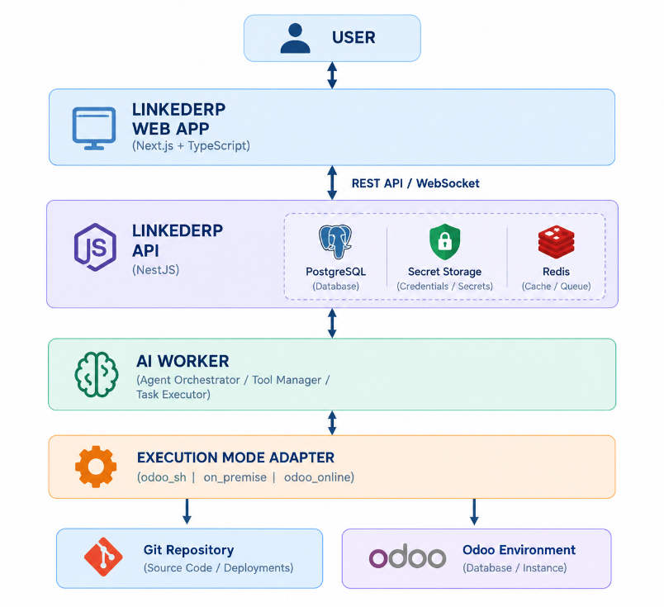
Figure 1: High-level platform architecture.

Core Components
The platform comprises the components set out in Table 1. The separation allows security, isolation, permissions and infrastructure concerns to be governed independently of the AI reasoning layer.
COMPONENT | RESPONSIBILITY
Web Application | User-facing interface for projects, agent workspace, tasks and approvals
API Backend | Request handling, state persistence and task orchestration
Authentication and Authorisation | Identity, tokens and permission enforcement
Project Management Service | Project, connection and environment configuration
AI Agent Orchestrator | Drives the understand, plan, tool-execution and validation loop
Tool Execution Layer | Mediates all agent access to repositories, Git, Odoo and the environment
Workspace Manager | Creates and destroys isolated per-task workspaces
Background Worker System | Executes long-running AI and validation tasks asynchronously
Database | Persistent store for users, projects, tasks, actions and audit records
Realtime Communication | Streams agent activity to the front end
Git Integration | Repository connection, cloning, branching and pushing
Odoo Integration | Version detection, module operations and shell access
On-Premise Connector | Secure outbound bridge to a customer server
Audit and Logging System | Records all actions and system events
Secret Management | Encrypted storage and controlled release of credentials
Execution Mode Adapters | Bind a project to one of three execution modes and decide how a task operates
Model Provider Abstraction | Binds the model configured for the deployment behind a single interface
AI Data Boundary | Filters every byte sent to and received from a model provider, in both directions
Process Execution Chokepoint | The single place a child process may be started, by argument vector and never a shell
Validation Runtime | Runs a real Odoo test suite against a scratch database created and dropped per task
Project Provisioning Service | Creates a running Odoo instance through the operator’s own scripts
Document Store | Holds a project’s specification documents as extracted text
Table 1: Core platform components.
§ 04 · FRONTEND ARCHITECTURE

Frontend Architecture
The front end is built with Next.js and TypeScript on React, and is responsible for the user-facing interface. It is organised into route-based application modules, reusable components, service clients for the API, WebSocket and authentication, and shared type definitions.
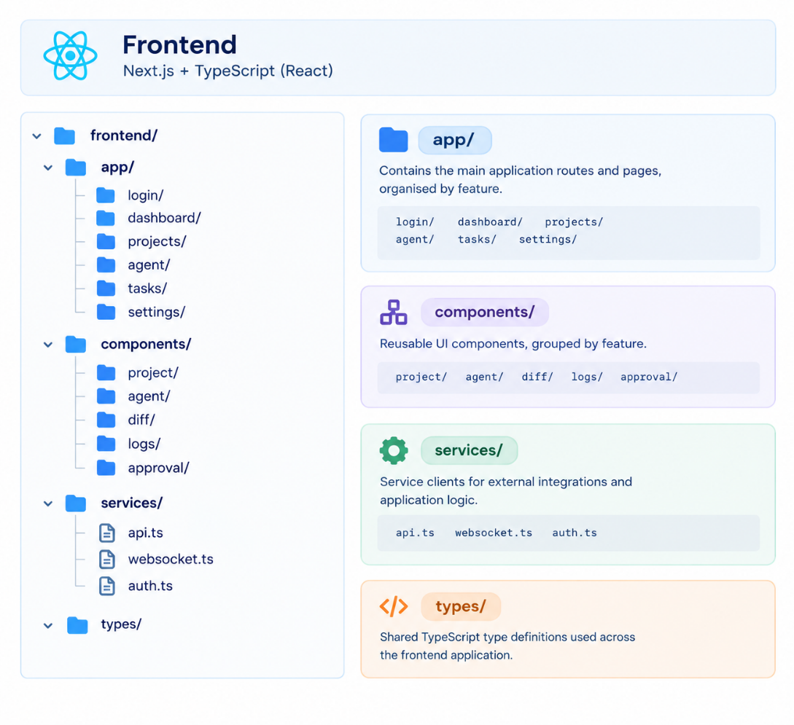

Principal Pages
The principal pages and their content are summarised in Table 2. The agent workspace is the central working surface.
ROUTE | PURPOSE
/login, /register, /forgot-password | Authentication
/dashboard | User projects, active AI tasks, recent activity, build status and failed tasks
/projects/{project_id} | Project information, repository details, Odoo version, connected environment, recent tasks and build status
/projects/{project_id}/agent | AI agent workspace: conversation list, thread of requests and answers, plan and diff review before approval, task inspection
Table 2: Principal front-end pages.
The agent workspace presents the project context alongside the AI chat, the agent activity stream, tool executions, file changes, the Git diff and any pending approval requests, so that the user can follow and steer the agent's work in one place.
§ 05 · BACKEND ARCHITECTURE

Backend Architecture
The back end is built with NestJS on TypeScript, keeping a single language across the portal, API and agent layers. It is organised into feature modules for authentication, projects, the agent, tasks and approvals, a core layer for configuration, security and database access, data models and schemas, domain services, the agent implementation, the tool implementations and the worker entry points. NestJS's dependency injection, guards and interceptors carry the permission-enforcement and audit logic.
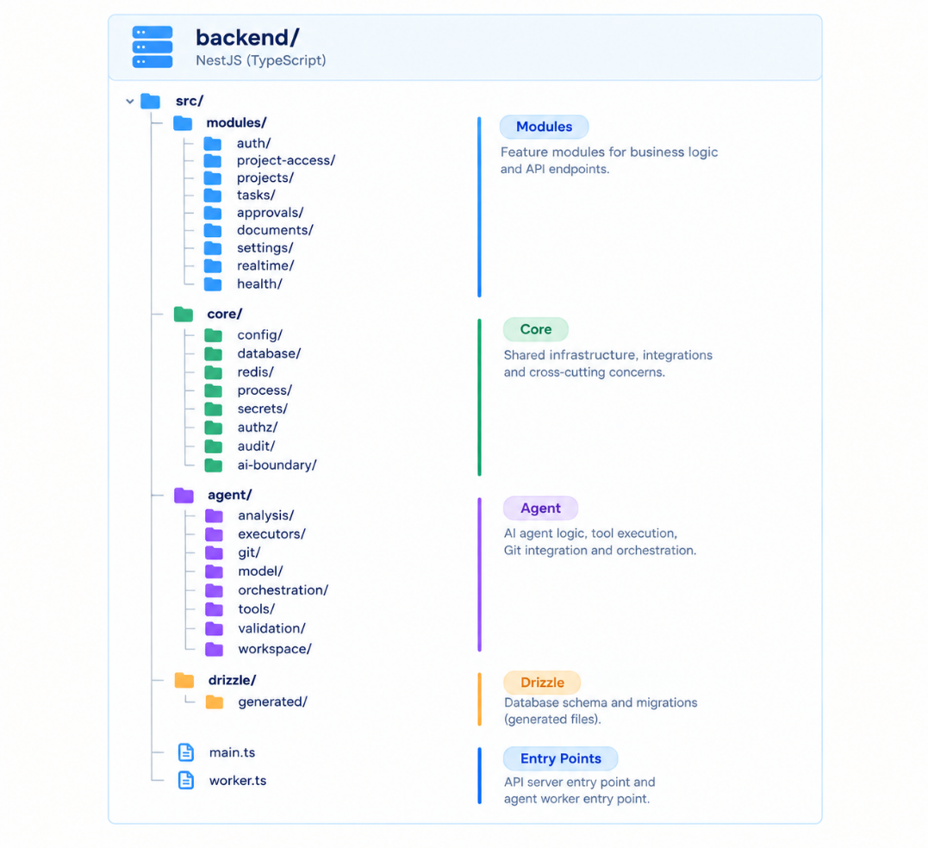
The API layer does not perform long-running AI work directly. Instead, an incoming request creates a task record and enqueues a durable job; a worker executes the agent workflow asynchronously, keeping the API responsive. Orchestration sits behind an AgentOrchestrator interface so that the durable-execution engine is an implementation detail: Redis and BullMQ drive it today and Temporal remains the target (ADR-011).
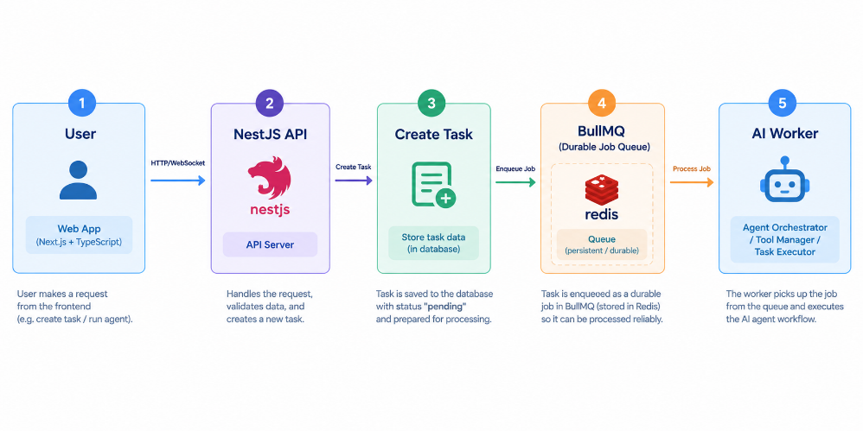
§ 06 · AI AGENT ARCHITECTURE

AI Agent Architecture
The AI agent is the core of the platform. It does not execute arbitrary code directly; it operates through controlled tools. The agent proceeds in a loop: it understands the request, loads the project context, creates a plan, selects a tool, executes it through the tool layer, analyses the result, and repeats until the task is complete.
User Prompt -> Understand -> Project Context -> Create Plan
-> Select Tool -> Execute Tool -> Analyse Result -> (repeat)
Figure 2: AI agent reasoning loop.

Agent State Machine
Each AI task follows a defined lifecycle. A task moves from creation through analysis, planning and — where required — an approval wait, into implementation, validation, commit, push and build, before completion. A failure during validation returns the task to the failed state for review, as shown in Figure 3.
CREATED -> ANALYZING -> PLANNING -> WAITING_FOR_APPROVAL -> IMPLEMENTING
-> VALIDATING --(failure)--> FAILED
-> COMMITTING -> PUSHING -> BUILDING -> COMPLETED
Figure 3: AI task state machine.
The permitted task states are thirteen: created, queued, analyzing, planning, waiting_approval, implementing, testing, committing, pushing, building, completed, failed and cancelled. The chapter 6 prose and the chapter 6 diagram disagreed on this list; the thirteen-state enumeration reconciles them, and every transition is asserted centrally rather than assumed by the caller (ADR-018).
The lifecycle is implemented as a durable workflow behind the orchestration abstraction, so that each state transition is persisted and the wait for approval suspends and resumes reliably. Temporal is the target engine and is deferred; the delivered implementation uses BullMQ with an explicit, centrally asserted state machine, and the audit trail is produced by the transition assertions rather than by deterministic replay (ADR-011, ADR-018). The agent reaches models through a provider-agnostic abstraction — the Vercel AI SDK — so that the hosted or self-hosted model may be selected for the whole deployment without changing the agent logic (ADR-020, ADR-023).
§ 07 · TOOL EXECUTION LAYER

Tool Execution Layer
The agent interacts with projects exclusively through tools. The AI model never directly accesses the server shell, the database, the filesystem, SSH or Git credentials. Every tool request passes through a permission validator before a tool executor carries it out against the project environment.
AI Agent -> Tool Request -> Tool Permission Validator -> Tool Executor -> Project Environment
INFO | The AI model requests actions; the platform validates and executes them. This boundary is the central security property of the architecture.

Repository Tools
list_directory, search_code, read_file, create_file, edit_file, update_file and delete_file. A request such as read_file for a model path is checked by the permission validator before the workspace returns the result. edit_file replaces one exactly quoted region and is the ordinary way to change a file; update_file rewrites a whole file, refuses a rewrite that would discard most of a substantial one, and is named a last resort (ADR-022).

Git Tools
git_status, git_diff, git_branch, git_checkout, git_pull, git_commit and git_push.

Odoo Tools
detect_odoo_version, list_modules, upgrade_module, install_module, run_odoo_shell and check_registry.

Validation Tools
run_python_test, run_odoo_test, run_linter, run_module_upgrade and check_logs.

Tools Withheld from the Model
Not every tool the platform implements is offered to the model. git_commit, git_push, git_branch and the validation tools are marked as unavailable to the model, so the model cannot commit or publish work before a person has reviewed it. The tool registry is the single catalogue, and it is tested to assert that no shell tool of any kind exists in it.

Process Execution Chokepoint
Beneath the tool layer there is one place a child process may be started. It accepts an argument vector and never a shell string, so no argument can be interpreted as a command, and it starts only three executables: git, python3 and sudo. The last two are refused outright unless their setting is enabled — python3 unless validation is enabled, and then only an odoo-bin inside a registered runtime; sudo unless provisioning is enabled, and then only the operator’s own scripts with a validated argument shape. git push is refused at this layer unless pushing is enabled, which makes the guarantee a property of the system rather than of how one tool happens to be written: no permission and no approval can reach past it (ADR-019, ADR-021, ADR-027, ADR-039).
§ 08 · WORKSPACE ARCHITECTURE

Workspace Architecture
Every AI task runs inside an isolated workspace. The workspace manager creates the workspace, clones the repository, creates the AI branch, runs the agent execution and validation, commits and pushes the result, and finally destroys the workspace. Isolation per task limits the blast radius of any single operation.
Task Created -> Workspace Manager -> Create Workspace -> Clone Repository
-> Create AI Branch -> AI Execution -> Validation
-> Commit / Push -> Destroy Workspace
A workspace holds the working copy, a logs directory and task metadata. Because each task executes code that must be treated as untrusted, the target isolation is a hardware-isolated Firecracker microVM, deployed through Kata Containers where the platform runs on Kubernetes, rather than a plain shared-kernel container. That boundary is deferred, and until it exists the platform does not rely on it: repository operations execute platform code against untrusted data rather than the repository’s own code, which is a different risk and is controlled differently (ADR-013, ADR-019). What bounds a task today is the process chokepoint described above, path containment that resolves every path through realpath before use so that a symbolic link cannot reach outside the permitted tree, read-only roots over shared Odoo source, and a workspace quota.
WARNING | Plain containers share the host kernel and are unsafe for untrusted code. Firecracker microVMs, or Kata Containers on Kubernetes, remain the target isolation boundary and are deferred (ADR-013). Until they exist, no capability that would execute a repository’s own code is enabled by default, and each such capability has its own switch at the process layer.
/workspaces/task-9281/
repository/
logs/
metadata/
§ 09 · EXECUTION MODES

Execution Modes
The architecture supports three environment types, and this version formalises them as three execution modes, each behind its own adapter. A project type records where a project came from; an execution mode records how a task on that project actually operates. The two are separate questions, and conflating them was the source of real defects, so one mapping decides the mode and no tool, workflow or validator answers the question a second time (ADR-028).
MODE | THE AGENT WORKS ON | GIT | FILESYSTEM
odoo_sh | A platform-managed per-task clone, released with the run | Managed by the platform; pushes to the connected remote | The workspace only
on_premise | The selected local directory, in place, with no clone | The directory’s own repository | That directory, with shared Odoo source mounted read-only
odoo_online | The Odoo instance, through Studio and supported APIs | None | None
Table 3: The three execution modes.
Two project types share the odoo_sh mode: a generic Git repository and an Odoo.sh project differ on branch policy and build monitoring rather than on which tools are legal. A project created by the platform from a specification has no execution mode until it is given a local directory, after which it runs on-premise like any other local project (ADR-036).
The on-premise mode operates in place rather than through a clone, and this is the consequential difference between the three. A change that lands only in a throwaway workspace lands nowhere the customer can use it, so where the platform is installed on the host that already runs the customer’s Odoo, the agent works the directory the customer actually serves. That moves the safety argument rather than weakening it: nothing is bounded by discarding the workspace afterwards, so the bound is path containment resolved through realpath, read-only roots over the shared Odoo and enterprise source, and the process chokepoint. Allocation refuses unless a root is configured, the selected path resolves inside it, and that path is a Git repository.
Beyond connecting to an existing project, the platform can create one: it scaffolds the module layout and a Git repository with a branch per environment, optionally provisions a running Odoo instance through the operator’s own scripts and issues a certificate for it, and optionally creates the remote repository its pushes land in. Each of those steps is off by default and enabled per deployment (ADR-032 to ADR-041).

Module Selection at Project Creation
By default, creating a project still clones the full-installation template for the chosen version and edition (§ 18, ADR-045) — every application installed, ready in seconds. ADR-056 adds the alternative: a person creating a project may instead choose which applications to install. The creation form reads a module catalogue built from the real Odoo manifests for the chosen version and edition, resolves the dependency closure of whatever is checked, and passes a sanitised, validated module list to provisioning, which runs a selective odoo-bin -i install against a base-only template rather than the full-installation one. Because an arbitrary module install can run past the safe foreground call budget, the selective path runs asynchronously on the existing provisioning queue, the shape the agent task pipeline already uses for long-running work, and the portal polls it the same way. The default path — no selection made — is unaffected: same template, same instant clone. The one root-run addition is list-installed-modules.sh, an eighth fixed shape in the provisioning allow-list, a single read-only SELECT name, state FROM ir_module_module against exactly the database a project's own odoo.conf names — the narrow alternative to giving the platform a database connection of its own, which it does not have. The decision is recorded as Accepted: the code implementing it has landed, catalogue endpoint, dependency resolver, sanitiser, base-only template and selective-install path included. Until 19 September 2026 the ADR file and the index both still read Proposed, lagging the implementation; that stale status is corrected as part of this revision — see § 21 and the overlap audit in docs/adr/overlap-audit-2026-09-19.md.
§ 10 · WORKERS AND REALTIME

Background Workers and Realtime
AI tasks and Odoo tests may take several minutes and include an explicit wait for human approval, so execution is asynchronous and durable. The task lifecycle runs behind the orchestration abstraction; Redis provides job queuing through BullMQ and the publish-and-subscribe channel for realtime events, and the suspend-and-resume of an approval is implemented by persisting the task state and resuming from it. Temporal remains the target engine (ADR-011).
NestJS API -> Durable Job (BullMQ) -> Worker -> AI Agent
Worker responsibilities include executing AI tasks, creating workspaces, cloning repositories, running agent workflows, executing tests, monitoring builds and publishing task events.

Realtime Updates
The user sees agent activity in real time. The worker publishes events to a Redis publish and subscribe channel, which the NestJS WebSocket layer relays to the Next.js front end. Each task has its own event stream, for example task:{task_id}:events.
AI Worker -> Event Publisher -> Redis Pub/Sub -> NestJS WebSocket -> Next.js
§ 11 · DATA ARCHITECTURE

Data Architecture
The persistent store is PostgreSQL, accessed through the Drizzle ORM with typed migrations. The principal entities and their key fields are set out in Table 4; the controlled enumerations are set out in Table 5. The project type enumeration is wider than the three environment types, because a project type records where a project came from while an execution mode records how a task on it operates, and the two are not the same question (ADR-017, ADR-028).
ENTITY | PRINCIPAL FIELDS
users | id, email, password_hash, name, region, is_admin, created_at, updated_at
projects | id, region, name, description, project_type, odoo_version, default_branch, timestamps
project_connections | id, project_id, connection_type, encrypted_credentials, status, timestamps
agent_sessions | id, project_id, user_id, started_at, ended_at
agent_tasks | id, project_id, session_id, prompt, status, branch, commit_hash, timestamps
agent_actions | id, task_id, action_type, tool_name, input, output, status, created_at
approvals | id, task_id, action, status, requested_at, approved_at, approved_by
audit_logs | id, project_id, user_id, event_type, metadata, created_at
model_settings | id, priority, label, enabled, provider_id, model, secret_ref, timestamps
odoo_settings | id, base_path, enterprise_path, projects_root, updated_by_user_id, timestamps
project_environments | id, project_id, name, kind, branch, is_default, timestamps
project_specifications | id, project_id, content, created_at
project_documents | id, project_id, filename, media_type, extracted_text, created_at
project_memory | id, project_id, key, value, updated_at
agent_task_events | id, task_id, type, status, message, created_at
agent_model_calls | id, task_id, provider, model, tokens, steps, redactions, created_at
agent_workspaces | id, task_id, path, mode, bytes_used, released_at
secret_records | id, project_id, reference, ciphertext, created_at
secret_data_keys | id, wrapped_key, created_at
refresh_tokens | id, user_id, token_hash, expires_at, revoked_at
Table 4: Principal data entities.
FIELD | PERMITTED VALUES
project_type | repository, odoo_sh, on_premise, odoo_online, ai_project
connection_type | github, gitlab, odoo_sh, odoo_api, connector
approval status | pending, approved, rejected
task status | created, queued, analyzing, planning, waiting_approval, implementing, testing, committing, pushing, building, completed, failed, cancelled
execution mode | odoo_online, odoo_sh, on_premise
task kind | change, chat
environment kind | production, staging, development
odoo edition | community, enterprise
credential kind | token, ssh_key
model provider | mock, anthropic, openai-compatible
Table 5: Controlled enumerations.
§ 12 · SECURITY AND PERMISSIONS

Security, Permissions and Approvals
Access control is layered from region and the admin flag down to the individual tool, and is complemented by an approval system, secret management and an overarching security principle that separates AI decision-making from execution.

Authentication and Authorisation
The initial system supports email and password sign-in with JWT access and refresh tokens. Authentication sits behind its own seam so that an external identity provider — Keycloak or Ory — can be adopted without changing the call sites; that adoption, and third-party OAuth sign-in, are deferred (ADR-015). A request is authenticated, then authorised in turn against region, project, environment and tool permissions, through one centralised authorisation layer.
User -> Authentication -> Access Token -> API
-> Organisation Permission -> Project Permission -> Action Permission

Project Roles
ROLE | ACCESS
Owner | Full project control
Admin | Manage project configuration and agent permissions
Developer | Create AI tasks and approve development actions
Viewer | Read-only access
Table 6: Project roles.

Agent Permissions
Agent permissions are configured per project and are independent of user roles. They determine which categories of action the agent may take, for example:
{
"repository_read": true,
"repository_write": true,
"git_commit": true,
"git_push": true,
"run_tests": true,
"database_metadata_read": true,
"database_record_read": false,
"database_export": false,
"restart_odoo": false,
"production_deploy": false
}
The database flags in the example reflect the default posture defined in the Data Sovereignty chapter: metadata may be read, but record access and export are disabled unless explicitly and granularly enabled.

Approval Architecture
Certain actions require human approval — for example a push to production, a production deployment, a database migration, a restart of a production service, or file deletion. When the agent requests a restricted action, the permission engine pauses the task until a user approves it, after which the task resumes.
AI Agent -> Restricted Action -> Permission Engine -> Approval Required
-> Task Paused -> User Approves -> Task Resumes
Two approval-adjacent behaviours were clarified after v1.9. First, an approved chat write no longer stops at a retained diff: once a conversational task's edit is approved, it proceeds through the same commit and push handling a change task's implementation already uses — the model still never commits or pushes itself, and the tools remain unavailable to it; what changed is that the platform now acts on an approval it previously only recorded (ADR-053). Second, promoting a project's staging branch onto main is its own named, admin-gated action — distinct from, and not a side effect of, any task's own push approval — audited as PROJECT_MERGED_TO_MAIN and refused outright unless the project has a repository and a staging environment (ADR-057).

Secret Management
API keys, passwords, Git tokens, OAuth tokens, connector credentials and deployment credentials are treated as secrets. Secrets are never stored directly in ordinary database fields; the application database holds only secret references, while the secret store holds the encrypted secret. The store sits behind a SecretsProvider interface: HashiCorp Vault is the target and is deferred, and the delivered implementation is envelope encryption with AES-256-GCM, in which each secret is sealed under its own data key and that key is wrapped by a root key held only in the deployment’s configuration (ADR-014). A credential is sealed on arrival and is returned by no endpoint: the response shapes the browser receives carry no field that could hold one.
Project -> Secret Reference -> Secret Manager -> Encrypted Secret

Security Model
The platform follows the principle that the AI can request actions, but the system controls execution. Each AI decision becomes a tool request that passes through permission, policy and approval checks before execution. The AI model never receives unrestricted SSH credentials, root passwords, database passwords or raw production secrets.
WARNING | The AI model is never given unrestricted SSH, root, database or production secrets. It requests actions; the platform decides and executes.
§ 13 · DATA SOVEREIGNTY AND ZERO-TRUST DATA ACCESS

Data Sovereignty and Zero-Trust Data Access
Encryption on its own is not a sufficient data-protection control. The architecture distinguishes four separate questions: whether the agent may access data at all; whether data may leave the customer environment; whether data may be stored; and who holds the encryption key. LinkedERP answers these through a data-minimisation and zero-trust data posture, in which the agent is code-aware but data-blind by default.
WARNING | TRANSACTION DATA NEVER REACHES AN AI MODEL. For every connected Odoo project — whichever execution mode it runs in — no tool available to the agent can open a database connection or read a business record. This is not a setting left off; the capability is absent from the tool registry itself.
WARNING | Enforced three separate ways, not one: (1) no tool that reads a database record exists for a repository-backed or on-premise project — the agent works on source files only; (2) an Odoo Online connection is restricted by a hard, code-checked allow-list to schema and view customisation — ir.model, ir.model.fields, ir.ui.view — and every other model, including every business model, is refused before the request leaves the platform; (3) the AI data boundary refuses, rather than merely redacts, any content shaped like a database export before it can reach a provider. See Table 8 for the mechanism named per execution mode.

Customer Data Sovereignty Principle
The platform must not copy, export, store or retain customer production database data by default. Production database access is disabled by default and may be enabled only through granular, explicit permission. When database information is genuinely required, the system prefers metadata, aggregation, anonymisation or sanitisation before any information leaves the customer environment. Source code and metadata are within the agent's reach; production data is not.
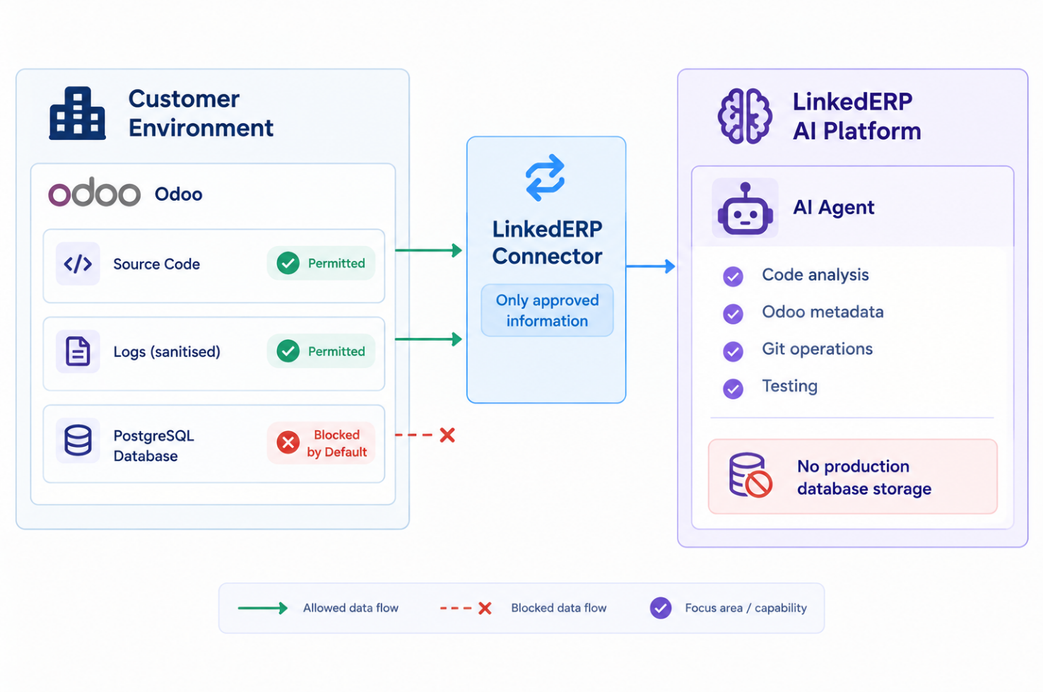
Figure 4: Customer data boundary — the production database is blocked by default.

Default Posture: Data-Blind Agent
By default the agent may read source code, module structure, XML views, Python models, manifest files, configuration and sanitised logs, and may run tests against isolated databases. It may not dump PostgreSQL, download the database, read customer records, export customer data, transmit database content to an external AI provider, or store database rows within LinkedERP infrastructure. The default connection flags are:
database_read = false
database_write = false
database_export = false
database_download = false

Metadata Access versus Record Access
A clear distinction is drawn between database metadata and database records. Metadata — the list of models and fields, field types, relations, indexes, module information and database version — may optionally be permitted and carries no customer data. Records are denied by default. When the agent asks whether the sale.order model has a customer_reference field, for example, the connector returns the schema rather than any data:
{
"model": "sale.order",
"fields": ["name", "partner_id", "customer_reference"]
}
A query such as SELECT * FROM res_partner or SELECT * FROM sale_order is never satisfied by default. Record access must be enabled manually and at a granular level; export and backup are never available to the agent.

Exceptional Debugging with Sanitisation
Some debugging cases may require knowledge of database state — for example, investigating why a specific invoice produced an incorrect tax value. Rather than transmitting whole records, the connector selects only the relevant data, removes personally identifiable information, reduces the field set, and returns the minimum necessary. This is a special, explicitly enabled mode, not a default feature.
Query -> Minimise -> Sanitise (remove PII) -> Encrypt in transit -> Send only necessary data
In place of the customer's name, email and telephone number, only the values needed to diagnose the calculation are returned:
{
"invoice_id": 123,
"amount_untaxed": 4309.92,
"tax_rate": 0,
"amount_tax": 0,
"amount_total": 4310.00
}

No Storage of Production Data
Production database data is not stored anywhere in the platform. Although the platform operates PostgreSQL, a vector store, Redis and logs, the agent must never inadvertently persist customer names, email addresses, telephone numbers, invoices, employee data or financial data. The storage positions are set out in Table 7.
STORE | PRODUCTION DATA PERMITTED
Application database | Not allowed
Agent memory | Not allowed
Conversation history | Not allowed
Vector database | Not allowed
Logs | Not allowed
Table 7: Production data storage policy.

Project Memory Boundary
The persistent project context holds only technical information — Odoo version, custom modules, repository structure, coding conventions, dependencies, known technical issues and architecture notes. It never holds customer records such as customers, invoices or employee data.
{
"project": "Omnisurge",
"odoo_version": "19.0",
"python_version": "3.11",
"modules": ["omnisurge_base", "omnisurge_sale", "omnisurge_account"]
}

How the Database Boundary Is Enforced, by Execution Mode
The distinction above — metadata permitted, records denied by default — is a policy until it is asked where in the code it holds. It holds in three different ways, one per execution mode (ADR-028), summarised in Table 8 and named precisely below because a claim of this kind is only as good as the file a reader can go and check.
EXECUTION MODE | HOW THE AGENT REACHES ODOO | WHERE A DATABASE RECORD IS REFUSED
odoo_sh / on_premise | Reads and writes source files only; no tool opens a database connection | No such tool exists in the tool registry — there is nothing to refuse, by omission rather than by a check
Any mode, when validating | Runs the project’s own Odoo against a database created fresh for that run and dropped afterwards | `CREATE DATABASE` — never a copy, a template or a restore — in OdooValidationRunner.createDatabase (ADR-027)
odoo_online | Calls the live instance over JSON-RPC, authenticated with the project’s own credential | A closed allow-list of exactly three technical models (ir.model, ir.model.fields, ir.ui.view), checked in one place — OdooOnlineClient.call — before any request leaves the platform
Table 8: Where a database record is refused, per execution mode.
The first row is the strongest guarantee because it needs no runtime check: backend/src/agent/tools/ holds every tool the model may be offered, and none of them imports a database client. A tool that could read a business record would have to be added — it does not exist to be misused.
The second row is what makes it possible to test a change at all without that test touching a customer’s data. The scratch database carries a reserved name prefix the platform refuses to reuse, is created by a dedicated role that may create databases and is never the customer’s own Odoo role, and is dropped in a finally block so a crash, a timeout or a thrown error all leave the same thing behind: nothing (ADR-027). This is the concrete answer to testing a change without exposing the project’s own data — a database built for that one run, never the client’s.
The third row exists because odoo_online has no filesystem and no clone to fall back on: the only way to customise it is to call it. The allow-list is enforced at the one method every call passes through, not at each of the four tools built on it, so adding a fifth tool later cannot widen the surface by forgetting the check — there is one check, not one per tool.
None of the three rows above cover an image. A screenshot pasted into a prompt (ADR-042) is not a database record and is not read by any Odoo tool — but it also does not pass through the text filters that inspect everything else an agent sends: the sensitive-data filter, the secret scanner and the PII filter operate on text, and image bytes reach the model provider unexamined. This is a documented, deliberate consequence rather than an oversight — inspecting image content for secrets or customer data before it leaves the platform is not built — and it is the one place in the architecture where the database boundary above does not have the last word: a person who pastes a screenshot of a customer record has sent it, regardless of what this table guarantees about the database itself.

AI Provider Data Boundary
Where an external AI provider is used, a data boundary is enforced. The agent may send the source code required for the task, module structure, error messages, sanitised logs, Odoo metadata and test results. It may not send a production database dump, customer or employee records, financial records, passwords, API keys or database credentials. Before any content reaches the provider, it passes through a sensitive-data filter, a secret scanner and a PII filter.
Agent Input / Output -> Sensitive Data Filter -> Secret Scanner -> PII Filter -> AI Provider

Isolated Test Databases
The agent never runs tests against a production database. A validation run creates its own scratch database, installs only the modules the task actually changed, and drops the database in a finally block so that a crash, a timeout and an error all leave nothing behind. Scratch databases carry a reserved name prefix and the platform refuses to create or drop any database whose name it did not generate. The run authenticates as a dedicated role that may create databases and is not a superuser, never as the customer’s own Odoo role, and the generated configuration carries no customer credential (ADR-027).

Data Residency for On-Premise
For an on-premise deployment the database remains on the customer’s own Postgres, and the platform reaches it only in the ways set out in Table 8 above — never by a general-purpose query tool. The Python connector once planned as the on-premise access path is deferred (Phase 6); the on-premise execution mode delivered instead operates directly on the selected local directory (ADR-028), and the residual risk it carries is different from a connector’s: on a Postgres instance shared with the customer’s own Odoo, the platform’s own database role can by default see every database on that host, because a fresh Postgres grants CONNECT to PUBLIC. The platform cannot revoke a privilege on a database it does not own, so it detects this and reports it — which databases its own role can reach — at an operator-facing endpoint, with the exact statement to run (ADR-026). Nothing here is a substitute for that statement being run.

Encryption and Key Custody
Encryption complements, but does not replace, these controls. Communication is protected in transit with TLS, and the connector-to-platform channel uses mutual TLS, so that the server verifies the connector and the connector verifies the server. Data that must be stored — Git tokens, API keys, Odoo credentials, connector tokens and deployment credentials — is encrypted at rest through a key-management service or secret manager, while the primary database holds only references rather than raw credentials. Encryption keys are never hardcoded; each customer secret is protected by a unique key, so that the compromise of one project does not expose another.
Secret -> Encrypt -> KMS / Secret Manager -> Encrypted Storage

Granular Data Permission Model
The permission model separates repository, database, server and AI-data capabilities. Database record read and write are denied by default, and export and backup are always denied, as set out in Table 9.
CATEGORY | CAPABILITY | DEFAULT
Repository | Read, write, commit, push | Allowed per project role
Database | Metadata read | Allowed
Database | Record read | Denied
Database | Record write | Denied
Database | Export | Always denied
Database | Backup | Always denied
Server | Read logs, restart Odoo, upgrade module, deploy | Per permission and approval
AI Data | Code analysis | Allowed
AI Data | Metadata analysis | Allowed
AI Data | Production data access | Denied
Table 9: Granular data permission model.
A deployment may already be configured to use only local model providers, but that is a deployment-wide choice. A per-project flag, projects.local_provider_only (default false, ADR-055), narrows the model chain for one project's tasks to providers whose base URL is loopback; when the narrowed chain is empty the task is refused with a named reason rather than silently falling back to an external provider. The flag rides on the task execution snapshot so a cached provider built without the restriction is never handed to a task that requires it, and only an administrator may turn it off, since doing so is what re-allows off-host egress for that project.
§ 14 · INTEGRATIONS

Integrations
The platform integrates with Git providers, Odoo.sh, on-premise servers through a connector, and Odoo Online through an API layer.

Git Integration
Initial support covers GitHub and GitLab. The repository flow connects the repository, clones it, creates a branch, applies the AI modification, validates, commits and pushes. AI branches follow the format ai/task-{task_id}-{short-description}, for example ai/task-9281-vat-rounding-fix.

Odoo.sh Integration
For the MVP, Odoo.sh is handled through the Git workflow: the agent modifies the repository and pushes, Odoo.sh detects the commit and builds, and the platform monitors the build. The platform will later integrate with available Odoo.sh project and build information where supported.
AI Agent -> Modify Repository -> Git Push -> Odoo.sh Detects Commit -> Build -> Platform Monitors Build

On-Premise Connector
The LinkedERP Connector is a separate Python application installed on the customer server. It establishes an outbound HTTPS or secure WebSocket connection to the platform, so that no inbound SSH access to the customer server is required. Its tool modules mirror the platform's repository, Git, Odoo, service and log tools.
The connector remains the design for reaching a customer server the platform cannot otherwise see, and is deferred to Phase 6. It is not required for the on-premise execution mode: where the platform is installed on the same host as the customer’s Odoo, a task operates directly on the selected local directory and needs no bridge (ADR-028).
linkederp-connector/
app/
client.py auth.py config.py
tools/ repository.py git.py odoo.py service.py logs.py
main.py
requirements.txt

Odoo Online Integration
Odoo Online uses a dedicated integration service. The agent's requests pass through the integration service and API authentication to Odoo Online. Capabilities are initially limited to supported API operations, and the agent does not attempt source-code modification.
AI Agent -> Odoo Integration Service -> API Authentication -> Odoo Online
§ 15 · LOGGING AND OBSERVABILITY

Logging and Observability
The system captures three categories of log, summarised in Table 10, to support diagnosis, traceability and audit.
CATEGORY | CAPTURED
Application logs | API requests, errors, authentication events and database errors
Agent logs | Agent reasoning steps, tool requests, tool results, failures and retries
Project logs | Git operations, test results, build output and deployment output
Table 10: Logging categories.
§ 16 · API DESIGN

API Design
The API is versioned under /api/v1 and exposes resources for authentication, users, projects, connections, tasks, task actions, and task approval and cancellation.
/api/v1/auth
/api/v1/users
/api/v1/settings
/api/v1/projects
/api/v1/projects/{id}/connections
/api/v1/projects/{id}/tasks
/api/v1/tasks/{id}
/api/v1/tasks/{id}/actions
/api/v1/tasks/{id}/approve
/api/v1/tasks/{id}/cancel

Create Agent Task
A task is created by posting a prompt to the project's tasks endpoint; the response returns the task identifier and its initial status.
POST /api/v1/projects/{project_id}/tasks

Request:
{ "prompt": "Add customer reference to Sales Order and Invoice." }

Response:
{ "task_id": "task_9281", "status": "queued" }

Agent Event Format
Events streamed to the front end carry the task identifier, a type, a status and a message.
{
"task_id": "task_9281",
"type": "agent_activity",
"status": "running",
"message": "Analyzing sale.order model"
}
The event types include: task_started, agent_activity, tool_started, tool_completed, file_modified, approval_required, test_started, test_completed, task_completed and task_failed.
§ 17 · DEPLOYMENT ARCHITECTURE

Deployment Architecture
The platform is deployed with Docker Compose for development and Kubernetes for production, comprising the front end, the back end, the workers, PostgreSQL and Redis. Traffic enters through a reverse proxy that routes to the Next.js front end and the NestJS back end. The Compose and Kubernetes paths are authored; the deployment that has actually been exercised is an unprivileged, Docker-free path in which the services run directly on the host, because the development and on-premise hosts have no container runtime and requiring one would have made on-premise installation conditional on a privilege the customer may not grant (ADR-012). Temporal and Vault appear in the target topology and are deferred behind their abstractions; the microVM workspace is likewise the target (ADR-011, ADR-013, ADR-014).
Internet -> Reverse Proxy
+--> Next.js
+--> NestJS API
+--> PostgreSQL
+--> Redis
+--> Secret Store (envelope encryption; Vault is the target)
+--> Worker (BullMQ; Temporal is the target) -> Workspace
Figure 5: MVP deployment topology.

Repository Structure
A monorepo is used, with the front end, back end, agent, connector and infrastructure held together. The agent is a directory inside the back end rather than a separate top-level package: it shares the back end’s database access, configuration, authorisation and audit layers, and separating them would have duplicated those or forced a premature service boundary (ADR-016). The components may later be separated into independent repositories.
cartenz_project/
frontend/ Next.js portal
backend/ NestJS API and agent worker; the agent lives inside it (ADR-016)
connector/ Python on-premise connector (Phase 6, not started)
infrastructure/ compose/ docker/ provisioning/ proxy/ scripts/
docs/ adr/ guides/ reference/
README.md
§ 18 · CLIENT ESTATE ARCHITECTURE

Client Estate Architecture
The deployment architecture describes how the platform itself runs. This chapter describes what the platform produces and looks after: the estate of a single client — one Odoo instance, its database, its code and its access — laid out both on a hosting server and in version control, and governed across its life by creation, security, access rights, backup and maintenance. It is written per client because that is the unit that is created, secured, backed up and eventually handed over or removed.

Two Hosting Relationships
A client’s Odoo is reached in one of two ways, and almost every operational question below is answered differently by each. The distinction is deliberate and is the first thing to establish for any client: a connected server belongs to the customer and the platform is a guest on it; a linked hosted server is operated by LinkedERP and the platform is the tenant administrator.
ASPECT | CONNECTED SERVER | LINKED HOSTED SERVER
Ownership of the host | The customer | LinkedERP
Custody of root | The customer’s administrator | LinkedERP operations
How the platform reaches it | Installed on that host and working in place, or through the connector | Installed on the hosting server it manages
Provisioning a new instance | Not performed by the platform; the customer’s own process | The operator’s scripts, behind the provisioning switch
Custody of backups | The customer’s own arrangement | LinkedERP, per client, independent of the platform
Security updates and monitoring | The customer’s responsibility | LinkedERP’s responsibility
What the platform may change | The selected project directory only | The client’s own project directory only
Table 11: The two hosting relationships.
The last row is the same in both columns, and deliberately so. Whoever owns the host, the agent’s reach is bounded by path containment and read-only roots rather than by the trust relationship, so a change in ownership does not change what the agent can touch.

The Per-Client Estate on a Hosting Server
On a linked hosted server each client occupies a named, self-contained estate. The elements are created together and named from the project, so that everything belonging to one client can be found, secured, backed up and removed as a unit.
ELEMENT | WHAT IT IS
Project directory | The root of the estate, created by the operator’s provisioning script
Addons repository | The client’s own modules, under version control; this is the Git repository of the project
Database | One PostgreSQL database, cloned from the version-and-edition template so every app is installed at creation
Filestore | Attachments and generated documents belonging to that database
Service unit | A systemd service running that instance, on its own allocated port
Site and domain | An Nginx server block for the client’s own domain, with its certificate
Master password | Generated at provisioning, sealed by the secret store, never returned by an ordinary endpoint
Source of Odoo itself | Not copied per client: the shared, read-only checkout for the project’s version
Table 12: The elements of one client’s estate on a hosting server.
The last row is the centralising decision. Odoo’s own source is held once per version in a catalog of version repositories and is read-only to every project of that version; only the client’s own addons are per client. A new installation therefore costs a database clone and a configuration file rather than a copy of Odoo, and it costs no model tokens at all, because nothing is generated that already exists on disk. The database is likewise cloned from a prepared template — one per version and edition, built once with every application installed — so a new client starts with a full Odoo in seconds rather than a bare one that someone must then configure.

Connected-Server Replica and the Standard Database Catalog
A connected server’s Odoo may be on another host entirely — the customer runs it elsewhere, and Cartenz cannot see that host’s filesystem to work in place. For that case a connected project that records a repository is repo-backed rather than in-place (ADR-050): it runs the same Cartenz-managed clone workspace as odoo_sh, and — because there is now a repository to build a working copy of — a full replica is built on the Cartenz host instead.
The replica is three things, and deliberately no client data at all:
PART | SOURCE
Addons code | The project’s own Git repository, cloned per task
Database | LinkedERP’s standard database for the version, edition and region (ADR-051) — never the customer’s
Odoo source | The shared, read-only checkout for the project’s version (ADR-045)
Table 13: What a connected-server replica is built from.
The standard database is LinkedERP’s own baseline — one archive per edition, region and Odoo series, catalogued in a manifest and committed with Git — restored once into a host template and then cloned per project, exactly as the version-and-edition templates of ADR-045 already work. This is what makes a real, runnable Odoo available for validation and for a UI preview on a host that is not the customer’s, without the customer’s data ever being copied anywhere. If a customer supplies an example database, restoring it is a separate, explicit, manual operator action — it is never the database an AI task runs against.
The replica and the customer’s own instance are kept distinct on purpose. The replica’s own deploy step is local (“pull-project”, ADR-049). The customer’s instance — possibly on a different server — pulls its own branch: a webhook, a CI job or a scheduled pull that the customer’s own host runs. Cartenz’s responsibility ends at pushing the change to the customer’s repository; it does not deploy to that host and holds no SSH path into it. This is the boundary that keeps “change and push” from becoming “change, push and also administer your server,” which was never the offer.

The Per-Client Estate in Version Control
Each project has its own repository rather than a directory inside a shared one. The repository is the client’s addons tree, and it carries one branch per environment: a development branch where the agent works, a staging branch work is promoted to, and the main branch that represents the live business. The platform never works or pushes to main, and an environment declared as production is not targetable at all, so the route from an agent’s change to the live system always passes through a human promotion that the platform does not perform.
One repository per client is also the access boundary: a person who should not see a client’s code is not added to that repository, and there is no shared repository from which their code could be read by someone entitled to a different client’s. Where the platform creates the repository it also seals the credential for it as that project’s own connection, so one client’s credential is never presented to another client’s host.

Development Architecture
Three repositories exist at three different scopes, and they are not interchangeable. The Cartenz monorepo (backend, frontend, infrastructure) is one deployment-wide codebase and is never per client. Each client’s addons are their own repository, created with the project (ADR-041). The Odoo source itself is a third kind of repository again: one shared, read-only checkout per version, catalogued once (ADR-045) and never copied per client.
Branch policy is the same for every client project. development and staging are targetable; main is not — a task creation request against production is refused before any row is written, and the same refusal applies to moving a project’s default target (ADR-021). A task works on the branch a person actually chose when they submitted the prompt, not a branch cut for the task and merged back in later (ADR-046): the workspace clones the environment’s branch and the push follows it. Only work destined for main keeps a branch of its own, because the platform never commits or pushes to main directly. Routine pushes to development or staging may be auto-approved (GIT_AUTO_PUSH_ON_TASK), each one audited; production remains unreachable either way.
What a task may do within its own repository is fixed regardless of client: read the repository and the shared Odoo source freely; write only into the project’s own addons directory, and only after an approval (the plan gate for a change task, the chat_edit approval for a chat task); commit only after that review — git_commit, git_push and git_branch are never offered to the model directly; and never execute an arbitrary shell command, export a database or run a backup tool, because no such tool exists in the registry for any client.

Region, Access Rights and Separation
Access is decided in three layers, and a person must pass all three. A user and a project each belong to a region, so a user ordinarily sees the projects of their own region; a per-project grant admits a named person to a single project across that boundary, and a request-and-approve flow exists so that admission is asked for and recorded rather than arranged out of band; and the user’s rank continues to govern how far they may go inside a project they can open. Enforcement sits in the authorisation service rather than at the call sites that reach it, because one forgotten call site is a silent hole.

Independent Backup and Restore
A client's estate must be restorable without the platform, and this is now built rather than only planned (ADR-054). A root-run backup-project.sh — the seventh fixed shape in the provisioning allow-list — snapshots one project's database (pg_dump --format=custom, as postgres), its filestore, and its addons repository as a full git bundle of every branch, into /opt/odoo/backups/<project>/<UTC-timestamp>/, with a manifest.json written last so a directory without one is never treated as a completed backup. Retention keeps the newest BACKUP_KEEP runs (default 14) per project. The matching restore-project.sh is deliberately not in the platform's own sudoers grant: it is an operator's tool, run directly as root, so custody of the backup and custody of the platform remain separable, which is also what makes a client's estate transferable at the end of an engagement.
The two requirements v1.9 stated are both met. A backup is taken automatically immediately before a push that targets a staging or main-named branch — development pushes, being routine, are not guarded — and a failed backup blocks that push outright, so a promotion always has an immediately preceding restore point rather than a hoped-for one. And because restore is an operator action taken with server access alone, it needs no platform access at all, which is the property that makes an engagement's handover possible. What remains is operator execution rather than a further decision: the first live backup and restore drill on this host has not yet been run, and until it is, “built” is a claim about the code rather than about a proven recovery.

Promoting Staging to Main, and Restarting the Instance
A task commits and pushes onto the environment's own branch (ADR-046) — staging for a staging environment — but nothing previously moved that work onto main or served it. ADR-057 closes both gaps as two independent, separately callable actions, sequenced by the portal into one “Ship to production” button for the common case.
Merging is a platform-run git operation, not a root script: it clones the repository shallowly into a throwaway workspace at main's tip, fetches staging, and runs git merge --no-ff -X theirs — always producing a commit, never stopping to ask a human to resolve a conflict, because staging is the branch a person already reviewed by asking for this merge. The route requires admin project access, refuses outright when the project has no repository or no staging environment, and is refused by the same GIT_PUSH_ENABLED gate every other push sits behind. main still receives no automatic, unreviewed write: the merge is always a named action an admin took, never a side effect of a task finishing.
Restarting does need root, because it applies a module upgrade against the instance's own database and reloads its systemd unit. restart-project.sh — a ninth fixed shape in the provisioning allow-list — records the current commit, calls pull-project.sh as a subprocess rather than duplicating its tested body, stops the unit before running odoo-bin -u all --stop-after-init against the instance's own database, then starts the unit again. A failed upgrade rolls the checkout back to the commit recorded before the attempt and restarts on the old code, naming the failure and its log path rather than leaving an operator guessing between a down instance and a half-migrated database. Because an -u all upgrade can run past the safe foreground call budget, restart runs on the existing provisioning queue and reports status the way the portal already polls provisioning.

Ephemeral Preview Instances Before Approval
Review was code-only: a person saw a diff and a named approval, not what the change looks like in Odoo. ADR-052 adds an explicit, per-task Preview action wherever a retained, non-truncated diff exists — typically at the pre-push approval — built from the task's retained diff_patch applied to a clone of its target branch, a scratch clone of the standard database for the project's version, edition and region (never a client database), and the shared read-only Odoo source. preview-project.sh, the sixth fixed shape in the provisioning allow-list, receives the patch on stdin as the pull's credential already does, so a draft never appears in a process listing.
The preview is deliberately bounded: one live preview per project, a TTL (for example 30 minutes) after which it is destroyed, a reaper for an orphan whose owning worker died, and an authenticated, short-lived link rather than a public URL. A draft that cannot be reconstructed — because its patch was truncated or is absent — is refused with that reason rather than shown incomplete. The preview database is always the standard baseline, stated on screen, because a change that depends on a customer's own records will look different there and a reviewer not told would read that as a bug in the draft rather than an expected property of a data-safe preview.

Connection Between the Platform and a Linked Hosted Server
The platform reaches a linked hosted server only through root-run scripts, each behind two independent gates — a sudoers Cmnd_Alias naming exact absolute paths, and a re-validation in the process chokepoint before anything is built:
ACTION | SCRIPT | GATE | RECORDS
Create or repair an instance | create_project / create_project_enterprise | PROJECT_PROVISIONING_ENABLED | the creation response
Issue HTTPS | setup-project-https.sh | PROJECT_HTTPS_ENABLED | certificate status on the project
Deploy a branch onto the instance | pull-project.sh | PROJECT_PULL_SCRIPT set | project.pulled / project.pull_failed
Table 14: How the platform reaches a linked hosted server — every path.
pull-project.sh runs as the instance’s own service user rather than as root, because the project directory is owned by that user and a root-run git would leave root-owned objects behind in it. The credential travels through a mode-0700 GIT_ASKPASS helper on stdin, never as a command-line argument, so it cannot be read from another process’s view of this one. There is no inbound connection from the client’s server to the platform anywhere in this table: a deploy is a person’s action taken in the portal, not a listener waiting on the client’s host. A webhook is a later option that can call the same script without changing anything below it.

On-Premise (Connected) Server: Administration Plan
For a linked hosted server, the ordinary administration of the host is LinkedERP’s; for a connected server it is the customer’s (Two Hosting Relationships, above). What follows is the explicit plan for the linked case, stated at the level an operator can act on directly — not as a principle, but as a table of tasks, each with when it runs, what runs it, and whether it exists today.
What the platform already exposes, today, without further building:
SURFACE | WHAT IT SHOWS
GET /health/ready | Whether Postgres and Redis are reachable
GET /health/posture | Whether pushing is enabled, whether the database is isolated from customer databases, and whether the AI data boundary applies to every model call
Per-project instance panel | URL, database name, HTTPS status, whether a master password exists, and a Deploy action
Table 15: What the platform already exposes for an administrator.
What a linked hosted server still needs — each of these is an operational task, not an architectural decision; none of them is blocked by anything recorded in this document:
TASK | CADENCE | TOOLING | STATUS
OS security updates | Stated cadence (e.g. weekly) | unattended-upgrades on the security pocket, with a reboot window | Not set up
Odoo security updates | Per Odoo release | Update the shared read-only checkout for the affected version, then restart every instance on it | Not set up
Certificate renewal | Automatic | certbot renewal timer | Depends on PROJECT_HTTPS_ENABLED; no timer verified yet
Disk monitoring | Continuous | An exporter plus an alert on the projects root and the Postgres volume | Script built (estate-monitor.sh checks headroom on the projects root and the Postgres volume); no scheduled timer or alert route configured yet
Service monitoring per instance | Continuous | A check that confirms each instance’s service is active and answering | Script built (estate-monitor.sh checks platform units and every odoo-* unit); no scheduled timer or alert route configured yet
Log retention | Rolling | Log rotation exists for the platform itself; per-instance Odoo logs still need a rule | Partial
On-call route for failures | Continuous | Alert delivery to a person (email or chat) | Not set up
Administration dashboard with notifications | Continuous | A portal surface presenting the estate, plus a route that pushes a notice rather than only showing a count | Not set up
Table 16: Administration tasks for a linked hosted server.
The cheapest controls that give the most signal, and the order to build them in: unattended-upgrades for the security pocket first, a disk-space alert on the projects root and the Postgres volume second, and a per-instance service check third. The administration dashboard and its notification route are the same gap named again in the access-control chapter above — a pending access request today sits in a queue with only a count beside it — and should be built once, serving both, rather than twice.
Security baseline for a linked hosted server, already the deployment’s practice and restated here because it is the plan a new host is measured against: the secrets file is mode 600, owned by the platform’s own service account, with its root key backed up off the server; Postgres, Redis, the model gateway and any local agent are bound to loopback only, so only the portal port and SSH are reachable from outside; every platform service runs as an unprivileged account, never as root, and each Odoo instance runs as its own service user; every capability that can push, provision, issue a certificate or run code is off by default and refused at the process layer until an operator turns it on; the platform can read the shared Odoo source but owns none of it, and validation authenticates as a role that may create databases and is not a superuser; and the platform’s own database role cannot open every client’s database on a shared host — a fresh Postgres grants that by default, so the revoke statement the platform prints at startup has to actually be run.

Implementation Status of This Chapter
This chapter describes a target architecture. What is built and what is still needed is set out capability by capability in Table 17, matched to the operator’s own nine-item request list rather than restated in the abstract.
# | REQUESTED CAPABILITY | STATUS
1 | Centralised Odoo version repository per installation, no AI tokens spent | Done (ADR-045). Operator step: build the templates on the host.
2 | Server + development architecture per client (GitHub and hosting server) | Documented in full below; built. Remote replica and standard-database catalog exist (ADR-050, ADR-051); a first monitoring script exists (estate-monitor.sh). Remaining: upload the archives, build the region templates, wire a monitoring schedule and dashboard/notification.
3 | Linked on-premise server: security updates, monitoring, server admin | First controls built: estate-monitor.sh checks platform units, odoo-* units, disk headroom, the certbot timer and log volume. Patch cadence, scheduling and alert delivery remain root installs, adopting the runbook above as the task table.
4 | Backup triggered on a push to staging or main | Done (ADR-054). A per-client backup is taken automatically before a push to staging or main, and a failed backup blocks that push. The first live backup-and-restore drill on this host is the remaining operator step.
5 | Fix code changes in Chat / Change code | Done (ADR-053). An approved chat write is committed and pushed exactly as a change task's implementation is; the platform still never commits or pushes without an approval, and the model still cannot commit or push itself.
6 | How data is exposed to an outside LLM (data-breach concern) | A structural boundary is enforced in code: one chokepoint, three filters, both directions, every call accounted. Two gaps are documented rather than hidden: source code itself is sent by design, and pasted image bytes bypass the text filters by design.
7 | Paste an image, photo or file in the chat | Images: done. A pasted screenshot uploads and attaches the same way a chosen file does. Non-image files (a PDF from the clipboard) are not yet handled by the paste path and still need the upload button.
8 | A UI preview before approving and deploying to Odoo | Done (ADR-052). An ephemeral preview instance is reconstructed from a task's retained diff, on the standard database, behind an authenticated short-lived link, one per project with a TTL and a reaper. The first live instance on a host with the script, sudoers entry, runtimes and a standard template is the remaining operator step.
9 | Access rights on the portal, completed | Done and verified: region scoping, the admin flag, per-project grants, a request-and-approve flow, and a 24-check smoke suite passing. The one deliberate gap is notifications, shared with item 3.
Table 17: The operator’s nine-item request register.
Every one of the nine items has now landed at the decision and code level (Table 17). What remains for three of them is operator execution on this host, not a further decision recorded in this document: uploading the standard-database archives and building the region templates, wiring a monitoring schedule and an alert route around the estate monitor script, and running the first live backup-and-restore drill and the first live preview instance.
§ 19 · SCOPE AND ROADMAP

Scope and Roadmap
The MVP establishes the reliable core loop of connecting a repository, prompting the agent, analysing and modifying code, testing, reviewing the diff, and committing and pushing. Production automation and autonomous capabilities are deferred to later phases. The phases are set out in Table 18.

In Scope for the MVP
- User authentication and region-scoped access.
- Project management, GitHub and GitLab connection, repository connection and branch selection.
- AI chat interface, repository analysis, code search and file modification.
- Git branch creation, Git diff, testing, commit and push.
- Approval workflow, conversation-based history, audit logs and Docker workspaces.

Out of Scope for the MVP
- Full production deployment automation and direct production server access.
- Autonomous database migration and unrestricted shell access.
- Full Odoo Online administration.
- Multi-agent orchestration and automatic rollback.

Development Phases
PHASE | FOCUS | PRINCIPAL ELEMENTS
Phase 1 | Platform foundation | Next.js, NestJS, PostgreSQL, Redis, authentication, projects and tasks
Phase 2 | Repository agent | Repository clone, code search, read and modify files, Git branch and Git diff
Phase 3 | AI development agent | Prompt, analysis, planning, tool execution and implementation
Phase 4 | Validation | Python validation, Odoo module validation, testing and log analysis
Phase 5 | Git automation | Commit, push, pull request and build monitoring
Phase 6 | On-premise connector | Connector, remote tools, Odoo service control, module upgrade and health checks
Table 18: Development phases.
The delivery status of each phase is set out in Table 19.
PHASE | STATUS | NOTE
Phase 1 — Platform foundation | Delivered | Authentication, region-scoped access, projects, tasks and audit
Phase 2 — Repository agent | Delivered | Real clone, analysis, code search, branch, diff and commit
Phase 3 — AI development agent | Delivered | Model-driven plan and tool loop, exercised against a real provider
Phase 4 — Validation | Delivered | A real Odoo test run in a scratch database, where a runtime is configured
Phase 5 — Git automation | Delivered | Real push behind its switch and approval; repository creation for new projects
Phase 6 — On-premise connector | Not started | The on-premise execution mode does not depend on it
Table 19: Delivery status of the development phases.
§ 20 · TECHNOLOGY STACK

Recommended Technology Stack
The recommended technology stack is set out in Table 20. It reflects the decisions in the Framework and Technology Selection record: a TypeScript-centred, provider-agnostic and self-hostable stack.
COMPONENT | TECHNOLOGY
Frontend | Next.js (TypeScript, React)
Backend | NestJS (TypeScript)
Model abstraction | Vercel AI SDK (provider-agnostic)
Agent orchestration | AI SDK tool loop with Temporal workflows
Durable execution | Temporal (self-hosted)
Database | PostgreSQL
ORM | Drizzle (Prisma as an alternative)
Cache, queue and pub/sub | Redis (BullMQ)
Realtime | WebSocket
Workspace isolation | Firecracker microVMs (Kata Containers on Kubernetes)
Repository | Git
Secret management | HashiCorp Vault
Authentication | OAuth and JWT (Keycloak or Ory)
Infrastructure | Docker Compose (development), Kubernetes (production)
Reverse proxy | Nginx or Caddy
On-premise connector | Python
Execution modes | Three adapters behind one mapping from project type
AI data boundary | Sensitive-data filter, secret scanner and PII filter, both directions
Validation runtime | Odoo, run against a per-task scratch PostgreSQL database
Document extraction | Markdown and plain text verbatim; PDF and DOCX extracted server-side
Table 20: Recommended technology stack.
Four technologies in Table 20 are the architecture’s target rather than its current state. Each is deferred behind an interface chosen so that adopting it later is a binding change rather than a rewrite, and each deferral is recorded with the condition under which it is retired. Their status is set out in Table 21.
TARGET TECHNOLOGY | STATUS | WHAT STANDS IN ITS PLACE
Temporal (durable execution) | Deferred (ADR-011) | BullMQ behind the AgentOrchestrator interface
Firecracker / Kata (isolation) | Deferred (ADR-013) | Process chokepoint, path containment, read-only roots, capability switches
HashiCorp Vault (secrets) | Deferred (ADR-014) | Envelope encryption behind the SecretsProvider interface
Keycloak or Ory (identity) | Deferred (ADR-015) | First-party JWT behind the authentication seam
Python on-premise connector | Not started (Phase 6) | The on-premise execution mode operates directly on a local directory
Table 21: Deferred target technologies and their current stand-ins.
§ 21 · IMPLEMENTATION STATUS AND DECISION REGISTER

Implementation Status and Decision Register
This document describes the target architecture. Where the delivered implementation departs from it, or resolves a conflict within it, the departure is recorded as a decision record rather than left as undocumented drift. ADR-001 to ADR-010 are the approved product decisions held in the Framework and Technology Selection record and are not restated. ADR-011 onward are implementation decisions taken while building the platform; each states the condition under which it is retired.
ADR | DECISION
ADR-011 | Orchestration is abstracted; BullMQ drives it, Temporal is the target
ADR-012 | The local runtime supports an unprivileged, Docker-free path alongside Compose
ADR-013 | Workspace isolation is deferred; no capability that executes a repository’s own code is on by default
ADR-014 | Secrets sit behind a provider interface; envelope encryption locally, Vault as the target
ADR-015 | Authentication is first-party JWT behind a seam; Keycloak or Ory is the target
ADR-016 | Agent code lives inside the back end, resolving a conflict between chapters 5 and 16
ADR-017 | The project type enumeration is widened beyond the three environment types
ADR-018 | Thirteen task states, reconciling the chapter 6 prose with the chapter 6 diagram
ADR-019 | Real repository operations ahead of microVM isolation, with the controls that make them safe
ADR-020 | Model provider binding, the AI data boundary, and the prompt-injection posture
ADR-021 | Push safety, target environments, and SSH remotes
ADR-022 | Tool output fidelity and targeted edits
ADR-023 | The model provider is configured in the portal (deployment-wide since ADR-044)
ADR-024 | Project removal: archive, restore, and a delete that destroys sealed secrets
ADR-025 | Candidate files are ranked by what they declare, not by text match
ADR-026 | On-premise deployment, and reporting which databases the platform’s role can reach
ADR-027 | Running a real Odoo for validation, in a scratch database, behind a narrowed grant
ADR-028 | Three execution modes behind separate adapters
ADR-029 | Conversational agent mode, with inline approval for a write
ADR-030 | Document ingestion: a project specification is read, and tasks are executed from it
ADR-031 | The Odoo source is a read-only reference on every Odoo project
ADR-032 | Scaffolding a custom addon when an Odoo project is created
ADR-033 | Odoo paths are configured in the portal (deployment-wide since ADR-044); each project gets its own addons directory
ADR-034 | A new project is ready to run: environments, addons path and module detection
ADR-035 | A scaffolded project runs as a local development server, without Docker
ADR-036 | A project created from a specification is scaffolded locally and runs on-premise
ADR-037 | The Odoo edition, Community or Enterprise, is chosen per project
ADR-038 | A scaffolded project is created with staging and development branches
ADR-039 | A created project is a running Odoo instance, provisioned by the operator’s scripts
ADR-040 | A provisioned instance gets HTTPS, and its master password is sealed rather than shown
ADR-041 | A created project gets a repository, and its pushes land in it
ADR-042 | Image attachments: paste a screenshot or mock-up and have the agent see it
ADR-043 | Per-project access control: grants, revocation and a request-and-approve flow
ADR-044 | One deployment, region-scoped — the organisation is gone, replaced by region plus an admin flag
ADR-045 | Centralised Odoo version repositories and full-installation template databases
ADR-046 | A task works on the branch a person chose, not a branch of its own
ADR-047 | The workspace history lists conversations, not requests
ADR-048 | One staged installer for the whole estate, replacing three overlapping scripts
ADR-049 | An instance pulls its own repository — the odoo.sh half ADR-041 left out
ADR-050 | Repo-backed connected projects, and the remote deploy target
ADR-051 | A standard-database catalog for AI-safe instances
ADR-052 | Ephemeral preview instances, reconstructed from a task's retained diff, before approval
ADR-053 | An approved chat write commits and pushes, like a change task's implementation
ADR-054 | Per-client backups (database, filestore, addons bundle) and the pre-push restore point
ADR-055 | A per-project “on-host models only” flag, narrower than the deployment-wide setting
ADR-056 | Module selection at project creation, installing only the chosen apps (status corrected to Accepted 19 September 2026 — see the note below the register)
ADR-057 | An admin-run action merges staging into main and restarts the served instance
Two entries in the ADR index lagged the code and were corrected during this revision: ADR-056's own file read Status: Proposed although the module catalogue endpoint, the dependency-closure resolver, the argument sanitiser, the base-only template and the selective-install path it describes were already in this repository's history; and the index listed ADR-057 as Proposed although its own file recorded Accepted and its merge-to-main and restart capability had shipped. Both now read Accepted, in the files and in docs/adr/README.md. A full sweep of all 47 ADRs found no other status mismatch and no two ADRs deciding the same question without one citing the other; the method and the amendment chains examined are recorded in docs/adr/overlap-audit-2026-09-19.md.
Table 22: Implementation decision register.
The four deferrals in Table 21 are the substantive gap between this document and the running platform. Each is deferred behind an interface chosen so that adopting the target technology later is a binding change rather than a rewrite, and none of them is load-bearing for a security property: the guarantees that matter — that the model cannot start a process, cannot push, cannot read a customer database, and cannot write outside the permitted tree — are enforced by code that exists, not by infrastructure that is planned.
§ 22 · PRINCIPLES AND SUCCESS CRITERIA

Architectural Principles and Success Criteria
The most important architectural decision for the platform is that the AI model does not directly control the server. Every AI decision is mediated by the agent orchestrator, a controlled tool, the permission engine and the approval system before it reaches the execution environment. This allows the agent to act like a developer while the platform remains responsible for security, isolation, permissions and infrastructure control.
AI Model -> Agent Orchestrator -> Controlled Tool -> Permission Engine -> Approval System -> Execution Environment
INFO | Guiding principle: the AI can request actions, but the platform controls execution.
INFO | Second guiding principle: the agent is code-aware but data-blind by default. Customer production data is never accessed, transmitted or stored unless explicitly and granularly enabled.

Definition of Success
The first working architecture is successful when it supports the following end-to-end workflow:
- The user logs into the platform.
- The user creates a project.
- The user connects a Git repository.
- The platform creates a task.
- The agent receives the prompt.
- The agent clones the repository into an isolated workspace.
- The agent analyses the Odoo project.
- The agent modifies the relevant files.
- The agent runs validation.
- The user reviews the generated changes.
- The agent creates a Git commit and pushes the branch.
- All actions are recorded in the audit log.
This workflow has been carried out end to end against a real repository and a real model provider, and is recorded in the project’s verification log. The architecture is therefore past its definition of success; what remains open is the deferred infrastructure set out in Table 21 and the on-premise connector of Phase 6.

Next Step
Once this architecture is approved, the recommended next document is the LinkedERP AI Development Agent MVP Implementation Plan, which breaks the architecture into development milestones covering project setup, authentication and organisations, project management, Git integration, the AI agent, workspace execution, testing and validation, the approval system, audit logs and MVP deployment. Delivery should first make the core loop reliable — connect repository, prompt the agent, analyse code, modify code, test, review the diff, commit and push — before extending toward Odoo.sh automation, on-premise connectors and more autonomous deployment.
§ 23 · ACRONYMS AND ABBREVIATIONS

Acronyms and Abbreviations
Acronyms and abbreviations used throughout this document are defined below.
ACRONYM | DEFINITION
ADR | Architecture Decision Record
AES | Advanced Encryption Standard
AI | Artificial Intelligence
API | Application Programming Interface
CSV | Comma-Separated Values
HTTPS | Hypertext Transfer Protocol Secure
JSON | JavaScript Object Notation
JWT | JSON Web Token
KMS | Key Management Service
LLM | Large Language Model
mTLS | Mutual Transport Layer Security
MVP | Minimum Viable Product
OAuth | Open Authorisation
ORM | Object-Relational Mapping
PII | Personally Identifiable Information
REST | Representational State Transfer
SDK | Software Development Kit
SQL | Structured Query Language
SSH | Secure Shell
TLS | Transport Layer Security
UI | User Interface
VAT | Value-Added Tax
VM | Virtual Machine
XML | Extensible Markup Language
TTL | Time To Live
Acronyms should be defined in full at first use in the body text and listed in this chapter for reference.
§ 24 · LEGAL NOTICE

Legal Notice
Confidentiality. This document is the property of Linked ERP and is provided on a confidential basis. It may not be reproduced, distributed, or disclosed to any third party without the prior written consent of Linked ERP.
Intellectual Property. All rights, title, and interest in any intellectual property contained in this document vest in Linked ERP. No licence, express or implied, is granted to the recipient by virtue of receiving this document.
Disclaimer. The information contained in this document is provided for general informational purposes only and does not constitute professional, legal, or financial advice. Linked ERP makes no representation or warranty as to the accuracy, completeness, or fitness for purpose of the information provided. Recipients should obtain their own independent advice before acting on any content.
Forward-looking Statements. Where this document contains forecasts, projections, roadmaps, schedules, or other forward-looking statements, these reflect Linked ERP’s current views as at the date of issue and are subject to risks, uncertainties, and assumptions. Actual outcomes may differ materially. Linked ERP undertakes no obligation to update such statements following the date of issue.
Trademarks. “Linked”, the Linked logo, and “Linked ERP” are trademarks of Linked ERP. Other names referenced in this document may be trademarks of their respective owners.
Personal Information (POPIA). Where this document contains personal information of identifiable individuals, that information is processed in accordance with the Protection of Personal Information Act (POPIA, Act No. 4 of 2013) and Linked ERP’s privacy policy. This clause may be removed where the document contains no personal information.
Document Status. Specifications and other information in this document may be subject to change without notice. The most recent version issued by Linked ERP is the authoritative version.

