Output 1

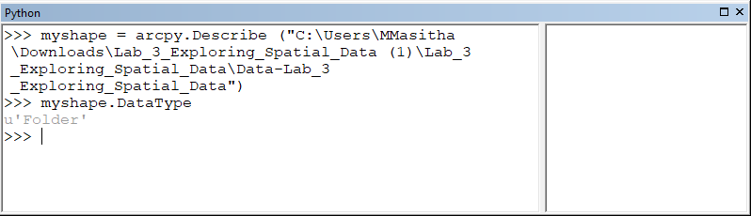

Additional output: Output 2

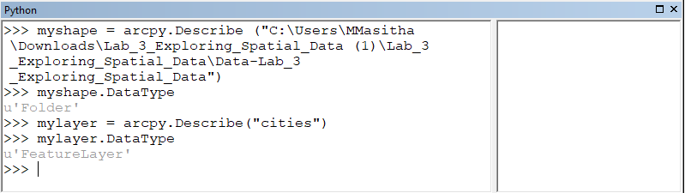

Entire output

