Global Malicious IP Threat Intelligence Analysis
Cleaning, validating, and exploring a real-world threat intelligence dataset
Author | [Your Name]
Date | September 2026
Dataset | final_kaggle_cyber_dataset.csv (10,000 reported malicious IP addresses)
Tools | Python, pandas, matplotlib, Jupyter Notebook
Companion file | Malicious_IP_Analysis.ipynb (full code, reproducible)

Executive Summary
This project takes a 10,000-record dataset of IP addresses reported as malicious and puts it through a full, documented data pipeline: auditing it for quality issues, cleaning it in a way that's transparent about what was fixed and what couldn't be, and analyzing it to answer a concrete question — where is malicious IP activity concentrated, and how widely spread is it geographically?
The dataset was structurally clean (no missing values, no duplicates) but had real content-level issues: 748 rows (7.5%) had failed geographic lookups that were fully recoverable, continent labels for transcontinental countries were inconsistently formatted, and one record could not be resolved without a live network lookup. Each issue is documented below along with the fix applied.
The analysis found that the United States accounts for roughly 43% of all reported malicious IPs — more than five times the next-highest country — while Asia, despite lower total volume, shows the widest geographic spread, with activity distributed across roughly 37 distinct countries rather than concentrated in one. This distinction has practical implications for anyone designing country-level security rules.

Project Objective
The goal of this project was twofold: first, to demonstrate a rigorous, reproducible approach to cleaning a messy real-world security dataset — one that documents every decision rather than silently dropping or guessing at bad data; and second, to extract meaningful geographic insight from that data that could inform how a security team thinks about where malicious traffic originates.
This mirrors a common early task in security and data roles: you're handed data of unknown quality and asked to turn it into something trustworthy enough to base decisions on.

Data Source & Description
The dataset (final_kaggle_cyber_dataset.csv) contains 10,000 rows and 16 columns, each representing a single IP address reported as malicious, along with its abuse confidence score, geographic origin, and the date/time of the report. It appears to be sourced from AbuseIPDB-style threat intelligence data, given the column structure (abuse_confidence_score, last_reported_at) and hosted via Kaggle.
Rows | 10,000
Columns | 16
Key fields | ip_address, country_code, country_name, continent, abuse_confidence_score
Snapshot type | Single-day pull — not a time series

Methodology: Data Cleaning

Step 1 — Structural Audit
Checked for missing values, duplicate rows, and duplicate IP addresses. Result: zero nulls, zero duplicates. This is a low bar — a dataset can pass every structural check and still contain content-level errors, which is exactly what was found next.

Step 2 — Content-Level Issues Identified
- 748 rows (7.5%) had country_name and continent set to “Unknown,” despite having a valid, recognizable country_code (e.g. AM, BG, NO). The lookup step that should have resolved these had failed upstream.
- 1 row had an invalid country_code itself, meaning no offline lookup could resolve it — it required a live IP geolocation query.
- Transcontinental countries were labeled inconsistently: Russia appeared as “Europe/Asia” while Turkey appeared as “Asia/Europe.” Grouping by continent without fixing this would have silently split one category into two.
- Nine columns (abuse_confidence_score, label, risk_level, severity, time_zone_attack, reported_weekday, and the reported date/time fields) were constant across all 10,000 rows — this is a snapshot of already-confirmed, maximum-confidence malicious IPs, not a labeled dataset with variation.

Step 3 — Fixes Applied
For the 748 recoverable rows, country_name and continent were filled in using a static ISO 3166 country-code reference — no network call was needed, since the code itself already identified the country unambiguously. Transcontinental continent labels were standardized to a single convention (“Europe/Asia”).
For the one row with no usable country_code, a live IP geolocation lookup was written into the analysis notebook using the free ip-api.com service. This correctly resolves the row when run in an environment with internet access. It is called out explicitly rather than silently patched, because a security dataset should never fabricate a value it can't verify.

Step 4 — What Was Deliberately Not Done
The nine constant-valued columns were kept in the cleaned dataset rather than dropped, since they may still serve as metadata for someone downstream. They are flagged here and in the notebook as having zero predictive value for any classification task, since a column with no variance cannot distinguish anything.

Key Findings

1. The US dominates raw volume
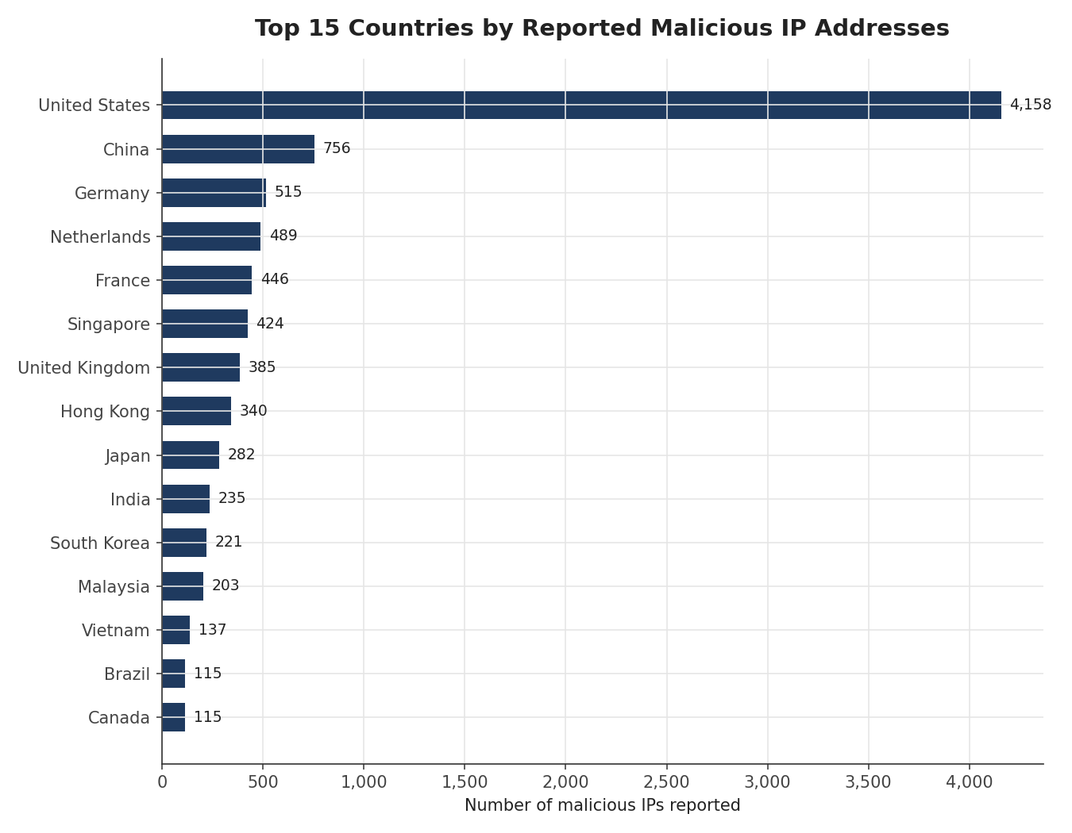
Figure 1. Top 15 countries by reported malicious IP count.
The United States accounts for 4,158 of the 10,000 reported IPs — roughly 43% of the entire dataset, and more than 5x the next-highest country, China (756). This is best read as a reflection of hosting infrastructure concentration: the US hosts a disproportionate share of the world's cloud and data-center IP space, so a large share of malicious traffic is proxied, hosted, or routed through US-based infrastructure regardless of the attacker's actual location.

2. Regional distribution
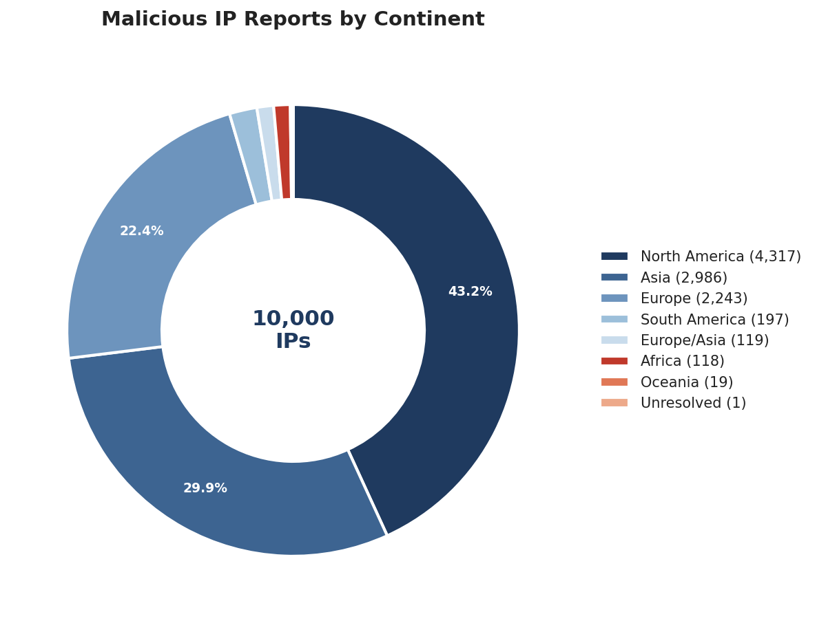
Figure 2. Share of reported malicious IPs by continent.
North America, Asia, and Europe together account for over 95% of all reports — unsurprising, since these are also the regions with the most internet infrastructure overall. Africa, South America, and Oceania each represent under 2% of the dataset.

3. Volume is not the same as concentration
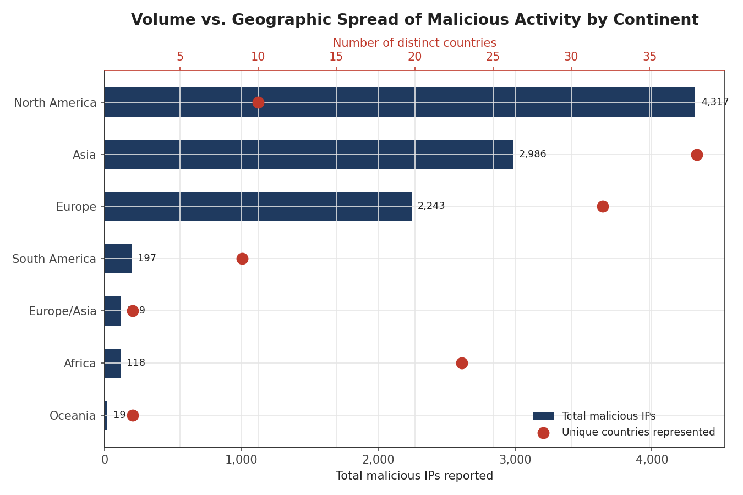
Figure 3. Total malicious IPs (bars) vs. number of distinct contributing countries (dots), by continent.
This is the most operationally useful finding in the analysis. North America has the highest total volume, but that volume comes from just 10 countries — dominated almost entirely by the US. Asia has lower total volume but is spread across roughly 37 distinct countries, with no single country dominating the way the US does. In practice, this means a country-level blocklist strategy would be far more effective in North America (block a handful of top offenders) than in Asia (where activity is diffuse across dozens of countries).

4. Leadership within each region
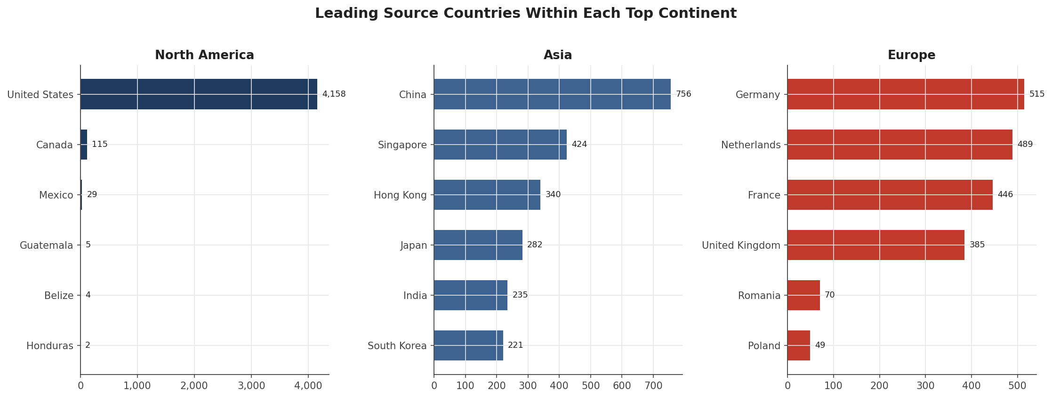
Figure 4. Top 6 source countries within each of the three leading continents.
Every continent has a clear leader — the US, China, and Germany respectively — but the drop-off after the leader differs sharply. In North America, the gap between the US and Canada (the second-place country) is roughly 36x. In Europe, the gap between Germany and the Netherlands is only about 1.05x, indicating a much more evenly distributed set of top reporters.

Limitations
- No benign/negative examples are included, so this data cannot be used to train a malicious-vs-benign classifier on its own.
- This is a single-day snapshot with no time dimension, so no trend analysis is possible without repeated data pulls.
- Country-level geography reflects where an IP is hosted, not necessarily where an attacker is physically located — VPNs, proxies, and compromised infrastructure can obscure true origin.
- One record (0.01% of the dataset) remains unresolved without a live network lookup.

Conclusion & Next Steps
This project demonstrates an end-to-end, defensible approach to preparing and analyzing a real-world security dataset: auditing beyond the surface-level checks, fixing what can be fixed transparently, documenting what can't, and using the resulting clean data to answer a concrete, actionable question about where malicious activity concentrates geographically.
Natural next steps would be to pair this dataset with a benign IP sample to enable classification modeling, and to repeat the data pull over time to support trend analysis rather than a single snapshot.

