build_patches_version_6.py — Workflow
GEDI footprints to 5×5 multi-sensor training patches
Northern California ROI, April–August 2021

What the script does
It turns GEDI laser footprints into training examples. For every usable GEDI shot it writes one small GeoTIFF holding a 5×5 pixel stack of satellite imagery centred on that shot, plus one row in a metadata CSV recording the biomass label and where the data came from.
Input: 139 GEDI .h5 granules, 6,720 HLS band files, 205 Sentinel-1 scenes, one NLCD raster, one ROI polygon.
Output: 221,743 patch GeoTIFFs and one metadata CSV.

Flowchart
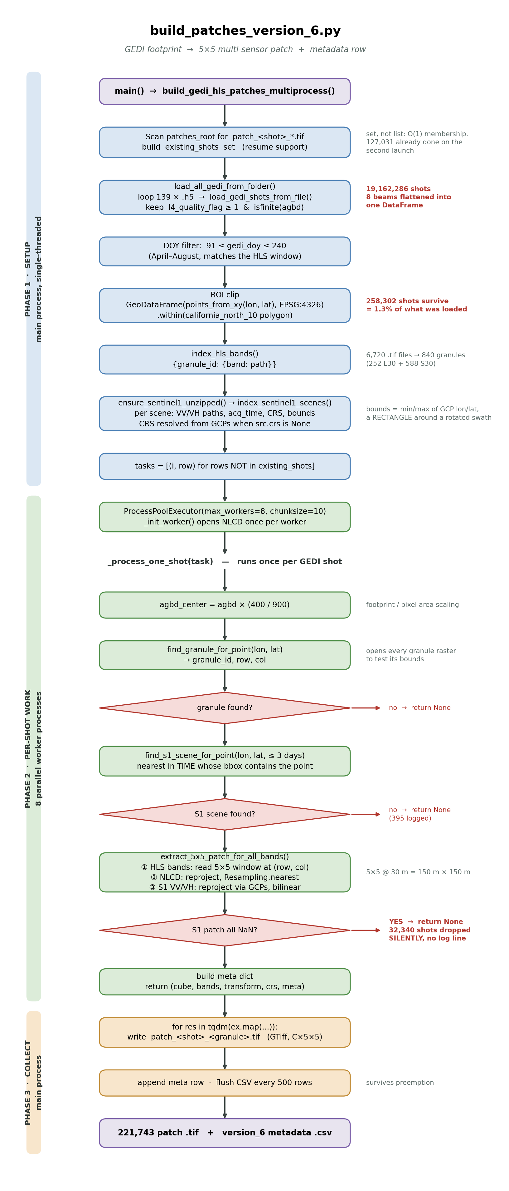

Phase 1 — Setup (main process, single-threaded)
Runs once. Nothing here reads pixel data; it builds the work list.
# | Function | What happens | Result
1 | inline | Scan patches_root for patch_<shot>_*.tif, extract the shot number with regex patch_(\d+)_, collect into existing_shots | Resume support. A set, not a list, so in is O(1). 127,031 found on the second launch
2 | load_all_gedi_from_folder | Loop 139 .h5 files, call load_gedi_shots_from_file on each, pd.concat the results | 19,162,286 shots. The 8 beams are flattened into one flat table
3 | inline | DOY filter 91 ≤ gedi_doy ≤ 240 | Restricts to April–August so GEDI and HLS describe the same season
4 | inline | Build a GeoDataFrame of Points from lon/lat, .within() the ROI polygon | 258,302 shots = 1.3% of what was loaded. GEDI granules follow orbit tracks, not your polygon
5 | index_hls_bands | Parse filenames into {granule_id: {band_code: path}} | 6,720 .tif files collapse to 840 granules (252 Landsat L30 + 588 Sentinel-2 S30)
6 | index_sentinel1_scenes | Unzip any .SAFE still archived, then record VV/VH paths, acquisition time, CRS and bounds per scene | CRS comes from GCPs when src.crs is None, which is the normal case for these GRD-HD products
7 | inline | Build tasks, skipping shots already in existing_shots | The work list handed to the pool

The quality filter
Inside load_gedi_shots_from_file, only two conditions are applied:
mask = (quality >= min_quality) & np.isfinite(agbd)
Note that GEDI marks missing biomass with −9999, not NaN, and np.isfinite(-9999) is True. So the second condition removes zero rows — the quality flag alone is keeping fill values out.

Phase 2 — Per-shot work (8 parallel worker processes)
ProcessPoolExecutor(max_workers=8, chunksize=10) with a spawn context. _init_worker opens the NLCD raster once per worker rather than once per shot.
_process_one_shot then runs for each GEDI shot:
# | Step | Detail
1 | Scale the label | agbd_center = agbd × (400 / 900) — the footprint-to-pixel area fraction
2 | find_granule_for_point | Opens each granule’s reference raster and tests whether the point falls inside its bounds. Returns granule_id, row, col
3 | parse_hls_datetime | Reads the acquisition time out of the granule ID (2021213T190305 = year 2021, day 213)
4 | find_s1_scene_for_point | Among scenes whose bounding box contains the point and whose acquisition is within 3 days, take the one nearest in time
5 | extract_5x5_patch_for_all_bands | Builds the image stack — see below
6 | Build meta | Label, coordinates, granule ID, S1 scene name, day gap

Building the 5×5 stack
Band order depends on which sensor produced the granule:
- S30 (Sentinel-2): B02, B03, B04, B8A, B11, B12, EVI, NDVI
- L30 (Landsat): B02, B03, B04, B05, B06, B07, EVI, NDVI
then NLCD, then S1_VV, S1_VH — 11 bands, each 5×5. At 30 m resolution a 5×5 window covers 150 m × 150 m.
Each source is handled differently, and the resampling choice matters:
Source | Method | Why
HLS bands | direct window read | Already on the target grid
NLCD | Resampling.nearest | Categorical land cover codes. Bilinear would average class 42 and class 82 into 62, which is not a class
Sentinel-1 | Resampling.bilinear, reprojected through GCPs | Continuous backscatter, and the product carries no affine transform

Where shots are dropped
Six places return None, discarding the shot. Only one of them logs anything.
Condition | Logged?
No HLS granule contains the point | no
A required band is missing from the granule | no
The point sits within 2 pixels of the raster edge | no
No Sentinel-1 scene within 3 days | yes — 395 times
The reprojected S1 window is entirely NaN | no — 32,340 times
Any exception | yes
The fifth row is the significant one. Because scene selection tests a rectangular bounding box around a rotated Sentinel-1 swath, points in the empty corners “find” a scene, the reprojection returns 25 NaNs, and the whole sample is discarded — including the perfectly good optical data already extracted.

Phase 3 — Collect (main process)
Results stream back through ex.map and are consumed in the main process:
- Write the cube to patch_<shot_number>_<granule_id>.tif as a multi-band GeoTIFF
- Append patch_tifs and bands to the metadata row
- Every 500 rows, append to the CSV and clear the buffer
The incremental flush matters on a preemptible queue: a job killed at hour 20 keeps everything written so far, and the next launch resumes from existing_shots.

The funnel
Stage | Count
Shots loaded from 139 granules | 19,162,286
After DOY and ROI filters | 258,302
Patches successfully written | 221,743
Lost during patch extraction | 36,559 (14.2%)
For comparison, version_5 lost only 3,824 (1.5%) from the same 258,302 candidates. The extra 32,735 is the cost of requiring Sentinel-1, and it is not evenly distributed: the lost shots average 26.8 Mg/ha against 70.9 for those kept, because coastal areas have dense overlapping radar coverage while the dry interior sits near swath edges.

Output format
Patch GeoTIFF — 11 bands × 5 × 5, float32, georeferenced to the HLS grid.
Metadata CSV — one row per patch:
gedi_file, shot_number, lat, lon, agbd_raw, agbd_center, agbd_log, center_frac, hls_granule, row, col, sentinel1_scene, sentinel1_time, sentinel1_days_diff, patch_tifs, bands
The bands column is what lets the training Dataset map a variable-length band list into fixed channel slots, which is how L30 and S30 granules coexist in one dataset.

