
HO CHI MINH CITY UNIVERSITY OF TECHNOLOGY
OFFICE FOR INTERNATIONAL STUDY PROGRAMS

PACKED COLUMN

Department: Processes and Equipment
Class: CC15HC1
Nguyeãn Minh Thuøy – 1552369
11 May 2018
OUTLINE
I. ABSTRACT: 3
1. Objective: 3
2. Experiment method: 3
3. Result data: 4
II. THEORY: 4
1. Pressure drop of inlet gas flow: 4
2. The friction factor f_{dry} as a function of Re_{c} for dried column: 5
3. Pressure drop ∆P_{wet} for wetted column: 6
4. The flooding point of packed column: 7
III. EXPERIMENTAL APPARATUS: 8
IV. RESULTS 10
V. DISCUSSION: 26
VI. APPENDIX: 27
VII. REFERENCES: 28

I. ABSTRACT:

Objective:
A Packed column was applied in mass transfer processes such as gas absorption, distillation, and liquid extraction. These experiments were to investigate the hydrodynamic characteristics and the effects of the gas and liquid velocities on the operating performance of the packed column. In the packed column, the inlet liquid is distributed over the top of the packed section and flows downward in the column, while the inlet gas was entered the distributing space below the packed section and flows upward through the interstices in the packing countercurrent to the flow of the liquid.
Through the experiments, the students could determine:
1) The effects of gas and liquid velocities on the pressure drop of gas flow in the packed column
2) The variation of the friction coefficient of dried – packing (f_{dry}) as a function Reynolds number (Re) of inlet gas flow rate and inferring the experimental relations
3) The change of “σ” factor, showing the relationship between the pressure drop of the gas flow through the dried packing and that through the wetted packing in different inlet liquid velocities
4) The diagram of limiting operation performance of packed column (loading and flooding points)

Experiment method:
Gas flow is supplied with different flowrate to packed column containing ceramic chocks. Pressure drop is surveyed in turn when only gas flow goes into column (dried column) and when gas flow goes into column combined with liquid flow goes down from the top with different flowrates (wetted column)

Result data:

 | L=0 | L=0.2 | L=0.4 | L=0.6 | L=0.8 | L=1.0 | L=1.2 | L=1.4 |  | L=1.6 |  | L=1.8
10 | 3 | 3 | 4 | 4 | 4 | 4 | 3 | 4 |  | 4 |  | 8
20 | 5 | 7 | 8 | 9 | 9 | 12 | 15 | 16 |  | 20 |  | 32
30 | 11 | 13 | 15 | 19 | 20 | 28 | 35 | 45 |  | 55 |  | 52
40 | 21 | 21 | 20 | 29 | 37 | 53 | 78 | 101
50 | 29 | 31 | 43 | 46 | 65 | 110 | 119
60 | 41 | 39 | 49 | 75 | 116 | 141
70 | 55 | 60 | 74 | 112
80 | 72 | 76 | 95 | 140
90 | 88 | 93 | 137
100 | 106 | 116 | 139

II. THEORY:

Pressure drop of inlet gas flow:
The Pressure drop (∆P_{dry}) of the gas flow through the packed column is depended on the gas velocity (G) in the condition of dried – packing (no countercurrent-liquid flow). The pressure drop in the packed column increases as raising the velocity of the inlet gas flowing through interstices in the packing materials. The pressure drop increases with the 1.8 – 2.0 power of the velocity of the gas.
∆P_{dry} = α G^{n}
Where in, n = 1.8 – 2.0
When the liquid enters the column at the top of packing and flows downward, the interstices in the packing are reduced, due to the occupation of the liquid in the free volume of the packing material. Therefore, the displacement of the gas flow was harder in the packed column. With an increment of gas flow rate, the impedimental effect of the liquid flow regularly increases. When the gas flow rate reaches a critical value, the pressure drop rises gradually. If the gas glow rate exceeds this loading point, the pressure drop increases more rapidly and does not follow the equation (1). In the local regions of the column, the liquid becomes a continuous phase, and the column reaches the flooding point. The entire column may fill with fluid at this flooding point.’
The graph of log(∆P_{c}/Z), describing the pressure drop per unit packing depth, is show in figure 1.

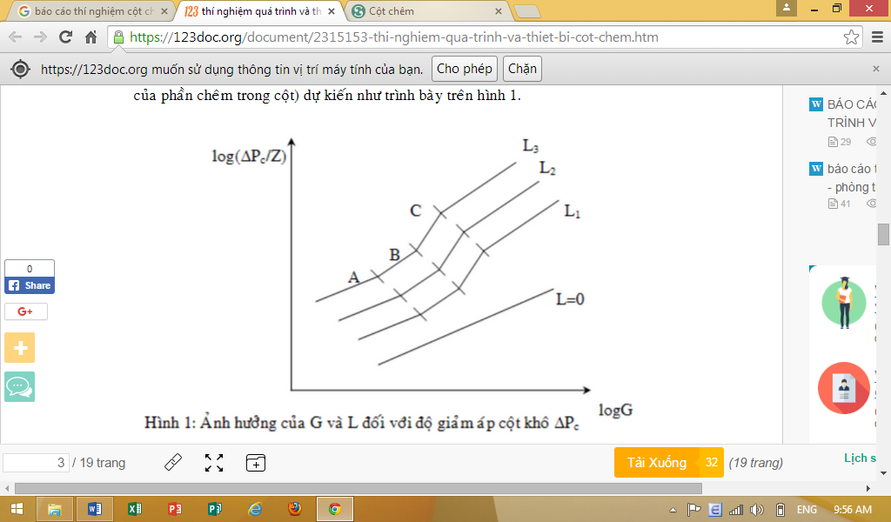
log G
Firgure 1: Effect of G and L on the pressure drop of packed column (∆P_{c})

The friction factor f_{dry} as a function of Re_{c} for dried column:
The pressure drop (∆P_{dry}) of gas flow through the packed column with no countercurrent-liquid flow can be determined using Ergun equation:
$$\frac{{∆P}_{dry}}{Z}\frac{ε^{3}}{(1-ε)}.\frac{d_{td}ρ_{G}}{G^{2}}=\frac{150(1-ε)}{Re}+1.75$$
Chilton and Colburn suggested a relation between pressure drop of gas flow and gas velocity through the packed column
$${∆P}_{dry}=2f_{dry}\frac{G^{2}Z}{ρ_{g}D_{h}}γ_{h}γ_{w} , N/m^{2}$$
Z: the paking depth, m
G: gas flow velocity per unit of packed section, kg/s.m²
D_{h}: nominal size of packing material, m
ρ_{g}: density of gas flow, kg/m³
γ_{h}: the adjustment factor of packing material
γ_{w}: the adjustment factor for effect of wall column on void fraction of packed column
Sherwood collected the data of previous studies and suggested the characteristic values for Raschig rings:
γ_{h} = 0.35
γ_{w} = 1
However, Zhavoronkov suggested another relation, referring the void fraction, is more accurate for ∆P_{dry:}
$${∆P}_{dry}=\frac{2f_{dry}G^{2}Z}{ε^{2}ρ_{G}D_{e}} , N/m^{2}$$
Wherein: ε: porosity of packing material
D_{e} = 4ε / a equivalent diameter of packing material, m
a: specific surface area of packing material, m²/m³
Friction factor f_{dry} is a function of dimensionless Re_{c} and is determined using the following equation:
$${Re}_{c}=\frac{GD_{e}}{εμ}=\frac{4G}{aμ}$$
µ: viscosity of gas flow, kg/ms
Zhavaronkov determined the variation of gas flow from laminar flow to turbulent flow regime through the Re_{c} of 50. In turbulent flow region, the Re_{c} is in the range of 50 < Re_{c} < 7000 with the random packed column. The f_{dry} is calculated as following equation:
$$f_{dry}=\frac{3.8}{{Re}_{c}^{0.2}}$$
However, this generalized relation is not accurate because it doesn’t entirely mention the effect of packing material’s shape.

Pressure drop ∆P_{wet} for wetted column:
The correlation between the pressure drop for dried column ∆P_{dry} and that for wetted column ∆P_{wet} can be described as following
∆P_{wet} = σ∆P_{dry}
Therefore, we can estimate:
f_{wet} = σ f_{dry}
Where σ is a coefficient as a function of the liquid velocity L, kg/m²s
Leva suggested a relation showing the effect of L on σ:
σ = 10^{ΩL}
or log σ = ΩL
The value of σ depends on types, dimension, packing mode (random or regular mode) and liquid velocity L.
For example, with the Raschig rings for 12.7 mm, random packing, the porosity ε of 0.568, the liquid velocity L from 0.39 to 11.7 kg/m²s, the column is operated below the loading point:
Ω = 0.084
From some previous studies, the relation between the ratio of $\frac{{∆p}_{wet}}{{∆p}_{dry}}$ and coefficient of fluid irrigation can be showed as following
$$A=\sqrt{\frac{1.75}{{Re}_{L}}\left(\frac{G_{L}}{Fρ_{L}}\right)\frac{q}{2gε^{2}}}$$
For A < 0.3 and ceramic packing material with d < 30 mm:
$$\frac{{∆p}_{wet}}{{∆p}_{dry}}=\frac{1}{{\left(1-A\right)}^{3}}$$
$${Re}_{L}=\frac{4G_{L}}{Faμ_{L}}$$

The flooding point of packed column:

When the packed column is flooded, the liquid seizes the packed section entirely, and the flows are disordered drastically. This phenomenon is atrocious for the operation of the packed column. The G_{L} which is responsible for this flooding situation is called G_{L}*.
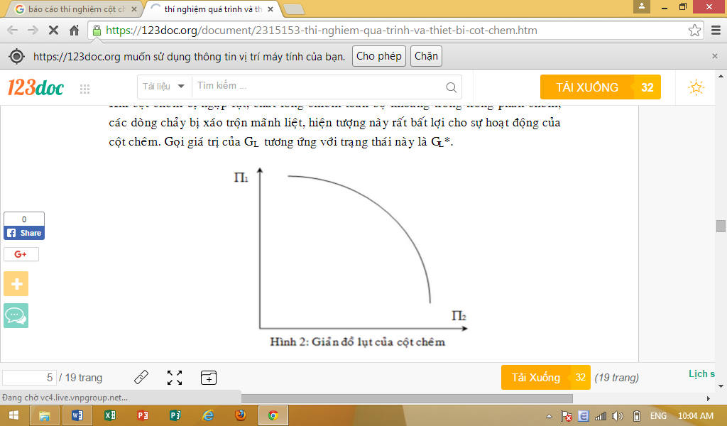
Figure 2: Flooding plot of packed column
Zhavoronkov pointed out that the flooding situation appears when the two number of π₁ and π₂ for the packed column have the relationship.
$$\prod{1}=\left(\frac{f_{dry}.a}{ε^{3}}\right)\frac{v^{2}}{2g}∙\frac{ρ_{G}}{ρ_{L}}∙μ_{tđ}^{0.2}$$
And
$$\prod{2=\frac{L}{G}\sqrt{\frac{ρ_{G}}{ρ_{L}}}}$$
Where f_{dry}: friction factor for dried column
v: the flow rate of gas before feeding to the packed column, m/s
µ_{tđ}: relative viscosity of liquid compared to water
$μ_{tđ}=\frac{μ_{l}}{μ_{water}}$, if the liquid is water µ_{tđ} = 1
Therefore, the correlation of π₁ and π₂ as showed in the plot of log π₁ – log π₂ determined the flooding graph of packed column. The limiting operation of the packed column is under this plot.

III. EXPERIMENTAL APPARATUS:
- Diagram of experimental apparatus
The experimental unit consists of:
- A glass column where the Raschig rings are packed randomly.
- Gas feeding equipment with air blower (B_{K}), gas pipe, U – tube manometer differential pressure gauge and gas flowmeter with scale from 8 to 100%.
- Water feeding equipment with feedtank (N), water pump (B_{L}) and liquid flowmeter with range from 0 to1.6.
- Characteristic of packed column
Glass column:
- Diameter d = 0.09 m
- Height H = 0.805 m
- Packing height Z = 0.42 m
Packing material which is Raschig rings is arranged randomly, with the nominal diameter “d” = 12.7 mm, surface area “a” = 370 – 380 m²/m³, porosity “ε” = 0.586.

Figure 3: Diagram of experimental apparatus
List of components in the diagram of experimental apparatus:
- A: Panel
- C: Packed column
- E: Bottom part of column
- F_{K}: Gas flowmeter, V = 0.286 m³/min
- g: a liquid level device (pipe) at the bottom part of column
- F_{L}: Liquid flowmeter, G_{L} = 5.805 l/min
- B_{K}: air blower with a capacity of 1.0 Hp
- B_{L}: liquid pump with a capacity of 0.5 Hp
- N: liquid tank
- AK: pressure gauge
- Experimental Method
  - Preparation
- Close all of the liquid valves
- Turn on the air valve and switch the air blower in 5 min for removing all moisture in the column. Then, shut down the blower
- Open valve “1” and valve “3”, and pumping water into the bottom part of the column. Using valve “2” to adjust the water level equal to the height of level device (the height = $3/4$ of the bottom part of the column). Then, turn off the pump and close valve “3”.
  - Measurement of pressure drop for dried column
- Close all of the liquid valves. Open air valve “6” when the air valve “5” is closed. Turn on the air blower and open valve “5” slowly for adjusting the gas flow into the column
- With a fixed gas flow rate, determining of P_{dry} on the pressure gauge for the mmH2O unit. After that, turn off the blower and waiting for 5 min
  - Measurement for pressure drop of the wetted column
- Switch on the air blower and adjust gas flow rate into the column in range of 15 – 20% for maximum flow rate
- Open the liquid valve “1” and turn on the pump. Using valve “VL” from the liquid flowmeter to adjust the water flow rate at the top of the column. If the float in flowmeter does not pop up as the valve “VL” is opened at full volume, close the valve “1” closely to raise the liquid flow rate
- At a specific liquid flow rate, altering the air flow rate and measuring the P_{wet} until the operation of the column reaches the flooding point and accomplishing the experiment
- Raising the liquid flow rate and conducting the experiment as above
Note:
- Adjust the valve “4” to maintain the height of water level equal to $3/4$ the height of the bottom part of the column through the measurement of the pressure drop
- Using the valve “2” to reduce water level from the column, if needed
- Turn off the water pump B_{L} before opening the valve “4” at full volume. Finally, switch off the air blower B_{K}.
- If the water infiltrates into the gas feeding pipe, opening the blue valve behind the panel to eliminate water.

IV. RESULTS
Table 1: The result for dry column L = 0
G% | G (kg/m².s) | ∆Pck (mm H₂O) | ∆P_{ck} (N/m²) | ∆P_{ck}/Z (N/m) | f_{ck} | Re_{ck} | logG | log∆P_{ck}/Z
10 | 0.08 | 3 | 29.43 | 70.07 | 11.85 | 46.86 | -1.07 | 1.85
20 | 0.17 | 5 | 49.05 | 116.79 | 4.94 | 93.73 | -0.77 | 2.07
30 | 0.25 | 11 | 107.91 | 256.93 | 4.83 | 140.59 | -0.59 | 2.41
40 | 0.34 | 21 | 206.01 | 490.50 | 5.18 | 187.45 | -0.47 | 2.69
50 | 0.42 | 29 | 284.49 | 677.36 | 4.58 | 234.32 | -0.37 | 2.83
60 | 0.51 | 41 | 402.21 | 957.64 | 4.50 | 281.18 | -0.29 | 2.98
70 | 0.59 | 55 | 539.55 | 1284.64 | 4.43 | 328.04 | -0.23 | 3.11
80 | 0.68 | 72 | 706.32 | 1681.71 | 4.44 | 374.91 | -0.17 | 3.23
90 | 0.76 | 88 | 863.28 | 2055.43 | 4.29 | 421.77 | -0.12 | 3.31
100 | 0.85 | 106 | 1039.86 | 2475.86 | 4.19 | 468.63 | -0.07 | 3.39

Chart LogΔP_{ck}/Z following LogG with L = 0

Table 2: The result for wetted column L = 0.2
G% | G (kg/m².s) | ∆P_{cư} (mm H₂O) | ∆P_{cư} (N/m²) | ∆P_{cư}/Z (N/m) | σ (kg/m²s) | f_{cư} | Re_{cư}
10 | 0.08 | 3 | 29.43 | 70.07 | 1.00 | 11.85 | 46.86
20 | 0.17 | 7 | 68.67 | 163.50 | 1.40 | 6.91 | 93.73
30 | 0.25 | 13 | 127.53 | 303.64 | 1.18 | 5.70 | 140.59
40 | 0.34 | 21 | 206.01 | 490.50 | 1.00 | 5.18 | 187.45
50 | 0.42 | 31 | 304.11 | 724.07 | 1.07 | 4.90 | 234.32
60 | 0.51 | 39 | 382.59 | 910.93 | 0.95 | 4.28 | 281.18
70 | 0.59 | 60 | 588.60 | 1401.43 | 1.09 | 4.84 | 328.04
80 | 0.68 | 76 | 745.56 | 1775.14 | 1.06 | 4.69 | 374.91
90 | 0.76 | 93 | 912.33 | 2172.21 | 1.06 | 4.53 | 421.77
100 | 0.85 | 116 | 1137.96 | 2709.43 | 1.09 | 4.58 | 468.63

Chart ΔP_{cö}/Z following G with L = 0.2

Table 3: The result for wetted column L = 0.4

G% | G  (kg/m².s) | ∆P_{cư}  (mm H₂O) | ∆P_{cư} (N/m²) | ∆P_{cư}/Z (N/m) | σ  (kg/m²s) | f_{cư} | Re_{cư}
10 | 0.08 | 4.0 | 39.24 | 93.43 | 1.33 | 15.80 | 46.86
20 | 0.17 | 8.0 | 78.48 | 186.86 | 1.60 | 7.90 | 93.73
30 | 0.25 | 15.0 | 147.15 | 350.36 | 1.36 | 6.58 | 140.59
40 | 0.34 | 20.0 | 196.20 | 467.14 | 0.95 | 4.94 | 187.45
50 | 0.42 | 43.0 | 421.83 | 1004.36 | 1.48 | 6.79 | 234.32
60 | 0.51 | 49.0 | 480.69 | 1144.50 | 1.20 | 5.38 | 281.18
70 | 0.59 | 74.0 | 725.94 | 1728.43 | 1.35 | 5.96 | 328.04
80 | 0.68 | 95.0 | 931.95 | 2218.93 | 1.32 | 5.86 | 374.91
90 | 0.76 | 137.0 | 1343.97 | 3199.93 | 1.56 | 6.68 | 421.77
100 | 0.85 | 139.0 | 1363.59 | 3246.64 | 1.31 | 5.49 | 468.63

Chart ΔP_{cö}/Z following G with L = 0.4

Table 4: The result for wetted column L = 0.6
G% | G (kg/m².s) | ∆P_{cư}  (mm H₂O) | ∆P_{cư} (N/m²) | ∆P_{cư}/Z (N/m) | σ  (kg/m²s) | f_{cư} | Re_{cư}
10 | 0.08 | 4.0 | 39.24 | 93.43 | 1.33 | 15.80 | 46.86
20 | 0.17 | 9.0 | 88.29 | 210.21 | 1.80 | 8.89 | 93.73
30 | 0.25 | 19.0 | 186.39 | 443.79 | 1.73 | 8.34 | 140.59
40 | 0.34 | 29.0 | 284.49 | 677.36 | 1.38 | 7.16 | 187.45
50 | 0.42 | 46.0 | 451.26 | 1074.43 | 1.59 | 7.27 | 234.32
60 | 0.51 | 75.0 | 735.75 | 1751.79 | 1.83 | 8.23 | 281.18
70 | 0.59 | 112.0 | 1098.72 | 2616.00 | 2.04 | 9.03 | 328.04
80 | 0.68 | 140.0 | 1373.40 | 3270.00 | 1.94 | 8.64 | 374.91

Chart ΔP_{cö}/Z following G with L = 0.6

Table 5: The result for wetted column L = 0.8

G% | G (kg/m².s) | ∆P_{cư}  (mm H₂O) | ∆P_{cư} (N/m²) | ∆P_{cư}/Z (N/m) | σ (kg/m²s) | f_{cư} | Re_{cư}
10 | 0.08 | 4.0 | 39.24 | 93.43 | 1.33 | 15.80 | 46.86
20 | 0.17 | 9.0 | 88.29 | 210.21 | 1.80 | 8.89 | 93.73
30 | 0.25 | 20.0 | 196.20 | 467.14 | 1.82 | 8.78 | 140.59
40 | 0.34 | 37.0 | 362.97 | 864.21 | 1.76 | 9.13 | 187.45
50 | 0.42 | 65.0 | 637.65 | 1518.21 | 2.24 | 10.27 | 234.32
60 | 0.51 | 116.0 | 1137.96 | 2709.43 | 2.83 | 12.73 | 281.18

Chart ΔP_{cö}/Z following G with L = 0.8

Table 6: The result for wetted column L = 1

G% | G (kg/m².s) | ∆P_{cư}  (mm H₂O) | ∆P_{cư}  (N/m²) | ∆P_{cư}/Z (N/m) | σ  (kg/m²s) | f_{cư} | Re_{cư}
10 | 0.08 | 4 | 39.24 | 93.43 | 1.33 | 15.80 | 46.86
20 | 0.17 | 12 | 117.72 | 196.20 | 2.40 | 11.85 | 93.73
30 | 0.25 | 28 | 274.68 | 457.80 | 2.55 | 12.29 | 140.59
40 | 0.34 | 53 | 519.93 | 866.55 | 2.52 | 13.08 | 187.45
50 | 0.42 | 110 | 1079.10 | 1798.50 | 3.79 | 17.38 | 234.32
60 | 0.51 | 141 | 1383.21 | 2305.35 | 3.44 | 15.47 | 281.18

Chart ΔP_{cö}/Z following G with L = 1

Table 7: The result for wetted column L = 1.2

G% | G (kg/m².s) | ∆P_{cư}  (mm H₂O) | ∆P_{cư}  (N/m²) | ∆P_{cư}/Z (N/m) | σ  (kg/m²s) | f_{cư} | Re_{cư}
10 | 0.08 | 3 | 29.43 | 70.07 | 1.00 | 11.85 | 46.86
20 | 0.17 | 15 | 147.15 | 350.36 | 3.00 | 14.81 | 93.73
30 | 0.25 | 35 | 343.35 | 817.50 | 3.18 | 15.36 | 140.59
40 | 0.34 | 78 | 765.18 | 1821.86 | 3.71 | 19.25 | 187.45
50 | 0.42 | 119 | 1167.39 | 2779.50 | 4.10 | 18.80 | 234.32

Chart ΔP_{cö}/Z following G with L = 1.2

Table 8: The result for wetted column L = 1.4

G% | G (kg/m².s) | ∆P_{cư}  (mm H₂O) | ∆P_{cư}  (N/m²) | ∆P_{cư}/Z (N/m) | σ  (kg/m²s) | f_{cư} | Re_{cư}
10 | 0.08 | 4 | 39.24 | 93.43 | 1.33 | 15.80 | 46.86
20 | 0.17 | 16 | 156.96 | 373.71 | 3.20 | 15.80 | 93.73
30 | 0.25 | 45 | 441.45 | 1051.07 | 4.09 | 19.75 | 140.59
40 | 0.34 | 101 | 990.81 | 2359.07 | 4.81 | 24.93 | 187.45

Chart ΔP_{cö}/Z following G with L = 1.4

Table 9: The result for wetted column L = 1.6

G% | G (kg/m².s) | ∆P_{cư}  (mm H₂O) | ∆P_{cư}  (N/m²) | ∆P_{cư}/Z  (N/m) | σ  (kg/m²s) | f_{cư} | Re_{cư}
10 | 0.08 | 4 | 39.24 | 93.43 | 1.33 | 15.80 | 46.86
20 | 0.17 | 20 | 196.20 | 327.00 | 4.00 | 19.75 | 93.73
30 | 0.25 | 55 | 539.55 | 899.25 | 5.00 | 24.13 | 140.59

Chart ΔP_{cö}/Z following G with L = 1.6

Table 10: The result for wetted column L = 1.8

G% | G (kg/m².s) | ∆P_{cư}  (mm H₂O) | ∆P_{cư}  (N/m²) | ∆P_{cư}/Z  (N/m) | σ  (kg/m²s) | f_{cư} | Re_{cư}
10 | 0.08 | 8 | 78.48 | 130.80 | 2.67 | 31.59 | 46.86
20 | 0.17 | 32 | 313.92 | 523.20 | 6.40 | 31.59 | 93.73
30 | 0.25 | 52 | 510.12 | 850.20 | 4.73 | 22.82 | 140.59

Chart ΔP_{cö}/Z following G with L = 1.8

CHART

Chart of effect of G (gas flowrate) on ΔP/Z (pressure drop per height unit) and relative comparison among different flowrate values L

Chart of effect of LogG on Log(ΔP/Z) (pressure drop per height unit) and relative comparison among different flowrate values L

Chart of the effect of Re on
LogRe_{ck}
logf_{ck} and logf_{cö} and relative comparison among the different values L

Chart of the relation between Logσ and L at positions under loading point (choosing position G = 10, 20, 30%)

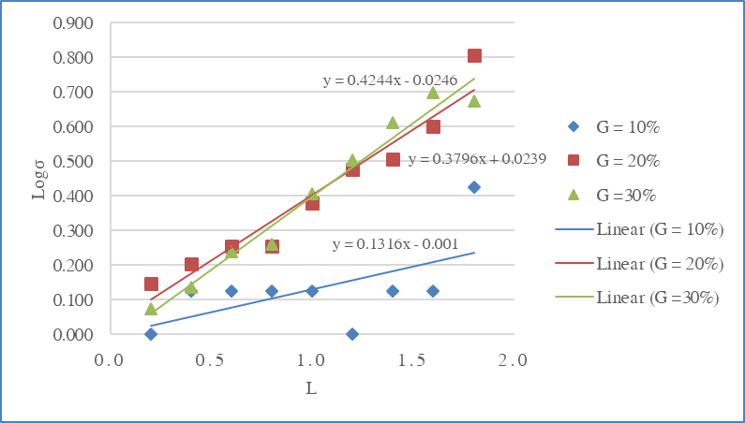

Table 8: The values after flooding

L (galon/ph) | G* (%) | L (kg/s) | L/G* | G* (kg/m².s) | v (m/s) | Π₁ | Π₂ | logΠ₁ | logΠ₂
0.6 | 80 | 5.92 | 8.71 | 0.68 | 0.599 | 0.172 | 0.293 | -0.76 | -0.53
0.8 | 60 | 7.90 | 15.49 | 0.51 | 0.450 | 0.098 | 0.522 | -1.01 | -0.28
1 | 60 | 9.87 | 19.44 | 0.51 | 0.450 | 0.098 | 0.655 | -1.01 | -0.18
1.2 | 50 | 11.85 | 27.94 | 0.42 | 0.375 | 0.069 | 0.941 | -1.16 | -0.03
1.4 | 40 | 13.82 | 40.65 | 0.34 | 0.300 | 0.050 | 1.370 | -1.30 | 0.14
1.6 | 30 | 15.80 | 63.19 | 0.25 | 0.225 | 0.026 | 2.129 | -1.58 | 0.33
1.8 | 30 | 17.77 | 71.09 | 0.25 | 0.225 | 0.026 | 2.395 | -1.58 | 0.38

Flooding chart of packed column logΠ₁ following logΠ₂

LogΠ₁

LogΠ₂

Table 9: The emperical results and equations
Relation | Empirical results
ΔP_{ck}/Z followed G at L = 0  ΔP_{cö}/Z followed G at L = 0.2  ΔP_{cö}/Z followed G at L = 0.4  ΔP_{cö}/Z followed G at L = 0.6  ΔP_{cö}/Z followed G at L = 0.8  ΔP_{cö}/Z followed G at L = 1  ΔP_{cö}/Z followed G at L = 1.2  ΔP_{cö}/Z followed G at L = 1.4  ΔP_{cö}/Z followed G at L = 1.6  ΔP_{cö}/Z followed G at L = 1.8 | y = 3070.4x² + 359.51x – 8..9536  y = 3723.9x² – 28.828x + 56.836  y = 4784.4x² – 30.917x + 28.029  y = 9146x² – 1549.4x + 184.35  y = 17323x² – 4402.1x + 397.07  y = 11702x² – 1448.7x + 109.08  y = 35809x² – 6342.2x + 385.39  y = 35809x² – 6342.2x + 385.39  y = 23601x² – 3240x + 198.54  y = -4557.5x² + 5790.7x - 327

Relation | Empirical results
Logf_{ck} followed Re_{ck} at L = 0  Logf_{cö} followed Re_{ck} at L = 0.2  Logf_{cö} followed Re_{ck} at L = 0.4  Logf_{cö} followed Re_{ck} at L = 0.6  Logf_{cö} followed Re_{ck} at L = 0.8  Logf_{cö} followed Re_{ck} at L = 1  Logf_{cö} followed Re_{ck} at L = 1.2  Logf_{cö} followed Re_{ck} at L = 1.4  Logf_{cö} followed Re_{ck} at L = 1.6  Logf_{cö} followed Re_{ck} at L = 1.8 | y = -0.0006x + 0.8656  y = -0.0007x + 0.9235  y = -0.0006x + 0.9861  y = -0.0005x + 1.046  y = -0.0002x + 1.0543  y = 0.0003x + 1.1032  y = 0.0011x + 1.0434  y = 0.0015 x + 1.0995  y = 0.002x + 1.1082  y = 0.0015x + 1.5938

Relation | Empirical results
Logσ followed L | at G = 10% : y = 0.13x – 0.001  at G = 20% : y = 0.38x + 0.02  at G = 30% : y = 0.42x – 0.02

V. DISCUSSION:
- Based on the chart and practical data, we have:
Dry column: G increases, the $∆P$ increases linearly.
Wet columnL G increases, $∆P$ increases obviously partly as separated areas as chart mentioned in the theory. When the liquid flowrate increases, column is closer to the flood point.
After the loading point, $∆P$ increases rapidly, suddenly. The line in this area becomes so inclined that it is difficult to operate the packed column at the bubble mode, although it is the best condition for the packed column to operate. In fact, when carrying out the experiment, till the flooding point, we stop the experiment, so there is no area after loading point on the chart.

- Purpose and the usage of the chart f according to Re.
The chart f according to Re is built to express the dependence of the restriction force into the flowrate of the fluid. If the fluid flowrate increases, the friction factor f between two phases increases. The chart is built to determine the suitable flowrarte to operate the column with the small restriction force and get the best mass transfer efficiency between two phases without making the column reach the flooding point. Nonetheless, the observation showed from the chart is opposite, which means when the flowrate increases, the restriction force reduces gradually. This result is due to the effect of the error during the experiment.
If one of both values Re or F is given, it can use the chart to determine another: From the given f or Re, draw a straight line horizontally or vertically, cut the chart f_Re at one point. From that intersection point, draw a perpendicular line to the other axis, then, missing value is determined.

- Does the relation between the analyzed objectives follow the prediction? If not, explain:
The relation between the objectives are approximately closer to the prediction. Particularly, the relation is expressed as following:
- Log(ΔP_{ck}/Z) and logG are dependent linearly together following the theoritical statement above.
- ΔP_{cö}/Z and G are nearly separated into two distinguished areas: The area under the loading point and the area above the loading point.
+ The area below the loading point: $∆P$ increases slowly and gradually, so these points are virtually lie on one line.
+ The area above the loading point: $∆P$ increases rapidly, suddenly, so the line is very inclined; If increasing the liquid flowrate and gas flowrate, the column will gradually reach the flooding point.
- Logσ and L: Completely depends linearly together, so expressed as a line on the chart.

- Nevertheless, during the experiment, some factors can cause the error.
- Pump makes the liquid flowrate unstable.
- Fan makes the liquid flowrate unstable.
- The water column maintained at the bottom of the column is not sufficient as the requiremnt, which leads to the flooding in the difference pressure tube affecting the result.
- Error in reading and experiment implement.
- The experiment conditions are different among the measurement.
Note:
After adjusting the gas flowrate and liquid flowrate, the data must be collected immediately.
During the experiment, it needs to take 10 minutes to cool down the apparatus and stabilize the system, then continue the operation.
If the water runs in unconcidentally into the gas tube, open the valve after the board.

VI. APPENDIX:
- Calculation f_{ck}:
- Calculation f_{cö}:
f_{cö} = σ.f_{ck}
- Calculation Re_{ck}:
μ: The viscosity of air at 45⁰C.
- Calculation σ:
ΔP_{cö} = σ.ΔP_{ck}
- Calculation the flowrate transfer:
- Gas flowrate:
V = 0.286 m³/ph
ρ_{K}: density of gas stream at 45⁰C.
The parameters of the gas stream from the tables:
ρ_{K} = 1.1305 kg/m³
μ = 1928.10⁻⁸kg/m.s

- Liquid flowrate:
4.586. Exchange factor from galon to litre.
ρ_{L}: density of liquid stream at 30ºC

With F: across area of the packed column:
0,0064 (m²)
- Calculate the flooding point:
With f_{ck}: friction factor of wetted column.
v: long velocity of the gas stream before entering the column, m/s
v = G/F With: Gas stream flowrate (m³/s)
μ_{td} :Relative viscosity of liquid compared to water . If case liquid is the water μ_{td} = 1.

VII. REFERENCES:
1. Treybal, R.E., “Mass Transfer Operation”, Third Edition, pages 187 – 201, McGraw-Hill Book Company, New York, 1980.
2. Bennett, C.O., and J.E. Myers, “Momentum, Heat and Mass Transfer”, Third Edition, pages 187 – 201, McGraw-Hill Book Company, New York, 1982.
3. Vu Ba Minh, “Process and Units – Vol 3 – Mass Transfer”, BKU
4. McCabe W.L. et al, Units Operations of Chemical Engineering, McGraw-Hill, 1993, pg.689.
5. Hanesian, D. and Perna A.J., “A Laboratory Manual for Fundamentals of Engineering Design”, NJIT

