Отчет лабораторная работа 11

1. Первая программа используя React и JSX

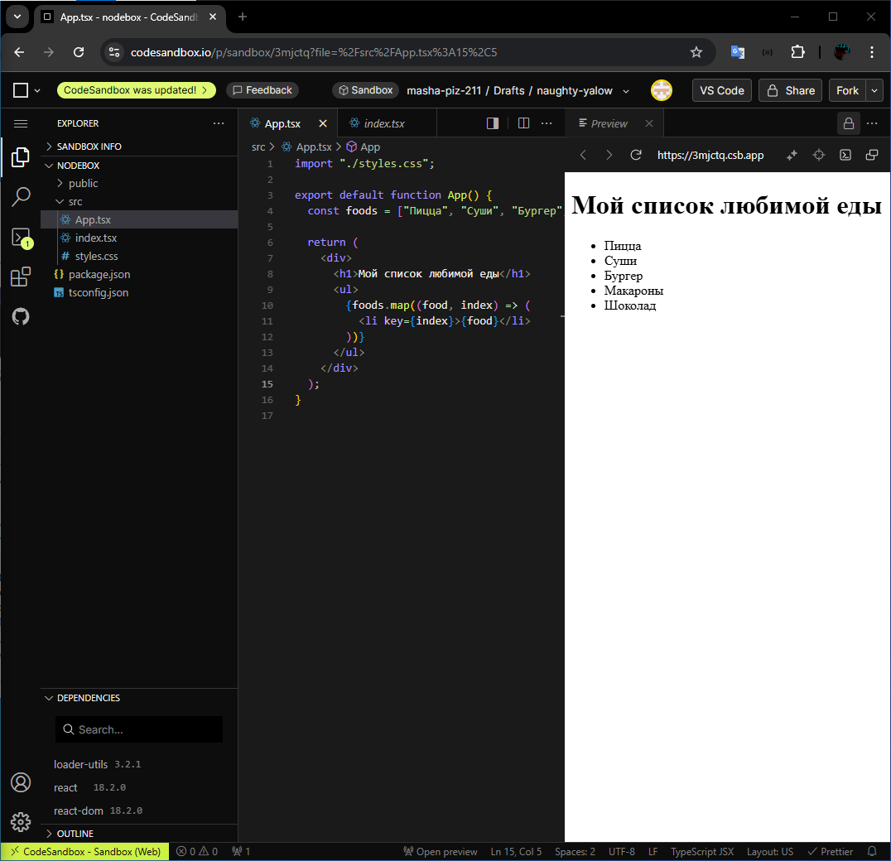

Листинг:

import "./styles.css";

export default function App() {

const foods = ["Пицца", "Суши", "Бургер", "Макароны", "Шоколад"];

return (

<div>

<h1>Мой список любимой еды</h1>

<ul>

{foods.map((food, index) => (

<li key={index}>{food}</li>

))}

</ul>

</div>

);

}

1. Фигурные скобки в JSX и переменные

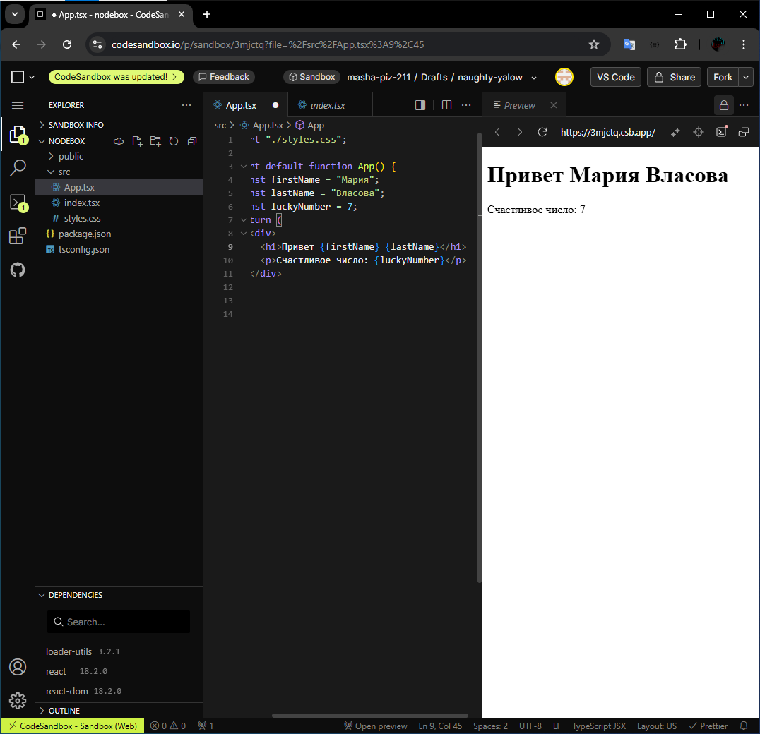

Листинг:

import "./styles.css";

export default function App() {

const firstName = "Мария";

const lastName = "Власова";

const luckyNumber = 7;

return (

<div>

<h1>

Привет {firstName} {lastName}

</h1>

<p>Счастливое число: {luckyNumber}</p>

</div>

);

}

1. Стили

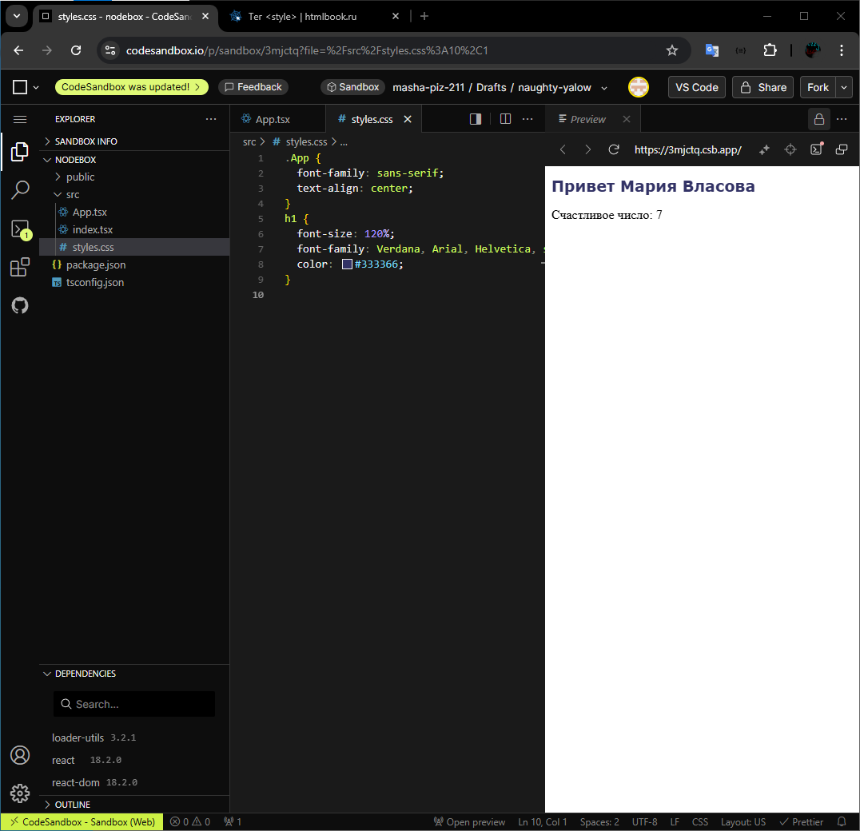

Листинг

.App {

font-family: sans-serif;

text-align: center;

}

h1 {

font-size: 120%;

font-family: Verdana, Arial, Helvetica, sans-serif;

color: #333366;

}

5. Модули

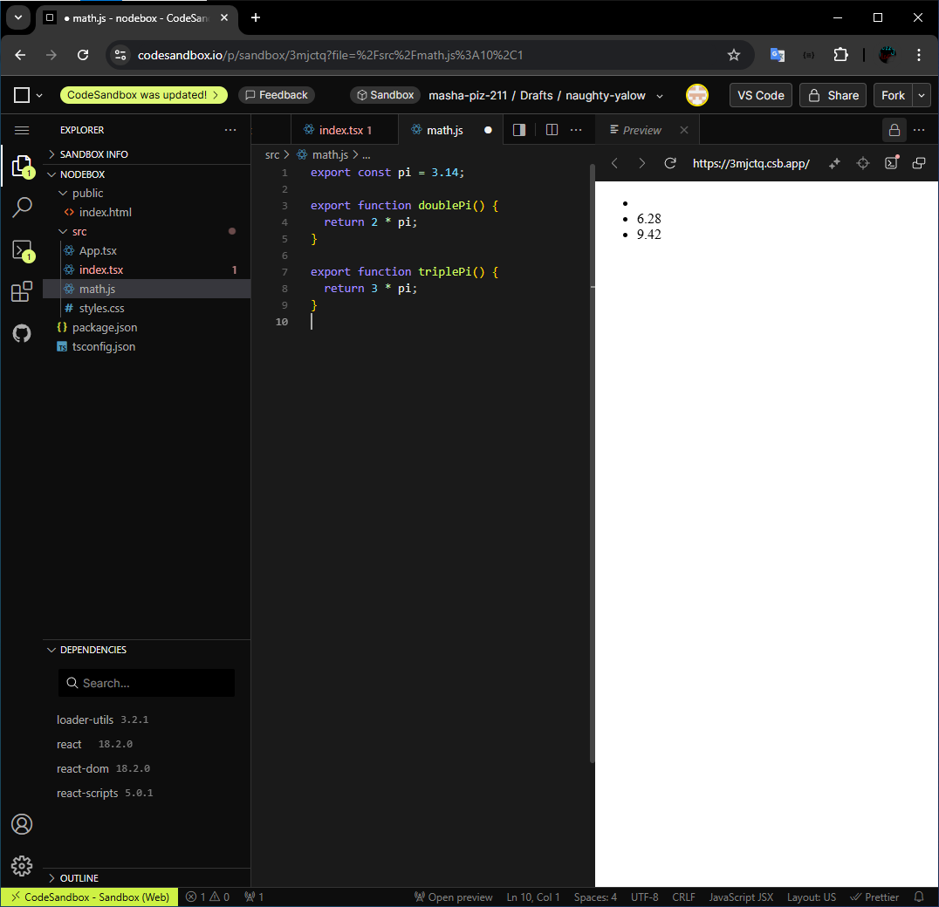

Листинг math.js

export const pi = 3.14;

export function doublePi() {

return 2 * pi;

}

export function triplePi() {

return 3 * pi;

}

6. Динамическое приветствие

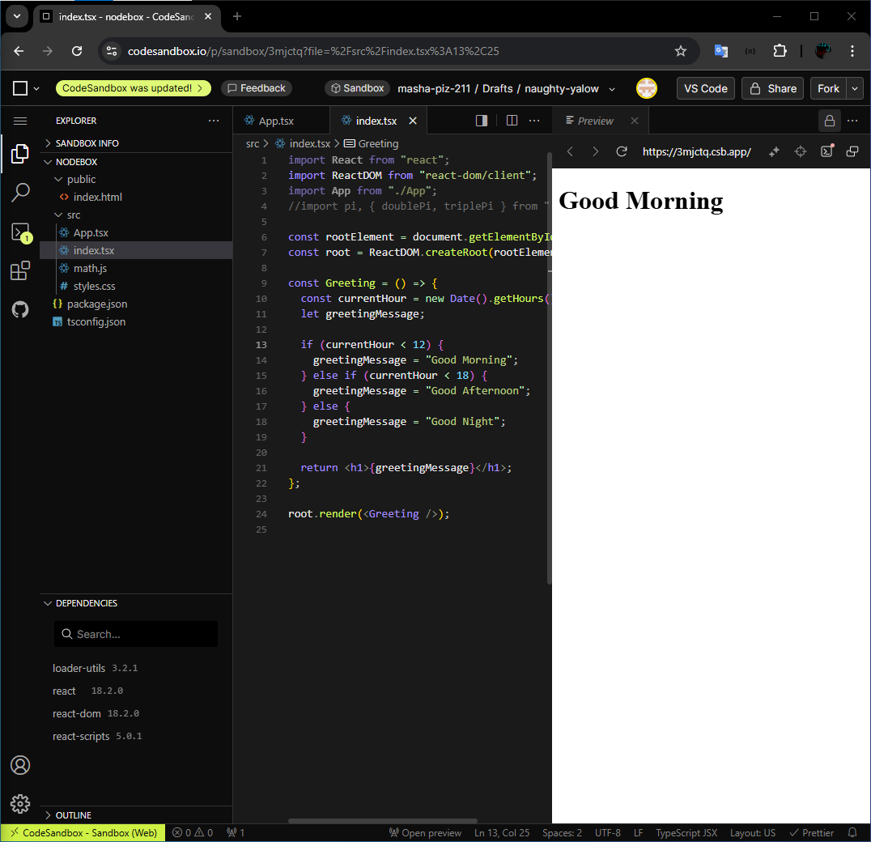

Листинг кода:

import React from "react";

import ReactDOM from "react-dom/client";

import App from "./App";

//import pi, { doublePi, triplePi } from "./math.js";

const rootElement = document.getElementById("root")!;

const root = ReactDOM.createRoot(rootElement);

const Greeting = () => {

const currentHour = new Date().getHours();

let greetingMessage;

if (currentHour < 12) {

greetingMessage = "Good Morning";

} else if (currentHour < 18) {

greetingMessage = "Good Afternoon";

} else {

greetingMessage = "Good Night";

}

return <h1>{greetingMessage}</h1>;

};

root.render(<Greeting />);

7. Пропсы

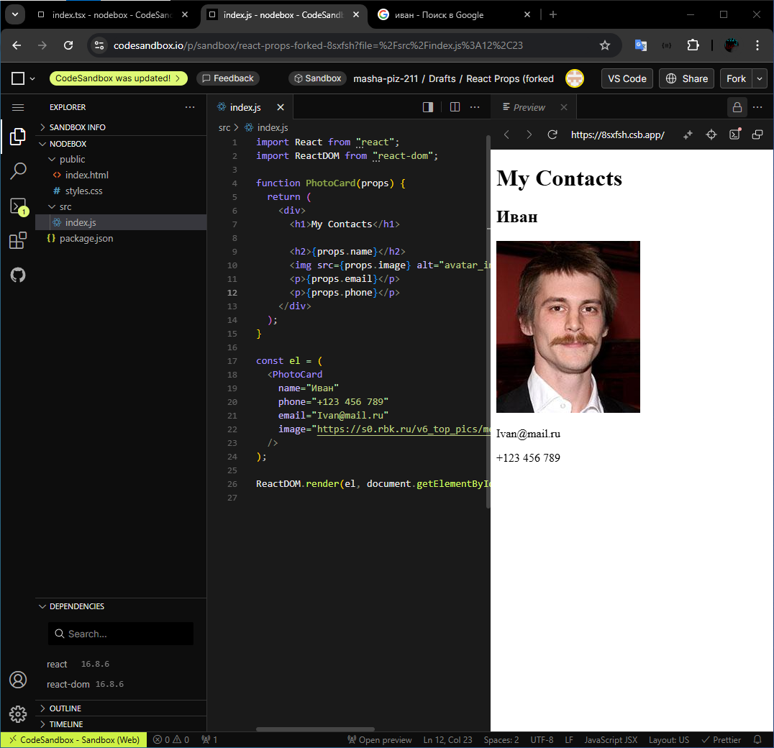

Листинг:

import React from "react";

import ReactDOM from "react-dom";

function PhotoCard(props) {

return (

<div>

<h1>My Contacts</h1>

<h2>{props.name}</h2>

<img src={props.image} alt="avatar_img" />

<p>{props.email}</p>

<p>{props.phone}</p>

</div>

);

}

const el = (

<PhotoCard

name="Иван"

phone="+123 456 789"

email="Ivan@mail.ru"

image="https://s0.rbk.ru/v6_top_pics/media/img/7/70/347048939043707.jpeg"

/>

);

ReactDOM.render(el, document.getElementById("root"));

8. Хуки!

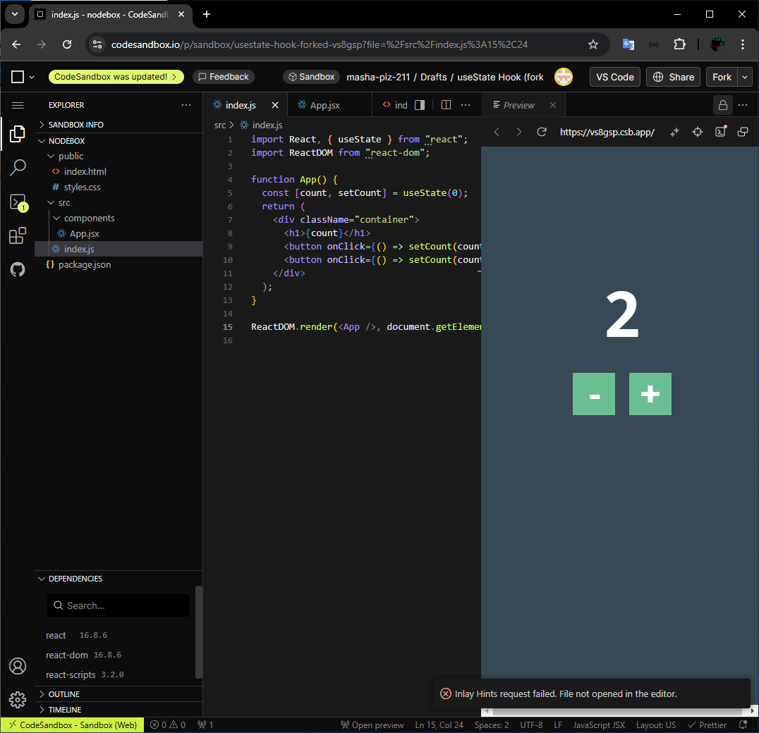

Листинг:

import React, { useState } from "react";

import ReactDOM from "react-dom";

function App() {

const [count, setCount] = useState(0);

return (

<div className="container">

<h1>{count}</h1>

<button onClick={() => setCount(count - 1)}>-</button>

<button onClick={() => setCount(count + 1)}>+</button>

</div>

);

}

ReactDOM.render(<App />, document.getElementById("root"));

9. Время

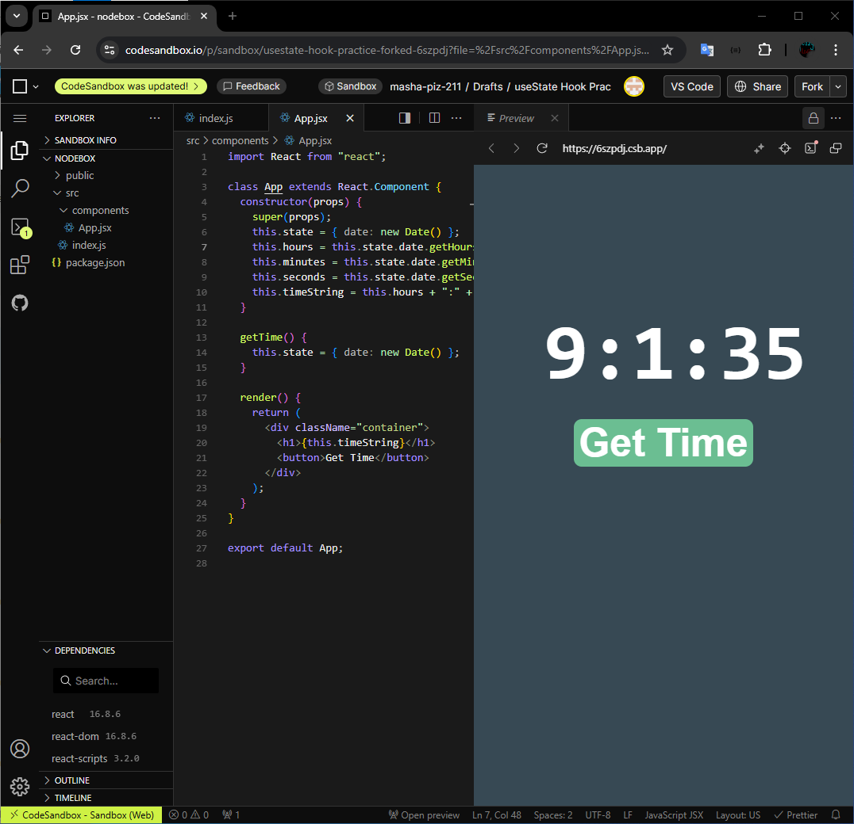

Листинг:

import React from "react";

class App extends React.Component {

constructor(props) {

super(props);

this.state = { date: new Date() };

this.hours = this.state.date.getHours();

this.minutes = this.state.date.getMinutes();

this.seconds = this.state.date.getSeconds();

this.timeString = this.hours + ":" + this.minutes + ":" + this.seconds;

}

getTime() {

this.state = { date: new Date() };

}

render() {

return (

<div className="container">

<h1>{this.timeString}</h1>

<button>Get Time</button>

</div>

);

}

}

export default App;

10. Hello !@#$%^&

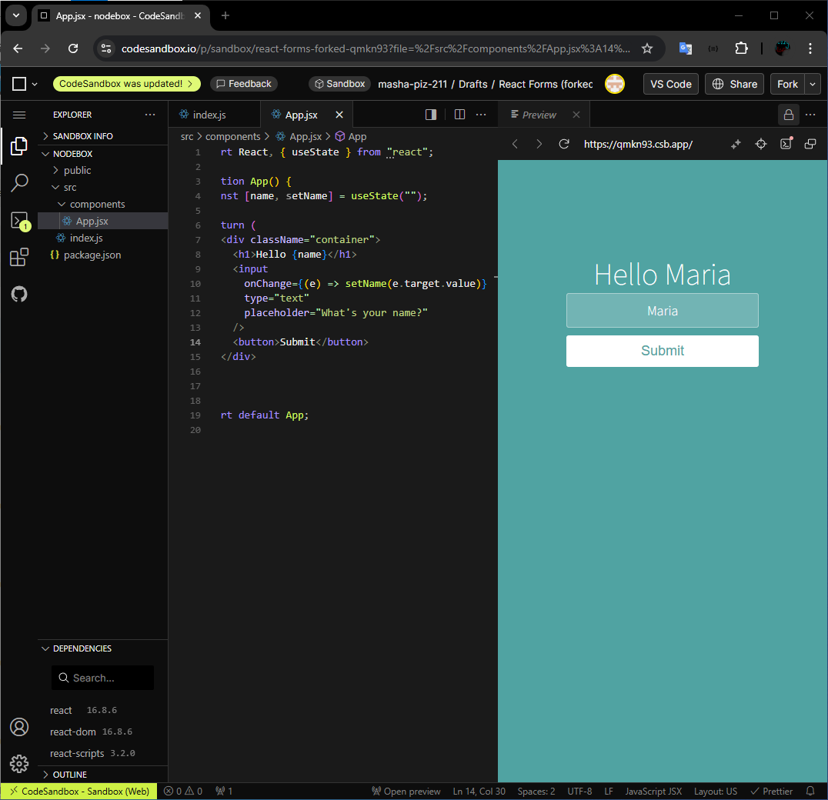

Листинг:

import React, { useState } from "react";

function App() {

const [name, setName] = useState("");

return (

<div className="container">

<h1>Hello {name}</h1>

<input

onChange={(e) => setName(e.target.value)}

type="text"

placeholder="What's your name?"

/>

<button>Submit</button>

</div>

);

}

export default App;