Colța Maria, clasa a 10-a “C”

Exemplele: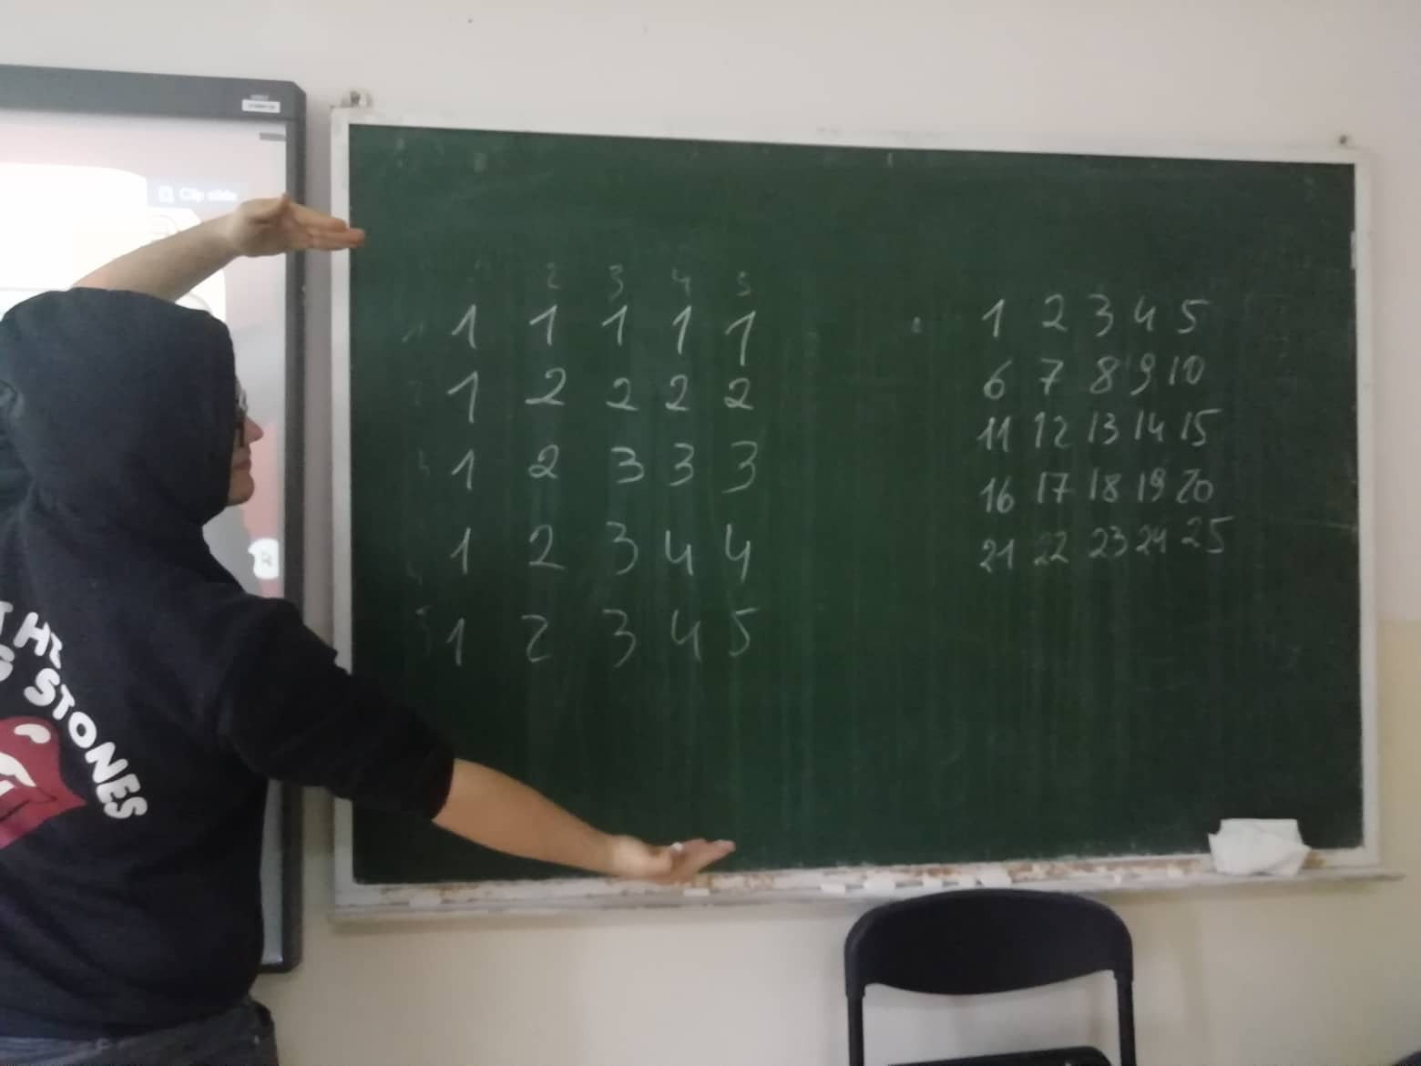

**Codul:**

import java.util.Scanner;

public class Main{

public static void main(String[]args){

Scanner t = new Scanner(System.in);

int x = t.nextInt();

t.close();

Ex1 z = new Ex1();

z.Loop1(x);

Ex2 q = new Ex2();

q.Loop2(x);

}

}

public class Ex1{

void Loop1(int x){

for(int i = 1; i < x + 1; i++){

for(int j=1; j< x + 1; j++){

System.out.printf("%3d", Math.min(i,j));

}

System.out.println();

}

System.out.println();

}

}

public class Ex2{

void Loop2(int x){

for(int i = 0; i < x; i++){

for(int j=1; j< x + 1; j++){

System.out.printf("%3d", x * i + j);

}

System.out.println();

}

System.out.println();

}

}

**Output:**