Colța Maria, clasa a 10-a “C”

*Problemele: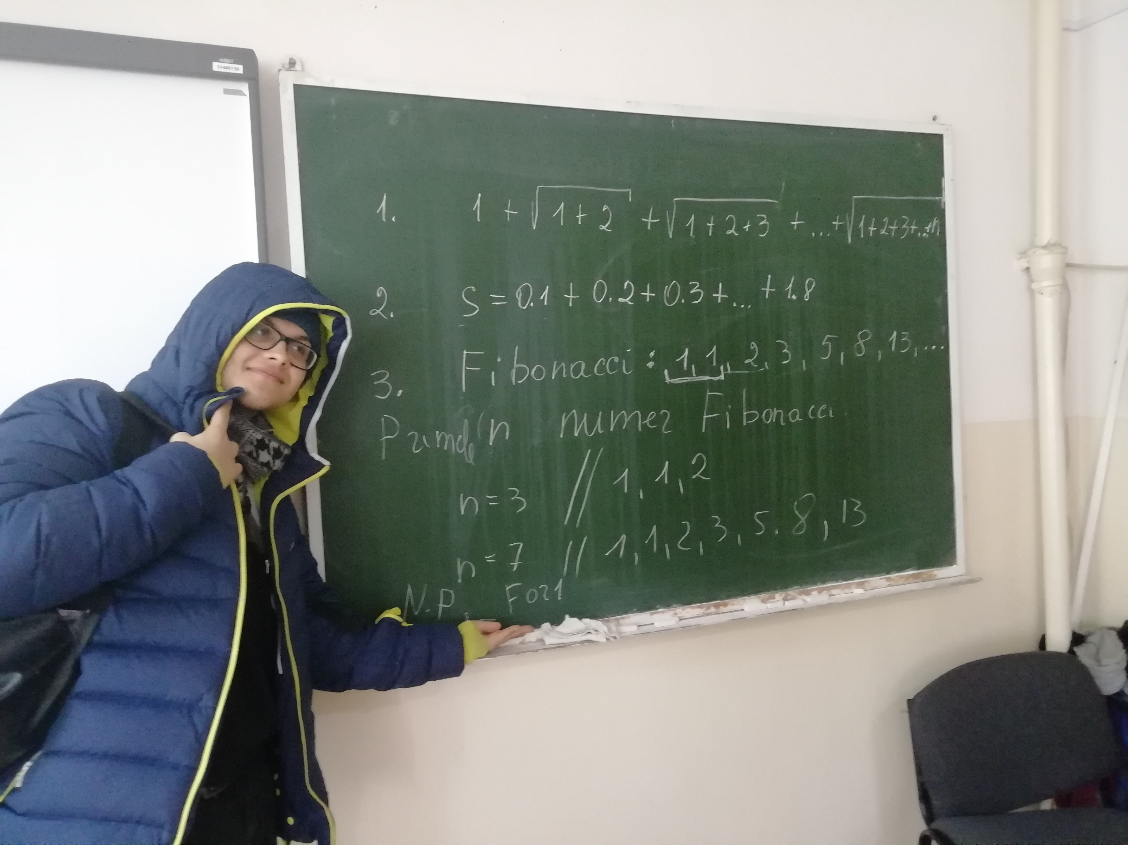*

:))))

*Codul:*

import java.util.Scanner;

public class Main {

public static void main(String[]args) {

Scanner t = new Scanner(System.in);

int n = t.nextInt();

t.close();

Ex1 x = new Ex1();

x.SumaRadical(n);

Ex2 y = new Ex2();

y.SumaZecimal();

Ex3 z = new Ex3();

z.Fibonacci(n);

}

}

public class Ex1 {

void SumaRadical(int n){

double s1 = 0;

double s = 0;

for(int i = 0; i < n; i++){

s1 = s1 + i;

s = s + Math.sqrt(s1);

}

System.out.println("Suma este " + s);

}

}

public class Ex2 {

void SumaZecimal(){

double z = 0;

for(float i = 1; i < 19; i++){

z += (i/10);

}

System.out.println("Suma este " + z);

}

}

public class Ex3{

void Fibonacci(int n){

int n1=0,n2=1,n3,i;

System.out.print(n1+" "+n2);

for(i=2;i<n;++i){

n3=n1+n2;

System.out.print(" "+n3);

n1=n2;

n2=n3;

}

}

}

*Output: