

King Abdulaziz University
Faculty of Computing and Information Technology – Girls Campus
Computer Science Department
CPCS 403 – Web Applications
Spring Semester 2026

Little Leaf

Dr. Samar Alkhuraiji
Project ID: group 18

ID | Student Name | Serial number
2212857 | Mshael Waleed Alshwaf | 1
2212855 | Shahad Mohammed Ebrahim | 2
2206898 | Jumanah Jamal Banabilah | 3
Table of Contents:
1. Project idea 3
2. Recommended Solution 3
3. Our website 3
5. Site map 4
6. Storyboard 5

Project idea

The Little Leaf website is a platform designed to make purchasing and caring for plants simple and accessible. In modern life, many people spend most of their time indoors and often lack access to nature. This can lead to increased stress and a less calming living environment. The idea behind Little Leaf is to reconnect people with nature by bringing plants into their homes and personal spaces.
The website acts as a digital botanical shop where users can explore a collection of plants that improve home aesthetics and create a peaceful atmosphere. By providing detailed plant descriptions, care instructions, and an easy purchasing process, the platform helps users choose plants that suit their lifestyle and environment.

Recommended Solution

Little Leaf is a user-friendly e-commerce website that allows customers to browse, learn about, and purchase plants online. The website provides several features including:
- Online Plant Catalog
Users can browse a variety of plants with images, and information about each plant.
- Plant Care Guidance
The platform offers simple instructions on watering, sunlight, and maintenance so customers can properly care for their plants.
- Simple Shopping Experience
The website allows users to easily add plants to their cart, review their order, and complete purchases online.
- User Account System
Customers can create accounts to manage their profiles, view order history, and track purchases.
- Search and Navigation
A clear navigation system helps users quickly find plants suitable for their homes.
- Educational Content
The website promotes awareness about the benefits of plants especially indoor plants and encourages users to create relaxing and green environments.

Our website

The domain of our website is www.my-plants.site . In the current phase of the project, the main pages of the website have been developed, including Home, Products, Services, Cart, Login, Profile, Contact, Feedback, and About. The website is built using HTML for structure, CSS for styling, and JavaScript for interactive functionality, following modern UI/UX design principles to ensure a clear and user-friendly interface.

all functionality of the website.
- Benefits
The Little Leaf website offers several benefits for users:
- Convenience
Customers can explore and purchase plants from the comfort of their homes without visiting physical stores.
- Stress Reduction and Well-Being
Indoor plants can improve mood, reduce stress, and create a calming environment.
- Improved Living Spaces
Plants enhance interior design and bring natural beauty into homes and workspaces.
- Easy Plant Care
Providing care instructions helps beginners successfully grow and maintain their plants.
- Encouraging Sustainable Living
Promoting plants helps people reconnect with nature and develop environmentally friendly habits.

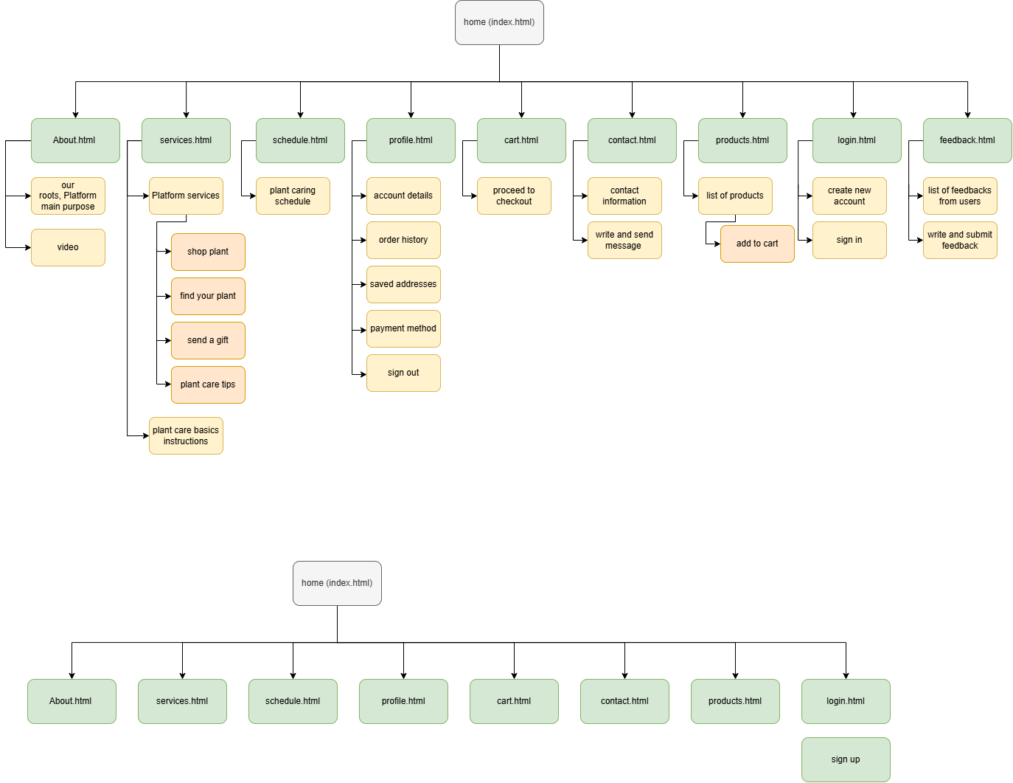
Site map

Storyboard

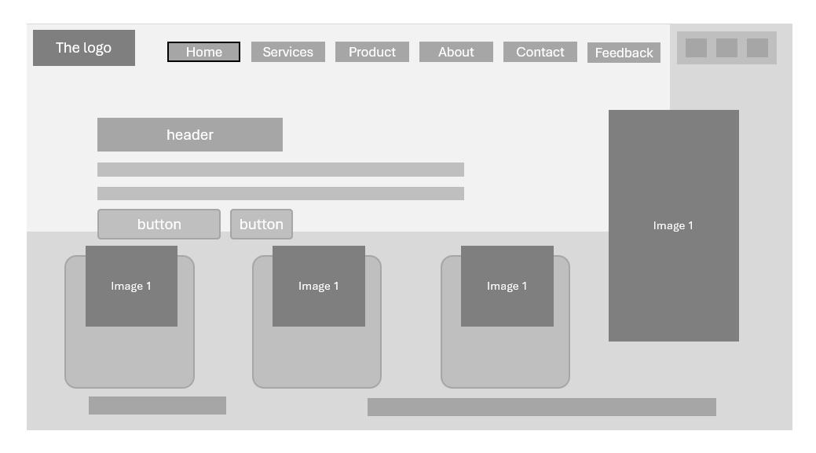
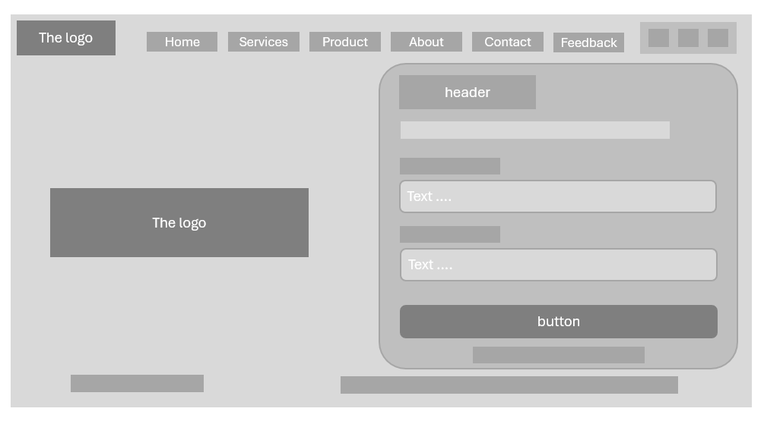
figure 1 home page layout

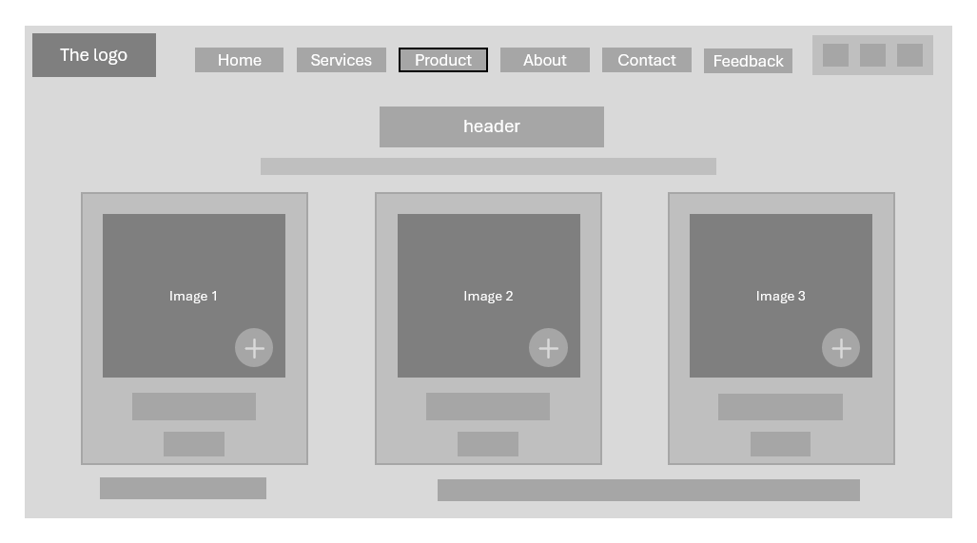
figure 2 login page layout
figure 3 products page layout

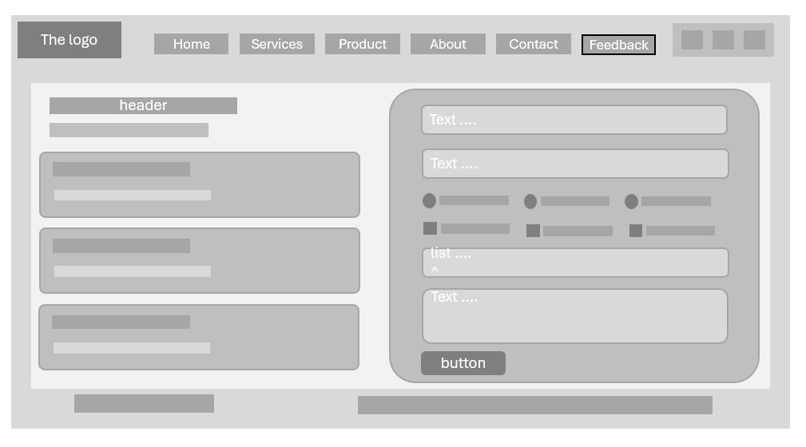
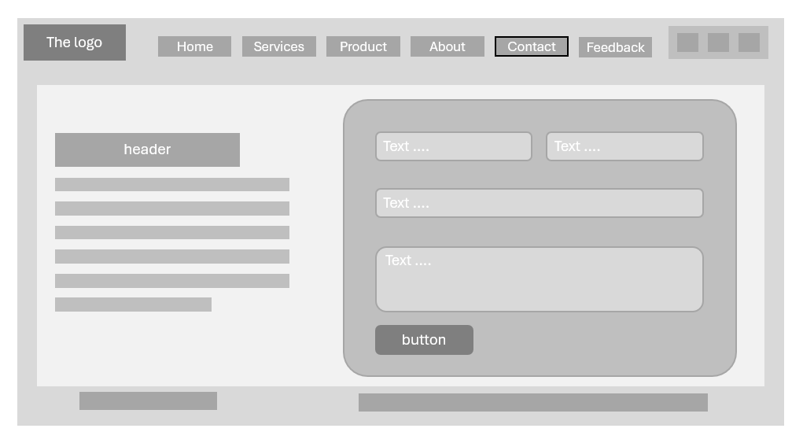
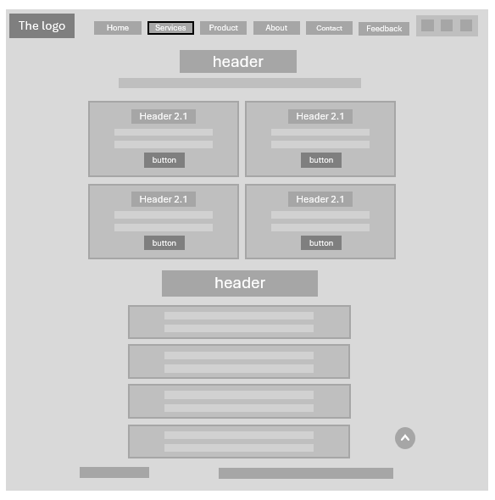
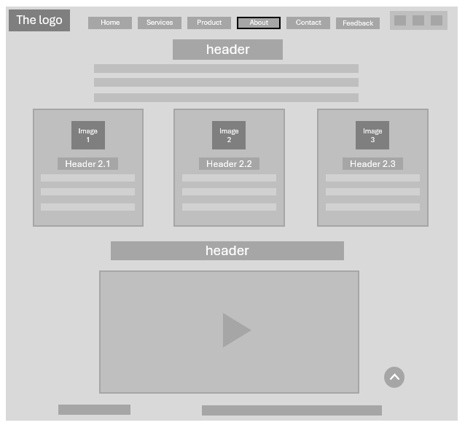
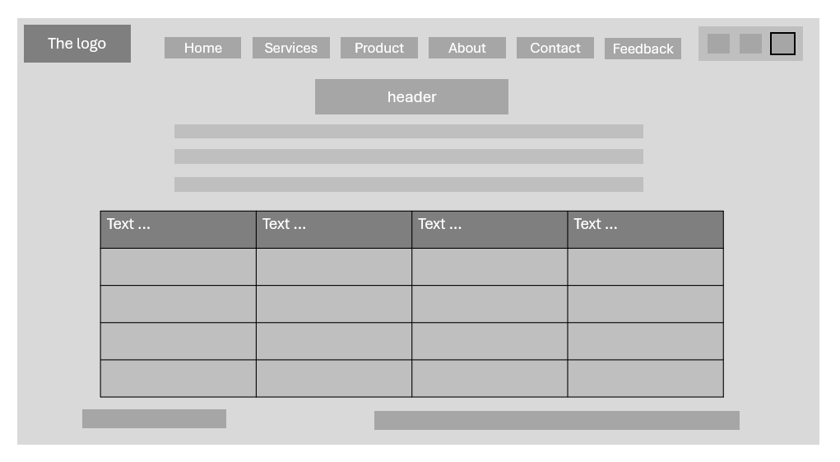
Figure 7 feedback page layout
Figure 6 contact page layout
figure 5 about page layout
figure 4 Services page layout
figure 8 schedule page layout
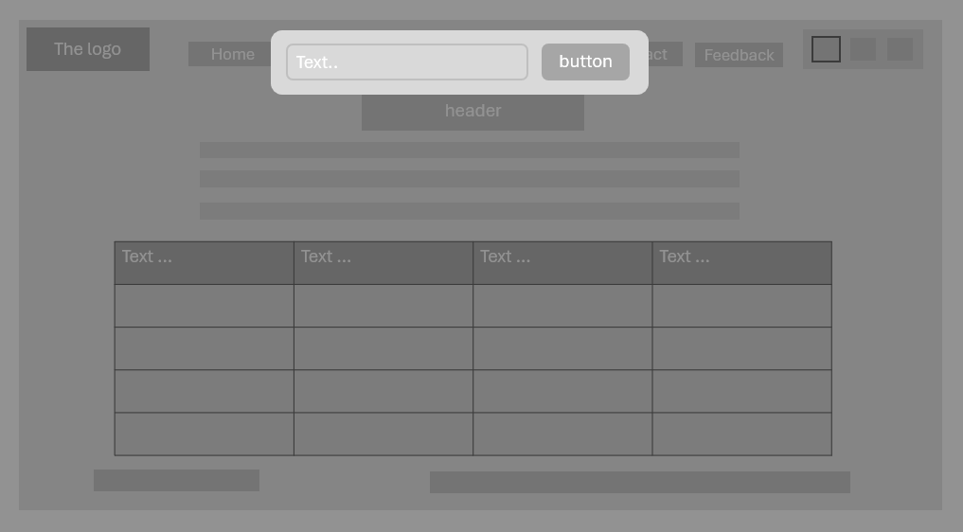
Figure 9 search page layout
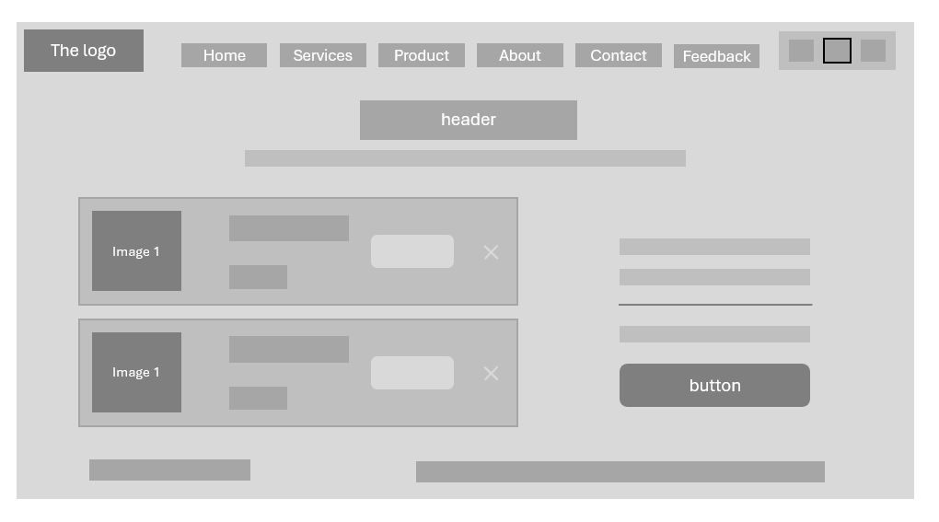
Figure 10 cart page layout

