## SOFTWARE DESIGN & ANALYSIS

## PROJECT REPORT

## TOPIC: ONLINE MOBILE STORE

## Submitted By:

## 19I-0412 Fizzah Ilyas

## 19I-0585 Mas’haf Zaman

## 19I-0653 Noor ul Eman

## Section G

**USE CASE DIAGRAM:**

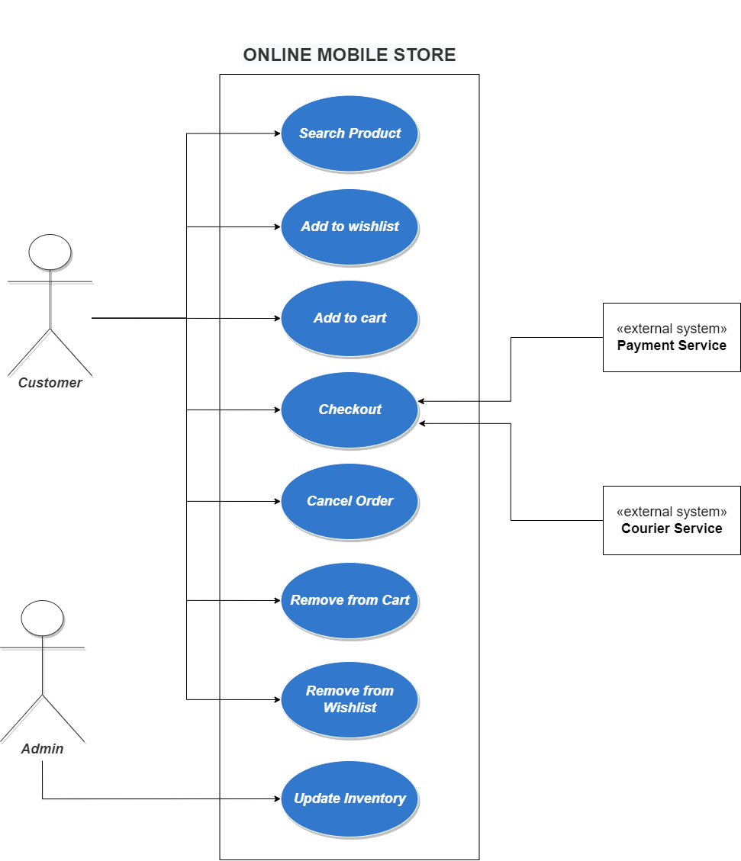

DESCRIPTION:

**Search Product:**

The customer enters the product parameters or keywords and searches the product. The system will search through all the products available and return the exact or relevant information, respective to the type of search. If the product is not available, a failure message is returned.

**Add to wishlist:**

When the customer finds the product he wants to buy, he/she adds it to the wishlist. The system stores and tracks the information about the product, whilst the customer is searching further.

**Add to cart:**

When the customer finds the product he/she wants to buy, the system finds it in the products list and adds it to the cart. Then system stores and tracks the information about the product.

**Checkout:**

After adding products to the cart or searching further, the customer requests a checkout. The customer will be asked to enter his/her name, email, address, phone number, and credit card information. If credit card information is valid, the order will be processed by the system via a payment extension. After the order is placed successfully, the product is shipped to the customer by an extension linking to a courier or logistics service. A confirmation message of the order and a tracking number will be sent to the customer that he/she can use to check on order status in the future.

**Cancel Order:**

After checking out, the customer can cancel his/her order within 24 hours without penalty and with a full refund to the original form of payment. The customer will be asked for their order number and email. Once the order is canceled, a confirmation message is displayed and an email is sent to the customer confirming the cancellation of the order.

**Remove from cart:**

After the products are added to cart, the customer can remove the products from cart by clicking on “remove item”. The system finds it in the cart array stored in inventory and removes it from the cart.

**Remove from wishlist:**

After the products are added to wishlist, the customer can remove the products from wishlist by clicking on “remove item”. The system finds it in the wishlist array stored in inventory and removes it from the wishlist.

**Update Inventory:**

The admin, upon receiving a new shipment of products, updates the inventory and product information e.g. prices, specifications, etc. and the system updates the relevant information in the database/cloud.

EXTENDED USE CASES

USE CASE: ADD TO CART

|  |  |
| --- | --- |
| ACTOR ACTION | SYSTEM RESPONSE |
| 1. Customer asks to add a product to cart. |  |
|  | 1. System checks inventory for availability. |
|  | 1. System adds the product to cart. |
|  | 1. System shows the cart. |
|  | 1. System displays the total amount of products in cart. |

2(a): The product is not available. System displays an error message.

3(a): The product is already in cart.

USE CASE: REMOVE FROM CART

|  |  |
| --- | --- |
| ACTOR ACTION | SYSTEM RESPONSE |
| 1. Customer asks to remove a product from cart. |  |
|  | 1. System checks if the product is in cart. |
|  | 1. System removes the product from cart. |

2(a): The product is not in cart.

ADD TO WISHLIST

|  |  |
| --- | --- |
| ACTOR ACTION | SYSTEM RESPONSE |
| 1. Customer asks to add a product to wishlist. |  |
|  | 1. System checks inventory for availability. |
|  | 1. System adds the product to wishlist. |
|  | 1. System shows the wishlist. |

2(a): The product no available. System displays an error message.

3(a): The product is already in wish list.

REMOVE FROM WISHLIST

|  |  |
| --- | --- |
| ACTOR ACTION | SYSTEM RESPONSE |
| 1. Customer asks to remove a product from wish list. |  |
|  | 1. System checks if the product is in wish list. |
|  | 1. System removes the product from wish list. |

2(a): The product is not in wish list.

DOMAIN MODEL

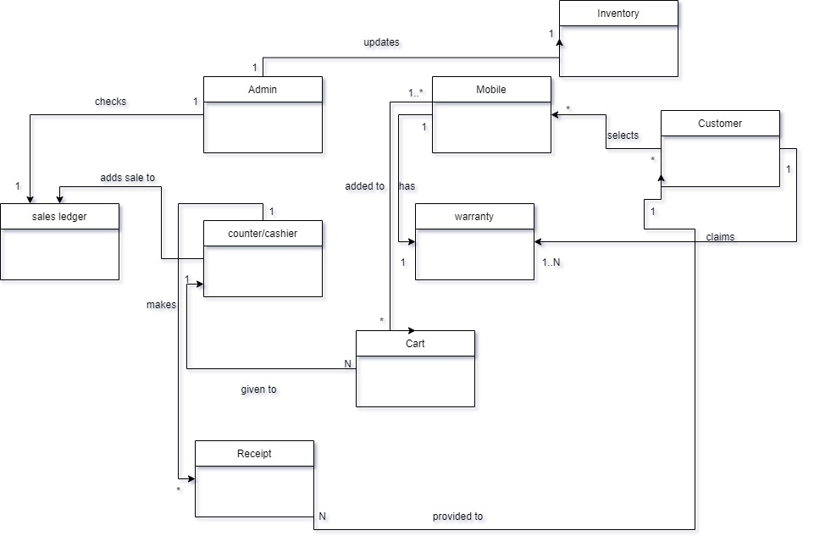

## SYSTEM SEQUENCE DIAGRAM: ADD TO CART

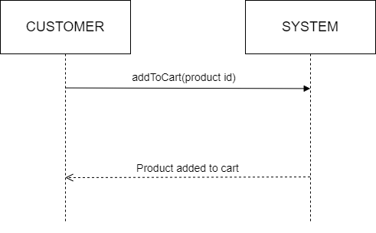

## SYSTEM SEQUENCE DIAGRAM: REMOVE FROM CART

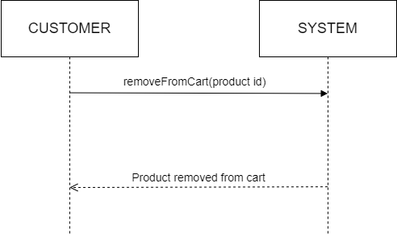

## SYSTEM SEQUENCE DIAGRAM: ADD TO WISHLIST

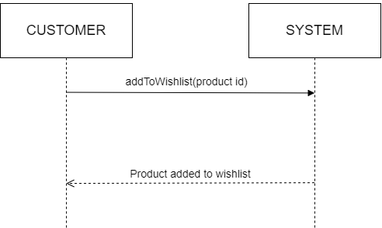

## SYSTEM SEQUENCE DIAGRAM: REMOVE FROM WISHLIST

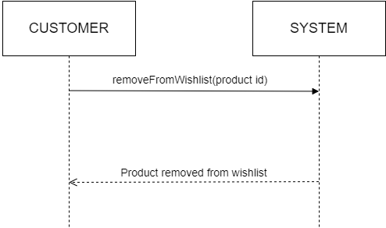

## SEQUENCE DIAGRAM: ADD TO CART

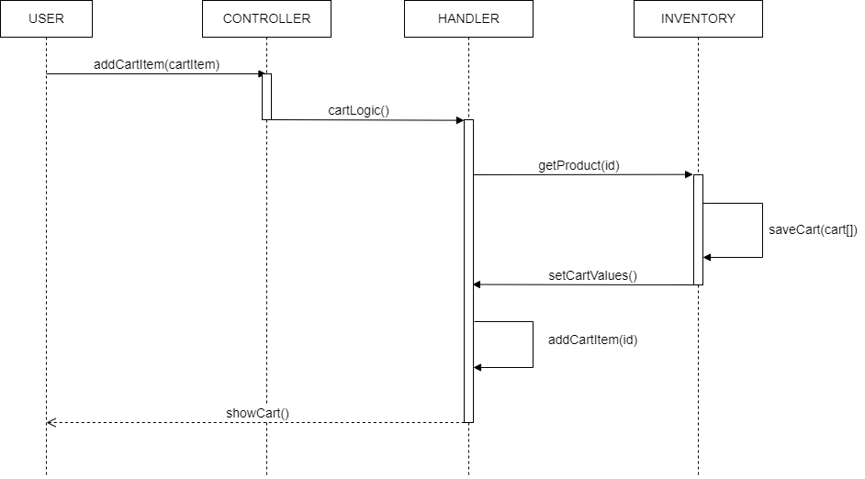

**SEQUENCE DIAGRAM: REMOVE FROM CART**

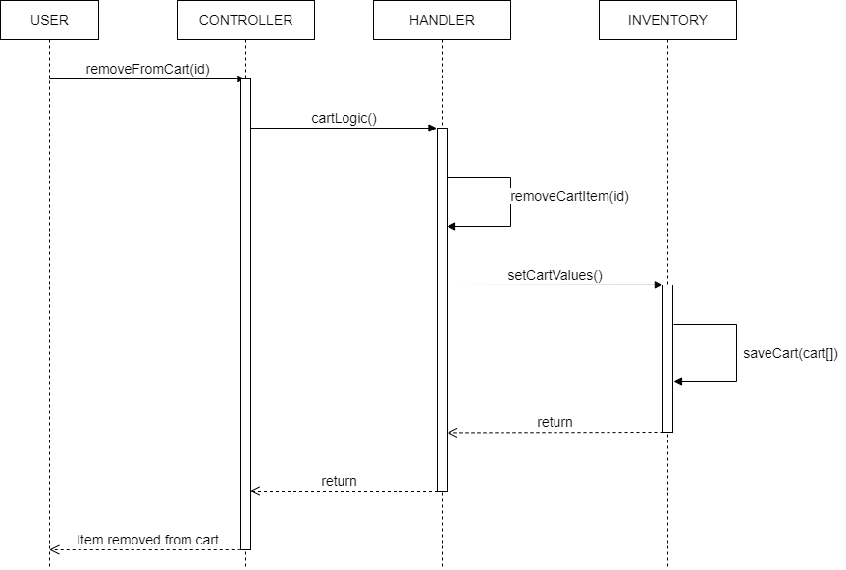

**SEQUENCE DIAGRAM: ADD TO WISHLIST**

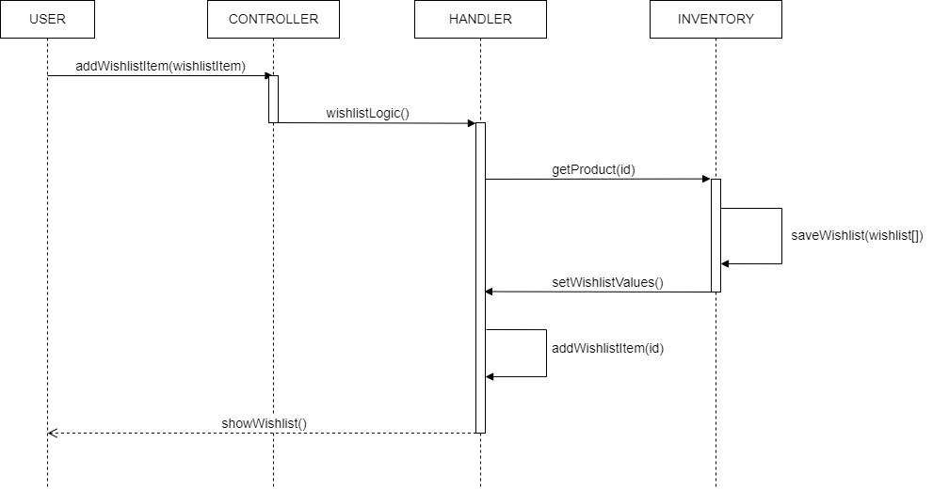

**SEQUENCE DIAGRAM: REMOVE FROM WISHLIST**

