1. Create an account screen

* Add datepicker in date of birth input
* When I add some text in date of birth “sdsds” , normally we have an error message to indicate that some date format required dd/mm/yyyy

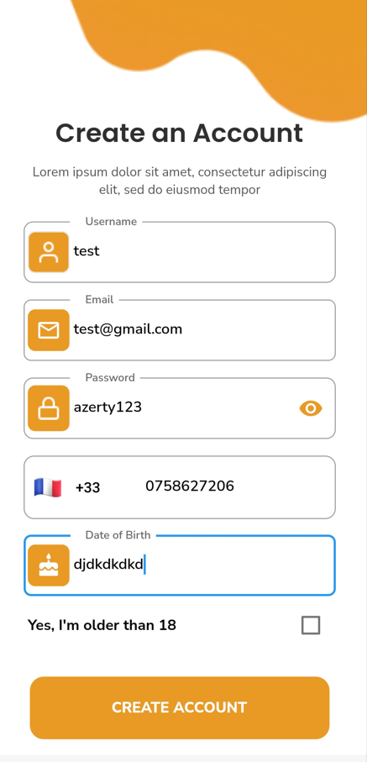

* When I add “04/12/2020” (less than 18) nothing is happening/ even when I set “04/12/1987” (older than 18 years)

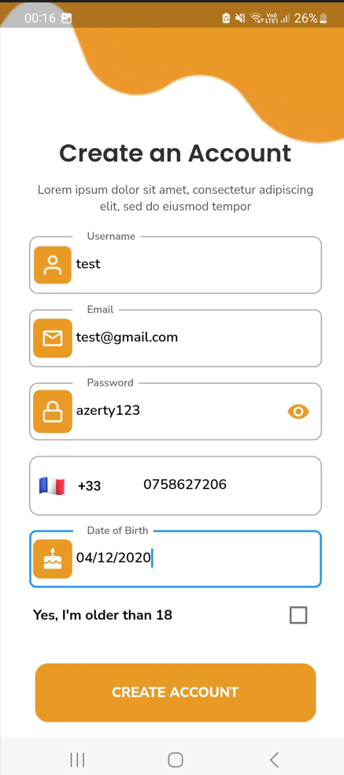

1. Enter your address screen

* Add google api to propose address when I start typing the address

1. Profil screen (add as a friend)

* When I add a person as a friend, the person have receive an invitation. And he has the possibility to accept him or refuse. Not be accepted automatically.

1. My profil screen :

* Add a cancel button when I edit some area (about me for exemple)

* When I want to add slot of time (breaks timings) we must have a time slot as dropdown list

Some think like this but every 15 min (in the exemple bellow every 30 minutes)

* In my profil screen, I have the possibility of editing “work address” and “home address”

1. Authentication screen :

* in the authentication page, when I put fake data. a technical error is displayed

