**Part C: General Tasks:**

1. **$_SESSION** superglobal is used to set and get the session variables. However, why is it so that in the case of cookies, **setcookie()** method is used to set cookie data while the **$_COOKIE** superglobal is used to retrieve that data. Provide reasons.

Ans: We use **setcookie(),** instead of **$_COOKIE** because the data is sent from the web server in the form of HTTP header which is ususally takes place using **setcookie()** method. Then the browser sends the cookie back to the server in an HTTP header using **$_COOKIE**. The **setcookie()** functions runs when the web browser requests the page for the first time( i.e reload). This cookie is stored in the users browser and isn’t available to script on the server until the next request. Upon the next request, the browser sends that cookie to the server and the array **$_COOKIE** will have the value that you initially set and the browser sent back upon the second request.

1. Turn off cookie propagation in **php.ini** setting and turn on the url propagation for the session id. Use sessions and observe (display output) how session id is being propagated between pages. What happens when both the settings are turned on in **php.ini** file? How will the session id get propagated then?

Ans**:**

The PHP configuration file, php.ini, is the final and most immediate way to affect PHP's functionality. The php.ini file is read each time PHP is initialized.in other words, whenever httpd is restarted for the module version or with each script execution for the CGI version. If your change isn.t showing up, remember to stop and restart httpd. If it still isn.t showing up, use phpinfo() to check the path to php.ini.

The php.ini file is the default configuration file for running applications that require PHP. It is used to control variables such as upload sizes, file timeouts, and resource limits.

Output of Session id propagates using Url:

** **

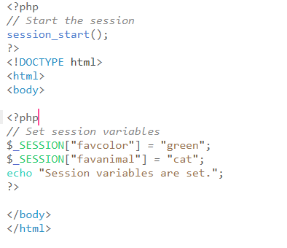

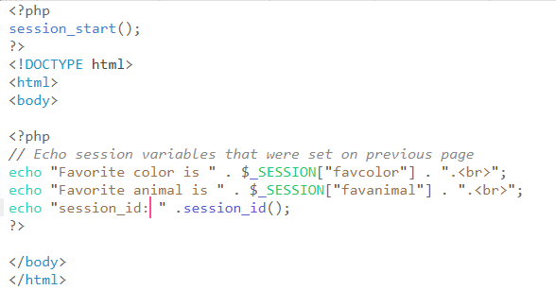

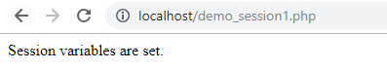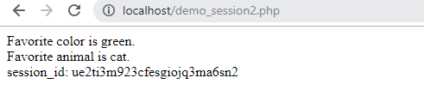

2) Output of When Both are Turn on:



And id is 

So, there is no any change observed when session id is propagates through either url or cookies or both. Output is same.