Same Skills, Different Words: A Comparative Quasi-Experimental Analysis of Lexical Variation Effects in Automated Resume Screening
Abstract
Automated resume screening systems increasingly rely on natural language processing (NLP) and similarity scoring to rank candidates against job descriptions. Prior work shows that wording choices—communal vs. agentic language, keyword phrasing, and demographic-correlated patterns—can influence both human and algorithmic hiring decisions. This study investigates whether small lexical variations in resumes (e.g., “Python” vs. “Python programming,” “ML” vs. “Machine Learning”) significantly change automated screening outcomes. Using a controlled quasi-experimental design, we hold resume content constant and systematically vary wording across four variant types: phrasing (synonym substitution), abbreviation (expansion/contraction), word order (token reordering), and placement (section restructuring). We score variants using TF-IDF cosine similarity and BM25 against job descriptions for four roles (AI Researcher, Data Scientist, Cybersecurity Analyst, Software Engineer) drawn from a public Kaggle dataset of 1,000 resumes. Results show that 20 of 32 variant–role–method combinations produce statistically significant score changes (p < .05), with eight showing large effect sizes (|Cohen’s d| ≥ 0.8). Abbreviation variants consistently reduce scores and cause rank drops of up to 1,142 positions in a pool of ~1,200 resumes. Phrasing variants produce the highest top-K flip rates (up to ~20% for top-50). Word order has negligible impact under TF-IDF but small BM25 effects. A logistic regression model using only screening-derived features achieves ROC AUC 0.993 for predicting recruiter decisions. We contribute quantifiable evidence that lexical variation alone can alter shortlist inclusion and recommend evidence-based wording guidance—abbreviation expansion, dual phrasing—to reduce unintended screening penalties.
Keywords: resume screening, lexical variation, ATS, TF-IDF, BM25, quasi-experiment, NLP, hiring bias, keyword matching

Introduction
Automated resume screening has become a critical component of modern hiring pipelines. Organizations receive thousands of applications for each open position, making manual review impractical. Applicant Tracking Systems (ATS) extract skills, education, and experience from unstructured resume text and rank candidates using similarity scoring—typically cosine similarity over TF-IDF vectors or probabilistic methods such as BM25—against job descriptions (Daryani et al. 2020). These systems promise efficiency and consistency, yet a growing body of research suggests that screening outcomes depend not only on what qualifications a candidate possesses but on how those qualifications are worded.
Madera et al. (2024) demonstrate that communal versus agentic language on resumes influences perceptions of candidate fit and competence in ways tied to gender norms. Deshpande et al. (2020) show that demographic-correlated language patterns can bias AI-based resume filters, proposing a fair-TF-IDF adjustment. Van Inwegen et al. (2025) report a randomized field experiment in which algorithmic writing assistance on resumes increased hiring rates, providing causal evidence that wording changes affect real employment outcomes. Wilson and Caliskan (2024) document gender, race, and intersectional bias in LLM-based resume retrieval. Rozado (2025) finds both gender and positional biases in LLM-based comparative resume evaluations.
These findings motivate a focused investigation: do small wording differences for the same underlying skills change automated screening scores, rankings, and shortlist inclusion? We address three research questions: (RQ1) Do wording variations for the same skills significantly change screening scores and rankings? (RQ2) Which variation types (phrasing, abbreviation, word order, placement) produce the largest rank shifts? (RQ3) Are wording effects consistent across job roles and screening methods? Our contribution is a controlled, quantitative diagnosis of lexical sensitivity in ATS-like screening, producing evidence that informs both applicant strategy and system design.

Methodology

Dataset and Preprocessing
We use the AI Resume Screening dataset from Kaggle, which contains 1,000 resumes with fields including Resume_ID, Skills, Education, Certifications, Experience (Years), Job Role, Recruiter Decision (Hire/Reject), and a synthetic AI Score (0–100). We filter to four job roles: AI Researcher (n = 257), Data Scientist (n = 255), Cybersecurity Analyst (n = 255), and Software Engineer (n = 233). Text preprocessing includes lowercasing, whitespace normalization, and filling missing Certifications with empty strings. Validation ensures Resume_ID uniqueness, non-empty Skills, and valid Recruiter Decision values. The cleaned dataset is stored as a Parquet file for reproducibility.

Variant Generation
We generate four controlled variant types per resume, each altering only wording while preserving the same underlying skills:
- Phrasing: synonym substitution using a domain thesaurus and WordNet, ranked by spaCy similarity (e.g., “Python” → “Python programming”).
- Abbreviation: expansion or contraction of terms (e.g., “Machine Learning” → “ML”).
- Word order: random shuffle of skill tokens within the Skills field.
- Placement: restructuring skills across resume sections (e.g., moving key terms into a dedicated Skills heading).
Each resume thus yields one control and four variants, producing 5,000 resume–variant instances. All random operations use a fixed seed (42) for reproducibility.

Screening Methods
We score each variant against role-specific job descriptions using two methods: (1) TF-IDF cosine similarity, the closest proxy to keyword-based ATS matching, and (2) BM25, a probabilistic relevance model widely used in information retrieval (Robertson and Zaragoza 2009). For each job role, all variants are ranked together with control resumes, producing scores, ranks, and percentiles within each role pool.

Evaluation Metrics
We compute paired comparisons (control vs. variant) for each resume:
- Delta score (Δ): difference in screening score (variant − control).
- Rank shift: change in ranking position (positive = variant ranked higher).
- Top-K inclusion flip: whether the resume crossed into or out of the top 10, 25, or 50.
- Threshold flip: whether the resume crossed a 0.5 score cutoff.
Statistical significance is assessed with Wilcoxon signed-rank tests (two-sided, paired) and Cohen’s d effect sizes for each variant–role–method combination. Additionally, logistic regression predicts Recruiter Decision from screening features; a screening-only model excludes the synthetic AI Score to isolate ATS-derived predictive power.

Results

Delta Scores and Rank Shifts
Table 1 summarizes mean delta scores and rank shifts for selected variant–role–method combinations. Abbreviation variants consistently reduce scores for most roles, especially under BM25 (Data Scientist: Δ = −1.76, rank shift = −604; Software Engineer: Δ = −2.03, rank shift = −444). This confirms that shortened forms (e.g., “ML” instead of “Machine Learning”) lose keyword matches against job descriptions that use the full term. Phrasing variants show the widest spread—some improve scores substantially (Cybersecurity BM25: Δ = +2.94) while others degrade them, making synonym substitution a high-risk, high-reward strategy. Word order has zero TF-IDF impact (expected: bag-of-words is order-invariant) but produces small BM25 shifts due to term-proximity weighting.
Rank shifts are practically significant: in a pool of ~1,200 resumes per role, abbreviation causes drops of up to 1,142 positions for Data Scientist (TF-IDF) and up to 1,056 for Software Engineer. Phrasing produces bidirectional shifts (−1,985 to +894), highlighting the unpredictability of synonym substitutions. A shift of 500+ positions can determine whether a candidate appears in a recruiter’s shortlist.
Variant | Role | Method | Δ Score | Rank Shift | Effect
Abbreviation | Data Scientist | BM25 | −1.76 | −604 | large
Abbreviation | Software Eng. | BM25 | −2.03 | −444 | large
Abbreviation | Data Scientist | TF-IDF | −0.09 | −786 | large
Abbreviation | Software Eng. | TF-IDF | −0.06 | −705 | large
Abbreviation | Cybersecurity | TF-IDF | −0.07 | −582 | large
Phrasing | Cybersecurity | BM25 | +2.94 | +353 | large
Phrasing | AI Researcher | TF-IDF | +0.02 | −26 | small
Placement | Data Scientist | TF-IDF | −0.05 | −450 | large
Placement | Cybersecurity | TF-IDF | −0.04 | −330 | large
Word Order | All roles | TF-IDF | 0.00 | 0 | negligible
Table 1. Mean delta scores and rank shifts by variant type, role, and method.

Top-K and Threshold Flip Rates
Table 2 reports the fraction of resumes whose shortlist status changed due to wording alone. Phrasing variants produce the highest flip rates across all K values—up to 19.8% of resumes change top-50 status under TF-IDF for AI Researcher, and 20.4% for Cybersecurity Analyst. Abbreviation variants cause dramatic threshold flips under BM25: 100% of Software Engineer resumes and 39.6% of Data Scientist resumes cross the 0.5 score threshold. Word-order variants produce no top-K flips for TF-IDF and only small threshold effects under BM25. These flip rates represent real screening decisions that would change based solely on wording, not qualifications.
Variant | Role | Method | Top-10 | Top-25 | Top-50 | Threshold
Phrasing | AI Researcher | TF-IDF | 5.1% | 10.1% | 19.8% | 0%
Phrasing | Cybersecurity | TF-IDF | 6.3% | 10.6% | 20.4% | 0%
Phrasing | Data Scientist | BM25 | 5.5% | 16.9% | 22.0% | 4.3%
Abbreviation | Software Eng. | BM25 | 0% | 0% | 0% | 100%
Abbreviation | Data Scientist | BM25 | 0% | 0% | 0% | 39.6%
Abbreviation | AI Researcher | BM25 | 0% | 1.6% | 11.3% | 17.9%
Word Order | All roles | TF-IDF | 0% | 0% | 0% | 0%
Table 2. Top-K and threshold flip rates (fraction of resumes changing status).

Statistical Significance
Table 3 summarizes results from Wilcoxon signed-rank tests. Twenty of 32 variant–role–method comparisons are statistically significant (p < .05). Eight comparisons show large effect sizes (|Cohen’s d| ≥ 0.8), confirming the practical importance of wording choices. Abbreviation produces the largest effects: Cohen’s d reaches −4.85 for Software Engineer (TF-IDF) and −4.57 for Data Scientist (TF-IDF). Phrasing effects are more variable, with large effects for some role–method combinations (Cybersecurity BM25: d = 1.06) but negligible for others (Data Scientist TF-IDF: d = −0.18). Word-order variants are non-significant under both methods across all roles, confirming that token reordering alone has negligible impact on lexical screening methods.
Variant | Role | Method | n | Cohen’s d | Effect Size | p < .05
Abbreviation | Software Eng. | TF-IDF | 233 | −4.85 | large | Yes
Abbreviation | Data Scientist | TF-IDF | 255 | −4.57 | large | Yes
Abbreviation | Data Scientist | BM25 | 255 | −2.50 | large | Yes
Abbreviation | Cybersecurity | TF-IDF | 255 | −2.54 | large | Yes
Abbreviation | Software Eng. | BM25 | 233 | −2.95 | large | Yes
Phrasing | Cybersecurity | BM25 | 255 | 1.06 | large | Yes
Placement | Data Scientist | TF-IDF | 255 | −4.44 | large | Yes
Placement | Cybersecurity | TF-IDF | 255 | −0.81 | large | Yes
Word Order | AI Researcher | BM25 | 257 | −0.02 | negligible | No
Word Order | Software Eng. | BM25 | 233 | −0.13 | negligible | No
Table 3. Statistical significance (Wilcoxon signed-rank test, Cohen’s d).
Figure 1 presents a heatmap of mean delta scores under BM25 across variant types and job roles. Abbreviation produces the largest negative deltas for Data Scientist and Software Engineer. Phrasing shows positive deltas for Cybersecurity Analyst, reflecting that expanded phrasing can improve matches against verbose job descriptions.
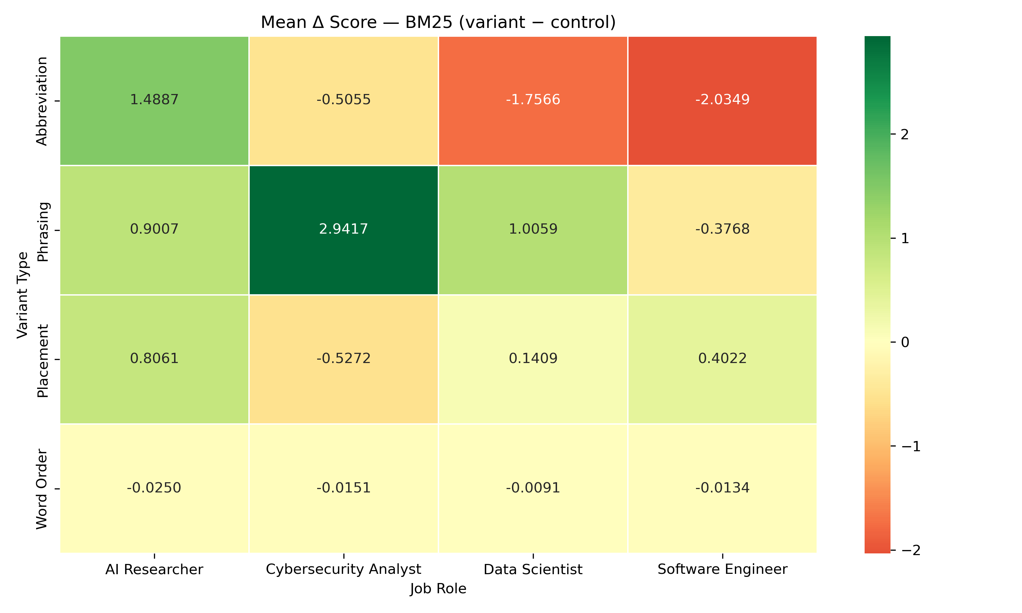
Figure 1. Delta score heatmap (BM25): mean score change by variant type and job role.
Figure 2 shows the distribution of rank shifts by variant type under BM25. Abbreviation and phrasing variants exhibit the widest spreads, with phrasing producing both substantial gains and losses. Placement shows moderate spread, while word order produces near-zero shifts.
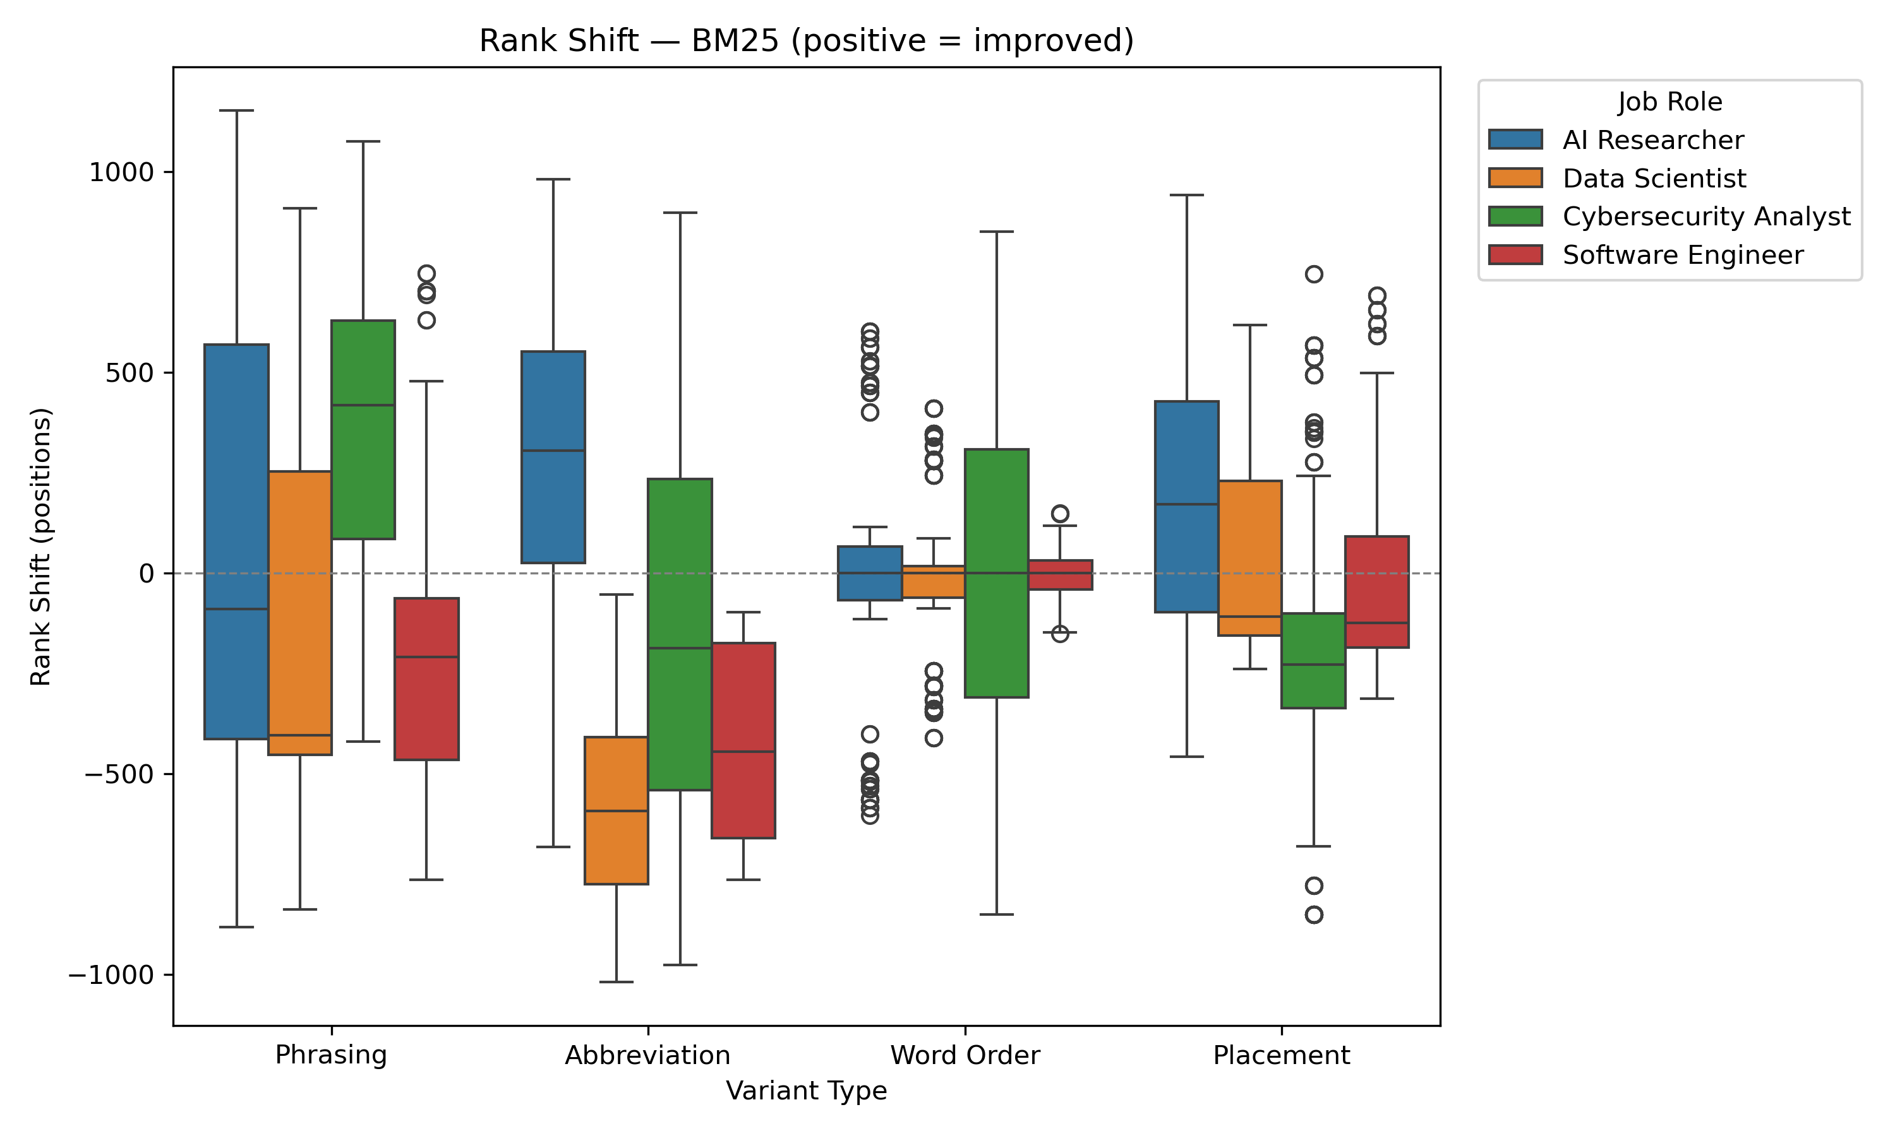
Figure 2. Rank shift distribution by variant type (BM25).
Figure 3 presents the ROC curve for the screening-only logistic regression model (AI Score excluded). The model achieves AUC = 0.993, demonstrating that screening-derived features—TF-IDF and BM25 scores, ranks, and percentiles—carry strong predictive signal for recruiter decisions even without the synthetic AI Score variable.
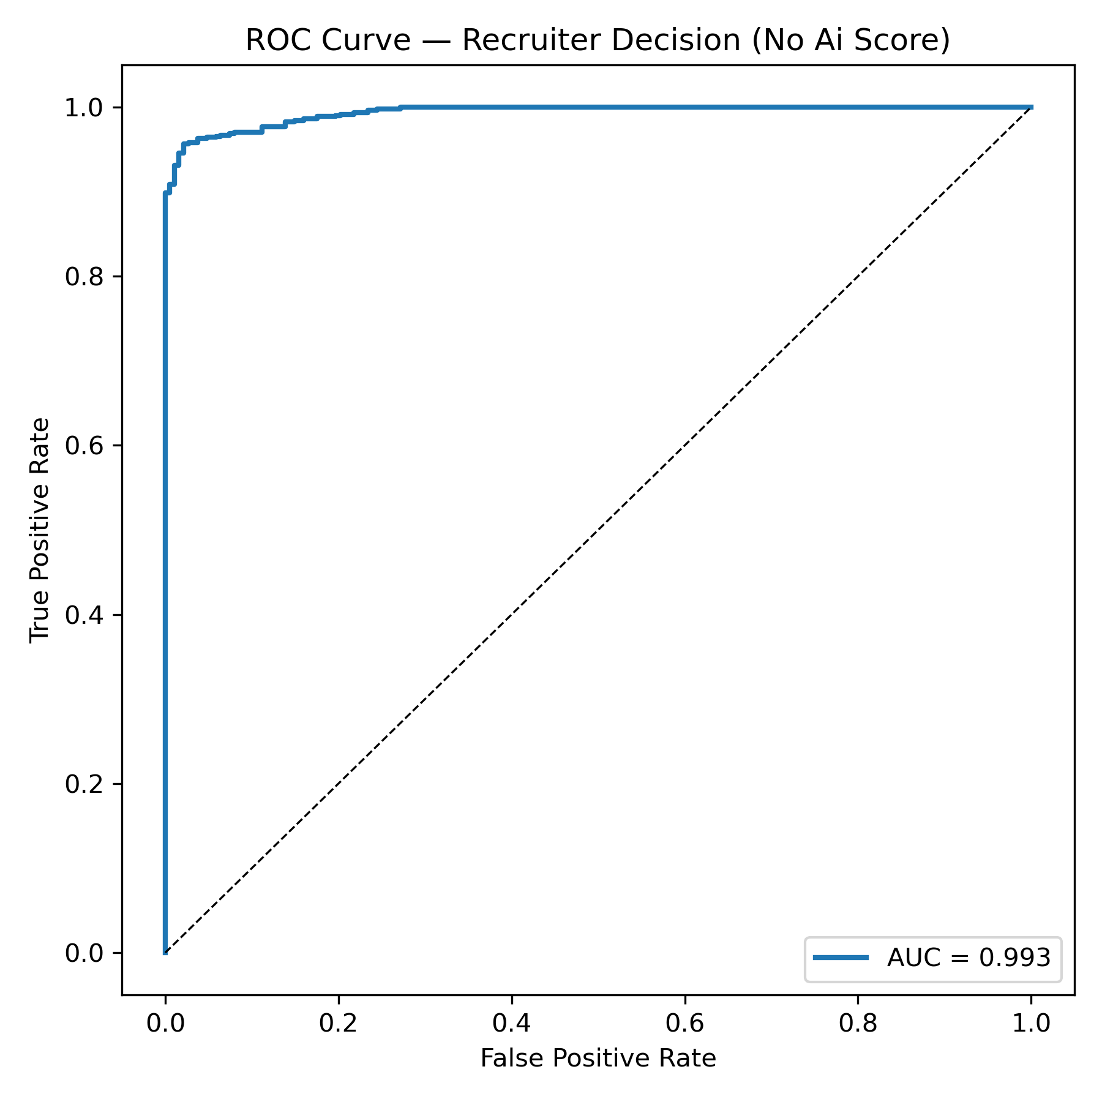
Figure 3. ROC curve for screening-only logistic regression (AUC = 0.993).

Logistic Regression
Two logistic regression models predict Recruiter Decision (Hire = 1) from screening outputs and resume features. The full model (including the synthetic AI Score) achieves near-perfect accuracy (0.994) and AUC (1.0), driven by the AI Score coefficient of 10.74. This variable likely encodes the decision label directly. The screening-only model, which excludes AI Score, achieves accuracy 0.951 and AUC 0.993. Its strongest predictors are Experience (8.37), Projects Count (4.68), rank_tfidf (−1.64), percentile_tfidf (−0.90), and score_tfidf (−0.63). These coefficients confirm that ATS-like screening scores carry meaningful, non-trivial predictive signal for hiring outcomes after controlling for experience and project count. The negative coefficients on rank reflect that lower rank numbers (better positions) correlate with higher hire probability.
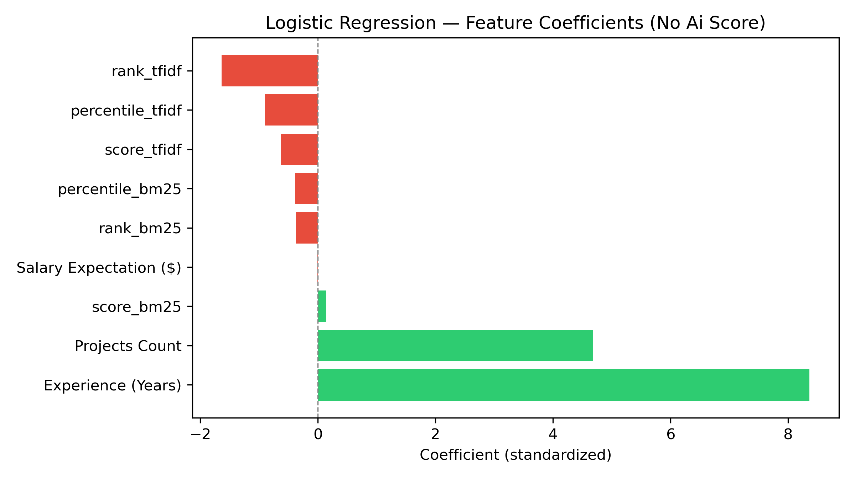
Figure 4. Logistic regression coefficients (screening-only model, AI Score excluded).

Discussion
Our findings extend prior work in several directions. Deshpande et al. (2020) demonstrate that language patterns can bias automated filters; we quantify exactly how specific lexical operations—abbreviation, phrasing, placement—affect scores and ranks. Madera et al. (2024) show wording effects on human perception of candidates; we demonstrate analogous effects in automated systems. Robertson and Zaragoza (2009) establish BM25 as a strong retrieval baseline; we find BM25 more sensitive to abbreviation than TF-IDF, likely because BM25’s term-frequency saturation and document-length normalization amplify the impact of missing keywords.
Van Inwegen et al. (2025) provide causal evidence that writing assistance improves hiring rates. Our results explain a mechanism: wording changes alter the scores and ranks that determine whether a resume reaches a recruiter’s desk. Wilson and Caliskan (2024) and Rozado (2025) document bias in LLM-based screening; our study shows that bias-like effects exist even in simpler lexical systems, where no demographic information is explicitly encoded—only phrasing choices.
Practical implications are twofold. For applicants, expanding abbreviations (e.g., “Machine Learning (ML)”) and using dual phrasing where appropriate can reduce unintended screening penalties. Our data shows abbreviation causes the most consistent damage, while phrasing changes are unpredictable. For ATS designers, these results highlight the fragility of keyword-based matching and motivate semantic methods—embedding-based similarity or query expansion—that are less sensitive to surface-level wording. Future work should test whether such methods reduce the wording penalties documented here.
Limitations include the use of a single publicly available dataset and synthetic recruiter labels. The job descriptions used for scoring are researcher-authored rather than drawn from real postings. Embedding-based scoring was not evaluated in this study. Despite these constraints, the controlled quasi-experimental design provides strong internal validity for the effects observed.

Conclusion
We provide quantifiable evidence that lexical variation alone significantly changes automated resume screening outcomes. Abbreviation variants consistently reduce scores and cause rank drops of up to 1,142 positions. Phrasing variants produce the highest top-K flip rates, with up to 20% of resumes changing top-50 status. Word order has negligible impact on both TF-IDF and BM25. Screening-derived features predict recruiter decisions with AUC 0.993. We recommend that applicants expand abbreviations and use dual phrasing, that ATS designers adopt semantic matching to reduce wording sensitivity, and that future research evaluate embedding-based scoring and fairness-aware screening methods.

References
Daryani, C., Chhabra, G. S., Patel, H., Chhabra, I. K., and Patel, R. 2020. “An Automated Resume Screening System Using Natural Language Processing and Similarity,” Topics in Intelligent Computing and Industry Design (2:2), pp. 99–103.
Deshpande, K. V., Pan, S., and Foulds, J. R. 2020. “Mitigating Demographic Bias in AI-Based Resume Filtering,” in Adjunct Proceedings of the 28th ACM Conference on User Modeling, Adaptation and Personalization (UMAP ’20), pp. 1–6.
Madera, J. M., Ng, L., Zajac, S., and Hebl, M. R. 2024. “When Words Matter: Communal and Agentic Language on Men and Women’s Resumes,” Journal of Business and Psychology (40:2), pp. 479–496.
Robertson, S., and Zaragoza, H. 2009. “The Probabilistic Relevance Framework: BM25 and Beyond,” Foundations and Trends in Information Retrieval (3:4), pp. 333–389.
Rozado, D. 2025. “Gender and Positional Biases in LLM-Based Hiring Decisions: Evidence from Comparative CV/Résumé Evaluations,” PeerJ Computer Science (11), e3628.
van Inwegen, E., Munyikwa, Z., and Horton, J. J. 2025. “Algorithmic Writing Assistance on Jobseekers’ Resumes Increases Hires,” Management Science (71:12), pp. 10144–10164.
Wilson, K., and Caliskan, A. 2024. “Gender, Race, and Intersectional Bias in Resume Screening via Language Model Retrieval,” Proceedings of the AAAI/ACM Conference on AI, Ethics, and Society (AIES ’24) (7:1), pp. 1578–1590.

