Name: Mashhood Farqaleet

Class:BSCS-2-C

Roll no.:232511

DATABASE SYSTEMS

PROJECT PHASE->1



***E-COMMERCE FULFILLMENT HUB***

**SUBMITTED TO: MAM KAINAT NAZIR**

**Planning Phase**

**PURPOSE.**

**Stores Verified Product**

**The basic purpose of E commerce Fulfillment Hub DBMS is have Efficient Inventory management at store’s end and give ease and assurance about product to buyer that seller really own’s the product which saves from scam and fraud and fulfillment center can assure the product condition which saves buyer from further inconvenience.**

**In case of Return**

**This DBMS helps employees working in fulfillment center that how to deal with Return Processing Phase. The DBMS deals with if a customer initiates a return, the DBMS handles the return authorization process, issuing return labels and tracking return shipments.**

**TARGET AUDIENCE.**

**Fulfillment centers**

* **E-commerce businesses such as *fulfillment centers* interested in leveraging expertise in designing and implementing a database solution for e-commerce fulfillment hubs.**

**Business owners**

* **Business owners and decision-makers seeking to enhance their operations, streamline order fulfillment processes, and improve efficiency through advanced database management systems.**

**Smart Seller**

* **Help smart seller to keep database of their products available in inventory and keep details of products verified from fulfillment centers and also products rejected, sold , remaining, etc.**

**ERD**

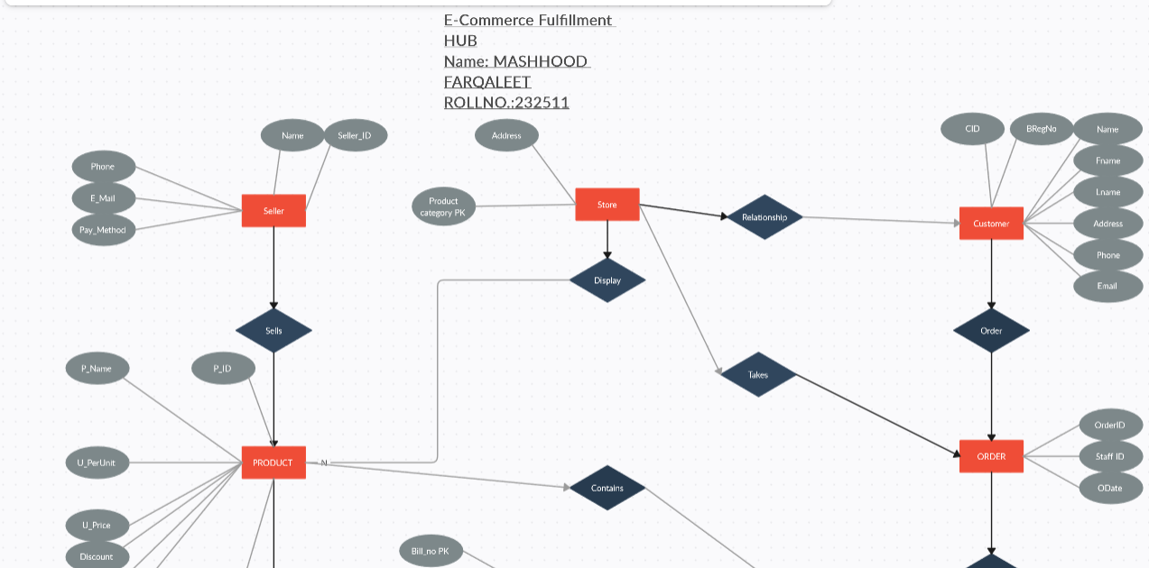

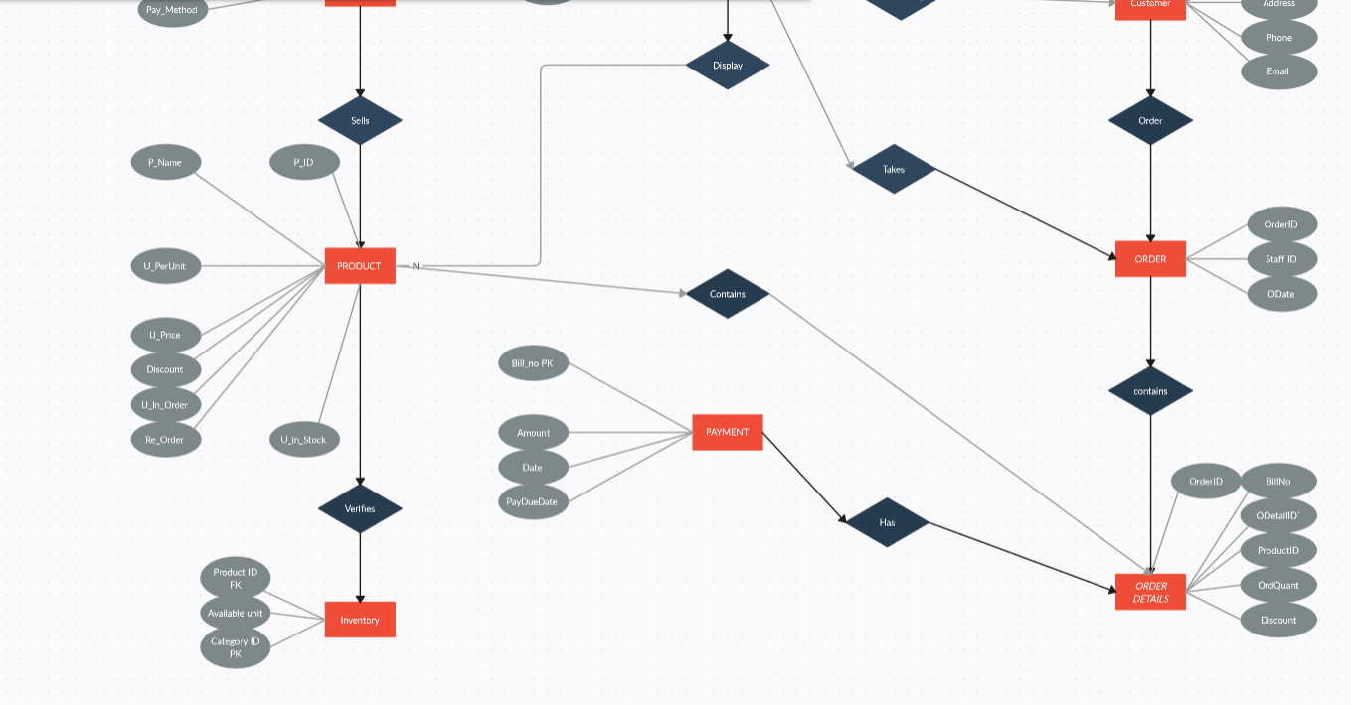

**OVERALL**

