**FACULTY ACCOUNT User Interface**

Log in

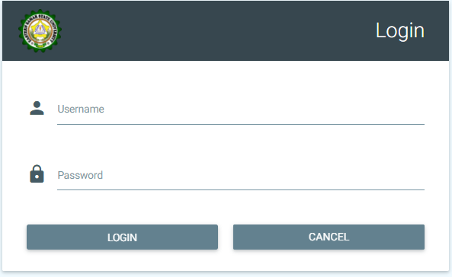

Home Page

View Rating

Evaluate Peer



Menu

Profile

Change Password

Change Email

2016-2017

2nd Semester

Logout Profile Search

Recent Evaluation

100

80

60

40

20

0



Knowledge of Subject Matter

Teaching for Independent Learning

Commitment

Management of Learning

View Rating > Students

View Rating

-Students

-Peers

-Supervisor

Evaluate Peer

Logout Profile Search

Menu

Profile

Change Password

Change Email



**Students Rating**

School Year

Semester

View

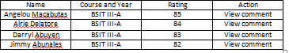

Average Rating: ____

View Rating > Peers



**Peers Rating**

Average Rating: ____

Profile

Change Password

Change Email

Menu

Logout Profile Search

View Rating

-Students

-Peers

-Supervisor

Evaluate Peer

School Year

Semester

View

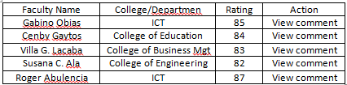

View Rating > Supervisor



School Year

Semester

View

View Rating

-Students

-Peers

-Supervisor

Evaluate Peer

Logout Profile Search

Menu

Profile

Change Password

Change Email

**Supervisor Rating**

**Evaluator Name:** Roger R. Abulencia **College/Dept.:** ICT

**Position**: Dean

**Commitment**

**Knowledge of Subject Matter**

**Teaching for Independent Learning**

**Management of Learning**

**Comments:**

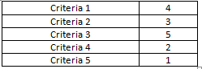







*Comments of the dean/supervisor*

Total Rating: ____

Evaluate Peer

View Rating

-Students

-Peers

-Supervisor

Evaluate Peer



Profile

Change Password

Change Email

Menu

Search

Enter Code: __

Logout Profile Search

**Peer Evaluation**

Evaluation Code**: wa32**

**Faculty Name**: Jared Harem Celis **School Year:** 2016-2017 **Semester**: 2nd

**Subject Handled**: Computer Programming **College/Dept.:** ICT

Legend:

Comment/Suggestion:

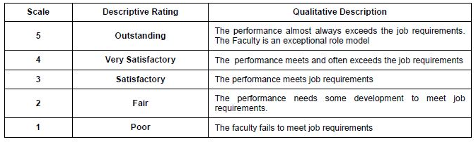

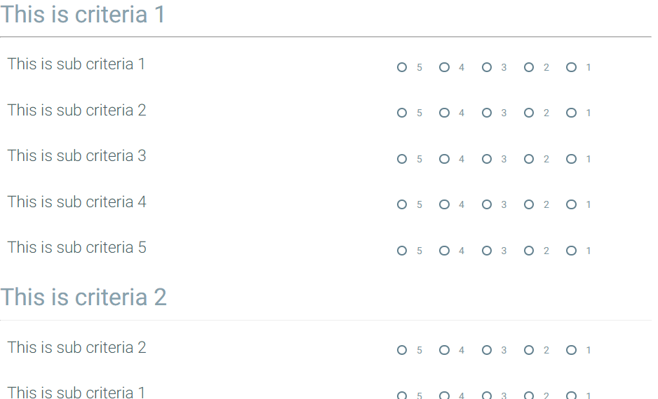

*Input box*

Submit