1. Login form: the forget password button doesn't lead anywhere.



Steps to play back:

1. Open the form.

2. Click on the forget password button.

ER:

Opening the password recovery form.

AR:

Nothing happened, the button doesn't lead.

2. Login form: the username field does not give an error when entering an invalid email.

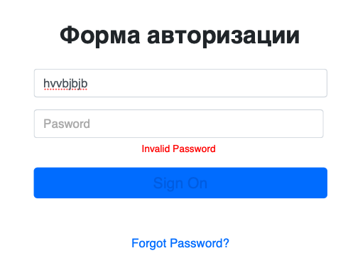

Steps to play back:

1. Open the form.

2. Enter an invalid email address.

3. Press the Sign On button.

ER:

Invalid username error appears.

AR:

The error did not appear, the field is not highlighted.

3. Login form: typo in the error message (invalid username).

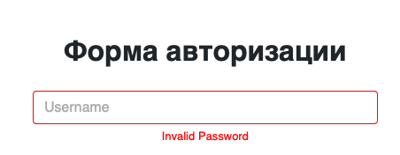

Steps to play back:

1. Open the form.

2. Click on the sign on button.

ER:

Invalid Username error appears.

AR:

Invalid Password error appears.

4. Login form: typo in the placeholder field password.



Steps to play back:

1. Open the form.

2. Check the placeholder of the password field.

ER:

Placeholder password.

AR:

Placeholder password.

5. Login form: the name of the page " authorization form” is written in Russian.

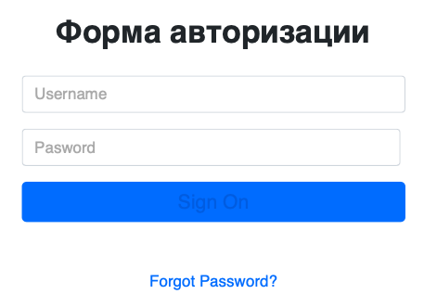

Steps to play back:

1. Open the form.

2. Check the page name.

ER:

Authorization form.

AR:

Форма авторизации.

6. Login form: the name of the sign on button instead of log in.



Steps to play back:

1. Open the form.

2. Check the sign on button.

ER:

Text on the button is Log In.

AR:

Text on the button is Sign On.

7. Login form: the font color of the Sign On button is too dark.



Steps to play back:

1. Open the form.

2. Check the sign on button.

ER:

The text on the button has light color.

AR:

The text on the button has dark color.

8. Login form: Password field length 385px

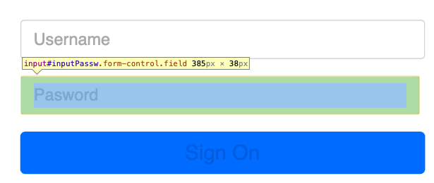

Steps to play back:

1. Open the form.

2. Open developer mode in the browser.

3. Check the length of the password field.

ER:

Field length 390px.

AR:

Field length 385px.

9. Login form: the number of characters entered in the username field is too small (15 characters)



Steps to play back:

1. Open the form.

2. Check the number of characters entered in the username field.

ER:

Number of characters 256, as in other forms.

AR:

Number of characters 15.

10. Login form: the password field does not give an error when entering an invalid password.

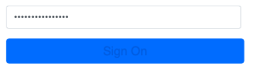

Steps to play back:

1. Open the form.

2. Enter an invalid password.

3. Click on the sign on button.

ER:

The field is highlighted, invalid password error message.

AR:

No error message.

11. Login form: login occurs when you enter the registered password and any login.

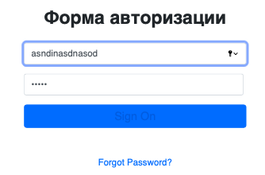



Steps to play back:

1. Open the form.

2. Enter invalid email address.

3. Enter a valid password.

4. Click on the log in button.

ER:

Error message " Login failed, please check your username and password”.

AR:

No error message.

12. Login form: no animation when you click on the sign on button.



Steps to play back:

1. Open the form.

2. Click on the sign on button.

ER:

Animation appearance.

AR:

Nothing is happening.

13. Login form: the password field is not highlighted when an error appears on it.

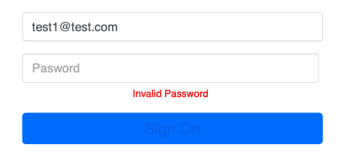

Steps to play back:

1. Open the form.

2. Click on the sign on button.

ER:

The password field is highlighted, an error message appears.

AR:

The field is not highlighted.