**Crypto Currency Exchange**

**Software Requirements Specification**

**Name:**  **Mashood Ahmed**

**Revision History**

|  |  |  |  |
| --- | --- | --- | --- |
| **Date (dd/mm/yyyy)** | **Version** | **Description** | **Author** |
| 31/12/2021 | 1.0 | In this Application we create restful api for Crypto currency Exchange and give accessibility to view the crypto currency live rates | Mashood Ahmed |
|  |  |  |  |
|  |  |  |  |
|  |  |  |  |

**SRS Document**

Functional and non-Functional Requirements:

*Functional Requirement 1:*

ID: FR1

TITLE: Signup

DESC: User Must register himself/herself.

RAT: In order to login

DEP: None

*Functional Requirement 2:*

ID: FR2

TITLE: Email Verification

DESC: User will able to verify their email address using link that send to their email.

RAT: In order to email verification

DEP: FR1

*Functional Requirement 3:*

ID: FR3

TITLE: Phone Number Verification

DESC: User will able to verify their Phone number using OTP.

RAT: In order verify phone number

DEP: FR1

*Functional Requirement 4:*

ID: FR4

TITLE: Forgot password

DESC: All users will able to forget.

RAT: In order to get password on their email.

DEP: FR1, FR2, FR3

*Functional Requirement 5:*

ID: FR5

TITLE: Authentication Login

DESC: User will be able to enter email and password in order to access the system.

RAT: In order to use assigned privileges.

DEP: FR1, FR2, FR3

*Functional Requirement 6:*

ID: FR6

TITLE: 2 Factor Authentication

DESC: 4-digit code will send to user in email, phone.

RAT: In order access system.

DEP: FR5

*Functional Requirement 7:*

ID: FR7

TITLE: KYC

DESC: User Must Provide KYC.

RAT: In order to access system.

DEP: FR5, FR6

*Functional Requirement 8:*

ID: FR8

TITLE: Logout

DESC: User will be able to logout from the system.

RAT: In order to getting out of the system.

DEP: FR5, FR6

*Functional Requirement 9:*

ID: FR9

TITLE: Deposit

DESC: User can add credit card.

RAT: In order to do some transactions.

DEP: FR5, FR6

Non-Functional Requirements:

Non-Functional Requirement 3.1

**ID: NFR1**

TITLE: Response Time

DESC: The response time of website should be fast. The user should be able to access all information of clothes and inventory in no time.

RAT: In order to access information quickly

DEP: None

Non-Functional Requirement 3.2

**ID: NFR2**

TITLE: Website Reliability

DESC: Website would work in all situations with 100% efficiency.

RAT: In order to make website reliable.

DEP: None

Non-Functional Requirement 3.3

**ID: NFR3**

TITLE: Website Testability

DESC: Test environments should be built for the website to allow testing of the website’s different functions.

RAT: In order to test the website.

DEP: None

Use Case Diagram(s):

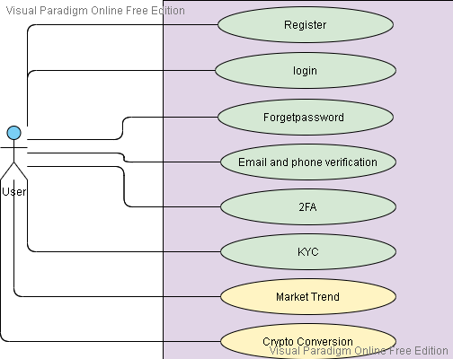

Usage Scenarios:

* **Use case 1**

|  |  |
| --- | --- |
| **Use Case Title** | Registration |
| **Use Case ID** | UC-01 |
| **Actors** | User |
| **Description** | This use case provides a registration form, by this form User can register on the website. |
| **Preconditions** | User have to request the system for registration by clicking on the Register button; the system will take the user to the registration form for registration. |
| **Alternate Steps** | If input is invalid, so user will provide it again. |
| **Postconditions** | Users successful login |
| **Exceptions** | Registration information incorrect or server not responds. |

* **Use case 2**

|  |  |
| --- | --- |
| **Use Case Title** | Email and mobile phone Verification/ Login |
| **Use Case ID** | UC-02 |
| **Actors** | User |
| **Description** | This use case provides a Login, by this user can login on the website. |
| **Preconditions** | User have to request the system for Login by clicking on the login button; the system will give access to the web by the login |
| **Alternate Steps** | If input is invalid, so user will provide it again. |
| **Postconditions** | Users and Admin successful login. |
| **Exceptions** | Request Data incorrect or server not responds. |

* **Use case 3:**

|  |  |
| --- | --- |
| **Use Case Title** | Forgot/Rest password |
| **Use Case ID** | UC-03 |
| **Actors** | User |
| **Description** | User can reset password. |
| **Preconditions** | Must have account. |
| **Alternate Steps** | If some information is incorrect in records so user can update record for that do all steps again. |
| **Postconditions** | User will be able to do login into and use system modules. |
| **Exceptions** | Server not respond or data format is not according to format. |

* **Use case 4:**

|  |  |
| --- | --- |
| **Use Case Title** | Login |
| **Use Case ID** | UC-04 |
| **Actors** | User |
| **Description** | Email and Phone otp will be send to user for verification. |
| **Preconditions** | User will just have to click on the link from the email section and phone number verification user have to put the value on the website field. |
| **Alternate Steps** | If input is invalid, so user will provide it again. |
| **Postconditions** | User verification completed |
| **Exceptions** | Request Data incorrect or server not responds. |

* **Use case 5:**

|  |  |
| --- | --- |
| **Use Case Title** | 2 factor authentication |
| **Use Case ID** | CCE 5 |
| **Actors** | User |
| **Description** | User will be able to do 2 factor authentication using OPT that system send to their email and phone number and google authenticator. |
| **Preconditions** | Must have account and successfully complete the use case 4. |
| **Alternate Steps** | If some information is incorrect in records so user can update record for that do all steps again or send query to admin. |
| **Postconditions** | User will be able to do login into and use system modules. |
| **Exceptions** | Server not respond or data format is not according to format. |

* **Use case 6:**

|  |  |
| --- | --- |
| **Use Case Title** | KYC |
| **Use Case ID** | CCE 6 |
| **Actors** | User |
| **Description** | User will be able to upload their document and sign the consignment for completing their profile. |
| **Preconditions** | Must have account and login to their account. |
| **Alternate Steps** | If some information is incorrect in records so user can update record for that do all steps again or send query to admin. |
| **Postconditions** | User able to use system modules. |
| **Exceptions** | Server not respond or data format is not according to format. |

Database Diagram

