Hotel Booking Cancellation Analysis
About 37% of all bookings were canceled, and the City Hotel lost far more bookings than the Resort Hotel (42% vs 28%). This report explains what was done in the analysis, shows every chart, and ends with suggestions to reduce cancellations.
The data is the public hotel bookings dataset: 119,390 bookings from a City Hotel and a Resort Hotel in Portugal, with arrivals between July 2015 and August 2017. Each row is one booking, with details such as hotel type, country, market segment, average daily rate (ADR, the average price per night) and whether the booking was canceled.
The analysis was done in Python using pandas, NumPy, Matplotlib and Seaborn.
Data cleaning
The raw data was checked and cleaned before any charts were made. 118,897 bookings remained after cleaning.
- Loaded the CSV and checked its size (119,390 rows, 32 columns), data types and missing values.
- Converted reservation_status_date from text to a proper date, so it could be grouped by day and month.
- Listed the unique values in every text column to understand the categories (hotel type, meal, country, market segment and so on).
- Dropped the agent and company columns. They were mostly empty (16,340 and 112,593 missing values) and not needed for the analysis.
- Dropped the remaining rows with missing values (4 in children, 488 in country), removing 492 rows.
- Removed one extreme outlier: a booking with an ADR of 5,400, far above every other booking. Only bookings with ADR below 5,000 were kept.
- Added a months column taken from the reservation status date, used for the monthly charts.

Charts and what they show
1. Reservation status count
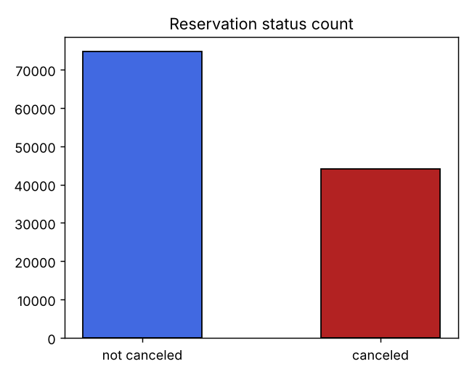
What was done: counted canceled and not-canceled bookings and drew them as a bar chart.
What it shows: 74,745 bookings (63%) went ahead and 44,152 (37%) were canceled. More than one in three bookings is lost, which is a big problem for hotel revenue.
2. Reservation status in different hotels
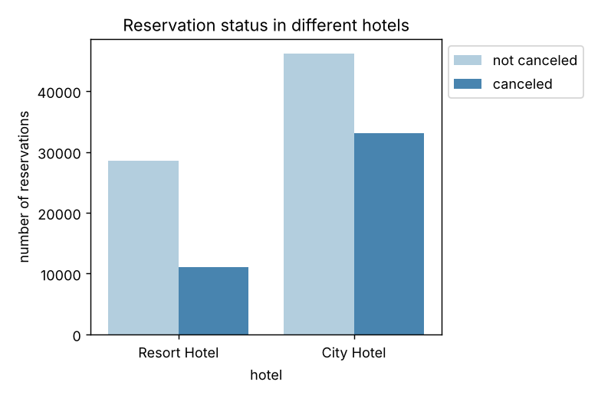
What was done: split the bookings by hotel type and compared canceled vs not canceled. The cancellation share was then worked out for each hotel separately.
What it shows: the City Hotel has about twice as many bookings as the Resort Hotel (79,301 vs 39,596) and a much higher cancellation rate: 42% vs 28%.
3. Average daily rate in City and Resort Hotel
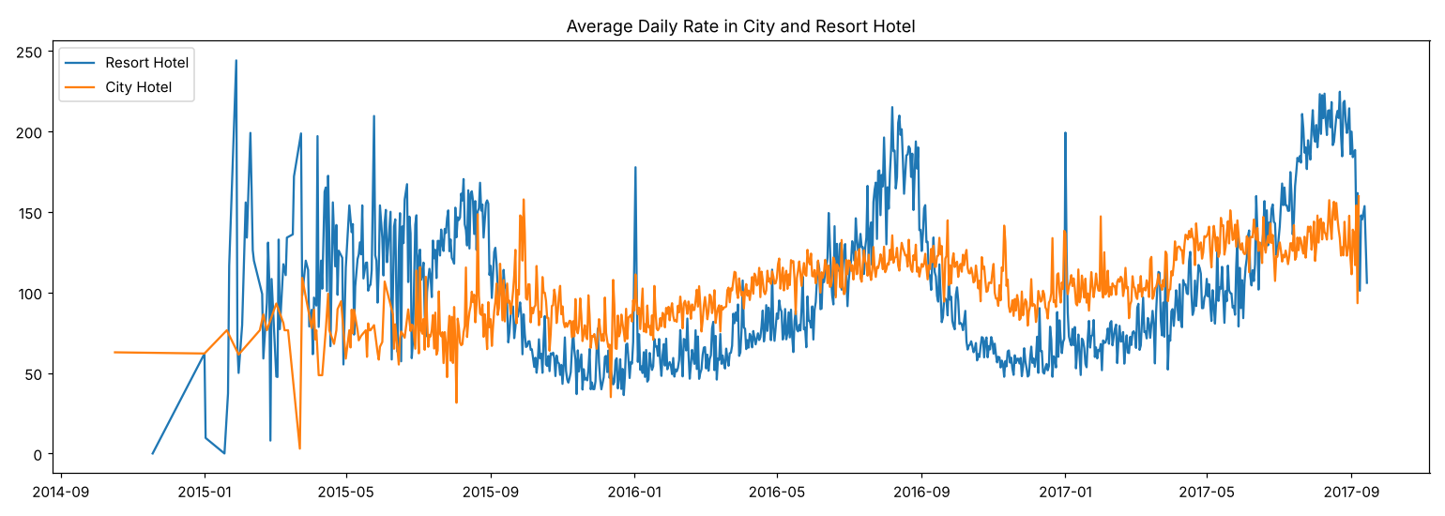
What was done: for each hotel, took the average ADR for each reservation status date and plotted both hotels over time.
What it shows: the City Hotel's price stays fairly steady through the year. The Resort Hotel's price swings with the seasons, rising sharply in summer and dropping in winter. It is sometimes higher than the City Hotel in peak season.
4. Reservation status in each month
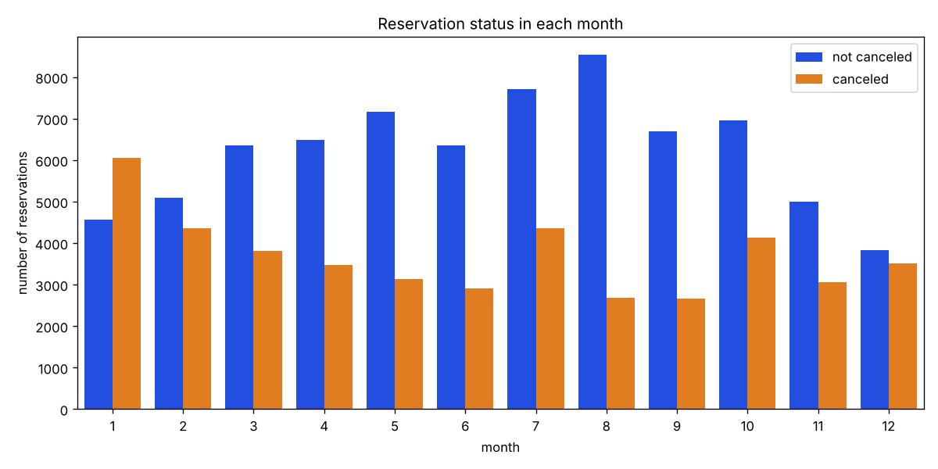
What was done: took the month from the reservation status date and counted canceled vs not-canceled bookings for each month.
What it shows: January is the only month where cancellations outnumber kept bookings (6,060 vs 4,562, a 57% cancellation share). December (48%) and February (46%) are also high. August has the most kept bookings and the lowest cancellation share (24%).
5. ADR per month (canceled bookings)
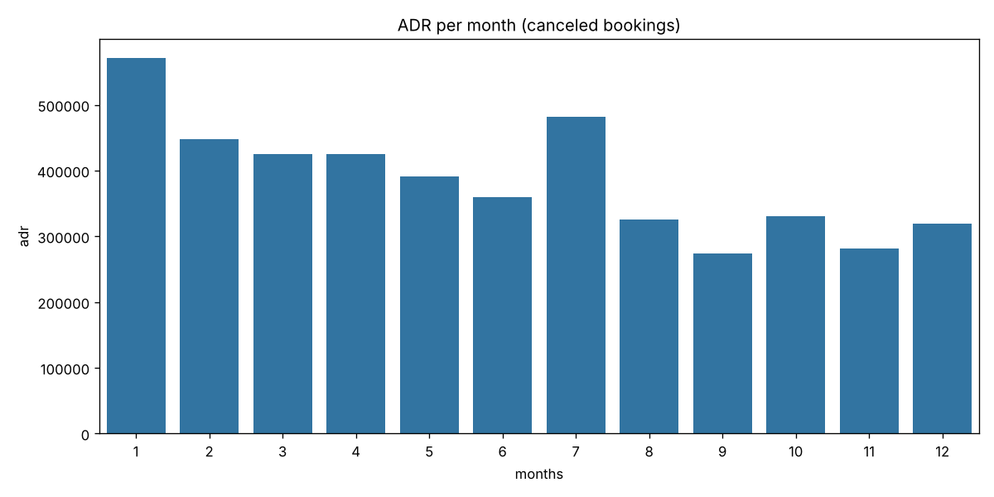
What was done: for canceled bookings only, added up the ADR for each month to see how much booking value was lost.
What it shows: January has the highest total ADR from canceled bookings (about 571,000), followed by July (481,000) and February (448,000). So the most revenue is lost in January.
6. Top 10 countries with most canceled reservations
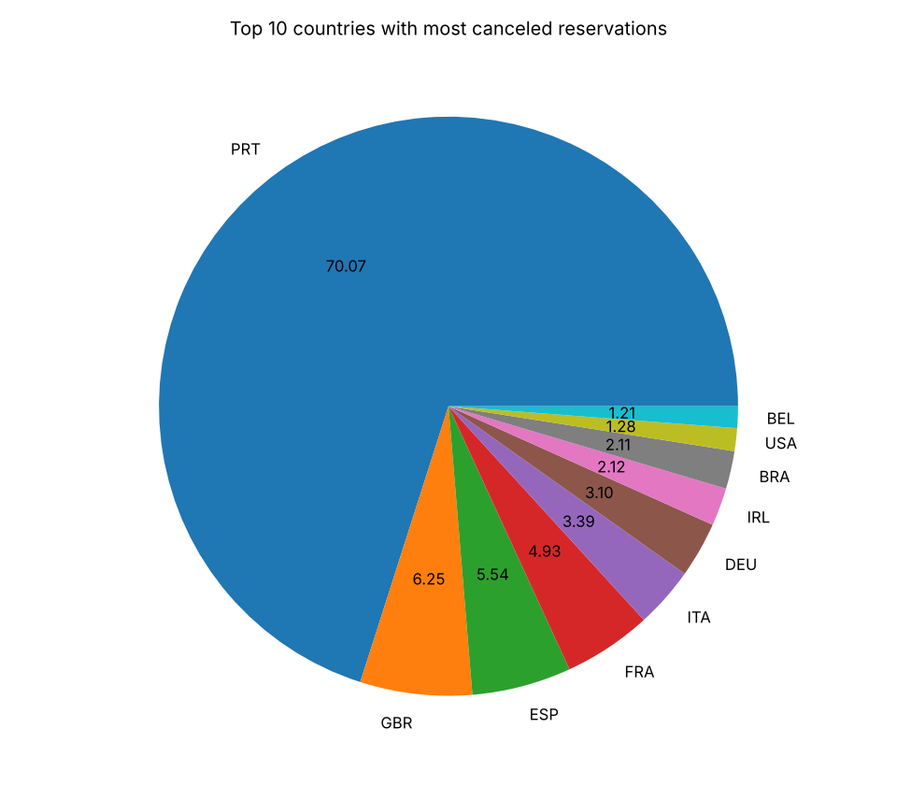
What was done: took the canceled bookings, counted them by country and drew the top 10 as a pie chart.
What it shows: Portugal (PRT) dominates, with 27,514 canceled bookings, about 70% of the top 10 and 62% of all cancellations. The UK, Spain, France and Italy follow far behind. Both hotels are in Portugal, so local guests make up a large share of bookings and of cancellations.
Market segment check: most bookings come through Online TA (56,402). Of all canceled bookings, 47% came from Online TA, 27% from Groups and 19% from Offline TA/TO.
7. Average daily rate: canceled vs not canceled (full period)
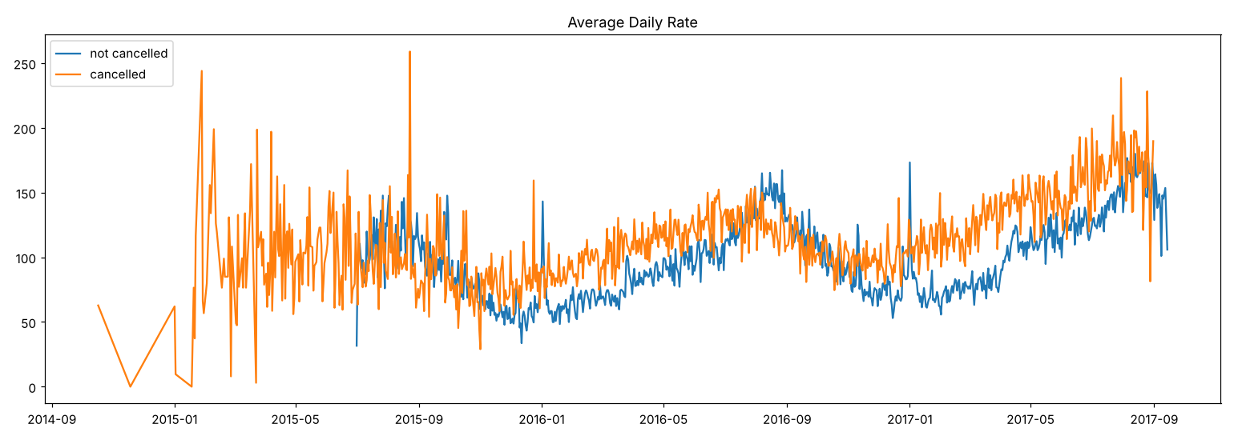
What was done: worked out the average ADR per reservation status date for canceled and kept bookings and plotted both lines.
What it shows: the two lines follow similar seasonal patterns, but the edges of the chart are noisy because few bookings fall on those dates.
8. Average daily rate: canceled vs not canceled (Jan 2016 to Sep 2017)
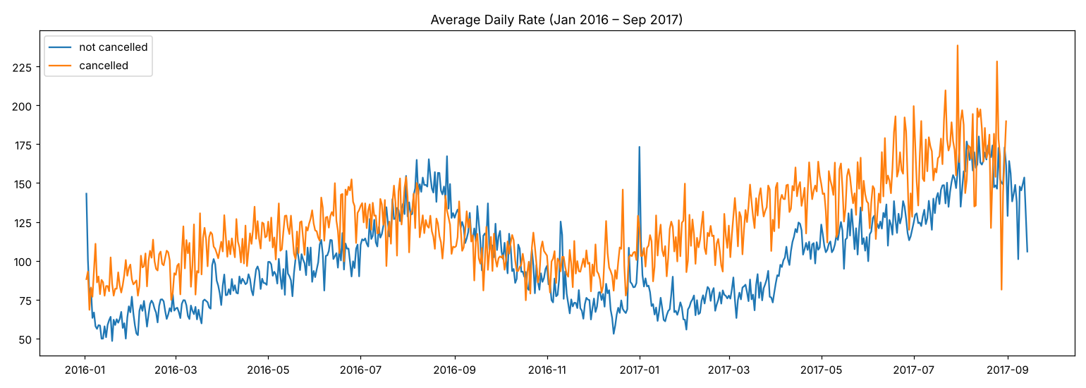
What was done: filtered both lines to January 2016 to September 2017 to remove the noisy edges and redrew the chart.
What it shows: the canceled line sits above the not-canceled line most of the time (average ADR about 122 vs 101). Bookings with higher prices are more likely to be canceled, which supports suggestion 1.
Key findings
- 37% of bookings were canceled (44,152 of 118,897).
- The City Hotel cancels more: 42% of its bookings were canceled, against 28% at the Resort Hotel. The City Hotel is also slightly pricier on average (ADR 105 vs 95).
- January had the highest cancellation share: 57% of reservation status changes recorded in January were cancellations, and it had the highest total ADR from canceled bookings. August had the lowest share (24%).
- Portugal accounts for most cancellations: 62% of all canceled bookings came from guests in Portugal, far ahead of the UK (6%) and Spain (5%).
- Online travel agents bring the most cancellations: 47% of canceled bookings came through Online TA, followed by Groups (27%) and Offline TA/TO (19%).
- Canceled bookings were priced higher: from January 2016 to September 2017, the average ADR of canceled bookings (about 122) was above that of kept bookings (about 101).
Suggestions
- Review pricing. Cancellation rates rise as the price does. To prevent cancellations, hotels could work on their pricing strategies and lower rates for specific hotels based on location. They can also offer discounts to customers.
- Discounts on weekends and holidays. The ratio of canceled to not-canceled bookings is higher in the resort hotel than in the city hotel, so hotels should offer a reasonable discount on room prices on weekends or holidays.
- January campaigns. Cancellations are highest in January, so hotels can start campaigns or marketing with a reasonable budget in that month to increase revenue.
- Improve quality in Portugal. Hotels can improve the quality of their rooms and services, mainly in Portugal, to reduce the cancellation rate.
Note on suggestion 2: the data shows the opposite ratio. The City Hotel cancels 42% of bookings and the Resort Hotel 28%, so the wording may need to be switched to the city hotel.
Note on suggestion 3: the months come from the reservation status date (when a booking was canceled or checked out), not the arrival date. So January is when the most cancellations are recorded, not necessarily when canceled stays were due.

