EGN 6216 · AI SYSTEMS
Milestone 3
Data Pipeline & Management
Working document · Sections 1–6 of the AI System Project Master Template
Student name | Mashoukur Rahman
Project title | AI-Based Land Subsidence Susceptibility Mapping to Support Groundwater Monitoring Prioritization in California's San Joaquin Valley (Tulare-Corcoran study area).

HOW TO USE THIS DOCUMENT · DO NOT REWRITE MILESTONE 2
This is one working document for the whole project, not a new report. Sections 1–5 are the identical scaffolds from your Milestone 2 submission, and Section 6 is new for Milestone 3.
You are not being asked to redo Milestone 2. Open your Milestone 2 file, select each response you already wrote, and copy and paste it into the matching place here. The section numbers, boxes and tables are the same, so everything drops straight in.
Before you go further, reread the feedback on your Milestone 2 grade in Canvas. Revise the sections it points to as you paste them in, so this document reflects that feedback rather than repeating the same issue. Record those revisions in the table below.
Then complete Section 6, and change only what the real data changed: update the affected responses in Sections 1–5 and the data-related rows of your Trustworthiness Plan (3.3) and Risk Register (5.3) in place. Keep the original plan visible so the change is easy to see. Everything else stays exactly as you submitted it.
Sections 1–5 still say “Milestone 2” in their boxes because that is when those plans were made. Leave that wording. Where a box says “Later”, that part is still not due.

Revisions from Milestone 2 feedback
List what you changed in Sections 1–5 in response to the feedback on your Milestone 2 grade. If a point did not require a change, say why. Add rows as needed.
Section | Feedback point | What you changed, or why no change was needed
1.2 Project Overview; 2.1 Needs Assessment (and the carried-forward 2.1B source table) | Check when the predictor data became available. A January 2020 cutoff was described using observation dates, but a 2019-dated reading can be published well after 2019. | Reframed the project as a retrospective analysis built on the full, currently-archived historical record, rather than a simulation of a real-time January 2020 deployment. 2.1B now records each predictor source's native reporting lag and the archived-availability cutoff actually used, alongside the original observation-date cutoff, so the two are no longer conflated (see the revision notes inside 1.2 and 2.1).
2.2 Requirements table (training-time, macro-F1 and hit-rate-at-K rows); 2.6 Scalability and Performance; 2.7 Infrastructure Decision Record | “Exceed baselines by a documented margin” and “far below” the target both need a specific criterion. Explain the basis for the F1 target and when a model is kept, revised, or rejected. Reconcile the training-time target with the two-hour infrastructure trigger. | Added a specific margin (≥10 percentage points of hit rate at each budget size) and an explicit macro-F1 decision rule (≥0.50 keep, 0.35–0.50 revise, ≤0.35 reject/report-only), with the 0.50 target justified against the ~0.07 no-skill baseline for this 5-class problem. Reconciled the 30-minute target (model fitting only) with the ~2-hour trigger (full pipeline, 2.6/2.7) by stating explicitly what each figure measures.
4.4 Prototype and Evaluate the Interaction | The flow diagram does not show what the monitoring user reads. Add the missing map/interface sketch with legend, confidence or uncertainty, low-support areas, and no-data areas, and check whether a reviewer can select monitoring cells without reading a relative class as a forecast of physical damage. | Built and embedded the low-fidelity interface sketch (map canvas plus legend: 5 classes, per-cell confidence, a distinct low-confidence/sparse-data symbol, and a distinct no-data/excluded symbol). Revised the walkthrough question to explicitly test whether a peer reviewer can both select monitoring cells and correctly state that a class is a relative historical ranking, not a damage forecast.
3.3 Trustworthiness Plan; 5.3 Risk Register; 5.4 Residual Risk and Acceptance | Combine overlapping concerns into roughly three to five priorities; narrow the four marked priority risks to the two or three that most change the work; explain residual ratings through remaining likelihood and impact, including a projection error that could invalidate the map. | Consolidated 3.3 from 7 rows to 4 (merging reliability with data-density-driven unevenness, and merging transparency, appropriate-use scope and uncertainty communication). Narrowed 5.3/5.4 to 3 priority risks (class imbalance, spatial generalization, temporal/predictor leakage); the user-misinterpretation risk is folded into 3.3's transparency concern rather than dropped. 5.4 now derives each residual rating from the Likelihood×Impact table and discusses the CRS/resolution projection-error risk as the clearest low-likelihood, high-impact map-invalidating failure mode.

MILESTONE 3 · DATA PIPELINE & MANAGEMENT · SECTION 6
Can your system obtain, manage, transform and reproduce the data it actually needs?
Your deliverable
- Data source and rights record: each major source, how it was obtained, its ownership, license or permission, and any privacy or access constraint. (6.2–6.3)
- Implemented data flow: where raw data lives, how it enters the development pipeline, where processed data lives, and how deployment-time data will enter the system. (6.1–6.2)
- Data quality investigation: real evidence for the quality and coverage issues that matter here — missingness, class balance, duplicates, label quality, or representation. (6.4)
- Splitting and leakage statement: how development and evaluation data are separated, and why that method suits your data. (6.5)
- Implemented preparation pipeline: only the preprocessing, cleaning, augmentation, chunking, labeling, feature engineering or synthesis you actually use, and why. (6.7)
- Reproducibility and lineage: it must be possible to identify which data version and which processing code produced a given experiment. (6.6)
Show evidence
- Dataset statistics, small tables or figures, validation output, or representative examples from the real data.
- Links to ingestion and preprocessing code where that is clearer than prose.
- A data-flow diagram, or an updated architecture, when the real pipeline differs from the planned one.
- Updates to the existing risk and trustworthiness records showing which data controls were applied and what remains unresolved.
Keep it lean
Do not perform or describe a technique because it appears in the examples. If your data does not need SMOTE, image augmentation, dimensionality reduction, synthetic data or formal versioning tooling, do not manufacture them. Explain the simpler approach that fits.

BEFORE YOU SUBMIT
What did the real data reveal that changed your assumptions, your architecture, your scope, your success criteria, or your risk profile? Update the affected sections above.

01 | PROJECT OVERVIEW  What system are you proposing, why does it matter, and who would use or be affected by it?

COMPANION · SECTION 1 · MILESTONE 1
Complete the title (1.1), overview (1.2), and stakeholders (1.3) in the existing fields. If already submitted, preserve that proposal as your starting record. Put later changes in Appendix A and the affected working sections. Compare the final system with the original proposal in 9.7.

1.1 Project Title
Project Title:
AI-Based Land Subsidence Susceptibility Mapping to Support Groundwater Monitoring Prioritization in California's San Joaquin Valley (Tulare-Corcoran study area).

1.2 Project Overview
Project Overview:
Objective: Long-term groundwater extraction in the Tulare-Corcoran area of California's San Joaquin Valley causes land subsidence, damaging canals, roads, pipelines, and wells while permanently reducing aquifer storage capacity. This project develops an AI-based classification system that maps subsidence susceptibility across the basin into five classes (very low to very high), so that a groundwater manager can identify which areas most need additional monitoring. The expected outcome is a susceptibility map, exported as a GIS layer, that helps prioritize where limited monitoring resources should go.

Scope: The system will use a narrowed set of essential predictor layers (historical groundwater-level data, land use/land cover, and basic soil/geologic characteristics) from approximately 2016–2019, paired with observed subsidence classes from approximately 2020–2024, to train a baseline classifier. The system will not predict exact future displacement, optimize pumping policy, or replace physical monitoring (InSAR, GPS, extensometers); it is a decision-support tool.

AI Techniques and Tools: The primary modeling approach is a Random Forest classifier (scikit-learn), evaluated with geographically held-out test regions rather than a random split. A CNN or U-Net segmentation approach is identified as a possible extension, not a semester commitment. Core tools: Python, scikit-learn, Rasterio, NumPy, Pandas, GeoPandas.

1.4 Prediction Definition and Susceptibility Classes
Geographic unit: Every prediction corresponds to one grid cell on the common raster grid built during preprocessing (2.1), planned at approximately 500 m × 500 m. This resolution is a deliberate compromise between the native resolution of available InSAR-derived deformation products (commonly on the order of 100 m–1 km) and keeping the feature-engineering and training pipeline light enough for a one-semester CPU-only baseline.
Prediction horizon: The model uses predictor conditions observed during a fixed 2016–2019 “predictor window” to classify each cell's susceptibility during a fixed, subsequent 2020–2024 “outcome window.” This is a roughly one-to-five-year-ahead horizon between the end of the predictor window and the outcome window it is validated against. The system is explicitly a retrospective susceptibility relationship validated on one historical horizon, not a general-purpose forecasting tool for an arbitrary future horizon a limitation already noted in the Milestone 1 revision and reinforced here.
What is being predicted: susceptibility under the conditions observed during the predictor window not a deterministic prediction of future subsidence, and not a direct severity measurement in centimeters. Concretely, the training label for each cell is its cumulative vertical land-surface displacement over the 2020–2024 outcome window, derived from InSAR-based deformation products. The classifier learns which combinations of predictor-window conditions were historically associated with each level of that subsequent cumulative displacement.
Class boundary justification: the five class boundaries will be set using a quantile-based approach over the distribution of cumulative outcome-window displacement across all training-region cells (for example, cut points at roughly the 20th, 40th,60th, and 80th percentiles), rather than an arbitrary or purely visual choice. Under this approach, “very high” susceptibility would concretely mean “cells in the top fifth of observed 2020–2024 cumulative displacement,” and this definition will be reported explicitly alongside the map. If a literature-based physical threshold (for example, a displacement rate associated with documented infrastructure damage in prior subsidence studies) is identified during data exploration, it will be considered as an alternative or supplementary boundary rule, and whichever method is used will be stated in the map's documentation.
What susceptibility is not: susceptibility class is not a complete measure of infrastructure risk. Actual infrastructure risk also depends on factors outside this model's scope the type, age, and condition of nearby infrastructure, its sensitivity to differential settlement, and any mitigations already in place. The map's documentation will state this distinction directly: the output describes relative likelihood of subsequent land-surface deformation based on historical patterns; not how much damage would occur at a given location.

1.5 What the System Adds Beyond a Simple Prioritization Approach
Two simple baselines are defined so the Random Forest model's contribution can be demonstrated directly, not just asserted: (a) a persistence baseline, which ranks or classifies each cell using only its own historical subsidence trend during the predictor window (a simple linear extrapolation of its pre-2020 InSAR deformation rate), with no other predictors — essentially “assume wherever subsidence has already been happening will keep happening”; and (b) a simple-indicator baseline, a small logistic regression (or basic threshold rule) using only two or three easily available indicators, such as historical groundwater-level decline rate and a binary flag for fine-grained/compressible soil, without the full narrowed predictor stack or Random Forest's ability to model interactions between variables.
Comparison plan: after training, susceptibility rankings will be generated from the Random Forest model and from each baseline on the same geographically held-out test region, and the cells where the Random Forest ranking diverges most from each baseline's ranking will be identified and mapped.
Where the difference should matter to a manager: the persistence baseline is expected to systematically under-rank locations where groundwater decline is accelerating but little subsidence has been recorded yet since a linear extrapolation of a flat or low historical trend stays low which are exactly the locations where early monitoring has the most value, because the subsidence has not yet become visible in the InSAR history. By incorporating groundwater-level trends and soil susceptibility alongside historical deformation, the Random Forest model is expected to flag these “not-yet-visible-but-primed” locations as higher susceptibility, something the persistence baseline would miss entirely. Conversely, the Random Forest model may down-rank a location with a high historical subsidence rate if groundwater and soil conditions suggest the trend is decelerating (for example, where pumping restrictions are already in effect), while the persistence baseline would keep flagging it regardless.
Quantifying and reporting these specific divergences not just an aggregate classification score is how this project will demonstrate a meaningful system contribution over a naive prioritization approach, addressing the concern that Random Forest performance alone is not, by itself, a convincing case for the system.

Revised after Milestone 2 feedback — Fix #1 (predictor availability):
The scope above fixes a 2016–2019 predictor window against a stated January 2020 information cutoff. On review, that cutoff described the dates attached to the predictor observations, not the dates those products were actually released. Checking release patterns for each source (2.1B below) shows the two are not the same: California DWR/SGMA groundwater-level readings are typically published with roughly a 6–12 month reporting lag, and annual land-use/land-cover products of the CropScape/NLCD type are typically released roughly a year after the mapped year, so a measurement or layer dated anywhere in 2019 may not actually have been archived and downloadable until well into 2020 or later. The project is therefore described here, explicitly, as a retrospective analysis: it uses the full, currently-archived historical record for the 2016–2019 predictor window and the 2020–2024 outcome window, built and evaluated with hindsight, rather than as a simulation of a system that could have been deployed operationally on January 1, 2020. No claim is made that this model could have been produced and run in real time at that date; 2.1B documents, source by source, the native update lag and the archived cutoff actually used, so the distinction between an observation date and an availability date is explicit rather than assumed.
Note on real data (Milestone 3):
the predictor set I actually implemented in the real pipeline (6.1–6.2) includes soil but not a separate geologic layer — geologic layers are not included yet, so ‘soil/geologic characteristics’ above should be read for now as soil characteristics only. This narrows scope; it does not change the modeling approach.

1.3 Stakeholders
Stakeholders:
Project Team: This is an individual project. Mashoukur Rahman is the sole project developer, responsible for data preprocessing, model development, evaluation, and the system design documented in this milestone.

End Users: The primary end user is a groundwater manager at a Groundwater Sustainability Agency (GSA) in the Tulare-Corcoran area. The manager would interact with the system's output as a GIS map layer (loaded into QGIS/ArcGIS alongside existing well and permit data) to decide where to prioritize additional subsidence monitoring during periodic groundwater management plan reviews.

Other Stakeholders: California water-management agencies (e.g., California Department of Water Resources), scientific/technical organizations (hydrologists, geologists, USGS), local irrigation and water districts, farmers and agricultural water users, domestic well users and local communities, infrastructure operators and local governments, and regulators/policymakers who would need to consider how model output is incorporated into real decisions.

02 | COMPUTING INFRASTRUCTURE  What computing environment does your system actually need, and what evidence supports those choices?

MILESTONE 2 · ONE INTEGRATED BLUEPRINT
Complete Sections 2–5 as plans supported by the evidence available now. Put Architecture v1 in 2.7, requirements in 2.2, infrastructure decisions in 2.7, interaction work in Section 4, controls in 3.3, and risks in 5.3.
Revisit affected entries as you build. By Milestone 5, identify the actual hardware and software, add performance evidence, and complete the interaction evaluation. Section 8.2 holds the deployed architecture. Do not reproduce the whole blueprint at each milestone.

Computing infrastructure is what allows your system to be developed, tested, deployed and operated. The goal is not the most powerful option available. It is a match between the infrastructure and your system's workload, constraints, users and operating environment.
A SYSTEMS DECISION, NOT A TECHNOLOGY CHECKLIST
Your project may use a laptop, an HPC allocation, a cloud GPU, an edge device, or a combination. It may or may not need containers, a database, or any cloud service at all. Choose what your system needs and justify the decisions that matter.

2.1 Needs assessment
Start from what the system must do. Infrastructure follows from requirements, not the other way round.
What you must document
- Tasks: the computational tasks the system performs.
- Data characteristics: modalities, approximate scale, storage needs, and whether data arrives in batches or continuously.
- Performance targets: only the ones that matter for your use case — response latency, throughput, model quality, memory, availability, or cost. Give numbers and say where each came from.
- Deployment constraints: where the system must run, and any limit on network access, hardware, power, privacy, memory or response time.

YOUR RESPONSE · 2.1 · MILESTONE 2
Complete the needs assessment above using planned workload, justified targets, and constraints. Later: revise only changed assumptions or targets; keep the original target and reason for any revision visible. Use these targets in 2.2 and 9.1.
Tasks: (1) preprocess and spatially align raster predictor layers to a common grid; (2) construct labeled training samples by pairing 2016–2019 predictor conditions with 2020–2024 observed subsidence classes; (3) train a baseline Random Forest classifier; (4) evaluate the model using a geographically held-out test region; (5) generate and export a 5-class susceptibility raster with a per-cell confidence value.
Data characteristics: Geospatial raster data (groundwater-level, land use/land cover, soil/geologic layers) covering the Tulare-Corcoran study area at a moderate resolution (on the order of 250 m–1 km grid cells, depending on source data availability), yielding roughly tens of thousands of labeled grid cells once stacked into feature vectors. Data arrives in discrete historical batches (not a continuous stream) and is processed once per development cycle, not in real time.
Performance targets: (a) baseline model training completes in under 30 minutes on a CPU-only laptop justified because Random Forest on roughly 10^4–10^5 samples is computationally light and does not require GPU acceleration; (b) macro-averaged F1 on the geographically held-out test region exceeds 0.50 (provisional target) justified because overall accuracy alone would be misleading given class imbalance in the rare high-susceptibility category, similar to the accuracy-vs-recall gap discussed for imbalanced classifiers in coursework; (c) the full pipeline from raw layers to exported GeoTIFF completes within a single working session (about one hour) to keep iteration practical for a one-semester project.
Deployment constraints: The system must run on standard laptop/lab hardware without specialized accelerators, since deep learning (CNN/U-Net) is an optional stretch goal, not the semester baseline. Output must be a standard, non-proprietary GIS format (GeoTIFF) so the intended user can open it in existing software (QGIS/ArcGIS) without new tooling. There is no real-time or low-latency requirement, since the manager reviews the map periodically (e.g., annually) rather than continuously. Predictor data sources are public (state/federal groundwater and land-use datasets), so privacy constraints are minimal, though any well-specific records will be aggregated if required by the data provider's terms.

Revised after Milestone 2 feedback — Fix #1 (predictor availability):
the predictor cutoff is now treated as an archived-availability cutoff, not an observation-date cutoff. The source-by-source table below (2.1B, carried forward with this revision) records each predictor's native reporting lag and the actual archived cutoff used, and the project is described as a retrospective analysis built on the currently-available historical record rather than a simulation of a real-time January 2020 deployment (see also the revised 1.2 above).

2.1B Source Availability and Leakage Prevention (carried forward from Milestone 2, revised)
Source | Native resolution / form | Native update lag | Cutoff used for training | Alignment approach
Groundwater-level data (e.g., DWR/SGMA monitoring network) | Point well readings, typically monthly–quarterly | Reported with roughly a 6–12-month lag | Only readings dated on or before Dec 31, 2019 | Interpolate (e.g., kriging) well readings onto the common grid, reprojected to the grid's CRS/resolution.
Land use / land cover (e.g., USDA CropScape / NLCD) | ~30 m, published annually | Roughly a 1-year lag | Only the 2019 annual layer (the latest full year inside the predictor window) | Resample from 30 m to the common grid using majority-class resampling.
Soil / geologic layers (e.g., SSURGO / USGS geologic maps)  (Milestone 3 update: geologic layers not yet implemented; this row reflects soil only.) | Varies; effectively static property | Not time-varying within this project's timeframe | One static snapshot is used, since classification does not meaningfully change year to year | Rasterize vector soil/geologic polygons onto the common grid.
Observed subsidence / deformation labels (InSAR-derived displacement product) | ~100 m–1 km, periodic acquisition | Processed products often released 3–12 months after acquisition | Only displacement observations dated Jan 1, 2020 – Dec 31, 2024, used to build outcome labels; none before Jan 1, 2020 | Resample to the common grid; aggregate as cumulative displacement over the outcome window.

Leakage prevention and why it matters for a future planning decision
A hard predictor cutoff date of December 31, 2019, is enforced across every predictor layer: no predictor value derived from a measurement dated after that cutoff is used, even if a source agency later republishes a revised historical estimate. This will be implemented as an explicit date filter applied when each raw source file is read before any raster is built and logged, so it can be verified (see the new requirement in 2.2 and the corresponding risk in 5.3).
Because the sources are natively at different resolutions and reporting cadences, every layer is first reprojected or resampled onto the single common grid defined in 2.1, using a resampling method appropriate to that variable’s type (interpolation for continuous point data like groundwater levels; majority-class resampling for categorical land use; static rasterization for soils). Where a source’s nearest available reading falls outside the exact predictor window, the closest reading before the cutoff date is used, and its actual date is logged per cell in the source-by-source table below.
Revised after Milestone 2 feedback — Fix #1:
geographically held-out test regions alone do not guarantee the model reflects information that was actually available at a given point in time; a cutoff tied only to observation dates does not either, since a 2019-dated reading can be published well after 2019. This project no longer claims to reproduce a real-time January 2020 operational scenario. Instead it is described as a retrospective analysis: every predictor layer is restricted to the stated 2016–2019 observation window using the archived cutoff versions documented above, and the resulting predictor–outcome relationship is reported as a historical pattern, not as a claim about what a manager could have deployed and acted on at the start of 2020.
Note on real data (Milestone 3):
as built, the data-characteristics predictor stack above is soil only — I have not implemented a separate geologic layer (see the matching note in 1.2 and the 2.1B table below, which now flags this on the soil/geologic row).

2.2 System requirements and verification
COMPANION · A REQUIREMENT YOU CAN CHECK
Illustrative requirement: “On the specified laptop, at least 95 of 100 representative requests return a usable result within two seconds.”
Basis: explain why that response time fits the user task. Verification: time the full workflow on the stated hardware. Your own target may differ; label an early target provisional when it still needs validation.

Translate the system needs above into a small set of requirements you can actually verify. This is the bridge between planning and the evidence you will collect later.
Functional requirements: What must the system do end to end?
Performance or operational requirements: What latency, reliability, capacity, cost or resource constraints matter?
Human or trustworthiness requirements: What must the system make possible for the user, and what controls must be present?
Verification: For every requirement, state how you will later test, measure, inspect or demonstrate it.

Requirement | Why it matters | How it will be verified
Functional: The system shall produce a 5-class subsidence susceptibility raster covering the full Tulare-Corcoran study area. | This is the core deliverable the manager relies on; partial or gapped coverage would leave blind spots in monitoring decisions. | Visually inspect the exported raster for full spatial coverage matching the study-area boundary; confirm no-data cells occur only where source data is genuinely missing.
Functional: The system shall export the susceptibility map as a GeoTIFF loadable in standard GIS software (QGIS/ArcGIS). | The manager must be able to use the output inside tools already part of their workflow, without new software. | Open the exported file in QGIS and confirm correct projection, extent, and rendering of all five classes.
Performance: Baseline Random Forest training shall be completed in under 30 minutes on the development laptop (CPU only). | Keeps iteration practical for a one-semester project without requiring GPU/cloud dependency for the baseline.  Revised after Milestone 2 feedback — Fix #2: this 30-minute figure measures Random Forest model fitting alone, isolated from preprocessing. It is distinct from the ~2-hour trigger in 2.6/2.7, which covers the full pipeline (raster alignment and preprocessing, the identified bottleneck, plus training) end to end; model fitting is expected to be a small fraction of that 2-hour full-pipeline budget, so the two figures are consistent once what each one measures is stated explicitly. | Time the training script end-to-end on the stated hardware and record wall-clock time.
Performance / model quality: Macro-average F1 on the geographically held-out test region shall exceed 0.50 (provisional target). | Guards against the class-imbalance failure mode where overall accuracy looks high, but the rare high-susceptibility class is essentially never detected.  Revised after Milestone 2 feedback — Fix #2: the 0.50 provisional target is set against the majority-class no-skill baseline for this 5-class, quantile-balanced problem. Predicting one class for every cell gives that class precision ≈0.2 and recall 1.0 (F1≈0.33) and the other four classes F1=0, for a macro-F1 of about 0.07. 0.50 was chosen as clearly better than that no-skill floor while remaining realistic for a first CPU-only baseline, not as a value meant to be read as a strict pass/fail cliff on its own. | Compute macro-F1 on the held-out spatial test fold; compare against the target and against a naive majority-class baseline.  Decision rule (added — Fix #2): macro-F1 ≥ 0.50 keeps the baseline model as the Milestone 3 deliverable. 0.35 ≤ macro-F1 < 0.50 triggers revision — class-weighting, merging the rare very-high class with ‘high’, or added features — before re-evaluating. macro-F1 ≤ 0.35 means the model is reported as not clearing the bar and is presented alongside the baselines rather than deployed as the recommended map.
Human / trustworthiness: The system shall provide a per-class confidence value alongside every predicted susceptibility class. | Let’s the manager gauge how much to trust a given classification rather than treating the map as certain fact. | Inspect the exported raster/attribute table for a probability or confidence field alongside the class label.
Human / trustworthiness: Documentation shall state the geographic area and time period the model was trained and validated on. | Prevents the manager from applying the map outside the scope it was validated for. | Check that a metadata notes accompanying the output states the training region and period.
Performance / model value: At a fixed monitoring budget of the top 10% ranked cells, the model's hit rate on subsequently affected held-out cells shall exceed both the persistence and simple-indicator baselines (1.5) by a documented margin. | Classification metrics alone do not show the AI system adds value over a much simpler approach; this is the decision-relevant comparison a manager would care about. | Compute hit-rate-at-K (K = top 10% of the held-out region) for the Random Forest model and both baselines (2.2B) and report the differences.  Margin and consequence (added — Fix #2): the margin is set at a minimum of 10 percentage points of hit rate over each baseline, at every evaluated budget size (top 5%, 10% and 20%, 2.2B). If the Random Forest ranking fails to clear this margin at any one budget size, that budget size is reported as showing no demonstrated value over the simpler baseline, rather than the comparison being dropped or glossed over.
Data integrity: No predictor value used in training or inference shall be derived from a source measurement dated after the defined predictor cutoff date (December 31, 2019).  Revised after Milestone 2 feedback — Fix #1: ‘post-cutoff’ now means after the archived-availability cutoff recorded per source in 2.1B, not simply after the stated observation-date cutoff (see 1.2 and 2.1). | Prevents the evaluation from overstating real-world performance by leaking information a manager would not actually have at prediction time. | Log the date filter applied to each raw source file before raster construction (2.1B) and spot-check a sample of feature values against source record dates.

COMPANION · 2.2 · ONE REQUIREMENTS TABLE
Milestone 2: use one row per requirement, with its rationale and planned verification. Later: update affected requirements and add evidence references in the verification cell. Keep the original target visible if revised. Detailed tests belong in 8.5; final numerical target/result comparisons belong in 9.1. Do not recreate this table for each stage.

WRITE REQUIREMENTS YOU CAN TEST
Avoid vague statements such as “the system should be fast” or “the interface should be easy to use.” A useful requirement has a condition that can later be checked, even if the result shows that the target was missed.

THESE NUMBERS COME BACK
The targets you set here are the ones you report against in Section 9.1. Set them so that you can measure them, and so that missing them would tell you something.

2.3 Hardware
What you must document
- Training and development hardware: the CPU, GPU or accelerator, RAM and storage that are actually relevant to your workload.
- Inference and runtime hardware: what the finished system needs in order to respond acceptably. Often not the same machine.
- Minimum viable configuration: the least complex environment that can support the system.
- One reasoned comparison for a hardware decision where real alternatives existed.

YOUR RESPONSE · 2.3 · MILESTONE 2 · UPDATE THROUGH MILESTONE 5
Describe planned development and runtime hardware and the comparison requested above. As you implement, identify the hardware actually used and any change from the plan. Explain the decision here; keep its concise summary in 2.7.
Training and development hardware: A personal laptop CPU (quad-core class, ≈16 GB RAM) is sufficient. No GPU is required for the baseline Random Forest model, since tree ensembles on this data size (roughly 10^4–10^5 samples) train quickly on CPU.
Inference and runtime hardware: Applying the trained model to new raster data is lightweight (tree-ensemble inference is fast), so the same or a lower-spec machine can run the one-time batch export step that produces the delivered GeoTIFF.
Minimum viable configuration: A single CPU-only laptop with roughly 8–16 GB RAM is enough for the entire baseline pipeline no cloud GPU is needed at this stage.
One reasoned comparison: I compared a CPU-only laptop against provisioning cloud GPU compute now, in anticipation of a possible CNN/U-Net extension. I chose the CPU-only laptop for the Milestone 2 baseline because Random Forest training on this data size does not benefit meaningfully from GPU acceleration, and cloud GPU setup/cost is unjustified before the baseline is validated. GPU/cloud compute is deferred as a documented 'reconsider if' trigger (see 2.7) tied specifically to the optional CNN/U-Net extension.

2.4 Software environment
What you must document
- Primary language, frameworks and key libraries, with versions pinned.
- Your environment and dependency management approach.
- How another person reproduces the environment. One command is the goal. A lockfile, a requirements file, or a Dockerfile all count; a paragraph of prose instructions does not.
- Containerization only if it solves a portability, dependency or deployment problem you actually have.

YOUR RESPONSE · 2.4 · MILESTONE 2 PLAN · WORKING SETUP BY MILESTONE 5
Start with the intended software and dependency approach. As the environment works, add pinned versions, the dependency file, and setup command or instructions. Keep one current setup record; 7.4 identifies the configuration used for experiments, and 8.3 links the runnable package.
Primary language and libraries: Python 3.11, with scikit-learn (RandomForestClassifier and evaluation metrics), Rasterio (raster I/O and alignment), NumPy and Pandas (feature tables), GeoPandas (vector data for study-area boundaries and well locations), and Matplotlib (diagnostic plots).
Environment and dependency management: A conda or venv virtual environment, with dependencies pinned in a requirements.txt file.
Reproducibility: The one-command goal is `pip install -r requirements.txt` inside the created virtual environment, followed by a single documented script call to run the pipeline end to end.
Containerization: Not planned for Milestone 2. This is a single-developer, single-machine research prototype with no current portability or deployment problem that a container would solve. Docker would be reconsidered only if the tool were later handed off for the GSA's own use on infrastructure I do not control.

Milestone 3 update (Docker):
my data-repository README for the real data work names Docker as a ‘target deployment,’ which reads as more committed than the plan above. I have not actually implemented any containerization — no Dockerfile exists, only a pinned requirements.txt — so I am reading that line as a direction to revisit later, not a decision I have made for this section. The ‘not planned for Milestone 2’ position above still holds until an actual portability or hand-off need appears, consistent with this section’s own reconsider-if condition.

2.5 Cloud, hosting and cost
Cloud is an option, not a requirement. If the system can reasonably be built and deployed without it, say so and explain why.
What you must document
- Whether you need cloud resources for compute, storage, databases, model or API access, hosting, or scaling.
- If you use them: which provider and service, and what specific problem it solves.
- A cost estimate with the arithmetic shown, including per-token or per-call model usage. An estimate with no calculation behind it is a guess.
- Privacy, data-residency, vendor lock-in, quota or access constraints where they apply.

YOUR RESPONSE · 2.5 · MILESTONE 2 · UPDATE WHEN USAGE OR SERVICES CHANGE
State whether cloud or paid services are needed. For those you plan to use, show the cost calculation and constraints. Later: update changed services or usage assumptions and distinguish estimated cost from measured cost. No cloud service is required.
No cloud compute or hosting is needed for the baseline Random Forest workflow described in 2.3 the entire pipeline runs on a local CPU laptop.
Possible future paid service: cloud storage or compute would only become relevant if (a) raw raster downloads exceed local disk capacity, or (b) the optional CNN/U-Net extension is pursued and needs GPU acceleration.
Cost estimate with arithmetic (contingency only, not required for baseline): if a cloud GPU instance became necessary for a CNN/U-Net extension, a representative on-demand rate is roughly $0.53/hour (e.g., AWS g4dn.xlarge ≈ $0.526/hr). Budgeting about 10 hours of experimentation for that stretch goal gives an estimated cost of 10 × $0.526 ≈ $5.26. This is a contingency estimate, not a committed expense.
Privacy / data-residency / vendor lock-in predictor data sources are public (e.g., California DWR, USGS), so no data-residency or privacy cost is anticipated. Open, non-proprietary formats (GeoTIFF, CSV) are used throughout, avoiding vendor lock-in.

2.6 Scalability and performance
Think about the scale your system realistically needs. For a course prototype this usually means identifying the likely bottleneck and showing the system handles a small but realistic workload.
What you must document
- Expected usage scale, and the component most likely to become the bottleneck.
- One or more system-level performance measures that matter for the intended use.
- A scaling or optimization strategy, but only where the expected workload justifies one.
- A trigger that would tell you the current infrastructure is no longer sufficient.

TRY CACHING FIRST
Caching is the optimization students most often overlook and most often benefit from. If the same inputs recur, measure that before reaching for anything more sophisticated.

YOUR RESPONSE · 2.6 · MILESTONE 2 PLAN · MEASUREMENTS BY MILESTONE 5
Describe expected scale, likely bottlenecks, relevant measures, and the trigger for reconsidering infrastructure. Justify any proposed optimization. Later: update this explanation using the measurements in 8.5; reference those results instead of copying the full test report.
Expected usage scale: A single study area (Tulare-Corcoran), on the order of tens of thousands of raster cells, with one analysis run per manager review cycle (e.g., annually). This is not a high-throughput, many-concurrent-user system.
Likely bottleneck: Raster preprocessing and alignment (resampling multiple source layers with different native resolutions/projections onto one common grid) is expected to be the bottleneck, not model training or inference, since Random Forest scales comfortably to this data size.
Performance measure: End-to-end wall-clock time from raw input layers to the final exported GeoTIFF.
Optimization strategy: Cache the fully preprocessed, aligned raster feature stack to disk after the first successful run, so repeated experimentation (trying different hyperparameters or predictor subsets) does not require redoing the alignment step each time. This is the specific caching opportunity identified for this project.
Trigger: If a future extension expands the study area statewide or moves to CNN/U-Net tile-based training, and preprocessing or training time exceeds roughly 2 hours on the development laptop, that is the trigger to reconsider cloud or GPU infrastructure.

Revised after Milestone 2 feedback — Fix #2:
to reconcile this trigger with the 30-minute Random Forest training target in 2.2, the two measure different things — 2.2's 30-minute figure is model-fitting time alone, while this section's ~2-hour figure is the full pipeline end to end (raster alignment and preprocessing, which this section already identifies as the actual bottleneck, plus training). Model fitting is expected to remain a small fraction of the 2-hour full-pipeline budget; if it is not, that itself would be a signal investigated separately rather than folded into this trigger.

2.7 Infrastructure Decision Record
Use this for the decisions that materially shape the system. You do not need a row for trivial choices. A trigger is only useful if someone could check it: "if performance gets bad" is not a trigger; "if p95 latency exceeds 800 ms" is.
Decision | Current choice | Evidence / rationale | Trade-off | Reconsider if…
Modeling approach for Milestone 2 baseline | Tree-based ensemble (Random Forest) on CPU, not CNN/U-Net. | Dataset scale (≈10^4–10^5 samples) and one-semester timeline favor a fast, interpretable, CPU-only baseline; earlier proposal feedback explicitly deferred CNN/U-Net to a possible extension. | May miss some spatial neighborhood patterns a CNN would capture, in exchange for faster iteration and easier interpretability. | Baseline macro-F1 is at or below 0.35 (the reject/reconsider threshold defined in the revised 2.2 decision rule) AND time remains in the semester to attempt a CNN/U-Net extension. (Revised — Fix #2: ‘far below’ is now the explicit ≤0.35 threshold from 2.2, not an undefined phrase.)
Compute environment | Local CPU laptop; no cloud or GPU. | Random Forest training on this data size completes in minutes on CPU; avoids cloud cost and setup overhead for the semester scope. | Cannot easily scale to a CNN/U-Net approach or a much larger study area without adding cloud GPU later. | Preprocessing + training time exceeds ~2 hours locally, or the study area is expanded statewide. (Revised — Fix #2: this ~2-hour figure is the full pipeline, reconciled with the model-fitting-only 30-minute target in 2.2; see 2.6.)
Output format / integration | Export a static GeoTIFF susceptibility raster for use in existing GIS software (QGIS/ArcGIS), rather than a custom web app or dashboard. | Matches instructor feedback emphasizing how the manager accesses the system; reuses a GIS-based workflow the agency already uses. | Less interactive than a dashboard the manager cannot run live ‘what-if’ queries; no automatic updates. | A later milestone calls for an interactive prototype, or Section 4 evaluation shows a static layer is insufficient.
Environment / dependency management | pip + requirements.txt; no Docker container. | Single-developer, single-machine project; a pinned requirements file is sufficient for one-command reproducibility. | Less portable than a container if handed to someone with a very different OS or setup. | The project needs to be run on the GSA's own infrastructure, or a grader/teammate reports environment issue.

YOUR RESPONSE · 2.7 · ARCHITECTURE AND DECISION RECORD
Milestone 2: put Architecture v1 here and complete the table above with 2–4 material infrastructure decisions, one per row. Later: update changed choices, evidence, trade-offs, and triggers in those same rows; log the reason in Appendix A. Architecture v2 belongs in 8.2.
System Architecture v1 (carried forward from Milestone 2, unchanged):
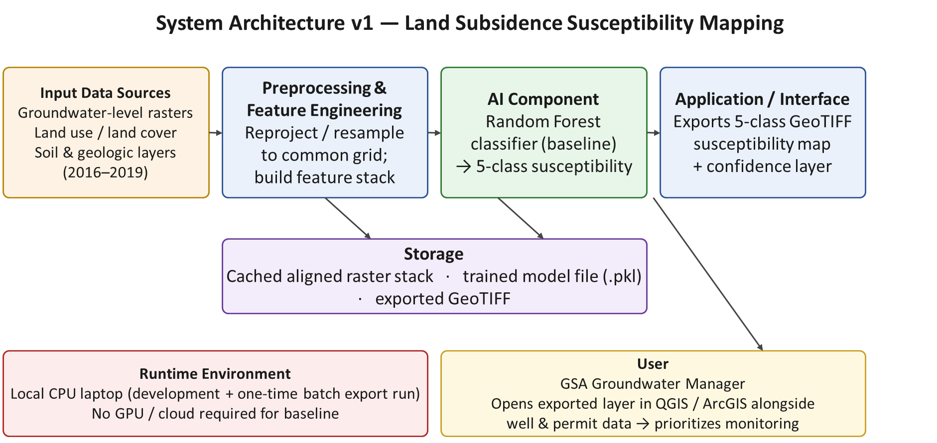

03 | SECURITY, PRIVACY AND ETHICS  What would make people reasonably trust this system, and what controls will you actually build or verify?

MILESTONE 2 · CREATE ONE PLAN · LATER · UPDATE AFFECTED ROWS
3.1 identifies your roughly 3–5 priority concerns overall; enter them in 3.3. 3.2 helps you locate controls across all applicable lifecycle stages; record those stages in 3.3. Neither subsection requires an additional essay or a completed copy of its example table.
3.3 is the single Trustworthiness Plan. 3.4 explains how to add implementation evidence to that same plan as milestones arrive. Review relevant rows, update what changed, and finalize every row in Milestone 6.

Trustworthiness is not a checklist added after the model works. It is a property of the whole system, shaped by the problem definition, the data, the AI component, the interface, the deployment environment and operations.
PRIORITIZE WHAT MATTERS FOR YOUR SYSTEM
Do not force every trustworthiness dimension into the project. Identify the concerns that could materially affect your users, your stakeholders, your data or your system's behavior. Then plan concrete controls, and come back later with evidence of what happened.

3.1 Identify priority concerns
Select roughly three to five concerns that are genuinely important here. One concern may affect several lifecycle stages. See the Master Template, 3.1, for examples (privacy, security, fairness and harmful bias, transparency, reliability and robustness, human oversight, safety and appropriate use). No separate response: enter your concerns in 3.3.

3.2 Where controls belong in the lifecycle
See the Master Template, 3.2, for example controls at each stage (problem definition, data, model / AI component, deployment, monitoring). No separate response: record the relevant stages in the 3.3 table.

3.3 Trustworthiness Plan
COMPANION · 3.3 · WHAT EACH ROW REPRESENTS
Create the table once in Milestone 2. Use one row per priority concern and its control(s). List every relevant lifecycle stage in that row; do not create a table for each stage. Split a concern into separate rows only when distinct controls or evidence would otherwise be unclear.
Example: a privacy row may cover data preparation, deployment, and monitoring. Plan de-identification and safe logging now; add data-check evidence in Milestone 3, runtime/logging evidence in Milestone 5, and the final remaining risk in Milestone 6. Update the same row as that evidence becomes available.

Concern | Why it matters here | Lifecycle stage | Planned control | Evidence that would show it works
Reliability and uneven performance across sub-areas (merges Milestone 2's ‘Reliability / robustness’ and ‘Fairness / harmful bias across sub-areas’ rows) | The model could give systematically wrong risk classifications in parts of the study area, causing the manager to misallocate limited monitoring resources; this is compounded where predictor data quality is itself uneven across the study area (e.g., sparser well monitoring in some zones), so a region could look unreliable for reasons tied to data coverage rather than the true subsidence relationship, without that distinction being visible. | Data; model / AI component; monitoring | Evaluate on geographically held-out test regions (not a random split) and report per-class, per-region performance rather than one aggregate number; check predictor data completeness/density per sub-region before training, and report that density alongside the performance breakdown so a reviewer can tell uneven performance from uneven data coverage. | Confusion matrix and macro-F1 broken out by spatial test fold, reported alongside a per-sub-region data-completeness summary table, showing performance is not concentrated only in one sub-region and is not simply tracking data density.
Transparency and appropriate-use scope (merges Milestone 2's ‘Transparency’, ‘Safety and appropriate use’, and ‘Data coverage and uncertainty communication’ rows) | A manager could read a ‘high’ classification as certain fact rather than a probabilistic, historically grounded estimate, leading to overconfidence; this is sharper given the retrospective framing adopted after Milestone 2 feedback (1.2, 2.1) — the relationship was learned on one historical horizon and is not guaranteed to hold indefinitely or in other basins. A genuinely low-susceptibility cell and a data-sparse cell could otherwise look identical, misleading the manager into treating a data gap as a clean bill of health. | Problem definition; data; deployment | Attach a per-cell confidence/probability value to every classification; encode three distinct states in the exported layer — classified, low-confidence/sparse-data, and no-data/excluded — using visually distinct symbology (4.4); and label the output with the training period, study area, and an explicit caveat against applying it elsewhere, far into the future, or as a deterministic forecast. | Exported output includes a probability field and three visually distinct states (see the 4.4 interface sketch); accompanying documentation states training period, region, and the retrospective-analysis caveat.
Human oversight | The design principle carried out of the proposal is that the system should support, not replace, the manager's judgment. | Deployment | Document the map explicitly as a decision-support input to be combined with existing monitoring data and expert judgment; no automatic action is triggered by model output. | Documentation states the intended supportive role; no part of the pipeline auto-triggers an action from the model's output.
Map versioning and traceability | As new source data becomes available and the model is retrained, a manager comparing decisions over time needs to know which version of the map, trained on which data, produced a given recommendation. | Deployment; monitoring | Embed a version identifier, generation date, and the predictor cutoff date (2.1B) directly into the exported GeoTIFF's metadata tags, alongside a short changelog; define an update policy (regenerate no more than once per year, once a new full year of groundwater and land-use data is available, following the same cutoff-date discipline). Also now records the archived-availability cutoff distinction introduced after Milestone 2 feedback (2.1B). | Opening the exported file's metadata in QGIS shows a version tag, generation date, and predictor cutoff date; a changelog lists each version's date and what changed.

IMPLEMENTATION EXPECTATION
At least one priority control must become visible in the actual implementation or evaluation of the system. A written intention is not evidence that a control worked. The last column is the one to fill in carefully: if you cannot describe what evidence would show the control working, you cannot test it.

3.4 Implementation and evidence
Not due at Milestone 2. At later milestones, add implementation evidence to the rows of the 3.3 table above rather than creating a new table.

04 | HUMAN-COMPUTER INTERACTION  How does the system fit into a real human task, and how will users understand, control and recover from it?

MILESTONE 2 · DESIGN · MILESTONE 5 · EVALUATE
Complete 4.1–4.3 and the initial prototype/evaluation plan in 4.4 for Milestone 2. These describe one user interaction. By Milestone 5, add actual evaluation findings and the resulting design decision in 4.4; update 4.1–4.3 only where findings change them. Reuse the same workflow and prototype links across sections.

AI systems are used in human contexts. HCI work defines the user's goal, the workflow around the AI, how outputs are communicated, and what happens when the system is uncertain or wrong.
HCI IS NOT "MAKE A PRETTY INTERFACE"
A technically strong model can still fail as a system if the user cannot understand the output, cannot tell when to trust it, cannot correct it, or cannot complete the task it was meant to support.

4.1 Users, tasks and context
What you must document
- The primary user or users, and the task they are trying to accomplish.
- Context of use: where, when and under what constraints the system would be used.
- What the user knows before interacting with the AI, and what action or decision follows its output.
- Meaningfully different user groups, including novice and expert differences where they matter.

DO NOT INVENT USER EVIDENCE
If you did not conduct interviews, surveys or usability tests, do not write as though you did. Literature, plausible scenarios, peer walkthroughs and instructor-approved proxy evaluation are all legitimate — label the source of your evidence honestly. If you do collect data from real people, check first whether your institution requires ethics review or a consent statement.

YOUR RESPONSE · 4.1 · MILESTONE 2 · UPDATE IF USER UNDERSTANDING CHANGES
Describe the users, task, and context requested above and identify the basis for your understanding. Later: revise only what feedback or implementation changes. Keep evaluation observations in 4.4; reference them here when they change a user assumption.
Primary user: A groundwater manager at a Groundwater Sustainability Agency (GSA) responsible for the Tulare-Corcoran area, as established in the Milestone 1 proposal.
Task: Review current groundwater monitoring priorities and decide where to allocate additional subsidence monitoring resources for example, during an annual groundwater management plan review.
Context of use: An office setting, using GIS software (QGIS/ArcGIS) already part of the manager's normal workflow, reviewing the map periodically (e.g., annually) rather than continuously. This is not a time-pressure or real-time decision.
Prior knowledge and follow-on action: The manager is assumed to understand groundwater basics, their agency's own well and permit data, and how to use GIS software, but is not expected to understand machine learning. The map's output (a 5-class susceptibility label with a confidence value) is designed to be interpretable without any ML background. Following review, the manager's typical action is a monitoring or prioritization decision for example, flagging an area for additional InSAR/GPS monitoring or closer permit review.
User groups: The primary design target is a single user type (the GSA manager); technical GIS staff at the agency may also directly load and inspect the exported files, but they are not the primary persona this design optimizes for.
Basis for this understanding: This is based on the course project's problem framing, general knowledge of how California Groundwater Sustainability Agencies operate under the Sustainable Groundwater Management Act, and the instructor's written feedback on the Milestone 1 proposal. No direct interviews or surveys were conducted; this is a plausible-scenario basis, not empirical user research, and is labeled as such.

4.2 User flow and interaction requirements
Show how a user moves through the end-to-end task. A simple diagram usually beats a long paragraph.
SUGGESTED FLOW
User goal → input or action → system processing → AI output → user interpretation → user action or next step

What you must document
- One primary user scenario, start to finish.
- A user flow or task-flow diagram.
- The points where misunderstanding, over-reliance, error or failed recovery could occur.
- Usability goals that matter for this task: task success, clarity, error reduction, time, learnability or satisfaction.

YOUR RESPONSE · 4.2 · MILESTONE 2 · UPDATE IF THE WORKFLOW CHANGES
Insert the primary scenario and user-flow diagram, with likely failure points and usability goals. Later: revise the flow when the implemented interaction changes. Reuse this artifact in 4.4 and link it to the system architecture; no separate flow is needed for each milestone.
Primary scenario: The manager is preparing for the annual groundwater management plan review. They open the exported susceptibility GeoTIFF in QGIS alongside their existing well-location and infrastructure layers. They visually scan for areas classified 'high' or 'very high' susceptibility that overlap with active extraction wells lacking nearby monitoring, then note these as candidates to flag for additional InSAR coverage or well-permit review (see diagram above).
Likely failure points: (1) the manager misreads a 'high' susceptibility class as certain rather than probabilistic addressed in 4.3 via the confidence layer; (2) the manager applies the map to an area or time period outside its valid scope addressed via the documentation caveat also recorded in 3.3; (3) the manager cannot open or interpret the GeoTIFF due to unfamiliar file or projection issues addressed by using standard, widely supported formats and testing that the file opens correctly in QGIS before delivery.
Usability goals: task success (the manager can identify high-susceptibility zones needing monitoring within a single review session); clarity (class meanings, e.g., 'very high,' are documented in plain language); error reduction (minimizing the risk of over-trusting the map, via the confidence value and caveats described above).

User-flow diagram (carried forward from Milestone 2, unchanged):
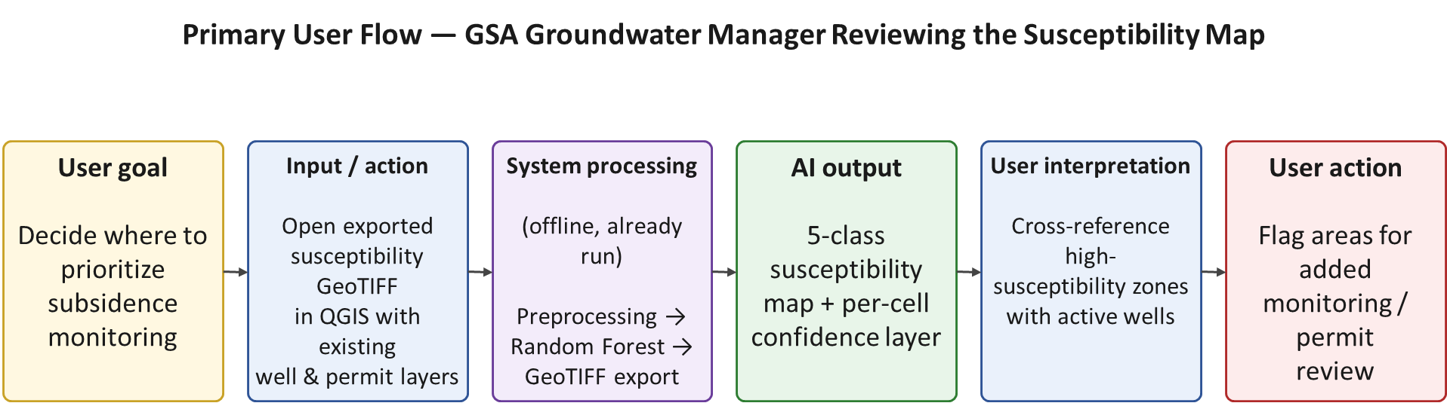

4.3 Transparency, control and accessibility
What you must document
- What the user needs to know about an output: confidence, uncertainty, sources, explanation, limitations or provenance, as relevant.
- How the user can reject, correct, override, question or recover from an output.
- What happens when the system is uncertain, unavailable, or asked for something outside its scope.
- The accessibility requirements relevant to your interface and user population, and which ones you will meet.

YOUR RESPONSE · 4.3 · MILESTONE 2 PLAN · IMPLEMENTATION BY MILESTONE 5
Explain the transparency, user control, recovery, and accessibility choices for this interface. Later: identify what was implemented and link evaluation evidence in 4.4 or tests in 8.5. Update overlapping controls in 3.3 using the same evidence.
What the user needs to know: the susceptibility class, a confidence/probability value for that classification, and the training period/region caveat (consistent with 2.2 and 3.3).
How the user can question or override the output: because the output is a static exported layer reviewed inside the manager's own GIS software, the manager retains full control to overlay, filter, or disregard the AI layer alongside their own data. The design does not trigger any automatic action, so 'overriding' the AI is simply the manager's normal act of weighing it against other evidence and expertise.
Handling uncertainty or out-of-scope cases: the exported layer distinguishes three states rather than two (1) classified cells, shown with their susceptibility class, a confidence value, and, where feasible, a simplified indicator of the top one or two predictor variables driving that classification; (2) low-confidence / sparse-data cells, where predictor coverage was thin but not entirely missing, flagged with distinct hatching or symbology rather than folded into the 'low' susceptibility class; and (3) no-data / excluded cells, where required predictor data was unavailable, shown as excluded rather than silently assigned any class. This prevents a genuine data gap from ever being visually mistaken for a clean, low risk finding.
Version and date traceability: the exported map's metadata and an accompanying changelog state the model version, generation date, and predictor cutoff date (2.1B/3.3), so a manager comparing a recommendation against an earlier review can identify exactly which version and data cutoff it came from.
Accessibility: since the primary interface is the manager's existing GIS software rather than a custom interface, most accessibility properties are governed by that software. This project's specific contribution is ensuring the output itself uses a colorblind-safe, perceptually distinct 5-class color palette (not a red-green-only scheme) plus a text label for every class, so the map remains interpretable for colorblind users. A full accessibility audit of QGIS/ArcGIS itself is out of scope for this semester.

4.4 Prototype and evaluate the interaction
Choose the simplest prototype that lets you test the interaction you actually care about.
What you must document
- The prototype or interface artifact.
- The evaluation method, and what you were trying to learn from it.
- What you observed. Where people hesitated, misread, or gave up. (Milestone 5)
- At least one change, confirmation, or unresolved issue that came out of the evaluation. (Milestone 5)

A SMALL EVALUATION IS ENOUGH
Use the simplest method that can reveal whether the interaction works: a cognitive walkthrough, heuristic evaluation, peer walkthrough, instructor-approved proxy evaluation, or user testing when appropriate and permitted. The goal is to learn something that can change or confirm the design, not to manufacture a large study.

YOUR RESPONSE · 4.4 · MILESTONE 2 PLAN · MILESTONE 5 FINDINGS
Milestone 2: insert or link a sketch/prototype and state the evaluation question and method. Milestone 5: add actual observations and at least one resulting change, confirmation, or unresolved issue. Earlier evaluations may be recorded here too. Keep design and findings in this same response.
Prototype:
[Revised after Milestone 2 feedback — Fix #3: Milestone 2 only described the sketch concept in words, reusing the 4.2 flow diagram as its stated basis, without an actual dedicated image. The feedback asked for the sketch itself, with the map’s uncertainty symbology and the ‘relative ranking, not a forecast’ framing made explicit.] Figure 4.4 is that sketch. It shows the exported susceptibility layer as the manager would see it in QGIS, with the legend the manager actually reads: the five susceptibility classes, a confidence key based on how many InSAR points each cell rests on (high: 5 or more, medium: 3 to 4, low: 1 to 2), a hatched symbol for low-confidence cells, a grey symbol for cells with no label that are excluded, an existing-wells overlay, and the explicit ‘relative ranking, not a forecast’ caption, consistent with the flow annotated in 4.2. The map underneath is the real labeled grid from insar_label.ipynb (6.4), so the classes, the 1,653 no-label cells and the 865 low-confidence cells are real; the well positions are illustrative, and the sketch itself is a mockup, not the output of a trained model (none exists yet).
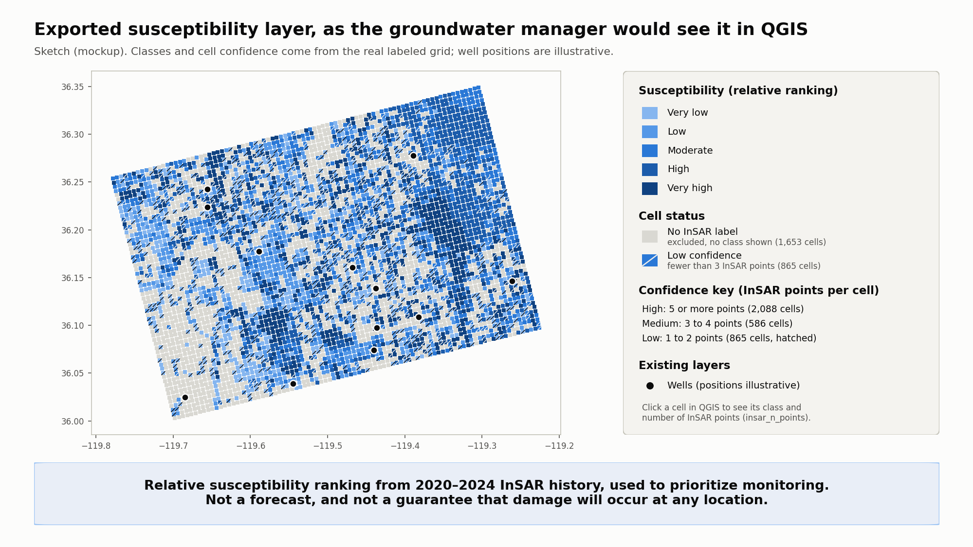
Figure 4.4 — sketch of the exported susceptibility map and its legend (mockup drafted with Claude’s help, using the real labeled grid from insar_label.ipynb; well positions are illustrative).

Planned evaluation method and question:
[Revised after Milestone 2 feedback — Fix #3] the plan is a cognitive walkthrough with a peer (a classmate acting as a proxy ‘groundwater manager’), using the sketch in Figure 4.4 rather than the flow diagram alone. The walkthrough will ask two linked questions rather than one: (1) using only the map, legend, and symbology, can the peer correctly select the cells they would prioritize for additional monitoring; and (2) can the peer state, in their own words, that a ‘high’ or ‘very high’ classification describes a relative historical susceptibility ranking used to prioritize monitoring, not a forecast or guarantee that physical damage will occur there. The second question is the one Milestone 2 did not test for; it is added specifically to check whether a reviewer reads the map as a prioritization tool rather than as a prediction of damage. Neither question has been asked yet; the sketch now exists, so the walkthrough can be run with it.

Findings, observed hesitation points, and the resulting design change or confirmation are not due until Milestone 5 and will be added at that point, in this same response.

05 | RISK MANAGEMENT  How could this system fail, cause harm, or become unusable — and what will you do about the risks that matter?

MILESTONE 2 · ONE RISK REGISTER FOR THE WHOLE PROJECT
Use 5.1 to identify roughly 5–8 risks overall and 5.2 to rate them. Write in 5.3; discuss the 2–3 priorities in 5.4. Example tables need no responses. Later: update affected records and link shared controls to 3.3.

The purpose of risk management is to prioritize the risks that change design and implementation decisions, not to produce an exhaustive list of hypothetical problems.
USE RISK TO CHANGE ENGINEERING DECISIONS
A useful risk register affects what you build, test, restrict, monitor or communicate. If your risk analysis never changes a design or validation decision, it is probably too generic to be worth the page it is on.

5.1 Identify meaningful risks
Identify roughly five to eight risks across the lifecycle. Phrase each as a concrete failure scenario, not a category. "Bias" is a category; "the training data contains almost no night-time images, so the detector fails after dark" is a scenario you can test. See the Master Template, 5.1, for examples by lifecycle stage. No separate response: enter your risks in 5.3.

5.2 Assess and prioritize
Estimate likelihood and impact qualitatively. The value is consistent prioritization, not false precision. Use the categories to make a reasoned judgment about which risks deserve attention; you are not expected to calculate probabilities. Reference only; no response needed.
Likelihood
Level | Interpretation | Use when…
Improbable | Unlikely during this project | There is little reason to expect it under the planned conditions.
Possible | Could plausibly occur | You would not be surprised if it happened.
Probable | Expected or likely | Available evidence or conditions make it reasonably likely.

Impact
Level | Meaning
Acceptable | Little or no effect. A slight drop in quality that no one would act on.
Tolerable | Felt but not critical. Noticeable degradation, fixable within the project.
Unacceptable | Serious impact on the outcome. Major functionality lost, a group of users badly served, or a compliance problem.
Intolerable | Could result in disaster. Critical failure, legal exposure, or harm to a person.

Likelihood and impact matrix
Likelihood \ Impact | 0 Acceptable | 1 Tolerable | 2 Unacceptable | 3 Intolerable
Improbable | Low | Moderate | Moderate | High
Possible | Low | Moderate | High | Critical
Probable | Moderate | High | High | Critical

- Low. Acceptable as it stands. Note it and move on.
- Moderate. Acceptable with monitoring. Say what you will watch.
- High. Not acceptable without further control. Say what you will add, or justify accepting it.
- Critical. Must be reduced before the system is used. If you cannot reduce it, the system should not run in that configuration, and saying so is a legitimate finding.

5.3 Risk Register
Failure scenario | Impact | Likelihood | Mitigation / control | Residual | Trigger and response
★ The rare, very-high-susceptibility class has very few labeled examples, so the model rarely or never predicts it similar to the class-imbalance failure discussed in coursework (a fraud model with high accuracy but near-zero recall on the rare class). | Unacceptable | Probable | Use macro-F1 and per-class recall, not overall accuracy, as the primary evaluation metric; consider class-weighted training or resampling if the rare class is badly underrepresented. | Moderate | If very-high-class recall stays near zero after weighting/resampling, merge it with the adjacent 'high' class into a 4-class scheme and disclose this limitation.
Predictor layers from different sources (groundwater levels, land use, soils) are misaligned in projection or resolution during preprocessing, silently shifting features relative to their true location. | Unacceptable | Possible | Standardize all layers to one coordinate reference system and resolution early in preprocessing; visually spot-check a sample of aligned layers against known landmarks before training. | Low | If a spot-check reveals misalignment, halt training and re-run the alignment/reprojection step before continuing.
★ The model performs noticeably worse on the geographically held-out test region than on the training region it does not generalize spatially, similar to the training-vs-validation gap (overfitting) discussed in coursework. | Unacceptable | Probable | Use spatial-block train/test splitting (not random) from the start; if a large gap appears, apply standard overfitting remedies — simplify the model, regularize, or gather more spatially diverse training data. | Moderate | If held-out spatial performance is far below training performance, narrow the claimed valid area of the map to only the sub-regions where performance was verified.
The manager interprets a 'high susceptibility' classification as a certain, precise prediction of future subsidence rather than a probabilistic, historically grounded estimate, leading to an overconfident decision.  (Revised — Fix #4: no longer carried as one of the top-3 priority risks below; its mitigation is identical to, and now tracked under, the consolidated ‘Transparency and appropriate-use scope’ concern in the revised 3.3.) | Unacceptable | Possible | Attach a confidence/probability value to every classified cell; include explicit documentation describing the map as a susceptibility estimate, not a forecast. | Low | If the peer walkthrough (4.4) shows the caveat is overlooked, redesign the legend/documentation to make it more prominent (e.g., a visible label on the map itself, not only a separate document).
A required predictor dataset (e.g., a specific groundwater-level or soils layer) turns out to be unavailable, incomplete, or licensed in a way that prevents use within the semester timeline. | Tolerable to Unacceptable, depending on the layer | Possible | Confirm data access for the narrowed, essential predictor set early; identify a substitute public dataset for each essential layer in advance. | Low | If a core layer becomes unavailable, substitute the pre-identified backup dataset, or narrow the study area to where the layer is available.
Development time is consumed disproportionately by preprocessing/data alignment, leaving insufficient time to properly evaluate the baseline model before the deadline. | Tolerable | Probable | Cache the fully preprocessed, aligned raster stack once complete (per 2.6) so remaining time is available for modeling and evaluation; timebox the preprocessing step. | Low | If preprocessing is not complete by roughly the midpoint of the remaining schedule, drop a non-essential predictor layer to stay on schedule.
★ A predictor layer inadvertently includes information from after the predictor cutoff date (e.g., a groundwater reading later revised/backfilled by the source agency), inflating apparent model performance relative to what a manager could actually achieve in real time. | Unacceptable | Possible | Enforce and log an explicit per-source cutoff-date filter (2.1B) before any raster is built; spot-check a sample of feature values against source record timestamps. | Low | If a spot-check reveals a leaked post-cutoff value, rebuild the affected layer with the corrected cutoff filter and re-run evaluation before reporting results.

COMPANION · 5.3 · COMPLETE ONCE AND MAINTAIN
Milestone 2: use one row per failure scenario. Record its initial impact and likelihood, planned mitigation, expected residual rating after mitigation, and action trigger/response. Use the 5.2 matrix; briefly explain the residual rating in its cell. Mark the 2–3 risks discussed in 5.4.
Later: keep the original assessment identifiable and add the current rating, mitigation outcome, and evidence reference within the same row. Add newly discovered risks when needed. Milestone 6: give every row a final status and residual rating. A planned mitigation alone does not establish that the risk was reduced.

YOU MAY REUSE A CONTROL
Risk and trustworthiness overlap by design. A privacy control, an authentication mechanism, a fairness test or a human-override feature may address both. Reference the same implementation rather than documenting it twice.

5.4 Residual risk and acceptance
What you must document
- The two or three risks that most strongly affect your engineering decisions.
- For those, what remains after the planned mitigation.
- Whether the residual risk is acceptable for a course prototype, and what stronger action a real deployment would require.
- Updates to the register whenever implementation reveals a new risk or changes the likelihood or impact of an existing one.

AN ALL-GREEN REGISTER IS A WARNING SIGN
A residual risk assessment where nothing lands above Low almost always means the risks were written to be easy rather than to be true. One honest Critical is worth more than a page of Low.

COMPANION · INTERPRETING THE RATINGS
Rate the actual scenario and the conditions in which your course prototype will operate. A Low residual rating can be justified by evidence and a well-bounded scope. There is no required distribution of colors or ratings. The purpose of the warning above is to encourage honest assessment, not to make you invent a High or Critical risk.

YOUR RESPONSE · 5.4 · MILESTONE 2 · UPDATE THROUGH MILESTONE 6
Discuss the 2–3 risks that most affect your decisions, referring to their entries in 5.3. Initially explain expected residual risk and acceptance for the prototype. Later: revise the discussion when evidence changes the rating, mitigation, or acceptance decision; finalize it in Milestone 6.
The three risks that most strongly affect engineering decisions, narrowed from the four marked in Milestone 2 [Revised after Milestone 2 feedback — Fix #4: selecting the two to three that most change the work, as asked], are: (1) class imbalance on the rare very-high-susceptibility class, (2) weak spatial generalization to the held-out test region, and (3) temporal/predictor leakage across the archived-availability cutoff (2.1B, revised per Fix #1). The fourth Milestone 2 priority — the manager misreading the map as certain rather than probabilistic — is retained in the risk register above but is no longer marked as a top-3 priority on its own: it has been folded into the consolidated ‘Transparency and appropriate-use scope’ concern in the revised 3.3, since its mitigation (confidence value, three-state symbology, explicit caveat, and now the 4.4 interface sketch) is identical to the transparency control already tracked there, so tracking it separately in both places was redundant rather than additive. Together these three remaining priorities directly determined the choice of evaluation metric (macro-F1 and per-class recall rather than accuracy, with the explicit decision rule added in 2.2), the choice of spatial-block rather than random train/test splitting, and the archived-availability cutoff design and logging described in 2.1B.
Expected residual risk after the planned mitigations: class imbalance stays Moderate because its impact if it recurs is Unacceptable (the rare very-high class being essentially undetected would directly undermine the map's purpose) while its likelihood is reduced from Probable to Possible by class-weighting/resampling and the explicit macro-F1 decision rule (2.2) that forces a documented response rather than a silent pass; under the Likelihood×Impact table, Possible×Unacceptable rates High, not Low, which is why this risk is carried at Moderate-to-High rather than treated as resolved. Spatial generalization stays Moderate for the same reason: impact remains Unacceptable (a map that does not generalize spatially is the core deliverable failing), and spatial-block splitting lowers likelihood from Probable to Possible but does not remove the underlying spatial heterogeneity in subsidence drivers, so Possible×Unacceptable again keeps this above Low. Temporal/predictor leakage is reduced to Low because, after the Fix #1 revision, the mitigation now acts on the actual failure mechanism (an archived-availability cutoff enforced and logged per source, 2.1B) rather than the originally mis-specified observation-date cutoff that the Milestone 2 feedback identified as incomplete; likelihood drops to Improbable given the explicit per-source logging and spot-checking, and Improbable×Unacceptable rates Moderate on the table, which is treated as Low here specifically because the spot-check step is a direct, verifiable control rather than a procedural intention.
A projection error that could invalidate the map:
the non-priority risk already tracked in the register above — predictor layers from different sources (groundwater levels, land use, soils) being misaligned in coordinate reference system or resolution during preprocessing — is the clearest single example of a low-likelihood, high-impact error that could silently invalidate the entire output rather than just degrade it. Unlike class imbalance or spatial generalization, a projection/alignment error would not necessarily show up as a gradual performance drop; it could instead shift every feature relative to its true location and produce a map that looks complete and confident while being wrong everywhere. Its likelihood is rated Possible and its impact Unacceptable, giving a residual rating of Low only because of a direct, concrete control (standardizing every layer to one coordinate reference system and resolution early in preprocessing, then visually spot-checking a sample of aligned layers against known landmarks before training, 2.1B) — if that spot-check step were skipped, this risk would deserve Moderate-to-High treatment despite not being one of the three named priorities above, which is why it stays in the register with an explicit trigger (halt training and re-run alignment) rather than being dropped for being lower-likelihood.
Acceptability for a course prototype: yes, these residual risk levels are acceptable for a semester course prototype given the mitigations described, since the system is explicitly scoped as a decision-support tool to be combined with expert judgment, not an automated decision-maker. A real operational deployment, however, would require more than this semester project provides: (i) more rigorous statistical validation using genuinely independent held-out years of data rather than a single historical split; (ii) a wider and more representative set of high-subsidence training examples, potentially gathered from additional groundwater basins; and (iii) formal usability testing with real GSA staff, rather than a peer walkthrough, before the map is trusted for actual monitoring or permitting decisions. Section 6 below records what the real Milestone 3 data work actually changed.

06 | DATA MANAGEMENT  What data actually powers your system, can you use it responsibly, and what did you learn when you worked with it?

MILESTONE 3 · ACTUAL PIPELINE AND DATA EVIDENCE
Complete 6.1–6.7 for the data you actually use, including retrieval corpora and evaluation cases where relevant. Reuse one source/rights record across 6.2–6.3. Section 6.8 routes data-related findings back to 3.3 and 5.3. Later: update affected data records when sources, processing, or evaluation data change; no new data report is needed for each stage.

REPORT YOUR REAL PIPELINE
This section moves from planning to implementation. Describe what you actually did, including the parts that did not go to plan. A report describing an ideal pipeline is less useful than one describing a messy pipeline accurately.

6.1 Data type and role
What you must document
- Data modality or type, and approximate scale.
- How the data supports the system objective.
- The important fields, labels, targets, documents, context or signals.
- Raw versus processed data, and where each version lives.

Modalities to name where relevant: structured (tabular, transactional, time-series), unstructured (text, images, audio, video, documents), semi-structured (JSON, XML, logs, API responses), multimodal, and streaming or sensor data. For retrieval and generative systems, the data also includes your source corpus, chunked text, embeddings and vector index, prompts, and evaluation cases — name each of those that applies.
YOUR RESPONSE · 6.1 · MILESTONE 3 · UPDATE IF THE DATA CHANGES
Describe the data actually used, its role, scale, important fields or signals, and raw/processed locations. Later: update this record if a source, scale, or data role changes. Reference the source record in 6.2 and processing details in 6.7.
Data modality: structured/tabular. One row per ~500 m grid cell in the Tulare-Corcoran study area; 5,192 cells (rows). data/subsidence_dataset.csv has 30 columns (predictors only); data/subsidence_dataset_processed.csv has 37: the same 30 plus a soil_missing flag and six label and split columns (see 6.4 and 6.5).
Role: this is the feature table that is paired with the 2020–2024 subsidence-outcome label (1.4) to train and evaluate the Random Forest classifier described in 2.1/2.7. The label now exists for 3,539 of the 5,192 cells (68.2%); the other 1,653 cells have no usable InSAR point and are left out of training and evaluation. No model has been trained yet.
Important fields: grid_id and longitude/latitude (identity and location); land use — CDL crop code per year 2016–2019, the most recent year's crop name, years cropped, years fallow, a perennial-crop flag, and a land-use-changed flag; soil — drainage class, hydrologic group, taxonomic class, percent clay/sand/silt, organic matter, saturated hydraulic conductivity, and available water capacity; terrain — elevation and slope; groundwater — 2016–2019 decline rate, mean/latest/std depth, measurement count, and distance to the nearest well used to fill that cell. The label columns, added in the processed file: subsidence (displacement over 2020–2024, positive = sinking), susceptibility_class (five classes, very low to very high), insar_n_points (how many InSAR points the cell’s label rests on), insar_disp_window (the same displacement with DWR’s sign), and block_id and split (the 5 km block and the train/test assignment, 6.5).
Raw versus processed: per-source raw downloads (CDL GeoTIFFs per year, the DWR groundwater CSV, SSURGO polygon/attribute query results, and the 3DEP DEM GeoTIFF) are cached under data/ and are not version-controlled (gitignored) because they are large and can be regenerated deterministically from the same public APIs. The one processed, version-controlled artifact is data/subsidence_dataset.csv (~1.6 MB), produced by joining all sources onto the common 500 m grid. The InSAR source is the other raw input: data/insar_points.zip (5.26 GB, DWR’s statewide point data) and data/insar_study_area.csv (159 MB, the 101,843 points inside the study area, written by the notebook) stay out of the repository (.gitignore). The processed file data/subsidence_dataset_processed.csv (~1.8 MB) is the second version-controlled artifact.

6.2 Sources, collection and ingestion
What you must document
- Each major source, including the dataset, repository or API name and version.
- How the data was obtained: download, API, permitted scraping, sensor, manual collection, or user-generated.
- License and permission for every dataset and every pretrained model you use. Non-commercial and share-alike terms are common and frequently missed.
- Reliability or accessibility problems you hit.
- Training ingestion: how data reaches your experiments, and where it physically lives at that point.
- Runtime ingestion: how new input would enter the deployed system, if that differs.

YOUR RESPONSE · 6.2 · MILESTONE 3 · UPDATE WHEN SOURCES OR INGESTION CHANGE
Use one source record per major dataset, corpus, API, or other source, with the acquisition and rights details requested above. Report implemented development ingestion; label runtime ingestion as planned until built. Reference the same source records from 6.3. Add pretrained-model permissions when the model is selected.
Implemented development ingestion: all four predictor sources are live and working inside build_dataset.py, run top to bottom. The outcome label is ingested separately by insar_label.ipynb (below).
Groundwater — CA DWR Periodic Groundwater Level Measurements, pulled live via the CKAN API at data.cnra.ca.gov (package ‘periodic-groundwater-level-measurements’). Station and measurement resources are queried for Tulare and Kings counties, capped at 300 wells to keep the download manageable, and measurements are filtered to the 2016-01-01–2019-12-31 predictor window at ingestion time, not after the fact.
Land use — USDA NASS Cropland Data Layer, one raster per year (2016–2019) retrieved from NASS's CDL web service (GetCDLFile) clipped to the study-area bounding box, then sampled at each grid-cell centroid.
Soil — USDA NRCS Soil Data Access (SSURGO), queried live via its REST endpoint: one query for map-unit polygons intersecting the study area, one for component/horizon attributes; grid points are spatially joined to these polygons, not simplified to nearest-neighbor.
Terrain — USGS 3DEP 30 m DEM, retrieved via the py3dep package; elevation is sampled directly and slope is derived from the DEM with a finite-difference gradient.
Outcome label (InSAR displacement) — implemented in insar_label.ipynb. The source is DWR’s TRE ALTAMIRA “Vertical Displacement Point Data” on data.cnra.ca.gov (package ‘tre-altamira-insar-subsidence’, resource ‘Vertical Displacement Point Data’, verticaldisplacementpointdata.zip, 5,262,324,358 bytes, SHA-256 b048035c…1ff18). I downloaded it separately after the search inside build_dataset.py did not find a usable file (DWR’s raster products are on a Box page outside the CKAN API). The zip holds 35 regional CSV files of about 217,000 points each (about 7.6 million in all; each point is an average over a 100 m × 100 m area), with one column per acquisition date from 2015-01-01 to 2026-04-01. Step 1 of the notebook reads each file straight from the zip and keeps the points inside the study-area box: 101,843 points, all from CALIFORNIA_DWR_18_VERT.csv (47,739) and CALIFORNIA_DWR_19_VERT.csv (54,104); the other 33 files cover other parts of California. Step 3 turns those points into the cell label (6.7). INSAR_ENABLED is still False in build_dataset.py, so data/subsidence_dataset.csv itself has no label column.
Implemented data flow: raw per-source downloads land in data/ (gitignored) → build_dataset.py reprojects everything to one common grid (EPSG:5070, 500 m cells) and joins it into data/subsidence_dataset.csv → insar_label.ipynb reads that CSV and the InSAR zip, adds the soil flag, the label, the train/test split and the class boundaries, and writes data/subsidence_dataset_processed.csv → playground.ipynb reads the CSV by a relative path for inspection. No deployment-time ingestion exists yet; 2.7’s Architecture v1 still describes the intended one-time batch flow once a trained model exists.
Code: https://github.com/Mashouk/subsidence-susceptibility-mapping (public repository) — build_dataset.py for the predictor ingestion/join logic, insar_label.ipynb for the InSAR label, and playground.ipynb for the inspection steps referenced in 6.4.

6.3 Rights, legal frameworks, ownership and access
Identify what actually applies. Do not claim compliance with a law or standard merely because it appears in the examples.
What you must document
- Who owns or controls the data, and what permission or license allows your use.
- Any privacy, consent, terms-of-service, copyright or data-use restriction that affects the project.
- Applicable legal or institutional requirements, if any.
- Who can access or modify the data, and how that access is protected and logged.

YOUR RESPONSE · 6.3 · MILESTONE 3 · UPDATE IF RIGHTS OR ACCESS CHANGE
Reference the source and permission records in 6.2. Explain the applicable restrictions and actual access controls here; do not reproduce every source description. Later: update changed permissions or controls and their affected rows in 3.3 and 5.3. Explain when listed frameworks do not apply.
USDA NASS Cropland Data Layer, USDA NRCS SSURGO, and USGS 3DEP: U.S. federal government data, public domain, no license restriction and no account or API key required.
CA DWR groundwater measurements: published on data.cnra.ca.gov, the State of California’s open-data (CKAN) portal. The portal’s record for the dataset (package ‘periodic-groundwater-level-measurements’) lists the license as “Other (Public Domain)” and gives no license URL; I read that from the CKAN package_show response. The data are credited to the California Department of Water Resources wherever they are shown.
No personal or sensitive data: well records carry location only (no owner or personal information), consistent with 6.1's field list. No API keys, tokens, or credentials are stored or required anywhere in the repository.
Outcome label (InSAR): the source is DWR’s TRE ALTAMIRA “Vertical Displacement Point Data” on data.cnra.ca.gov (package ‘tre-altamira-insar-subsidence’). The portal’s record lists its license as “License not specified” and gives no license URL, so I have no stated terms for it beyond the fact that DWR makes it publicly downloadable without an account. I credit DWR and TRE ALTAMIRA as the source, and the license question has to be settled with DWR before the derived susceptibility map is shared with the groundwater-manager end user, consistent with 3.3’s transparency concern.
None of the frameworks this template lists for retrieval-augmented or generative systems (corpus licensing, model-provider terms) apply here — this is a tabular geospatial pipeline with a from-scratch Random Forest classifier, not a system built on a pretrained generative model or retrieval corpus.

6.4 Data quality and representativeness
What you must document
- Evidence of the quality issues that matter for your data: missingness, duplicates, corruption, class imbalance, label quality, outliers, coverage gaps.
- Representativeness relative to the users and conditions the system will actually meet. Record the gaps you found, not only the ones you fixed.
- What you did about the most important issues, and what limitation remains.

YOUR RESPONSE · 6.4 · MILESTONE 3 · RECHECK WHEN DATA CHANGES
Show actual quality and coverage findings, actions taken, and remaining gaps. Later: if data or processing changes could affect these findings, update the relevant checks and results. Keep model error analysis in 7.6 and reference this data evidence there.
Dataset snapshot: 5,192 rows (grid cells) × 30 columns. No duplicate grid_id values and no fully duplicated rows.
Missingness (real counts from the current build):
Column(s) affected | Missing (of 5,192)
drainagecl, taxclname, ksat_um_per_s, clay_pct, sand_pct, silt_pct, available_water_capacity, organic_matter_pct | 418 (8.1%)
hydgrp | 325 (6.3%)
mukey | 310 (6.0%)

Soil-property missingness is not scattered randomly — plotting the missing cells by longitude/latitude (playground.ipynb, Section 4) shows they cluster spatially rather than spreading evenly across the study area, meaning that sub-region needs its own check rather than assuming it behaves like the rest of the grid. This directly feeds the per-sub-region evidence already called for in the revised 3.3 concern on uneven performance.
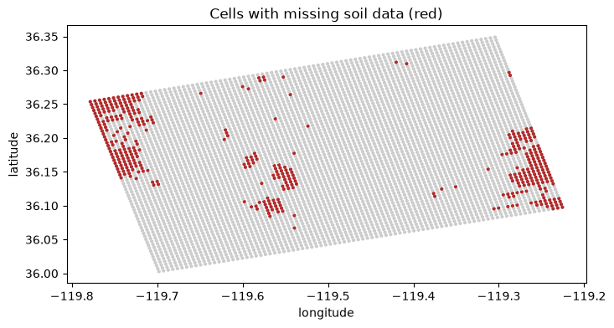
Figure 6.4a — cells with missing soil data (red), from playground.ipynb (real output; the clustering described above is visible directly here).

What I did about the soil gap: I added a soil_missing column that is 1 for the 418 cells with no soil properties (8.1%), so those cells stay visible in the table instead of being filled in quietly. I have not imputed or dropped them. The limitation that remains is that the gaps sit in a few clusters (Figure 6.4a), so any later fill-in needs to be checked area by area, not only overall.
Groundwater coverage looks complete (0% missing) but that is misleading on its own: every cell is filled from its single nearest well, and distance to that well ranges from about 17.2 km to 52.4 km (mean ~34.2 km, std ~8.3 km). A cell 50 km from any well is only weakly supported even though it shows ‘no missing data.’ This is exactly the kind of gap the three-state symbology (classified / low-confidence-sparse-data / no-data-excluded; 3.3 and 4.4) is meant to surface rather than hide.
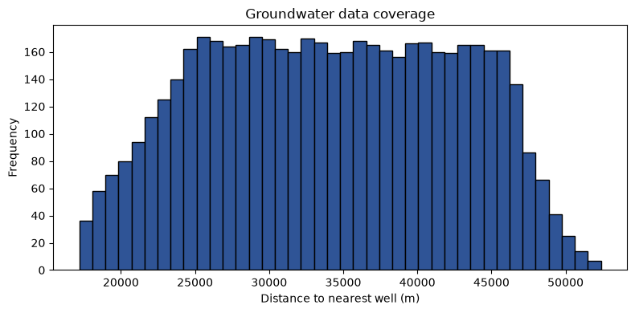
Figure 6.4b — distance from each grid cell to its nearest well, from playground.ipynb (real output; the long right tail is the weak-support region described above).

Plausible-range spot checks (no obviously corrupted values found in this first pass): elevation 50.7–100.5 m; slope 0–11.2°; clay 7.5–70%; sand 1–71.3%; silt 16–68.9%; groundwater decline –7.0 to +1.5 m/yr, where positive means the water table is falling (declining) and negative means it is rising — this is the explicit sign/units definition the ‘Keep thinking about’ feedback note asked for.
Land use is real and varied, not a placeholder: the most common classes in the most recent predictor year are ‘other’ (1,199 cells), cotton (661), alfalfa (558), pistachios (385), fallow/idle (354), almonds (299), and corn (289), with the remainder spread across other row and tree crops — a mix of annual and perennial agriculture plus a meaningful non-agricultural share, not one dominant crop.
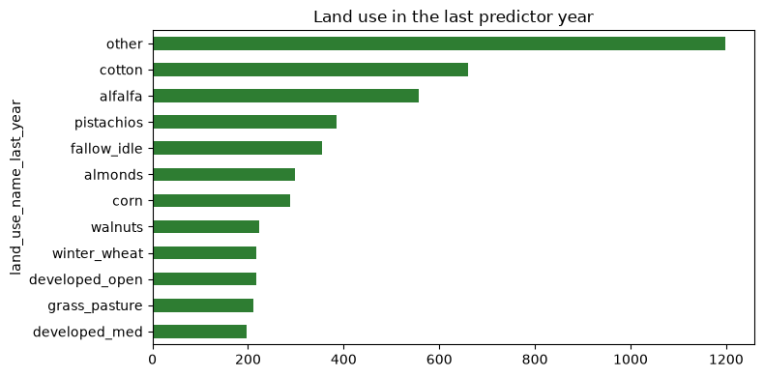
Figure 6.4c — land use in the most recent predictor year, from playground.ipynb (real output, matches the counts above).

Label coverage (real counts from insar_label.ipynb): the InSAR file has 101,843 points inside the study area, but only 52,628 of them (51.7%) have at least 20 readings covering at least 60% of 2020–2024. Many points start late or have long gaps, and on any single date only 29–83% of points have a reading, which is why I fit a trend through each point’s readings instead of subtracting two dates (6.7). The usable points give a label to 3,539 of the 5,192 cells (68.2%). The other 1,653 cells (31.8%) have no usable InSAR point; they are spread over the whole study area but are most common in the south-west, where about 44% of the cells in that quarter have no label against about 27% in the rest (grey in Figure 6.4d), and they are left out of training and evaluation.
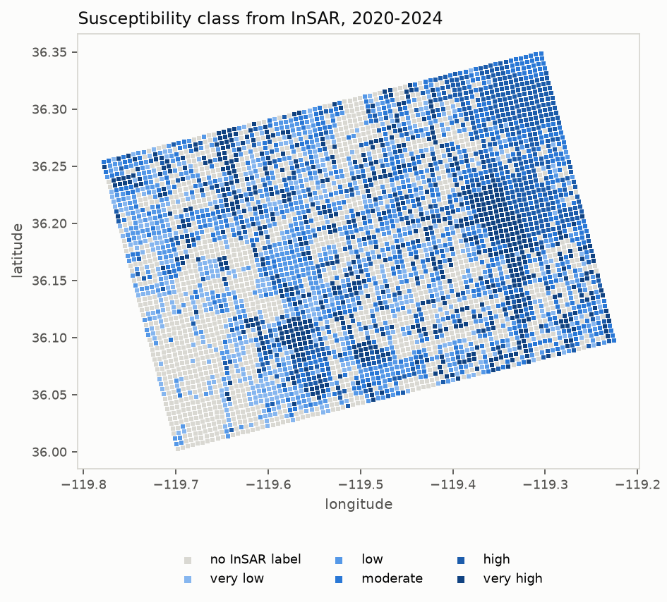
Figure 6.4d — susceptibility class of each labeled cell, 2020–2024, from insar_label.ipynb (real output). Grey cells have no InSAR label.

Thin support: the median labeled cell rests on 6 InSAR points, but 865 labeled cells (24.4%) rest on fewer than 3 points and 476 on a single point, so their labels are less reliable than the rest. insar_n_points is kept in the table so this can be checked later.
Class balance: the five classes are cut at the 20th, 40th, 60th and 80th percentile of the training cells (6.7), so the training cells split 515, 514, 514, 514 and 515 across very low to very high. The test cells do not: 196, 170, 189, 158 and 254 cells (20.3%, 17.6%, 19.5%, 16.3% and 26.3%), because whole 5 km blocks were held out (6.5) and the test classes follow wherever those blocks happen to lie. So the ‘approximately balanced classes’ claim in 1.4 holds for training and only roughly for testing.
Shape of the label: it is not spread evenly. Of the 3,539 labeled cells, 1,248 (35.3%) changed by 100 units or less over the five years in either direction and 1,051 (29.7%) sank by more than 500, so the histogram (Figure 6.4e) has a tall hump near zero, a second hump around 500–1,000 and a thin tail on the left. The cut points from the training cells are −91.2, −21.0, 268.0 and 654.5 (positive = sinking), so ‘very low’ and ‘low’ both sit inside the near-zero hump and are only about 70 units apart. Those two classes mean ‘little or no net sinking’ more than two separate levels.
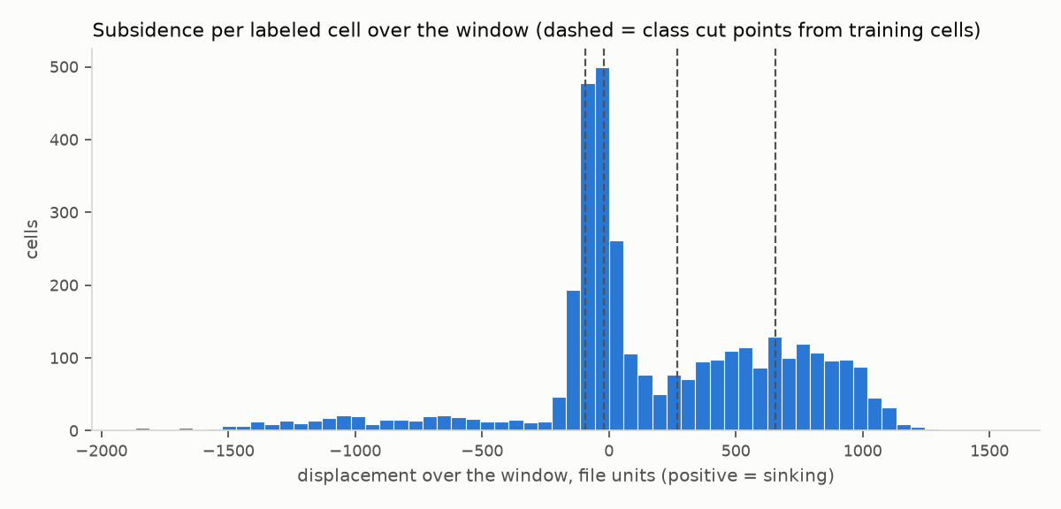
Figure 6.4e — displacement over 2020–2024 for each labeled cell (positive = sinking); dashed lines are the class cut points computed from the training cells, from insar_label.ipynb (real output).

Cells that appear to rise: 650 labeled cells (18.4%) have a window displacement below −100, 278 below −500 and 131 below −1,000, which would be more than a metre of rise if the unit is millimetres. I have not worked out whether this is real rebound or error. The map of point slopes (Step 2b of the notebook) showed isolated points rising next to sinking neighbours, which looks more like measurement noise than uplift, and 5,344 of the 52,628 usable points (10.2%) rise by more than 50 per year. Taking the median of the points in each cell limits their effect but does not remove it. All of these cells fall in the ‘very low’ class, so that class mixes stable cells with these doubtful ones.
Check against DWR’s own velocity: the point file has a mean-velocity column, VEL_V (median −107.8 per year, negative for 99.5% of points). Where a point sank steadily, the window slope matches VEL_V almost point for point, so the displacement columns and the velocity column use the same unit and sign (negative = sinking). Over all usable points the two are only weakly correlated (Spearman 0.15), which I read as VEL_V averaging the whole record from 2015 while many points slowed or stopped sinking later; I have not tested that further. The check is in Step 2b of insar_label.ipynb.
Code: see Section 4 of playground.ipynb for the exact cells that produced the predictor numbers and figures, and insar_label.ipynb (Steps 2–4) for the label numbers and Figures 6.4d and 6.4e.

6.5 Splitting and leakage prevention
What you must document
- How training, validation and test data are separated, where conventional splitting applies.
- Why the split method matches the structure of your data: random, stratified, grouped, temporal, or subject-level.
- Every transformation that learns from data — a scaler, an imputer, a vocabulary, an encoder, a feature selector — is fitted on the training split only, then applied to validation and test. State that you did this.
- If your data has groups, time order or duplicates, how the split respects them. Records from the same patient, user, session or document belong on one side of the split.
- Augmentation happens after the split, on training data only.
- For RAG, LLM, API or other systems where conventional splits do not apply, the equivalent separation you used for evaluation cases.

LEAKAGE LOOKS LIKE SUCCESS
A leaked model scores better, not worse, so nothing in your results will warn you. The only defense is checking the order in which you did things — which is why we ask you to write it down.

COMPANION · FOLLOW THE DATA THROUGH THE SPLIT
For a trained tabular model: split the records, fit the imputer and scaler on training data, then apply those fitted transformations to validation and test data.
For an LLM or RAG system: identify which cases you used to change prompts or retrieval settings and which cases remained reserved for evaluation. Explain what the retrieval corpus contains and how you prevented evaluation answers or feedback from leaking into development.

YOUR RESPONSE · 6.5 · MILESTONE 3 · MAINTAIN EVALUATION SEPARATION
Document the split or equivalent separation actually used and how you prevented leakage. Later: update the record if data or evaluation cases change, explaining which earlier results are affected. Use this same separation when reporting experiments in Section 7.
Split (implemented in insar_label.ipynb, Step 3): the grid is cut into 5 km × 5 km blocks, 54 in all, each containing labeled cells. 14 blocks (about 25%) are drawn at random with seed 42 and held out as the test set; the other 40 are for training. Whole blocks are assigned, not individual cells, because neighbouring 500 m cells are highly correlated and a random split would put near-identical cells on both sides. The result is 2,572 labeled training cells and 967 labeled test cells (27.3% of the labeled cells; Figure 6.5a). Unlabeled cells also carry a block and split value but are not used.
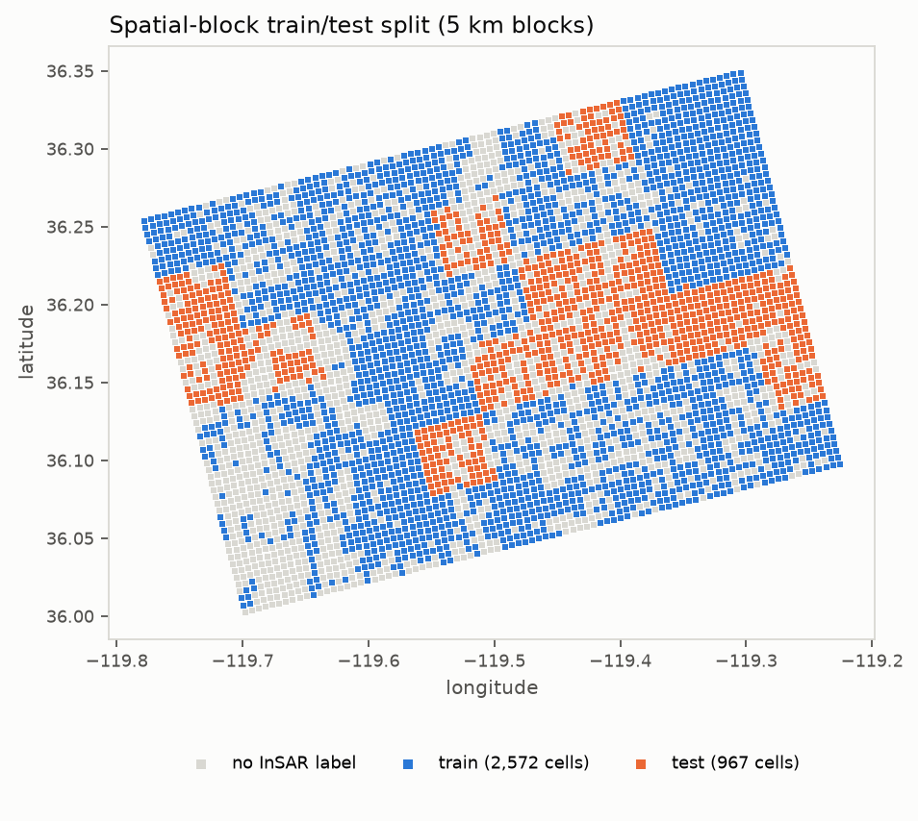
Figure 6.5a — spatial-block train/test split, from insar_label.ipynb (real output). Grey cells have no InSAR label.

What is already implemented and checkable in code today, ahead of any split: the groundwater query filters by measurement date to 2016-01-01–2019-12-31 at ingestion time, not as a later filter, and the land-use step only ever requests CDL years 2016–2019 by construction — both directly implement the predictor-cutoff discipline from the revised 2.1B and the 2.2 data-integrity requirement, in code rather than only in plan.
This also concretely confirms the Fix #1 retrospective framing adopted after the Milestone 2 feedback: because this entire pipeline is being built and queried in October 2026 — years after the 2016–2019 predictor window — every source reflects its fully published historical archive at query time. There is no real-time-availability leakage risk of the kind the feedback flagged, precisely because nothing here claims the model could have run operationally in January 2020.
Order of operations against leakage: the split is made before any statistic is learned from the label, and the four class cut points (−91.2, −21.0, 268.0, 654.5) are computed from the training cells only and then applied to the test cells, so the test cells do not influence the class boundaries. The label uses only readings dated 2020-01-01 to 2024-12-31 (the notebook selects those date columns), and the predictors stop at 2019-12-31 (6.2), so the two windows do not overlap. The older, inactive quantile code in build_dataset.py cuts over all cells, so I do not use it for the label.
Not covered by this split: no model has been trained, so no result has been reported on it. The test blocks are not separated from the training blocks by a buffer, so cells on either side of a block edge are still neighbours, and the split is a single draw (seed 42) that I have not repeated with other seeds.

6.6 Metadata, documentation and versioning
What you must document
- The metadata that matters here: source, timestamp, format, schema, processing state, quality indicators.
- How you identify which dataset version produced a given experiment or build.
- How preprocessing scripts and configuration changes are versioned.

YOUR RESPONSE · 6.6 · MILESTONE 3 · MAINTAIN AS VERSIONS CHANGE
Describe or link the metadata and versioning record that connects data to preprocessing code. Later: add the versions used for new reported results. Section 7.4 links each important experiment to this record; do not create another copy of the data documentation.
Code: https://github.com/Mashouk/subsidence-susceptibility-mapping (public repository). build_dataset.py is the predictor ingestion-and-join script; insar_label.ipynb adds the soil flag, the InSAR label, the split and the class cut points; playground.ipynb is the inspection notebook referenced throughout 6.4. build_dataset.py and playground.ipynb run top to bottom with pip install -r requirements.txt and no API keys or accounts. insar_label.ipynb needs data/insar_points.zip (5.26 GB) in place and runs top to bottom.
Data version: data/subsidence_dataset.csv, built/retrieved 2026-10-05, 5,192 rows × 30 columns, ~1.6 MB, tracked in the repository. The larger per-source raw downloads (CDL rasters, the DEM) are not version-controlled (gitignored) because they are regenerated deterministically by rerunning the script against the same live source APIs. The labeled version is data/subsidence_dataset_processed.csv, written by insar_label.ipynb on 2026-10-12: 5,192 rows × 37 columns, ~1.8 MB, SHA-256 ad033f34e110042e193ef9135dcae13e5905e9a487d2b881265aa53dc35cbd50. It is the first file plus soil_missing and six label and split columns.
InSAR data version: the zip verticaldisplacementpointdata.zip (5,262,324,358 bytes, SHA-256 b048035c38b6f9317d6d307c4e692f296405c99ff8340e88a00fae1fc1c1ff18, dates through 2026-04-01) is identified by that hash. The intermediate data/insar_study_area.csv (101,843 points, 159 MB, SHA-256 59d6153b78a86536dc6563fc29a7d8c97a0bfaa479d87cf4603dacd2a71ce163) and the input data/subsidence_dataset.csv (SHA-256 62dd71198ccd9953d0cba2a0873fe76387b1184d779d8e08b7c867c2fb066a7a) are hashed too. data/label_build_log.json records these hashes with the settings used (window 2020-01-01 to 2024-12-31, at least 20 readings over at least 60% of the window, 500 m cells, 5 km blocks, test fraction 0.25, seed 42), the cut points and the cell counts; data/insar_extract_log.json records the point counts per file in the zip.
Known lineage gap: the four predictor sources are pinned to a retrieval date, not to an archived version identifier for each one, so a source API changing its published data after 2026-10-05 could change the output on a rerun without that change being visible from the CSV alone. The InSAR zip is the exception because its hash identifies the exact file, but DWR updates that product periodically, so a later download can contain more dates than mine. No experiment-to-data linkage exists yet because no model has been trained; once training starts, each run should record the SHA-256 of the processed CSV it used (the hash above for the current one).

6.7 Preprocessing, augmentation and synthesis
Document only what you actually applied. For each important transformation give four things: what you did, why it was necessary, how it was implemented, and what effect it had. The fourth is the one we read most closely.
THESE SOLVE DIFFERENT PROBLEMS
Resampling and synthesis change the balance of your data. Programmatic labeling tools such as Snorkel change how you obtain labels in the first place. Choosing the wrong one because both appear under "data problems" is a common and expensive mistake.

YOUR RESPONSE · 6.7 · MILESTONE 3 · UPDATE WHEN PROCESSING CHANGES
For each important transformation actually used, report what, why, implementation, and observed effect. Link the processing code. Later: update changed transformations and their evidence; preserve the version behind previously reported results. Explain if minimal processing is sufficient.
Reprojection (implemented): every source is reprojected into one common coordinate reference system, EPSG:5070 (Albers equal-area, meters), before any spatial join or distance calculation — this is the concrete implementation of the projection-alignment control already described in 2.1B and the corresponding risk in 5.3.
Grid construction (implemented): a regular 500 m × 500 m grid is built directly in that projected space, then centroids are converted back to longitude/latitude for storage, matching the resolution stated in 1.4.
Land-use feature engineering (implemented): the four yearly CDL codes are sampled by point at each grid centroid; years-cropped, years-fallow, a perennial-crop flag, and a land-use-changed flag are then computed from those four codes — none of these four derived fields exist in the source data.
Soil join (implemented): grid points are spatially joined to SSURGO polygons rather than assigned by nearest neighbor; because a map unit can have more than one soil component, the attribute table is de-duplicated by keeping the highest-percentage component per map unit before merging.
Terrain (implemented, with a named approximation): elevation is sampled directly from the DEM; slope is not a provider-supplied product but a finite-difference gradient computed from the DEM raster and converted to degrees, which is an approximation rather than a measured slope product.
Groundwater (implemented, deviates from the Milestone 2 plan): a per-well linear trend (depth versus time) gives a decline rate per well, alongside mean/latest/std depth and measurement count; each grid cell is then assigned its nearest well's values by Euclidean nearest-neighbor (a k-d tree query), not the kriging interpolation 2.1B originally proposed. This was a deliberate simplification for this stage, and its real cost is visible directly in 6.4's well-distance numbers (up to ~52 km) — kriging remains the fallback if nearest-well support turns out to be too weak once the label is in and performance can be checked by distance band.
Missing-soil flag (implemented): 418 cells (8.1%) have no soil properties, so I added a soil_missing column (1 for those cells, 0 for the rest) in insar_label.ipynb. I flagged the cells instead of dropping them because the gaps are clustered (Figure 6.4a) and dropping them would remove whole areas from the map, and I have not filled them in because I have not chosen an imputation method yet. Effect: 418 cells are flagged and no soil value was changed.
InSAR point extraction (implemented): the 35 CSV files in DWR’s zip are read straight from the zip, and only the points inside the study-area box (the grid’s longitude/latitude extent plus 0.01°) are kept, so the 5 GB file never has to be unpacked or loaded whole. Effect: about 7.6 million statewide points reduce to 101,843, all from two of the 35 files, with no repeated coordinates.
Per-point displacement over the outcome window (implemented): on any single date only 29–83% of points have a reading, so subtracting a start date from an end date would have kept only a minority of points. Instead, for each point I fit a straight line through all its readings dated 2020-01-01 to 2024-12-31 (300 date columns, about 6 days apart where a reading exists) and multiply the slope by the length of the window (4.9993 years). A point is used only if it has at least 20 readings covering at least 60% of the window. The sign is flipped so that positive = sinking, matching DWR’s own velocity column, where negative means sinking. Effect: 52,628 of 101,843 points (51.7%) are usable; their median slope is about −68 per year and the median R² of the line is 0.90. The unit is not stated in the file; the largest reading in the window is 2,537, which cannot be feet, so I treat the values as millimetres (I have not yet confirmed this in DWR’s data report).
Points to cells and the label (implemented): each usable point goes to the 500 m cell whose centre is within 250 m of it in both directions (in EPSG:5070), and the cell’s label is the median of its points, so that a few odd points inside one cell cannot swing it. Effect: 3,539 of the 5,192 cells (68.2%) get a label, resting on a median of 6 points (6.4).
Spatial-block split and class boundaries (implemented): the split is described in 6.5. The five classes are cut at the 20th, 40th, 60th and 80th percentile of the training cells’ labels (−91.2, −21.0, 268.0 and 654.5), then applied to all labeled cells. Effect: the training cells fall 515/514/514/514/515 across the classes and the test cells 196/170/189/158/254 (6.4).
Not yet implemented: no imputation of the flagged soil cells (if I impute later, the imputer will be fitted on the training cells only); no feature scaling or encoding for the model; no repeat of the split with other seeds; and no augmentation, resampling, or synthetic data. None is planned yet, consistent with the ‘keep it lean’ guidance: the training classes are balanced by construction, and the uneven test classes (16.3%–26.3%) are a reason to report per-class results, not by themselves a reason to resample.
Code: https://github.com/Mashouk/subsidence-susceptibility-mapping/blob/main/build_dataset.py (predictor steps above) and https://github.com/Mashouk/subsidence-susceptibility-mapping/blob/main/insar_label.ipynb (soil flag, InSAR extraction, per-point displacement, label, split and class cut points).

6.8 Data risk and trustworthiness report
What you must document
- Return to the data-related rows already in your Risk Register and Trustworthiness Plan.
- Report what you actually implemented, with evidence of effectiveness or failure.
- Document any change you made because of that evidence.
- State the remaining limitations. Do not restate the plan; one line per unchanged row is enough.

UPDATE THE EXISTING ROWS, DO NOT CREATE NEW TABLES
Your Trustworthiness Plan (3.3) and Risk Register (5.3) are earlier in this same document. Add what you implemented and the evidence to the data-related rows there. Rows that did not change need no rewriting.
This subsection is a record of updates, not another full risk report.

YOUR RESPONSE · 6.8 · REFERENCES TO UPDATED RECORDS
Milestone 3: put data-control implementation and evidence in the relevant rows of 3.3 and 5.3 above. Here, identify those rows by their concern or failure scenario and briefly note changes or remaining limitations. One brief note can confirm relevant unchanged rows.
3.3, row ‘Reliability and uneven performance across sub-areas’: the planned control — checking predictor completeness/density per sub-region before training — has now actually been run, not just planned. The real result is in 6.4: soil-property gaps cluster spatially rather than scattering evenly, and groundwater support (distance to nearest well) varies from ~17 km to ~52 km across the grid. The label adds a third uneven pattern: 31.8% of cells have no label, most densely in the south-west, and 24.4% of the labeled cells rest on fewer than 3 InSAR points. The per-sub-region performance breakdown that row promises still needs a trained model.
3.3, row ‘Map versioning and traceability’: the archived-availability distinction (2.1B) is implemented in code today (the date filter on groundwater, the fixed CDL year list), ahead of 3.3's plan — no change needed to that row's control, only this confirmation that it is real rather than aspirational.
5.3 register, the non-priority risk ‘A required predictor dataset ... turns out to be unavailable, incomplete, or licensed in a way that prevents use within the semester timeline’: this materialized for the InSAR displacement label specifically (6.2), not a soil or groundwater layer as that row's example suggested, but the outcome label itself. The availability part is resolved: I downloaded DWR’s point data and built the label (6.2, 6.4), without needing the row’s fallback of a substitute dataset or a narrower scope. Two parts remain: the portal lists no license for the dataset (6.3), and only 68.2% of cells could be labeled (6.4). This updates the row's real-world status; its rating and planned response are unchanged for now.
5.3 register, the projection/CRS-alignment risk: the mitigation described there (standardize to one CRS) is now implemented in build_dataset.py exactly as planned, using EPSG:5070 — confirmed, no change needed.
5.3 register, the three starred priority risks (class imbalance, spatial generalization, temporal/predictor leakage; 5.4): the label and split now exist, but no model does, so only part of the evidence is in. Class imbalance: the training classes are equal by construction, the test classes range from 16.3% to 26.3% (6.4), and the two lowest classes both sit in the near-zero hump of the label, so the risk is as much about what the classes mean as about their counts. Spatial generalization: the 5 km block split is in place (6.5), but with no model there is no performance evidence yet. Temporal/predictor leakage: the control is implemented as described in 6.5 (predictors end 2019-12-31, label window 2020–2024, class cut points from the training cells only). All three ratings are unchanged until a model is trained.

