Human Resource Management (HRM) System with AI bot for AKIJ iBOS Ltd.

Mashrafe Uddin Tarafder
22303075

A Practicum in the Partial Fulfillment of the Requirements
for the Award of Bachelor of Computer Science and Engineering (BCSE)



Department of Computer Science and Engineering
College of Engineering and Technology
IUBAT—International University of Business Agriculture and Technology

Summer 2026

Human Resource Management (HRM) System with AI bot for AKIJ iBOS Ltd.

Mashrafe Uddin Tarafder
22303075

A Practicum in the Partial Fulfillment of the Requirements for the Award of Bachelor of Computer Science and Engineering (BCSE)
The practicum has been examined and approved,

_____________________________
Prof. Dr. Utpal Kanti Das
Dean, Chairman

_____________________________
Shahinur Alam
Co-supervisor, Coordinator and Assistant Professor

_____________________________
Rubayea Ferdous
Supervisor and Assistant Professor

Department of Computer Science and Engineering
College of Engineering and Technology
IUBAT—International University of Business Agriculture and Technology
Summer 2026

Letter of Transmittal
13th September, 2026
The Chair
Practicum Defense Committee
Department of Computer Science and Engineering
IUBAT—International University of Business Agriculture and Technology
4 Embankment Drive Road, Sector 10, Uttara Model Town
Dhaka 1230, Bangladesh.
Subject: Letter of Transmittal.
Dear Sir,
It is my pleasure to submit herewith my practicum report, which has been prepared under the sound and dynamic leadership of a personality like you.
This report is about the “Human Resource Management (HRM) System”. I have tried my level best to collect the relevant information in preparing this report. During the preparation of the report I have gained a great deal of practical experience that will help me in my career. It has enriched my practical knowledge of building a secure, multi-company human resource platform that automates attendance tracking, leave management and payroll generation, and that integrates an AI assistant for HR staff. I will be able to explain anything for further clarification if necessary.
I would like to thank you for giving me the opportunity to prepare a report on the above-mentioned topic.
Yours sincerely,

___________________
Masharfe Uddin Tarafder
22303075

Organization’s Certificate

[Insert image: Organization’s internship certificate]
Insert the scanned certificate issued by your organization (delete this caption if not needed).
Figure 1: Organization’s internship certificate

Student’s Declaration
This is to certify that the work presented in this report titled “Human Resource Management (HRM) System with AI bot” is the outcome of the investigation and research carried out by the following student under the supervision of Rubayea Ferdous, Assistant Professor, Department of Computer Science and Engineering, International University of Business Agriculture and Technology.

___________________
Mashrafe Uddin Tarafder
22303075

Supervisor’s Certification
The practicum report on “Human Resource Management (HRM) System” has been submitted by Mashrafe Uddin Tarafder, 22303075, student of the Department of Computer Science and Engineering, IUBAT—International University of Business Agriculture and Technology. The report has been prepared under my guidance and is a record of work carried out successfully. To the best of my knowledge and as per the student’s declaration, no part of this report has been submitted anywhere for any degree, diploma or certificate. The student is now allowed to submit the report. I wish the student every success in future endeavors.

_______________________________
Rubayea Ferdous
Assistant Professor
Department of Computer Science and Engineering
IUBAT—International University of Business Agriculture and Technology

Abstract
The Human Resource Management (HRM) System with AI Bot is a web-based, multi-company platform created to simplify and automate the day-to-day human resource operations of small and medium organizations. Conventional HR administration relies on manual attendance registers, spreadsheet-based leave tracking and hand-calculated monthly salaries, which are slow, error-prone and offer little transparency to employees. The proposed system replaces these practices with a single role-based application in which a Super Admin onboards companies, a Company Admin manages departments, roles, employees, attendance, leave and payroll for their own company, and ordinary employees (the Common role) check in and out, apply for leave and view their own records.
Attendance is captured through a check-in/check-out workflow with automatic detection of late arrival and early leave against a configured shift. A scheduled background service marks employees who have not checked in as absent every working day, while a second service generates the monthly payroll for the previous month automatically, applying deduction rules for absences and repeated lateness. A live payroll projection lets HR see the estimated net salary for the running month without storing anything. An integrated AI assistant, built on a large language model with strictly scoped read-only data tools, allows HR staff to ask natural-language questions such as “who was late the most this month?” and receive answers grounded in the company’s own data.
The backend is implemented with ASP.NET Core Web API on .NET 10 following Clean Architecture and the CQRS pattern with MediatR, Entity Framework Core and Microsoft SQL Server; the frontend is an Angular single-page application. Security is provided by JSON Web Token authentication with short-lived access tokens, HttpOnly refresh-token cookies and role-based authorization enforced on every endpoint. This report documents the complete development lifecycle of the system, from requirement analysis and design through implementation, project planning, risk management, testing and ethical considerations.

Acknowledgments
First, I would like to thank the Almighty for His blessings. Without His concern, nothing would be possible.
I am grateful to the late Professor Dr. Md. Alimullah Miyan, the founder and former Vice-Chancellor of the International University of Business Agriculture and Technology (IUBAT), who created the opportunity for students like me to study at this esteemed university. I would also like to express my sincere gratitude and respect to Professor Dr. Abdur Rab, the honorable Vice-Chancellor of IUBAT.
I sincerely acknowledge Prof. Dr. Utpal Kanti Das, Dean and Chairman of the Department of Computer Science and Engineering, for providing academic guidance and a supportive learning environment, and Shahinur Alam, Coordinator and Assistant Professor of the department, for continuous academic support and cooperation.
I am especially grateful to my respected supervisor, Rubayea Ferdous, Assistant Professor, Department of Computer Science and Engineering, IUBAT, for invaluable guidance, constructive feedback and academic supervision throughout the completion of this practicum report.
I would like to thank AKIJ iBOS for hosting my internship and Saidur Rahman Akash, Software Engineer L-2, for the practical mentoring that shaped this system.
Finally, I would like to express my gratitude to my parents, teachers and classmates, who have been a constant source of inspiration, motivation and encouragement during my academic journey.

Table of Contents
Letter of Transmittal iii
Organization’s Certificate iv
Student’s Declaration v
Supervisor’s Certification vi
Abstract vii
Acknowledgments viii
Table of Contents ix
List of Figures xiii
List of Tables xiv
Chapter 1: Introduction 2
1.1 Objectives of BCSE Program 3
1.2 Source of the Report 3
1.3 Methodologies 4
1.3.1 Primary Sources 4
1.3.2 Secondary Sources 4
1.4 Objectives 4
1.4.1 Broad Objective 5
1.4.2 Specific Objectives 5
1.5 Process Model 5
1.6 Feasibility Study 6
1.6.1 Technical Feasibility 6
1.6.2 Economic Feasibility 6
1.6.3 Operational Feasibility 7
Chapter 2: Organizational Overview 8
2.1 Organizational Vision 9
2.2 Organizational Mission 9
2.3 Organizational Services 9
2.4 Organizational Structure 9
2.5 Overview of ITS / IT Department 9
2.6 My Position in this Organization 10
2.7 Address of the Organization 10
Chapter 3: Requirements Engineering 11
3.1 Requirements Analysis 12
3.1.1 User Requirements & System Requirements 12
3.1.2 Functional Requirements 14
3.1.3 Non-Functional Requirements 15
3.2 Use Case Diagram of the System 16
Chapter 4: Analysis 17
4.1 Software Analysis Pattern 18
4.1.1 Why CQRS with the Domain Model Pattern? 18
4.2 ERD Diagram 19
4.3 Activity Diagram 19
4.4 Sequence Diagram 21
4.5 Swim-lane Diagram 22
Chapter 5: Project Management 25
5.1 Risk Engineering 26
5.1.1 Risk Identification 26
5.1.2 Risk Analysis Table 26
5.2 Risk Planning 27
5.3 Risk Monitoring 28
5.4 RMMM Plan 28
5.4.1 Project RMMM Detailed Risk Tables 29
Chapter 6: Project Planning 32
6.1 Project Planning 33
6.2 Project Estimation 33
6.3 Function Oriented Metrics 33
6.4 FP Calculation 34
6.4.1 Shared, Employee and Company Admin Functionalities 34
6.4.2 Super Admin and Company Admin Functionalities 35
6.4.3 Transactional Functions 35
6.4.4 Data Functions 36
6.4.5 Identifying Unadjusted Function Point Contribution Complexity 37
6.4.6 Data Functions (ILF / EIF) 38
6.4.7 Performance and Environment Impact 39
6.4.8 Unadjusted Function Points (UFP) 40
6.4.9 Value Adjustment Factor (VAF) 40
6.4.10 Adjusted Function Points (AFP) 40
6.4.11 Effort Estimation Using Function Points 40
6.5 Details Effort Distribution 41
6.6 Project Schedule Chart 42
6.7 Project Estimation (Cost) 42
6.8 Personnel Cost Estimation 43
Chapter 7: Designing 46
7.1 Data Flow Diagram (DFD) 47
7.1.1 DFD Level 0 (Context Diagram) 47
7.1.2 DFD Level 1 47
7.1.3 DFD Level 2 48
7.2 Entity Relationship Diagram 50
7.3 Database Table Structure 51
7.4 User Interface Design 55
Chapter 8: System Quality and Testing 60
8.1 Testing Report for HRM System 61
8.1.1 Testing Objectives 61
8.1.2 Testing Methodology 61
8.1.3 Levels of Testing 61
8.2 Testing Scenario 62
8.3 Functional Test Cases 63
8.4 Non-Functional Testing 64
8.5 Risk-Based Testing 64
Chapter 9: Ethical Considerations and Sustainability 65
9.1 Ethical Considerations in the Software Development Process 66
9.1.1 Data Privacy and Security 66
9.1.2 Data Encryption 66
9.1.3 Access Control 66
9.1.4 Data Minimization 66
9.1.5 Compliance with Data Protection Laws 66
9.1.6 Regular Security Audits and Vulnerability Assessments 66
9.1.7 Incident Response Plan 67
9.1.8 Intellectual Property 67
9.1.9 User Impact 67
9.1.10 Bias and Fairness 67
9.1.11 Responsibility to Stakeholders 67
9.1.12 Professional Responsibility 67
9.2 Sustainability in the Software Development Process 67
9.2.1 Environmental Impact 67
9.2.2 Economic Sustainability 68
9.2.3 Social Sustainability 68
Chapter 10: Conclusion 69
10.1 Brief Overview of the Project 70
10.2 Proposed System Benefits 70
10.3 Limitations of the Project 70
10.4 Practicum and Its Value 71
10.5 Future Plan 71
References 71

List of Figures
Figure 1: Organization’s internship certificate v
Figure 2: Working Environment 10
Figure 3: Use Case Diagram 16
Figure 4: ER Diagram 19
Figure 5: Activity Diagram for User Login and Role-Based Access 20
Figure 6: Activity Diagram for Company, Department, Role and Employee Management 20
Figure 7: Activity Diagram for Attendance Check-In/Check-Out and Automatic Absent Marking 20
Figure 8: Activity Diagram for Leave Request and Payroll Generation 21
Figure 9: Sequence Diagram for Employee (Check-In / Check-Out) 21
Figure 10: Sequence Diagram for Company Admin (Leave Approval and Payroll View) 22
Figure 11: Sequence Diagram for the AI Assistant 22
Figure 12: Swimlane Diagram for Super Admin 23
Figure 13: Swimlane Diagram for Company Admin 23
Figure 14: Swimlane Diagram for Employee 24
Figure 15: HRM System Effort Distribution 42
Figure 16: Gantt Chart — HRM System 43
Figure 17: DFD Level 0 (Context Level) 47
Figure 18: DFD Level 1 48
Figure 19: DFD Level 2 Process 1 — Authentication 48
Figure 20: DFD Level 2 Process 2 — Organization Management 49
Figure 21: DFD Level 2 Process 3 — Attendance Management 49
Figure 22: DFD Level 2 Process 4 — Leave Management 49
Figure 23: DFD Level 2 Process 5 — Payroll Management 50
Figure 24: DFD Level 2 Process 6 — AI Assistant 50
Figure 25: Entity Relationship Diagram 51
Figure 26: Login Page 55
Figure 27: Super Admin — Company Management 55
Figure 28: Company Admin Dashboard 56
Figure 29: Department Management 56
Figure 30: Employee Management 56
Figure 31: Employee Check-In / Check-Out 57
Figure 32: Leave Request and Approval 57
Figure 33: Attendance — Monthly Summary 57
Figure 34: Payroll View and Live Payroll Status 58
Figure 35: HR Assistant 58
Figure 36: Swagger API Documentation 58

List of Tables
Table 1: Project Risks (Risk Identification) 26
Table 2: Risk Analysis — Probability and Effects 26
Table 3: Risk Mitigation Strategy 27
Table 4: Risk Contingency Plans 27
Table 5: Risk Monitoring Indicators 28
Table 6: RMMM Summary Plan 28
Table 7: Detailed Risk — Unauthorized System Access 29
Table 8: Detailed Risk — Incorrect Attendance Records 29
Table 9: Detailed Risk — Incorrect or Duplicate Payroll 30
Table 10: Detailed Risk — AI Provider Failure or Wrong Answer 30
Table 11: Detailed Risk — Database/Server Failure 30
Table 12: Detailed Risk — User Operation Error 31
Table 13: Complexity Matrices — External Inputs 33
Table 14: Complexity Matrices — External Outputs / Inquiries 34
Table 15: Complexity Matrices — Data Functions 34
Table 16: Function Point Contribution Weights 34
Table 17: Shared Login and Employee Functionalities 34
Table 18: Admin and System Functionalities 35
Table 19: Transaction Functions (EI / EO / EQ) 37
Table 20: Transactional UFP Summary 38
Table 21: Data Function Complexity and UFP 39
Table 22: General System Characteristics and DI Ratings 40
Table 23: Final Function Point Calculation 40
Table 24: Actual Effort and Duration 41
Table 25: Phase-wise Effort Allocation 42
Table 26: Sprint Planning Table 42
Table 27: Staff Salary and Hourly Rate 43
Table 28: Personnel Payment Summary 44
Table 29: Depreciation Calculation Basis 44
Table 30: Hardware Requirement and Project-period Value 44
Table 31: Other Operating Costs 44
Table 32: Software Requirements and Budget 45
Table 33: Illustrative Project Budget Summary 45
Table 34: Testing Scenario — User Login and Token Refresh 62
Table 35: Testing Scenario — Role-Based and Company-Scoped Access 62
Table 36: Testing Scenario — Check-In after Automatic Absent Marking 62
Table 37: Testing Scenario — Payroll Generation Idempotency 63
Table 38: Testing Scenario — AI Assistant Question 63
Table 39: Functional Test Cases (Feature / Expected Result) 63

Chapter 1: Introduction

The Human Resource Management (HRM) System was developed as part of the Bachelor of Computer Science and Engineering (BCSE) practicum with the aim of bridging the gap between theoretical knowledge and practical software development experience. The project applies concepts from software engineering, web application development, database design, security and system analysis to a real business problem: managing the people, attendance, leave and salaries of an organization.
The project began with the problems that small and medium organizations face with conventional HR administration. Attendance is recorded on paper or in disconnected spreadsheets, leave requests travel through e-mail or verbal approval, and salaries are calculated by hand at the end of every month. These practices produce inaccurate records, a heavy administrative burden, disputes over late marks and deductions, and little visibility for employees into their own status. Organizations that serve several client companies, or that run several branches, additionally need their data kept strictly separate.
This practicum project is of both academic and practical importance. Academically, it allowed the application of requirement analysis, layered architecture, the CQRS pattern, relational database design, token-based security and the integration of a large language model into a production-style system. Practically, it delivers a structured digital platform that automates attendance, leave and payroll, enforces company-level data isolation and gives HR staff an AI assistant that answers questions from live data.

1.1 Objectives of BCSE Program
The significant objective of the Bachelor of Computer Science and Engineering (BCSE) program is to make students ready for their profession in industry, the academic community and administration by developing the required practical skills and shared expertise. The program provides students with a detailed theoretical understanding of computing methods and the analytical framework needed to face contemporary technical challenges in software, hardware and networking. The BCSE program is under the College of Engineering and Technology (CEAT) and comprises 143 credit hours. After completing all requisite courses, a BCSE student works as an intern with an appropriate organization.
IUBAT places strong emphasis on the practical dimension of the BCSE program. The practicum incorporates technical knowledge acquired earlier into a real project carried out under an organization that operates an internship program. The practicum period is twelve weeks and is overseen by a faculty member of the department.

1.2 Source of the Report
This practicum report has been prepared as an integral part of the internship and practicum requirements of the BCSE program at IUBAT. The report is the outcome of practical work carried out during the practicum period, which aimed to bridge the gap between academic knowledge and real-world software development practice.
The development of this report was guided by the academic supervision of the Department of Computer Science and Engineering. Prof. Dr. Utpal Kanti Das, Dean and Chairman of the department, and Shahinur Alam, Coordinator and Assistant Professor, provided overall academic guidance for the practicum program. Special supervision and continuous academic support were provided by Rubayea Ferdous, Assistant Professor, whose suggestions and feedback played an important role in completing this work.
The organization under which the internship was conducted, AKIJ iBOS, provided the opportunity to gain exposure to a professional software development environment. External supervision during the internship was provided by Saidur Rahman Akash, Software Engineer L-2 at AKIJ iBOS Ltd.. The combination of institutional guidance, external supervision and hands-on development formed the primary source of the information and experience used in this report.

1.3 Methodologies
Several methods were applied to complete this practicum work and develop this report. The primary and secondary sources utilized are given below.

1.3.1 Primary Sources
- Direct participation in the analysis, design, development and testing of the HRM System.
- Regular discussion and feedback sessions with the practicum supervisor and the organizational supervisor about requirements, design decisions and implementation strategy.
- Observation and analysis of real HR processes: attendance registers, shift rules, leave approval flow and monthly salary calculation with late and absence deductions.
- Hands-on experience with the full stack: Angular frontend, ASP.NET Core Web API backend, SQL Server database design, background job scheduling, JWT security and LLM tool-calling integration.

1.3.2 Secondary Sources
- Official documentation of the frameworks, libraries and tools used (ASP.NET Core, Entity Framework Core, MediatR, Angular, Microsoft.Extensions.AI, Swashbuckle).
- Academic references on software engineering, layered architecture, relational databases and secure web application design.
- Review of existing HR and attendance management products to understand common features and limitations.
- Online developer communities and technical articles used during implementation and debugging.

1.4 Objectives
The goals proposed for the system are divided into a broad objective and specific objectives.

1.4.1 Broad Objective
The overall goal of this practicum project is to design and develop a secure, web-based, multi-company human resource management system that automates attendance, leave and payroll administration, and to apply the theoretical knowledge of computer science and engineering to a real-world software development project.

1.4.2 Specific Objectives
- To create a role-based system (Super Admin, Company Admin, Common employee) in which each user can only access data and operations relevant to their role and their own company.
- To provide structured management of companies, departments, roles and employees with server-side pagination for large lists.
- To implement an attendance module with check-in/check-out, automatic late and early-leave calculation, and a scheduled job that marks employees absent on working days when they do not check in.
- To implement a leave management workflow with request, approval/rejection and automatic reflection of approved leave in attendance records.
- To automate monthly payroll generation from attendance data using configurable deduction rules, and to provide a live, non-persisted payroll projection for the running month.
- To integrate an AI assistant that answers HR questions in natural language using only the company’s own data through a controlled set of read-only tools.
- To secure the platform with JWT authentication, refresh-token rotation, password hashing and role-based authorization on every endpoint.
- To apply software engineering principles to analyze, design, implement, document and test the system, and to gain hands-on experience in full-stack development using current tools and practices.

1.5 Process Model
The HRM System was developed using the Agile process model. This model is iterative and incremental, with frequent feedback and improvement, which is appropriate for a web application whose requirements become clearer as working features are reviewed.
The system was built in several short iterations. Requirement analysis, design, implementation, testing and feedback were performed in each iteration, starting with authentication and company/employee management, then attendance, leave, payroll and finally the AI assistant. Working software was reviewed at the end of each iteration and the backlog was adjusted accordingly.
Reasons for choosing the Agile process model:
- It provides flexibility to change requirements based on feedback and testing results—for example, the check-in rule was revised after discovering that the automatic absent-marking job could run before a late employee arrived.
- It allows incremental delivery of functional modules (authentication, employee management, attendance, leave, payroll, AI assistant) that can be demonstrated early.
- It helps in detecting and correcting problems early, such as pagination inconsistencies and tenant scoping issues.
- It encourages continuous testing and refinement, which was especially important for the payroll rules and the AI assistant’s tool design.
- It is well suited to web-based projects that evolve over time.

1.6 Feasibility Study
The feasibility study has been split into three segments: technical, economic and operational feasibility. The proposed system was found feasible in all three, as discussed below.

1.6.1 Technical Feasibility
The project is technically feasible because it is built on modern, mature and well-supported technologies. The frontend is developed with Angular and TypeScript, which provide a component-based, responsive user interface for administrators and employees. The backend is an ASP.NET Core Web API running on .NET 10, organized according to Clean Architecture into Domain, Application, Infrastructure and Web API layers, with MediatR implementing the CQRS pattern so that every use case is an isolated command or query handler.
Data is stored in Microsoft SQL Server and accessed through Entity Framework Core; a stored procedure performs the daily absent-marking efficiently in a single set-based operation. Scheduled work (absent marking, payroll generation) runs as hosted background services inside the API process, so no external scheduler is needed. The AI assistant uses the Microsoft.Extensions.AI abstraction over an OpenAI-compatible endpoint, which allows the language-model provider to be changed by configuration alone. All required software is freely available, and the system runs on standard computing resources.

1.6.2 Economic Feasibility
The system is economically viable because it relies entirely on free or open-source technologies: Angular, .NET, Entity Framework Core, MediatR, SQL Server Express/LocalDB and the free tier of the language-model provider. No paid licenses or special hardware are required for development or for a small deployment.
By automating attendance marking, leave tracking and payroll calculation, the system removes repetitive manual administrative work, reduces calculation errors and disputes, and lets HR staff obtain answers to routine questions instantly through the AI assistant. These time and labor savings make the system financially sustainable to develop and operate.

1.6.3 Operational Feasibility
The user interface is simple and role-specific, so administrators and employees only see the functions relevant to them. Employees check in and out with a single action; administrators manage departments, employees, leave and payroll from clear list and form pages with pagination; and the AI assistant accepts plain-language questions in English or Bangla. Because the attendance and payroll jobs run automatically and catch up on missed runs when the server restarts, day-to-day operation requires minimal intervention, allowing the system to fit naturally into an organization’s routine.

Chapter 2: Organizational Overview

AKIJ iBOS Ltd. is a software development and technology solutions company based in Lalmatia, Mohammadpur, Dhaka. It’s a sub company of Akij Resource. This company works with Bangladesh’s largest ERP based software called ‘Managerium’. The POS software of Managerium is used whole Bangladesh. Also, PeopleDesk, Prime Vat is also renowned projects of this company.

2.1 Organizational Vision
A future where every business sector operates under the umbrella of full automation and structured, digital-first operational frameworks.

2.2 Organizational Mission
Simplifying day to day businesses through technology.

2.3 Organizational Services
AKIJ iBOS offers software development and technology services such as:
- End-to-end custom software development, from requirement analysis to deployment and maintenance.
- Enterprise business applications including human resource, payroll and attendance solutions.
- Web and mobile application development.
- AI-driven automation and intelligent process automation.

2.4 Organizational Structure
This Organization has CEO, CTO, MD and under them there are project leads who lead entire team on many projects. There’re many teams like Managerium, PeopleDesk, Business Analyst, SQA. All of them contribute together making efficient software’s.

2.5 Overview of ITS / IT Department
The technology team provides the core service delivery for AKIJ iBOS by developing and maintaining software systems for external clients and internal use. The team follows a structured software development lifecycle of discovery and analysis, planning and design, development, testing and quality assurance, deployment, and support. This company works with ASP .NET Core, React, AI, Azure and WinUI3.

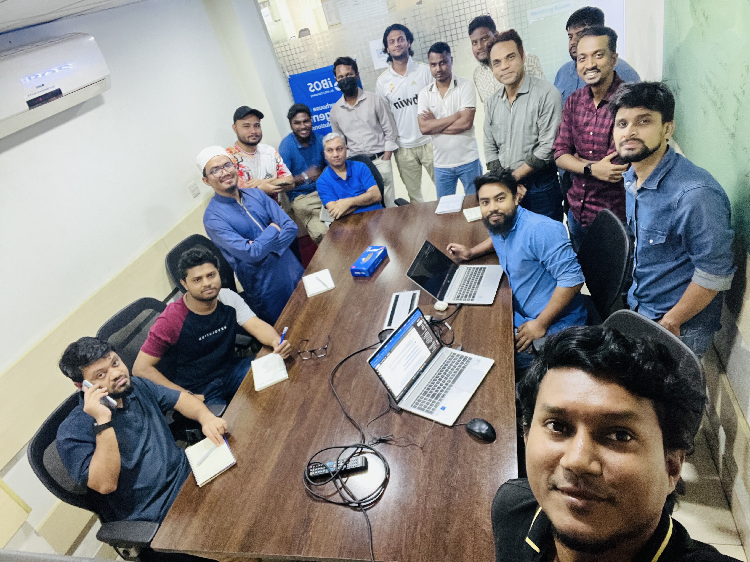

Figure 2.1 Working Environment

2.6 My Position in this Organization
For the practicum I worked at AKIJ iBOS as a Backend Intern, where I participated in the analysis, design and development of the HRM System. My work covered both backend and frontend development: designing the database schema, implementing the Web API with Clean Architecture and CQRS, building the background services for attendance and payroll, securing the API with JWT and role-based authorization, integrating the AI assistant, and developing the Angular user interface. This role provided industry-level experience of full-stack development, multi-tenant data design and the integration of AI components in a professional environment.

2.7 Address of the Organization
Office: 6/2 Kazi Nazrul Islam, Lalmatia, Mohammadpur
Dhaka, 1207, Bangladesh

Chapter 3: Requirements Engineering

3.1 Requirements Analysis
Requirement analysis identifies the essential functionalities of the proposed system. The HRM System serves three user roles—Super Admin, Company Admin and Common (employee)—each with distinct access levels. The Super Admin onboards and manages companies. A Company Admin manages the departments, roles, employees, attendance, leave requests, payroll and AI assistant of their own company. A Common user checks in and out, applies for leave and views their own attendance and payroll. Role-based access control, secure authentication, company-level data isolation and structured data management form the core system-wide requirements that guided design and implementation.

3.1.1 User Requirements & System Requirements
UR-01: Onboard new tenant companies onto the platform.
SR-1.1: A tenant-provisioning endpoint that creates a Company record (Name, Email) and seeds its first Company Admin account.
SR-1.2: A Super-Admin-only bounded context/API area, unscoped by CompanyId, separate from tenant business endpoints.
UR-02: View and manage all registered tenants.
SR-02.1: System needs to return company records on the basis of creation date and status only for Super Admin.
UR-03: Deactivate or suspend a tenant without deleting its data.
SR-03.1: System needs to deactivate/block any company.
UR-04: Have platform-wide visibility without accessing tenant business data.
SR-04.1: System needs to ensure Employee Data, Attendance Records and Payroll is only accessible to HRs of each company.
UR-05: Register/log in securely and manage only their own company's data.
SR-05.1: System needs to let users access the platform individually securing privacy and roles.
SR-05.2: System will distinguish users from different tenants, no user will get to see other company data except Super Admin.
UR-06: Create, update, and organize departments.
SR-06.1: Depending on Company, System will let Company Admin/HR manage departments.
UR-07: Add, update, and deactivate employees.
SR-07.1: System will let HR manage the employee of their company only.
SR-07.2: System will ensure deactivating a user without removing his records.
UR-08: Review and approve/reject employee leave requests.
SR-08.1: System will allow HR of a company to manage leave requests.
UR-9: View attendance and leave reports company-wide or per department.
SR-9.1: System will allow HR to see attendance and payroll reports of their company.
UR-10: Get AI-generated insights on attendance patterns.
SR-10.1: System will have AI integrated Services.
UR-11: Get an AI-assisted answer to ad-hoc HR questions.
SR-11.1: System will need AI-integration service accepting free-text questions plus a snapshot of relevant company data, returning a structured/parseable answer (e.g., ranked list of employees by absentee count).
UR-13: Receive a monthly AI-generated summary of attendance/leave health.
SR-13.1: System will need a payroll calculation feature deriving Net Salary from Employee Salary, Attendance, and Leave Request data.
UR-14: Log in securely and see only their own data.
SR-14.1: Each user will have access to their own personal data and features, System will ensure no one logs in on another person’s account.
UR-15: Check in and check out daily.
SR-15.1: System needs to mark the attendance of each employee of every company.
UR-16: View their own attendance history and working-hour summary.
SR-16.1: System needs optional date-range filtering for employee attendance.

Functional Requirements:
FR-01: System shall issue JWT access tokens (short-lived) and refresh tokens (long-lived, rotatable) on successful login.
FR-02: System shall embed role and CompanyId (and EmployeeId for Employee role) as claims in the JWT.
FR-03: System shall reject any request where the resource's CompanyId does not match the caller's CompanyId claim.
FR-04: System shall support exactly three roles: SuperAdmin, CompanyAdmin, Employee.
FR-05: System shall allow Super Admin to create a Company and its first Company Admin account in one operation.
FR-06: System shall allow Super Admin to update a Company's SubscriptionPlan.
FR-07: System shall allow Super Admin to deactivate a Company (soft delete), blocking login for all its users. viii. FR-08: System shall allow Company Admin to create/update Departments within their own Company.
FR-09: System shall allow Company Admin to create/update Employees, validating Department and Company consistency.
FR-10: System shall support soft-deactivation of Employees without removing historical records.
FR-11: System shall allow an Employee to Check In once per day, recording the timestamp.
FR-12: System shall allow an Employee to Check Out, computing WorkingHours = CheckOut − CheckIn.
FR-13: System shall compute LateMinutes and EarlyLeaveMinutes against a configured shift schedule.
FR-14: System shall set Attendance Status to one of: Present, Absent, Late, Leave, Holiday, Weekend.
FR-15: System shall allow an Employee to submit a LeaveRequest (LeaveType, FromDate, ToDate, Reason), auto-computing TotalDays and setting Status = Pending.
FR-16: System shall allow an Employee to cancel their own LeaveRequest while it is Pending.
FR-17: System shall allow Company Admin to Approve or Reject a LeaveRequest, recording ApprovedBy and ApprovedAt.
FR-18: On approval, system shall update the corresponding
Attendance records for the leave date range to Status = Leave.
FR-19: System shall calculate DailySalary = MonthlySalary / TotalWorkingDays.
FR-20: System shall calculate NetSalary = MonthlySalary − AbsentPenalty − LatePenalty.
FR-21: System shall expose payroll figures via a read-only Query, computed on demand (no tax/provident fund/bonus logic).
FR-22: System shall generate natural-language attendance insights from aggregated lateness/absence data per employee.
FR-24: System shall answer free-text HR questions from Company Admin using company attendance/leave data as context.

3.1.3 Non-Functional Requirement:
NFR-01: Passwords stored as salted hashes, never plaintext.
NFR-02: JWT access tokens expire within a short window (e.g., 15– 30 min); refresh tokens are rotated and revocable.
NFR-03: All API endpoints served over HTTPS; secrets (DB connection strings, AI API keys) kept out of source control.
NFR-04: No query shall return cross-tenant data even under application bugs — enforced via a global EF Core query filter, not just per-handler checks.
NFR-05: Read-heavy endpoints (Employee list, Department list, Attendance summary) shall serve from Redis cache when available, falling back to PostgreSQL on cache miss.
NFR-06: Attendance check-in/check-out writes shall complete within sub-second latency under normal load.
NFR-07: The API layer shall support horizontal scaling — session state lives in JWTs (stateless), shared cache lives in Redis (not inprocess).
NFR-08: Business logic (leave approval rules, payroll formula, attendance status derivation) shall reside in Domain/Application layers, independent of EF Core/ASP.NET Core.
NFR-09: Commands and Queries shall follow CQRS convention — one handler per use case — to keep business logic units small and independently modifiable.
NFR-10: Background jobs (Hangfire) shall be idempotent and safely re-runnable if a job fails mid-execution.
NFR-11: AI integration failures (LLM timeout/error) shall degrade gracefully — core HR workflows (attendance, leave approval) shall not be blocked by AI feature unavailability.
NFR-12: The full stack (API, PostgreSQL, Hangfire, optional Angular frontend) shall run via a single docker compose up with no manual setup.
NFR-13: API shall expose Swagger/OpenAPI documentation for all endpoints.
NFR-14: Key state changes (leave approval/rejection, employee deactivation) shall retain who performed the action and when.
NFR-15: Foreign key constraints shall enforce that Department, Employee, Attendance, and LeaveRequest always reference a valid, same-tenant parent — no orphaned records.

3.2 Use Case Diagram of the System
The use case diagram represents the functional interactions between the users and the HRM System. The Super Admin manages companies; the Company Admin manages departments, roles, employees, attendance, leave and payroll and uses the AI assistant; the Common employee checks in/out, applies for leave and views their own attendance and payroll. Scheduled system jobs act as a secondary actor that marks absences and generates payroll.
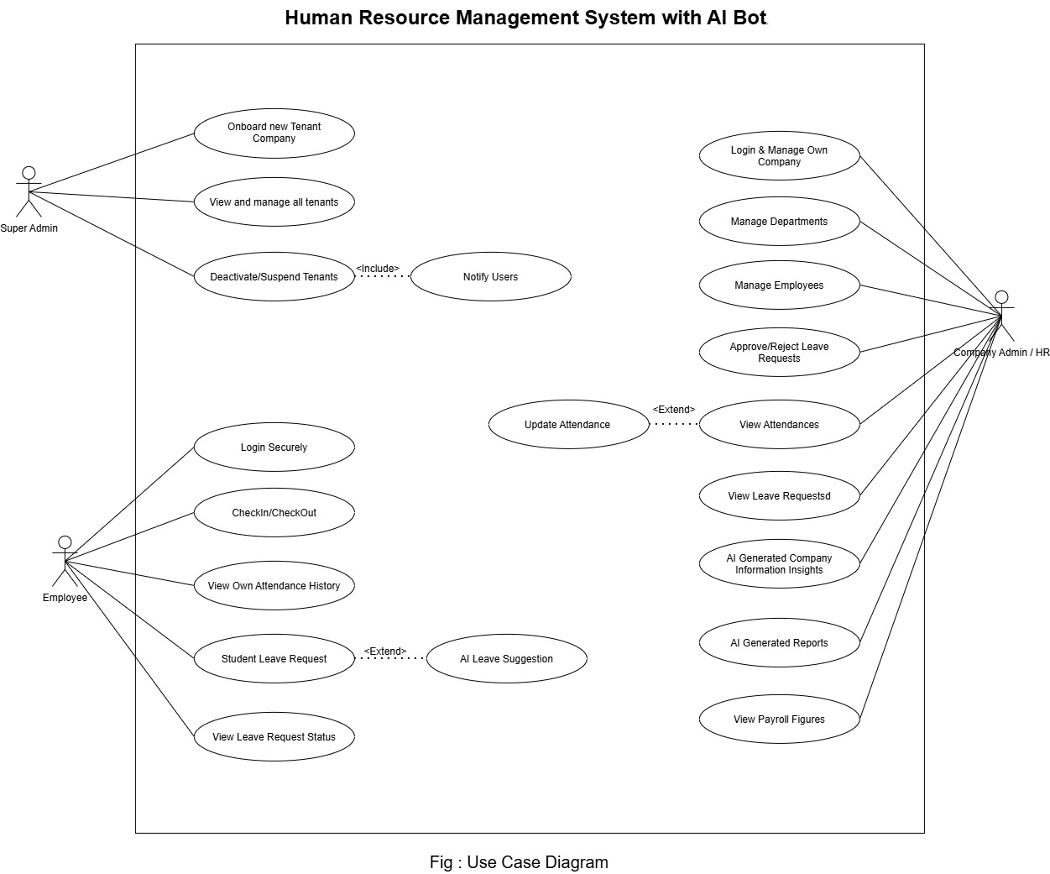
[Insert image: Use Case Diagram]
Actors: Super Admin, Company Admin, Common (Employee), System Scheduler. Use cases: Login, Manage Companies, Manage Departments & Roles, Manage Employees, Check In/Out, Mark Absent (auto), Apply Leave, Approve/Reject Leave, Generate Payroll (auto), View Payroll, View Attendance Summary, Ask AI Assistant.

Figure 3: Use Case Diagram

Chapter 4: Analysis

4.1 Software Analysis Pattern
The HRM System follows a Three-Tier Client-Server Architecture combined with Clean Architecture in the application tier. The application is divided into clearly separated layers, which gives high modularity, testability, security and scalability.
- Presentation Tier: the Angular single-page application that provides the login page, role-specific dashboards, company/department/employee management screens, attendance check-in/out, leave management, payroll views and the HR assistant chat page. It communicates with the backend only through the REST API and attaches the JWT access token to every request.
- Application Tier (Business Logic): the ASP.NET Core Web API organized as four projects—Domain (entities), Application (DTOs, interfaces, MediatR commands/queries and handlers, validation, business rules such as pagination defaults and the payroll formula), Infrastructure (EF Core DbContext, repositories, token service, password service, background job services, AI assistant service) and Web API (controllers, authentication/authorization pipeline, Swagger, hosted services).
- Data Tier: Microsoft SQL Server storing companies, departments, roles, employees, attendance, leave requests, leave types, payroll, refresh tokens and AI audit data, plus the stored procedure used for set-based absent marking.

4.1.1 Why CQRS with the Domain Model Pattern?
Inside the application tier the Command Query Responsibility Segregation (CQRS) pattern is applied through MediatR: every write operation is a Command with its own handler and every read operation is a Query with its own handler. Domain entities (Company, Department, Employee, Role, Attendance, LeaveRequest, LeaveType, Payroll, RefreshToken) model the real HR domain, and business rules live close to the data they govern.
- Clarity and real-world representation: rules such as “a check-in after 09:00 is Late”, “a second check-out on the same day is not allowed”, “approved leave produces On-Leave attendance days” and “every three late arrivals count as one absence in payroll” are expressed explicitly in dedicated handlers and services.
- Maintainability: each use case is an isolated handler (for example CheckInCommandHandler, GetCompaniesQueryHandler, GetPayrollStatusForEmployeeQueryHandler), so a change to one feature does not ripple through unrelated code.
- Testability: handlers depend on repository interfaces defined in the Application layer, so they can be unit-tested without a database.
- Reuse: the same repository queries serve the REST controllers, the background jobs and the AI assistant’s tools, so all three always agree on the data.
- Security by construction: the company identifier is taken from the caller’s token and injected into handlers and AI tools rather than accepted from the request, so tenant isolation cannot be bypassed.

4.2 ERD Diagram
The Entity-Relationship Diagram (ERD) is the design document for the database. It identifies the main data entities and their relationships, ensures data integrity and avoids redundancy through normalization. A Company has many Departments and many Employees; an Employee belongs to one Department and one Role; an Employee has many Attendance records (one per day), many LeaveRequests (each of one LeaveType), many Payroll records (one per month) and many RefreshTokens. AI conversations, audit logs and reports are linked to a Company and optionally to an Employee.
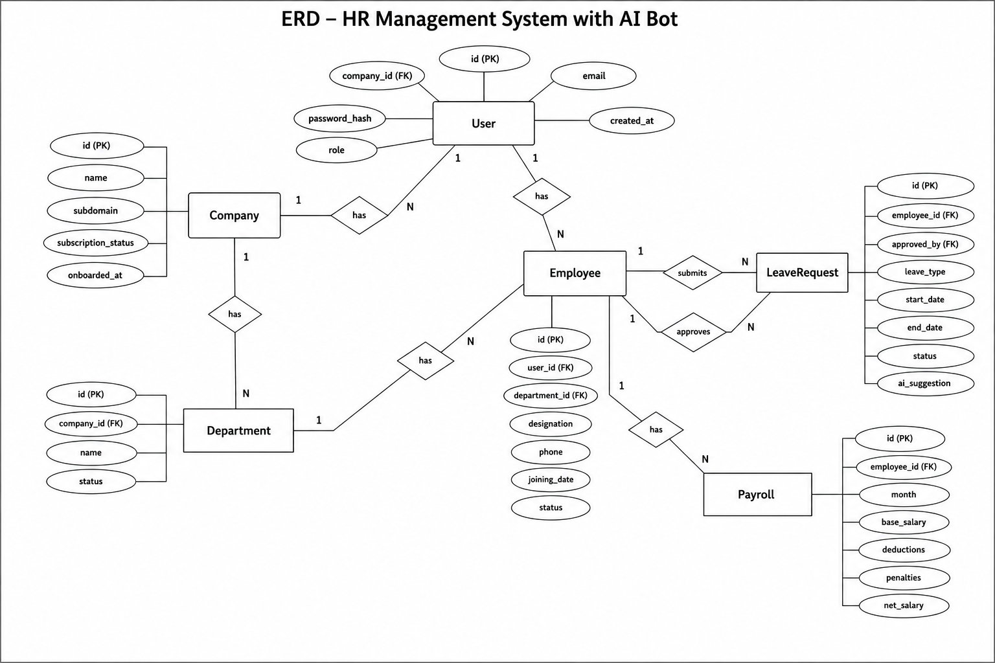

Figure 4: ER Diagram

4.3 Activity Diagram
The activity diagram illustrates the workflow of a process by showing the sequence of activities, decisions and interactions from its initial state to completion.

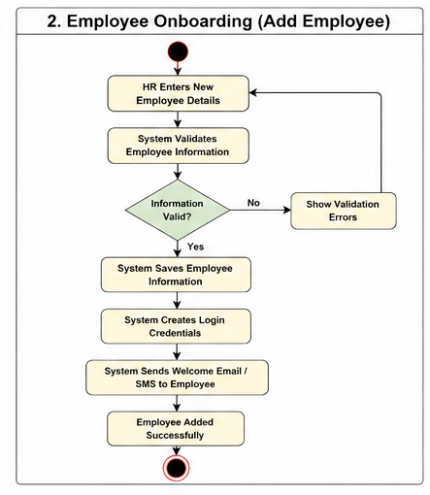

Figure 5: Activity Diagram for Employee Onboarding

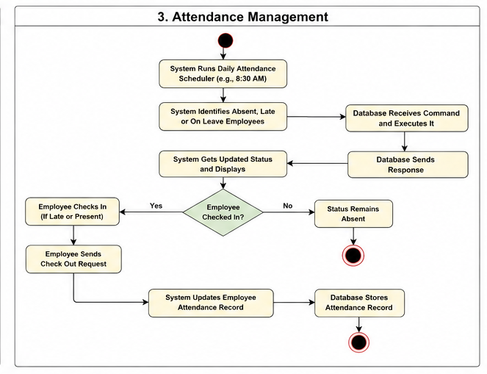
Figure 6: Activity Diagram for Check In, Check Out

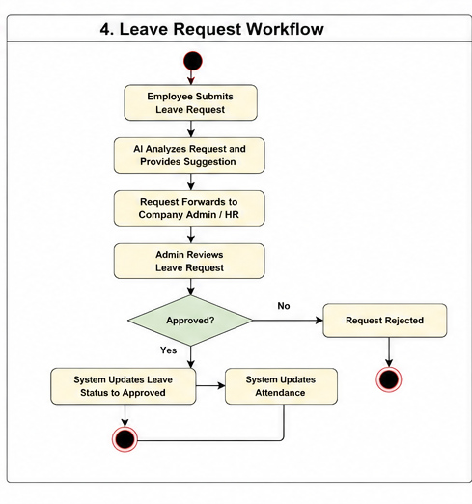

Figure 7: Activity Diagram for Leave Request

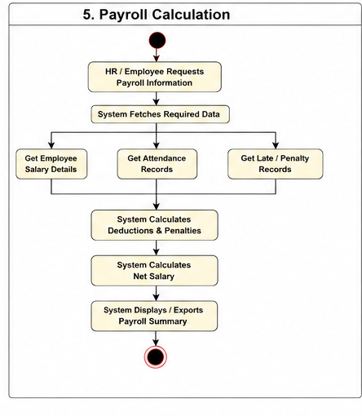

Figure 8: Activity Diagram for Payroll Generation

4.4 Sequence Diagram
The sequence diagram represents the interaction between the user, the Angular client, the Web API (controller → MediatR handler → repository) and the database over time.

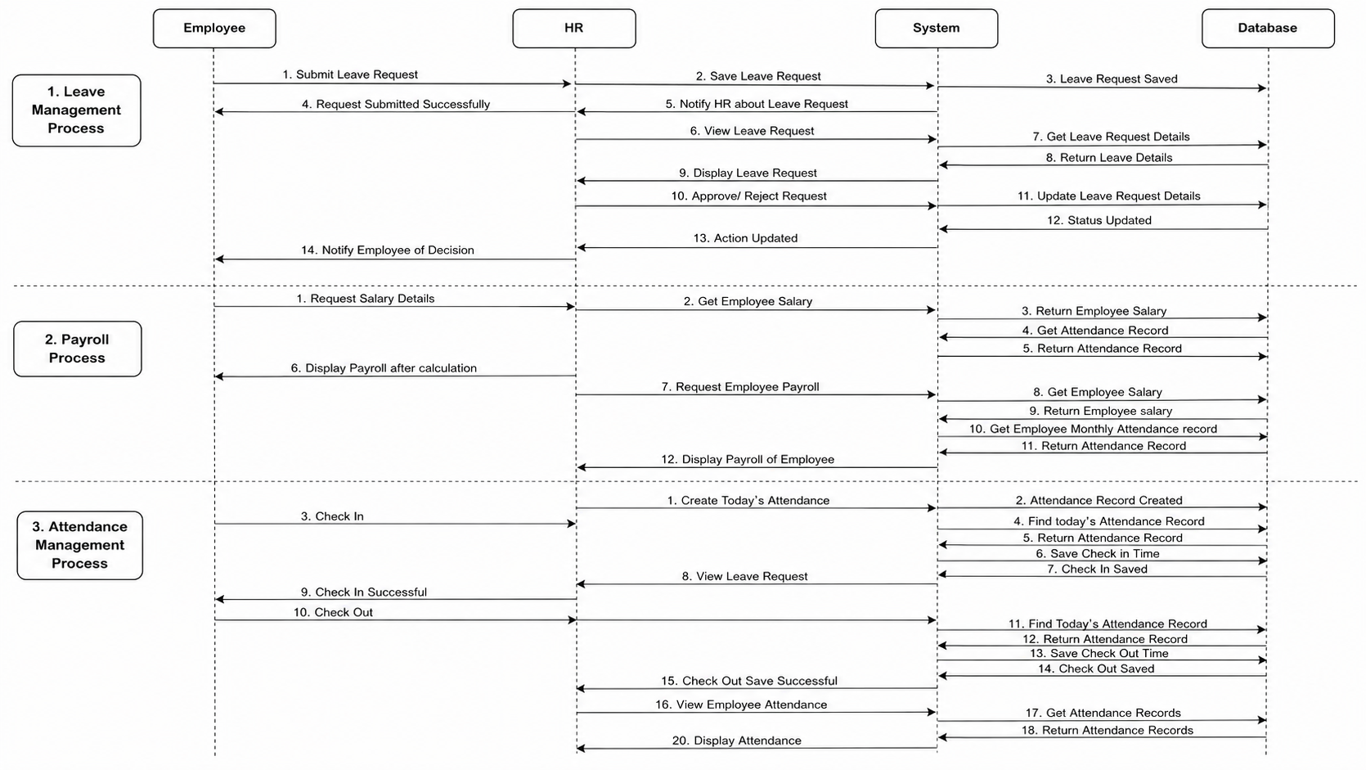

Figure 9: Sequence Diagram for All Actors

4.5 Swim-lane Diagram
Swim-lane diagrams extend activity diagrams by grouping actions by the responsible actor or system component, giving a clearer view of who does what and of the hand-offs between parties.

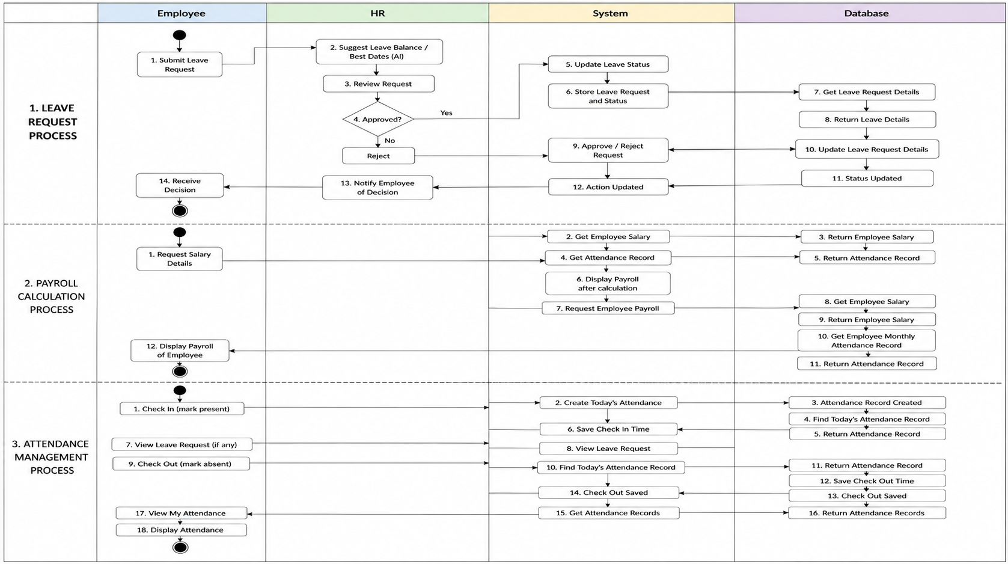

Figure 12: Swimlane Diagram for Super Admin

Chapter 5: Project Management

5.1 Risk Engineering
Risk engineering is the systematic process of identifying, analyzing, planning for and monitoring risks that can impact the successful development and operation of a software system. For the HRM System it is particularly important because the system holds salary and personal data, marks employees absent automatically, calculates pay, and relies on an external language-model service.

5.1.1 Risk Identification
Table 1: Project Risks (Risk Identification)
Risk Type | Possible Risks
Technology | Unauthorized users may gain access to employee, salary or attendance data, or a user of one company may reach another company’s data. (1)
Technology | The automatic absent-marking job may not run (server down at 09:30) or may mark a late employee absent, producing incorrect attendance. (2)
Technology | Payroll may be generated twice or with wrong deductions, resulting in incorrect salaries. (3)
Technology | The external LLM provider may be unavailable, rate-limited, retire the configured model, or produce a wrong answer. (4)
Technology | The database or API server may become unavailable during check-in or payroll generation. (5)
People | Administrators or employees may operate the system incorrectly due to insufficient training. (6)
Organizational | Changes in shift rules, holidays, departments or deduction policy may create inconsistencies. (7)

5.1.2 Risk Analysis Table
Risk analysis evaluates the likelihood of each identified risk and the severity of its consequences. Probability scale: Very Low, Low, Moderate, High, Very High. Impact scale: Insignificant, Tolerable, Serious, Catastrophic.
Table 2: Risk Analysis — Probability and Effects
Risk | Probability | Effects
Unauthorized or cross-company data access (1) | Moderate | Catastrophic
Incorrect attendance from the auto-absent job (2) | High | Serious
Duplicate or wrong payroll (3) | Moderate | Catastrophic
LLM provider unavailable / wrong answer (4) | High | Tolerable
Database or server failure (5) | Moderate | Serious
User operation error (6) | Moderate | Tolerable
Policy/organizational data inconsistency (7) | Moderate | Tolerable

5.2 Risk Planning
Risk planning defines the actions that will be taken to avoid, minimize or control identified risks.
Table 3: Risk Mitigation Strategy
Risk | Mitigation Strategy
Unauthorized / cross-company access (1) | JWT bearer authentication on every endpoint, role-based [Authorize] attributes, company id taken only from the token claim, BCrypt password hashing, HttpOnly refresh cookies with rotation and revocation, and secrets kept out of source control.
Incorrect attendance (2) | Run the absent-marking job at a fixed local time, skip weekly holidays and approved leave, use an idempotent stored procedure, catch up automatically at startup, and let a later check-in convert an auto-Absent record to Late instead of rejecting it.
Wrong or duplicate payroll (3) | Check whether a month’s payroll exists before generating, encapsulate the deduction formula in a single service used by both generation and the live projection, and keep the payroll job idempotent across restarts.
LLM unavailability / wrong answer (4) | Use a provider-agnostic client so the model can be changed by configuration; give the model only read-only, company-scoped tools; instruct it to answer strictly from tool data and to say when it cannot; return the list of tools used with every answer.
Database / server failure (5) | Regular SQL Server backups, EF Core transactions, health monitoring, and startup catch-up logic for scheduled jobs.
User operation error (6) | Simple role-specific interfaces, clear validation messages, confirmation before leave decisions, and short user instructions.
Policy / data inconsistency (7) | Keep shift times, holidays and penalties in configuration and code constants reviewed with HR, validate department/role references when saving employees, and avoid inner-join queries that would hide employees with stale references.

Table 4: Risk Contingency Plans
Risk | Contingency Plan (If It Happens)
Unauthorized access | Revoke all refresh tokens of the affected accounts, rotate the JWT signing key, reset credentials, review logs and fix the vulnerability before restoring access.
Incorrect attendance | The Company Admin corrects the affected attendance records; if the job did not run, restart the API so the catch-up logic re-runs it for the missed day.
Wrong payroll | Delete the incorrect payroll rows for the month and re-run generation after fixing attendance; compare with the live projection.
LLM failure | Switch the configured model or provider, or temporarily disable the assistant; all data remains available through normal screens.
Database/server failure | Restore the latest validated backup; employees record attendance manually until the service returns, after which admins enter corrections.
User operation error | Provide additional training and allow the administrator to correct the entered data.
Policy inconsistency | Update the configuration/constants, review affected records and regenerate reports.

5.3 Risk Monitoring
Risk monitoring continuously observes the identified risks throughout the project and determines whether their probability or impact is changing.
Table 5: Risk Monitoring Indicators
Risk Area | Monitoring Indicator
Security / tenant isolation | Failed login attempts, 401/403 rates, unexpected refresh-token failures, any record returned outside the caller’s company during testing.
Attendance integrity | Number of Absent records converted to Late, days on which the job did not run, manual corrections per month.
Payroll integrity | Difference between live projection and generated payroll, duplicate rows per employee/month, payroll job errors in logs.
AI assistant | Provider errors (404 model not found, 429 rate limit), average response time, answers with empty toolsUsed, user complaints of wrong answers.
Database / server | Connection errors, API 5xx rate, response latency, backup status.
User errors | Support requests, repeated validation failures, incorrect leave decisions.
Policy consistency | Employees with missing department/role references, holiday calendar changes, penalty changes.

5.4 RMMM Plan
Risk Mitigation, Monitoring and Management (RMMM) is a structured plan used to reduce the probability or impact of risks, observe their warning indicators, and take corrective action when a risk occurs.
Table 6: RMMM Summary Plan
Risk | Mitigation | Monitoring | Management / Contingency
Unauthorized access – (High) | JWT + roles, tenant scoping from token, hashing, refresh rotation. | Auth failures, 403s, suspicious activity. | Owner: Technical Lead. Revoke tokens, rotate keys, investigate.
Incorrect attendance – (High) | Idempotent SP, holiday calendar, startup catch-up, Absent→Late conversion. | Missed job runs, corrections count. | Owner: Backend Lead. Correct records, re-run job.
Wrong payroll – (High) | Existence check before generation, single formula service. | Duplicates, projection vs actual gap. | Owner: Backend/QA Lead. Regenerate after fixing data.
LLM failure – (Medium) | Provider-agnostic client, scoped tools, honest prompt. | Provider errors, latency, complaints. | Owner: Technical Lead. Switch model/provider.
Server/DB failure – (Medium) | Backups, transactions, monitoring. | Errors, latency, backup status. | Owner: System Admin. Restore backup.
User error – (Medium) | Training, validation, confirmations. | Support requests. | Owner: Admin Team. Assisted correction.
Policy inconsistency – (Medium) | Configurable rules, reference validation. | Orphaned references, rule changes. | Owner: HR/Admin. Update config, review records.

Risk Mitigation: actions performed before a risk occurs to reduce its probability or impact. Risk Monitoring: continuous observation of indicators that show whether a risk is becoming more likely. Risk Management: corrective or contingency actions performed when the risk actually occurs.

5.4.1 Project RMMM Detailed Risk Tables
Table 7: Detailed Risk — Unauthorized System Access
Risk Name | Unauthorized or Cross-Company Data Access
Probability | Moderate (3)
Impact | Catastrophic (4)
Description | An unauthorized person, or a legitimate user of another company, may gain access to employee, attendance, leave or salary information because of compromised credentials or incorrect access-control configuration.
Mitigation & Monitoring | JWT bearer authentication, [Authorize(Roles = …)] on every endpoint, company id read only from the token’s CompanyId claim, BCrypt hashing, refresh-token rotation and revocation, secrets in user-secrets/environment variables. Monitor failed logins and 401/403 patterns.
Management | Owner: Technical/Security Lead. Strategy: Avoidance/Mitigation. Contingency: revoke tokens, rotate signing key, reset credentials, investigate and fix before restoring access.
Status | Not encountered

Table 8: Detailed Risk — Incorrect Attendance Records
Risk Name | Incorrect Attendance from Automatic Absent Marking
Probability | High (4)
Impact | Serious (3)
Description | The scheduled job may not run if the server is down at 09:30, or it may mark an employee Absent who then arrives late; without care the late check-in would be rejected.
Mitigation & Monitoring | Idempotent stored procedure that only inserts missing rows, weekly-holiday and approved-leave exclusion, startup catch-up when the scheduled time has passed, and check-in logic that converts an Absent row with no check-in time into a Late record. Monitor missed runs and corrections.
Management | Owner: Backend Lead. Strategy: Mitigation. Contingency: administrator corrects records; restart triggers re-run.
Status | Encountered during testing and resolved

Table 9: Detailed Risk — Incorrect or Duplicate Payroll
Risk Name | Incorrect or Duplicate Payroll Generation
Probability | Moderate (3)
Impact | Catastrophic (4)
Description | Payroll for a month could be generated more than once (e.g. after a restart) or computed with the wrong attendance counts, producing wrong salaries.
Mitigation & Monitoring | The job checks whether payroll rows already exist for the target month before generating; generation always targets the previous, completed month; the same PayrollCalculateService is used for the stored payroll and the live projection. Monitor duplicates and projection/actual differences.
Management | Owner: Backend/QA Lead. Strategy: Avoidance. Contingency: delete wrong rows, correct attendance, regenerate.
Status | Not encountered

Table 10: Detailed Risk — AI Provider Failure or Wrong Answer
Risk Name | LLM Provider Unavailability or Hallucinated Answer
Probability | High (4)
Impact | Tolerable (2)
Description | The free-tier language-model provider may retire a model, apply rate limits or be unreachable; the model may also answer without data.
Mitigation & Monitoring | Microsoft.Extensions.AI abstraction with base URL/model/key in configuration; tools are read-only and company-scoped; the system prompt forbids inventing data; toolsUsed is returned with every answer. Monitor provider errors and latency.
Management | Owner: Technical Lead. Strategy: Mitigation. Contingency: change the model or provider by configuration, or disable the assistant.
Status | Model retirement encountered (model_not_found) and resolved by configuration

Table 11: Detailed Risk — Database/Server Failure
Risk Name | Database or Backend Server Failure
Probability | Moderate (3)
Impact | Serious (3)
Description | SQL Server, the API or the network may become unavailable during check-in, leave approval or payroll generation.
Mitigation & Monitoring | Regular backups, EF Core transactions, health monitoring; scheduled jobs recover automatically after restart.
Management | Owner: System Administrator. Strategy: Mitigation. Contingency: restore backup; manual attendance until restored.
Status | Not encountered

Table 12: Detailed Risk — User Operation Error
Risk Name | Incorrect System Operation by Administrators or Employees
Probability | Moderate (3)
Impact | Tolerable (2)
Description | Administrators may enter wrong employee data, approve the wrong leave request or misread payroll; employees may forget to check out.
Mitigation & Monitoring | Clear forms with validation, confirmation dialogs, role-specific pages and short instructions. Monitor support requests and repeated errors.
Management | Owner: Administrator/Project Team. Strategy: Mitigation. Contingency: training and administrator-assisted correction.
Status | Not encountered

Chapter 6: Project Planning

6.1 Project Planning
Project planning defines the scope, resources, effort and timeline needed to create the HRM System. The system is role-based and multi-company, with employee administration, daily attendance, leave, monthly payroll, analytics and an AI assistant. Planning links these functions to a sequence of analysis, design, implementation, testing and delivery tasks.
The HRM System is built with an Angular frontend, an ASP.NET Core (.NET 10) Web API backend organized with Clean Architecture and MediatR/CQRS, Entity Framework Core and Microsoft SQL Server. Scheduled work runs as hosted background services, and the AI assistant uses Microsoft.Extensions.AI over an OpenAI-compatible endpoint. This structure is the basis of the functional size and work breakdown used in this chapter.

6.2 Project Estimation
The project estimate is broken down into four components:
- Product size estimation: the function-point count identifies 14 external inputs, 7 external outputs, 11 external inquiries and 12 internal logical files, which establish the size baseline.
- Translation into effort, time and cost: the schedule is 3 months, 22 working days per month and 8 hours per day for 1 developer.
- Alignment with team capabilities: one developer is responsible for planning, analysis, design, coding and testing, with guidance from the organizational supervisor.
- Consistency of requirements and environment: role permissions, tenant scoping, attendance rules and payroll rules are consistent across the frontend, API and database.

6.3 Function Oriented Metrics
Function-oriented measurement relates software size to the information it stores and the transactions it performs for users. Data functions are Internal Logical Files (ILF), maintained inside the application, and External Interface Files (EIF), maintained elsewhere but read by the application. Transaction functions are External Inputs (EI), External Outputs (EO) and External Inquiries (EQ).
Transaction complexity uses File Types Referenced (FTR) and Data Element Types (DET); data-function complexity uses Record Element Types (RET) and DET. The resulting Low, Average or High band determines each contribution.
UFP = Sum of transaction contributions + Sum of data contributions
TDI = Sum of the 14 Degree of Influence ratings
VAF = 0.65 + (0.01 × TDI)
AFP = UFP × VAF
Table 13: Complexity Matrices — External Inputs
EI: FTR | 1–4 DET | 5–15 DET | 16+ DET
0–1 | Low | Low | Average
2 | Low | Average | High
3+ | Average | High | High

Table 14: Complexity Matrices — External Outputs / Inquiries
EO/EQ: FTR | 1–5 DET | 6–19 DET | 20+ DET
0–1 | Low | Low | Average
2–3 | Low | Average | High
4+ | Average | High | High

Table 15: Complexity Matrices — Data Functions
ILF/EIF: RET | 1–19 DET | 20–50 DET | 51+ DET
1 | Low | Low | Average
2–5 | Low | Average | High
6+ | Average | High | High

Table 16: Function Point Contribution Weights
Complexity | EI | EO | EQ | ILF | EIF
Low | 3 | 4 | 3 | 7 | 5
Average | 4 | 5 | 4 | 10 | 7
High | 6 | 7 | 6 | 15 | 10

6.4 FP Calculation

6.4.1 Shared, Employee and Company Admin Functionalities
Table 17: Shared Login and Employee Functionalities
Functionality | Input | Output
User can log in to the system | E-mail, Password | Access token; refresh-token cookie; role
User can refresh session / log out | Refresh-token cookie | New access token / logout confirmation
Employee can check in / check out | Employee ID, Company ID, Date (time taken by server) | Attendance record with status, late/early minutes, working hours
Employee can submit a leave request | Leave type, From date, To date, Reason | Pending leave request
Employee can view own attendance | Employee ID | Attendance records and monthly statistics
Employee can view own payroll | Employee ID, Month, Year | Payroll details

6.4.2 Super Admin and Company Admin Functionalities
Table 18: Admin and System Functionalities
Functionality | Input | Output
Super Admin can create/update a company | Name, E-mail, Phone, Address, Logo URL, Subscription plan, Active flag | Company record confirmation
Super Admin can list/view companies | Page number, Page size, Order | Paged company list / company details
Admin can create/update a department | Company ID, Name, Description, Active flag | Department record confirmation
Admin can list departments | Company ID, paging | Paged departments with employee counts
Admin can create/update a role | Role name, Active flag | Role record confirmation
Admin can create/update an employee | Code, Names, E-mail, Password, Phone, Department, Role, Gender, DOB, Join date, Salary, Status | Employee record confirmation
Admin can list/search employees | Company ID, Department ID, paging | Paged employee list / employee details
Admin can approve/reject/cancel leave | Leave request ID, Status | Updated request; On-Leave attendance days
Admin can view attendance by date / by employee | Company ID, Date / Employee ID | Attendance records
Admin can view attendance summaries | Company ID, Date / Month, Year | Daily and monthly summaries, per-employee statistics
Admin can view payroll | Employee ID or Company ID, Month, Year | Payroll records
Admin can view live payroll status | Employee ID | Projected payroll for the current month
Admin can ask the AI assistant | Question text | Answer and list of tools used
System generates payroll monthly | Scheduled trigger (1st of month) | Payroll rows for previous month
System marks absent employees daily | Scheduled trigger (09:30 working days) | Absent attendance rows

6.4.3 Transactional Functions
External Inputs (EI) — 14
1. User login (all roles)
2. Refresh access token
3. Logout (revoke refresh token)
4. Create/update company
5. Create/update department
6. Create/update employee
7. Create/update role
8. Employee check-in
9. Employee check-out
10. Submit leave request
11. Approve/reject/cancel leave request
12. Mark on-leave attendance for a date range
13. Automatic daily absent marking (system)
14. Automatic monthly payroll generation (system)
Total EI = 14; EI contribution = 59 UFP
External Outputs (EO) — 7
1. Monthly attendance summary
2. Daily attendance summary
3. Employee attendance statistics
4. Payroll for an employee
5. Payroll for a company
6. Live payroll status (calculated)
7. AI assistant answer
Total EO = 7; EO contribution = 36 UFP
External Inquiries (EQ) — 11
1. List companies (paged)
2. Company by ID
3. Departments by company (paged, with employee count)
4. Department by ID
5. Employees by company (paged)
6. Employee by ID
7. Roles list / role by ID
8. Attendance by date
9. Attendance by employee
10. Leave requests by status
11. Leave history by employee
Total EQ = 11; EQ contribution = 41 UFP

6.4.4 Data Functions
Twelve Internal Logical Files are identified: Company, Department, Role, Employee, Attendance, LeaveRequest, LeaveType, Payroll, RefreshToken, AiConversation, AiAuditLog and AiReport. All are Low complexity. No External Interface File is counted: the language-model provider is an external service invoked through an API, not a logical data file read by the application.
Total ILF = 12; Total EIF = 0; Data contribution = 84 UFP

6.4.5 Identifying Unadjusted Function Point Contribution Complexity
Table 19: Transaction Functions (EI / EO / EQ)
Transaction Function | Fields / File Involvement | FTR | DET | Complexity | UFP
User login (EI) | Fields: E-mail, Password, Submit. Files: Employee, RefreshToken | 2 | 3 | Low | 3
Refresh token (EI) | Fields: Refresh cookie, Submit. Files: RefreshToken, Employee | 2 | 2 | Low | 3
Logout (EI) | Fields: Refresh cookie. Files: RefreshToken | 1 | 1 | Low | 3
Create/update company (EI) | Fields: Name, E-mail, Phone, Address, Logo, Plan, Active, Submit. Files: Company | 1 | 9 | Low | 3
Create/update department (EI) | Fields: Company ID, Name, Description, Active, Submit. Files: Department, Company | 2 | 6 | Average | 4
Create/update employee (EI) | Fields: Code, First/Last name, E-mail, Password, Phone, Department, Role, Gender, DOB, Join date, Salary, Status, Active, Submit. Files: Employee, Department, Role, Company | 4 | 16 | High | 6
Create/update role (EI) | Fields: Name, Active, Submit. Files: Role | 1 | 4 | Low | 3
Check-in (EI) | Fields: Employee ID, Company ID, Date, Time, Status, Late minutes. Files: Attendance, Employee | 2 | 6 | Average | 4
Check-out (EI) | Fields: Attendance ID, Time, Early-leave, Working hours. Files: Attendance, Employee | 2 | 6 | Average | 4
Submit leave request (EI) | Fields: Employee, Leave type, From, To, Reason, Total days, Status, Submit. Files: LeaveRequest, Employee, LeaveType | 3 | 9 | High | 6
Approve/reject leave (EI) | Fields: Request ID, Status, Approved by, Approved at. Files: LeaveRequest, Employee, Attendance | 3 | 5 | High | 6
Mark on-leave range (EI) | Fields: Employee, From, To, Remarks, Status. Files: Attendance, Employee | 2 | 5 | Average | 4
Auto absent marking (EI) | Fields: Date, Company, Employee, Status. Files: Employee, Attendance, LeaveRequest | 3 | 4 | Average | 4
Auto payroll generation (EI) | Fields: Month, Year, Basic, Absent deduction, Late deduction, Net, Generated at. Files: Employee, Attendance, Payroll | 3 | 8 | High | 6
Monthly attendance summary (EO) | Fields: Company, Month, Year, Avg rate, Late arrivals, Perfect attendance, Employee list (4), Punctual dept (2), Late rate, Highest absentees (3). Files: Attendance, Employee, Department | 3 | 17 | Average | 5
Daily attendance summary (EO) | Fields: Company, Date, Total, Present, Late, Leave, Absent, Absent arrival. Files: Attendance, Employee | 2 | 8 | Average | 5
Employee attendance statistics (EO) | Fields: Employee, Month, Year, Present, Late, Leave, Ratio. Files: Attendance, Employee | 2 | 7 | Average | 5
Payroll for employee (EO) | Fields: Employee, Month, Year and 9 payroll fields. Files: Payroll | 1 | 12 | Low | 4
Payroll for company (EO) | Fields: Company, Month, Year, Employee name and payroll fields. Files: Payroll, Employee | 2 | 13 | Average | 5
Live payroll status (EO) | Fields: Employee, Month, Year, Salary, Absent/Late counts, deductions, Net. Files: Employee, Attendance | 2 | 12 | Average | 5
AI assistant answer (EO) | Fields: Question, Company, Answer, Tools used, Tokens, Time. Files: Employee, Attendance, LeaveRequest, Department, AiConversation | 5 | 6 | High | 7
List companies (EQ) | Fields: paging (3) + 10 company fields + counts. Files: Company | 1 | 14 | Low | 3
Company by ID (EQ) | Fields: ID + 10 company fields. Files: Company | 1 | 11 | Low | 3
Departments by company (EQ) | Fields: Company, paging, 7 dept fields, Employee count. Files: Department, Employee, Company | 3 | 12 | Average | 4
Department by ID (EQ) | Fields: ID, 7 dept fields, Employee count. Files: Department, Employee | 2 | 9 | Average | 4
Employees by company (EQ) | Fields: Company, Department, paging, 16 employee fields, Role name. Files: Employee, Role, Department | 3 | 20 | High | 6
Employee by ID (EQ) | Fields: ID, 14 employee fields, Role name. Files: Employee, Role | 2 | 16 | Average | 4
Roles list / by ID (EQ) | Fields: ID, Name, Active, timestamps. Files: Role | 1 | 4 | Low | 3
Attendance by date (EQ) | Fields: Company, Date, 11 attendance fields. Files: Attendance | 1 | 13 | Low | 3
Attendance by employee (EQ) | Fields: Employee, 12 attendance fields. Files: Attendance | 1 | 13 | Low | 3
Leave requests by status (EQ) | Fields: Status, Company, 13 leave fields. Files: LeaveRequest, Employee | 2 | 15 | Average | 4
Leave history by employee (EQ) | Fields: Employee, 13 leave fields. Files: LeaveRequest, Employee | 2 | 14 | Average | 4

Table 20: Transactional UFP Summary
Type | Function Count | UFP Subtotal
EI | 14 | 59
EO | 7 | 36
EQ | 11 | 41
Total | 32 | 136

6.4.6 Data Functions (ILF / EIF)
Table 21: Data Function Complexity and UFP
Data Function | Fields | RET | DET | Complexity | UFP
Company (ILF) | CompanyId, CompanyName, CompanyEmail, CompanyPhone, CompanyAddress, LogoUrl, SubscriptionPlan, IsActive, CreatedAt, UpdatedAt | 1 | 10 | Low | 7
Department (ILF) | DepartmentId, CompanyId, DepartmentName, Description, IsActive, CreatedAt, UpdatedAt | 1 | 7 | Low | 7
Role (ILF) | RoleId, RoleName, IsActive, CreatedAt, UpdatedAt | 1 | 5 | Low | 7
Employee (ILF) | EmployeeId, CompanyId, DepartmentId, EmployeeCode, FirstName, LastName, Email, Phone, PasswordHash, RoleId, Gender, DateOfBirth, JoinDate, Salary, Status, IsActive, CreatedAt, UpdatedAt | 1 | 18 | Low | 7
Attendance (ILF) | AttendanceId, CompanyId, EmployeeId, AttendanceDate, CheckIn, CheckOut, WorkingHours, LateMinutes, EarlyLeaveMinutes, Status, Remarks, CreatedAt | 1 | 12 | Low | 7
LeaveRequest (ILF) | LeaveRequestId, CompanyId, EmployeeId, LeaveTypeId, FromDate, ToDate, TotalDays, Reason, Status, ApprovedBy, ApprovedAt, AiRecommendation, AiNotes, CreatedAt | 1 | 14 | Low | 7
LeaveType (ILF) | LeaveTypeId, LeaveTypeName, LeaveTypeDescription, CreatedAt, UpdatedAt | 1 | 5 | Low | 7
Payroll (ILF) | PayrollId, CompanyId, EmployeeId, Month, Year, BasicSalary, AbsentDeduction, LateDeduction, NetSalary, GeneratedAt | 1 | 10 | Low | 7
RefreshToken (ILF) | RefreshTokenId, Token, EmployeeId, ExpiresAt, CreatedAt, IsRevoked | 1 | 6 | Low | 7
AiConversation (ILF) | AiConversationId, CompanyId, EmployeeId, UserPrompt, AiResponse, TokensUsed, ResponseTimeMs, CreatedAt | 1 | 8 | Low | 7
AiAuditLog (ILF) | AiAuditLogId, CompanyId, EmployeeId, FeatureName, PromptLength, TokensUsed, Success, ErrorMessage, CreatedAt | 1 | 9 | Low | 7
AiReport (ILF) | AiReportId, CompanyId, ReportType, Month, Year, ReportContent, GeneratedBy, GeneratedAt | 1 | 8 | Low | 7

Total Data UFP = 12 × 7 = 84

6.4.7 Performance and Environment Impact
The 14 General System Characteristics are rated with a Degree of Influence (DI) from 0 to 5. Their sum gives the Total Degree of Influence (TDI). The ratings are planning judgments, not measured results.
Table 22: General System Characteristics and DI Ratings
GSC (General System Characteristic) | DI (0–5)
1. Data Communications | 4
2. Distributed Data Processing | 2
3. Performance | 3
4. Heavily Used Configuration | 0
5. Transaction Rate | 2
6. Online Data Entry | 5
7. End-User Efficiency | 4
8. Online Update | 4
9. Complex Processing | 4
10. Reusability | 3
11. Installation Ease | 1
12. Operational Ease | 3
13. Multiple Sites | 3
14. Facilitate Change | 3
Total Degree of Influence (TDI) | 41

TDI = 4 + 2 + 3 + 0 + 2 + 5 + 4 + 4 + 4 + 3 + 1 + 3 + 3 + 3 = 41

6.4.8 Unadjusted Function Points (UFP)
Transactional UFP = 59 + 36 + 41 = 136
Data UFP = 12 × 7 = 84
Total UFP = 136 + 84 = 220

6.4.9 Value Adjustment Factor (VAF)
VAF = 0.65 + (0.01 × 41) = 1.06

6.4.10 Adjusted Function Points (AFP)
AFP = UFP × VAF = 220 × 1.06 = 233.2 FP
Table 23: Final Function Point Calculation
Metric | Calculation | Result
Transactional UFP | 59 + 36 + 41 | 136
Data UFP | 12 × 7 | 84
Total UFP | 136 + 84 | 220
TDI | Sum of 14 DI values | 41
VAF | 0.65 + 0.01 × 41 | 1.06
Adjusted FP | 220 × 1.06 | 233.2

6.4.11 Effort Estimation Using Function Points
Actual effort is reconstructed from the developer’s working schedule rather than predicted from a generic productivity rate. The accepted schedule is 1 developer working 8 hours per day, 22 working days per month, for 3 months.
Actual Effort = 1 × 3 × 22 × 8 = 528 person-hours
Observed effort per FP = 528 / 233.2 = 2.264 ≈ 2.26 hours/FP
Effort check = 233.2 × 2.264 = 528 hours
This rate is derived from the reported effort and is not an industry benchmark.
Table 24: Actual Effort and Duration
Item | Basis / Calculation | Result
Developers | Developer count | 1 person
Daily working hours | Reported schedule | 8 hours/day
Working days per month | Agreed convention | 22 days
Project duration | Reported duration | 3 months
Actual effort | 1 × 3 × 22 × 8 | 528 person-hours
Effort per FP | 528 / 233.2 | 2.26 hours/FP
Project person-days | 528 / 8 | 66 person-days
Project person-months | 528 / (8 × 22) | 3 person-months

6.5 Details Effort Distribution
Effort is allocated across planning, analysis, design, coding and testing using a standard planning distribution applied to the 528-hour baseline. It is a planning allocation, not a measured timesheet.
Table 25: Phase-wise Effort Allocation
Phase | Allocation | Effort (hours)
Planning | 15% | 79.20
Analysis | 15% | 79.20
Design | 15% | 79.20
Coding | 35% | 184.80
Testing | 20% | 105.60
Total | 100% | 528.00

6.6 Project Schedule Chart
The three-month schedule is shown as 13 weekly slots. Phases recur within sprints, so the phase percentages need not equal the calendar widths of the sprint bars.
Table 26: Sprint Planning Table
Sprint # | Task Name | Duration (Weeks) | Start–End | Key Dependencies
Sprint 0 | Requirements, backlog, Clean Architecture skeleton and database schema | 2 | Weeks 1–2 | None
Sprint 1 | JWT authentication with refresh tokens; company, role and department management | 2 | Weeks 3–4 | Database schema
Sprint 2 | Employee management, pagination, Swagger security | 2 | Weeks 5–6 | Sprint 1
Sprint 3 | Attendance check-in/out, automatic absent marking, summaries; leave workflow | 3 | Weeks 7–9 | Sprint 2
Sprint 4 | Payroll generation job, live payroll status, AI assistant | 2 | Weeks 10–11 | Sprint 3
Final | Angular integration, testing, documentation and deployment preparation | 2 | Weeks 12–13 | All sprints

6.7 Project Estimation (Cost)
Cost planning considers developer time, existing equipment usage, software and operating costs. The following amounts are an indicative academic budget, not actual spending.
- Team member expenses: one developer performing analysis, design, implementation and testing.
- Infrastructure costs: depreciation of one development laptop and a shared router for the project period.
- Software tools and licenses: the entire stack (Angular, .NET, EF Core, SQL Server Express/LocalDB, Visual Studio/Rider community or educational licenses, free-tier LLM API) is available without cost.
- Miscellaneous expenses: internet, electricity and optional backup storage for three months.

6.8 Personnel Cost Estimation
Working hours per month = 22 × 8 = 176 hours; working hours for the project = 3 × 176 = 528 hours. Assumed developer salary = BDT 40,000 per month. Hourly rate = 40,000 / 176 = BDT 227.27.
Table 27: Staff Salary and Hourly Rate
Position | Persons | Salary/Month (BDT) | Salary/Hour (BDT)
Developer (analysis, design, coding, testing) | 1 | 40,000.00 | 227.27

Personnel cost = 528 × (40,000 / 176) = BDT 120,000.00
Table 28: Personnel Payment Summary
Job Title | Persons | Total Salary (BDT) | 60% Advance (BDT) | 40% Balance (BDT) | Weekly Installment (13 slots)
Developer | 1 | 120,000.00 | 72,000.00 | 48,000.00 | 3,692.31*

*Balance / 13 = BDT 3,692.31 per weekly slot (last installment BDT 3,692.28 to settle exactly).
Hardware Cost Estimation
Existing equipment is allocated using the sum-of-years’-digits method with a five-year life, zero residual value and three months of use. Sum of digits = 5 + 4 + 3 + 2 + 1 = 15; project allocation = original cost × applicable annual fraction × (3 / 12).
Table 29: Depreciation Calculation Basis
Service Year | Annual Fraction | Annual Depreciation
Year 1 | 5/15 | 33.33%
Year 2 | 4/15 | 26.67%
Year 3 | 3/15 | 20.00%
Year 4 | 2/15 | 13.33%
Year 5 | 1/15 | 6.67%

Table 30: Hardware Requirement and Project-period Value
Equipment | Qty | Original Price (BDT) | Assumed Age | Annual Dep. | 3-Month Cost (BDT)
Development laptop | 1 | 85,000 | 3 years | 2/15 (Yr 4) | 2,833.33
Router | 1 | 15,000 | 4 years | 1/15 (Yr 5) | 250.00
Total |  | 100,000 |  |  | 3,083.33

Other Cost Estimation
Table 31: Other Operating Costs
Category | Description | Monthly Cost (BDT) | Total (3 Months)
Internet | Shared connection budget | 2,500 | 7,500
Electricity | Project allocation for one workstation | 1,500 | 4,500
LLM API usage | Free tier (Groq) — no charge | 0 | 0
Backup storage | Optional storage budget | 150 | 450
Total Other Costs |  | 4,150 | 12,450

Software Cost Estimation
Table 32: Software Requirements and Budget
Software Item | Type | Purpose | Budget (BDT)
Angular, TypeScript, Node.js | Frontend packages | Role-based interface, forms and pages | 0
.NET 10 SDK, ASP.NET Core, MediatR, FluentValidation | Backend stack | REST API, CQRS handlers, validation | 0
Entity Framework Core, SQL Server Express/LocalDB | Data access and database | Persistence, migrations, stored procedure | 0
Microsoft.Extensions.AI, OpenAI SDK | AI abstraction | LLM tool-calling for the HR assistant | 0
Swashbuckle (Swagger) | API documentation | OpenAPI description and test UI | 0
Visual Studio / JetBrains Rider (educational) | IDE | Development and debugging | 0
Git and GitHub | Version control | Source management | 0
Total Software Cost |  |  | 0

Table 33: Illustrative Project Budget Summary
Cost Category | Amount (BDT)
Personnel | 120,000.00
Hardware usage allocation | 3,083.33
Other operating costs | 12,450.00
Software purchases budgeted | 0.00
Total Illustrative Budget | 135,533.33

Chapter 7: Designing

7.1 Data Flow Diagram (DFD)
A Data Flow Diagram depicts the flow of data in a system between external entities, processes and data stores. DFDs explain what the system does and how information is managed rather than how it is implemented.

7.1.1 DFD Level 0 (Context Diagram)
The context diagram shows the HRM System as a single process interacting with four external entities. The Super Admin logs in and manages companies. The Company Admin logs in and manages departments, roles, employees, leave decisions, views attendance analytics and payroll, and asks the AI assistant. The Employee logs in, checks in and out, applies for leave and views their own records. The LLM Provider receives questions with tool definitions and returns tool calls and answers.
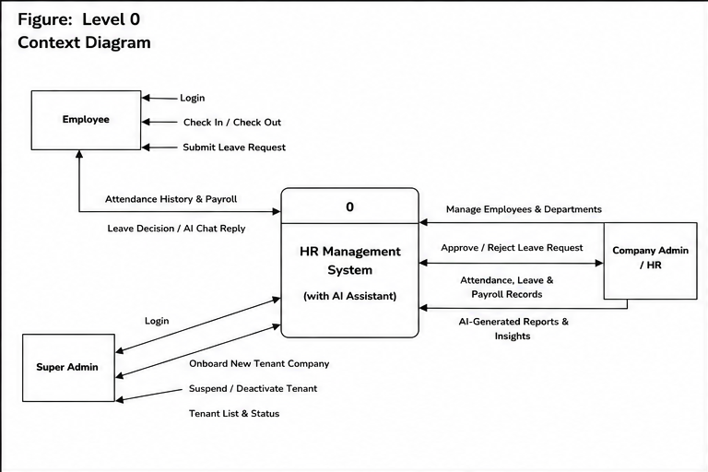

Figure 17: DFD Level 0 (Context Level)

7.1.2 DFD Level 1
The Level 1 DFD decomposes the system into its main processes: (1) Authentication & Authorization, (2) Organization Management (companies, departments, roles, employees), (3) Attendance Management (check-in/out, automatic absent marking, summaries), (4) Leave Management, (5) Payroll Management (generation and projection) and (6) AI Assistant. The data stores are the Employee/Organization tables, the Attendance table, the Leave tables, the Payroll table, the RefreshToken table and the AI log tables.

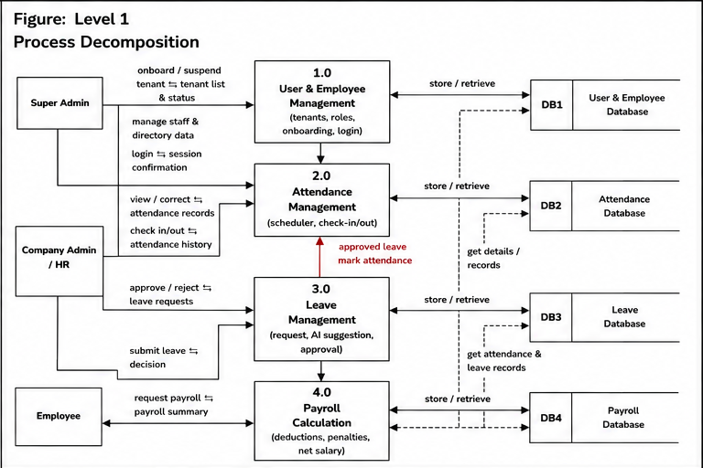

Figure 18: DFD Level 1

7.1.3 DFD Level 2
The Level 2 DFDs decompose each Level 1 process into detailed sub-processes showing how data is validated, processed and stored.
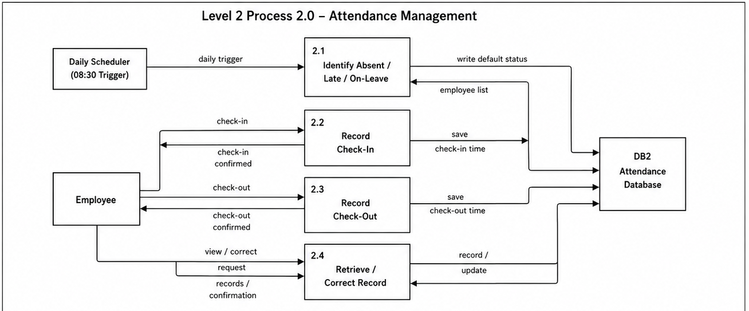

Figure 19: DFD Level 2 Process 1 — Attendance Management

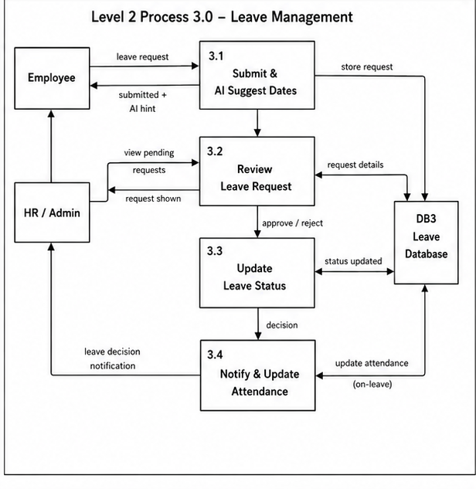

Figure 20: DFD Level 2 Process 2 — Leave Management

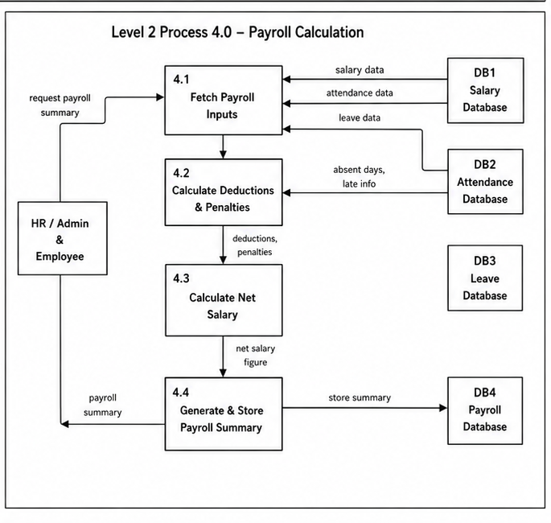
Figure 21: DFD Level 2 Process 3 — Payroll Management

7.2 Entity Relationship Diagram
The ERD illustrates the important entities of the HRM System and their relationships. A Company owns many Departments and many Employees. An Employee belongs to one Department and one Role, and has many Attendance records (one per date), many LeaveRequests (each referencing a LeaveType), many Payroll records (one per month/year) and many RefreshTokens. AiConversation, AiAuditLog and AiReport belong to a Company and optionally to an Employee. This design minimizes redundancy, ensures integrity and keeps every business record scoped to a company.

Figure 25: Entity Relationship Diagram

7.3 Database Table Structure
Based on the ER model and normalization principles, the following tables support the functionality of the HRM System. Each table serves a specific purpose and together they ensure consistency, integrity and scalability.
1. Company Table
Purpose: Stores the organizations (tenants) that use the platform; managed by the Super Admin.
Columns:
- CompanyId (Primary Key, BIGINT)
- CompanyName (NVARCHAR)
- CompanyEmail (NVARCHAR)
- CompanyPhone (NVARCHAR)
- CompanyAddress (NVARCHAR, NULLABLE)
- LogoUrl (NVARCHAR, NULLABLE)
- SubscriptionPlan (NVARCHAR, NULLABLE)
- IsActive (BIT, NULLABLE)
- CreatedAt (DATETIME, NULLABLE)
- UpdatedAt (DATETIME, NULLABLE)
2. Department Table
Purpose: Stores the departments of each company.
Columns:
- DepartmentId (Primary Key, BIGINT)
- CompanyId (Foreign Key → Company.CompanyId)
- DepartmentName (NVARCHAR)
- Description (NVARCHAR, NULLABLE)
- IsActive (BIT)
- CreatedAt (DATETIME, NULLABLE)
- UpdatedAt (DATETIME, NULLABLE)
3. Role Table
Purpose: Stores the roles that drive authorization (e.g. Super Admin, Company Admin, Common).
Columns:
- RoleId (Primary Key, BIGINT)
- RoleName (NVARCHAR)
- IsActive (BIT, NULLABLE)
- CreatedAt (DATETIME, NULLABLE)
- UpdatedAt (DATETIME, NULLABLE)
4. Employee Table
Purpose: Stores every user of the system with profile, credentials, department, role and salary.
Columns:
- EmployeeId (Primary Key, BIGINT)
- CompanyId (Foreign Key → Company.CompanyId)
- DepartmentId (Foreign Key → Department.DepartmentId)
- EmployeeCode (NVARCHAR)
- FirstName (NVARCHAR)
- LastName (NVARCHAR)
- Email (NVARCHAR, UNIQUE)
- Phone (NVARCHAR)
- PasswordHash (NVARCHAR, BCrypt hash)
- RoleId (Foreign Key → Role.RoleId)
- Gender (NVARCHAR, NULLABLE)
- DateOfBirth (DATETIME, NULLABLE)
- JoinDate (DATETIME)
- Salary (DECIMAL)
- Status (NVARCHAR)
- IsActive (BIT)
- CreatedAt (DATETIME, NULLABLE)
- UpdatedAt (DATETIME, NULLABLE)
5. Attendance Table
Purpose: Stores one attendance record per employee per date, created by check-in, by the daily absent-marking job or by approved leave.
Columns:
- AttendanceId (Primary Key, BIGINT)
- CompanyId (Foreign Key → Company.CompanyId)
- EmployeeId (Foreign Key → Employee.EmployeeId)
- AttendanceDate (DATE)
- CheckIn (TIME, NULLABLE)
- CheckOut (TIME, NULLABLE)
- WorkingHours (DECIMAL, NULLABLE)
- LateMinutes (TIME, NULLABLE)
- EarlyLeaveMinutes (TIME, NULLABLE)
- Status (NVARCHAR: Present, Late, Absent, On Leave)
- Remarks (NVARCHAR, NULLABLE)
- CreatedAt (DATETIME, NULLABLE)
6. LeaveType Table
Purpose: Stores the leave categories available to employees.
Columns:
- LeaveTypeId (Primary Key, BIGINT)
- LeaveTypeName (NVARCHAR)
- LeaveTypeDescription (NVARCHAR, NULLABLE)
- CreatedAt (DATETIME, NULLABLE)
- UpdatedAt (DATETIME, NULLABLE)
7. LeaveRequest Table
Purpose: Stores employee leave requests and the administrator’s decision.
Columns:
- LeaveRequestId (Primary Key, BIGINT)
- CompanyId (Foreign Key → Company.CompanyId)
- EmployeeId (Foreign Key → Employee.EmployeeId)
- LeaveTypeId (Foreign Key → LeaveType.LeaveTypeId)
- FromDate (DATETIME)
- ToDate (DATETIME)
- TotalDays (INT)
- Reason (NVARCHAR)
- Status (NVARCHAR: Pending, Approved, Rejected, Cancelled)
- ApprovedBy (Foreign Key → Employee.EmployeeId, NULLABLE)
- ApprovedAt (DATETIME, NULLABLE)
- AiRecommendation (NVARCHAR, NULLABLE)
- AiNotes (NVARCHAR, NULLABLE)
- CreatedAt (DATETIME, NULLABLE)
8. Payroll Table
Purpose: Stores the generated monthly payroll of each employee.
Columns:
- PayrollId (Primary Key, BIGINT)
- CompanyId (Foreign Key → Company.CompanyId)
- EmployeeId (Foreign Key → Employee.EmployeeId)
- Month (BIGINT)
- Year (BIGINT)
- BasicSalary (DECIMAL)
- AbsentDeduction (DECIMAL, NULLABLE)
- LateDeduction (DECIMAL, NULLABLE)
- NetSalary (DECIMAL, NULLABLE)
- GeneratedAt (DATETIME, NULLABLE)
9. RefreshToken Table
Purpose: Stores refresh tokens issued at login so sessions can be renewed and revoked.
Columns:
- RefreshTokenId (Primary Key, BIGINT)
- RefreshToken (NVARCHAR, random 64-byte value)
- EmployeeId (Foreign Key → Employee.EmployeeId)
- ExpiresAt (DATETIME)
- CreatedAt (DATETIME)
- IsRevoked (BIT)
10. AiConversation Table
Purpose: Stores questions asked to the AI assistant and the answers returned.
Columns:
- AiConversationId (Primary Key, BIGINT)
- CompanyId (Foreign Key → Company.CompanyId, NULLABLE)
- EmployeeId (Foreign Key → Employee.EmployeeId, NULLABLE)
- UserPrompt (NVARCHAR, NULLABLE)
- AiResponse (NVARCHAR, NULLABLE)
- TokensUsed (INT, NULLABLE)
- ResponseTimeMs (INT, NULLABLE)
- CreatedAt (DATETIME, NULLABLE)
11. AiAuditLog Table
Purpose: Stores an audit trail of AI feature usage for accountability and cost tracking.
Columns:
- AiAuditLogId (Primary Key, BIGINT)
- CompanyId (NULLABLE)
- EmployeeId (NULLABLE)
- FeatureName (NVARCHAR, NULLABLE)
- PromptLength (INT, NULLABLE)
- TokensUsed (INT, NULLABLE)
- Success (BIT, NULLABLE)
- ErrorMessage (NVARCHAR, NULLABLE)
- CreatedAt (DATETIME, NULLABLE)
12. AiReport Table
Purpose: Stores AI-generated periodic reports for a company.
Columns:
- AiReportId (Primary Key, BIGINT)
- CompanyId (NULLABLE)
- ReportType (NVARCHAR, NULLABLE)
- Month (INT, NULLABLE)
- Year (INT, NULLABLE)
- ReportContent (NVARCHAR, NULLABLE)
- GeneratedBy (BIGINT, NULLABLE)
- GeneratedAt (DATETIME, NULLABLE)

7.4 User Interface Design
The following screenshots show the main screens of the implemented system.

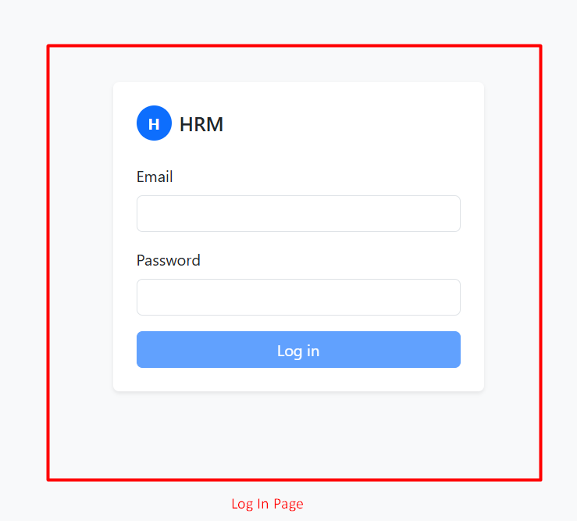

Figure 26: Login Page

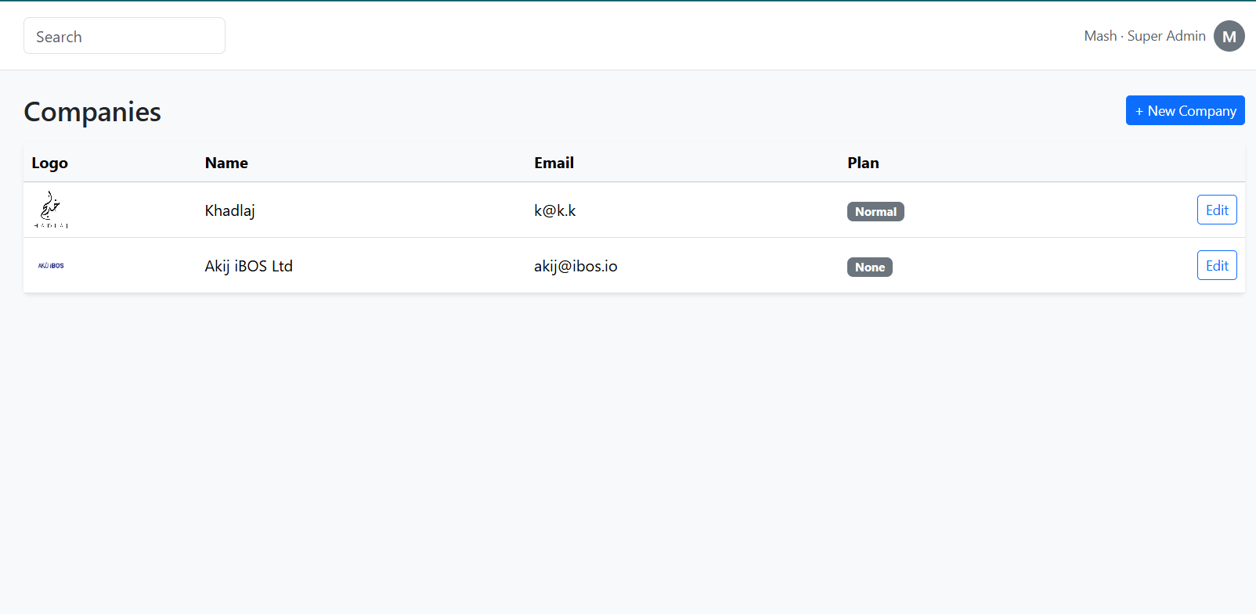

Figure 27: Super Admin — Company Management

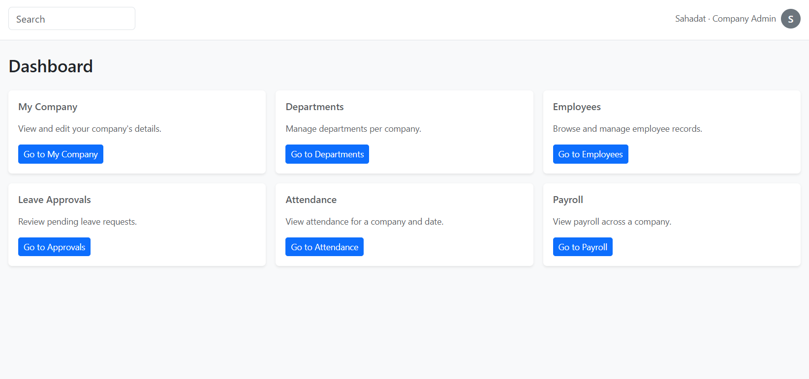

Figure 28: Company Admin Dashboard

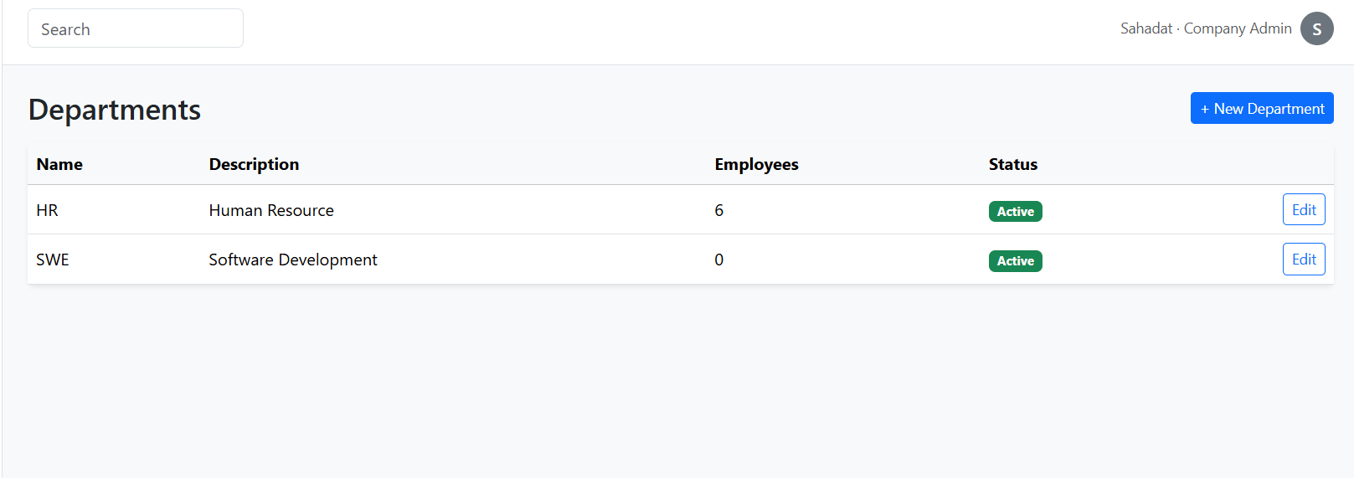
Figure 29: Department Management

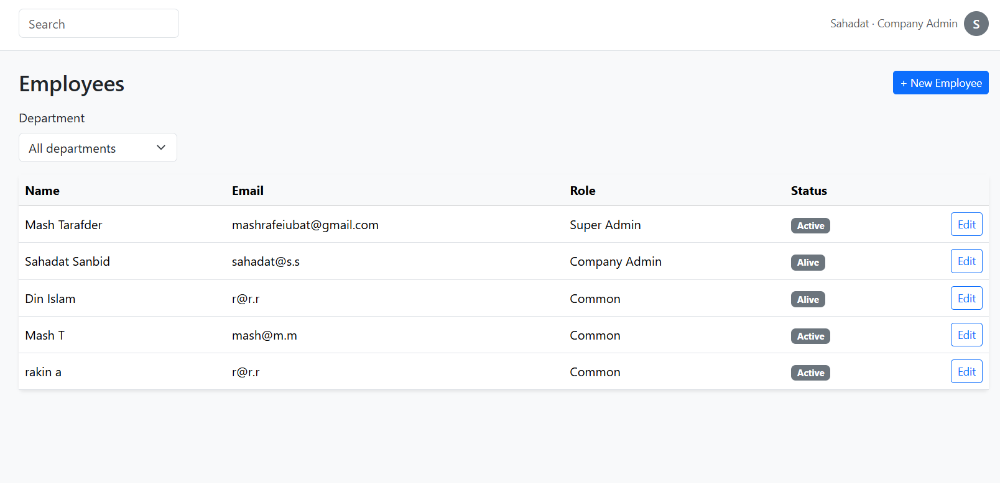

Figure 30: Employee Management
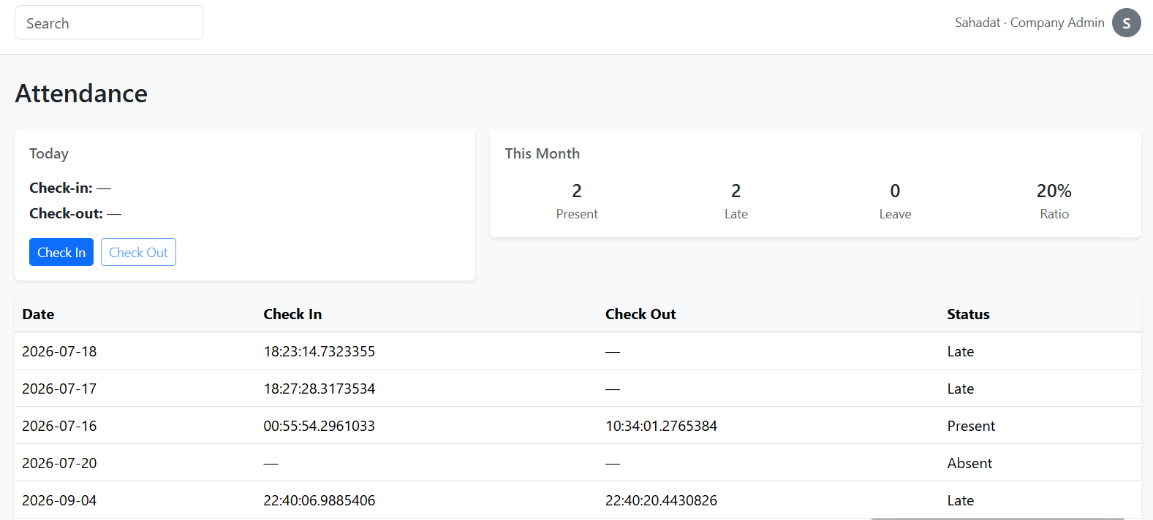
Figure 31: Employee Check-In / Check-Out
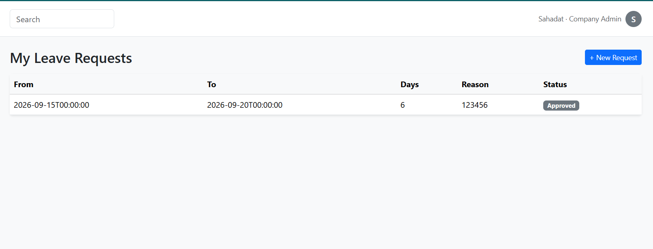

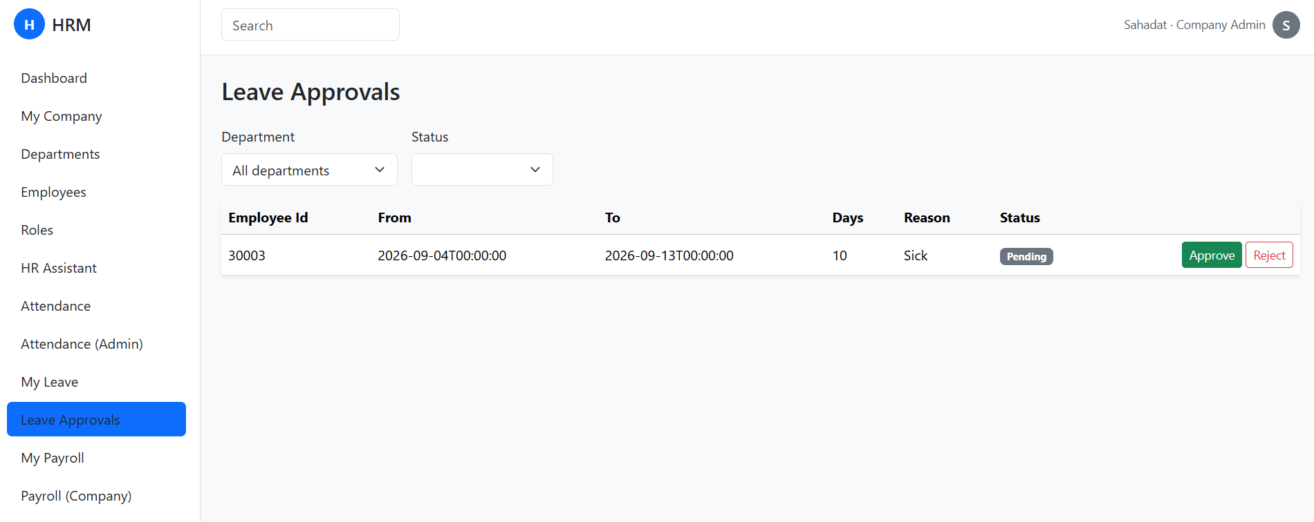

Figure 32: Leave Request and Approval

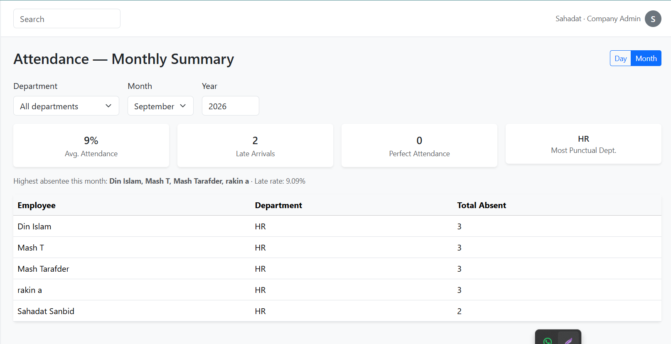
Figure 33: Attendance — Monthly Summary

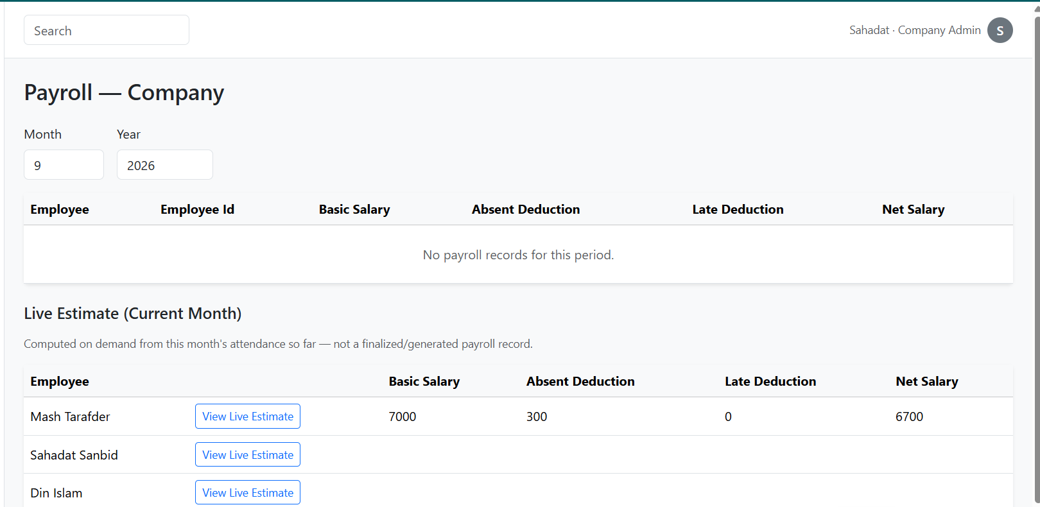

Figure 34: Payroll View and Live Payroll Status

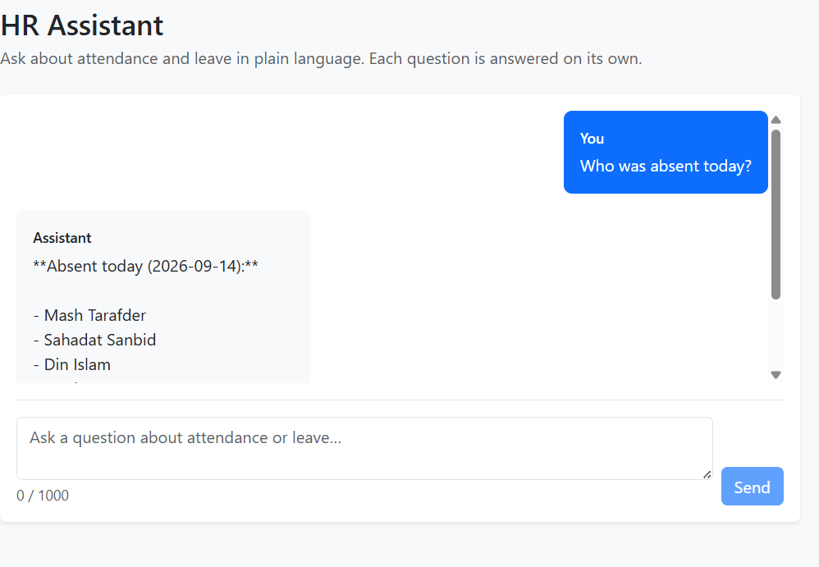

Figure 35: HR Assistant
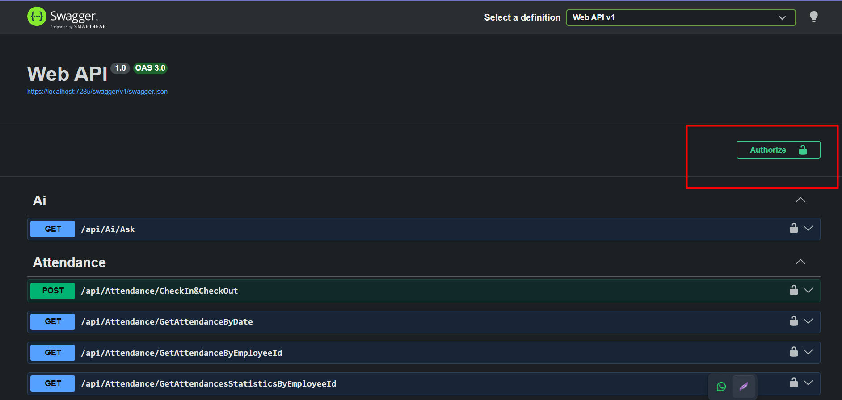
Figure 36: Swagger API Documentation

Chapter 8: System Quality and Testing

8.1 Testing Report for HRM System

8.1.1 Testing Objectives
The aim of the testing phase for the HRM System is to ensure reliable attendance and payroll data, secure access and correct HR procedures. The system is implemented with an ASP.NET Core Web API, a SQL Server database and an Angular frontend, and is used by Super Admins, Company Admins and employees. The testing goals are:
- Validate functional integrity: authentication, company/department/role/employee management, check-in/check-out, automatic absent marking, leave workflow, payroll generation, live projection, summaries and the AI assistant must behave as specified, and their data must stay consistent.
- Identify defects and reduce their effects: tests must detect cross-company data exposure, duplicate attendance or payroll rows, wrong late/absence counts, incorrect deduction arithmetic, pagination inconsistencies and background jobs that do not run or run twice. Boundary cases include a late check-in after auto-absent marking, holidays, month boundaries and empty companies.
- Assure security and data protection: every endpoint must reject requests without a valid token or with the wrong role, and no request may return data outside the caller’s company.
- Optimize user experience and performance: list endpoints must be paginated, responses must be fast, and the AI assistant must respond within an acceptable time with clear messages when it cannot answer.

8.1.2 Testing Methodology
- Black-Box Testing: the tester acts as Super Admin, Company Admin or employee through Swagger and the Angular UI, supplying valid and invalid inputs (wrong password, malformed dates, missing fields, wrong role) and comparing outputs with expectations.
- White-Box Testing: the developer reviews command/query handlers, validation, repository queries and conditional branches—for example the three-way check-in branch (new record / auto-absent record / check-out), the payroll existence check and the late-to-absence conversion rule.
- Grey-Box Testing: with knowledge of the database schema, the tester performs API actions and then verifies the Attendance, LeaveRequest and Payroll tables directly (row counts, statuses, computed values).
- Evidence basis: the project was verified through manual API testing with Swagger and curl, direct database inspection and end-to-end use of the Angular application.

8.1.3 Levels of Testing
- Unit Testing: individual rules such as late-minute calculation, working-hour rounding, pagination normalization (default 50, maximum 100), the payroll deduction formula (every three lates = one absence, fixed penalty per absence) and date parsing in AI tools.
- Integration Testing: handlers with the real database—check-in creates or converts records correctly, approved leave produces On-Leave rows, the absent-marking stored procedure skips employees on leave, payroll generation reads the right month’s attendance.
- System Testing (End-to-End): Super Admin creates a company → Company Admin creates departments, roles and employees → employees check in/out over several days → leave is requested and approved → the scheduled jobs mark absences and generate payroll → summaries and the AI assistant reflect the data.

8.2 Testing Scenario
Table 34: Testing Scenario — User Login and Token Refresh
Inputs (Test Data) | Active employee account with valid e-mail/password; repeat with wrong password; call refresh with and without the cookie.
Desired Output | Valid credentials return an access token and set an HttpOnly refresh cookie; wrong password is rejected; refresh returns a new token only with a valid cookie.
Actual Output | Access token issued with Role and CompanyId claims; refresh cookie rotated; invalid credentials and missing cookie rejected.
Status | Pass

Table 35: Testing Scenario — Role-Based and Company-Scoped Access
Inputs (Test Data) | Call Company Admin endpoints with a Common token, with no token, and with a token whose role string differs in case.
Desired Output | 401 without a token, 403 with an insufficient role; data returned only for the caller’s company.
Actual Output | Endpoints returned 401/403 as expected; company id is read from the token, not the request.
Status | Pass

Table 36: Testing Scenario — Check-In after Automatic Absent Marking
Inputs (Test Data) | Run the absent-marking job for today, then check in as an employee who was marked Absent.
Desired Output | The existing Absent row is converted to Late with the check-in time; no error and no duplicate row.
Actual Output | Initially the system threw “Cannot check out before checking in”; the handler was corrected to branch on the record’s state and the scenario now passes.
Status | Pass (after fix)

Table 37: Testing Scenario — Payroll Generation Idempotency
Inputs (Test Data) | Start the API twice in the same month; then compare generated payroll with the live projection.
Desired Output | Exactly one payroll row per employee for the previous month; deductions follow the rule set.
Actual Output | Second start detected existing rows and skipped generation; values matched the projection formula.
Status | Pass

Table 38: Testing Scenario — AI Assistant Question
Inputs (Test Data) | “Who was late the most this month?” and “How many days was <name> late in August?” as Company Admin.
Desired Output | Answers grounded in the company’s data with the tools used listed; durations shown as hours and minutes; clarification asked for ambiguous names.
Actual Output | Correct employee and counts returned; toolsUsed contained get_monthly_attendance_by_employee / find_employees.
Status | Pass

8.3 Functional Test Cases
Table 39: Functional Test Cases (Feature / Expected Result)
Feature | Expected Result
User Login and Role Access | Valid e-mail/password authenticates; invalid or unauthorized access is rejected; each role receives only permitted data and actions.
Company Management | Super Admin can create, update, activate/deactivate and list companies with pagination.
Department and Role Management | Company Admin can maintain departments (with employee counts) and roles within the company.
Employee Management | Employees are created with hashed passwords and valid department/role; lists are paginated and filterable.
Check-In / Check-Out | First action creates a Present/Late record; second action records check-out, early-leave minutes and working hours; a third action is rejected.
Automatic Absent Marking | Every working day at the scheduled time employees without records are marked Absent, skipping holidays and approved leave; missed runs are caught up at startup.
Leave Workflow | Requests are created as Pending with computed total days; approval records the approver and creates On-Leave attendance days.
Payroll Generation | Previous month’s payroll is generated once per month with correct absence/late deductions.
Live Payroll Status | Projection uses the same formula as generation and is never stored.
Attendance Summaries | Daily, monthly and per-employee summaries produce consistent totals, including tie handling for highest absentee.
AI Assistant | Answers use only company-scoped tools, report tools used, mirror the question’s language and decline questions outside the data.
API Documentation | Swagger lists all endpoints and attaches the bearer token after Authorize.

8.4 Non-Functional Testing
- Performance Testing: measure login, list (paginated) and summary endpoint latency with a representative dataset; measure AI answer time (typically 2–10 s) and background job duration.
- Security Testing: verify token expiry (15 minutes), refresh rotation and revocation, HttpOnly/Secure cookie flags, role enforcement on every endpoint, absence of secrets in source control, and that AI tools cannot be steered to another company’s data.
- Usability Testing: check clarity of forms, validation messages, loading states and the HR assistant’s example questions with representative users.
- Portability Testing: run the API on Windows and Linux under .NET 10 and the frontend on major browsers and screen sizes.

8.5 Risk-Based Testing
- Attendance and payroll integrity: repeated job runs, restarts around 09:30 and month boundaries, holidays, leave overlapping absences, and late check-ins after auto-absent marking.
- Authentication and tenant isolation: invalid/expired tokens, role mismatches, and attempts to pass a different company id in requests.
- AI assistant: provider outages, retired model names, rate limits, ambiguous employee names and questions outside the available tools.
- Database integrity: concurrent check-ins, interrupted writes and orphaned department/role references that must not hide employees from lists.

Chapter 9: Ethical Considerations and Sustainability

9.1 Ethical Considerations in the Software Development Process

9.1.1 Data Privacy and Security
The HRM System handles personal and financial information: names, contact details, dates of birth, salaries, attendance and leave history. Disclosure or misuse of this information could harm employees and the organization. Access is therefore restricted to legitimate HR administration and self-service, enforced through authenticated APIs, role permissions and company scoping. Questions sent to the AI assistant, and the data returned by its tools, are transmitted to an external language-model provider; only attendance, leave and non-sensitive employee identity fields are exposed to it, never salaries, passwords or contact details.

9.1.2 Data Encryption
Passwords are stored only as BCrypt hashes. Access tokens are signed with HMAC-SHA256 and expire after 15 minutes; refresh tokens are random 64-byte values stored in HttpOnly, Secure, SameSite cookies and can be revoked. HTTPS is used for all client connections. Encryption of database storage and backups is a deployment responsibility and is not claimed as an application-level feature.

9.1.3 Access Control
Three roles separate responsibilities: Super Admin (companies), Company Admin (everything within one company) and Common (own records only). These boundaries are enforced in the backend on every endpoint, so they hold even if a user bypasses the interface and calls the API directly. The company identifier is always derived from the token, never accepted from the request.

9.1.4 Data Minimization
Only information necessary for identification, payroll and attendance administration is collected. The AI assistant’s tools expose the minimum fields required to answer HR questions. Retention of attendance, payroll and AI conversation logs should follow the organization’s policy.

9.1.5 Compliance with Data Protection Laws
Before operational deployment the organization should confirm the legal requirements applicable to employee records and salary data, inform employees how their data is processed—including that HR questions may be processed by an external AI provider—and establish access and correction procedures. The presence of login and role controls does not by itself constitute legal compliance.

9.1.6 Regular Security Audits and Vulnerability Assessments
Periodic reviews should cover endpoint permissions, dependency vulnerabilities, JWT configuration, cookie flags, secret handling and the AI tool surface. Regression tests should be run whenever attendance, payroll or authorization logic changes.

9.1.7 Incident Response Plan
An incident procedure should define who is notified of exposed data, compromised accounts or wrong payroll. Initial actions are to revoke refresh tokens, rotate the signing key, limit access to affected records and preserve evidence; recovery includes verifying attendance and payroll integrity and fixing the underlying weakness.

9.1.8 Intellectual Property
The system uses open-source and freely licensed components: Angular, .NET, Entity Framework Core, MediatR, FluentValidation, BCrypt.Net, Swashbuckle, Microsoft.Extensions.AI and the OpenAI SDK, and the language model is accessed under the provider’s terms. Dependency notices and license terms should be preserved when packaging the application, and third-party contributions credited appropriately.

9.1.9 User Impact
An incorrect Absent or Late mark directly affects an employee’s salary. The system therefore shows the employee their own attendance, allows administrators to correct records, converts auto-absent rows when a late employee checks in, and lets HR see a live payroll projection before generation. Interfaces should remain readable and accessible to users with limited digital experience.

9.1.10 Bias and Fairness
Attendance and deduction rules are applied identically to every employee by code, not by human judgment. The AI assistant is instructed to answer only from tool data and to report the tools it used, so its statements can be verified; it should not be used as the sole basis for consequential decisions.

9.1.11 Responsibility to Stakeholders
Employees need privacy and accurate records; administrators need reliable automation and traceable changes; the organization remains responsible for deployment, policy and retention decisions; the developer documents the system and its limitations.

9.1.12 Professional Responsibility
Professional responsibility includes reporting implemented features truthfully, distinguishing expected from observed results, keeping secrets out of source control, documenting configuration, and fixing defects that affect the integrity of attendance or payroll.

9.2 Sustainability in the Software Development Process

9.2.1 Environmental Impact
The environmental footprint arises from the development workstation, the API and database server, and the external language-model inference. Energy use is reduced by set-based database operations (the absent-marking stored procedure processes all employees in one statement), pagination, running jobs once per day/month with idempotency checks, and keeping the AI assistant’s tool round-trips bounded. If moved to the cloud, capacity should be sized to the actual number of employees; no renewable-energy claim is made in this report.

9.2.2 Economic Sustainability
The system is built entirely on free technologies and a free-tier AI provider, so operating cost is limited to hosting. Clean Architecture and CQRS keep modules separate, which reduces maintenance effort. Automating absent marking, leave tracking and payroll calculation removes repetitive manual work and reduces salary disputes; the actual saving should be measured against the organization’s previous process.

9.2.3 Social Sustainability
Transparent attendance and payroll records, employee self-service and a fair correction process support trust between staff and management. The AI assistant lowers the effort of routine reporting for HR staff while keeping humans responsible for decisions. Long-term benefit depends on continued maintenance, clear policies and accessible workflows.

Chapter 10: Conclusion

10.1 Brief Overview of the Project
The Human Resource Management (HRM) System is a web-based, multi-company platform that modernizes human resource administration. A Super Admin onboards companies; each Company Admin manages departments, roles, employees, attendance, leave and payroll for their own company; and employees check in and out, apply for leave and view their own records. Attendance is captured through check-in/check-out with automatic late and early-leave detection, absent employees are marked by a daily scheduled job, approved leave is reflected in attendance, and the previous month’s payroll is generated automatically with absence and late deductions. An AI assistant answers HR questions from live company data through a controlled set of read-only tools.
The system is built with Angular on the frontend and ASP.NET Core (.NET 10) on the backend using Clean Architecture, MediatR/CQRS, Entity Framework Core and SQL Server, secured with JWT access tokens, refresh-token cookies, BCrypt hashing and role-based authorization.

10.2 Proposed System Benefits
- Automated and accurate attendance: check-in/check-out with computed late/early minutes and automatic absent marking remove manual registers.
- Automated payroll: monthly payroll is generated once, consistently, from attendance data with transparent deduction rules, and can be previewed live.
- Structured role-based, multi-company access: each user sees only what their role and company permit.
- Efficient HR administration: departments, roles, employees and leave are managed from paginated, validated screens.
- AI-assisted insight: HR staff get immediate, data-grounded answers to natural-language questions, with the sources listed.
- Maintainable architecture: Clean Architecture and CQRS make the system easy to extend.

10.3 Limitations of the Project
- No dedicated mobile application: the system is accessed through the responsive web interface only.
- Fixed shift and penalty rules: shift start/end, the weekly holiday calendar and the deduction penalty are constants shared by all companies rather than per-company settings.
- Global payroll generation: payroll is generated for all companies in one run; a company added mid-month after generation must wait for the next run.
- Limited AI scope: the assistant currently covers attendance, leave and employee lookup; payroll and salary questions are not yet available, and it has no conversation memory.
- No real-time notifications: users must log in to see leave decisions or attendance warnings.
- Free-tier AI dependency: the assistant depends on an external provider whose models and rate limits may change.

10.4 Practicum and Its Value
The practicum provided hands-on experience of the complete software development lifecycle—analysis, design, implementation, testing and documentation—on a system with real business rules. I gained practical skills in building an Angular frontend; designing a layered .NET backend with CQRS; modelling and normalizing a multi-tenant relational schema; implementing JWT security with refresh tokens; writing idempotent scheduled background services; diagnosing subtle defects such as inner-join data loss, swagger authorization wiring and time-zone/date handling; and integrating a large language model safely through tool calling. It also strengthened problem-solving, documentation and professional communication skills.

10.5 Future Plan
- Per-company configuration: shift times, holidays, leave balances and deduction policies configurable by each Company Admin.
- Payroll enhancements: allowances, tax and bonus components, per-company generation, payslip export (PDF/Excel) and self-service payslips.
- AI assistant growth: payroll tools, conversation memory, proactive monthly reports and per-employee self-service questions.
- Notifications: e-mail or push notifications for leave decisions, late warnings and payroll generation.
- Mobile application: a dedicated app for check-in/out with location or biometric verification.
- Advanced analytics: attendance trends, department comparisons and at-risk employee insights on dashboards.
- Automated testing and CI/CD: unit and integration test suites with continuous deployment.

References
- Bass, L., Clements, P. and Kazman, R. (2013) Software Architecture in Practice. 3rd edn. Boston: Addison-Wesley.
- Booch, G., Rumbaugh, J. and Jacobson, I. (2005) The Unified Modeling Language User Guide. 2nd edn. Boston: Addison-Wesley.
- Date, C.J. (2019) An Introduction to Database Systems. 8th edn. New Delhi: Pearson Education.
- Fowler, M. (2004) UML Distilled: A Brief Guide to the Standard Object Modeling Language. 3rd edn. Boston: Addison-Wesley.
- Martin, R.C. (2017) Clean Architecture: A Craftsman’s Guide to Software Structure and Design. Boston: Prentice Hall.
- Microsoft (2025) ASP.NET Core Documentation. Available at: https://learn.microsoft.com/aspnet/core
- Microsoft (2025) Entity Framework Core Documentation. Available at: https://learn.microsoft.com/ef/core
- Microsoft (2025) Microsoft.Extensions.AI Libraries. Available at: https://learn.microsoft.com/dotnet/ai/microsoft-extensions-ai
- MediatR Documentation (2025) Simple mediator implementation in .NET. Available at: https://github.com/jbogard/MediatR
- Angular Documentation (2025) Angular – The web development framework. Available at: https://angular.dev
- Swashbuckle.AspNetCore (2025) Swagger tools for ASP.NET Core APIs. Available at: https://github.com/domaindrivendev/Swashbuckle.AspNetCore
- Jones, M., Bradley, J. and Sakimura, N. (2015) JSON Web Token (JWT), RFC 7519. IETF.
- Pressman, R.S. and Maxim, B.R. (2020) Software Engineering: A Practitioner’s Approach. 9th edn. New York: McGraw-Hill.
- Sommerville, I. (2016) Software Engineering. 10th edn. Harlow: Pearson Education.

