Use Case Diagram
Components, Notation and Theory

A use case diagram is a UML behavioural diagram that shows what a system does for the people and systems around it, never how it does it. It is built from a small set of components: actors, use cases, the system boundary and four kinds of relationship (association, include, extend and generalization), plus notes for anything the notation cannot express. Each component is explained below with its standard notation, using the HRM System as the running example.

1. Actor
An actor is a role played by a person, an organization, a device or another system that interacts with the system but lives outside its boundary. It is not a specific individual: “Company Admin” is an actor; a particular employee is not. One person can play several roles, and several people can play one role.
- Primary actor – initiates a use case to achieve a goal (an Employee starts Check In). Conventionally drawn on the left of the diagram.
- Secondary actor – is called upon by the system to complete a use case (the payroll Scheduler, an e-mail service, a payment gateway). Conventionally drawn on the right.
Notation | Stick figure with the role name written beneath it. A non-human actor may be drawn as a box or stick figure stereotyped «system» or «device».
Rule | Actors never connect to each other except by generalization; they connect only to use cases.

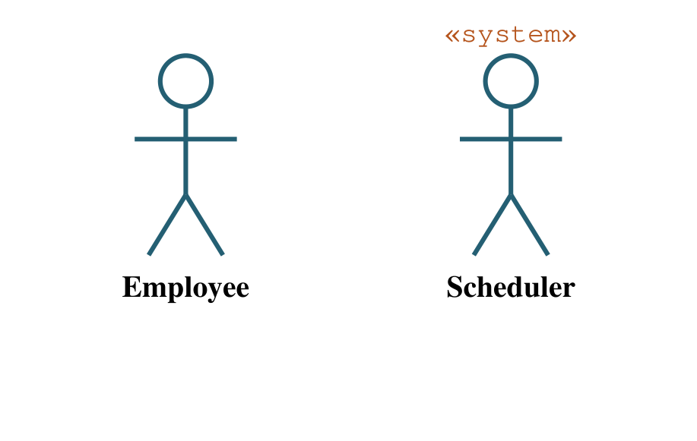
Figure 1: Actor notation – primary (human) and secondary («system») actors

2. Use Case
A use case is a unit of functionality – a complete, observable goal that the system delivers to an actor, from trigger to result. It specifies behaviour, not a step, a screen or a function in code. “Log In”, “Book Parcel” and “Approve Leave” are use cases; “Click the Submit button” is not.
- Name it with an active verb phrase written from the actor’s point of view (verb + object).
- Each use case should be valuable on its own: the actor is better off when it ends.
- The detail (main flow, alternative flows, pre-conditions, post-conditions) is written in a use case description table, not in the diagram.
Notation | A horizontal ellipse with the name inside (or just below).
Rule | Every use case must be connected to at least one actor, directly or through an include/extend chain.

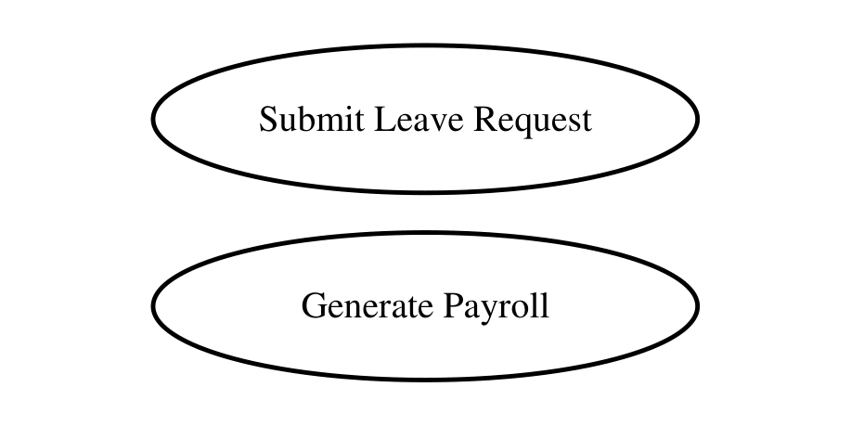
Figure 2: Use case notation – ellipses named as verb + object

3. System Boundary (Subject)
The boundary rectangle defines the scope of the system being modelled. Everything inside is behaviour the system is responsible for; everything outside is the environment. The name of the system (or subsystem or package) is written at the top.
- It answers the first question of analysis: what is in scope and what is not?
- Actors are always drawn outside the boundary; use cases always inside.
- A large system may be split into several boundaries (Attendance, Leave, Payroll) on separate diagrams.
Notation | A rectangle enclosing the use cases, labelled with the system name; optionally stereotyped «subsystem».

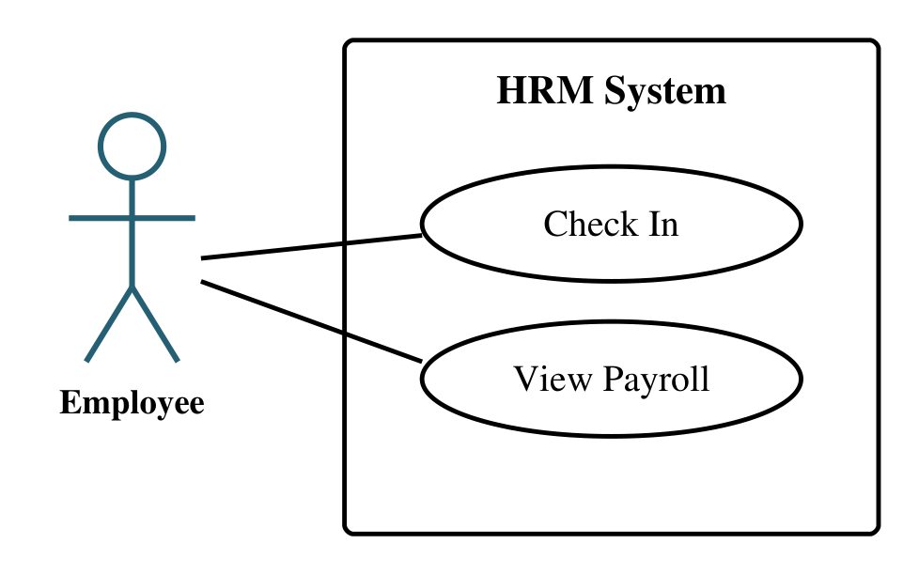
Figure 3: System boundary – actors outside, use cases inside

4. Association (Communication Link)
A plain solid line between an actor and a use case means the actor participates in that use case – it sends messages to it or receives results from it. It is the only relationship allowed between an actor and a use case.
- Usually undirected. An open arrowhead may be added to show who initiates the interaction (actor → use case for a primary actor; use case → actor for a secondary actor).
- Multiplicity may be written at the ends (one Company Admin may run many Approve Leave instances), but it is rarely needed in a report.
Notation | A solid line; no stereotype, no diamond, no arrowhead required.
Rule | Never draw an association between two use cases – use include, extend or generalization for that.

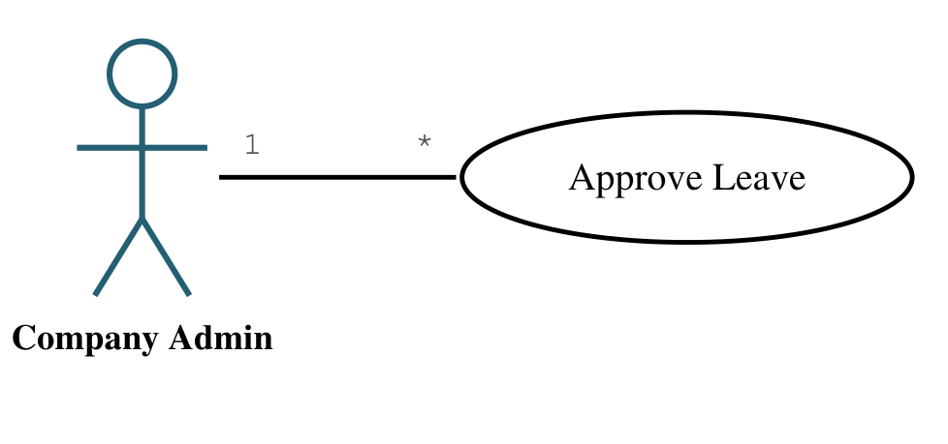
Figure 4: Association between an actor and a use case, with optional multiplicity

5. Include Relationship («include»)
An «include» relationship says that the base use case always performs the included use case as part of its flow. It is used to factor out behaviour that is mandatory and shared by several use cases so that it is described once. The base use case is incomplete without the included one.
- Direction: the dashed arrow points from the base to the included use case.
- Read it as: “Approve Leave includes Mark On-Leave Days” – approval cannot finish without it.
- Typical included use cases: Authenticate User, Validate Input, Calculate Charge, Log Tracking Event.
Notation | Dashed line with an open arrowhead, labelled «include».
Rule | The included use case does not know which base cases use it; the base decides where in its flow the inclusion happens.

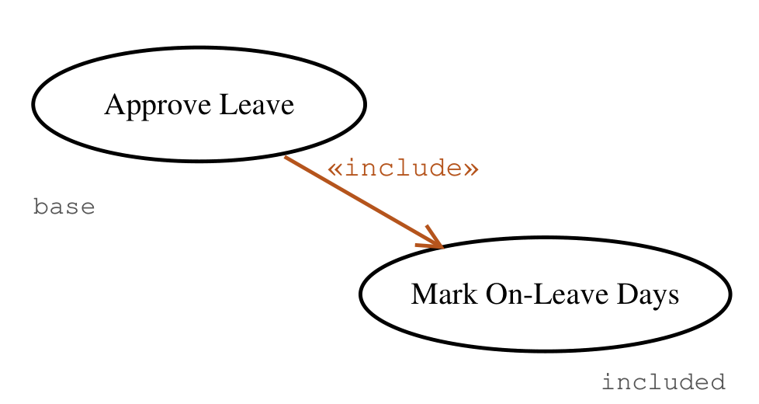
Figure 5: Include relationship – the base use case always performs the included use case

6. Extend Relationship («extend»)
An «extend» relationship says that the extension use case may add behaviour to the base use case, but only under a condition and only at a named extension point. The base is complete on its own; the extension is optional.
- Direction: the dashed arrow points from the extension to the base – the opposite of include.
- Read it as: “Convert Absent to Late extends Check In when the employee was already marked absent.”
- The condition can be written in a note attached to the dashed line, e.g. {condition: an Absent row exists}.
- Typical extensions: exceptional or optional paths – Apply Discount, Retry Payment, Send Delay Notification.
Notation | Dashed line with an open arrowhead, labelled «extend»; the base ellipse may list its extension points below a separator line.
Rule | The base use case must not depend on the extension; removing the extension leaves the base valid.

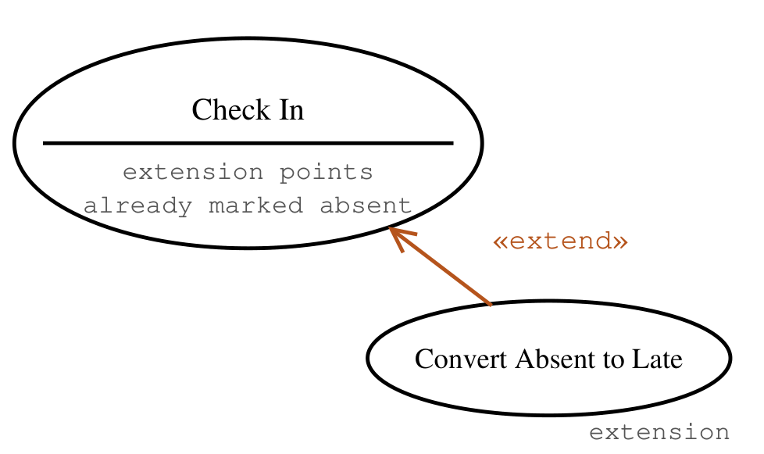
Figure 6: Extend relationship – the extension adds optional behaviour at an extension point of the base
Include versus extend
Table 1: Include versus extend
Aspect | «include» | «extend»
Is the behaviour mandatory? | Yes – always executed | No – only when the condition holds
Which use case depends on the other? | The base depends on the included case | The extension depends on the base; the base is independent
Arrow direction | Base → included | Extension → base
Purpose | Reuse common, required steps | Add optional or exceptional steps
HRM example | Approve Leave → Mark On-Leave Days | Convert Absent to Late → Check In

7. Generalization (Inheritance)
Generalization means that one element is a specialised kind of another and inherits all of its relationships. It applies both to actors and to use cases.
- Actor generalization: a Company Admin is a User – it can do everything User is associated with (Log In, View own attendance) plus its own use cases. This avoids drawing the same association lines for every role.
- Use case generalization: Pay Online and Pay COD are alternative ways of achieving Make Payment; a child may override or add steps to the parent’s flow.
Notation | A solid line with a large hollow triangle pointing at the parent (general) element.
Rule | The child must be usable wherever the parent appears (substitutability); if the relationship is not a true “is-a”, use include or extend instead.

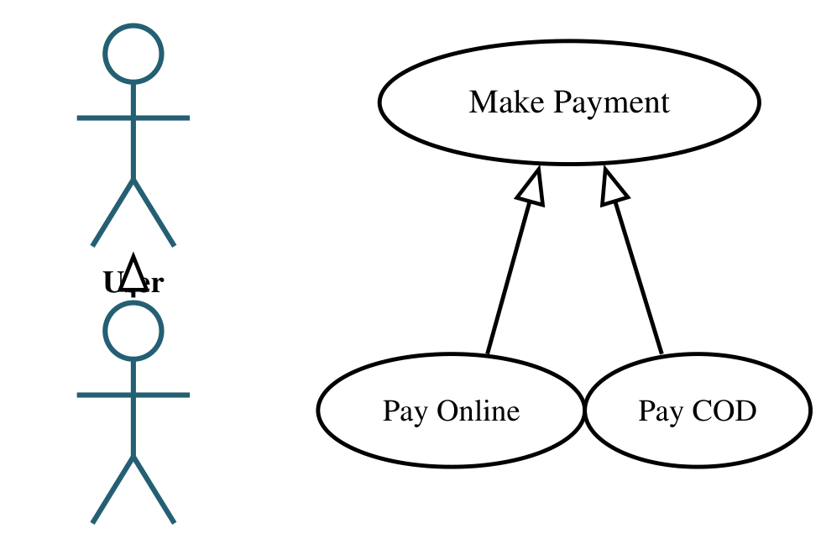
Figure 7: Generalization – between actors (left) and between use cases (right)

8. Note (Comment)
A note carries free text that the notation cannot express: a business rule, an extend condition, a constraint or a schedule. It is attached to the element it explains with a dashed anchor line and has no semantic effect on the model.
Notation | A rectangle with a folded top-right corner, connected to the element by a dashed line.
Use it for | Extend conditions, non-functional constraints (“must respond within 10 seconds”) and clarifying who a secondary actor is.

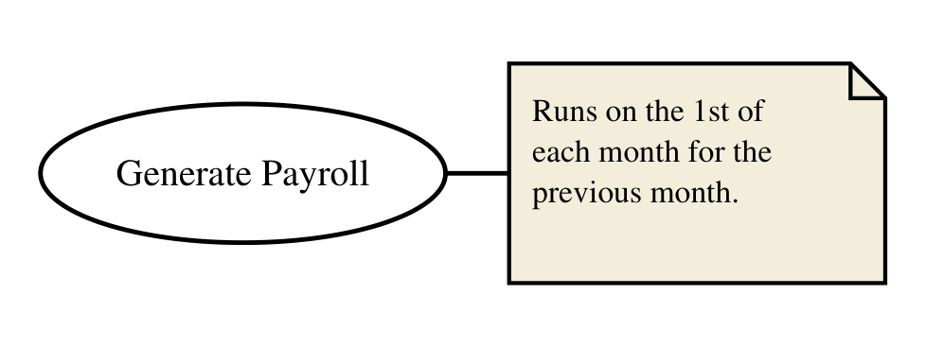
Figure 8: Note attached to a use case

9. All Components in One Diagram
The diagram below combines every notation element for the HRM System: three primary actors related by generalization, one secondary «system» actor (the Scheduler), the system boundary, associations, one «extend» relationship with its condition in a note, and one «include» relationship.
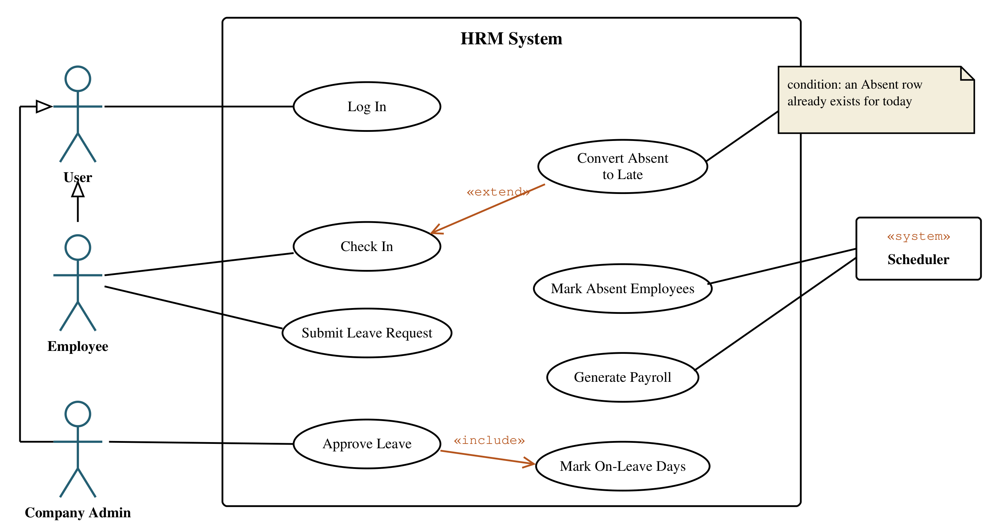
Figure 9: Use case diagram of the HRM System showing every notation element
Table 2: Summary of relationships in the worked example
Relationship | Drawn as | Reads as
Association | Solid line, actor ↔ use case | “Employee participates in Check In.”
«include» | Dashed, base → included | “Approve Leave always marks the on-leave days.”
«extend» | Dashed, extension → base | “Convert Absent to Late happens only if an absent row already exists.”
Generalization | Solid line, hollow triangle at the parent | “Employee and Company Admin are kinds of User, so both can Log In.”

10. Checklist for Drawing a Use Case Diagram
1. Name the system and draw its boundary.
2. List the roles that interact with it; place primary actors on the left and secondary actors on the right.
3. Write each goal an actor wants as a verb-phrase use case inside the boundary.
4. Connect each actor to its use cases with associations.
5. Factor mandatory shared behaviour into included use cases; model optional or conditional behaviour as extensions.
6. Use generalization only for true “is-a” relationships between actors or use cases.
7. Add notes for conditions and constraints; keep the diagram to roughly 10–20 use cases per boundary.

