Attention-Based Bidirectional LSTM for Multi-Class Hand Gesture Recognition Using sEMG Signals from NinaPro DB2

Mashrafe Uddin Tarafder
Department of Computer Science and Engineering
International University of Business Agriculture and Technology
Dhaka, Bangladesh
mashrafeiubat@gmail.com
Din Islam
Department of Computer Science and Engineering
International University of Business Agriculture and Technology
Dhaka, Bangladesh
dinislamweb402@gmail.com
Ferdous Anam Jibon
Department of Computer Science and Engineering
International University of Business Agriculture and Technology
Dhaka, Bangladesh
jibon.cse@iubat.edu
Takrim Uddin Ahmed Jengi
Department of Computer Science and Engineering
International University of Business Agriculture and Technology
Dhaka, Bangladesh
takrimahmedjengi@gmail.com

Hand gesture recognition is a key research area in human–computer interaction and assistive technologies, with surface electromyography (sEMG) enabling non-invasive acquisition of muscle activation signals. This paper presents a novel deep learning architecture combining Bidirectional Long Short-Term Memory (BiLSTM) networks with an attention mechanism for multi-class hand gesture recognition using the NinaPro Database 2 (DB2). The sEMG signals represent the body movement of a human that can be analyzed and identified through deep learning models [1]. The proposed attention based BiLSTM model addresses the temporal dependencies inherent in sEMG signals while focusing on the most discriminative features through learned attention weights. We evaluate the proposed model on 49 gestures from 40 subjects in NinaPro DB2. The model attains a mean accuracy of 67.65% ± 6.76% across subjects (best: 81.68%, worst: 53.87%). Incorporating an attention mechanism provides interpretability by visualizing which temporal segments of the sEMG signal contribute most to gesture classification. This study contributes to sEMG-based hand gesture recognition by presenting a reproducible attention-enhanced BiLSTM framework for modeling temporal muscle activation patterns. The analysis highlights the role of temporally informative signal segments in improving gesture discrimination across subjects. The results indicate that incorporating attention mechanisms can enhance both recognition performance and interpretability in myoelectric control systems. Future work will investigate subject adaptation strategies and multimodal sensor integration to further improve robustness and generalization.
Keywords— Surface electromyography, Hand gesture recognition, Bidirectional LSTM, Attention mechanism, Deep learning, NinaPro database

Introduction
Hand gesture recognition is a fundamental research problem in human–computer interaction, prosthetic control, rehabilitation engineering, and wearable assistive technologies. Accurate recognition of hand gestures enables intuitive and natural communication between humans and machines, supporting applications such as upper-limb prostheses, sign-language translation, robotic teleoperation, and virtual and augmented reality systems. Among various sensing modalities, surface electromyography (sEMG) has attracted considerable attention due to its non-invasive nature and its ability to capture neuromuscular activity that directly reflects human motor intention [1]. However, reliable sEMG-based gesture recognition remains challenging because sEMG signals are inherently non-stationary, highly subject-dependent, and sensitive to electrode placement, muscle fatigue, and environmental noise [2].
Early sEMG-based gesture recognition approaches primarily relied on handcrafted time-domain or frequency-domain features combined with conventional machine learning classifiers, such as support vector machines and k-nearest neighbors. Although these methods achieved reasonable performance under controlled experimental conditions, their generalization capability across large-scale, multi-class, and multi-subject datasets was limited. In recent years, deep learning techniques have substantially advanced sEMG signal analysis by enabling automatic feature extraction and effective modeling of complex nonlinear temporal dynamics. Recurrent neural networks (RNNs), particularly long short-term memory (LSTM) networks, are well suited for sEMG data due to their ability to capture temporal dependencies. Bidirectional LSTM (BiLSTM) architectures further improve performance by exploiting both past and future contextual information within signal windows.
Despite these advances, not all temporal segments of an sEMG sequence contribute equally to gesture discrimination. Attention mechanisms address this limitation by adaptively weighting time steps according to their relevance, allowing models to focus on the most informative signal regions. The integration of attention mechanisms with BiLSTM architectures has shown promising improvements in both classification accuracy and model interpretability. The NinaPro Database 2 (DB2), which contains multi-channel sEMG recordings from 40 subjects performing a wide range of hand gestures, serves as a challenging benchmark for evaluating such models. Nevertheless, achieving consistently high recognition performance across all subjects remains difficult, underscoring the need for robust attention-based deep learning frameworks and systematic evaluation across the full dataset

related Work
In medical sector, the use of machine learning and deep learning models have increased exponentially in last few years for their easier application and human-machine interaction. Surface electromyography (sEMG) is a famous technique mostly used to detect muscle movement using electrophysiological signals and it's very beneficial for acquiring robust muscle information and the functionality [3], [4]. Surface electromyography (sEMG) is a famous technique mostly used to detect muscle movement using electrophysiological signals and it's very beneficial for acquiring robust muscle information and the functionality.
Most recently, Sakinala et al. [5] achieved raw accuracy 85% using stacking ensemble method constituting CNN, LSTM and Random Forest for only 29 gestures of NinaPro DB1 dataset. Similarly, Doostkam et al. [6] showed ViEMGT, a Vision-EMG Transformer that was able to bring 95.2% accuracy on 22 gestures. Though, this model is heavily dependable on high density sEMG hardware, it’s application for light weight prosthetic devices is limited. To cop up with the problems raised by signal variations, Liu et al. [7] introduced a Dual-Model Adaptive Continuous Learning (DM-ACL) technique using k-Nearest Neighbors(kNN), CNN and LSTM, achieving 95.33% on 5 gestures. Later, Aarotale and Rattani [8] published their research showing 97% accuracy using 1D dilated CNN and 94.95% using Random Forest. However, the dataset contained only 12-16 gestures only. Nahid et al. classified sEMG as an Image Recognition Problem, where he used CNN-LSTM architecture to gain 99.83% on Rami Khusaba repository (10 gestures) and 99.72% (6 gestures) in UCI machine learning repository using only 2 channel sEMG system.

methodology
An attention-based deep learning framework for surface electromyography (sEMG)-based hand gesture identification was developed and assessed using an organized methodology. Dataset selection, signal preprocessing, temporal segmentation, model architecture creation, training, and performance assessment utilizing subject-wise accuracy and statistical variability criteria are all included in the approach. In order to address the difficulties of inter-subject variability and signal non-stationarity in large-scale sEMG datasets as NinaPro DB2. This methodology adopts well-established techniques in myoelectric signal processing and deep learning. Python was used for all of the experiments, and deep learning tools including NumPy, Pandas, Scikit-learn, and TensorFlow/Keras were used. To guarantee reproducibility and transparency, the complete workflow was constructed in a Jupyter Notebook environment.

Dataset Description
The NinaPro Database 2 (DB2), a popular benchmark dataset for surface electromyography (sEMG)-based hand gesture identification, is used in this study. The dataset offers preprocessed sEMG signals that have been filtered using a band-pass filter between 10 and 1000 Hz and a notch filter at 50 Hz [9]. The multi-channel sEMG recordings in NinaPro DB2 were obtained from 40 healthy participants, each of whom executed a predetermined series of hand and wrist motions under carefully monitored experimental circumstances. The dataset is ideal for robust model evaluation because it is particularly created to analyze gesture recognition algorithms under genuine inter-subject variability. For each subject, sEMG signals are recorded using 12 electrodes uniformly placed around the forearm and sampled at 2000 Hz, ensuring high temporal resolution for capturing rapid muscle activation dynamics. In addition to the raw sEMG recordings, the dataset provides synchronized annotation files containing gesture labels (restimulus) and repetition indices (repetition) for each time sample, enabling precise segmentation and supervised learning.
In addition to a rest class, NinaPro DB2 has 49 gesture classes that cover a wide variety of hand, wrist, and finger motions. The data can be divided into training, validation, and testing subsets according to repetition indices since each motion is performed several times per individual. While preserving subject-dependent consistency, our repetition-based split guarantees evaluation on unseen gesture executions. NinaPro DB2 is a demanding and exacting benchmark for deep learning-based gesture recognition models because of its extensive gesture set, signal non-stationarity, and significant inter-subject variability.
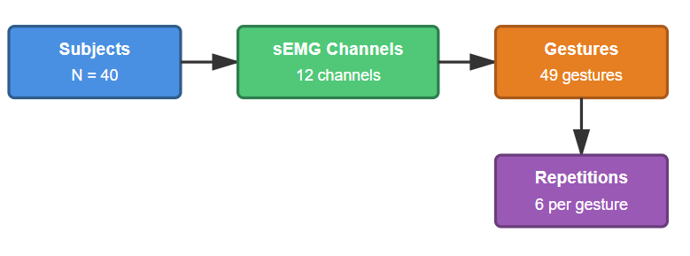

B. Data Preprocessing
The raw surface electromyography (sEMG) signals from the NinaPro DB2 dataset necessitate comprehensive preprocessing to guarantee signal reliability, minimize noise, and maintain consistency among subjects. Preprocessing requires amplification, windowing, and filtering exclusively [10]. Given that sEMG recordings are particularly susceptible to motion artifacts, electrode displacement, power-line interference, and inter-subject variability, preprocessing is essential for enhancing the robustness and generalization capacity of the proposed learning framework. The preprocessing pipeline adopted in this study is designed to preserve discriminative muscle activation patterns while eliminating redundant and corrupted signal components.
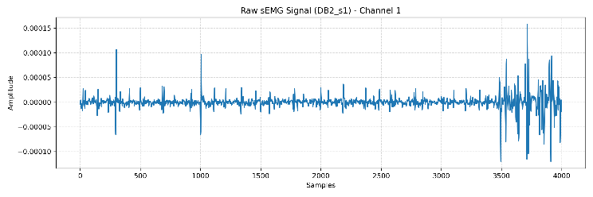

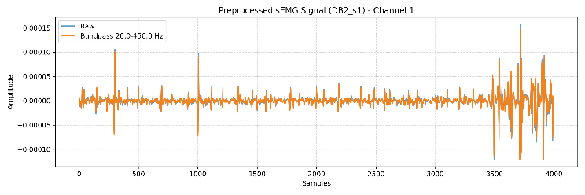

Signal Alignment and Integrity Checking

All sEMG channels are first inspected to ensure temporal alignment and data completeness across electrodes. Segments containing missing values or corrupted samples are excluded to maintain signal consistency and reliability throughout the dataset.

Band-Pass Filtering
To suppress noise and retain physiologically meaningful frequency components, a fourth-order Butterworth band-pass filter is applied to the EMG signals. The cutoff frequencies are selected between 20 Hz and 450 Hz, which is a commonly accepted range for sEMG analysis. This filtering step effectively removes low-frequency motion artifacts and high-frequency electrical noise, ensuring that the retained signal components primarily reflect muscle activation dynamics. Zero-phase filtering is employed to avoid phase distortion and preserve temporal characteristics of the EMG waveforms.

Windowing and Segmentation
After filtering, the continuous EMG signals are segmented into overlapping temporal windows using a sliding window approach. Each window represents a short-term muscle activation pattern and is treated as an individual training sample. A fixed window length of several hundred milliseconds is chosen to capture sufficient temporal context, while a smaller stride ensures overlap between consecutive windows to increase sample diversity. To prevent gesture transitions within a window, only windows corresponding to a single repetition and a dominant gesture label are retained, thereby reducing label ambiguity and improving classification reliability.

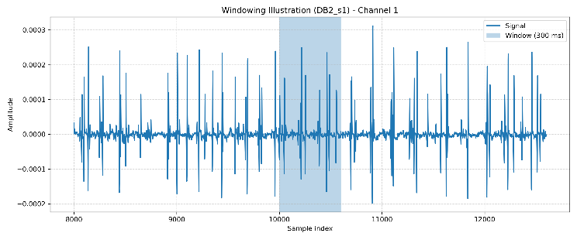

Rest Class Removal and Gesture Purity Control

The rest gesture (label 0) is excluded from the dataset to focus the learning process on active hand gestures only. Additionally, gesture purity constraints are enforced, whereby a window is accepted only if a high percentage of its samples correspond to the same gesture class. This prevents mixed-gesture windows from entering the training set and ensures that each sample represents a clearly defined motor activity. Such filtering is especially important in sEMG-based systems, where transition regions between gestures can introduce significant noise.

Feature Normalization
To address inter-subject variability and amplitude differences across EMG channels, normalization is applied to the segmented windows. Robust normalization is employed using statistics computed exclusively from the training data to avoid information leakage. Each EMG channel is scaled independently, ensuring that all features contribute equally to the learning process. This step stabilizes gradient updates during training and improves convergence behavior for deep learning models.

Feature Level Augmentation
To enhance generalization and mitigate overfitting, controlled feature-level data augmentation is applied during training. Small amounts of Gaussian noise are added to the feature sequences, simulating natural variations in muscle activation patterns. Unlike aggressive signal-level augmentation, this lightweight perturbation preserves the semantic meaning of gestures while increasing robustness to unseen conditions.

Following preprocessing, the dataset is divided into training, validation, and test subsets based on repetition indices to ensure subject-specific and repetition-independent evaluation.

Deep Learning Model

Overview of Proposed Architecture

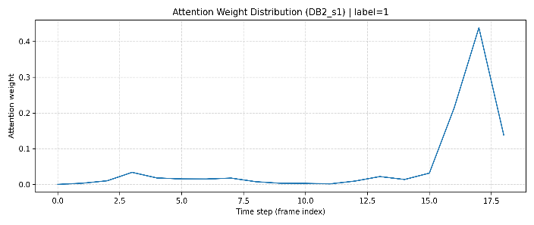
An attention-enhanced Bidirectional Long Short-Term Memory (Attn-BiLSTM) network is employed to model the temporal dynamics of surface electromyography (sEMG) signals for hand gesture recognition. Due to the non-stationary and sequential nature of sEMG signals, discriminative information is distributed unevenly over time. Traditional machine learning methods are limited in modeling such temporal dependencies, which motivates the adoption of recurrent neural network–based architectures.

The proposed architecture consists of three mains components:
- input feature sequence representation,
- a Bidirectional LSTM network for temporal modeling, and
- an attention mechanism to emphasize informative time steps before final classification.

Long Short-Term Memory (LSTM)
The Long Short-Term Memory (LSTM) network is a specialized RNN designed to overcome the vanishing gradient problem encountered in standard RNNs by introducing gated memory units. Each LSTM cell maintains a memory state that selectively retains or forgets information over time.
At time step t, given an input vector x​, the LSTM computes the following gates:
$$f_{t}= σ\left(W_{f}x_{i}+ U_{f}h_{t-1}+b_{f}\right) \\ i_{t}= σ\left(W_{i}x_{i}+ U_{i}h_{t-1}+b_{i}\right) \\ \tilde{c}=\tanh\left(W_{c}x_{t}+ U_{c}h_{t-1}+ b_{c}\right) \\ c_{t}= f_{t} ⊙c_{t-1}+i_{t} ⊙{\tilde{ c}}_{t} \\ o_{t}= σ\left(W_{o}x_{t}+ U_{o}h_{t-1}+b_{o}\right) \\ h_{t}=o_{t}⊙{tanh⁡({c}}_{t})$$
where σ (⋅) denotes the sigmoid activation function, ⊙ represents element-wise multiplication, and h_{t}​ and c_{t} are the hidden and cell states, respectively.

Bidirectional LSTM (Bi-LSTM)
To exploit both past and future temporal context, a Bidirectional LSTM (Bi-LSTM) is used. Unlike a unidirectional LSTM, Bi-LSTM processes the input sequence in forward and backward directions.
For a given time step t, the forward and backward hidden states are computed as:
$${\vec{h}}_{t}= {LSTM}_{forward}\left(x_{t}\right) \\ {\overset{⃖}{h}}_{t}={LSTM}_{backward}{(x}_{t})$$
The final Bi-LSTM output is obtained by concatenating both states:
$$h_{t}= \left[{\vec{h}}_{t};{\overset{⃖}{h}}_{t}\right]$$
his bidirectional representation enables the model to capture gesture dynamics more effectively by considering entire signal context, which is particularly beneficial for complex hand movements.

Attention Mechanism
Although Bi-LSTM captures temporal dependencies, not all-time steps contribute equally to gesture classification. To address this limitation, an attention mechanism is introduced to assign higher importance to more informative segments of the sEMG sequence.
The attention score for each time step t is computed as:
$$e_{t}= \tanh\left(W_{a}h_{t}+ b_{a}\right) \\ α_{t}=\frac{\exp\left(e_{t}\right)}{\sum_{k=1}^{T}{\exp\left(e_{k}\right)}}$$
where α_{t}​ represents the normalized attention weight and T is the total number of time steps.
The context vector c is then obtained as a weighted sum of Bi-LSTM outputs:
$$c= \sum_{t=1}^{T}{α_{t}h_{t}}$$
This mechanism allows the model to focus on salient temporal features, improving robustness against noise and irrelevant signal fluctuations.

Classification Layer
The context vector c is passed through a fully connected layer followed by a softmax activation to produce the final gesture class probabilities:
$y=Softmax(W_{s}c+b_{s})$
The model is trained using the categorical cross-entropy loss function:
$$L= -\sum_{i=1}^{C}{y_{i}log⁡({\tilde{y}}_{i}})$$
where C is the number of gesture classes, ${\hat{y}}_{i}$​ is the ground-truth label, and ${\hat{y}}_{i}$​ is the predicted probability.

Result and Experiments

Experimental Setup
All experiments were conducted using the NinaPro Database 2 (DB2), which contains surface electromyography (sEMG) recordings from 40 subjects, each performing 49 hand and wrist gestures. A subject-dependent evaluation protocol was adopted, where each subject’s data were partitioned into training, validation, and test sets based on repetition indices to ensure temporal separation between training and testing samples. Specifically, repetitions 1–4 were used for training, repetition 5 for validation, and repetition 6 for testing.
To account for inter-subject variability in muscle activation patterns, the proposed attention-based BiLSTM model was trained independently for each subject. Model optimization was performed using the AdamW optimizer, with early stopping applied based on validation accuracy to mitigate overfitting. Performance was evaluated using classification accuracy, weighted precision, weighted recall, and weighted F1-score, which are standard metrics for multi-class sEMG-based gesture recognition.

Subject-Wise Classification Performance
Figure 6 (Accuracy per Subject) illustrates the gesture classification accuracy obtained for each of the 40 subjects. The results demonstrate noticeable inter-subject variability, which is a well-known characteristic of sEMG-based systems due to differences in muscle physiology, electrode placement, and signal quality.
Several subjects (e.g., DB2_s1, DB2_s40, DB2_s55, DB2_s58) achieved accuracies above 75%, with the highest accuracy exceeding 80%, indicating that the proposed model is capable of learning highly discriminative temporal patterns from sEMG signals. Conversely, a small number of subjects exhibited lower accuracies (around 55–60%), which can be attributed to noisy signal acquisition, weaker muscle contractions, or higher intra-class variability.
These results highlight the realistic and challenging nature of subject-specific sEMG gesture classification, where perfect performance across all users is rarely attainable without subject adaptation or calibration.

Distribution of Accuracy Across Subjects
To further assess the robustness of the proposed approach, the distribution of classification accuracy across all subjects is illustrated using a histogram.
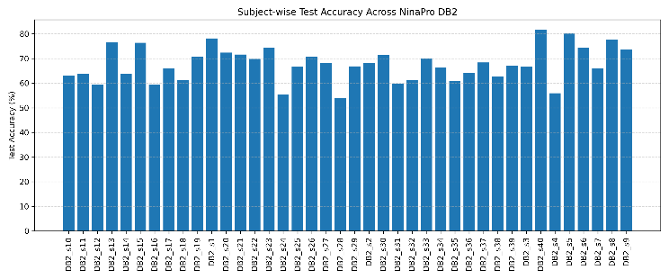
Figure 6-Accuracy achieved for each subject across the NinaPro Dataset
The results indicate that most subjects achieve accuracies in the range of 60%–75%, with a smaller subset exceeding 80%. This distribution suggests a relatively consistent performance across subjects and indicates that the proposed attention-based BiLSTM does not rely on high accuracy from a limited number of individuals.

Discussion of Attention Mechanism Effectiveness
The incorporation of an attention mechanism into the BiLSTM architecture allows the model to assign higher importance to informative temporal segments within each sEMG window. This is particularly advantageous for gesture recognition, where discriminative muscle activation patterns may occur only during short time intervals. As indicated by the attention weight visualizations, the model places greater emphasis on time steps associated with active muscle contractions while attenuating redundant or low-information segments. This selective focus supports improved generalization, especially for gestures with subtle inter-class differences.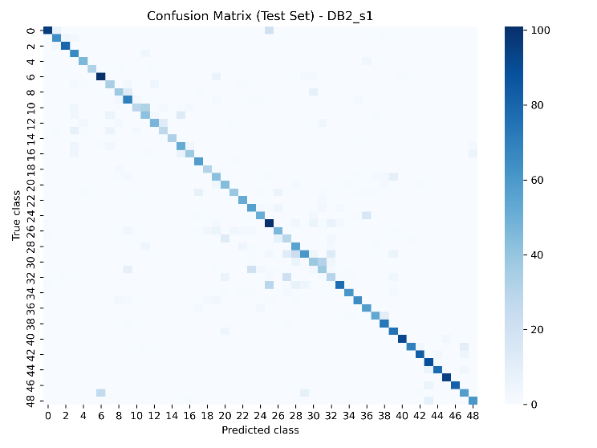
Figure 7-Confusion matrix that shows performance across subjects
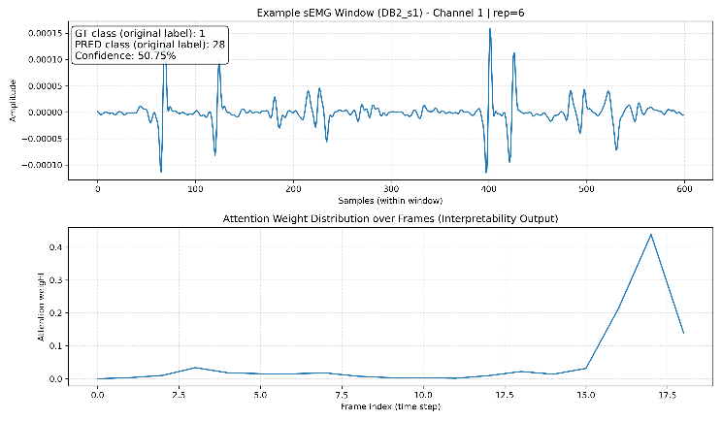
Figure 8-gesture prediction and attention-based interpretability for DB2_s1
Though Figure 8, illustrates a representative sEMG window and the corresponding attention distribution used by the proposed model to make a prediction. While individual windows may be misclassified, the example highlights how the attention mechanism focuses on discriminative temporal regions that influence the final decision.

Comparative and Practical Analysis
Although higher classification accuracies have been reported in prior studies, many of these results are obtained under reduced gesture sets, subset-based evaluations, or highly controlled experimental conditions. In contrast, the present study evaluates all 49 gestures across 40 subjects, resulting in a substantially more challenging and practically relevant setting. Within this context, the proposed framework demonstrates a balanced trade-off between model complexity, computational efficiency, and classification performance, indicating its potential suitability for real-time human–machine interaction and assistive technology applications.

CONCLUSIONS AND FUTURE WORKS
This study presented an attention-based BiLSTM framework for surface electromyography (sEMG)–based hand gesture recognition using the NinaPro DB2 dataset. By combining robust signal preprocessing, discriminative time–frequency feature extraction, and an attention mechanism that emphasizes salient temporal segments, the proposed model demonstrated consistent performance across all 40 subjects. Experimental results indicate that the framework generalizes reasonably well to inter-subject variability, achieving competitive subject-wise accuracies and stable weighted performance metrics. While the results do not surpass all state-of-the-art deep learning methods that rely on larger models or cross-subject fine-tuning, the approach offers a balanced trade-off between accuracy, computational efficiency, and interpretability. The attention mechanism provides additional insight into the temporal importance of muscle activations, enhancing the explainability of the model for biomedical applications. Future work will focus on improving generalization through advanced domain adaptation and subject-invariant learning strategies, such as transfer learning and self-supervised pretraining on large-scale sEMG datasets. Incorporating convolutional temporal encoders or transformer-based architectures may further improve long-range dependency modeling. Real-time deployment aspects, including latency optimization and evaluation on embedded hardware, will be explored to support practical applications in prosthetic control and human–computer interaction. Additionally, extending the framework to cross-dataset validation and multi-modal bio-signal fusion represents a promising direction for enhancing robustness in real-world clinical and assistive scenarios.

References
[1] Z. Lu, X. Chen, Q. Li, X. Zhang, and P. Zhou, “A hand gesture recognition framework and wearable gesture-based interaction prototype for mobile devices,” IEEE Trans. Human-Machine Syst., vol. 44, no. 2, pp. 293–299, 2014, doi: 10.1109/THMS.2014.2302794.
[2] Z. Feng, Y. Wang, and L. Liu, “Muscle fatigue detection method based on feature extraction and deep learning,” 2022 7th Int. Conf. Intell. Comput. Signal Process. ICSP 2022, pp. 97–100, 2022, doi: 10.1109/ICSP54964.2022.9778406.
[3] “陈 云 1,2 ， 杨晓雪 1,2,” no. 852, pp. 159–161, 2017.
[4] J. Xia et al., “Assessment of Neuro-Musculo-Vascular Activity in Hemiplegic Shoulder Pain: A Multimodal Study with HD-sEMG, Ultrasonography, and Laser Speckle Imaging,” IEEE Trans. Neural Syst. Rehabil. Eng., vol. 34, pp. 490–499, 2025, doi: 10.1109/TNSRE.2025.3636606.
[5] U. Chandra Sakinala and S. Abinaya, “Enhanced Detection of Hand Gestures From sEMG Signals Using Stacking Ensemble With Particle Swarm Optimization and Meta-Classifier,” IEEE Access, vol. 13, no. March, pp. 63611–63626, 2025, doi: 10.1109/ACCESS.2025.3559182.
[6] S. Doostkam, R. Boostani, and Z. Azimifar, “ViEMGT: A Novel Transformer Architecture for Enhanced Hand Gesture Recognition From HD-sEMG in Individuals With Traumatic Brain Injury,” IEEE Access, vol. 13, no. September, pp. 171009–171024, 2025, doi: 10.1109/ACCESS.2025.3616066.
[7] Y. Liu, R. Wang, Y. Li, and Y. Wang, “A Novel Dual-Model Adaptive Continuous Learning Strategy for Wrist-sEMG Real-Time Gesture Recognition,” IEEE Trans. Neural Syst. Rehabil. Eng., vol. 32, pp. 4186–4196, 2024, doi: 10.1109/TNSRE.2024.3502624.
[8] P. N. Aarotale and A. Rattani, “Machine Learning-based sEMG Signal Classification for Hand Gesture Recognition,” Proc. - 2024 IEEE Int. Conf. Bioinforma. Biomed. BIBM 2024, pp. 6319–6326, 2024, doi: 10.1109/BIBM62325.2024.10822133.
[9] J. Chang, A. Phinyomark, and E. Scheme, “Assessment of EMG Benchmark Data for Gesture Recognition Using the NinaPro Database,” Proc. Annu. Int. Conf. IEEE Eng. Med. Biol. Soc. EMBS, vol. 2020-July, pp. 3339–3342, 2020, doi: 10.1109/EMBC44109.2020.9175260.
[10] N. Nahid and A. Rahman, “2020 Joint 9th International Conference on Informatics, Electronics & Vision (ICIEV) and 2020 4th International Conference on Imaging, Vision & Pattern Recognition (icIVPR) : 26-29 August 2020, Kitakyushu, Japan,” p. 369, 2020.

