Early Detection of Parkinson’s Disease Using Machine Learning Model

Bishwaprotap Ray
Department of Computer Science & Engineering
International University of Business Agriculture and University(IUBAT)
Dhaka, Bangladesh
baburay214@gmail.com
Mashrafe Uddin Tarafder
Department of Computer Science & Engineering
International University of Business Agriculture and University(IUBAT)
Dhaka, Bangladesh
mashrafeiubat@gmail.com
Md.Mostain Billa Ibna Haque
Department of Computer Science & Engineering
International University of Business Agriculture and University(IUBAT)
Dhaka, Bangladesh
billahibnahaquemustaine@gmail. com
Tasnimul Intazam Asif
Department of Computer Science & Engineering
International University of Business Agriculture and University(IUBAT)
Dhaka, Bangladesh
intazam2896@gmail.com
Ferdaus Anam Jibon
Associate Professor, Department of Computer Science & Engineering
International University of Business Agriculture and University(IUBAT)
Dhaka, Bangladesh
jiboncse07@gmail.com

Abstract— Parkinson’s disease (pd) is a persistent and progressing neurological dysfunction of brain which requires to be identified early to make the patient outcome better and begin the curing therapies early. The study is aimed at coming up with an AI model that can analyze early stage Parkinson’s disease using biomedical voice. Seven types of AI algorithms were used to make perfect model which were Support vector machine (svm), naïve bayes, Xgboost, Logistic regression, Decision tree, Random forest and k-nearest-neighbors (knn). The datasets used in this study was preprocessed and balanced and its selection was done statistically and with the help of pair plots and correlation heatmap, where it was observed to have critical characteristics. Some of the metrices like roc-auc, confusion, precision, accuracy, recall and f-1 score matrices were utilized in making the assessment and to explain the results. Xgboost was best followed by random forest, they were quite close and then knn and svm. This study indicates that within the context of PD pre-diagnosis ensemble-based models and distance-based models outperform the conventional ones.
Keywords— Early detection, parkinson’s disease, classification models, neurological diagnosis, XGBoost, , machine learning ,voice biomarkers.

introduction
Parkinson's disease (pd) is an advanced neural disorder by which a person gets weakened and stops him or her from moving and acting in a regular manner. It slowly erodes motor control to the point of beginning with symptoms such as tremors in the hands and stiff muscles, as well as an evident slowness of movement, or bradykinesia. The symptoms could be subtle and are easily mistaken to merely be growing old, yet due to this, several patients fail to get timely diagnosis and proper therapeutic solution. With the disease progression, everyday activities progressively gain in complexity, which significantly affects the autonomy of a patient and his or her well-being in general.
As the world moves towards the aged population quickly, the population of persons with Parkinson's is rising at an alarming manner. Meanwhile, other sources of Parkinson such as environmental factors which include exposure to pesticides, toxins, and industrial chemicals have also been blamed to cause more cases of Parkinson. Nevertheless, this is one of the main problems of the disease management, even though it is a growing concern in terms of public health. The condition may be unclear and inconsistent in the early stages, a situation that normally leads to late treatment due to confusion of the symptoms by the patient. Although clinical examinations, as well as neuroimaging methods, are available, early identification may be complicated and costly in PD. To conduct higher performance diagnosis, associations have a variety of specialist tools, which are inaccessible to every person, especially in rural or underserved areas. There is a need to apply expert interpretation most of the time when explaining the results.
This is where the modern technology, i.e. machine learning (ML) can be of immeasurable help. Over the past few years, the ML has revolutionized a number of disciplines providing clever and information-rich solutions to a wide range of tasks that are far out of reach to people. These methods are applied to medical diagnosis, and by doing so, the prospect will be seen of diagnosing illnesses such as Parkinson's in a less expensive, less time consuming and non-invasive method. Rather than basing decisions on physical symptoms or a brain scan alone, ML can use vast amounts of biomedical data to find minor signs that Parkinson's is present, even before it can be seen.
In this study we explore the notion of how artificial intelligence can be implemented in order to enhance pre-diagnoses of Parkinson's syndrome. Particularly, we are comparing the same seven well-known algorithms in ML, such as Support vector machine (svm), naïve bayes, Xgboost, Logistic regression, Decision tree, Random forest and k-nearest-neighbors (knn). All of the models mentioned were trained and tested on a strong biomedical dataset comprising different voice measurements- because praising alterations to the voice are one of the early symptoms of PD. Multiple toola for pre-processing were used for making the models as perfect and certain as possible. These involve the use of feature engineering to bring out the most pertinent data points, alteration of the hyperparameters to optimize model parameters and normalization in maintaining the consistency of data. Such standard measures of performance of the models as roc-auc, confusion, precision, accuracy, recall and f-1 score are carefully assessed. Such measures prevent us only with the appreciation of the level of performance of each model, but how accurate, generalizable, and reliable they are in practice.
The core concept of this research is to demonstrate an algorithm that may be effectively used as an assistant when diagnosing the patient by medical workers. Such an effective ML model would assist in the detecting the first symptoms of Parkinson disease more effectively than the conventional ones and the overall standings of the patient would have more potential of getting the disease treated early and their quality of life would be improved. The current study not only identifies the technical achievement of these algorithms which was implemented but also gets summed up to the incremental body knowledge, specially, in case of integrating artificial intelligence in real-life healthcare practices that are beneficial.

Literature Review
Early forecast of parkinson’s disease, a neurological disease, it’s different as its symptoms has quite resemblance of age-related disorders. Recently, its proved that machine learning systems will have a huge contribution in detecting pd also classifying it.
Govindu and Palwe [1] experimented with various types of machine learning algorithms with biological and vocal data and was able to show exceptional accuracy with their model. On the other hand, Radha et al. [2] applied neural network model and support vector machines (svm) to find the dissimilarities between two types of people, first who are healthy and second who are effected by pd, she used voice samples as data.The results they provided showed how much accurate ml models are in biomedical sector.
Zhang et al. [5] showed in their studies that hybrid AI models have a huge contribution in attribute selection and categorization of pd using the biological parameters with the help of deep learning. Several classifiers like random forest and Knn a decision trees were analyzed by Bourouhou et al. [6] and proved the differences between each model predicated on readability and vulnerability.
Challa et al. [7] presented an better ml model with feature selection that enhanced the model's accuracy for pd prediction. On the other hand, Shyamala and Navamani [8] constructed a model that is effective for early detection of pd in medical sectors by combining different classifiers with scope reduction.
The strength of this models has been studied various times. Templeton et al. [16] used time-series and labeling features for the detection of pd at an earlier stage. Makarious et al. [15] constructed a multi-module technique by adding clinical, genetic and voice information to enhance the diagnostics accuracy and the model gets more reliable. Mei et al. [12] found that the SVM and random forest classifiers were the best for voice-based PD detection after reviewing more than 100 ML articles with a PD focus.
Alshammri et al. [13] and Renuka and Rakshana [14] both of them constructed an model with signal features using naive bayes, logistics regression and ensemble learners and proved the importance of speech qualities like jitter and shimer.Tadse [19] experimented classifiers on processed datasets and mentioned about their higher sensitivity in their studies and Sharma and Mishra [18] emphasized about the normalization and feature transformation for developing a better ml model.
Breakthroughs [3] and Shabab [4] showed necessary basic insights about illness prediction using ml models and confirmed that comparison of concepts are also applied for pd, though they were not a part of core pd studies. In order to promote cross-domain applications in dementia detection, Nandan et al. [9] moreover, linked machine learning techniques throughout degenerative diseases.
A local classification technique was developed by Du et al. [17] and its improved precision significantly. Du et al. [17] invented a new boundary based local classifying technique for Parkinson's disease that increased the precision. Gupta and Awatramani [10] and Tiwari et al. [11] combined neural networks and tree-based techniques to settle the class unbalanced issue and rise the models elaborating skill.
All together these studies proves that machine learning models has enormous potential for earlier detection of Parkinson's disease. Some components such as ensemble modeling, signal analysis and better feature selection plays an significant role for enhancing prediction dependency and increasing prediction reliability.

Methodology
The main theme of this research is to construct an AI based system for pre-detection of parkinson’s disease by implementing organisms speech traits. We applied models like Support vector machine (svm), naïve bayes, Xgboost, Logistic regression, Decision tree, Random forest and k-nearest-neighbors (knn). which will provide accurate and well explained data support and properly manage clinical data sets.
This technology differentiates between an healthy patient whether he is effected or not. Which model is better was measured on the basis of multiple factors as such roc-auc, confusion, precision, accuracy, recall and f-1 score. This multi factor measurement assures both clinical verification and performance dependency. Giving medical professionals a dependable, scalable, and interpretable tool to help with timely diagnosis is the goal.
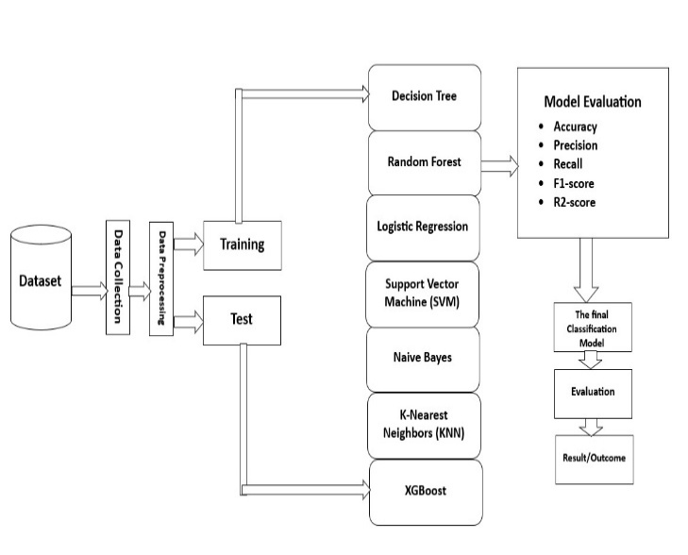
- Model Building Procedure
Fig. 1 shows the whole pipeline of the Parkinson’s disease prediction system with data collection, processing, model training and evaluation. It actually depicts how much unprocessed and unorganized the data are before being processed by the machine learning algorithm.

Data Collection
This study used a clinical dataset that was originally obtained from Kaggle and included biomedical voice measures. As the dataset has a strong clinical characteristics related to parkinson's disease, so it becomes very helpful for predictive modeling. These characteristics include jitter, shimmer, harmonic-to-noise ratios, and a number of nonlinear dynamic metrics that are known to capture the irregularities in vocal folds frequently seen in PD patients, including recurrence period density Entropy (RPDE) and detrended fluctuation analysis (DFA).
Every event recorded found data set depicts whether the symptoms of PD are present or not thus ensuring the guided learning of our system. De-identifying the data guarantees patient privacy. Previous studies and research has proved that the accuracy of dataset's is very helpful for identifying motor-related parameters through voice analysis and it's used or pd diagnosis generally. The audio or vocal features are one of the most crucial characteristic that is needed while developing a strong, reliable AI model in order to distinguish pd early.

Data Description
We used a dataset in our research which has 23 features and 1,195 instances that were all taken natural voice measurements which is used for parkinson's disease (pd).These characteristics contains vocal parameters are necessary for recognizing voice abnormalities suggesting whether the patient is effected such as harmonics-to-noise ratio, shimmer and mdvp jitter also with nonlinear metrics like rpde and dfa. Every record is noted as either 0 or 1, here 1 defines the patient is suffering from pd and 0 means he’s not effected by it . Pre-detection with observation of pd is made possible via dataset's optimization and numerical format that ensures the cooperative to many different machine learning algorithms.

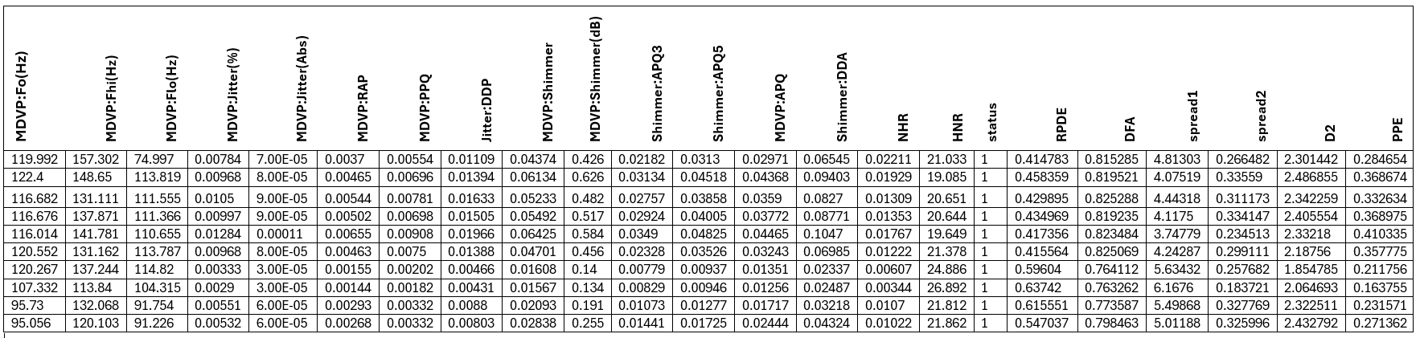
- Database picture

Data Preprocessing
The raw dataset went through a lot of proceedings and analysis to ensure the best system performance and result output possible. The dataset proved to be consistent and complete across 23 biological voice features and missing or null values were fixed. As every feature of this system was decimal so the encoding for categorizing wasn't necessary. To ensure about the consistency among various measurements including jitter, shimer and harmonic ratios, we applied standardization (z-score normalization) for feature scaling. Normalization, precise detection and discard/elimination was enforced heavily for the systems performance advancement. The class of healthy patients and pd patients was balanced through scikit-learn's train_test_split function was applied and the dataset was separated into two subsets, 80% of this dataset is for training and rest of the 20% is for experimenting. Then we applied an preprocessing pipeline to get a cleaner and organized version of data and improve the prediction making feature of our model better.
- Characteristics of the dataset
Characteristics of the dataset
Feature | Purpose
MDVP:Fo(Hz) | Pitch period fundamental frequency
MDVP:Fhi(Hz) | Maximum threshold or fundamental frequency upper limit for voice modulation
MDVP:Flo(Hz) | Minimal vocal basic frequency or lower limit
MDVP:Jitter(%) | Variation in frequency (absolute jitter in %)
MDVP:Jitter(Abs) | Variation in absolute frequency (in seconds)
MDVP:RAP | Frequency variation across brief cycles is known as relative average perturbation.
MDVP:PPQ | Short-term pitch variation, or five-point period perturbation quotient
Jitter:DDP | Three-cycle period perturbation, or the average absolute difference of variations between cycles
MDVP:Shimmer | Variation in the speech signal's amplitude (in percentage)
MDVP:Shimmer(dB) | Variation in amplitude in decibels
Shimmer:APQ3 | Three-point perturbation quotient for amplitude
Shimmer:APQ5 | Five-point perturbation quotient for amplitude
MDVP:APQ | Quotient of amplitude perturbation
Shimmer:DDA | Average absolute differences between three successive periods' amplitudes
NHR | The higher the noise-to-harmonics ratio, the more noise there is in the voice signal.
HNR | The ratio of harmonics to noise (which gauges vocal clarity and purity)
status | Target variable: PWP: Person with Parkinson's disease; 0 = Healthy; 1 = Parkinson's illness
RPDE | Signal periodicity and chaotic behavior are measured by the Recurrence Period Density Entropy.
DFA | Long-term speech variability is captured by detrended fluctuation analysis.
spread1 | Frequency variation range associated with MDVP:Fo(Hz)
D2 | One nonlinear dynamic feature that can be used to identify dysphonia is the correlation dimension.
PPE | Pitch Period Entropy: a logarithmic measure of random pitch variation

Model Testing
The ml models for PD forecast are assessed in this section. Among these models are Support vector machine (svm), naïve bayes, Xgboost, Logistic regression, Decision tree, Random forest and k-nearest-neighbors (knn).Common implementation metrics such as roc-auc, confusion, precision, accuracy, recall and f-1 score are put into practice to check the appeal of each model. This aids in determining the best accurate and successful technique for using acoustic biomarkers to diagnose Parkinson's disease.
Random Forest
A ML algorithm is random-forest (rf) where amounts of numerous decision trees to enhance prediction accuracy results.
$\hat{y}=\frac{1}{B}\sum_{i=1}^{B}{h_{i}(x)}$ (1)
Where, $h_{i}$ is the forecast of the $i^{th}$tree, and B is the amount of trees.
K-Nearest Neighbors (KNN)
This model uses Euclidean distance, where KNN assigns a data point . It is a non-parametric model that gauges similarity using Euclidean distance:
$d\left(x,y\right)=\sqrt{\sum_{i=1}^{n}{{(x_{i}-y_{i})}^{2}}}$ (2)
Logistic Regression
It’s an algorithm that decides whether a data is a part of a certain class or not by probability:
$P\left(y=\frac{1}{X}\right)=\frac{1}{1+e^{-(β_{0}+β_{1}X_{1}+…+β_{n}X_{n})}}$ (3)
Decision Tree
Decision tree is an easy model that shows the fits in tree shape and distinct the data as their feature requirements. To look at the biggest divides, they employ the Gini impurity:
$Entropy\left(S\right)=-\sum_{i=1}^{c}{p_{i}\log_{2}{{(p}_{i})}}$ (4)
Where $p_{i}$ is the ratio of class i in dataset S.
Naive Bayes
This model works with feature independence and it's made on the basis of Bayes’ theorem.
Support Vector Machine (SVM)
A decision boundary that optimizes the edge of difference among the cases with and without PD is to be produced by the SVM. Here, with just 60% accuracy and 0% precision, recall, and F1-score in this model, it performed poorly and shows that it was difficult to categorize unbalanced or nonlinear data without the right kernel think.
XGBoost (Best Model)
A scalable and incredibly effective gradient boosting technique is XGBoost. It fixes mistakes caused by earlier learners by sequentially combining weak learners. It was chosen as the final model for deployment since it outperformed all other models in our examination.
$\hat{y_{i}}=\sum_{k=1}^{K}{f_{k}\left(x_{i}\right) , f_{k}∊F }$ (5)
Where:
$\hat{y_{i}}$is the prediction for the i-th instance,
K is the total number of trees,
$f_{k }$represents the k regression tree, and
F is the area that includes every comprises regression tree.
Accuracy (A): Calculates the amount of true results among total cases.
$A=\frac{TP+TN}{TP+TN+FP+FN}$ (6)
precision (P): Determines total number of predicted positives t are positive integer.
$P=\frac{TP}{TP+FP}$ (7)​
recall (R): Describes the model’s capacity to count the positive cases.
$R=\frac{TP}{TP+FN}$ (8)
f1-score: It unifies the recall and precision and measures the harmonic mean, balancing both of these features.
$F1=\frac{2×P×R}{P+R}$ (9)
R²-Score: Determines how much of the variance the model explains.
$R^{2}=1-\frac{\sum{{(y_{i}-{\hat{y}}_{i})}^{2}}}{\sum{{(y_{i}-{\overline{y}}_{i})}^{2}}}$ (10)

ImplementationThe
In this research, theoretical pipeline containing data preparation, feature engineering, model training, explanation, performance comparison is applied in this research for implementation. python 3.12.7 in jupyter notebook was utilized for every operation , various modules such as numpy, pandas, matplotlib , seaborn, scikit-learn and xgboost. We used Github as our version control thus the code can be retrieve whenever needed and implemented in multiple systems.
This dataset contains 23 features with 1,195 instances and also contains auditory signal characteristics which was collected from voice records, also with Jitter, Shimmer, HNR, NHR, DFA, and RPDE. This markers are most crucial to diagnose the pd status of a patient. While training this model to maintain every stratified systems were saved through handling few missing variables by using 80/20 train-test split algorithm.
In order to obtain the superior diagnostic system, we trained and analyzed all seven models using algorithms as Support vector machine (svm), naïve bayes, Xgboost, Logistic regression, Decision tree, Random forest and k-nearest-neighbors (knn). Xgboost listened as the highest performing model with a recall of 100%, an F-1 score of 99.48%, a precision of 98.97%, an R-2 score of 98.09%, and an accuracy rate of 99.52%.

Descriptive Analysis
Important audio characteristics were analyzed by basic statistics to evaluate their value and their variance. To differentiate Parkinson’s disease with the patients without pd we use vocal instability which is measured through skewness, mean values and standard deviations of variables like mdvp:fo(Hz) and shimmer:apq3.
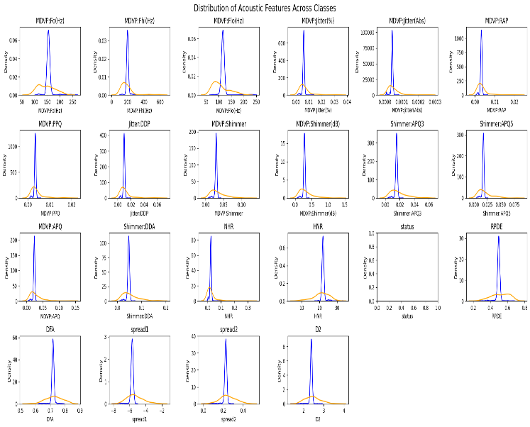
- Distribution of Acoustic Features Across Classes

Fig. 3 Shows the distribution of main auditory metrices among parkinson's and non-parkinson's patients with different density difference. Mdvp:fo(hz) , jitter, shimmer, rpde shows class based differences and emphasizes their importance is pd diagnosis.

Correlation Analysis
In order to analyze the correlation between feature and how are they related in diagnosis, we used Pearson correlation matrix. Moreover, shimmer(dB), shimmer:apq5 and shimmer:dda - all of them are known to worsen with vocal tremors are found to have good positive relationship.

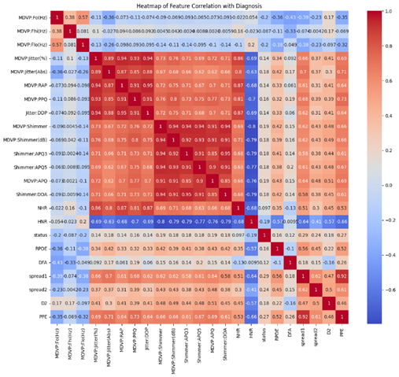
- Heatmap of Feature Correlation with Diagnosis

Fig. 4 shows the correlation between the diagnosis label and all other feature. PPE, spread1, and RPDE are the best sound-based features that help us to predict early Parkinson's disease.

Significance of feature
Gain based method of Xgboost was implemented to find the most necessary variables or inputs required to make the most accurate result.

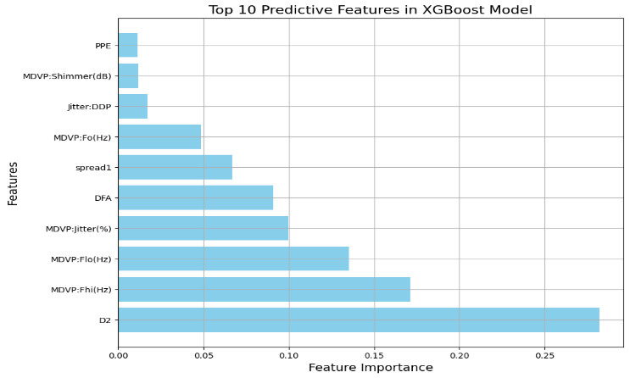

- Top Predictive Features in XGBoost Model

Fig.5. It shows top 10 predictive characteristic diagnosed by xgboost algorithm. The most significant contributions to the prediction of parkinson's disease were made by D2, MDVP:Fhi(Hz), and MDVP:Flo(Hz).

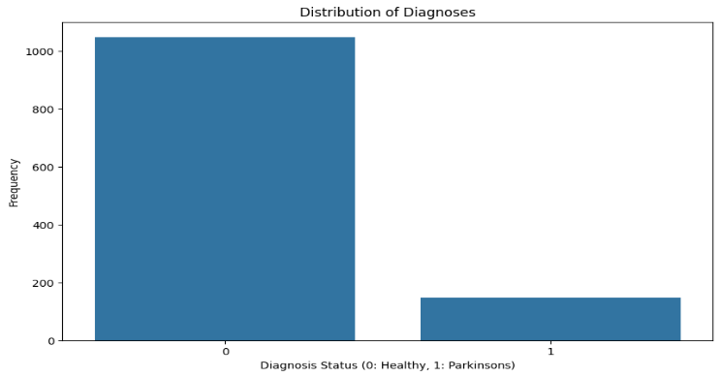

- Diagnosis Distribution

Fig.6. demonstrates the class imbalance of dataset's where most cases illustrate healthy persons as 0 and patient with PD symptoms 1.

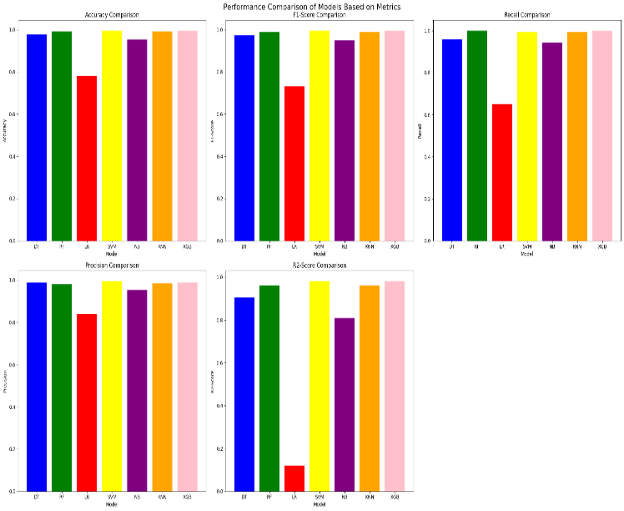
- Performance Comparison of Models Based on Metrics

Fig.7 The valuation of seven ML systems on the basis of 5 parameters like roc-auc, confusion, precision, accuracy, recall and f-1 score also r2 score. It can be said that, Xgboost outperformed other models.

RESULTS AND DISCUSSION
A dataset including 1,195 samples and 23 acoustic vocal biomarkers taken from patient voice recordings was used to test and assess the suggested model. To guarantee impartial and consistent checkup, There were two subsets, one for training that had 80% of the dataset and another for testing. Support vector machine (svm), naïve bayes, Xgboost, Logistic regression, Decision tree, Random forest and k-nearest-neighbors (knn) are among the categorization models were used to carry out the research.
Five important metrics - roc-auc, confusion, precision, accuracy, recall and f-1 score were used to assess each system. This metrices are important for finding out the most generalized and dependable model for clinical use.
TABLE I. RESULT ANALYSIS REPORT
RESULT ANALYSIS REPORT
Model | Accuracy | F1-Score | Recall | Precision | R²-Score
DT | 0.976 | 0.974 | 0.959 | 0.989 | 0.904
RF | 0.990 | 0.990 | 1.000 | 0.978 | 0.962
LR | 0.781 | 0.733 | 0.650 | 0.840 | 0.119
SVM | 0.995 | 0.995 | 0.995 | 0.995 | 0.981
NB | 0.952 | 0.948 | 0.943 | 0.953 | 0.808
KNN | 0.990 | 0.990 | 0.995 | 0.985 | 0.962
XGB | 0.995 | 0.995 | 1.000 | 0.990 | 0.981
Table 2 showed that xgboost performed extra ordinarily across all different criteria’s and achieved greatest accuracy (0.995) and recall (1.000) and established better for identifying the pd.
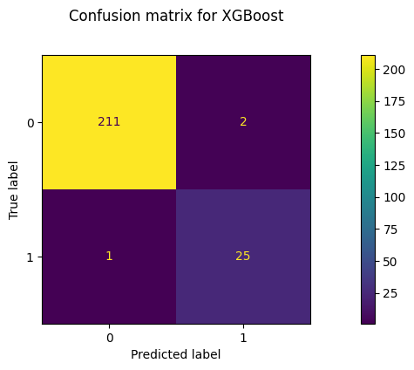
- Confution matrix for XGBoost

Fig. 8. Showed that it was able to assess 236 out of 239 cases successfully, showing it's diagnostic precision for the diagnosis of pd.
The audio or vocal features are most crucial characteristic for pd, it can be precisely used by a machine learning model and propose accurate result. The upgraded performance of xgboost model shows that it may capture and reduce the chances of any misdiagnosis in medical field. This implies that clinical techniques for non-invasive, scalable, and real-time Parkinson's disease screening may be implemented, particularly in environments with limited resources.

CONCLUSION AND FUTURE WORK
This research used biomedical speech data and successfully apply ML system for pre-detection of PD. It performed better than every other model in all statistic and achieved 99.52% accuracy,100% recall, 98.79% precision, and 99.48% f1-score on the test data, and also it had 3 confusion matrices demonstrated its durability, as did the wrong classification. This research used biomedical speech data and successfully apply AI model to diagnose early parkison’s disease symptoms in a patient. This discovery shows that the efficiency of ensemble models for predicting health issues specially the feature of faint voice linked to parkinson's disease in its earlier stage.
Though the results are remarkable but still there are limitations which should be focused. The models storage to generalize for clinical context may get hampered due to unbalanced distribution .All of these issues can be resolved in future by using multi modal datasets by adding sensors and facial expressions. Moreover, the model's may get more relevant and strengthen the resilience of system through data augmentation, transfer learning and implement it as diagnostic tool.This research can be taken as a foundation of implementing AI systems to detect brain related diseases early..

Acknowledgment
My heartiest appreciation goes to everyone, especially those who helped me while doing this project. The researchers and open source community must get special appreciation for helping us establishing a groundwork. Ultimately, we're grateful to the technologies that helped me in this research like python, xgboost, jupyter etc.
lastly, I want to highlight the role of my personal computer configuration which ensured a smooth and stable system to execute the model for training and testing stage.

References
- A. Govindu and S. Palwe, ‘Early detection of Parkinson’s disease using machine learning’, Procedia Comput. Sci., vol. 218, no. 2022, pp. 249–261, 2022, doi: 10.1016/j.procs.2023.01.007.
- N. Radha, S. M. Rm, and S. Sameera, ‘Pa rkinson ’ s Disease Detection using Machine Learning Techniques’, vol. XXX, pp. 543–552, 2021, doi: 10.24205/03276716.2020.4055.
- M. Breakthroughs, ‘P arkinson ’ s D isease P arkinson ’ s D isease’, vol. 1912, pp. 135–147, 1817.
- R. Shabab, ‘Analysis and Prediction of Cholera Disease using Machine Learning Algorithms’, no. Ml, p. 43, 2021.
- J. Zhang et al., ‘Prediction of Parkinson’s Disease Using Machine Learning Methods’, Biomolecules, vol. 13, no. 12, 2023, doi: 10.3390/biom13121761.
- A. Bourouhou, A. Jilbab, C. Nacir, and A. Hammouch, ‘Comparison of classification methods to detect the Parkinson disease’, Proc. 2016 Int. Conf. Electr. Inf. Technol. ICEIT 2016, pp. 421–424, 2016, doi: 10.1109/EITech.2016.7519634.
- K. N. R. Challa, V. S. Pagolu, G. Panda, and B. Majhi, ‘An improved approach for prediction of Parkinson’s disease using machine learning techniques’, Int. Conf. Signal Process. Commun. Power Embed. Syst. SCOPES 2016 - Proc., pp. 1446–1451, 2017, doi: 10.1109/SCOPES.2016.7955679.
- K. Shyamala and T. M. Navamani, ‘Design of an Efficient Prediction Model for Early Parkinson&#x2019;s Disease Diagnosis’, IEEE Access, no. July, pp. 137295–137309, 2024, doi: 10.1109/ACCESS.2024.3421302.
- G. Nandan, A. Lakkshmanan, and M. T. A. Reddy, ‘Early Detection of Dementia Disease using Machine Learning’, 7th Int. Conf. Inven. Comput. Technol. ICICT 2024, vol. 2, pp. 163–168, 2024, doi: 10.1109/ICICT60155.2024.10544484.
- V. Awatramani and D. Gupta, ‘Parkinson ’ s Disease Detection Through’, vol. 9, no. 6, pp. 21–23, 2022, [Online]. Available: http://dx.doi.org/10.1007/978-981-15-5148-2_83
- K. R. S. and G. A. Harshvardhan Tiwari, Shijji K Shridhar, Preeti V Patil, ‘Early Prediction of Parkinson Disease Using Machine Learning and Deep Learning Approaches’, EasyChair, vol. 12, no. January, pp. 69–79, 2020.
- [12] J. Mei, C. Desrosiers, and J. Frasnelli, ‘Machine Learning for the Diagnosis of Parkinson’s Disease: A Review of Literature’, Front. Aging Neurosci., vol. 13, no. May, pp. 1–41, 2021, doi: 10.3389/fnagi.2021.633752.
- R. Alshammri, G. Alharbi, E. Alharbi, and I. Almubark, ‘Machine learning approaches to identify Parkinson’s disease using voice signal features’, Front. Artif. Intell., vol. 6, 2023, doi: 10.3389/frai.2023.1084001.
- D. K. Renuka and S. Rakshana, ‘Prediction of Parkinson’s disease using machine learning classification from voice analysis’, Int. J. Health Sci. (Qassim)., vol. 6, no. March, pp. 11762–11771, 2022, doi: 10.53730/ijhs.v6ns1.7866.
- M. B. Makarious et al., ‘Multi-modality machine learning predicting Parkinson’s disease’, npj Park. Dis., vol. 8, no. 1, 2022, doi: 10.1038/s41531-022-00288-w.
- J. M. Templeton, C. Poellabauer, and S. Schneider, ‘Classification of Parkinson’s disease and its stages using machine learning’, Sci. Rep., vol. 12, no. 1, pp. 1–11, 2022, doi: 10.1038/s41598-022-18015-z.
- Q. Du, J. Shen, P. Wen, and X. Chen, ‘Parkinson’s Disease Detection by Using Machine Learning Method based on Local Classification on Class Boundary’, Discov. Appl. Sci., vol. 6, no. 11, 2024, doi: 10.1007/s42452-024-06295-1.
- K. Sharma and A. Mishra, ‘Prediction of Parkinson’s Disease Using Machine Learning Techniques’, SSRN Electron. J., 2020, doi: 10.2139/ssrn.3742953.
- S. Tadse, ‘Parkinson ’ s Detection Using Machine Learning’, no. Iciccs, pp. 1081–1085, 2021.

