Objective:
Understand and utilise basic memory concepts, binary, hex, and literals.
- Create a Github repository "Assembly_and_C"
- Create a sub directory PRACTICAL_01
- Add Github link to CA Spreadsheet
e.g https://STUDENTID.github.com/Assembly_and_c/PRACTICAL_01
- Invite Lab Supervisors including MuddyGames as a collaborators
- Go to designated group to complete practical
- Upload completed Practical files to Github repository
NOTE: Use of EASy68K editor and emulator allowed, use of internet allowed, use of slide deck(s) allowed. Installer located here http://www.easy68k.com/
For each of the following sections, create a unique file named partX.X68 (e.g., part1.X68, part2.X68, etc.).
1 | Know your bits  Create a new 68K project and name the file part1.logicly  Create the following circuit using logic.ly | Store the following Decimal Values as Binary (Bits LSB to MSB)  0 to 15
 | 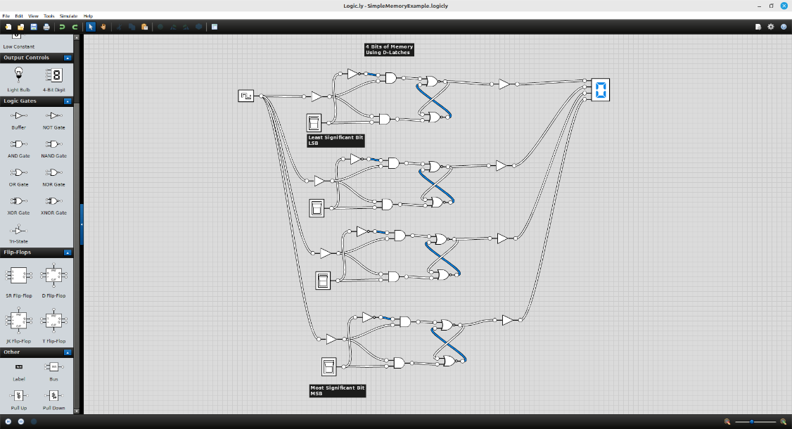
2 | Basic Memory Operations  Create a new 68K project and name the file part2.X68  Edit compile and execute the code across, examine and note contents of data registers and memory. Identify the memory location of $3000 and its contents after executing the code.
 | 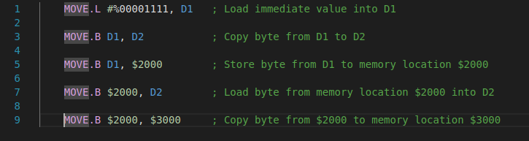
3 | Displaying Data with TRAP Calls  Create a new 68K project and name the file part3.X68  Edit compile and execute the code across and observe the output.
3 | 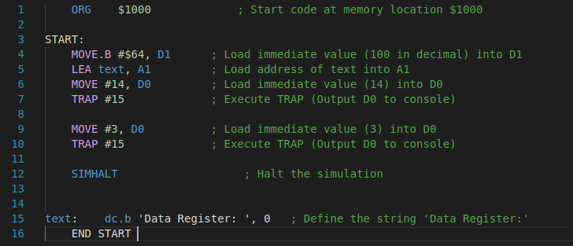
4 | More TRAP Calls and I/O Operations  Create a new 68K project and name the file part4.X68  Edit compile and execute the code across and observe the input and output.
 | 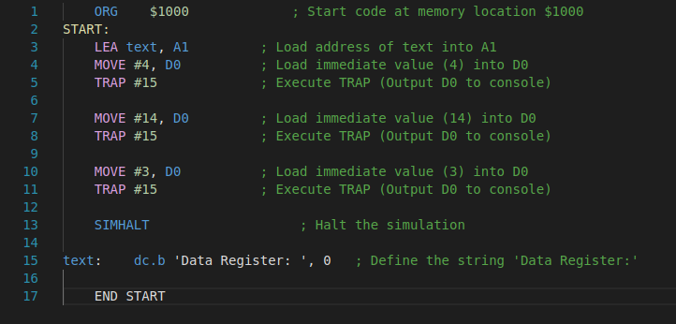

Demonstrate completed assembly files at the end of the LAB and ensure it has been checked
Student Name |  | Student Number
Date |  | Checked

Additional Notes:
- Ensure that each .X68 file is correctly named as per the instructions.
- If using external tools (like Logic.ly or Easy68K), ensure all configurations are saved and included in your repository.
- Double-check that your GitHub repository is accessible, and all required collaborators have access to your files.

