**Nike**

**Shoes**

**Branding**

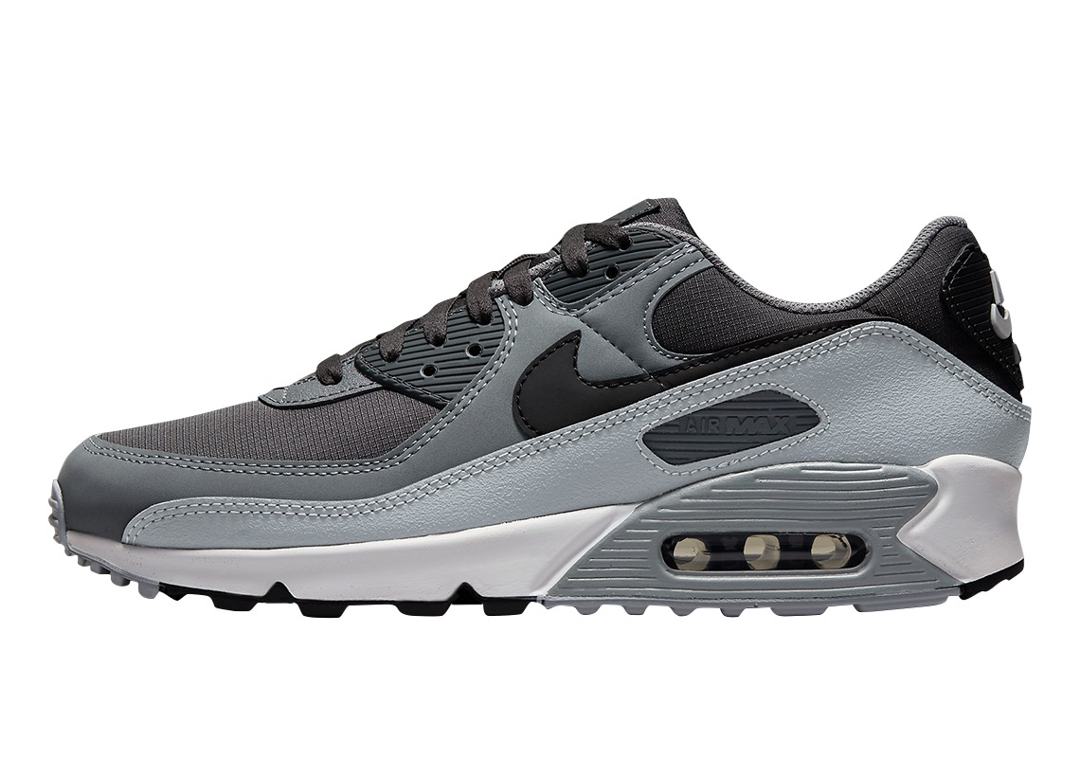

**Purpose:**

* **Brand Identity:** Clearly define the unique identity and personality of the shoe brand, encompassing values, aesthetics, and overall character.
* **Target Audience:** Identify the specific demographic and psychographic characteristics of the target market, ensuring alignment with the brand's offerings.
* **Product Range:** Outline the diverse range of shoes offered, emphasizing key features, materials, and design elements that set them apart in the market.
* **Quality Assurance:** Emphasize the commitment to quality and craftsmanship, detailing the rigorous standards and processes employed in manufacturing.
* **Innovation and Trends:** Highlight the brand's dedication to staying at the forefront of fashion and technology, showcasing how it adapts to and anticipates industry trends.
* **Sustainability Initiatives:** Communicate the brand's eco-friendly practices, detailing efforts to minimize environmental impact throughout the production lifecycle.
* **Customer Experience:** Emphasize the brand's dedication to providing an exceptional customer experience, both online and offline, including personalized services and hassle-free purchasing.
* **Marketing and Promotion:** Discuss the strategies for promoting the brand, encompassing digital marketing, collaborations, and other initiatives to build brand awareness.
* **Community Engagement:** Outline plans for engaging with the shoe community, such as sponsoring events, collaborating with influencers, and fostering a sense of belonging among customers.
* **Future Vision:** Conclude with a forward-looking perspective, articulating the brand's long-term vision, growth plans, and aspirations within the competitive footwear industry.

**Audience:**

1. **Fashion Enthusiasts:** Individuals who are passionate about staying on top of the latest trends and view footwear as a key element in expressing their personal style.
2. **Young Professionals:** Career-oriented individuals seeking stylish and comfortable shoes suitable for the workplace, networking events, and professional engagements.
3. **Athletic and Fitness Enthusiasts:** Those who prioritize performance and functionality, requiring specialized athletic footwear designed for various sports and physical activities.
4. **Trendsetters and Influencers:** Fashion-forward individuals who have a significant impact on shaping trends, making them crucial in amplifying brand visibility and desirability.
5. **Environmentally Conscious Consumers:** Individuals who prioritize sustainability and eco-friendly practices, seeking footwear options that align with their values and minimize environmental impact.
6. **Shoe Collectors:** Enthusiasts who appreciate craftsmanship, limited editions, and unique designs, often looking for exclusive pieces to add to their shoe collections.
7. **Students and Young Adults:** Budget-conscious individuals looking for trendy yet affordable footwear options for daily wear, social events, and campus life.
8. **Parents and Families:** Targeting parents in search of durable, comfortable, and stylish footwear for their children, offering options for various age groups and occasions.
9. **Tech-Savvy Shoppers:** Individuals comfortable with online shopping, leveraging digital platforms and social media for product discovery, reviews, and purchasing decisions.
10. **Global Consumers:** Recognizing the potential for a diverse international audience, catering to individuals from different cultures and backgrounds who share a common interest in quality footwear and fashion