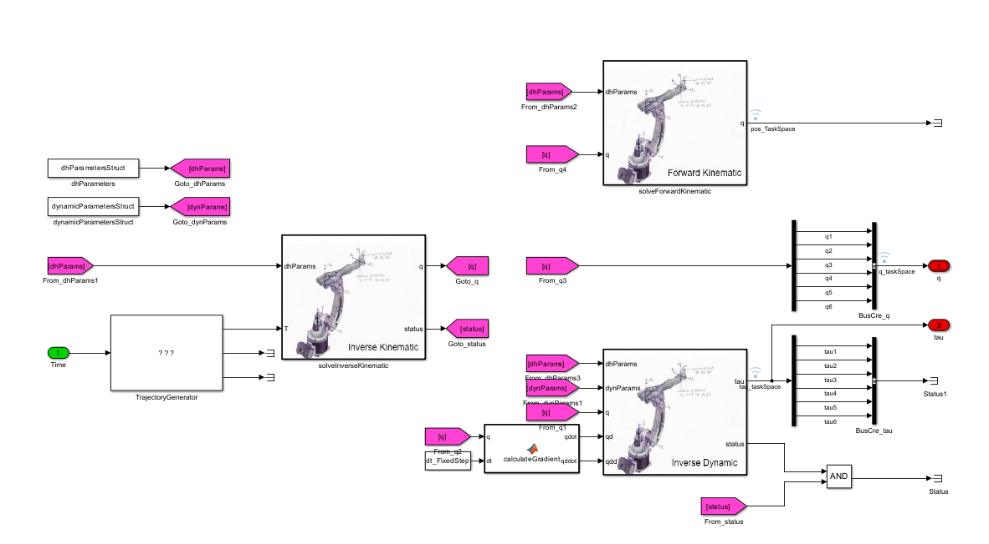
The provided Simulink model illustrates a comprehensive Robotic Control Architecture , integrating essential kinematic and dynamic subsystems for a high-degree-of-freedom manipulator. Trajectory Generation, The workflow begins with a Trajectory Generator that computes the desired task-space transformation matrix $T$over time. Inverse Kinematics (IK) : The IK block maps the target pose back to joint space, solving for the joint position vector $q$. This is critical for translating Cartesian goals into actuator commands. Forward Kinematics (FK) Simultaneously, the FK block validates the joint positions by calculating the end-effector's pose in task space, often used for feedback or monitoring. Inverse Dynamics The model calculates the required joint torques $τ$based on q, its derivatives $\left(\dot{q},\ddot{q}\right)$and the robot's inertial properties (Denavit-Hartenberg and dynamic parameters).

