AI ENGINEERING CASE STUDY

IRIS Security RAG
  - Local-first cited answers for SOC analysts

AUTHOR | Max Nikiforov
DATE | 6 August 2026
ENVIRONMENT | Windows 10 · CPU-only · 16 GB RAM
STACK | FastAPI · PostgreSQL · Qdrant · Ollama · Prometheus · Grafana

A production-style portfolio project covering corpus engineering, hybrid retrieval, reranking, local generation, evaluation, and observability.

Executive summary
IRIS is a local-first Retrieval-Augmented Generation system for SOC analysts. It combines reproducible corpus ingestion, multilingual dense and lexical retrieval, weighted RRF, optional cross-encoder reranking, local Ollama generation, citations, a no-answer guard, and end-to-end observability.
The strongest retrieval configuration achieved 100% Content Hit@5 and 0.972 Content MRR on 50 answerable questions. A separate batch of 20 measured HTTP requests completed without failures; 19 produced answers, one was rejected by the guard, every accepted answer included sources, and no fallback was used.
108  documents | 994  chunks | 100%  Content Hit@5 | 0.972  Content MRR

Interpretation: 95% batch answer rate is not accuracy. Retrieval quality is measured on the golden dataset; the batch validates the full HTTP and monitoring path.

Problem and requirements
SOC knowledge is split between ATT&CK techniques, Sigma rules, OWASP guidance, risk-management material, and local runbooks. Exact search misses paraphrases; pure vector search can miss technique IDs and command-line tokens; generated text without traceable evidence is unsafe for operational use.
- Local-first operation without a paid cloud LLM.
- CPU-friendly execution on a 16 GB laptop without a discrete GPU.
- Russian questions retrieving English security sources.
- Citations and source metadata by default.
- A guarded no-answer path and measurable latency.
- Reproducible source revisions and raw evaluation artifacts.

System architecture
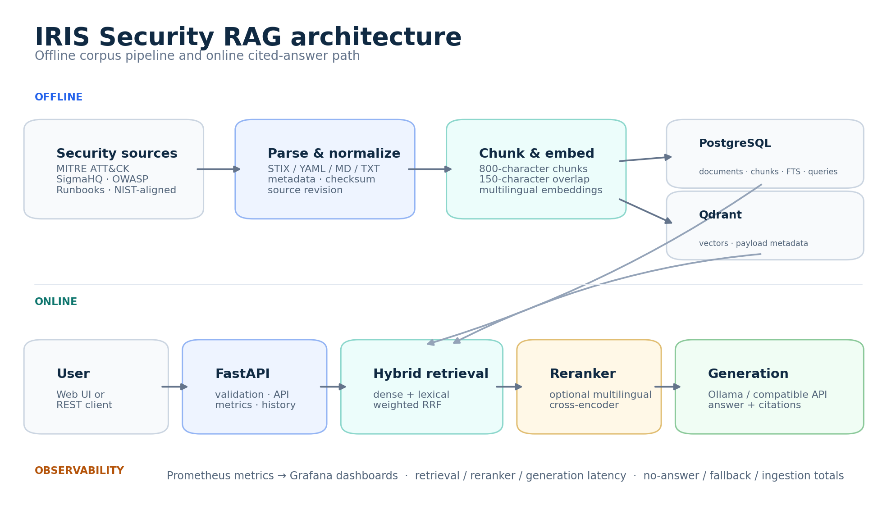
Figure 1. Offline corpus preparation and online cited-answer path.

Offline path
The corpus builder resolves upstream commits, downloads MITRE ATT&CK STIX, Sigma YAML, and OWASP Markdown, normalizes them, and writes a manifest with URLs, revisions, and SHA-256 hashes. Ingestion writes document and chunk records to PostgreSQL; indexing embeds chunks and upserts vectors plus metadata payloads into Qdrant.

Online path
FastAPI validates the request and executes dense or hybrid retrieval. Weighted RRF merges vector and lexical ranks. The optional cross-encoder reranks a larger pool, after which the generator returns a cited answer or the guard rejects weak context. Prometheus records every stage and Grafana visualizes the result.

Corpus and provenance
Source | Docs | Chunks | Provenance
MITRE ATT&CK | 30 | 277 | Official STIX → Markdown
Sigma | 64 | 461 | Official YAML → Markdown
OWASP Top 10:2025 | 10 | 214 | Official Markdown
NIST-aligned summary | 1 | 10 | Manual summary
SOC runbooks | 3 | 32 | Synthetic Russian docs
Total | 108 | 994 | 9.2 chunks / doc

The official-source manifest covers 100 fetched documents: 30 MITRE, 60 Sigma, and 10 OWASP. Four legacy Sigma documents, three runbooks, and one manual NIST-aligned summary bring the database to 108. The audit reports no empty documents and no documents without chunks, but flags incomplete provenance fields for eight manual or legacy items.
Provenance rule: The manual ransomware summary is not presented as an official NIST publication, and the runbooks are clearly marked synthetic.

Retrieval design
- Dense: multilingual cosine search in Qdrant for semantic similarity.
- Lexical: PostgreSQL full-text search for exact indicators and security tokens.
- Hybrid: weighted RRF merges ranks without comparing incompatible score scales.
- Reranker: a multilingual cross-encoder reorders the final candidate pool on demand.

Retrieval evaluation
The golden dataset contains 55 questions: 50 answerable and 5 unanswerable. The controlled retrieval comparison uses the same 50 answerable questions, corpus, embeddings, and top_k=5 for every configuration. Document Hit@5 measures document presence; Content Hit@5 requires evidence-bearing chunks; Keyword Recall checks expected concepts; MRR measures ranking position.
Config | Doc H@5 | Content H@5 | KW Recall | Content MRR | Latency
Dense | 98% | 94% | 86.0% | 0.844 | 68 ms
Hybrid | 100% | 98% | 90.3% | 0.913 | 79 ms
Hybrid + reranker | 100% | 100% | 93.7% | 0.972 | 1,287 ms

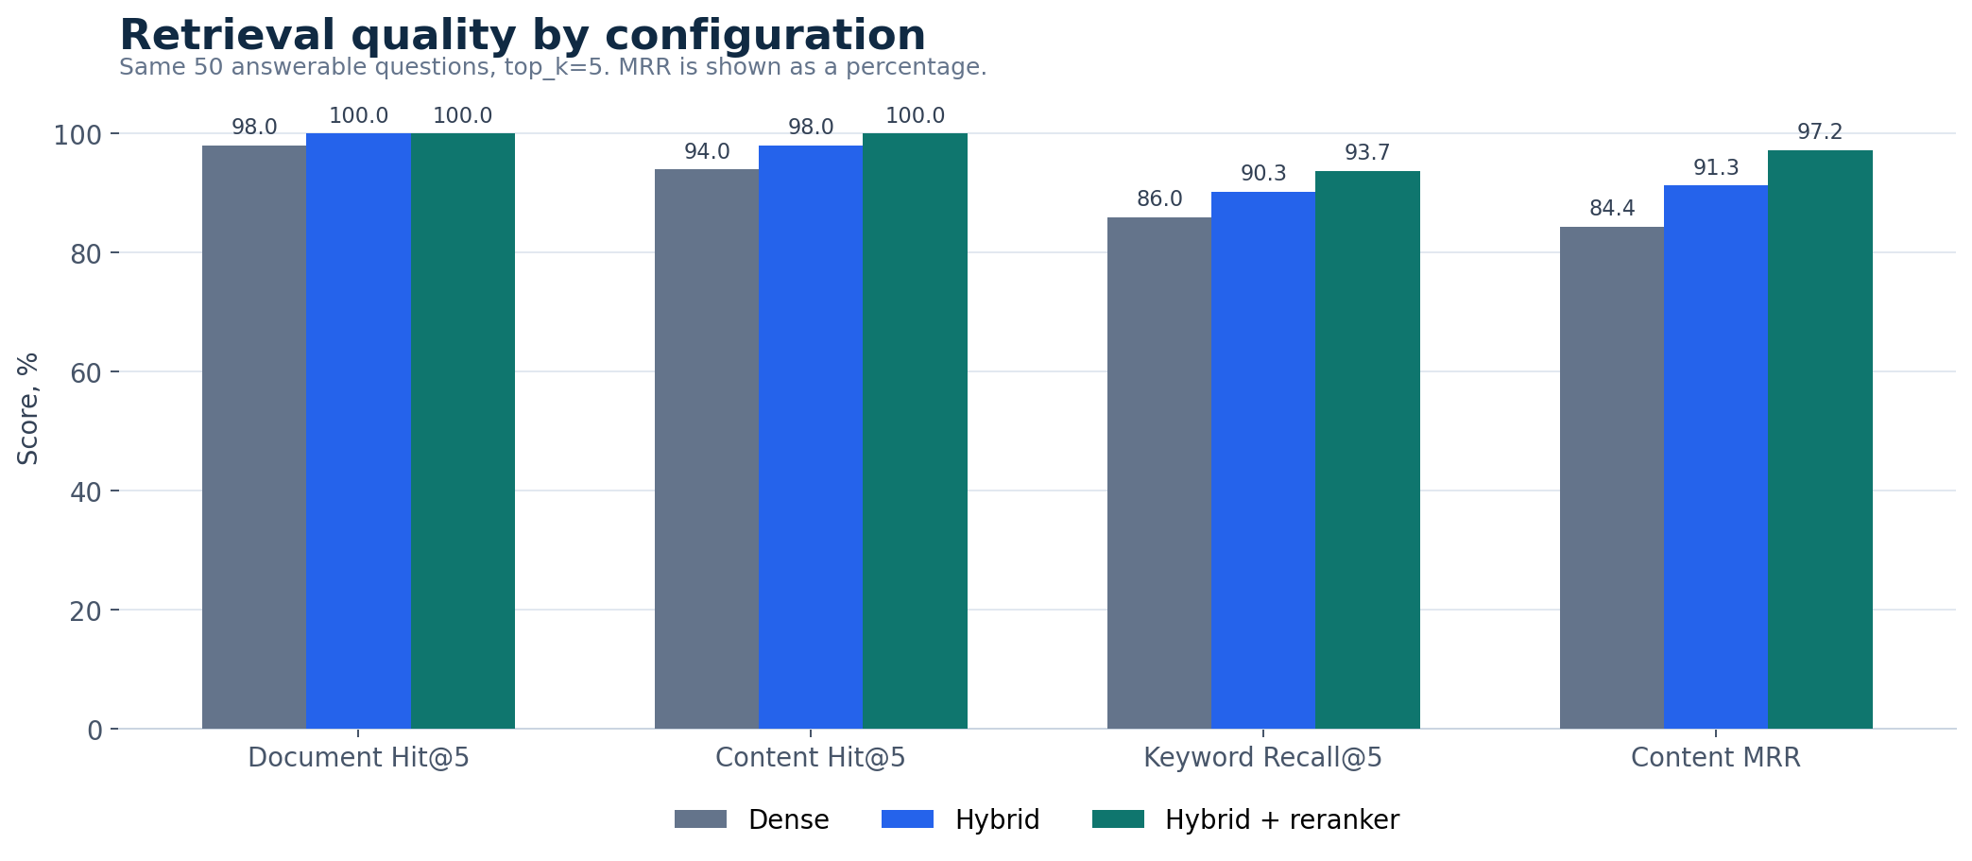
Figure 2. Content-level retrieval quality improves across the pipeline.

Trade-off analysis
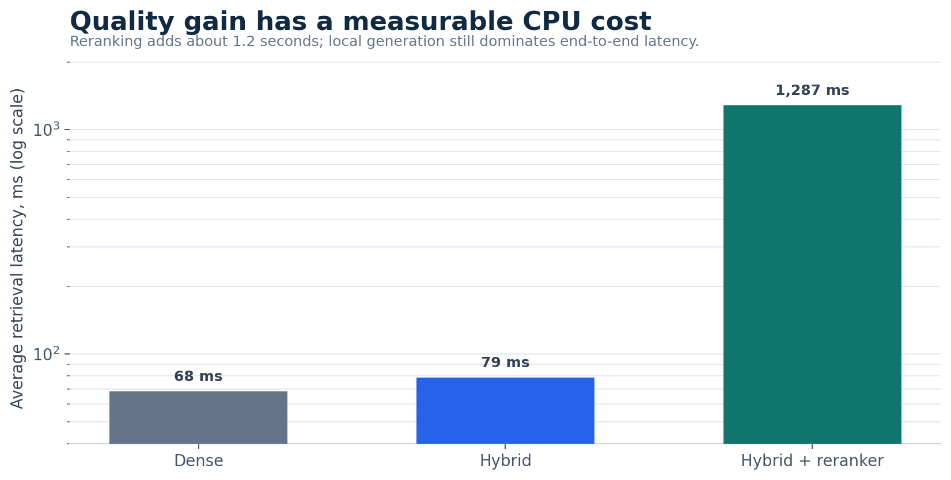
Figure 3. Average retrieval latency; logarithmic scale.
Hybrid retrieval is the practical default: it raises content quality for about 10 ms additional average latency. Reranking reaches perfect Content Hit@5 and the best Content MRR, but adds about 1.2 seconds on CPU. Primary/Document MRR decreases slightly from 0.990 to 0.967, while Content MRR rises from 0.913 to 0.972. Reporting both metrics prevents a misleading one-number conclusion.
Recommendation: Use hybrid without reranking for fast interactive work; enable reranking when evidence quality matters more than one additional second.

Operational batch experiment
A separate runner sent one warm-up and 20 measured sequential requests through the real /api/v1/query endpoint with hybrid retrieval, reranking, top_k=5, and local qwen3:4b generation. Sequential execution avoids distorting latency or exhausting memory on the CPU-only laptop.
Metric | Result
Successful HTTP | 20 / 20
Answers / no-answer | 19 / 1
Answers with sources | 100%
Fallbacks | 0
Average latency | 63.45 s
p50 / p95 | 70.68 s / 83.44 s
Avg reranker | 1.18 s
Wall time | 24 min 55 s

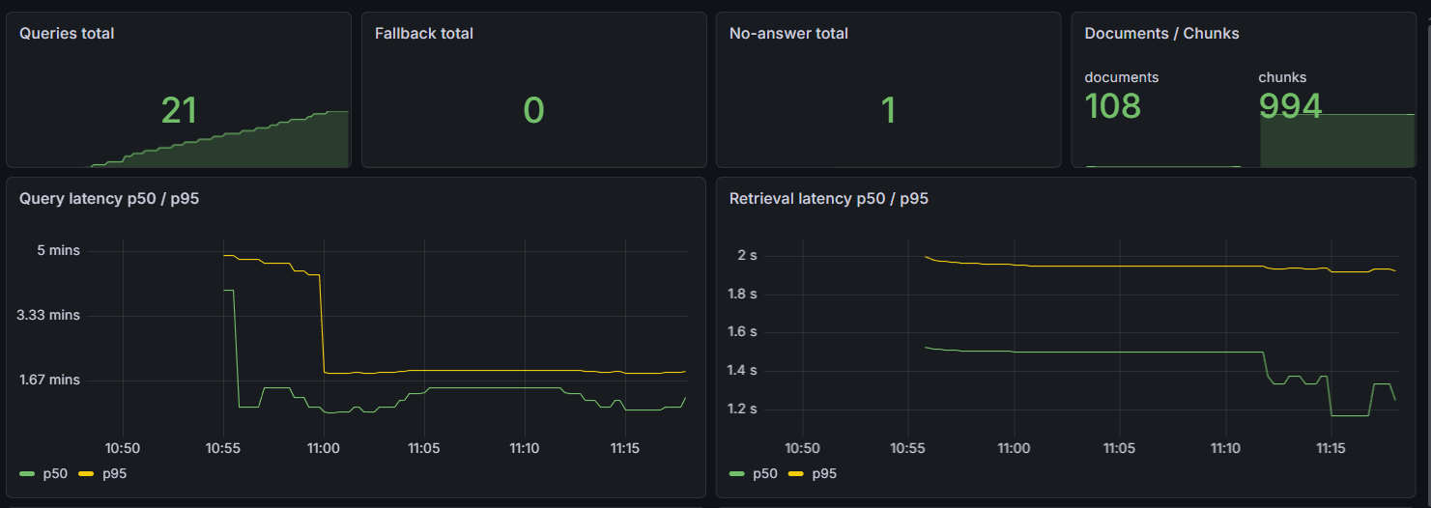
Figure 4. Grafana after one warm-up and 20 measured requests.

Latency diagnosis
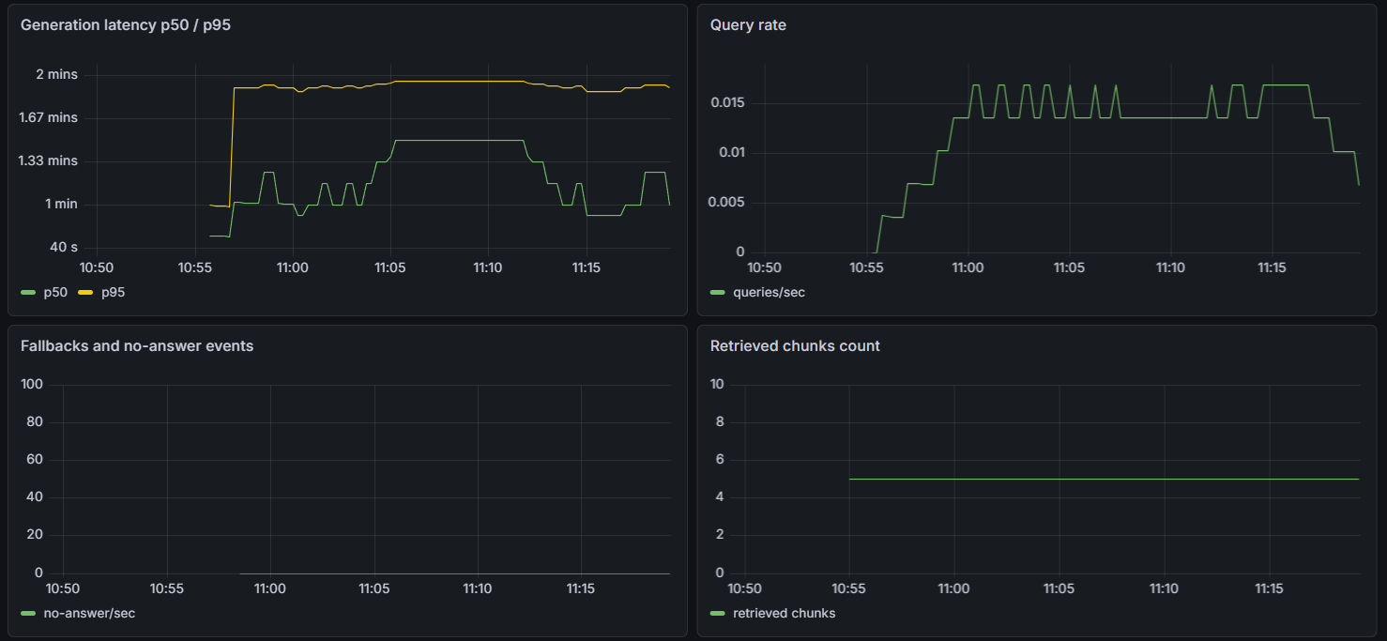
Figure 5. Generation dominates the end-to-end path; retrieved chunk count remains stable at five.
Grafana shows 21 total queries because the warm-up also updates counters. Retrieval and reranking remain small relative to local generation. The reported 63-second average is therefore a CPU-only Ollama baseline, not a production service-level target.

Failure analysis: q004
The only no-answer asked which email attachments are especially dangerous. The correct phishing-runbook chunk ranked first after reranking with a score of 5.70, but the guard rejected it because the fused retrieval score was 0.358, below the configured 0.50 threshold.
Finding: The answer existed; the guard used a pre-reranking score that did not represent final evidence quality. Calibrate on post-reranking evidence or use an answerability classifier.

Implementation highlights
- RAG implemented as an explicit pipeline rather than one framework call.
- Heterogeneous source parsing and reproducible upstream manifests.
- PostgreSQL for metadata, FTS, and history; Qdrant for vector search.
- Multiple controlled retrieval metrics instead of anecdotal examples.
- Citations and no-answer behavior treated as API contract requirements.
- Prometheus instrumentation of the actual HTTP path and Grafana diagnostics.

Limitations
- The dataset is small and domain-specific; generation quality was not independently scored.
- Five unanswerable questions are insufficient for robust guard calibration.
- CPU-only generation dominates latency.
- Eight manual or legacy documents need complete provenance metadata.
- The NIST-aligned summary and three runbooks are manually authored.
- Redis is provisioned but not used in the online query path.
- The system is a decision-support prototype, not an autonomous SOC responder.

Roadmap
- Calibrate the guard on final reranker evidence and a larger negative set.
- Replace the manual NIST-aligned summary with a revision-pinned official publication.
- Complete provenance metadata and enforce it in ingestion tests.
- Add answer-faithfulness and citation-correctness evaluation.
- Connect Redis with an explicit invalidation policy.
- Add CI, API containerization, authentication, and rate limiting.
- Benchmark GPU and hosted inference against the CPU baseline.

Reproducibility
Component | Configuration
Embeddings | paraphrase-multilingual-MiniLM-L12-v2
Fusion | Weighted RRF, k=60
Reranker | mmarco-mMiniLMv2-L12-H384-v1
Generator | Ollama · qwen3:4b
Stores | PostgreSQL 16 · Qdrant
Metrics | Prometheus · Grafana
Hardware | Windows 10 · CPU-only · 16 GB RAM

python scripts\run_query_batch.py --limit 20 --strategy hybrid --reranker

Conclusion
IRIS demonstrates an end-to-end RAG engineering workflow: corpus provenance, retrieval design, measurable experiments, cited generation, operational monitoring, and failure analysis. The strongest result is not a single score, but a system whose assumptions and trade-offs can be inspected and reproduced.

References
- MITRE ATT&CK - https://attack.mitre.org/
- SigmaHQ rules - https://github.com/SigmaHQ/sigma
- OWASP Top 10 - https://owasp.org/Top10/
- NIST ransomware resources - https://csrc.nist.gov/projects/ransomware-protection-and-response
- Raw IRIS artifacts - data/eval/ and data/manifests/

