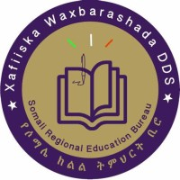
XAFIISKA WAXBARASHADA DOWLADA DEEGAANKA SOOMAALIDA
SOMALI REGIONAL STATE EDUCATION BUREAU
PROJECT PROPOSAL
Offline Teacher Training and Certification System
Better teachers, successful students
For primary school teachers (Grades 1–8) in all zones of the Somali Region
Prepared by: ______________________________
Date: October 2026

Contents
1. Summary
2. The Problem
3. Goal and Objectives
4. What the System Is
5. Training Content
6. How the System Works
7. Benefits
8. Who Will Benefit and Where
9. What Is Needed
10. Implementation Plan
11. How We Will Measure Success
12. Risks and Solutions
13. Main Costs
14. Sustainability
15. Conclusion
Annex A: Sample Certificate
Annex B: Sample Lesson

1. Summary
We want every primary school teacher in the Somali Region to teach well, so that every student can learn and succeed.
To do this, we built a simple training system on the computer. It works without internet. Teachers read short lessons in Somali, practise with questions, take tests, and get an official certificate from the Education Bureau.
In one sentence
A free, offline, Somali-language training system that makes teachers more professional and helps every student succeed.

2. The Problem
Many teachers in our region want to teach better, but they face these problems:
- Little training. Many teachers have had little or no training in how to teach.
- No internet. Most schools have no internet, so online courses do not work.
- Training is far and costly. Workshops need travel, money and time, so they happen rarely.
- Big classes. Many classes are very large. Some teachers teach two grades in one room.
- Students left behind. Some students fall behind or leave school, for example girls, slow learners and children of families who move with their animals.
- No clear records. The Bureau has no easy way to know which teachers are trained.

3. Goal and Objectives

Goal
Every teacher becomes a well-trained, professional teacher, and every student succeeds.

Objectives
- Train all primary teachers (Grades 1–8) in modern teaching methods.
- Give the training in Somali, in short and clear lessons.
- Reach every school in every zone, even schools without internet.
- Help teachers support all students: weak students, girls and children who move.
- Give a trusted certificate to every teacher who passes.
- Give the Bureau clear records of who is trained.

4. What the System Is
The system is one computer file. It opens in a normal web browser (Chrome, Edge or Firefox). Nothing needs to be installed, and it needs no internet. The file can be copied to any computer with a USB flash disk.
Part | What it does
7 training modules | 35 short lessons in Somali about good teaching.
Practice questions | 105 questions. Teachers see the right answer and a short explanation at once.
Module tests | One test after each module. The teacher must pass to open the next module.
Final exam | One exam with questions from all 7 modules.
Certificate | A beautiful official certificate with a number, a code and a QR code.
Teacher Toolkit | A printable page: 10 rules of a good teacher, a daily checklist, reflection questions and a lesson plan form.
Verify page | Anyone can check if a certificate is real.
Admin page | For the Bureau: see results, print reports, save backups, change settings.

5. Training Content
The training has 7 modules. Modules 6 and 7 are new and focus on helping every student succeed.
Module | What teachers learn
1. The Professional Teacher | What good teaching is. The roles of a teacher. Teacher ethics. No physical punishment.
2. Teaching Methods | Active learning. Asking good questions. Making teaching aids from local materials.
3. Classroom Management | A safe classroom. Class rules. Positive discipline. Large and mixed-grade classes.
4. Lesson Planning | Clear lesson goals. A lesson in 5 steps. Practice teaching with feedback.
5. Assessment | Checking learning every day. Useful feedback. Fair tests. Using results.
6. Every Student Succeeds (new) | Weak students. Girls. Children who move. Reading and maths basics. Stopping dropout.
7. Professional Growth (new) | Thinking about your teaching. Teacher groups. Working with parents and elders. A personal plan.

How every lesson is built
Every lesson is short and has the same 4 parts:
- Key idea: the main message in one or two sentences.
- Key points: 3 to 5 simple points.
- Example: a real example from a school in the Somali Region.
- Try it tomorrow: one small action the teacher does in class the next day.

6. How the System Works

For the teacher
- Register. Write your name, school, zone and woreda.
- Read. Read each lesson and mark it as done.
- Practise. Answer practice questions. You see the right answer at once.
- Take the module test. 10 questions in 20 minutes. You need 60% to pass.
- Try again if needed. There is no limit. After each test you see your mistakes and the right answers.
- Open the next module. Passing one module opens the next one.
- Take the final exam. 56 questions in 60 minutes. You need 60% to pass.
- Get your certificate. Print it or save it as a PDF.

For the Education Bureau
- See how many teachers registered, passed and got a certificate, by module and by zone.
- Download reports (CSV) to open in Excel.
- Save a backup of all data and move it to another computer.
- Change pass marks, number of questions and time limits.
- Check any certificate on the Verify page, or cancel a certificate if needed.

Fair exams
During an exam, copy and paste are blocked. If a teacher leaves the exam screen, they get a warning. After 2 warnings the exam stops, and the teacher waits 15 minutes before trying again.

7. Benefits
Who | Benefits
Teachers | Learn in their own language. Short, clear lessons. Ideas they can use the next day. Unlimited tries, so every teacher can pass. An official certificate.
Students | More active and interesting lessons. Fair treatment and no physical punishment. More help for weak students, girls and children who move. Better reading and maths.
Schools | Better classroom order. Teachers who plan their lessons. Teachers who learn from each other.
Education Bureau | Training reaches every zone. Very low cost: no travel, no printing, no internet. Clear records of trained teachers. Certificates that can be checked.
Parents and community | Better results for their children. More contact with teachers. More girls staying in school.

8. Who Will Benefit and Where
- Main users: primary school teachers, Grades 1–8.
- Also useful for: new teachers, school principals and woreda education experts.
- Where: all zones of the Somali Region: Afdheer, Daawa, Doollo, Erer, Faafan, Jarar, Liibaan, Nogob, Qorahay, Shabeelle and Sitti, and the city administrations.

9. What Is Needed
Need | Details
Computer or tablet | At least one per school, or one per group of nearby schools. Any normal computer works.
Web browser | Chrome, Edge or Firefox. These are free.
The system file | One file, copied with a USB flash disk. No installation.
Internet | Not needed.
A focal person | One person per woreda to share the file, help teachers and collect results.
Printer (optional) | To print certificates and the Teacher Toolkit.

10. Implementation Plan
We suggest 5 phases. Dates will be agreed with the Bureau.
Phase | What happens | Who
1. Review | Somali education experts check all lessons and questions. | Bureau experts
2. Pilot | Start in a few schools in each zone. Collect teacher feedback. | Bureau, woreda focal persons
3. Improve | Update lessons, questions and settings based on feedback. | Project team
4. Expand | Copy the system to all primary schools in all zones. | Bureau, zone and woreda offices
5. Follow up | Collect results every term. Visit classrooms to see the change. | Woreda focal persons, supervisors

11. How We Will Measure Success
What we measure | How
Teachers registered | Admin page and CSV report
Teachers who passed each module | Admin page
Certificates given | Admin page and Verify page
Results by zone | Admin page (results by zone)
Change in the classroom | Classroom visits by supervisors using the Teacher Toolkit checklist
Student learning | School test results and attendance, compared before and after

12. Risks and Solutions
Risk | Solution
Some schools have no computer. | Share one computer between nearby schools, or train at the woreda office.
Data is lost. | Save a backup file regularly from the Admin page.
Teachers cheat in exams. | Copy and paste are blocked, questions change each time, and leaving the exam stops it.
Mistakes in the lessons. | Experts review all content before the pilot.
Teachers do not finish. | Unlimited retakes, short lessons, and support from the woreda focal person.

13. Main Costs
The system is already built, so costs are low. The main costs are:
Item | Notes | Amount (ETB)
Expert review workshop | Check the Somali lessons and questions
Pilot support | Focal person time and travel in pilot schools
Computers or tablets | Only for schools that have none
Printing | Certificates and Teacher Toolkit
Follow-up visits | Classroom visits after training
Total
Amounts will be filled in with the Bureau.

14. Sustainability
- The system is one file. It can be copied for free to any school, any time.
- No internet and no monthly cost.
- The Bureau can add new questions and change settings without a programmer.
- New teachers can take the training every year.
- Teacher groups in each school keep the learning going after the certificate.

15. Conclusion
Good teachers make successful students. This system gives every teacher in the Somali Region a simple, free and offline way to become a better, more professional teacher. We ask the Education Bureau to approve a pilot and support the roll-out to all zones.
Our request
1. Approve the expert review of the lessons.
2. Approve a pilot in a few schools in each zone.
3. Name one focal person in each woreda.

Annex A: Sample Certificate
Every teacher who passes the final exam receives this certificate. Each real certificate has its own number, verification code and QR code.
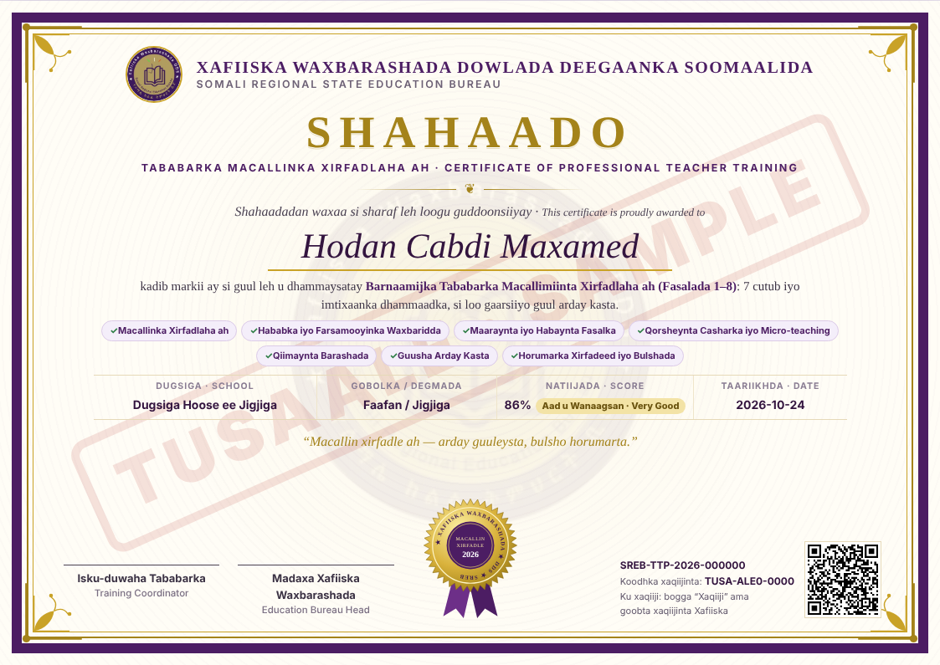

Annex B: Sample Lesson
This is Lesson 1 of Module 1, as teachers see it (in Somali).
Waa maxay waxbaridku? (What is teaching?)
Fikradda muhiimka ah: Waxbaridku maaha hadal keliya. Waa hawl qorsheysan oo ujeeddo leh, oo ardayga ka caawisa inuu barto aqoon, xirfad iyo dabeecad wanaagsan.
Qodobo: Waxbaridku wuxuu guuleystaa marka ardaygu barto, maaha marka macallinku hadlo. Waa is-dhexgal. Waxbaridda wanaagsan waxay leedahay yool cad, hab ku habboon iyo hubinta barashada.
Tusaale: Macallin sayniska ah oo Jigjiga jooga ayaa casharka uumiga biyaha ku bilaabay laba koob oo biyo ah. Ardaydu iyagaa arkay farqiga oo sharxay.
Isku day berri: Dhammaadka casharkaaga xiga, weydii 3 arday: “Maxaad maanta baratay?”

