HW5  
Student ID: 109598001 Student Name: 鄭濠營

1. the support vectors of the following training data samples: $\left\{{\left[\begin{matrix}1 & 1\end{matrix}\right]}^{T},{\left[\begin{matrix}2 & 2\end{matrix}\right]}^{T},{\left[\begin{matrix}3 & 3\end{matrix}\right]}^{T}\right\}∈C_{+}$ and $\left\{{\left[\begin{matrix}0 & 0\end{matrix}\right]}^{T},{\left[\begin{matrix}-3 & 2\end{matrix}\right]}^{T},{\left[\begin{matrix}-5 & -5\end{matrix}\right]}^{T}\right\}∈C_{-}$。  
   Answer: -1x+1=y, w = -1, b = 1, Maximum margin approximates 0.7。Support Vector is (0,0)-, (1,1)+。  
   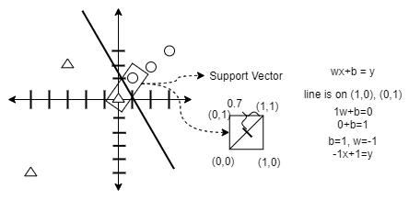
2. Ensemble Learning是 Nonlinear classifier，是來自不同的linear weak classifier 結合並以其他策略 (e.g., voting, weight error, etc.) 來決定其中最好的weak classifier得出的結果。Linear weak classifier 是指那些準確率低下 (low accuracy) 的分類器。藉由結合各種linear weak classifier 去做比較，選擇相較好的classifier 去作為該分類的Model，其準確率也相對有保證。
3. Consider the following example with five training samples:  
   P1=(1, 2.1), C= +1; P2=(2, 1.1), C=+1; P3=(1.3, 1), C= -1; P4=(1, 1),C= -1; P5=(2, 1),C= +1。  
   Weight Error w = [0.5, 0.125, 0.125, 0.125, 0.125]。  
   We want to find a weak classifier to minimize weighted errors.  
   And we use decision stump classifier.  
   if 1st feature < 1st threshold OR 2nd feature > 2nd threshold:  
    class: +  
   else:  
    class: -  
   optimal weak classifier: y (2nd feature) = 1.05; Weight error w: 0.125\*1 = 0.125  
   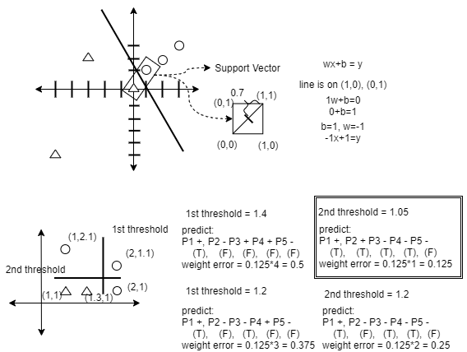

4. 程式在背後頁面。  
5. (1) 9個 weak classifiers能讓train accuracy達到1.0。(2) 從後面程式顯示的圖表觀察，accuracy是隨著weak classifiers的數目而有所提升。(3) accuracy基本上在100的week classifiers數目內，有達到9成以上，是相當不錯的結果。程式在背後頁面。