Bid Data Mining Homework 4

Team Member:

SID: 109598033 SID: 109598001

**Spark Platform:**

The platform consists of:  
1. Raspberry Pi 4 Model B x2

* OS: Linux Ubuntu 20.04 Server
* CPU architecture: aarch64
* RAM: 8GB
* CPU: Broadcom BCM2711, Quad core Cortex-A72 (ARM v8) 64-bit SoC @ 1.5GHz
* Number of CPU: 4C (CPU) 1T (Thread Per CPU)

2. Asus-vivobook notebook

* OS: Linux Ubuntu 20.04 LTS
* 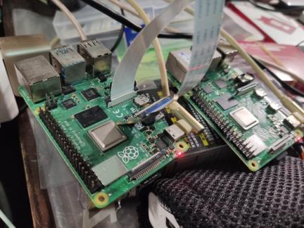CPU architecture: x86_64
* RAM: 8GB
* CPU: Intel(R) Core(TM) i3-8130U CPU @ 2.20GHz
* Number of CPU: 4C (CPU) 2T (Thread Per CPU)

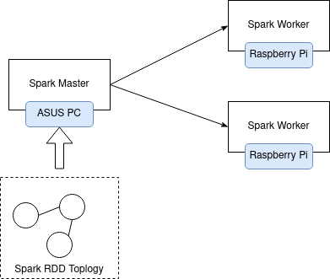The simple architecture of spark cluster:

**Task arrangement for Team:   
SID: 109598033  
1. Q3  
2. Q4  
3. Q5  
SID: 109598001  
1. Q1  
2. Q2  
3. Document**

**The description of tree directory:**

Explain where the files put into and how it does.

* **README file explains in detail for what the steps of spark implementation in this homework.**
* **‘outputs’ directory shows the result of the homework.**
* **park project is ‘109598033_109598001_hw4.ipynb’ which codes by Python.**

**The generated output:**

**Q1—the top-rated movies by all users**

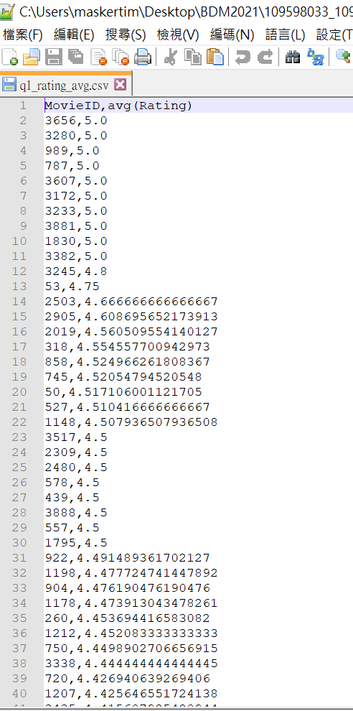 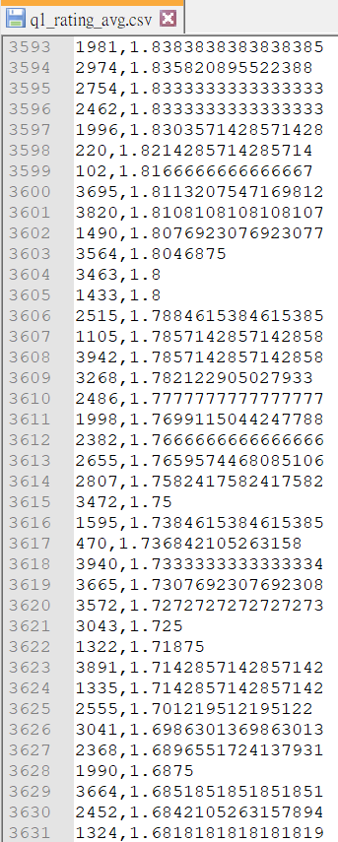

**Q2—the top-rated movies grouped by gender, by age group, and by occupation, respectively**

Age:

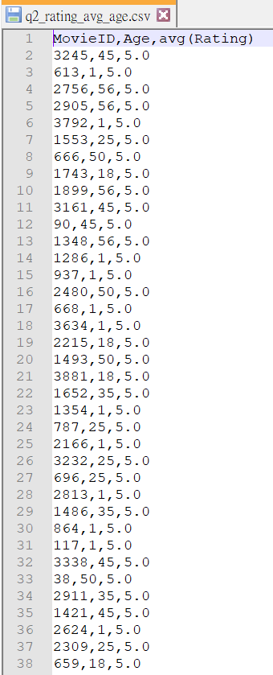 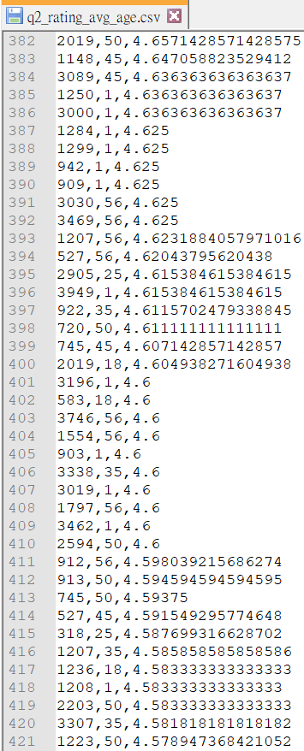

Occupation:

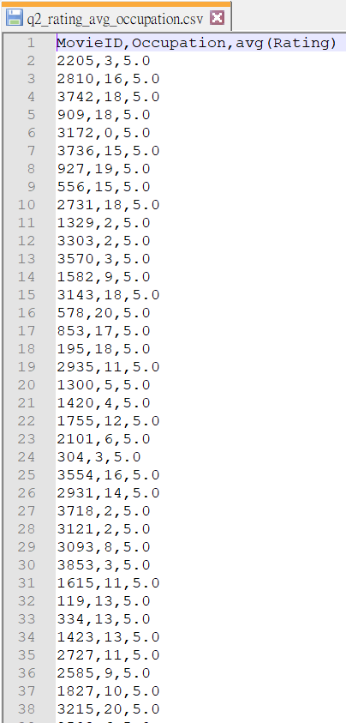 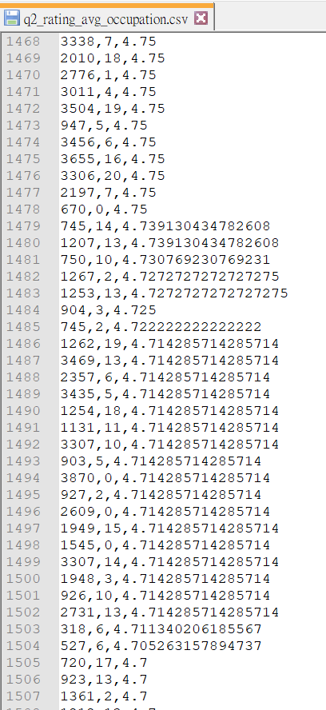

Gender:

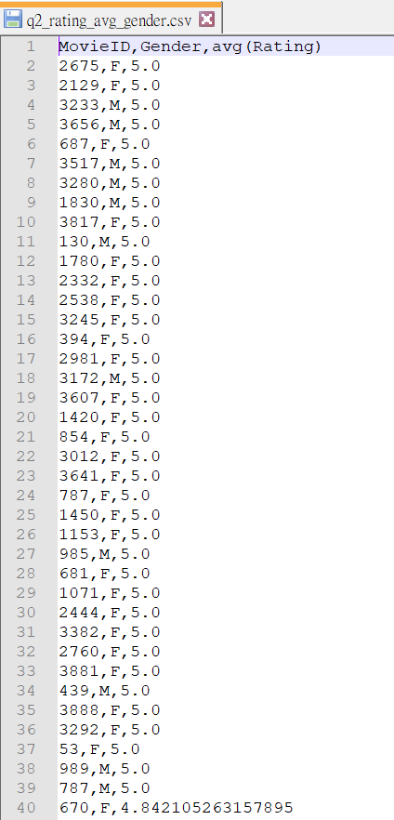 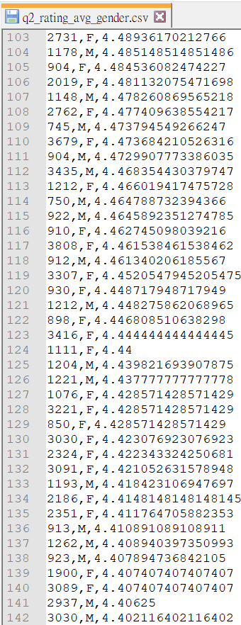

**Q3—the average rating score of each user for all movies, and grouped by genre, respectively.**

User:

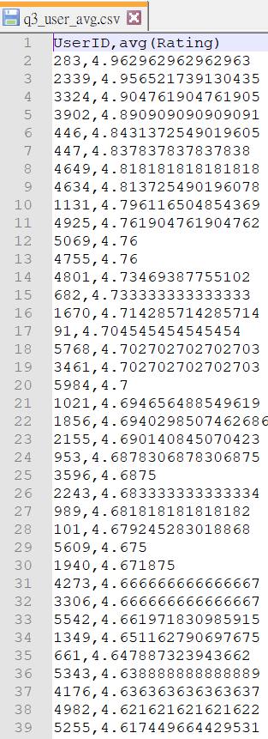 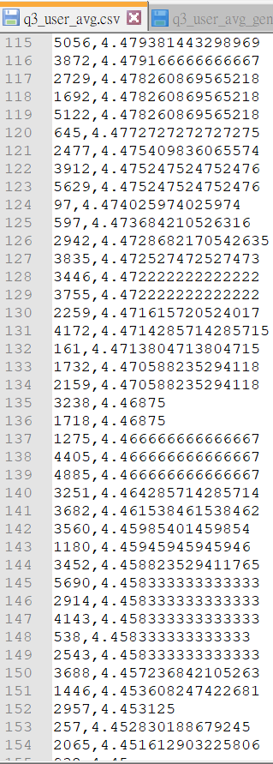

User Grouped by Genre

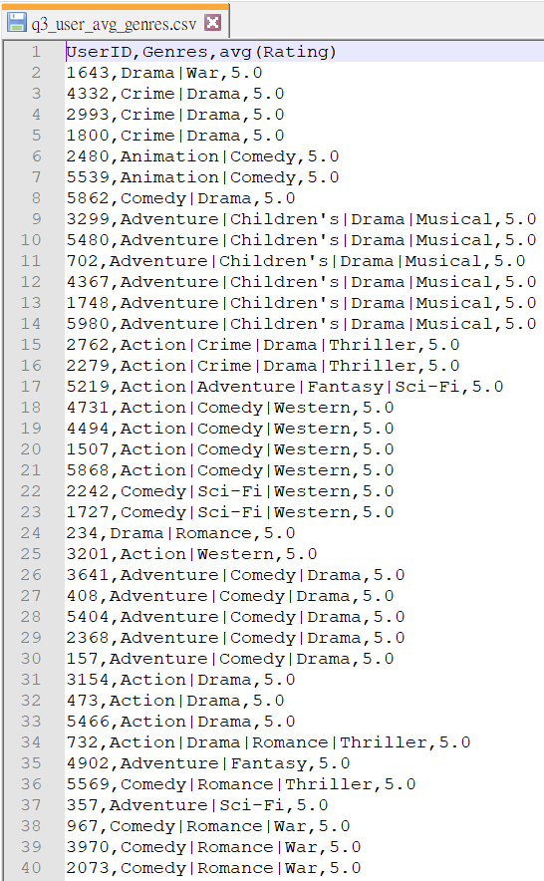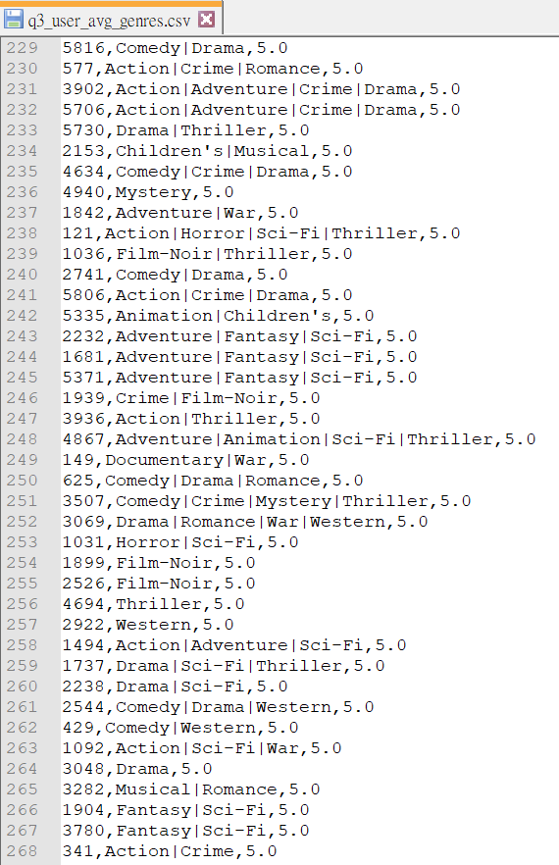

**Q4—the top-’similar’ users based on the cosine similarity of previous ratings each user has given. (sorted in descending order of ‘user’ similarity score)**

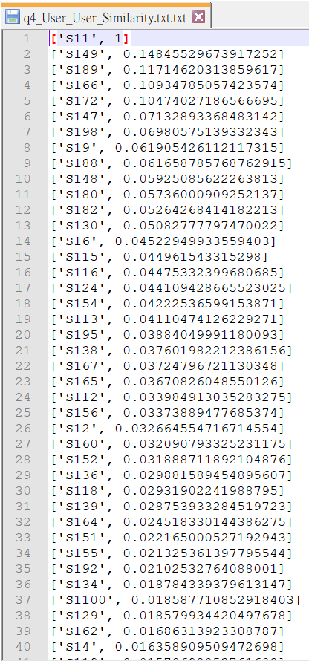 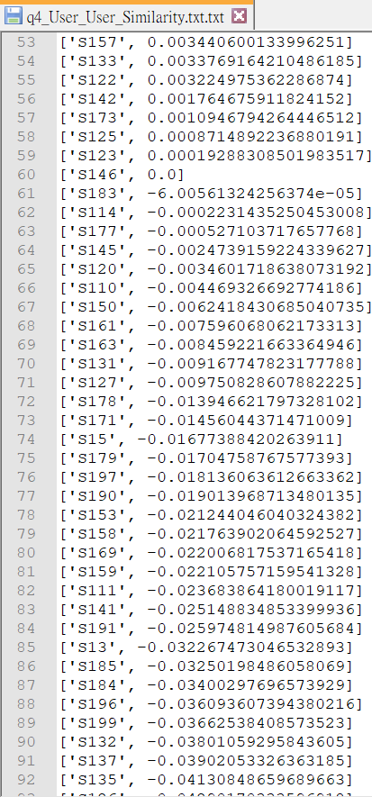

**Q5—the top-’similar’ movies based on the cosine similarity of previous ratings each movie received. (sorted in descending order of ‘item’ similarity score)**

