Big Data Mining Homework 1

# Team Member:

# SID: 109598001

# SID: 109598033

# Spark Platform:

The platform consists of:

1. Raspberry Pi 4 Model B x2
   * OS: Linux Ubuntu 20.04 Server
   * CPU architecture: aarch64
   * RAM: 8GB
   * CPU: Broadcom BCM2711, Quad core Cortex-A72 (ARM v8) 64-bit SoC @ 1.5GHz
   * Number of CPU: 4C (CPU) 1T (Thread Per CPU)
2. Asus-vivobook notebook
   * OS: Linux Ubuntu 20.04 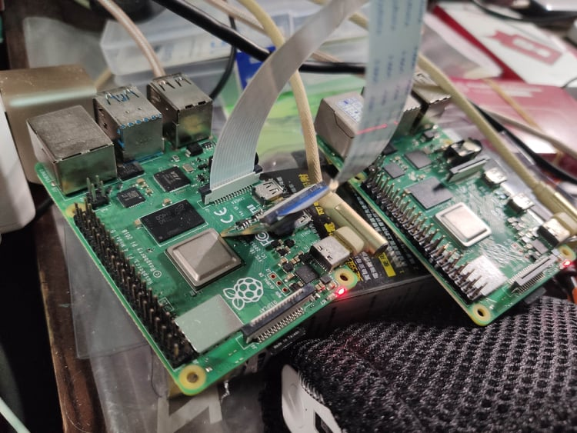LTS
   * CPU architecture: x86_64
   * RAM: 8GB
   * CPU: Intel(R) Core(TM) i3-8130U CPU @ 2.20GHz
   * Number of CPU: 4C (CPU) 2T (Thread Per CPU)

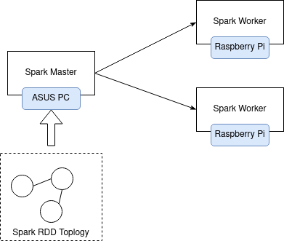The simple architecture of spark cluster:

# Task arrangement for Team:

**Prepare:**

**SID: 109598001**

**--Physics Part--**

* 1. **Prepare the physical machine (e.g., raspberry pi 4 Model B)**
  2. **Environment Construction and Configuration (e.g., IP, raspberry pi environment)**

**--Code Part—**

**1. Calculate min, max, and count**

**2. Calculate mean and standard deviation**

**SID: 109598033**

**--Physics Part—**

**1. Build a Spark Cluster (1 Master, 2 Worker)**

**--Code Part—**

**1. Calculate min-max normalization and write out into file**

# The description of tree directory:

Explain where the files put into and how it does.

* **Min, max, mean, standard deviation of calculation results are written into ‘./processed_data/App.log’ file.**
* **Min-max normalization calculation results are written into ‘./generate_report/reports/output.csv’.**
* **Spark project is in ‘powerconsumption’ directory which codes by Java.**
* **Generate the min-max normalization calculation report is in ‘generate_report’ directory which codes by Python.**
* **README file explains in detail for what the steps of spark implementation in this homework.**
* **‘picture’ directory shows the snapshot of the spark processes.**
* **‘docs’ directory contains this ‘hw1_environment_document’ file and the tutorial of Spark installation we did.**

# The generated output:

### Log the RDD (Resilient Distributed Dataset) output

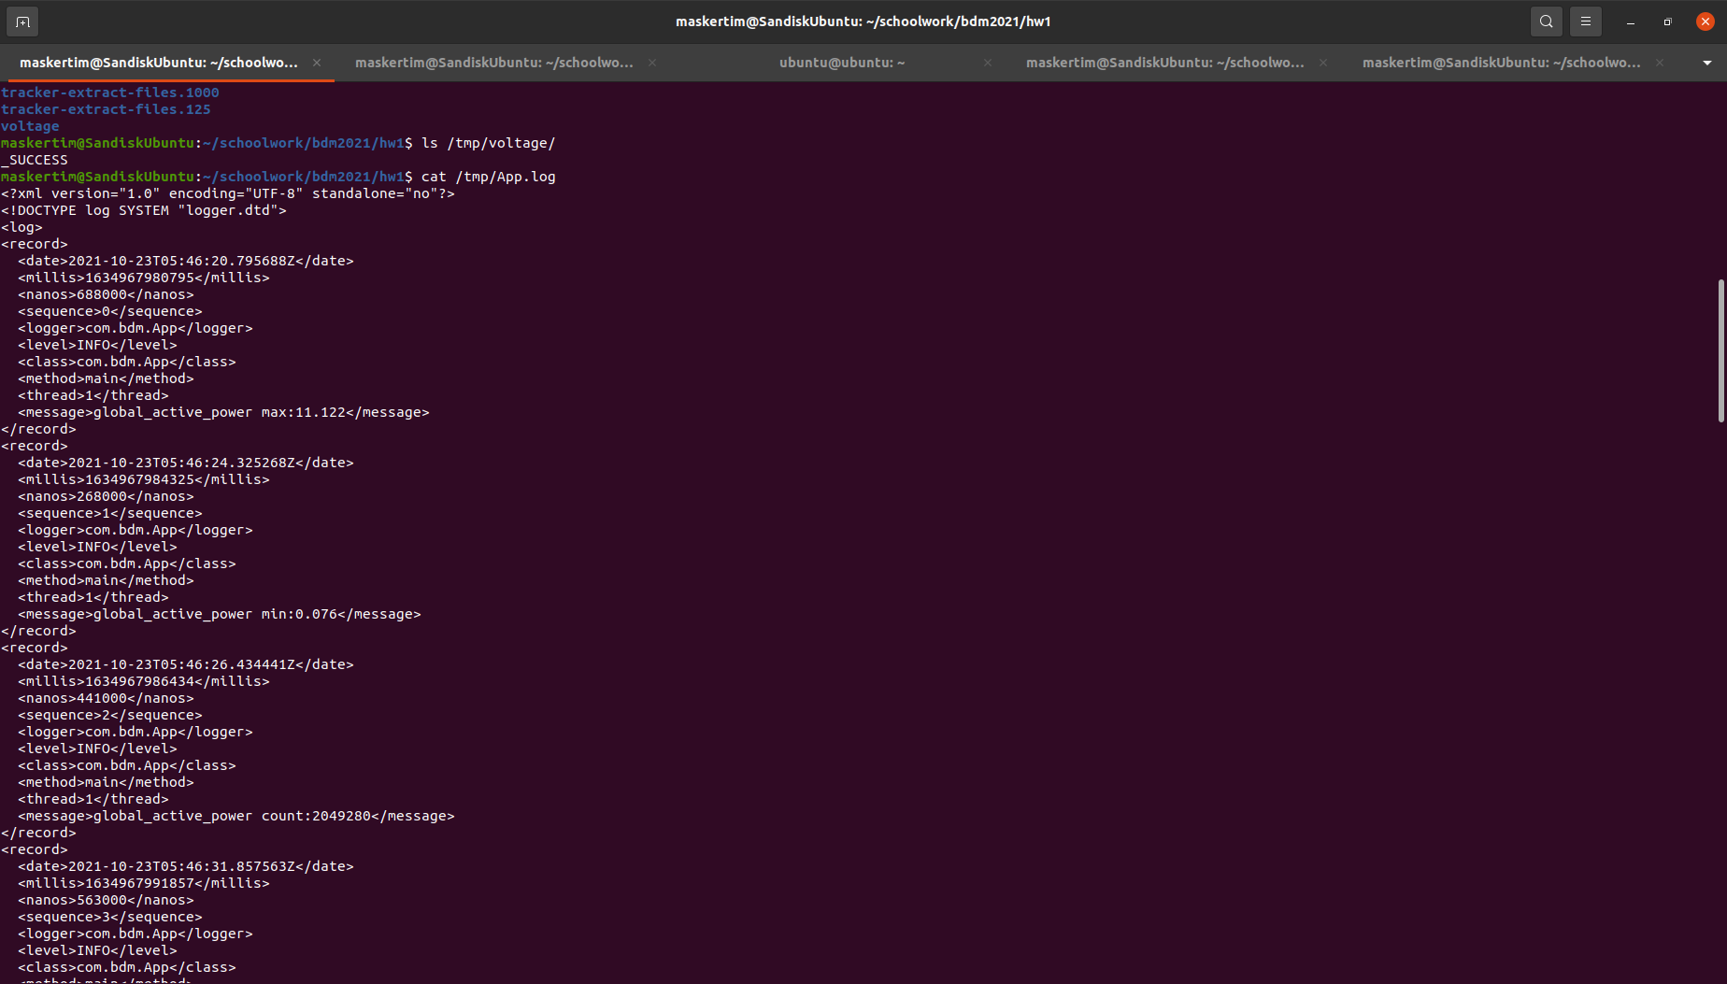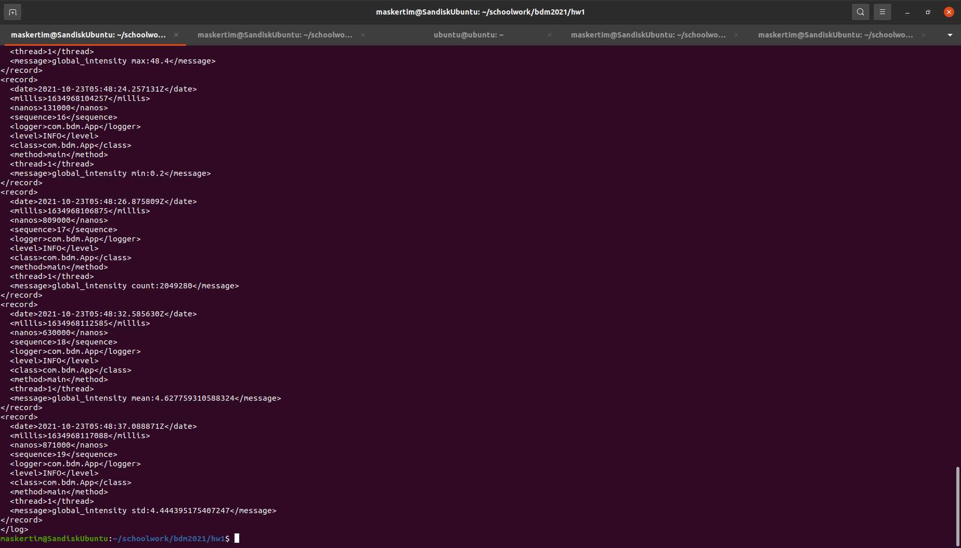

### The completed data processed by spark cluster on Raspberry Pi

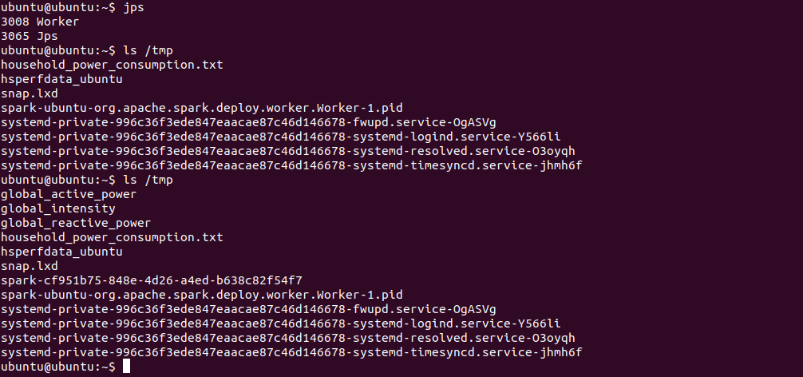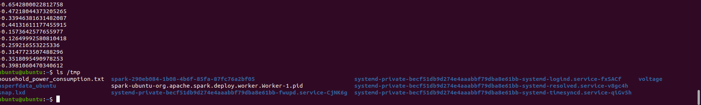

### Spark Web GUI and Logging of Spark Cluster

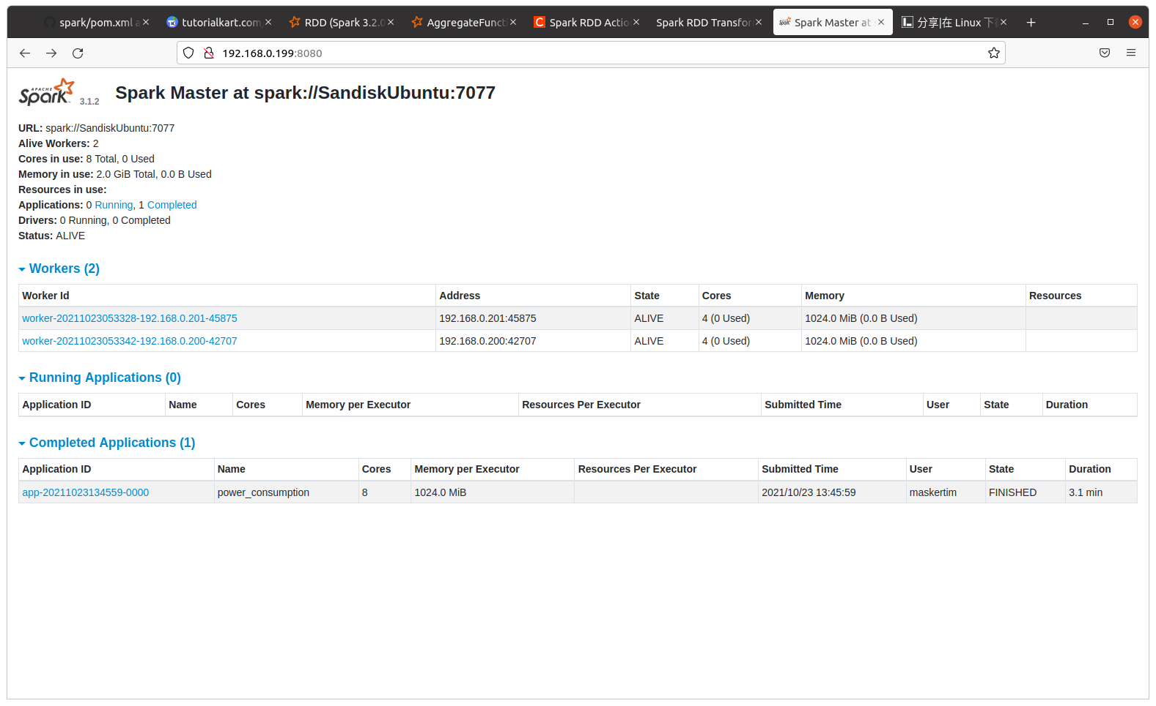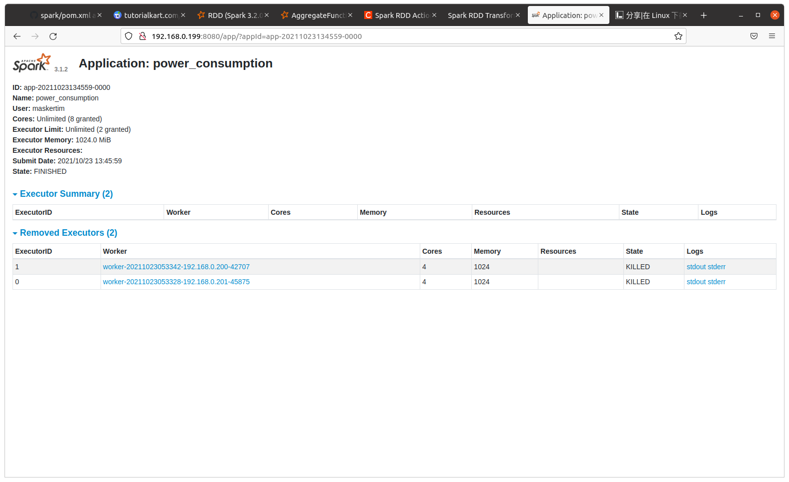

### Report of min-max normalization (using formula of Z-Score)

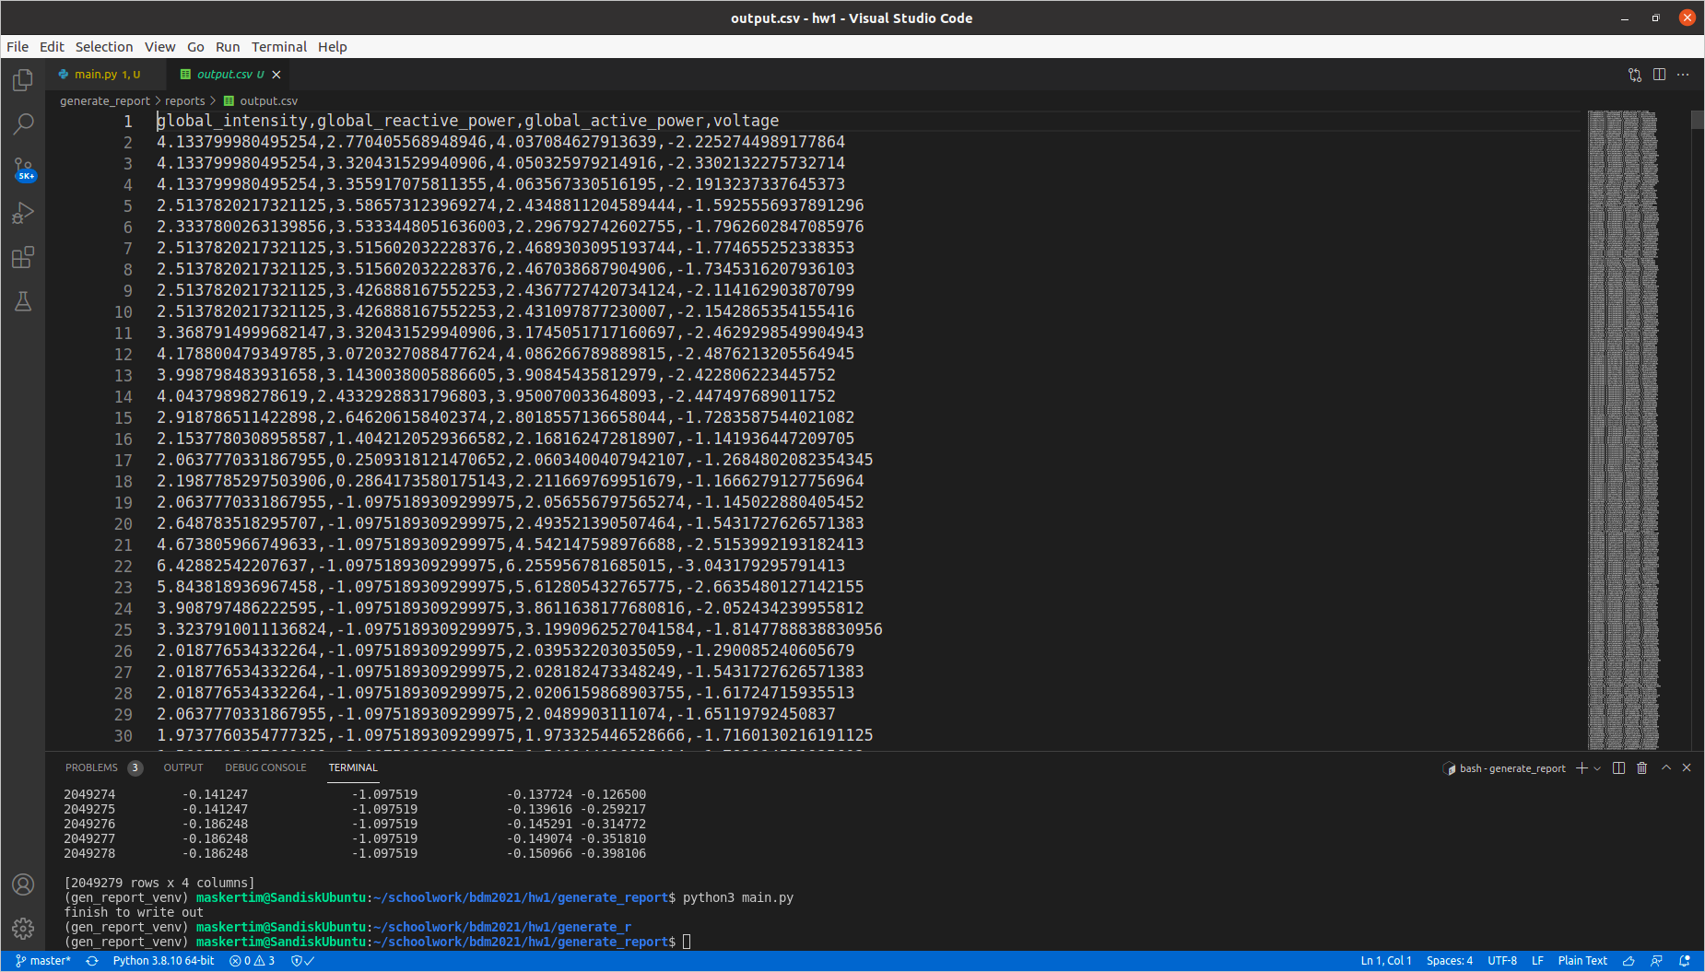

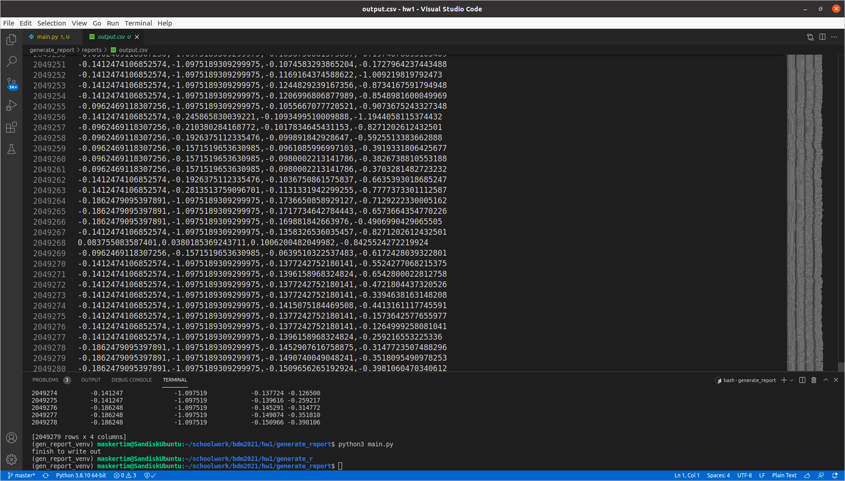

# What the workflow of implementation using spark?

1. Start spark master by “start-master.sh” command.
2. Start spark worker by “start-worker.sh [your spark url]” command to connect spark master.
3. Writing the Spark API with any program (e.g., Java, R, Python, Scala) that spark provides, in this work, that uses Java Language.
4. If you finish to write a program, as follows:
5. 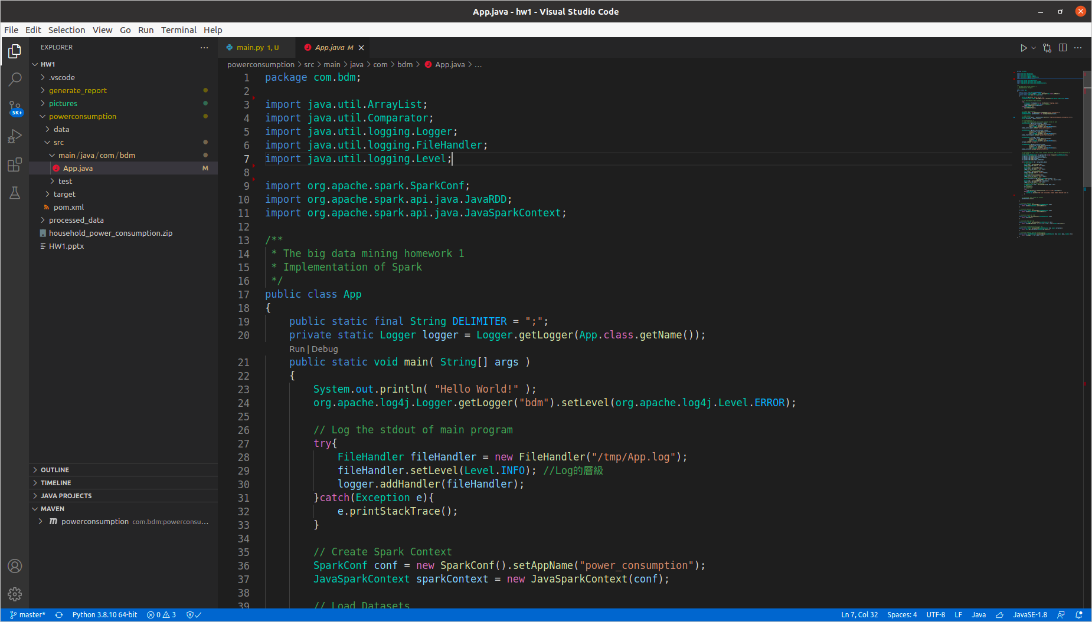Later using the 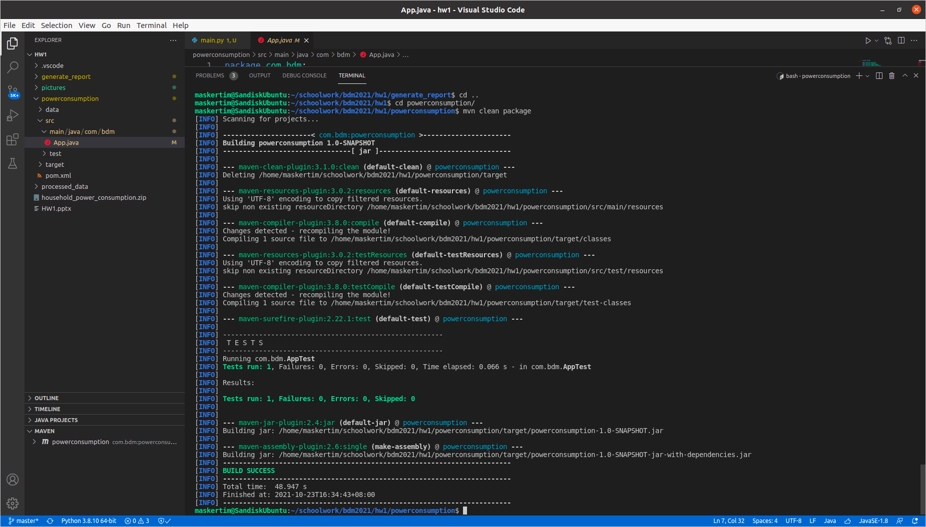maven (Java package management) to compile and package jar file. The command is “mvn clean package”. (Note that you may configure different settings in pom.xml, so this just a reference)
6. Finally, that can find a jar package in target directory, let just submit your jar file to spark cluster.   
   “spark-submit --class "com.bdm.App" --master spark://192.168.0.199:7077 /home/maskertim/schoolwork/bdm2021/hw1/powerconsumption/target/powerconsumption-1.0-SNAPSHOT.jar”.  
   As above that is my setting for spark cluster. Need to change some variable to apply different environment settings.