Task - 1: Implementation of MCP Neurons:
Design a MCP Neuron for ”AND” Boolean Functions and ”OR” Boolean Functions with two inputs:
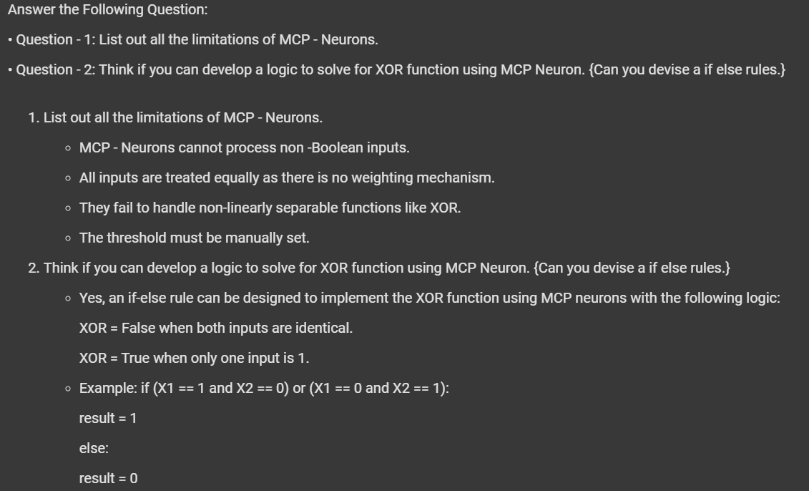
Task 2: Perceptron Algorithm for 0 vs 1 Classification.
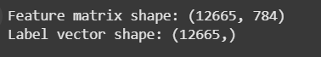
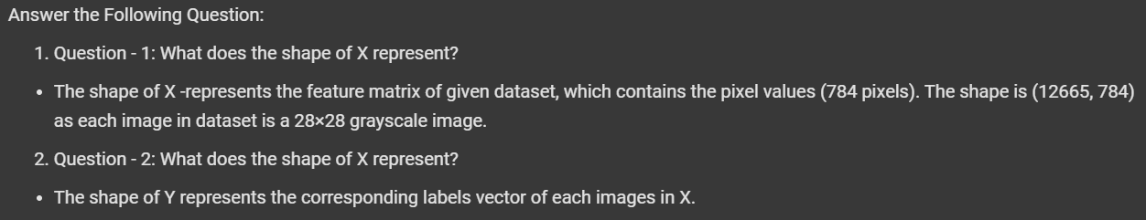

Visualize the Dataset:
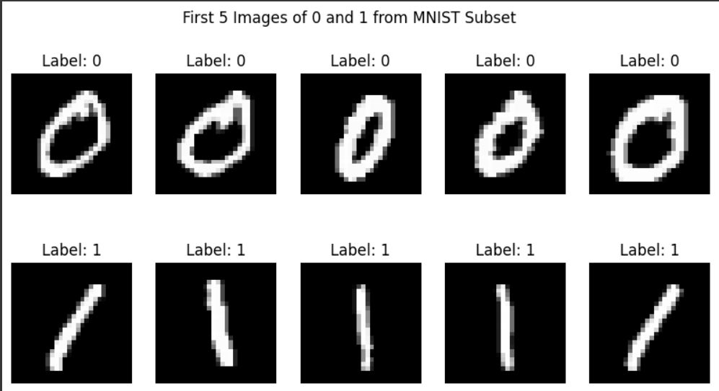
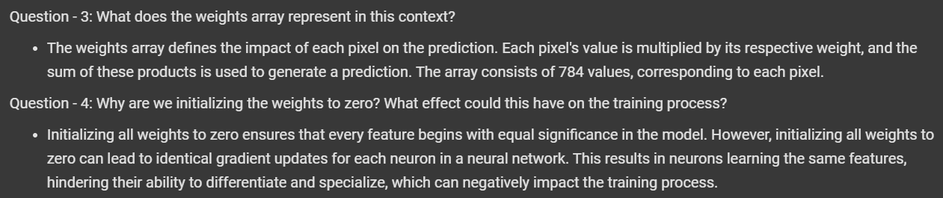
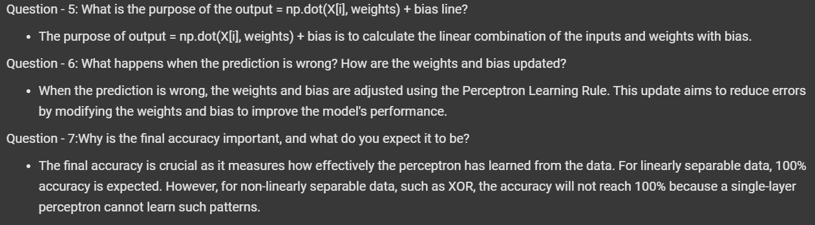
Training the Perceptron Algorithm:
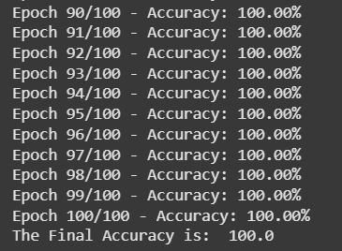
Visualizing Misclassified Image.
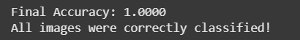
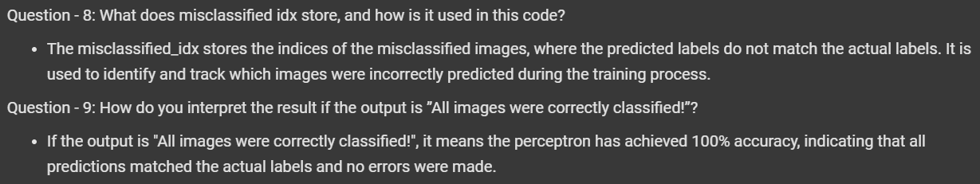
Task 3: Perceptron Algorithm for 3 vs 5 Classification.
