MNIST_Digit_Classification_with_Logistic_Regression
Some Helper Function:
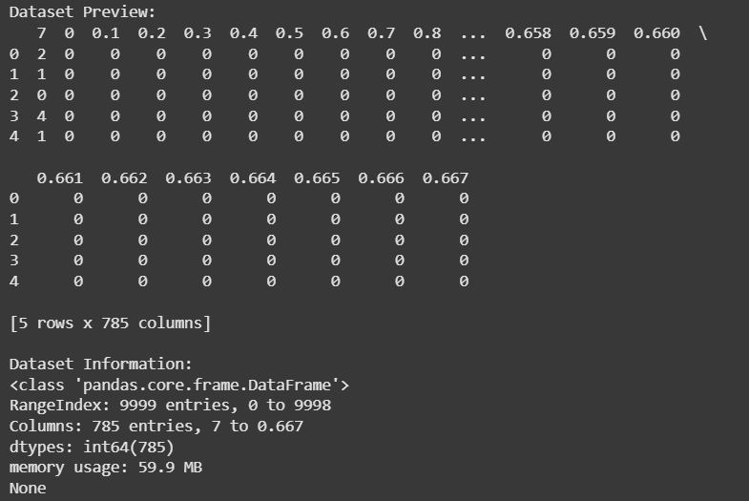
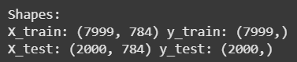
Softmax Test Case:
Test Function for Prediction Function:

Test case for Loss Function:


Test Case for Cost Function:
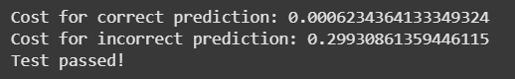
Test case for compute_gradient function:
