Alias $a=l_{3},b=l_{2},c=l_{1},d=l_{0}$

SEL1-1

$$\overline{l_{3}}⋅\overline{l_{2}}⋅l_{1}⋅l_{0}$$

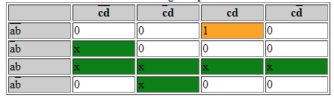

SEL1-0

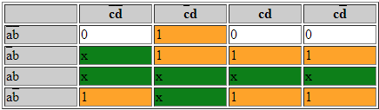

SEL2-1

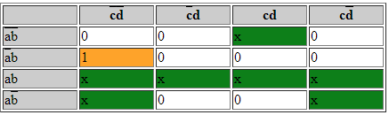

SEL2-0

SEL3-1 & SEL3-0 & SEL4-1

0

SEL4-0

SEL5-1

0

SEL5-0

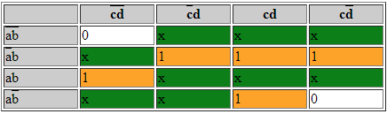

SEL6-1

$$l_{3}+l_{2}$$

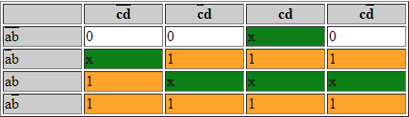

SEL6-0

$$l_{3}+l_{2}+l_{0}$$

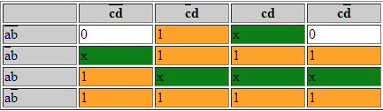

OP1

$$l_{3}⋅l_{2}+l_{3}⋅l_{1}$$

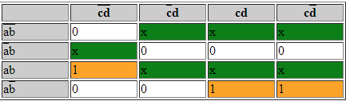

OP2

$$l_{3}⋅\overline{l_{1}}+\overline{l_{3}}⋅l_{1}⋅l_{0}$$

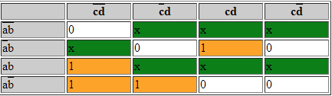

OP3

$$l_{3}⋅\overline{l_{2}}⋅\overline{l_{1}}+\overline{l_{3}}⋅l_{1}⋅\overline{l_{0}}$$

