SURVEY 4 ALL

Requirements Specification and Analysis

Version:

<10.11.2019>

Berkay YILMAZ

Emre Yasin NALBANT

Gözde GÖKYOKUŞ

Umut YILDIZ

Prepared for

SE301 Software Engineering



Table of Contents

1. Introduction 1

1.1. Purpose of the System 1

1.2. Scope of the System 1

1.3. Objectives and Success Criteria of the Project 1

1.4. Definitions, Acronyms, and Abbreviations 1

1.5. Overview 2

2. Current System 2

3. Proposed System 2

3.1. Overview 2

3.2. Functional Requirements 3

3.3. Nonfunctional Requirements 3

3.4. System Models 4

**Scenarios** 4

**Use case model** 13

Usecase model 21

Object model 22

22

Dynamic model 23

User interface—navigational paths and screen mock-ups 23

3.5. Project Schedule 27

4. Glossary 28

5. References 29

REQUIREMENTS ANALYSIS DOCUMENT [1]

# Introduction

Survey4All is a survey management website and it presents functions as creating survey, answering survey question, sharing survey, showing statistics of survey.

## Purpose of the System

The purpose of Survey4All is that survey management who creates from registered corporate compony or individuals is more easily accessible and more easily answerable and also If users will be registering Survey4All, they can create survey and answer the survey questions or If user won’t Survey4All, they can only answer the survey questions.

## Scope of the System

Users will be able to creating survey, answering the created survey question, deleting survey, searching other Registered User in Survey4All and searching created surveys. Users can share the created survey and add the survey to their favorite survey list. When users register Survey4All, they can do every function of Survey4All except banning user and registering the Survey4All.RegisteredUser can delete their survey. Registered User can login Survey4All and create a survey and also every user can access it using search. Users can also search other users to see their surveys. Every users can fill survey or share the survey. If Registered User forget its password, it can use forget password function. Registered User can see their statistics of survey. Only Admin can ban a user. Admin can see statistics of every survey and it can delete any survey.

## Objectives and Success Criteria of the Project

The users can create a survey, share survey, delete survey or fill the survey in a little number of steps. Survey4All has a user-friendly interface and a fast system. The most important function of Survey4All is searching user and searching user in system. The user will be supported if it meets a confronted problem while using the system.

## Definitions, Acronyms, and Abbreviations

Admin: Admin is an actor in Survey4All, Admin is the actor who manages Survey4All as ban user.

Registered User: Registered User is an actor of Survey4All, Registered User is a user who registers the system and has function as create survey, delete survey.

Unregistered User: Unregistered User is a user who isn’t register the Survey4All and it has functions as sharing survey, answering survey.

## Overview

Rest of the RAD contains non-functional requirements(includes usability , reliability,performance,supportability,implementation,interface,operational,packaging , legal) , functional requirements, system models, glossary and references.

# Current System

Survey4All is a website that everyone can participate the surveys which created by anyone who wants.The main goal is website which manages surveys mostly leave the website purpose to only fill A survey which gives instant results. We wanted to change that to a website which manages surveys and deploys them to the users like a social media instead of just a tool.In current systems you can create or share any survey without registering to the system.But wth out system we are creating a way that registered and unregistered users can interact with each other.Giving the statistics about a survey must be selectable by the user , since most of the current systems doesn’t apply to that.

# Proposed System

## Overview

Our Survey4All website is a survey management system that can be used by variety of people from different professions to create survey. You can use the Survey4All as a guest user to look around or register user to create and share your own surveys. People will always in need of opinions of other person for variety of reasons but reaching diverse group of people and getting countable statistic from them is has problem of its own. By using Survey4All user can get best statistic for its survey topic because users have complete control over participated group. Guest users can only see and participate the ongoing active surveys. Registered user can participate other surveys as well as they can create their own survey to. It can be a survey about usability of a mobile application or opinion about public matter. Every registered user can create and share a survey by deciding required participant info and survey questions. After this process Registered user can get statistic from their survey. There is a lot of difference between being a guest user and registered user, but the biggest difference begins with the survey creation permissions. Registered users are the only user that can create a survey. Admin can ban a user’s account that violate any site policy. And, admins can delete a survey as he/she decided that its violated site policy. Admin can also check the statistic of any survey they want just like the creator of that survey. Registered users can see the info’s of previously created or shared surveys in their profile page. Admin and other users will also be able to look each other’s profile pages.

## Functional Requirements

Our Survey4All website is an online survey manager, publisher analyzer platform for everyone who wants to create or participate a survey thorough internet as easily and fast as possible.

On the registered user side, the website has several functions to offer such as, they can look through the active survey through the main page and if they want to participate to them, they can do it easily. Or they can just simply create a new survey east and fast through the website.

On the guest user side, guests are just downgraded versions of the registered users. They can just use the main page to check active surveys and participate them if they want to. If they want to create their own survey they must register to do so.

Admins are the ones who control the whole website. They can ban the user who isn’t respectful to the website policies. They can also delete any survey they see fit and, they check the statistic of any survey they require just like the creator of that survey.

## Nonfunctional Requirements

**Usability:**

* For a person who needs to register to the Survey4All should make at least 25 clicks to register.
* For a person who needs to login or logout to Survey4all should make at least 18 clicks to login and logout.

**Reliability:**

* Survey4All must be running 100% of time when there is an election.

**Performance:**

* Survey4All must allow to at least 200 parallel users.

**Supportability:**

* Survey4All must be able to be maintained and change easily.

**Implementation:**

* Survey4All will be implemented on Visual Studio Code .In addition , its back-end technologies is Firebase and for framework , the technology is Angular and front-end technology is HTML and CSS and TypeScript. User Interface should be web-based(accessible via WWW Browser).

**Interface:**

* There is no external or legacy systems to work with.Thus, there is no interface requirements.

**Operations :**

* There is no constraints on admin .

**Packaging:**

* No constraints on the actual delivery of the Survey4All are determined.Thus, packaging requirements will be decided in the future.

**Legal**:

* There is no licensing, regulation or certification.

## System Models

### **Scenarios**

|  |  |
| --- | --- |
| *Scenario name* | **Edit my Survey as Registered User** |
| *Participating actors* | Berkay as Registered User |
| *Flow of events* | 1. Berkay opens his browser to edit the survey he posted yesterday. He enters the SURVEY4ALL. He entered his login credentials and clicks login. 2. After logged in Berkay clicks on the Profile button on the navbar and profile page loaded on the screen. 3. Berkay clicks on my Surveys section of his profile page and all the surveys Berkay created loaded and shown to berkay. 4. Berkay clicks on the edit button next to the survey he posted yesterday, and the editing page opened on the SURVEY4ALL. 5. Berkay retyped some of the misspelled words he noticed after he published the survey by just simply clicking on the wanted text areas and text inputs. 6. Finally, Berkay clicked on the save the changes button on the bottom of the screen. 7. A confirmation dialog opened on the SURVEY4ALL asking “Are you sure to save the changes you made?” and Berkay clicks yes. 8. Survey Edited to the according changes. |

|  |  |
| --- | --- |
| *Scenario name* | **Edit my Survey as Registered User** |
| *Participating actors* | Berkay as Registered User |
| *Flow of events* | 1. Berkay opens his browser to delete one of the questions on his only survey. He enters the SURVEY4ALL. He entered his login credentials and clicks login. 2. After logged in Berkay clicks on the Profile button on the navbar and profile page loaded on the screen. 3. Berkay clicks on my Surveys section of his profile page and the survey Berkay created is shown. 4. Berkay clicks on the edit button next to the survey and the editing page opened on the SURVEY4ALL. 5. Berkay scrolled down through the page and find the question he is looking for to delete. 6. Berkay clicked on the remove button next to the question. 7. A confirmation dialog opened on the SURVEY4ALL asking “Are you sure to delete question #Number?” and Berkay clicks yes. 8. Berkay clicked yes and question deleted on the screen 9. Finally, Berkay clicked on the save the changes button on the bottom of the screen. 10. A confirmation dialog opened on the SURVEY4ALL asking “Are you sure to save the changes you made?” and Berkay clicks yes. 11. Survey Edited to the according changes. |

|  |  |
| --- | --- |
| *Scenario name* | **Check my Survey Statistics as Registered User** |
| *Participating actors* | Berkay as Registered User |
| *Flow of events* | 1. Berkay opens his browser to check some feedback to his survey. He enters the SURVEY4ALL and he entered his login credentials and clicks login. 2. Berkay clicks on the profile button and the profile page loaded on the SURVEY4ALL. 3. Berkay clicks on my Surveys section and the surveys Berkay created is shown. 4. Berkay can see how many people completed his survey next to the survey he wants but he wants to investigate more specific statistics, so he clicks on the inspect button and inspection page loaded. 5. Berkay investigated the statistics of his survey and noticed all the participants answered same on the first question. 6. Berkay successfully looked to the statistics. |

|  |  |
| --- | --- |
| *Scenario name* | **Favorite Survey as Registered User** |
| *Participating actors* | Berkay as Registered User |
| *Flow of events* | 1. Berkay opens his browser to check some surveys online. He enters the SURVEY4ALL. 2. Berkay wants to check all the new surveys on the SURVEY4ALL so he just clicks on the search bar without writing anything to search. 3. Surveys page opened on the SURVEY4ALL and Berkay looks through the list of surveys listed according to their creation date. 4. Berkay saw a survey that he wants to do it later when he is with his friend so Berkay clicks on the favorite button on the selected survey. 5. A dialog comes up and shown “You should be logged in first” and Berkay realizes that he needs to be logged in to favorite. 6. Berkay entered his login credentials and clicks login on the navbar. 7. Berkay clicks on the favorite button again to save it 8. Berkay successfully saved the survey to his favorite surveys. |

|  |  |
| --- | --- |
| *Scenario name* | **Favorite Survey as Registered User** |
| *Participating actors* | Berkay as Registered User |
| *Flow of events* | 1. Berkay clicks on the link a friend sends to him and with that link the SURVEYSYSTEM opens in the browser. 2. Berkay is directed to the shared surveys page by the SURVEY4ALL. Berkay noticed that his name is written on the navbar as he logged in before to the SURVEY4ALL. 3. Berkay inspects the survey but don’t have time so Berkay clicks on the favorite button on the top of the surveys page to save it. 4. Berkay successfully added the survey to his favorite surveys. |

|  |  |
| --- | --- |
| *Scenario name* | **Unfavorite as Registered User** |
| *Participating actors* | Berkay as Registered User |
| *Flow of events* | 1. Berkay wants to empty his favorite survey list after some time so he enters the SURVEY4ALL via browser. He enters his login credentials to the text fields and clicks login on the navbar. 2. Berkay clicks on the profile button on the navbar and Profile page loaded. 3. Berkay clicks on his favorite surveys and Favorited surveys by Berkay loads on the list view. 4. Berkay clicks on the unfavorite button on respecting survey. 5. A confirmation dialog opened on the SURVEY4ALL asking “Are you sure to unfavorite #surveyname?” and Berkay clicks yes. 6. Survey successfully unfavorited. |

|  |  |
| --- | --- |
| *Scenario name* | **Delete my Survey as Registered User** |
| *Participating actors* | Berkay as Registered User |
| *Flow of events* | 1. Berkay opens his browser to delete the survey he posted a month ago to get some statistics about his interest. He enters the SURVEY4ALL. He entered his login credentials and clicks login. 2. After logged in Berkay clicks on the Profile button on the navbar and profile page loaded on the screen. 3. Berkay clicks on my Surveys section of his profile page. 4. Berkay clicks on the delete button next to the survey and A confirmation dialog opened on the SURVEY4ALL asking “Are you sure to delete #surveyname?” and Berkay clicks yes. 5. Survey deleted successfully. |

|  |  |
| --- | --- |
| *Scenario name* | **Login as Admin** |
| *Participating actors* | Umut as Admin |
| *Flow of events* | 1. Umut opened the system in browser and he entered his correct username and his correct password to related areas and he activated login function. 2. Username and password areas are dissipated and Logout function is appeared. |

|  |  |
| --- | --- |
| *Scenario name* | **Login as Registered User** |
| *Participating actors* | Umut as Registered User |
| *Flow of events* | 1. Umut opened the system in browser and he entered his wrong username and his wrong password to related areas and he activated login function. 2. An error message is appeared, and it is about telling wrong username or password to Umut. |

|  |  |
| --- | --- |
| *Scenario name* | **Create Survey as Registered User** |
| *Participating actors* | Umut as Registered User |
| *Flow of events* | 1. Umut logged into the system. 2. Umut activated Create Survey and he met a form including question types, answer types. 3. Umut selected question types and answer types when he created a survey question and he entered question texts and answer texts. 4. When Umut completed the creating survey, Umut called to complete survey function and the survey is created by Umut. |

|  |  |
| --- | --- |
| *Scenario name* | **Edit Profile as Registered User** |
| *Participating actors* | Umut as Registered User |
| *Flow of events* | 1. Umut logged into the system. 2. Umut went to his profile and he activated Edit Profile. 3. Umut met a form including his information and Umut edited necessary areas and he activates confirm function. 4. His information is updated with new data successfully. |

|  |  |
| --- | --- |
| *Scenario name* | **Edit Profile as Registered User** |
| *Participating actors* | Umut as Registered User |
| *Flow of events* | 1. Umut logged into the system. 2. Umut went to his profile and he activated Edit Profile. 3. Umut met a form including his information and Umut edited necessary areas but he didn’t want to edit his profile. 4. Umut activated cancel function and his information is not updated with new data successfully. |

|  |  |
| --- | --- |
| *Scenario name* | **Search User as Registered User** |
| *Participating actors* | Umut as Registered User |
| *Flow of events* | 1. Umut logged into the system. 2. Umut entered the username of a user to search bar and he activated search function. 3. He met a form like filter all user according to related searching and he selected one of them. 4. He accessed to user profile who is searched by Umut. |

|  |  |
| --- | --- |
| *Scenario name* | **Search User as Registered User** |
| *Participating actors* | Umut as Registered User |
| *Flow of events* | 1. Umut logged into the system. 2. Umut entered the username of a user to search bar and he activated search function. 3. SURVEY4ALL could not find user who is searched by Umut and it sends a message to Umut about this status. |

|  |  |
| --- | --- |
| *Scenario name* | **Search User as Unregistered User** |
| *Participating actors* | Umut as Unregistered User |
| *Flow of events* | 1. Umut entered the username of a user to search bar and he activated search function. 2. He met a form like filter all user according to related searching and he selected one of them. 3. He accessed to user profile who is searched by Umut. |

|  |  |
| --- | --- |
| *Scenario name* | **Search User as Unregistered User** |
| *Participating actors* | Umut as Unregistered User |
| *Flow of events* | 1. Umut entered the username of a user to search bar and he activated search function. 2. SURVEY4ALL could not find user who is searched by Umut and it sends a message to Umut about this status. |

|  |  |
| --- | --- |
| *Scenario name* | **Ban User as Admin** |
| *Participating actors* | Yasin as Admin |
| *Flow of events* | 1. Yasin opens his browser to ban a user that broken SURVEY4ALL site rules. 2. He enters the SURVEY4ALL . He clicks login as admin and admin login page opens. He enters his credentials and clicks login. 3. After logged in Yasin clicks on the Users button on the navbar and User List page loaded on the screen. 4. Yasin searches the list finds user he’s going to ban then clicks on the ban button next to the username. 5. A confirmation dialog opened on the SURVEY4ALL asking “Are you sure that you want to ban this user?” and Yasin clicks yes. 6. User banned form SURVEY4ALL . |
|  |  |
| *Scenario name* | **Search Survey as Registered user** |
| *Participating actors* | Yasin as Registered user |
| *Flow of events* | 1. Yasin opens his browser to search a survey he requires. He enters the SURVEY4ALL . He entered his login credentials and clicks login. 2. After logged in Yasin clicks on the Search bar and type the survey name then clicks search button. 3. SURVEY4ALL redirects Yasin the search result page shows results. 4. Yasin successfully found the survey he searched for. |
|  |  |

|  |  |
| --- | --- |
| *Scenario name* | **Search Survey as Unregistered user** |
| *Participating actors* | Yasin as Unregistered user |
| *Flow of events* | 1. Yasin opens his browser to search a survey he requires. He enters the SURVEY4ALL . 2. After opened the SURVEY4ALL he clicks on the Search bar and type the survey name then clicks search button. 3. SURVEY4ALL redirects Yasin the search result page shows results. 4. Yasin successfully found the survey he searched for. |
|  |  |
| *Scenario name* | **Share a (Existing) Survey** |
| *Participating actors* | Yasin as a Registered user |
| *Flow of events* | 1. Yasin opens his browser to search a survey he requires. He enters the SURVEY4ALL . He entered his login credentials and clicks login. 2. After logged in Yasin clicks on the Profile button on the navbar and profile page loaded on the screen. 3. Yasin clicks on my Surveys section of his profile page and all the surveys Yasin created loaded and shown to Yasin. 4. Yasin clicks on the share button next to the survey he posted and the SURVEY4ALL pop a dialog that ask the Yasin choose a sharing method. 5. After choosing a method Yasin clicks share button. 6. SURVEY4ALL successfully shares the selected survey. |
|  |  |

|  |  |
| --- | --- |
| *Scenario name* | **Share a (Existing) Survey 2** |
| *Participating actors* | Yasin as Registered user |
| *Flow of events* | 1. Yasin opens his browser to search a survey he requires. He enters the SURVEYSYSTEM. 2. After logged in Yasin clicks on the Search bar on the navbar and type a survey name then clicks search button. 3. Yasin clicks on the share button next to the survey he chooses from search results and the SURVEYSYSTEM pop a dialog that ask the Yasin choose a sharing method. 4. After choosing a method Yasin clicks share button. 5. SURVEYSYSTEM successfully shares the selected survey. |
|  |  |
| *Scenario name* | **Share a (Existing) Survey as Unregistered user** |
| *Participating actors* | Yasin as Unregistered user |
| *Flow of events* | 1. Yasin opens his browser to search a survey he requires. He enters the SURVEY4ALL . 2. After logged in Yasin clicks on the Search bar on the navbar and type a survey name then clicks search button. 3. Yasin clicks on the share button next to the survey he chooses from search results and the SURVEY4ALL pop a dialog that ask the Yasin choose a sharing method. 4. After choosing a method Yasin clicks share button. 5. SURVEY4ALL successfully shares the selected survey. |
|  |  |

|  |  |
| --- | --- |
| *Scenario name* | **Register as Unregistered user** |
| *Participating actors* | Gözde as Unregistered user |
| *Flow of events* | 1. Gözde as an unregistered user, opens SURVEY4ALL via her laptop then she clicks the “Register” button 2. Register button directs her to a form page, expecting her information (email, password, name…) 3. She types the requested information and clicks the button “Register”. 4. Gözde successfully registers the system. |
|  |  |
| *Scenario name* | **Fill a Survey as Registered user** |
| *Participating actors* | Gözde as Registered user |
| *Flow of events* | 1. Gözde as registered user, opens SURVEY4ALL via her laptop then she enters her e-mail and password to log in. 2. She opens the browse surveys page and selects one. 3. Gözde as a registered user, answers the questions and clicks the “Send” button at the end of the page. 4. She successfully fills a survey. |
|  |  |

|  |  |
| --- | --- |
| *Scenario name* | **Check all Survey as Registered user** |
| *Participating actors* | Yasin as Registered user |
| *Flow of events* | 1. Yasin opens his browser to search a survey he requires. He enters the SURVEYSYSTEM. He entered his login credentials and clicks login. 2. After logged in Yasin clicks on the Surveys button on the navbar and surveys page loaded on the screen. 3. After checking the surveys page Yasin successfully choose the survey he looked for. |
|  |  |
| *Scenario name* | **Check all Survey as Unregistered user** |
| *Participating actors* | Yasin as Unregistered user |
| *Flow of events* | 1. Yasin opens his browser to search a survey he requires. He enters the SURVEY4ALL . 2. After logged in Yasin clicks on the Surveys button on the navbar and surveys page loaded on the screen. 3. After checking the surveys page Yasin successfully choose the survey he looked for. |
|  |  |

|  |  |
| --- | --- |
| *Scenario name* | **Forgot Password as Registered user** |
| *Participating actors* | Gözde as Registered user |
| *Flow of events* | 1. Gözde as a registered user, opens SURVEY4ALL via her laptop then she enters her e-mail and password to log in. 2. System show a notification that she entered her password incorrectly. 3. Gözde as a registered user, clicks the “Forgot Password” button at the end of the page. 4. A link is sent to her mail account to reset her password. 5. She clicks the link and gets directed to a page, asking for a new password. |
|  |  |
| *Scenario name* | **Logout as Registered user** |
| *Participating actors* | Gözde as a Registered user |
| *Flow of events* | 1. Gözde as a registered user, opens SURVEY4ALL via her laptop then she enters her e-mail and password to log in. 2. After she is done with browsing the surveys and viewing her profile, she wants to sign out. 3. As Gözde clicks the sign out button, SURVEY4ALL directs to the login page. |
|  |  |

### **Use case model**

|  |  |
| --- | --- |
| *Use case name* | **Delete Survey** |
| *Participating actors* | Admin |
| *Flow of events* | 1. Admin opens up the SURVEY4ALL. 2. Admin clicks on the control-panel button and panel page opens up by the SURVEY4ALL. 3. Admin user clicks on the Manage Surveys tab on the profile page and the All surveys tab opens up.. 4. Admin clicks on the delete button of selected survey. 5. SURVEY4ALL opens a shows a notification panel to give ask that if Admin really want to delete the survey.. [Decline] 6. Admin clicks “Yes” to delete the survey |
| *Entry condition* | * Admin must be logged in. |
| *Exit condition* | * Admin succefully deleted the survey. |
| *Exceptional Cases* | * [Decline]:Admin after initiated the process clicks “No” and after that SURVEY4ALL will show a message that gives a feedback about the cancelation. |

|  |  |
| --- | --- |
| *Use case name* | **Check** |
| *Participating actors* | Admin |
| *Flow of events* | 1. Admin opens up the SURVEY4ALL on the browser and logs in. 2. Admin clicks on the control-panel button and panel page opens up by the SURVEY4ALL. 3. Admin user clicks on the Manage Surveys tab on the profile page and the All surveys tab opens up.. 4. Admin clicks on the inspect button of selected survey. 5. Admin forwarded to the inspection page 6. Admin successfully inspected the statistics |
| *Entry condition* | * Admin must be logged in. |
| *Exit condition* | * Admin succefully see the statistic of the selected survey. |
| *Exceptional Cases* | * None |

|  |  |
| --- | --- |
| *Use case name* | **Favorite Survey** |
| *Participating actors* | Registered User |
| *Flow of events* | 1. Registered user opens the SURVEY4ALL on the browser and logs in. 2. Registered user clicks on the search button and surveys page opens by the SURVEY4ALL. 3. Registered user finds the survey to save in the list view and clicks on the save button according to the chosen survey. 4. SURVEY4ALL opens a show a notification panel to give feedback that the survey saved successfully to registered users profile. |
| *Entry condition* | * Registered User must be logged in. |
| *Exit condition* | * Registered User successfully saved the survey to favorite surveys of the registered user. |
| *Exceptional Cases* | * None. |

|  |  |
| --- | --- |
| *Use case name* | **Unfavorite Survey** |
| *Participating actors* | Registered User |
| *Flow of events* | 1. Registered user opens the SURVEY4ALL on the browser and logs in. 2. Registered user clicks on the profile button and profile page opens by the SURVEY4ALL. 3. Registered user clicks on the Favorites tab on the profile page and the favorites tab opens in the profile page. 4. Registered user clicks on the unfavorite button of selected survey in the list view by the registered user. 5. Registered User successfully unfavorited the survey |
| *Entry condition* | * Registered User must be logged in. |
| *Exit condition* | * Registered User successfully unfavorited survey that registered user wanted. |
| *Exceptional Cases* | * None |

|  |  |
| --- | --- |
| *Use case name* | **Delete Survey** |
| *Participating actors* | Registered User |
| *Flow of events* | 1. Registered user opens the SURVEY4ALL on the browser and logs in. 2. Registered user clicks on the profile button and profile page opens by the SURVEY4ALL. 3. Registered user clicks on the My Surveys tab on the profile page and the My surveys tab opens. 4. Registered user clicks on the delete button of selected survey. 5. SURVEY4ALL opens a show a notification panel to give ask that if registered user really want to delete the survey. 6. Registered User clicks “Yes” to unfavorite the survey [Decline] |
| *Entry condition* | * Registered User must be logged in. |
| *Exit condition* | * Registered User successfully deleted the survey that registered user wanted. |
| *Exceptional Cases* | * [Decline]: Registered user after initiated the process clicks “No” and after that SURVEYSYSTEM will show a message that gives a feedback about the cancelation. |

|  |  |
| --- | --- |
| *Use case name* | **Edit Survey** |
| *Participating actors* | Registered User |
| *Flow of events* | 1. Registered user opens the SURVEY4ALL on the browser and logs in. 2. Registered user clicks on the profile button and profile page opens by the SURVEY4ALL. 3. Registered user clicks on the My Surveys tab on the profile page and the My surveys tab opens. 4. Registered user clicks on the edit button of selected survey. 5. SURVEY4ALL shows registered user to the edit survey panel. 6. Registered User edits the survey’s required information. 7. Registered User clicks “Save” to change the surveys info.  [Invalid character]: 8. Survey successfully edited. |
| *Entry condition* | * Registered User must be logged in. |
| *Exit condition* | * Registered User successfully edited the survey that registered user wanted. |
| *Exceptional Cases* | * [Invalid character]: SURVEYSYSTEM detects that a text box is empty or that a text box has got an invalid character and it displays a message saying invalid information and asks the Registered User to try again and displays the sell product page. |

|  |  |
| --- | --- |
| *Use case name* | **Check** |
| *Participating actors* | Registered User |
| *Flow of events* | 1. Registered user opens the SURVEY4ALL on the browser and logs in. 2. Registered user clicks on the profile button and profile page and page opens. 3. Registered user clicks on the My Surveys tab on the profile page and the My surveys tab opens. 4. Registered user clicks on the inspect button of selected survey. 5. Registered user forwarded to the inspection page 6. Registered User successfully inspected the statistics |
| *Entry condition* | * Registered User must be logged in. |
| *Exit condition* | * Registered User successfully see the statistic of the selected survey. |
| *Exceptional Cases* | * None |

|  |  |
| --- | --- |
| *Use case name* | **Check All Surveys** |
| *Participating actors* | * Admin * Registered User * Unregistered User |
| *Flow of events* | 1. Actor opens the SURVEY4ALL on the browser. 2. Actors clicks on the surveys button. 3. SURVEY4ALL list the all surveys page for the actors. |
| *Entry condition* | * Actors must open the SURVEY4ALL on the browser. |
| *Exit condition* | * Actors successfully completed process. |
| *Exceptional Cases* | * None |

|  |  |
| --- | --- |
| *Use case name* | **Ban User** |
| *Participating actors* | Admin |
| *Flow of events* | 1. Admin opens the SURVEY4ALL on the browser and logs in. 2. Admin clicks on the User List button and user list page opens by the SURVEY4ALL. 3. Admin selects a user from list and clicks ban button. 4. SURVEY4ALL shows a notification panel to ask that if Admin really want to Ban the user. 5. Admin clicks “Yes” to ban the user. 6. SURVEY4ALL bans the selected user successfully. |
| *Entry condition* | 1. Admin must be logged in |
| *Exit condition* | 1. Admin successfully completed banning process |
| *Exceptional Cases* | * None |

|  |  |
| --- | --- |
| *Use case name* | **Search Survey** |
| *Participating actors* | * Admin * Registered User * Unregistered User |
| *Flow of events* | 1. Actors opens the SURVEY4ALL on the browser 2. Actor clicks on the search button and search page opens by the SURVEYSYSTEM. 3. Actor type a survey name to search panel and click search button. 4. SURVEY4ALL return actors the results. |
| *Entry condition* | 1. Actors must open the SURVEY4ALL on the browser. |
| *Exit condition* | 1. Actors successfully completed searching process. |
| *Exceptional Cases* | * . [Survey Not Found]: SURVEY4ALL can not found any result related to typed survey name and its displays a message saying Survey Not Found therefor ask to Actors try again with a different survey name. |

|  |  |
| --- | --- |
| *Use case name* | **Share a (Existing) Survey** |
| *Participating actors* | * Admin * Registered User * Unregistered User |
| *Flow of events* | 1. Actor opens the SURVEY4ALL on the browser. 2. Actor clicks on the surveys button and survey page opens by the SURVEY4ALL. 3. Actor choses a survey from all survey list or uses Search Survey to select and open a survey. 4. Actor clicks on the share button of selected survey. 5. SURVEY4ALL shows Actor to the share survey panel. 6. Actor choses a sharing method from share survey panel. 7. Actor clicks share button and survey becomes shared. |
| *Entry condition* | 1. Actors must open the SURVEYSYSTEM on the browser. |
| *Exit condition* | 1. Actor successfully completed sharing process. |
| *Exceptional Cases* | * None |

|  |  |
| --- | --- |
| Use case name | **Register** |
| Participating actors | Unregistered User |
| Flow of events | 1. Unregistered user opens the SURVEY4ALL on the browser. 2. Unregistered user is directed to the login page and clicks the sign-up button. 3. SURVEY4ALL opens the registration page and shows the registration form. 4. Unregistered user enters his/her information to the registration form and clicks the register button. 5. Account successfully created. |
| Entry condition | * None |
| Exit condition | * Unregistered user successfully became a registered user. |
| Exceptional Cases | * If given information doesn’t fit the password conditions, email conditions, “have to fill” blanks then SURVEY4ALL shows error messages. |

|  |  |
| --- | --- |
| Use case name | Fill a Survey |
| Participating actors | Registered User |
| Flow of events | 1. Registered user opens the SURVEY4ALL on the browser and logs in. 2. Registered user clicks on the browse surveys button and surveys page opens by the SURVEY4ALL. 3. Registered user clicks on a survey and the sees the survey questions. 4. Registered user fills the survey questions’ answers. 5. Registered User clicks “Send” to save his/her entries. 6. SURVEY4ALL sends notification to the registered user to show a feedback that he/she filled the survey successfully. |
| Entry condition | * Registered User must be logged in. |
| Exit condition | * Registered User successfully filled the survey that registered user wanted. |
| Exceptional Cases |  |

|  |  |
| --- | --- |
| Use case name | **Logout** |
| Participating actors | Registered User |
| Flow of events | 1. Registered user opens the SURVEY4ALL on the browser and logs in. 2. Registered user clicks on the logout button on the menu. 3. SURVEY4ALL directs the user to the login page. 4. The user successfully logged out from the SURVEY4ALL. |
| Entry condition | * Registered User must be logged in. |
| Exit condition | * Registered user became an unregistered user, as he/she logged out of the SURVEYSYSTEM. |
| Exceptional Cases |  |

|  |  |
| --- | --- |
| Use case name | **Forgot Password** |
| Participating actors | Registered User |
| Flow of events | 1. Registered user opens the SURVEY4ALL on the browser and tries to log in. 2. Registered user clicks on the “Forgot Password” button on the login page. 3. SURVEY4ALL shows a form for the user to enter his/her mail address. 4. SURVEY4ALL sends an email to the user. 5. Password reset link is delivered to the user by email. The user clicks the link. 6. Link directs to the set a new password page. 7. Registered user sets a new password and logs in with that password. |
| Entry condition | * Registered User must be logged out. |
| Exit condition | * Registered user changed his/her password. |
| Exceptional Cases | * New password should fit the password conditions. |

|  |  |
| --- | --- |
| *Use case name* | **Login** |
| *Participating actors* | Initiated by Registered User  Initiated by Admin |
| *Flow of events* | 1. Register User inputs username and password to related areas. 2. 2. SURVEY4ALL searches this information in data stores and If SURVEY4ALL finds Registered User, SURVEY4ALL enable to log in by Registered User. |
| *Entry condition* | * SURVEY4ALL must be open. |
| *Exit condition* | * Registered User logs into the system successfully. |
| *Exceptional Cases* | * If Registered User enters wrong username or password, THESYSTEM sets an error message about login barrier. |

|  |  |
| --- | --- |
| *Use case name* | **Create Survey** |
| *Participating actors* | Initiated by Registered User |
| *Flow of events* | 1. Registered User activates the function of Create Survey.  2. SURVEY4ALL presents that the form includes questions type area for input question and answer type of question.  3. Create Survey has question types and answer types according to type of question. Registered User selects a type of question.  4. SURVEY4ALL shows options for types of answer.  5.RegisteredUser select an option for answer type and Registered User inputs its question and options. If Register User finishes to add new question, Register User calls complete survey function.  6. SURVEY4ALL accepts to create a new survey successfully. |
| *Entry condition* | * Registered User is logged into SURVEY4ALL. |
| *Exit condition* | * Registered User created new survey successfully. |
| *Exceptional Cases* | * None. |

|  |  |
| --- | --- |
| *Use case name* | **Edit Profile** |
| *Participating actors* | Initiated by Registered User |
| *Flow of events* | 1.RegisteredUser goes to its profile and activates the Edit Profile.  2. SURVEY4ALL shows as a form user information and SURVEY4ALL enables to editing this information by Registered User.  3.RegisteredUser edits this information and Registered User activates confirm function.  4. SURVEY4ALL updates old information to new entered information and confirm the data system. |
| *Entry condition* | * Registered User must be log into SURVEY4ALL. |
| *Exit condition* | * Registered User activates confirm function. |
| *Exceptional Cases* | * Registered User activates cancel function. |

|  |  |
| --- | --- |
| *Use case name* | **Search User** |
| *Participating actors* | Initiated by Registered User  Initiated by Unregistered User |
| *Flow of events* | 1. Registered User activates SURVEY4ALL.  2. SURVEY4ALL shows a form who has an area for searching and login, logout functions.  3.RegisteredUser enter the username into the search area and Registered User activates search function.  4. SURVEY4ALL shows related registered users according to searching filters.  5.RegisteredUser can access to related registered user profile.  6. SURVEY4ALL shows all surveys of searched user in a form. |
| *Entry condition* | * None. |
| *Exit condition* | * Registered User searches a username and SURVEY4ALL shows something about that. |
| *Exceptional Cases* | * If SURVEY4ALL cannot find user who entered username, SURVEY4ALL set an error message. |

### Usecase model

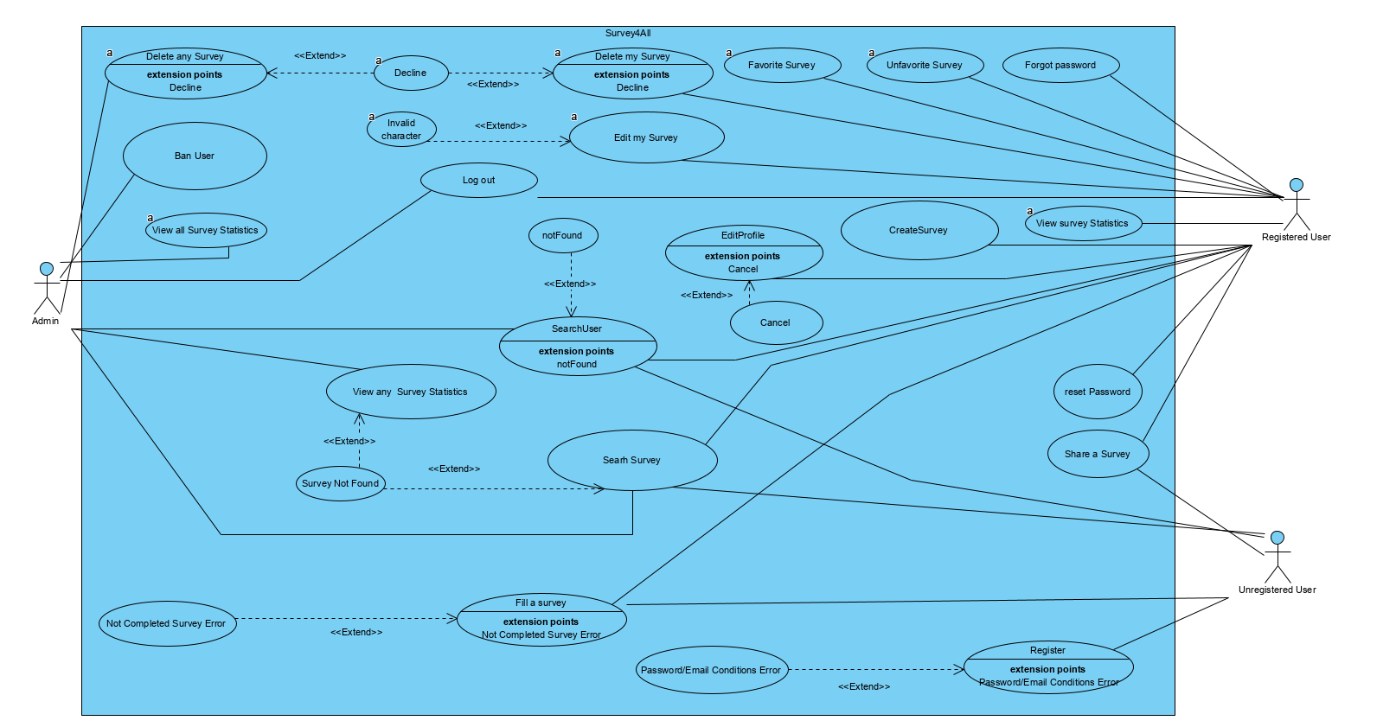

### Object model

### 

### Dynamic model

**Login**

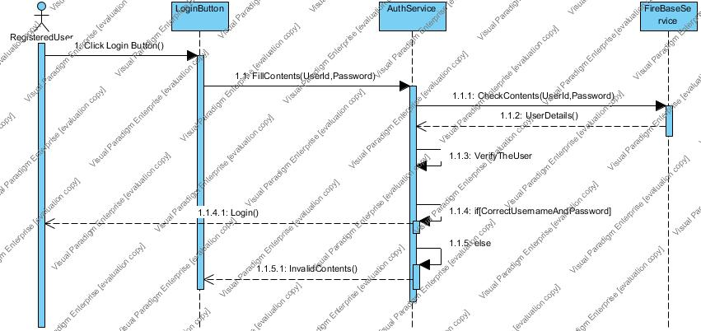

**Search User**

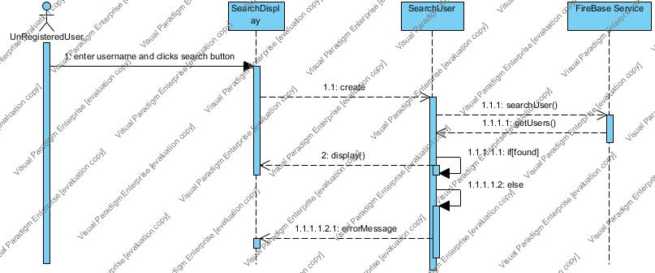

**Delete my Survey**

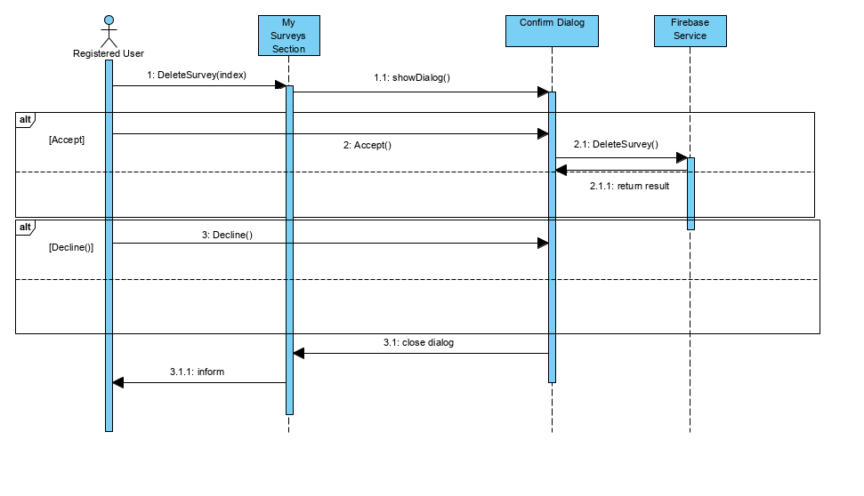

**Create Survey**

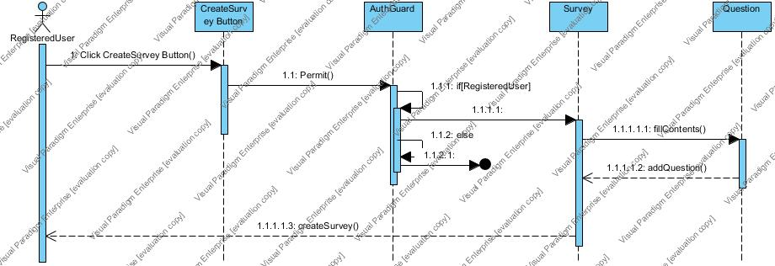

**Edit Profile**

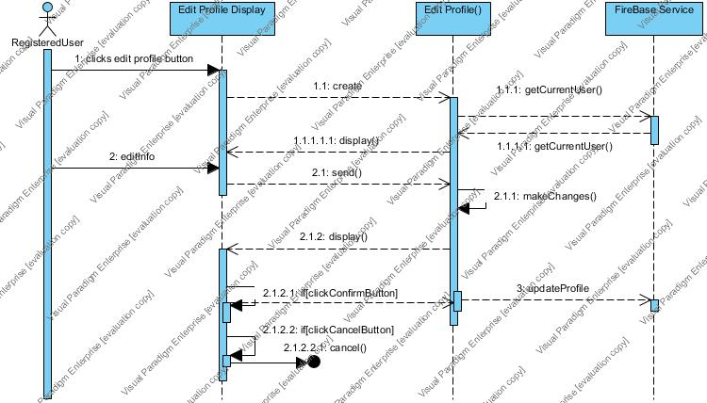

**Edit My Survey**

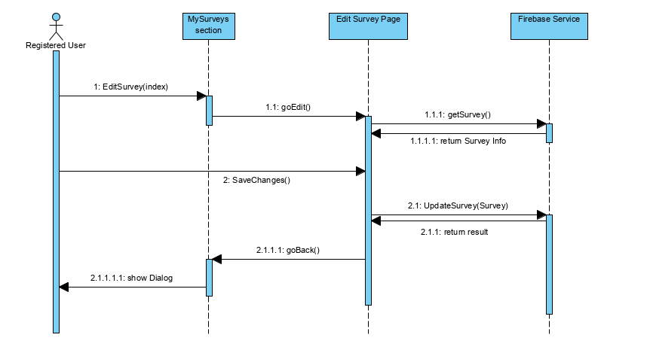

**Check My Survey Statistics**

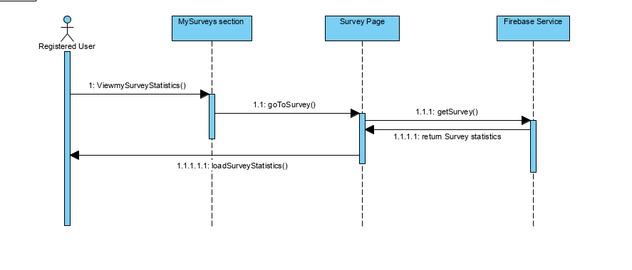

**Favorite Survey**

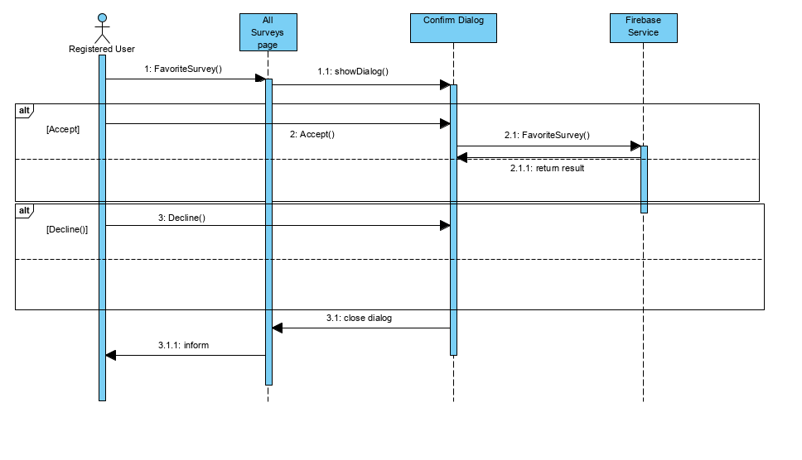

**Unfavorite Survey**

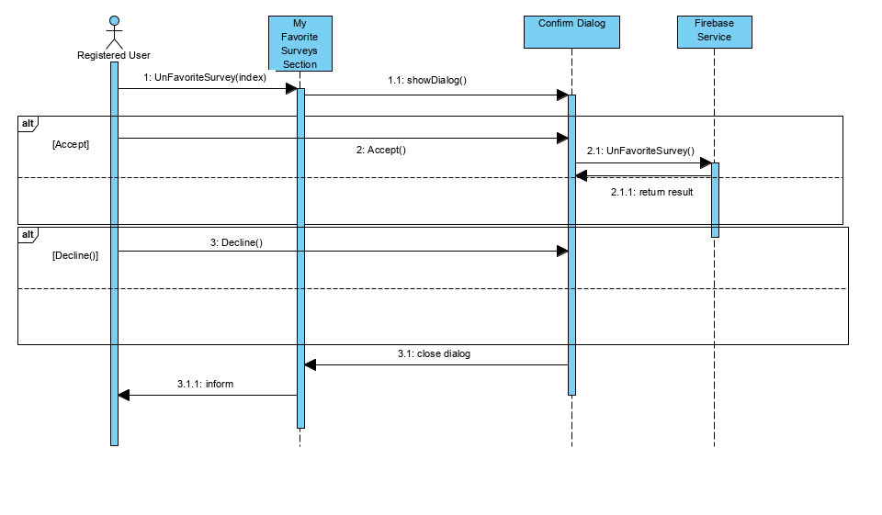

**Delete any Survey**

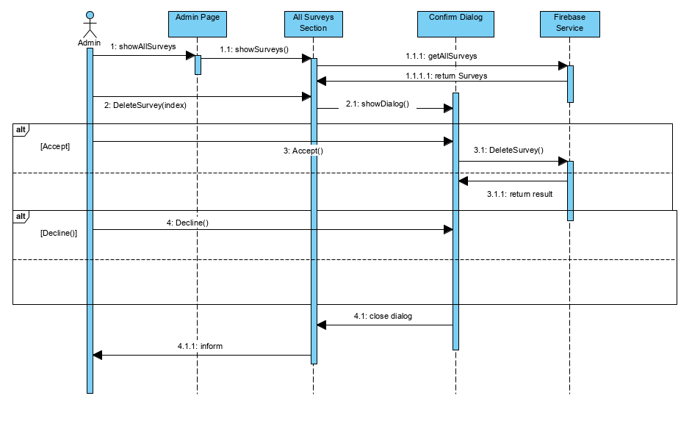

**Ban User**

**ekran görüntüsü içeren bir resim

Açıklama otomatik olarak oluşturuldu**

**Check All Survey**

**ekran görüntüsü içeren bir resim

Açıklama otomatik olarak oluşturuldu**

**Share Survey**

**ekran görüntüsü içeren bir resim

Açıklama otomatik olarak oluşturuldu**

**Search a Survey**

**ekran görüntüsü içeren bir resim

Açıklama otomatik olarak oluşturuldu**

### User interface—navigational paths and screen mock-ups

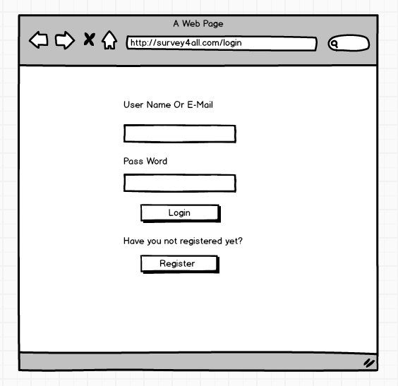

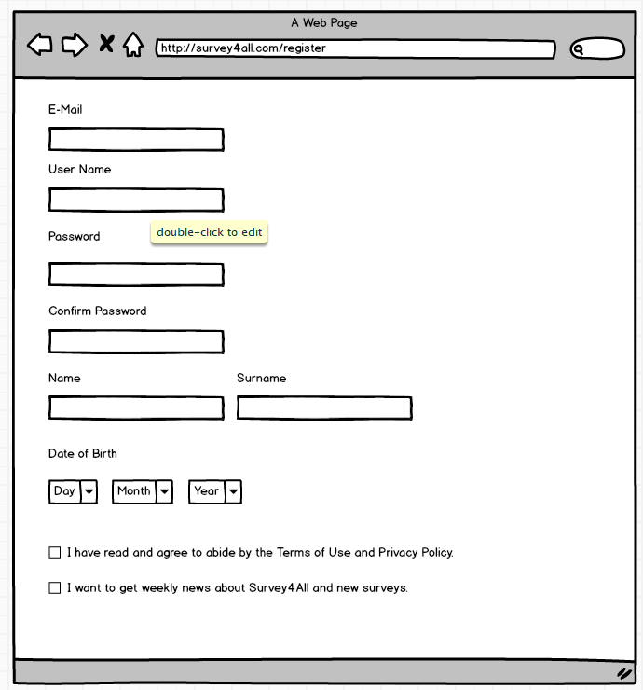

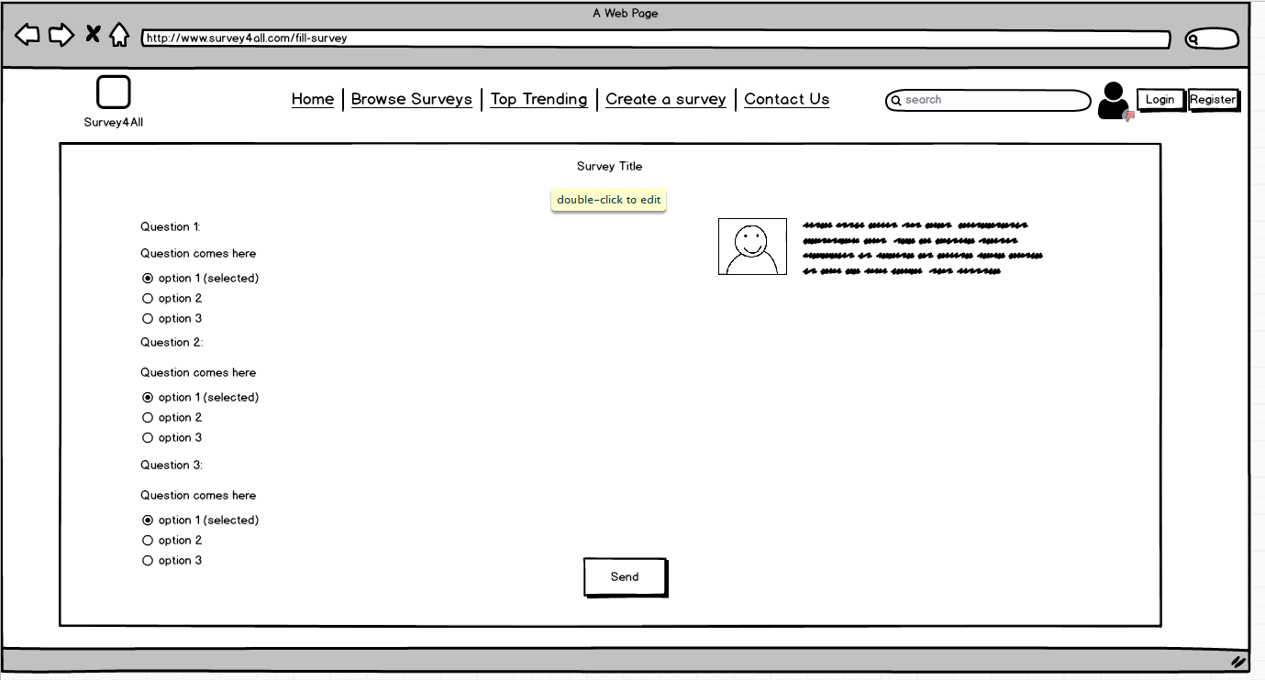

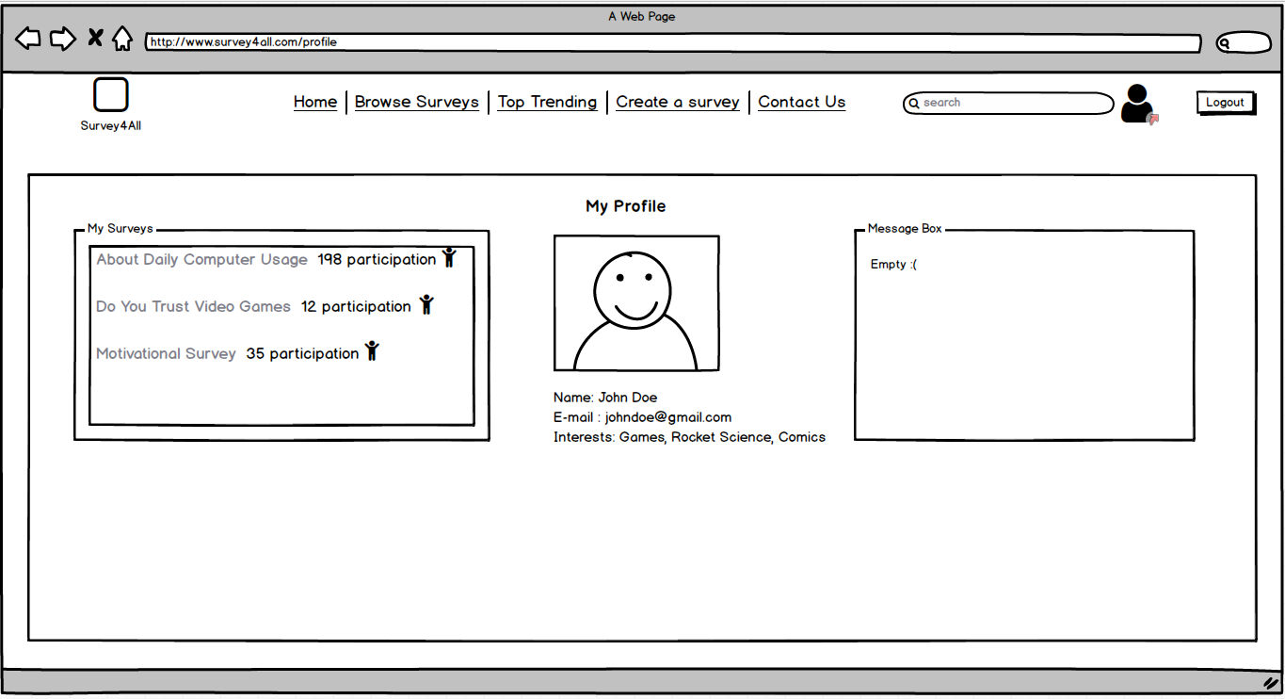

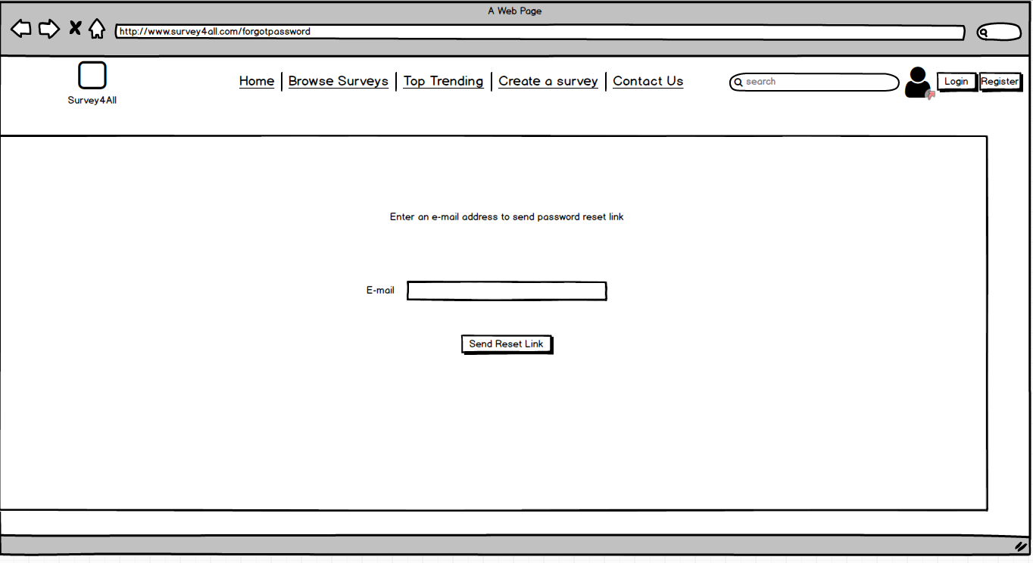

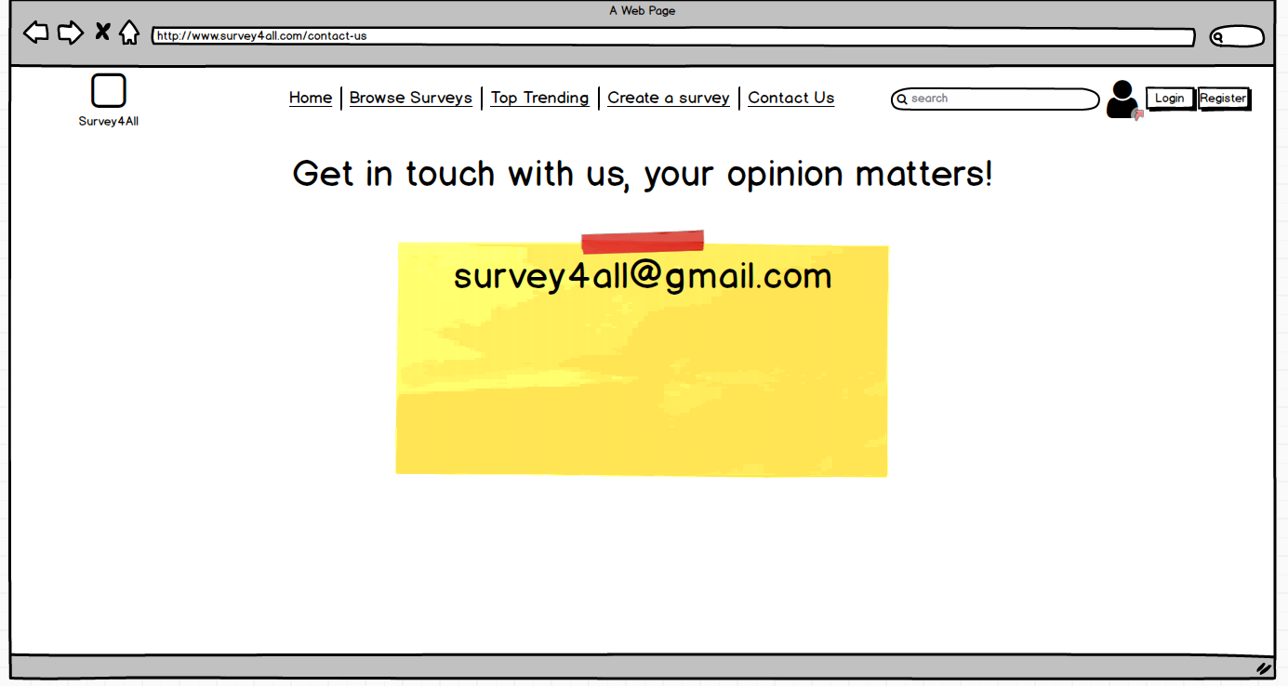

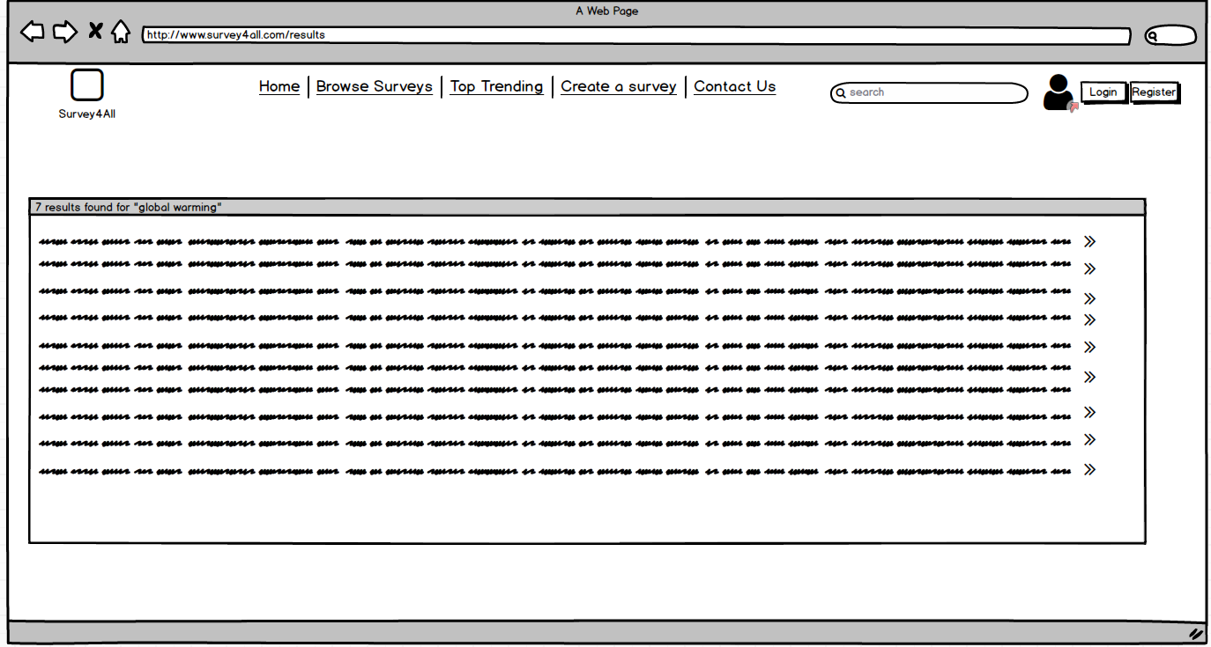

## Project Schedule

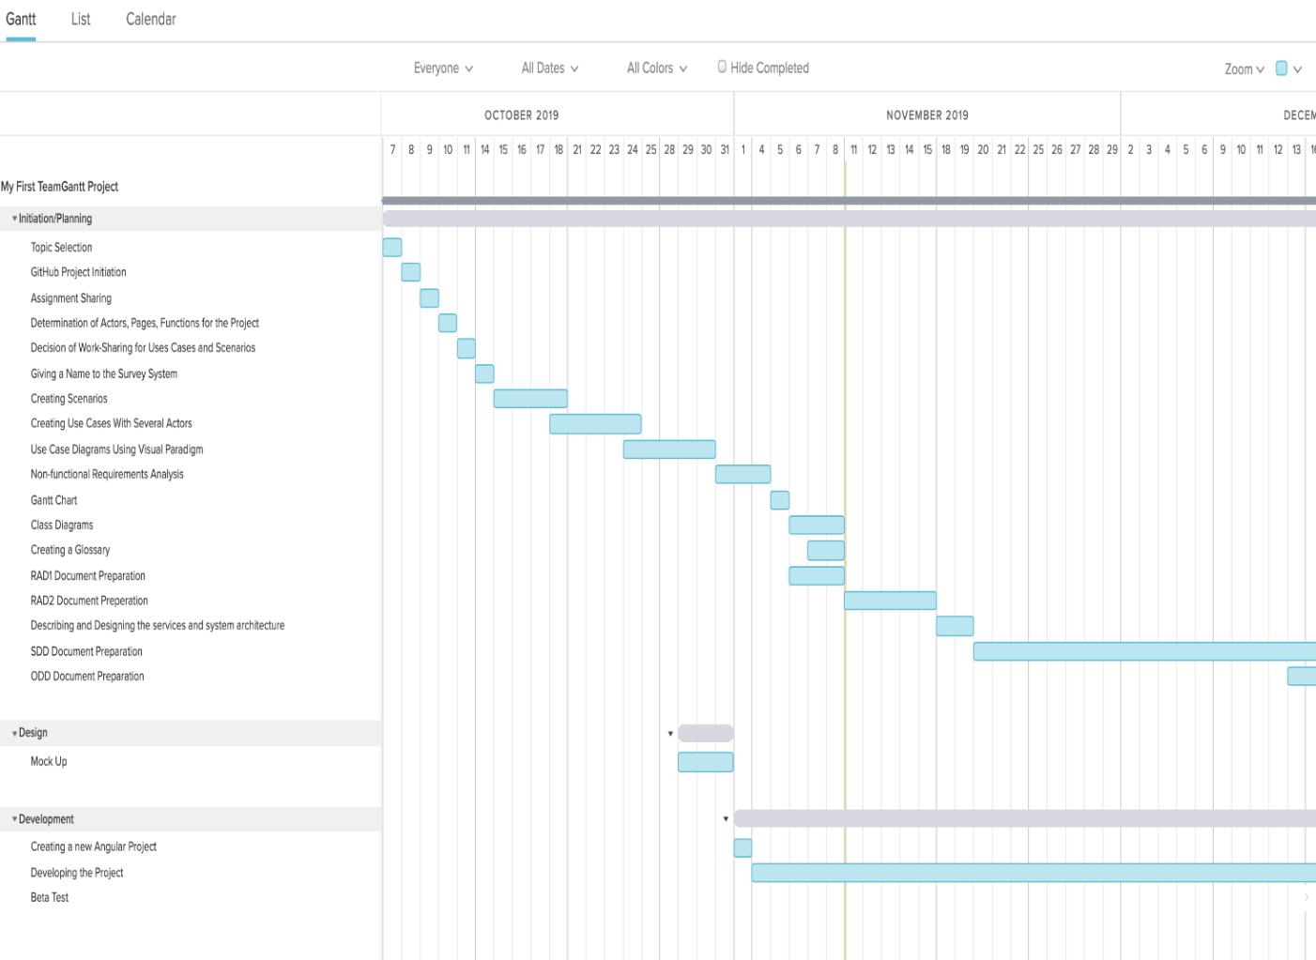

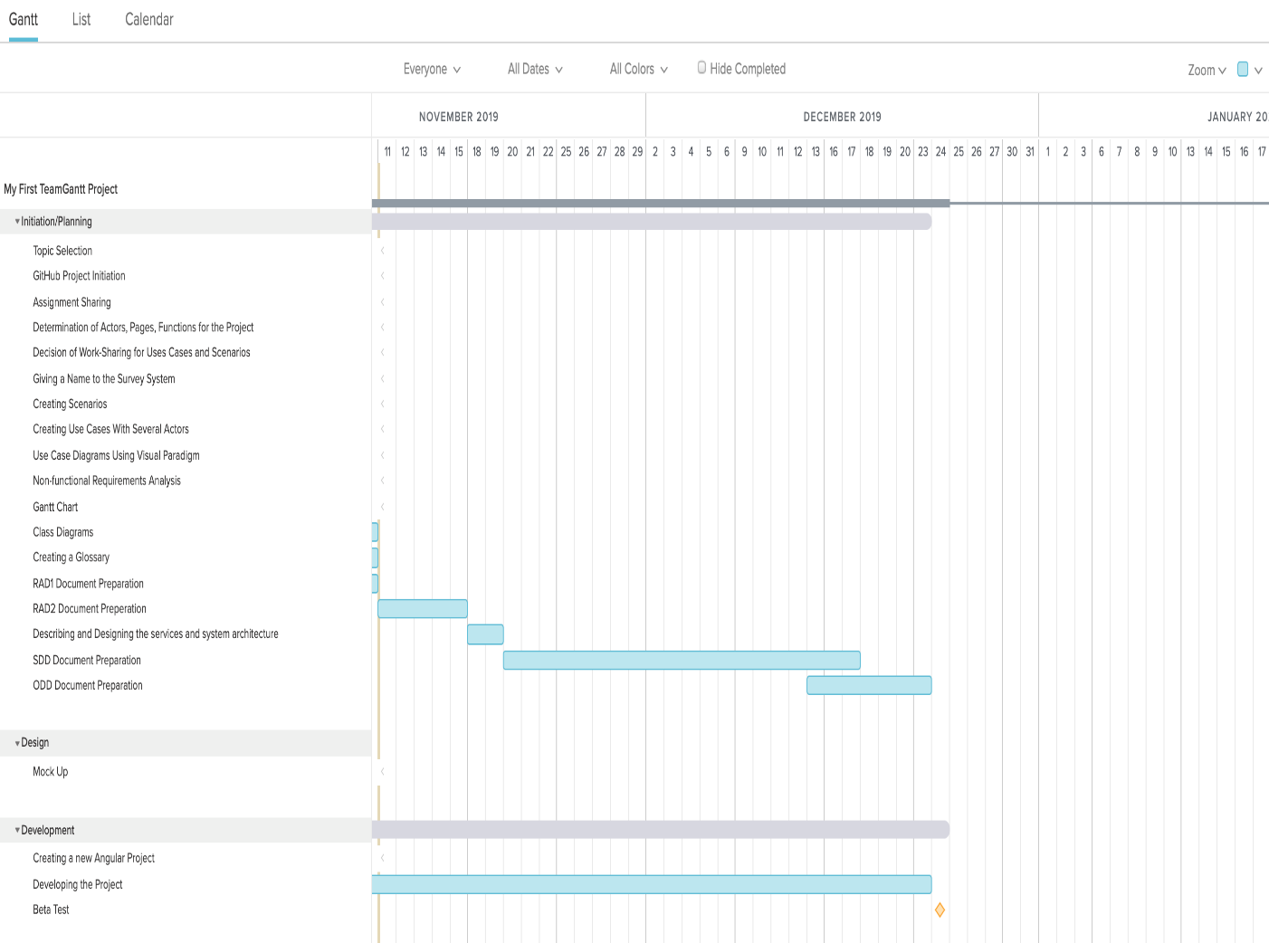

# Glossary

* Angular: AngularJS is a JavaScript-based open-source front-end web framework mainly maintained by Google and by a community of individuals and corporations to address many of the challenges encountered in developing single-page applications.
* Firebase: Firebase is a mobile and web application development platform then acquired by Google in 2014. As of October 2018, the Firebase platform has 18 products, which are used by 1.5 million apps.
* Github: GitHub is a Git repository hosting service, but it adds many of its own features. While Git is a command line tool, GitHub provides a Web-based graphical interface. It also provides access control and several collaboration features, such as a wikis and basic task management tools for every project.
* Use Case: A use case is a list of actions or event steps typically defining the interactions between a role and a system to achieve a goal.
* Scenario: A scenario is a tool used during requirements analysis to describe a specific use of a proposed system.
* Use Case Scenario: A use case diagram is a graphic depiction of the interactions among the elements of a system.
* AuthGuard:Auth guard is the service that blocks the unregisteredusers from unwanted pages.(F.E:Unregistered Users can not access profile page)
* Auth-Service:Auth Service is the service that controls the user based actions like login, forgotpassword,get user info etc.
* Share survey panel: A dialog box opens which contains the people you can select to share your survey when you click the share survey button you will see this.
* Login Barrier: A login barrier is a tactical element in a site. You set the conditions for the user to access a page.

# References