Portfolio 2

# 1:

Theoretical line is plotted using function: $N⋅Log_{2}\left(N\right)⋅factor$ where factor is to get the two graphs intersect each other in endpoints. The practical data is a variable counted one up each time perculate_down is called after buildheap is done. It can be seen from the plot that the data follow $N⋅Log_{2}\left(N\right)$ pretty good

# 2:

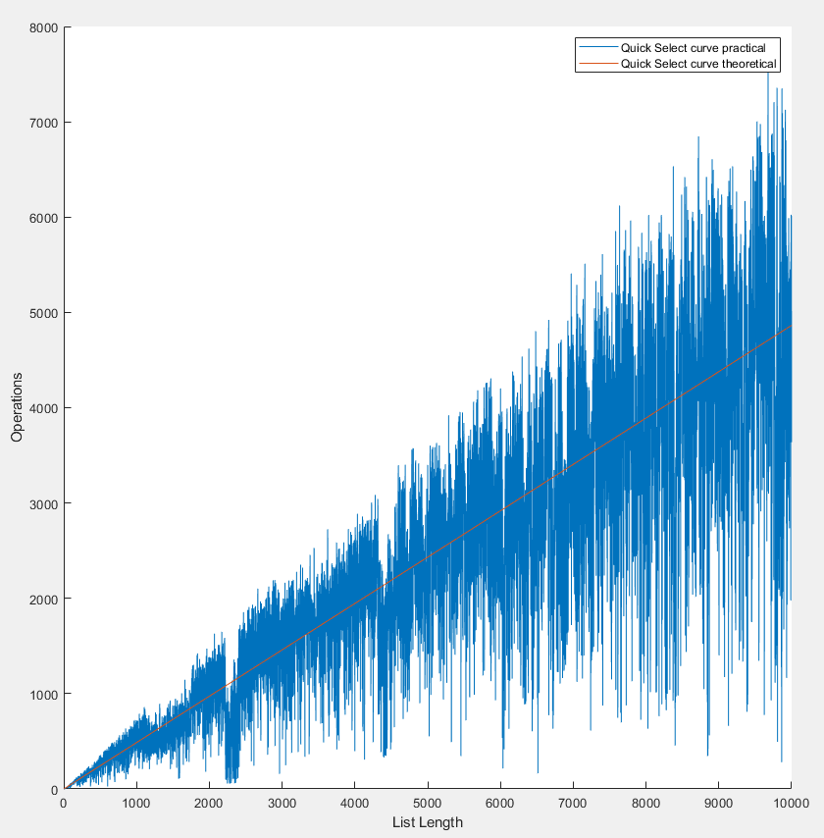

Theoretical line is plotted using function: $N⋅factor$ where factor is to get the two graphs intersect each other in endpoints. The practical data is a variable counted one up each time it swaps in the while(true) inside quick_select. This means we do not count one up if it is using insertions_sort (only for small list sizes). It can be seen from the plot that the operations vary a lot. This is due to the list generated is random which mean if the list is nearly sorted, the operations used is few. The tendency of the graph is linear.

# 3: Bevis average case quick select

Average case:

$T\left(N\right)=\frac{1}{N}\left[\sum_{j=0}^{N-1}{T\left(j\right)}\right]+c⋅N$ (1)

Multiple by N:

$N⋅T\left(N\right)=1⋅\left[\sum_{j=0}^{N-1}{T\left(j\right)}\right]+c⋅N^{2}$ (2)

Substitute N with N-1:

$\left(N-1\right)⋅T\left(N-1\right)=\left[\sum_{j=0}^{N-2}{T\left(j\right)}\right]+c⋅{(N-1)}^{2}$ (3)

Subtract (3) from (2):

$N⋅T\left(N\right)-\left(N-1\right)⋅T\left(N-1\right)=T\left(N-1\right)+c⋅N^{2}-c⋅{\left(N-1\right)}^{2}$

$N⋅T\left(N\right)-\left(N-1\right)⋅T\left(N-1\right)=T\left(N-1\right)+c⋅N^{2}-c\left(N^{2}-2N+1\right)$

$$N⋅T\left(N\right)-\left(\left(N-1\right)⋅T\left(N-1\right)\right)=T\left(N-1\right)+2cN-c$$

Rearrange and drop insignificant c:

$N⋅T\left(N\right)=T\left(N-1\right)+\left(N-1\right)⋅T\left(N-1\right)+2cN$ (4)

$$N⋅T\left(N\right)=T\left(N-1\right)+NT\left(N-1\right)-T\left(N-1\right)+2cN$$

$N⋅T\left(N\right)=N⋅T\left(N-1\right)+2cN$ (5)

Divide equation (5) by N:

$T\left(N\right)=T\left(N-1\right)+2c$ (6)

Telescope:

$$T\left(N-1\right)=T\left(N-2\right)+2c$$

$$T\left(N-2\right)=T\left(N-3\right)+2c$$

$$⋮$$

$$T\left(2\right)=T\left(1\right)+2c$$

Adding all equations:

$T\left(N\right)=T\left(1\right)+\sum_{i=1}^{N}{2c }=O(N)$ (7)