Portfolio 2

1. Write a method that solves the selection problem using a priority queue and conduct a series of experiments that indicate that the time complexity of your method is O(N log N).
2. Implement the quickSelect method and conduct a series of experiments that indicate that the time complexity of the method is O(N).
3. Solve the average case recurrence equation for quickSelect.

# 1: Priority Queue

The experiment is done on a random generate list from 0 to 10 000 with a step size of 100. Each iteration is done 100 times. The average of each iteration is plotted in figure 1.

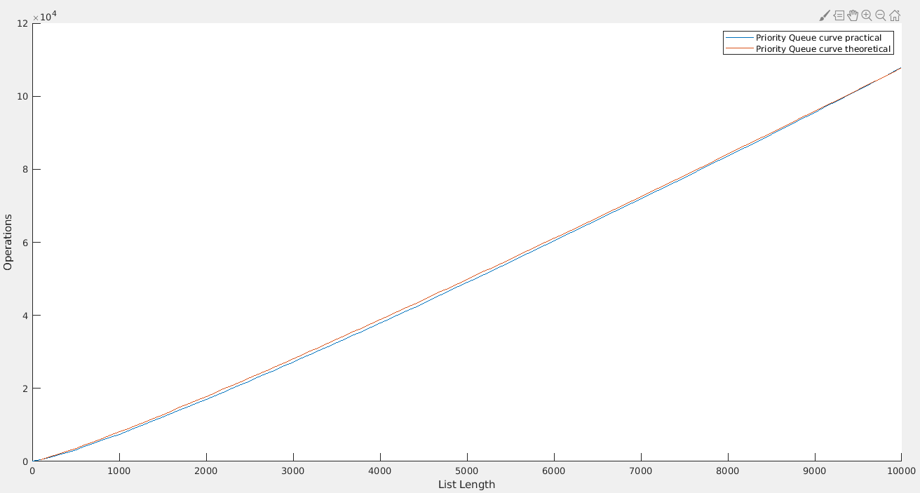  
Figure 1: Priority Queue: Operation versus list length.

Theoretical line is plotted using function: $N⋅Log_{2}\left(N\right)⋅factor$ where factor is to get the two graphs intersect each other in endpoints. The practical data is a variable counted one up each time perculate_down is called after buildheap is done. It can be seen from the plot that the data follow $N⋅Log_{2}\left(N\right)$ pretty good

# 2: Quick Select

The experiment is done on a random generate list from 0 to 10 000 with a step size of 100. Each iteration is done 100 times. The average of each iteration is plotted in figure 2.

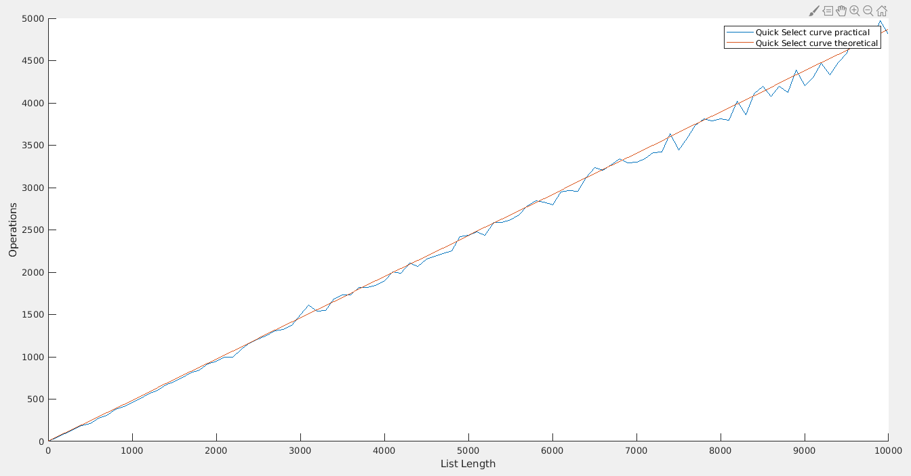  
Figure 2: Quick Select: Operation versus list length

Theoretical line is plotted using function: $N⋅factor$ where factor is to get the two graphs intersect each other in endpoints. The practical data is a variable counted one up each time it swaps in the while(true) inside quick_select. This means we do not count one up if it is using insertions_sort (only for small list sizes).

# 3: Average case Quick Select

Average case:

$T\left(N\right)=\frac{1}{N}\left[\sum_{j=0}^{N−1}{T\left(j\right)}\right]+c⋅N$ (1)

Multiple by N:

$N⋅T\left(N\right)=1⋅\left[\sum_{j=0}^{N−1}{T\left(j\right)}\right]+c⋅N^{2}$ (2)

Substitute N with N-1:

$\left(N−1\right)⋅T\left(N−1\right)=\left[\sum_{j=0}^{N−2}{T\left(j\right)}\right]+c⋅{\left(N−1\right)}^{2}$ (3)

Subtract (3) from (2):

$N⋅T\left(N\right)−\left(N−1\right)⋅T\left(N−1\right)=T\left(N−1\right)+c⋅N^{2}−c⋅{\left(N−1\right)}^{2}$

$N⋅T\left(N\right)−\left(N−1\right)⋅T\left(N−1\right)=T\left(N−1\right)+c⋅N^{2}−c\left(N^{2}−2N+1\right)$

$N⋅T\left(N\right)−\left(\left(N−1\right)⋅T\left(N−1\right)\right)=T\left(N−1\right)+2cN−c$

Rearrange and drop insignificant c:

$N⋅T\left(N\right)=T\left(N−1\right)+\left(N−1\right)⋅T\left(N−1\right)+2cN$ (4)

$N⋅T\left(N\right)=T\left(N−1\right)+NT\left(N−1\right)−T\left(N−1\right)+2cN$

$N⋅T\left(N\right)=N⋅T\left(N−1\right)+2cN$ (5)

Divide equation (5) by N:

$T\left(N\right)=T\left(N−1\right)+2c$ (6)

Telescope:

$T\left(N−1\right)=T\left(N−2\right)+2c$

$T\left(N−2\right)=T\left(N−3\right)+2c$

$⋮$

$T\left(2\right)=T\left(1\right)+2c$

Adding all equations:

$T\left(N\right)=T\left(1\right)+\sum_{i=1}^{N}{2c}=O\left(N\right)$ (7)