|  |  |
| --- | --- |
| **Practicum Case** |  |
| MOBI6012001  Web Design |
| **Computer Science** | **O1-T1094-CP01** |
| ***Valid on*** *Odd Semester Year 2021/2022* | **Revisi 00**  *Revision 00* |

## Learning Outcomes

* Explain the HTML5 Concept

## Topic

* Session 01 - Introduction to HTML5

## Sub Topics

* Basic HTML tag
* List
* Image
* Viewport

## Soal

*Case*

**Bluez Bookstore** is a bookstore that sells all kinds of books. **Bluez** **Bookstore** wants to create a website to sell and promote those kinds of books. As a web developer, you are asked to create a **Home** page from that website that contains a short description from **Bluez** **Bookstore** and a list of new books published which contain **title**, **picture**, **author**, and **description** from that book.

You can use table for your website structure and for styling or alignment you can use attributes in HTML. Make sure your website can be displayed perfectly in device with **5.1 inch** and **480x800 pixel mdpi** resolution.

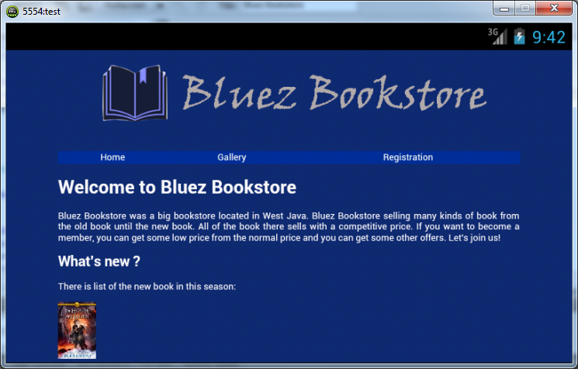

**Website Bluez Bookstore1.1(Landscape)**

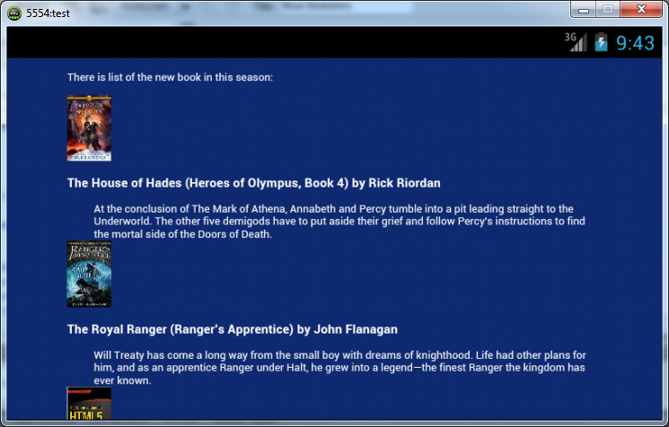

**Website Bluez Bookstore 1.2(Landscape)**

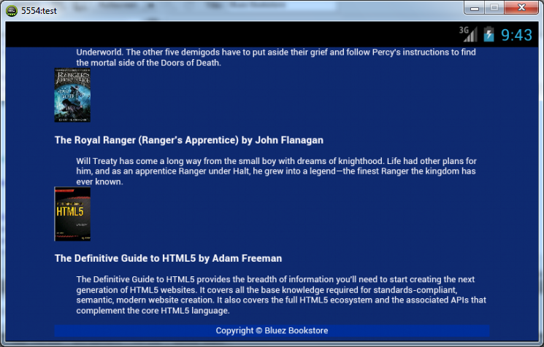

**Website Bluez Bookstore 1.3(Landscape)**

**References**:

<http://www.wheatonbible.org/content.aspx?content_id=256436&site_id=10713>

<http://www.amazon.com/House-Hades-Heroes-Olympus-Book/dp/1423146727/ref=zg_bsnr_books_3>

<http://www.amazon.com/The-Royal-Ranger-Rangers-Apprentice/dp/0399163603/ref=pd_sim_b_3>

<http://www.amazon.com/Definitive-Guide-HTML5-Adam-Freeman/dp/1430239603/ref=sr_1_4?s=books&ie=UTF8&qid=1378419871&sr=1-4&keywords=html5>