**Internet/Mobile Programming 2**

Project 1

Routing over the Internet

Mason Chong Yi Tian 32169122

Chong Ming Luen 32169121

Dankook University

Spring 2018

1.

Implementing a routing protocol at the application layer and to simulate one of the primary functions in IP protocol: routing. Routing sends data packets to other network so that they can send and receive messages.

2. Motivation

This project gave us a chance to utilize Djikstra Algorithm in our codes, something that we did not do in our home university. It was also useful to break down the steps on how the Djikstra algorithm works in order to get a deeper understanding on the topic.

3. Concepts used in CPU simulation

Djikstra:

This was used to find the shortest path from the initial node to the goal node.

Socket:

This was used to create the connections from the server to clients.

Routing:

This was used to find the cost of a node’s neighbors’.

4. Program Structure

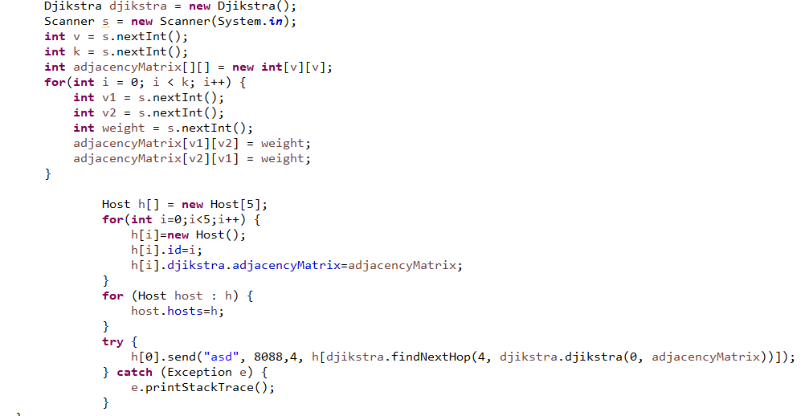

The code requires the user to input their own matrix for the Djikstra algorithm to work, including the number of vertices and nodes on the top. It has been set that it can only have 5 nodes in total. However this code only sends a message from host 0 or number 1 to host 4.

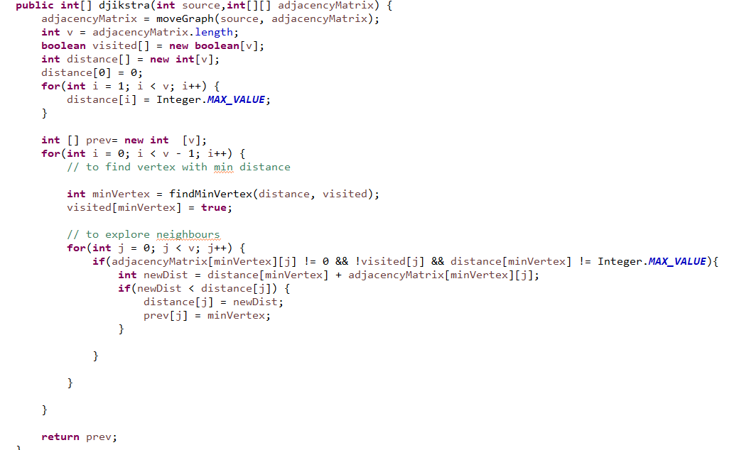

This Djikstra function is used to find the shortest path to the destination that is, in this case, Host 4.

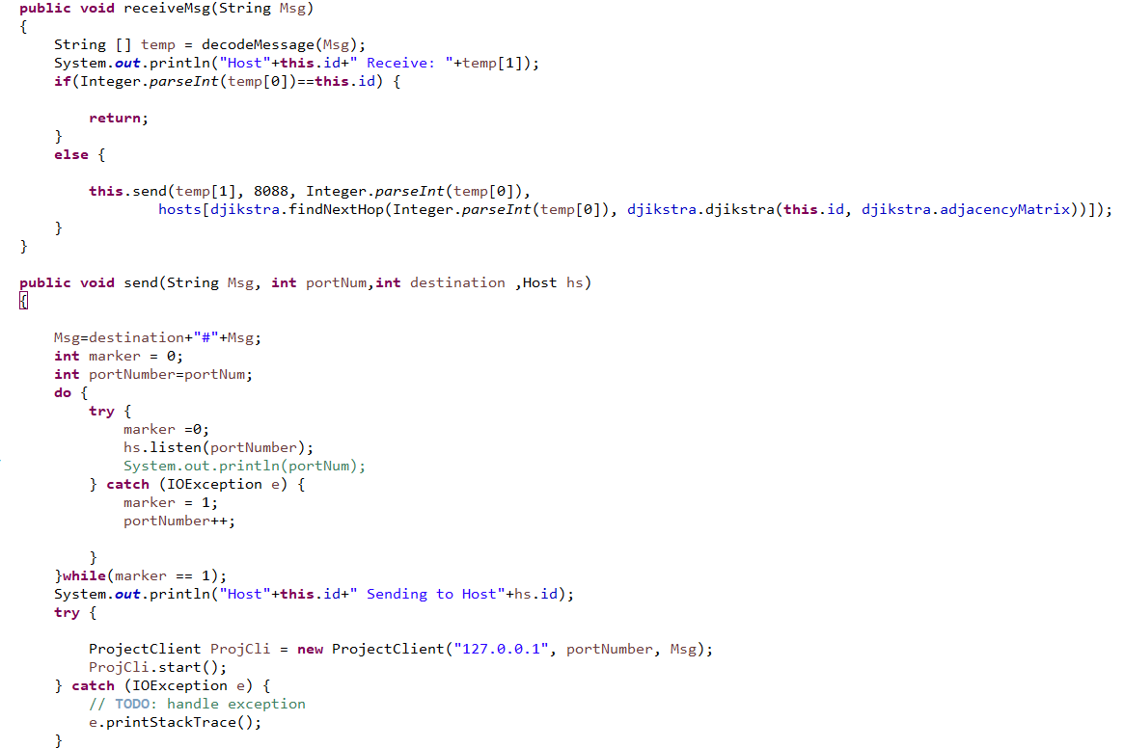

Send function is to send a message from the sender host to the next hop host until it reaches the destination through socket function. Receive function receives the message that it receives from the socket function.

5. Problems and Solutions

In the beginning I was constantly creating something that I thought was relevant to the project but turned out to not be the case, resulting in a lot of time wasted. The code was also not properly structured in the beginning.

To resolve the problems, I had to edit and remove some code while also tidying up the code.

6. Build Environment

Compilation: Eclipse Java

To run, please type ‘F11’.

In order to initiate the program, copy a matrix from the ‘matrix.txt’ file and paste it on the console.

7. Screen capture

The snippet below is the result of the algorithm.

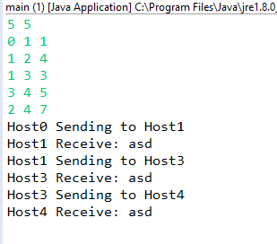

8. Personal Feelings

We were satisfied in the end as we were able to finish in time.

It was very challenging as we had never done something like this before. It was made harder with the limited resources online.

I cannot say much about what could be taught in class prior to this assignment as I am only an exchange student and do not know what was taught in the previous classes, i.e. Internet/Mobile Programming 1, however, some lessons on socket programming would be useful.