|  |
| --- |
| **Vaccination Culture Calculator Software Requirements Specification [Front End] Version 1.0 October 8th 2018  Ned Sherman & Mason** **Baird** |

Table of Contents

1.0 Introduction2

1.1 Purpose2

1.2 Definitions, Acronyms, & Abbreviations 2

1.3 System Overview 2

2.0 Functional Description3-4

3.0 System Requirements4

3.1 Hardware Requirements4

3.2 Software Requirements4

4.0 Miscellaneous5

4.1 Contact5

4.2 GitHub5

**Revision History**

|  |  |  |  |
| --- | --- | --- | --- |
| **Date** | **Version** | **Description** | **Author(s)** |
| Oct 1st 2019 | 0.1 | Initial Draft | Mason Baird, Ned Sherman |
| Oct 2nd 2019 | 1.0 | Completion of all sections for current vision of the application, Table of contents | Mason Baird, Ned Sherman |
| Oct 8th 2019 | 1.1 | Revisions | Mason Baird, Ned Sherman |
| Oct 10th 2019 | 1.2 | Redesign | Mason Baird, Ned Sherman |

**1. Introduction**

The United Nations third Goal of Sustainable Development, “Good Health & Well-Being”, prompts people to vaccinate themselves and their family members. Vaccine preventable diseases are again a cause of death even in countries that used to have the deadly diseases under control. Chicken pox, pertussis, diphtheria, and measles are diseases that still cause deaths in the United States, and across Europe. In some cases these deaths are a result of the population’s inaccessibility to vaccination but there are also cases of voluntary refusal to vaccinate leading to death. If understanding of the safety and importance of vaccination becomes more widespread fewer deaths might be caused by vaccine preventable diseases.

1.1 Purpose

The Vaccination Culture Calculator will be a tool that shows a countries acceptance of vaccination so that users can educate themselves on the vaccination stance of the supplied country. The Vaccination Culture Calculator will also provide information for vaccination advocates to get in touch with each other through the use of the users table. The Users table will enable users of the tool to input their own name, contact information, and opinion on vaccination so that future users might get in touch with someone who has used the tool before.

1.2 Definitions, Acronyms, and Abbreviations

**Front End** – a software interface (such as a graphical user interface) designed to enable user-friendly interaction with a database

**Back End** - core computational logic of a website or database.

**CSV** - Comma Separated Values

**SD** – Share that Disagree …

**SA** – Share that Agrees …

**SNAD** – Share that neither Agrees nor Disagrees

**VCC** – Vaccination Culture Calculator

1.3 System Overview

The minimum functional requirement for the completed Vaccination Culture Calculator is the ability to take a country as input and output a summary of the supplied country’s stance on vaccination so users can educate themselves on different countries.

**2. Functional Description**

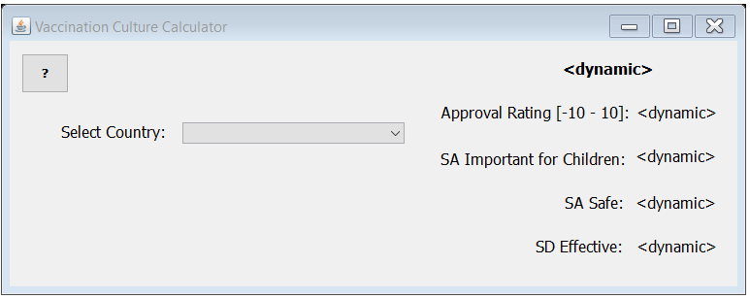

The Vaccination Culture Calculator, in its current state, is very basic. The tool involves:

* A JFrame and JPanel
* A jButton in the upper left hand corner that will spawn a pop up window with information about the developers and background on the data the tool displays.
* A jCcomboBox (or drop down menu) that will have all the countries the user can select from.

10 jLabels:

1. A jLabel to label the country drop down menu.
2. A jLabel to display the currently selected country.
3. A jLabel to display the countries Approval Rating.
4. A jLabel to label the countries Approval Rating.
5. A jLabel to display the share that agree vaccines are important.
6. A jLabel to label the share that agree vaccines are important.
7. A jLabel to display the share that agree vaccines are safe.
8. A jLabel to label the share that agree vaccines are safe.
9. A jLabel to display the share that disagree vaccines are effective.
10. A jLabel to label the share that agree vaccines are safe.

5 Classes

* + 1. A main class that will hold the GUI code and some code to treat data to be displayed
    2. A Qrecord class to query the back end for the data records on a country
    3. A Qcountry class to query the back end for the country list
    4. A country object to pipeline country data
    5. A record object to pipeline record data

Data Structures and constructors:

* + 1. A constructor for records with 5 String parameters (entity, approvalRating, SAsafe, SAimportant, and SDeffective)
    2. A constructor for country with one String parameter (country)
    3. A toString for the record object
    4. An ArrayList for the countries to be read into
    5. An ArrayList of records to create a pseudo table
    6. A List<String> for the record toString to be indexed into

A user should be able to select the country they want to see data about and the dynamic jLabels should update with the selected countries data. For example, with input “Ireland” the GUI should update to appear as it does below: 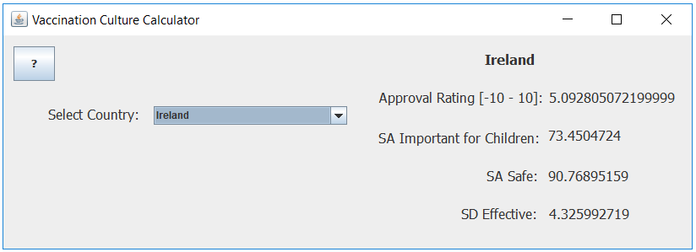

The VCC should be developed error free.

**3. System Requirements**

The Vaccination Culture Calculator will not require any specific hardware beyond that of a standard computer. The front end development will require the machine to be equipped with the software to develop and run Java application.

3.1 Hardware Requirements

The application will not be hardware demanding and will not require any specific hardware. The application will be suitable to run on any machine with baseline hardware.

3.2 Software Requirements

The front end development will require Java and the java UI swing packages.

**4. Miscellaneous**

|  |  |  |
| --- | --- | --- |
| Name | Slack Handle | Email |
| Mason Baird | Mason Baird | [mgbaird@smcm.edu](mailto:mgbaird@smcm.edu) |
| Ned Sherman | Edmund Sherman | easherman@smcm.edu |

4.1 Contact

4.2 Data Sets

The artifacts pertaining to this project are available at: <https://github.com/MasonGBaird/450MajorProject>