GA TECH CODING BOOTCAMP

**Project 2**

**Inventory Management Systems**

Table of Contents

Team members 3

Introduction 3

Problem description 3

Solution 3

# Team members

* Franklyn Diaz

Back-end

Proposal

GitHub repository directory structure

* Mason Hames

Front-end

Wireframe

User story

* Logon Pierce

Front-end

* Wilson Sous

Back-end

wireframe

# Introduction

This project will focus on the application of technologies learning in the last few weeks in the bootcamp. We are going to leverage what we have practiced in the areas of databases (MySQL), express, node.js, HTML and CSS (for presentation

# Problem description

In a company there is a warehouse that is connected to the sales department. The company needs to track the inventory in the warehouse and update it according to the sales and requisition area updates

# Solution

The application we propose takes care of the inventory management and has some functionality in the sales area as well as the requisitions area (buy products).

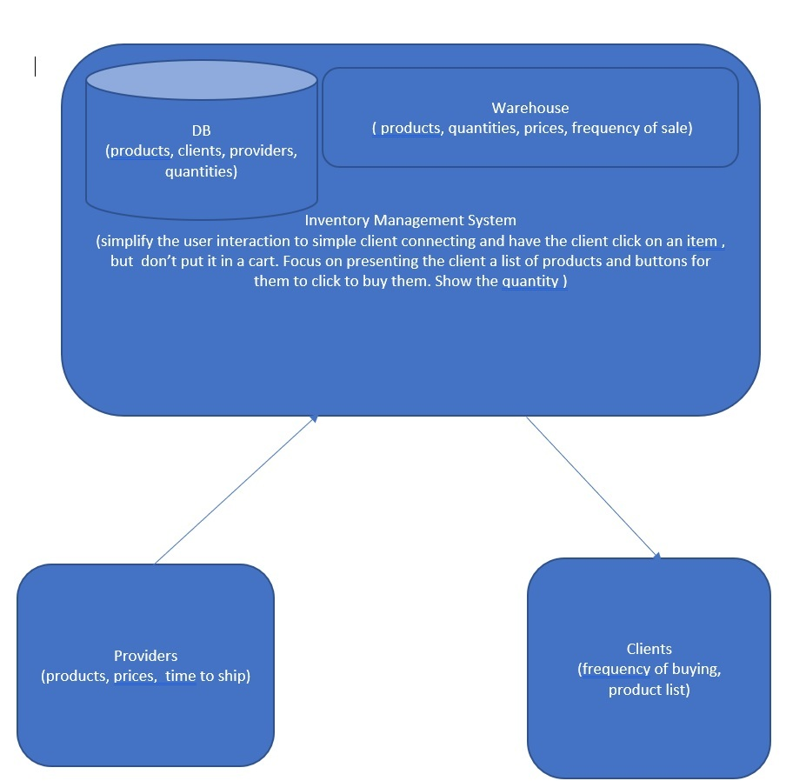

The system will have a database containing tables for:

* Products

|  |  |  |  |  |  |
| --- | --- | --- | --- | --- | --- |
| productid * | Name | price | description | Provider1@ | Provider2@ |
| Int(autoIncr) | Char(20) | float | Char(50) | From  provider ->providerID | From  provider ->providerID |

* Customers

|  |  |  |  |  |  |
| --- | --- | --- | --- | --- | --- |
| Client ID* | name | Last name | phone | address | preferred |
| Int(autoIncr) | Char (20) | char (20) | Number (10) | Char (40) | bool |

* Providers

|  |  |  |  |  |
| --- | --- | --- | --- | --- |
| Provider ID* | providerName(company) | Contact Name | phone | address |
| Int(autoIncr) | Char (20) | char (20) | Number (10) | Char (40) |

The system has these functions:

* Maintains a list of products with the quantity available
* Produces a sub list of products and the quantities to show to the client
* When a sell is finished then the inventory quantities is updated for each product sold.
* When it receives an order to buy product and the product is received (in our case order and delivery of product is immediate) then it updates the quantities in inventory of those product received in inventory.